Developing Fire Susceptibility Models Using Remote Sensing to Identify Wildlife Habitats in the Sagebrush-Steppe Ecosystem Threatened by Wildfires

Courtney Ohr, Priscilla Addison, Jenna Williams

Corresponding Author: peaddiso@mit.edu

Developing Fire Susceptibility Models Using Remote Sensing to Identify Wildlife Habitats in the Sagebrush-Steppe Ecosystem Threatened by Wildfires

Wildfires can be disastrous for declining, threatened, or endangered wildlife species. Encroachment of non-native annual grasses such as cheatgrass or woody-vegetation such as juniper have increased fuel loads, intensified wildfire severity, and altered fire regimes throughout the Great Basin and Intermountain West. This project partnered with Craters of the Moon National Monument and Preserve (CRMO) and the Bureau of Land Management (BLM) in Idaho to identify wildlife habitats with increased susceptibility to wildfires due to fuel loads. This project is unique in its inclusion of kipukas, islands of wildlife habitats found throughout lava formations. Wildlife habitats of the diminished Greater Sage-grouse (GRSG) (Centrocercus uraphasignus) and declining mule deer (Odocoileus hemionus) were included in the study. Sagebrush-steppe is a resilient ecosystem and is able to handle many different environmental extremes but wildfires can be disastrous to the flora, and as a result the fauna, because it takes so long to re-establish. This project leveraged Landsat 8 Operational Land Imagery (OLI) data from June 2015, Sentinel-2 data from June 2016, fuel loads measured in tons per acre, and topographic variables to produce four threatened habitat wildfire susceptibility models. One of the main objectives of the project was to investigate the effect of differing spatial resolutions on the accuracy of the output models. Weightings from expert opinion and industry standards were applied to model variables to discern fire behaviour and habitat vulnerability. The burned area from the Timbered Dome fire of July 4, 2016 was analyzed to serve as validation for the effectiveness of the models and reinforces the need for continued monitoring of habitats that are highly susceptible to wildfires. Methods developed provided decision makers with new and effective ways to monitor remote areas and threatened habitats.

**Keywords:** mule deer; Greater Sage-grouse; Landsat 8 OLI; Sentinel-2; threatened habitats

# 1. Introduction

## 1.1. Background

Many species such as the Greater Sage-grouse (Centrocercus urophasianus) and mule deer (Odocoileus Hemionus) depend on the sagebrush-steppe ecosystem to provide shelter, food, and rearing grounds. Both cheatgrass (Bromus tectorum) and juniper (Juniperus communis) are primary drivers of change in native semi-arid savanna ecosystems and play a large role in changing fire regimes. Sagebrush-steppe is a resilient ecosystem and known to have plant populations as old as 150 years. This ecosystem is adapted to fires; historically, wildfires would occur in long intervals from decades to hundreds of years allowing native vegetation the chance to re-establish. Though fire often plays an essential role in wildland ecology and helps maintain natural processes, too many occurrences of wildfires can induce a loss of biodiversity, disrupt ecosystems, and deplete resources (Oppenheimer, 2012; Whisenant, 1990). Found within this study area were habitat designations for Greater Sage-grouse (GRSG), a well-known species that has struggled to survive in modern day. Mule deer, a keystone management species in Idaho, is a common big game species serving roughly 150,000 hunters. In 2006, the Idaho Department of Fish and Game (IDFG) gathered $6.3 million in mule deer license and tag sales making up 20% of the overall license/tag revenues (American et al., 2008).

Population declines of the Greater Sage-grouse and mule deer began in the 1960s and 1990s, respectively (Aldridge et al., 2008; & Bishop et al., 2009). Two primary threats to the sustainability of Greater sage-grouse are wildfire and invasive annual grasses encroaching the low- to mid-elevation sagebrush (Ielmin et al., 2015). Other disturbance factors included improper grazing, development, and other anthropogenic activities that spread these invasive species (Anderson et al., 2015; Ielmini et al., 2015; & Bishop et al., 2009). These disturbances interact with each other to create a complex system of positive feedbacks. For instance, cheatgrass, an exotic annual grass is able to quickly establish in disturbed areas and creates a positive feedback cycle with wildland fire, resulting in landscapes that burn more frequently and become increasingly dominated by this invasive plant (Balch et al., 2013; and Brooks et al., 2010). This feedback loop has caused a decrease in the sagebrush-steppe spatial range causing difficulty for species reliant on the ecosystem. The Secretary of Interior issued Executive Order 3336 on January 6th, 2015 that called for thorough science-based analysis of the sagebrush steppe landscape (Ielmini et al., 2015). This order aims to help land managers address landscape-scale issues like the increasing frequency of wildfires and declining habitats throughout the Great Basin **(**DOI, 2015**).** This project helps these initiatives through the use of remote sensing technologies to identify habitat areas more susceptible to wildfires discovering how fire could affect habitats.

This study is unique in its consideration of fire susceptibility of the basalt flows and kipukas, islands of vegetation encapsulated by lava flows found at Craters of the Moon National Monument and Preserve (CRMO). This roughly 753,000-acre park is home to over 3,000 different animal species and 93 vegetation communities’ (Vegetation Inventory Project, 2015). CRMO is often excluded from fire susceptibility studies under the assumption there are little to no burnable vegetation within the lava flows and it is unlikely for fire to spread through the sparse fuels and across natural lava breaks made by basalt (Arabas et al., 2006). However, CRMO experiences an average of four to five fires per year and in recent years has experienced drought conditions that have increased fire access across historical lava flows due to excessively dry vegetation found throughout the basalt (Todd Stefanic, personal communication, June 28, 2016).

## 2.2 Study Area

This study focuses on CRMO found in eastern Idaho’s semi-arid savanna rangelands. This landscape consists of volcanic derived substrate, such as basalt and granite, a result of a hotspot activity from 16 million years ago that traced a path across Idaho to its present-day location of Yellowstone National Park (Smith & Braile, 1994). This region encompasses the Snake River Plain, a 70-mile (110 km) channel that has crosscut the basin and range patterns of the Rocky Mountains and has significantly altered the climate of this region. The Snake River flows west from Yellowstone through the desiccated countryside and sustains a tremendous diversity of plant and animal species.

## 2.3 Fire Susceptibility

Semi-arid shrubland environments lead to potential severe and widespread wildfires (Cruz et al., 2013). Spatial patterns of wildfires are controlled by complex interactions of ignition sources, vegetation, topography, and weather conditions (Mermoz et al., 2005). This study excluded weather conditions and focuses instead on intrinsic characteristics such as topography and vegetation type. Topography is an important control of fire spread because radiant energy is transferred easily in the direction of the higher slopes (Rothermal, 1983). Vegetation type affects fuel loading and moisture, which can affect how fire spreads. Pristine sagebrush-steppe ecosystems are increasingly rare but can be found within some of the kipukas at CRMO. Unfortunately, many areas across this greater ecosystem are experiencing encroachment by junipers and noxious grasses, some of which increase wildfire susceptibility. These changes to the sagebrush-steppe ecosystems also decrease habitat suitability and as wildfires occur sagebrush is outcompeted by encroaching juniper and noxious cheatgrass.

## 2.4 Project Partners

Our project addressed NASA’s Disaster Application area partnering with CRMO and the BLM to provide information on wildfire susceptibility which will be used to prioritize wildfire mitigation efforts in sage-grouse and mule deer habitats. Currently the CRMO relies on outside resources to provide fire susceptibility information and these resources are extremely limited. Leveraging Earth observations provides Craters with a way to monitor remote areas that currently require long distance foot travel over difficult terrain.

# 3. Methodology

## 3.1 Data Profile

Ercanoglu et al.’s (2006) methodology for fire susceptibility models at wildland-urban interfaces (WUI), was modified to produce fire susceptibility models for habitat where mule deer and Greater Sage-grouse habitats replaced the WUI component. Three data types representing land cover, topography, and habitat suitability were used (Table 1). One of the main objectives of the project was to investigate the effect of differing spatial resolutions on the accuracy of the output models, so our analyses were done with two different sensors— 30 m Landsat 8 Operational Land Imager (OLI) and 10 m Sentinel-2 (Table 2). Landsat 8 OLI scenes taken in June 2015 were downloaded to coincide with peak fuel loading in the study region and acquisition date of habitat data, however, the Sentinel-2 scenes downloaded were taken in June 2016 because the European Space Agency (ESA) keeps a 6-month rolling archive of data freely available. Topography information was extracted from digital elevation models (DEMs) obtained at 30 m and 10 m spatial resolutions to correspond with Landsat 8 OLI and Sentinel-2 data, respectively. Information on the habitats of the two focus species, mule deer and the Greater Sage-grouse, were obtained from Idaho Fish and Game (IDFG). The mule deer winter habitat suitability data from 2015 was obtained as a raster layer that showed gradation of habitat suitability, from high to low, as indicated by a model developed by the IDFG. The Greater Sage-grouse data on the other hand, was obtained as point data showing active and occupied lekking grounds for 2015. A lekking ground is a location where one or more male birds strut to attract female partners. A typical breeding ground uses this location as a nucleus with brooding and nesting grounds forming outwardly. In Idaho, the majority of brooding and nesting sites are found on average within a 6.2 mi (10 km) radius of the lekking ground (Crawford et al. 2004). There was however, no clear indication of gradation in the suitability of these habitats so it was assumed that the entire buffer contained suitable habitat.

Table . Required datasets and model inputs for fire susceptibility models

|  |  |  |
| --- | --- | --- |
| **Component** | **Dataset** | **Required Input** |
| Topography | DEM | Aspect: sun’s position |
| Slope: rate of Spread |
| Slope: suppression difficulty |
| Land cover | Landsat 8 OLI  Sentinel-2 | Fuel load: vegetation moisture |
| Fuel load: rate of spread |
| Fuel load: fire intensity |
| Habitat suitability | Habitat | Mule deer habitat  Greater Sage-grouse habitat |

Table 2. Landsat 8 and Sentinel-2 data downloaded for analyses

|  |  |  |  |  |  |
| --- | --- | --- | --- | --- | --- |
| Sensor | Spatial Res. | Source | Product Level | Identifier | Acquisition Date |
| Landsat 8 OLI | 30 m | USGS Earth Explorer | 1B | Path 39, row30 | 13-Jun-15 |
| Path 40, row 30 | 22-Jun-15 |
| Sentinel-2 | 10 m | ESA Sentinel online | 1C | Relative orbit R127 | 5-Jun-16 |

## 3.2 Data Processing

Although both Landsat 8 OLI scenes were downloaded in June 2015, there was a 9-day difference in acquisition dates so scenes were analysed separately. Both scenes were converted to surface reflectance using the Cos(t) model correction to remove distortions caused by Mie and Rayleigh scattering (Chavez, 1996).

The Sentinel-2 data was downloaded as a Level -1C product, with geometric corrections completed and top-of-atmosphere reflectance converted. We used the plugin in QGIS to convert all associated granules to surface reflectance. This data was not divided into two as was done for the Landsat 8 OLI since all scenes were obtained on the same day.

## 3.3 Data Analysis

### 3.3.1 Aspect

The study area aspect was generated from the DEMs to investigate the effect the sun’s position has on the degree of desiccation, and how that relates to fire susceptibility. Weightings from 0 to 1,000 were applied depending on the amount of sunlight a surface has the potential to receive (Ercanoglu et al., 2006). Since south and southwest facing slopes are known to receive the highest amount of sunlight, they were assigned the highest weight of 1,000 while north facing slopes were assigned the lowest weight of 100.

### 3.3.2 Slope: rate of spread

The rate of fire spread is influenced by slope, where fire is easily spread as steepness increases (Rothermal, 1983). Slope, in degrees, was generated for the entire study site using DEMs. Weightings from 0 to 1,000 showing an incremental increase with increase in slope were applied following after Ercanoglu et al. (2006).

### 3.3.3 Slope: suppression difficulty

Fire suppression efforts become more difficult with increasing slope since suppression equipment cannot easily traverse steep slopes. This presupposes that habitats on higher ground must be more susceptible to fire since it takes longer for firefighters to fully suppress such fires. Firefighters have identified a threshold of 30º where suppression efforts become especially difficult (Michelle Mavor, personal communication, June 19, 2015). Weightings from 0 to 1,000 were applied to the study area slopes, being gradual from 0º to 30º and increasing sharply at the 30º slope threshold (Ercanoglu et al., 2006).

### 3.3.4 Fuel load

To determine fuel load, a sub model was developed using classification tree analysis (CTA) to classify the different fuel loads found within the study area. Three different inputs, vegetation moisture, rate of spread, and fire intensity, were derived from fuel load. A total of 1,572 randomly sampled *in situ* data points represent fuel loads throughout the study site, 53 of these sample points were compiled by the BLM and 1,519 points were collected in 2014 by researchers at Idaho State University (ISU). Fifty-three basalt points were sampled virtually by cross referencing NAIP 2015 imagery (1 m spatial resolution) and NDVI classifications computed from the Landsat 8 OLI scenes. These samples had been grouped into four fuel load classes by the field experts (Table 3).

Table . Fuel load classes

|  |  |  |
| --- | --- | --- |
| **Class** | **Description** | **Fuel load (ton/acre)** |
| 1 | Barren rock and water | 0 |
| 2 | Grass | 1 |
| 3 | Shrub | 4 |
| 4 | Forest | 6 |

The data points were randomly split into 60% training and 40% validation sets. Using the training dataset alone, a CTA model was developed with these input predictors:

1. Landsat 8 OLI bands 1-7 5. Elevation (DEM)

2. NDVI 6. Slope

3. MSAVI2 7. Aspect

4. NDBSI 8.Tasselled cap indices  
Using the validation dataset, a standard error matrix was developed which compared each predicted class (modelled) against the actual measured class (field and virtual samples). The kappa statistic was used as the standard for evaluating the model’s performance. Weightings from 0 to 1,000 were suggested by expert opinion and applied to the model predictions.

### Vegetation moisture: This input accounts for how moisture in vegetation affects the different fuel load classes. High vegetation moisture decreases fire susceptibility of a location with high fuel load by making the vegetation less flammable. The fuel load sub-model was used in combination with generated NDVI to determine locations of vegetation that have high fuel loads but a low probability of burning due to excesses of moisture in the vegetation. Pixels with high vegetation moisture values negatively influenced the overall fire susceptibility and were hence given the lowest weights, whereas those with dry vegetation and high fuel load had the highest weighting.

### Rate of spread: The rate of spread takes into account how easily a fire spreads depending on different fuel load classes. Lower fuel classes like grass have been known to be the main carriers of fire (Ercanoglu et al., 2006) and thus were assigned higher weightings in comparison to denser vegetation like slash.

### Fire intensity: The fire intensity variable takes into account how different fuel loads affect the fire intensity, the amount of energy produced during a fire. This parameter was found to be directly proportional to the total fuel load present within each pixel such that higher fuel load equalled higher intensity.

### 3.3.5 Fire Susceptibility Model

After completing the above analyses, percentage contributions of each of the seven inputs on the overall fire susceptibility were applied. The weightings that Ercanoglu et al., 2006 applied were adopted, changing the input for urban areas to reflect the mule deer and Greater Sage-grouse habitat inputs. The output map was reclassified using natural breaks for the distribution of the data to represent fire susceptibility classes. All these analyses were done for the Landsat 8 OLI data as well as the Sentinel-2 data to investigate the effect of changing spatial resolutions on the accuracy of the output model.

# 4. Results & Discussions

## 4.1. Vegetation Model

The CTA generated vegetation model showed that contrary to popular belief, there is indeed vegetation within the lava flow formation of the CRMO. The Sentinel-2 vegetation model was seen to register more vegetated areas than Landsat 8 OLI. Visual verification with Google Earth showed that these locations identified by Sentinel-2 were indeed vegetated. There was, however, some disparity between the classes of vegetation classified by Landsat 8 OLI and Sentinel-2 which is likely due to the difference in the spatial and radiometric resolutions of these two sensors and how they identify spectral signatures.

## 4.2. Fire Severity Models

The resulting fire susceptibility models were divided into low, moderate, and high classes using the natural breaks in the data distribution which showed great agreement between both sensors. Model outputs for Sentinel-2 had more areas classified as moderate and high susceptibility when compared to Landsat 8 OLI. This is likely a result of Sentinel-2 being able to identify more vegetated areas than Landsat 8 OLI within the lava formations.

### 4.2.1. Mule Deer Habitats

Mule deer fire susceptibility models developed with Landsat 8 OLI and Sentinel-2 sensors, are shown in figures 1a and 1b, respectively. The Sentinel-2 model identified twice as many highly susceptible acres in comparison to that of Landsat 8 OLI (Table 4). Together both models classified a total of approximately 25,400 acres (3.4%) of the CRMO as highly susceptible to wildfires (Table 6). Spatial analyses of these areas classified as highly susceptible show 5,600 acres (0.74%) of agreement between both models (Figure 2, Table 5). Also, both models agreed that a well-known summer migration path of the mule deer is highly susceptible to wildfires. This may be something that land managers need to allocate resource toward in future planning (Figure 1).

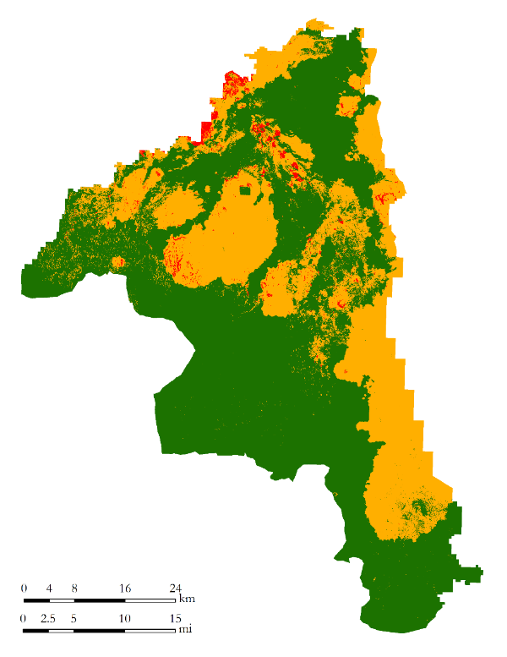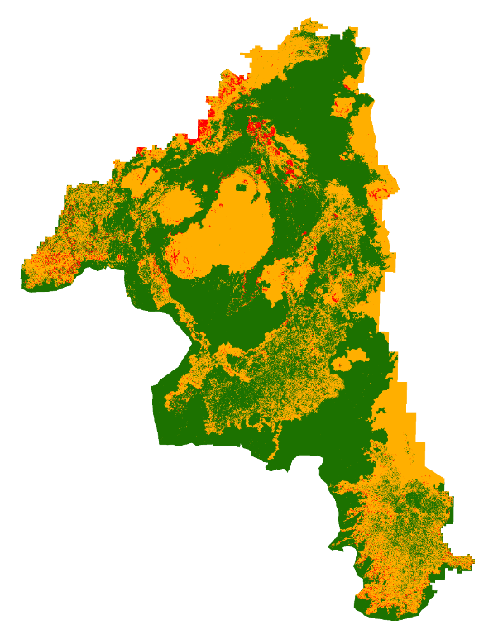

Low

Moderate

High

Known mule deer summer migration path

**Fire Susceptibility**

Figure 1. Mule deer fire susceptibility models generated with Landsat-8 OLI (a) and Sentinel-2 (b), respectively.

Table . Area of mule deer fire susceptibility classes for CRMO in acres.

|  |  |  |
| --- | --- | --- |
| Fire Susceptibility Class | Area (acres) | |
| **Landsat-8 OLI** | **Sentinel-2** |
| Low | 478,099 | 419,059 |
| Moderate | 264,059 | 312,785 |
| High | 10,360 | 20,676 |

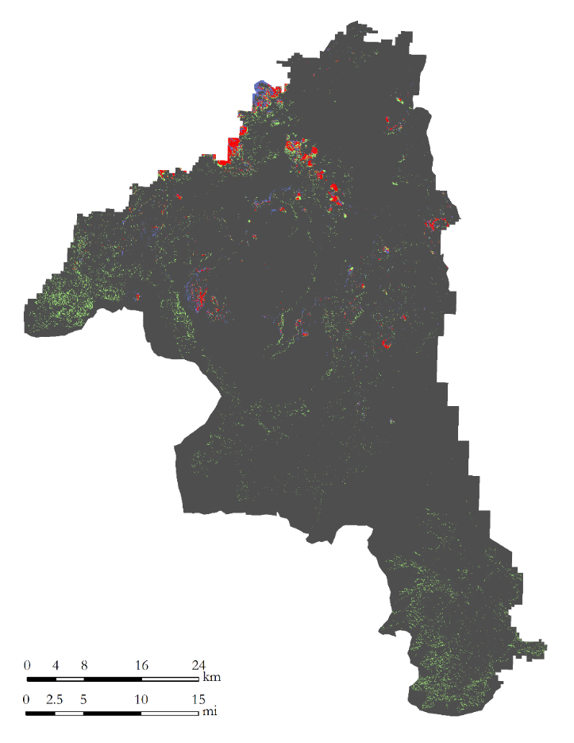

Neither

Landsat 8 OLI

Sentinel-2

Both

**High Fire Susceptibility**

Figure 2. High fire susceptibility for mule deer models with Landsat 8 OLI in blue, Sentinel-2 in green, agreement of both sensors in red and areas without a high fire susceptibility classification in grey.

Table 5. Summary of areas classified as highly susceptible to wildfires in CRMO for mule deer model.

|  |  |  |
| --- | --- | --- |
| Sensor | Area | |
| Acres | Percentage |
| **Landsat 8 OLI** | 4,750 | 0.63% |
| **Sentinel-2** | 15,069 | 2.0% |
| **Both** | 5,591 | 0.74% |
| **Neither** | 726,839 | 96.6% |

### 4.2.2. Greater Sage-grouse Habitats

Figures 3a and 3b show the Greater Sage-grouse fire susceptibility models developed with Landsat 8 OLI and Sentinel-2 sensors, respectively. Both models showed comparable areas of high susceptibility with Sentinel-2 registered 16,568 more acres of high susceptibility than Landsat 8 OLI (Table 6). Together, both models registered approximately 292,700 acres (38.9%) of the areas as highly susceptible to wildfires (Table 7). This is likely an overestimation of high susceptibility areas due to the fact that the suitability of the different areas of the Greater Sage-grouse habitats were not clearly identified or graded into classes as was done for the mule deer data. Sentinel-2 and Landsat 8 OLI models agreed that the same 164,700 acres or 21.9% of the CRMO study area were highly susceptible to wildfires.

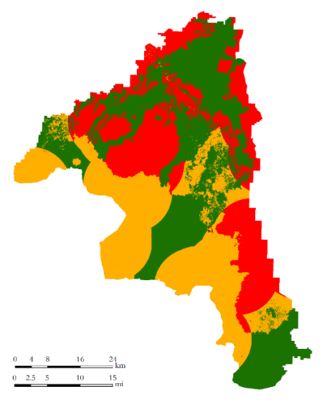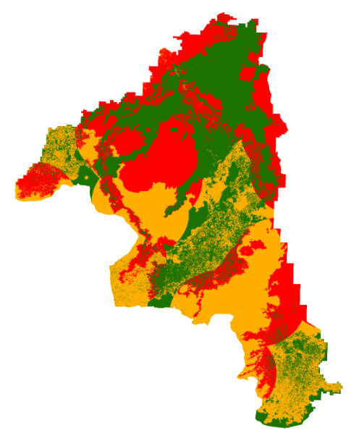

Low

Moderate

High

**Fire Susceptibility**

Figure . Greater Sage-grouse fire susceptibility models generated with Landsat 8 (a) OLI and Sentinel-2 (b), respectively

Table 6. Area of mule deer fire susceptibility classes for CRMO in acres.

|  |  |  |
| --- | --- | --- |
| Fire Susceptibility Class | Area (acres) | |
| **Landsat-8 OLI** | **Sentinel 2** |
| Low | 285,973 | 262,846 |
| Moderate | 246,011 | 252,570 |
| High | 220,522 | 237,090 |

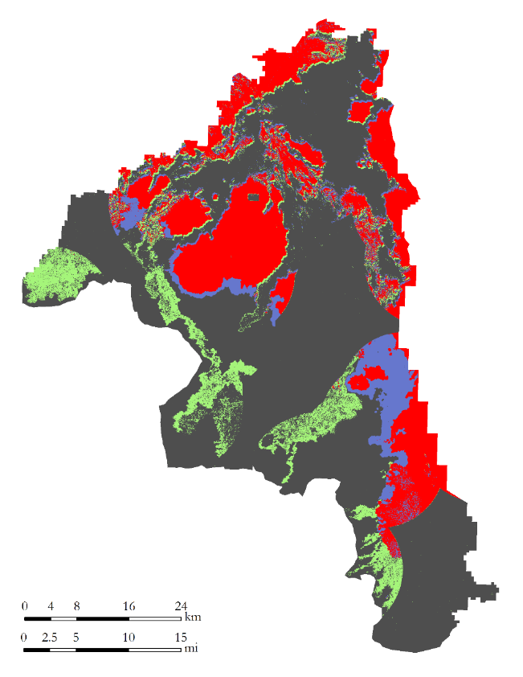

Neither

Landsat 8 OLI

Sentinel-2

Both

**High Fire Susceptibility**

Figure . High fire susceptibility for Greater Sage-grouse models with Landsat 8 OLI in blue, Sentinel-2 in green, agreement of both sensors in red and areas without a high fire susceptibility classification in grey.

Table 7. Summary of areas classified as highly susceptible to wildfires in CRMO for Greater Sage-grouse model.

|  |  |  |
| --- | --- | --- |
| Sensors | Acres Classified | |
| Acres | Percentage |
| **Landsat 8 OLI** | 55,685 | 7.4% |
| **Sentinel-2** | 72,250 | 9.6% |
| **Both** | 164,719 | 21.8% |
| **Neither** | 459,584 | 61% |

## 4.3. Model Validation

The accuracy of susceptibility models is difficult to evaluate because ignition sources are a major control of real-world wildfires, therefore extensive validations could not be covered in this paper. However, random visual verification of the models were completed using Google Earth to determine whether the locations classified as highly susceptible to wildfires correlated with the highly vegetated areas and vice versa. These verifications did indeed confirm the highly vegetated areas corresponded with high fire susceptible areas. Low fire susceptible areas in turn correlated with rocky terrains that had little to no discernible vegetation which gives credibility to the models performing satisfactorily.

On July 04, 2016, a few days after the generation of these models, the roughly 2,100-acre Timbered Dome fire occurred just 3 miles north of CRMO. Upon further analyses, we realized that this location had suitable habitats for both mule deer and the Greater Sage-grouse. These lost habitats will take years to regenerate, if at all. Analyzing the burned areas based on the models developed in this project, highly susceptible habitats for each species were identified prior to the burn. The results indicated that 96% of the Greater Sage-grouse lekking and nesting and at least 76% of the mule deer winter habitats were highly susceptible to wildfire (Table 5a and 5b). Both models agreed that of the burned area 95.4% of the Greater Sage-grouse habitats were classified as highly susceptible and 70.5% of the mule deer habitats (Figure 5a and 5b). This analysis serves as validation for the effectiveness of the models and reinforces the need for continued monitoring of habitats that are highly susceptible to wildfires.

5b.

5a.

**95.7% high**

**70.5% high**

**Mule Deer**

**Greater**

**Sage-grouse**

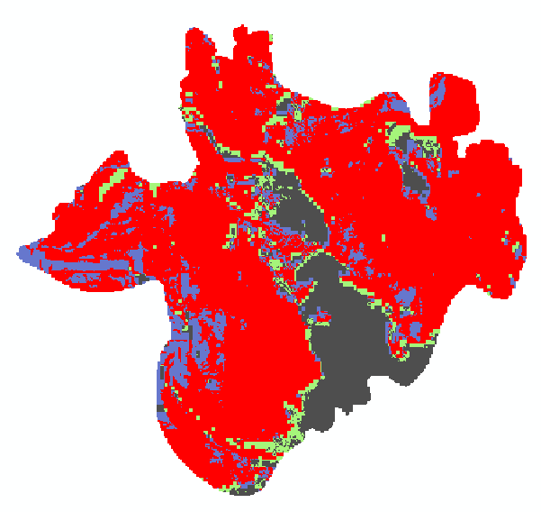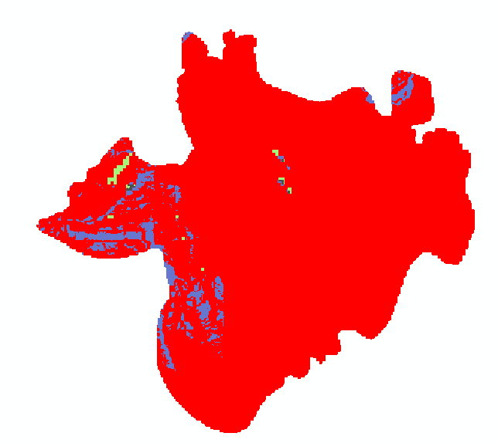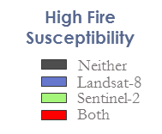

Figure 5. Susceptibility prediction of the Timbered Dome fire with developed models.

Table 8a. Summary of areas classified as highly susceptible to wildfires within the Timbered Dome fire boundary for Greater Sage-grouse model.

|  |  |  |
| --- | --- | --- |
| Sensors | Acres Classified | |
| Acres | Percentage |
| **Landsat 8 OLI** | 87 | 4% |
| **Sentinel-2** | 7 | 0.35% |
| **Both** | 1,987 | 95.4% |
| **Neither** | 1 | 0.07% |

Table 8b. Summary of areas classified as highly susceptible to wildfires within the Timbered Dome fire boundary for mule deer.

|  |  |  |
| --- | --- | --- |
| Sensors | Acres Classified | |
| Acres | Percentage |
| **Landsat 8 OLI** | 232 | 11.1% |
| **Sentinel-2** | 106 | 5.1% |
| **Both** | 1,469 | 5.1% |
| **Neither** | 276 | 13.3% |

# 5. Conclusions and Future Work

For this study, we built fire susceptibility models for both mule deer winter habitats and Greater Sage-grouse lekking and nesting grounds found in CRMO. These models were generated at both a 30 m and 10 m spatial resolutions to investigate their effect on the accuracy of the output. Generally, the 10 m model was seen to pick up vegetation within the basalt formation better than that of the 30 m, a likely benefit of the increase in spatial resolutions. However, the 30 m model performed satisfactorily and is therefore a recommended choice for compromise between analysis speed and accuracy. Random visual validation using Google Earth correlated high fire susceptible areas to highly vegetated areas and low susceptibility to rocky areas with little to no discernible vegetation which gives credibility to the models performing satisfactorily.

Independent validation with a recently occurred Timbered Dome fire showed all four models to predict at least 76% of this burn as highly susceptible to fire and would have helped in mitigating the loss of this habitat had the model been developed earlier. We believe these models are great tools that will better inform park and land managers in their quest to prevent the loss of these species.

# 6. Acknowledgments

We would like to thank Scott Bergen and Ann Moser from IDFG for providing us with the most current mule deer winter range and Greater Sage-grouse lekking ground data. A special thanks to Shelli Mavor, Mike Kuyper, and Karen Kraus at the BLM Pocatello Regional Office for providing us with expert knowledge on how fires spread throughout our study region.

Any opinions, findings, and conclusions or recommendations expressed in this material are those of the author(s) and do not necessarily reflect the views of the National Aeronautics and Space Administration.

This material is based upon work supported by NASA through contract NNL11AA00B and cooperative agreement NNX14AB60A.

# 8. Content Innovation

**Content Innovation #1**

Audio Slides

Emailed to [Lauren.M.Childs@nasa.gov](mailto:Lauren.M.Childs@nasa.gov) with filename 2016Sum_ID_EasternIdahoDisasters_TechPaper_AudioSlides

**OR** shared through Google Drive at: <https://drive.google.com/open?id=0B3vHKPuC_mTlQklKVE14OGVQbEk>

**Content Innovation #2**

Featured Multimedia

* Please see Earthzine

**Content Innovation #3**

Inline Supplementary Material

**Figure 1.** Mule deer fire susceptibility models generated with Landsat-8 OLI (a) and Sentinel-2 (b), respectively. 12

**Figure 2.** High fire susceptibility for mule deer models with Landsat-8 OLI in blue, Sentinel-2 in green, agreement of both sensors in red and areas without a high fire susceptibility classification in grey. 13

**Figure 3.** Greater Sage-grouse fire susceptibility models generated with Landsat-8 (a) OLI and Sentinel-2 (b), respectively 15

**Figure 4.** High fire susceptibility for Greater Sage-grouse models with Landsat-8 OLI in blue, 16

**Figure 5.** Susceptibility prediction of the Timbered Dome fire with developed models. 17

**Table 1.** Required datasets and model inputs for fire susceptibility models 7

**Table 2.** Landsat-8 and Sentinel-2 data downloaded for analyses 7

**Table 3.** Fuel load classes 9

**Table 4.** Area of mule deer fire susceptibility classes for CRMO in acres. 12

**Table 5.** Summary of areas classified as highly susceptible to wildfires in CRMO for mule deer model. 14

**Table 6.** Area of mule deer fire susceptibility classes for CRMO in acres. 15

**Table 7.** Summary of areas classified as highly susceptible to wildfires in CRMO for Greater Sage-grouse model. 16

# 8. Citations

Aldridge, Cameron L., Scott E. Nielsen, Hawthorne L. Beyer, Mark S. Boyce, John W. Connelly, Steven T. Knick, and Michael A. Schroeder. 2008. “Range-Wide Patterns of Greater Sage-Grouse Persistence.” *Diversity and Distributions* 14 (6): 983–94. doi:10.1111/j.1472-4642.2008.00502.x.

Anderson, Pete, Chad Boyd, Jeanne Chambers, Tom Christiansen, Dawn Davis, Shawn Espinosa, Doug Havlina, et al. 2015. “Invasive Plant Management and Greater Sage-Grouse Conservation : A Review and Status Repo

Arabas, Karen B, Keith S Hadley, and Evan R Larson. 2006. “Fire History of a Naturally Fragmented Landscape in Central Oregon.” *Canadian Journal of Forest Research* 36 (5): 1108–20. doi:10.1139/x06-004.

Balch, Jennifer K., Bethany A. Bradley, C M. D’Antonio, and Jose Gomez-Dans. 2013. “Introduced Annual Grass Increases Regional Fire Activity across the Arid Western USA (1980-2009).” *Global Change Biology* 19 (1): 173–83. doi:10.1111/gcb.12046.

Bishop, Chad J, Gary C White, David J Freddy, Bruce E Watkins, and Thomas R Stephenson. 2009. “Effect of Enhanced Nutrition on Mule Deer Population Rate of Change.” *Wildlife Monographs* 177 (172): 1–28. doi:10.2193/2008-107.

Brooks, M L, M L Brooks, C M D’Antonio, D M Richardson, D M Richardson, J B Grace, J B Grace, et al. 2004. “Effects of Invasive Alien Plants on Fire Regimes.” *Bioscience* 54 (7): 677–88. doi:10.1641/0006-3568(2004)054[0677:EOIAPO]2.0.CO;2.

Chávez, Pat S. Jr. 1996. “Image-Based Atmospheric Corrections - Revisited and Improved.” *Photogrammetric Engineering and Remote Sensing* 62 (9): 1025–36. doi:0099-1112/96/6209-1025.

Crawford, John A, Rich A Olson, Neil E West, Jeffrey C Mosley, Michael A Schroeder, Tom D Whitson, Richard F Miller, Michael A Gregg, and Chad S Boyd. 2004. “Ecology and Management of Sage-Grouse and Sage-Grouse Habitat.” *Source: Rangeland Ecology & Management* 57 (1): 2–19. doi:10.2111/1551-5028%282004%29057%5B0002%3AEAMOSA.

Cruz, M. G., W. L. McCaw, W. R. Anderson, and J. S. Gould. 2013. “Fire Behavior Modelling in Semi-Arid Mallee-Heath Shrublands of Southern Australia.” *Environmental Modelling and Software* 40 (February): 21–34. doi:10.1016/j.envsoft.2012.07.003.

Department of Interior (DOI). *Final Report: An Integrated Rangeland Fire Management Strategy.* By Rangeland Fire Task Force. Washington: Government Printing Office, May 2015. (SO 3336).

Ercanoglu, Murat, Keith Weber, Jackie Langille, and Richard Neves. 2006. “Modeling Wildland Fire Susceptibility Using Fuzzy Systems.” *GIScience & Remote Sensing* 43 (3): 268–82. doi:10.2747/1548-1603.43.3.268.

Ielmini, M.R., T.E. Hopkins, K.E. Mayer, K. Goodwin, C. Boyd, B. Mealor, M. Pellant, and T. Christiansen. 2015. “Invasive Plant Management and Greater Sage-grouse Conservation: A Review and Status Report with Strategic Recommendations for Improvement.” Western Association of Fish and Wildlife Agencies. Cheyenne, Wyoming. 47 pp.

Mermoz, Mónica, Thomas Kitzberger, and Thomas T. Veblen. 2005. “Landscape Influences on Occurrence and Spread of Wildfires in Patagonian Forests and Shrublands.” *Ecology* 86 (10): 2705–15. doi:10.1890/04-1850.

Oppenheimer, J. 2015. “Fire in Idaho: Lessons for Human Safety and Forest Health- a Review of Idaho’s 2007 Fire Season.” Boise, ID: Idaho Conservation League Offices.

Rothermel, Richard C. 1983. “How to Predict the Spread and Intensity of Forest and Range Fires.” *USDA Forest Service General Technical Report INT-143*. Ogden, UT: Intermountain Forest and Range Experiment Station.

Smith, Robert B., and Lawrence W. Braile. 1994. “The Yellowstone Hotspot.” *Journal of Volcanology and Geothermal Research* 61 (3-4): 121–87. doi:10.1016/0377-0273(94)90002-7.

Whisenant, S G. 1989. “Changing Fire Frequencies on Idaho’s Snake River Plains: Ecological and Management Implications.” In *Symposium on Cheatgrass Invasion, Shrub Die-Off, and Other Aspects of Shrub Biology and Management*, 1–7. Las Vegas, NV.