**NASA DEVELOP National Program**

https://lh4.googleusercontent.com/LvycVwRQASDeV-5Yv5ld_Xjq-gRo4YMr7znAEHt7aP8geV3Eyk1eN_OncAqy_DDBgjAM7AXp7s_o9DwTA17jUZFX1yF0WMlasPaLjXrtmhZV9hgbgf0RXH82bHilywIjUhNNH-ijaMP4NASA Ames Research Center

*Summer 2015*

Navajo Nation Climate II

Monitoring Drought Conditions in the Navajo Nation Using NASA Earth Observations

https://lh3.googleusercontent.com/4nD1xqiL_iH48aHoQQvktZbPnEEiWJFaLGqVIHECOYnzHWGIQHt6cHJztTZFLvnE-ay593X0nBVziVAT2EwGivvi1ZmFHdCc_Ehevg09U5yD-VbIgFpMOKPn-hOLjNlE0oYZKMdPVb-A**Technical Report**

Rough Draft – June 25, 2015

Cheryl Cary (Project Lead)

Michael Gao

Vickie Ly

Anton Surunis

Sophie Turnbull-Appell

Dr. Jay W. Skiles, NASA Ames (Science Advisor)

Dr. Venkat Lakshmi, University of South Carolina (Science Advisor)

Previous Contributors:  
Amber Brooks

Clayton Sodergren

# I. Abstract

# The Navajo Nation has been increasingly impacted by severe drought events and climate change. Coupled with a lack of domestic water infrastructure and economic resources, approximately one-third of the population is without access to potable water in their homes. Current methods of drought monitoring rely on national-scale state-based monthly drought maps calculated by the Western Regional Climate Center that do not have the spatial resolution to illustrate differences in drought severity across the vast Nation. To better understand and monitor drought events and drought regime changes in the Navajo Nation, this project created an SPI tool to allow the NN to generate SPI values specific to chosen boundaries within the Nation. Tropical Rainfall Monitoring Mission (TRMM)-observed precipitation data and Parameter-elevation Relationships on Independent Slopes Model (PRISM)-modeled historical precipitation data were used in the geodatabase and tool. These products will give resource managers in the Navajo Nation the facility to utilize current and future NASA Earth observation data for increased decision-making capacity regarding future climate change impact on water resources.

**Keywords**

Navajo Nation, drought, remote sensing, Standardized Precipitation Index (SPI), water management, TRMM, GPM

**II. Introduction**

**2.1 Background**

The Navajo Nation (NN), located within the southwestern United States, is the largest Native American territory in the country in terms of land area and population (US Census, 2010). Historically, precipitation trends in the NN exhibit two rainy seasons a year: one in the winter (December-March), and one in the summer (July-September), with dry seasons in spring (April-June) and fall (October-November). The two rainy seasons are distinctly different in precipitation mechanism and distribution. Winter precipitation brings low-intensity precipitation evenly over large areas, whereas summer precipitation brings intense, often-localized precipitation over small areas (Crimmins, 2013). The periodic oscillations between wet and dry seasons create a complex environment for monitoring drought and water resources.

The NN has been experiencing nationwide drought since 1994. It officially declared a state of emergency in 2011, and renewed the state of emergency in 2012 and 2013 (NNDWR, 2011; Nania et al., 2014). Between 1901 and 2010, annual average temperatures in the southwest have increased by 1.6 °F +/- 0.5 °F (Hoerling et al., 2013). Climate change is predicted to continue trends of high temperatures, high aridity, and low snowpack (Redsteer et al., 2011). In addition, droughts such as the current one are predicted to become more common in the second half of this century as a result of climate change (Gershunov et al., 2013).

At least 70,000 people in the Nation (approximately one-third of the population) are without direct access to potable water in their homes(US Census, 2000; NNDWR, 2011). Public water systems do not have the infrastructure to meet the demand in rural areas, leaving a significant percentage of residents dependent on water hauling to meet their needs. This process is economically unsustainable, costing as much as $43,000 per acre-foot of water, compared to the $600 typically paid in surrounding regions (NNDWR, 2011). No other region in the US has such a large percentage of its population lacking the basic necessity of potable tap water in their homes (NNDWR, 2011). This lack of access puts additional pressure on Navajo water resource managers.

**2.2 Current Water Conditionsand Monitoring**

The Navajo Nation Department of Water Resources (NNDWR) currently monitors water conditions using a network of 88 rain collection cans, 8 stream gauges, and 9 climate stations (NNDWR, 2003). However, limited governmental funding, as well as staff and infrastructural constraints, have made it difficult to consistently collect these data and maintain an accurate record of rainfall.

Quantifying drought intensity is necessary to monitoring water resources. To determine the Nation’s drought status, the NNDWR uses the Standardized Precipitation Index (SPI), an internationally used probability-based indicator of abnormally wet or dry time periods. The NN currently relies on an SPI that is calculated by the Western Regional Climate Center (WRCC). However, this SPI lacks the spatial resolution to provide a detailed understanding of the climate regime within the Nation boundaries. The NN does not currently calculate the SPI for its specific region, and does not collect or process any remotely-sensed data for management purposes (personal communication, Feb. 11, 2015). The use of NASA Earth observation data can provide coverage and spatial resolution to calculate an SPI for the reservation to better monitor drought conditions in the NN.

**2.2 Project Objectives**

This project was the conclusion of a two-term project focusing on water resources in the NN and the role of NASA Earth observation data in water management and drought mitigation. The first term created a geodatabase of historical climate information. The second term focused on creating an SPI tool in the statistical program R to allow the NN to generate SPI values specific to chosen boundaries within the Nation.

**2.3 Study Area**

The NN is a 65,700 km2 (25,350 mi2) Native American territory located at the intersection of Arizona, New Mexico, and Utah. The project used a 62 km buffer to define the study area and to accommodate original TRMM data resolution around US Geological Survey (USGS) Hydrologic Unit Code 8 (HUC 8) watershed boundaries that intersect the political boundary of the NN. This method was used in order to more accurately represent hydrologic processes within a watershed, making the total area of study 150,705 km2.

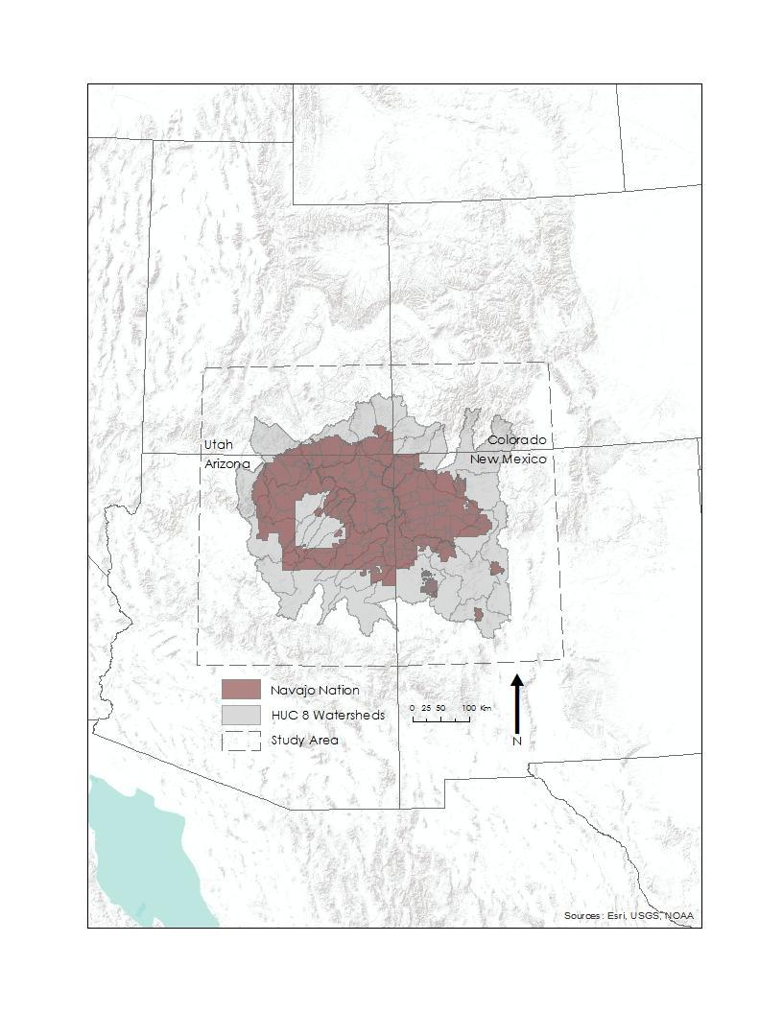

*Fig. 1- Study area, Navajo Nation boundary, and USGS HUC-8 watersheds.*

**2.4 Project Partners**

This project partnered with the Navajo Nation Department of Water Resources: Water Management Branch, and the Navajo Technical University.

**III. Methodology**

**3.1 Data**

Parameter-elevation Relationships on Independent Slopes Model (PRISM) data from 1901-2000 were downloaded from an FTP server hosted on the Northwest Alliance for Computational Science and Engineering website. A model was created in ArcGIS ModelBuilder to convert the data from BIL to TIFF format. The model then projected the data for use in the NN and clipped the data to the study area boundary.

Monthly rainfall rate data from the Tropical Rainfall Measuring Missing (TRMM) were downloaded from NASA’s Precipitation Processing System (PPS STORM) data portal. A model was created in ArcGIS ModelBuilder to define the projection of the original data, convert average rainfall rate (mm/hr) into monthly accumulated rainfall (mm), reproject, and downscale the TRMM data to spatially match the PRISM data’s footprint. In order to maintain data integrity while projecting the originally undefined TRMM data into the same projected coordinate system used by the Navajo Nation, these data were converted into center of cell points, projected, transformed into a triangulated network, and then interpolated back into a raster, downscaling bilinearly to match the historical precipitation data.

GPM … tbd

All sets of processed data were renamed using a Python script to conform to a consistent naming convention necessary for use in the SPI tool.

**3.2 Calculating Standardized Precipitation Index Rasters**

An SPI can be calculated for varying timescales, depending on user needs. For example, a 6-month SPI has been shown to be a good indicator of seasonal precipitation trends, while a 24-month SPI may give insight to watershed cycles and aquifer recharge (Zagar et al., 2011). The SPI compares precipitation at a time of interest to historical average precipitation, and is calculated using the following equation (Bhuiyan et al., 2006):

$$SPI= \frac{(X_{i}-\underline{X})}{σ}$$

Where:

$X_{i}$ = precipitation at time of interest

$\underline{X }$ = historical average precipitation

$σ$ = standard deviation

The SPI is based on comparing precipitation deviations using the normal distribution to find the likelihood of a given precipitation amount with the historical average in that area. However, as precipitation is not a normally-distributed variable, data must first be transformed using a Gamma function. The series is then transformed into a normal distribution, the standard deviation is identified, and the SPI value for the location and time is calculated.

|  |  |  |
| --- | --- | --- |
| SPI Value | Precipitation Intensity | Probability of occurrence (%) |
| 2.00+ | Extremely wet | 2.3 |
| 1.5 to 1.99 | Very wet | 4.4 |
| 1.0 to 1.49 | Moderately wet | 9.2 |
| -0.99 to 0.99 | Near normal | 68.2 |
| -1.00 to -1.49 | Moderately dry | 9.2 |
| -1.5 to -1.99 | Severely dry | 4.4 |
| $≤$-2.00 | Extremely dry | 2.3 |

Table 1- SPI values, corresponding precipitation intensities, and corresponding probabilities of occurrence as defined by McKee et al.1993. This enables comparison of both wet and dry periods relative to the historical trend for a set of months at a specific location.

*R Methodology:*

SPI rasters were created by first producing a time series of precipitation data from TRMM and PRISM. SPI was then calculated for each pixel across the time period. Effectively, this produced rasters of SPI values for each time step in the time period (Fig. 2).

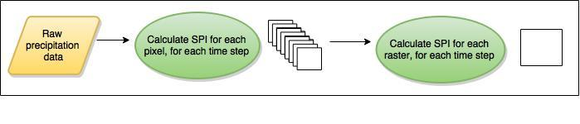

*Fig. 2: A flowchart for calculating the SPI for each raster.*

*Zonal statistics:*

Zonal statistics were calculated by collecting all pixels falling within a designated “zone.” These zones were defined by a polygon (shapefile). Summary statistics were calculated from all pixels within the zone for each time period. It is important to note that zonal statistics are produced only from the SPI values in a single time step, not across all time steps (Fig.3).

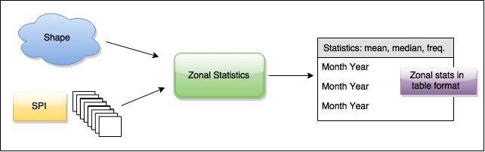

*Fig. 3: A flowchart for zonal statistics.*

**3.3 Single SPI Values for Specified Boundaries**

tbd

**IV. Results & Discussion**

**4.1 Selecting drought index**

With no single accepted definition of drought, and multiple existing drought types, defining and characterizing drought can be a difficult task. Drought indices serve to transform raw climatic data into a meaningful quantity in order to allow for monitoring, documentation, and comparison (Paulo et al., 2006; Zagar et al., 2011). SPI is a well-known, internationally-used index to characterize  
meteorological drought (McKee et al., 1993). It is useful because it is a  
relatively simple index calculated exclusively using precipitation data, can  
quantify abnormally wet as well as abnormally dry periods, and does not require  
calculating the entire study area’s water balance (Magyari-Saska et al., 2009;  
Zargar et al., 2011). Additionally, the NNDWR currently uses a 6-month SPI as  
its drought index of choice.

**V. Conclusions**

**VI. Acknowledgments**

Thanks to Ramsey Seweingyawma of the Navajo Technical University for communication and coordination of incoming Navajo Technical University students, to Maurice Upshaw, Robert Kirk, Teresa Showa, and Jason John of the Navajo Department of Water Resources: Water Management Branch for providing project guidance and Navajo Nation in-situ GIS data, and to Amber Brooks of the NASA DEVELOP Program and Eric Wittner of ESRI for technical guidance in ArcGIS.

The authors also wish to thank the Ames DEVELOP management team, Andrew Nguyen and Chippie Kislik, for their overall support and help with this project.

This material is based upon work supported by NASA through contract NNL11AA00B and cooperative agreement NNX14AB60A.

**VII. References**

Bhuiyan, C., R. P. Singh, F. N. Kogan (2006), Monitoring drought dynamics in the Ravalli region (India) using different indices based on ground and remote sensing data, *International Journal of Applied Earth Observation and Geoinformation*, *8,* 289-302.

Crimmins, M., N. Selover, K. Cozzetto, and K. Chief (2013), Technical review of the Navajo Nation drought contingency plan. Drought Monitoring.

Gershunov, A., B. Rajagopalan, J. Overpeck, K. Guirguis, D. Cayan, M. Hughes , M. Dettinger, C. Castro, R. E Schwartz, M. Anderson, A.J. Ray, J. Barsugli, T. Cavazos, M. Alexander (2013), Future climate change: Projected extremes, Chapter 7 in the Assessment of climate change in the Southwestern United States: A report prepared for the National Climate Assessment, edited by G. Garfin, A. Jardine, R. Merideth, M. Black, and S. LeRoy. A report by the Southwest Climate Alliance, Island Press, Washington, DC, pp. 126-147.

Giddings, L., M. Soto, B. M. Rutherford, and A. Maarouf (2005), Standardized Precipitation Index zones for Mexico. Atmosfera 33-56.

Guttman, N. B. (1998), Comparing the Palmer Drought Index and the Standardized Precipitation Index. *Journal of American Water Resources Association. 34(1)*, 113-121.

Guttman, N. B. (1999), Accepting the Standardized Precipitation Index: A calculation algorithm. Journal of American Water Resources Association. 35(2), 311-322.

Hoerling, M.P, Dettinger M, Wolter K, Lukas J, Eischeid J, Nemani R, Liebmann B, Kunkel KE (2013), Present Weather and Climate: Evolving Conditions, Chapter 5 in the Assessment of Climate Change in the Southwestern United States: A Report Prepared for the National Climate Assessment, edited by G Garfin, A Jardine, R Merideth, M Black, and S LeRoy. A report by the Southwest Climate Alliance, Island Press, Washington, DC, pp. 74-100.

Kumar, M. N., C. S. Murthy, M. V. R. Sesha Sai, and P. S. Roy (2009), On the use of Standardized Precipitation Index (SPI) for drought intensity assessment, *Meteorological Applications.* *16:* 381-389.

Magyari-Saska, Z., I. Haidu (2009), Drought and extreme moisture evaluation and prediction with GIS software module. Proceedings of the ITI 2009 31st International Conference on Information Technology Interfaces, Cavtat, Croatia, June 22-25, 2009.

McKee, T. B., N. J. Doesken and J. Kleist (1993) The relationship of drought frequency and duration to time scales, *In Proceedings of the 8th Conference on Applied Climatology*, Anaheim, California, 17– 22 January 1993. American Meteorological Society.

Nania, J., K Cozzetto, N. Gillett, S. Duren, A. M. Tapp, M. Eitner, and B. Baldwin (2014), Considerations for climate change and variability adaptation on the Navajo Nation.

National Drought Mitigation Center, SPI DOS Program, http://drought.unl.edu/MonitoringTools/DownloadableSPIProgram.aspx

Navajo Nation Department of Water Resources (NNDWR) (2003), Navajo Nation drought contingency plan.

Navajo Nation Department of Water Resources (NNDWR) (2011), Water resource development strategy for the Navajo Nation.

Neves, J. (2012) Computer SPI Index v.1.1, <http://cran.r-project.org/web/packages/spi/index.html>

Paulo A.A. and L.S. Pereira (2006), Drought concepts and characterization. Comparing drought indices, *Water International. 31:* 37–49.

Redsteer, M. H., K. B. Kelley, H. Francis, and D. Block (2011), Disaster risk assessment case study: Recent drought on the Navajo Nation, southwestern United States, *UN Global Assessment Report 2011.*

Steinemann, A. (2003), Drought indicators and triggers: A stochastic approach to evaluation. *Journal of the American Water Resources Association 39 (5)*: 1217-1233.

US Census Bureau (2000), 2000 American Community Survey.

US Census Bureau (2010), 2010 American Community Survey.

Zagar, A., R. Sadiq, B. Naser, and F. I. Khan (2011), A review of drought indices. *Environmental Reviews 19:* 333-349.

# VIII. Content Innovation

* [Featured article in Earthzine](http:///h)
* AudioSlides
* User interface