**NASA DEVELOP National Program**

**Summer 2016 Project Proposal**

**NOAA National Centers for Environmental Information in Asheville, NC**

**Pacific Water Resources II**

Illustrating year to date accumulated rainfall in the U.S. Affiliated Pacific Islands (USAPI) using the C-MORPH Climate Data Record.

**Project Overview**

***Objective:*** To provide the Pacific ENSO Applications Climate Center (PEAC) an updated, higher resolution El Niño Southern Oscillation (ENSO) based precipitation atlas using the NOAA Climate Data Record (CDR) CMORPH to quantify the severity of drought and heavy precipitation events for climate monitoring and disaster preparations.

***Community Concern:*** The majority of the U.S. Affiliated Pacific Islands (USAPI) relies solely on precipitation for their fresh water. Depending on the season and phase of the El Niño Southern Oscillation (ENSO), the USAPI may experience heavy precipitation or drought conditions. Being able to plan and manage fresh water resources for the USAPI depends on accurate long-term precipitation forecasts across the islands. This project will use precipitation estimates from NOAA’s Climate Prediction Center (CPC) morphing technique (C-MORPH). The CMORPH dataset will provide precipitation estimates at an 8km x 8km grid at 30-mintue intervals from 1998 to 2016.

***National Application Areas Addressed:*** Water Resources and Climate

***Study Location:*** Hawaii and the U.S.-affiliated Pacific islands: Guam, American Samoa, Commonwealth of Northern Mariana Islands, Federated States of Micronesia, Republic of Palau, and the Marshall Islands

***Study Period:*** January 1998 to May 2016

***Advisors:*** Michael Kruk (Earth Resources Technology, Inc.), John Marra (NOAA National Centers for Environmental Information)

***Source of Project Idea:*** The idea for this project originated during the 2015 summer term when discussing the first Pacific Water Resources project with the science advisors. Since there was so much interest for the summer project, the science advisors wanted to provide a higher resolution (temporal and spatial) precipitation estimate for the USAPI.

**Partner Overview**

***Partner Organization:***

|  |  |  |  |
| --- | --- | --- | --- |
| **Organization** | **POC (Name, Position/Title)** | **Partner Type** | **Boundary Org?** |
| Pacific ENSO Applications Climate Center | TBD, Pacific Region Climate Officer | End-User | Yes |

***End-User Overview***

***End-User’s Current Decision Making Process:***

Currently, the Pacific ENSO Applications Climate Center uses *in situ* data, models, and the PERSIANN-CDR ENSO-based atlas to estimate precipitation for the USAPI. They rely heavily on the National Weather Service’s offices and personnel to provide them with accurate precipitation forecasts. They then work with their local offices and personnel to help plan and manage their fresh water resources.

***End-User’s NASA Earth Observations Capacity:***

Pacific ENSO Applications Climate Center – Some of the personnel working at PEAC are familiar with NASA Earth observations and NOAA CDRs because of the previous 2015 summer DEVELOP project. However, PEAC needs more explanation and training in using satellite data to supplement in-situ observations with near real time satellite precipitation estimates.

***Collaborator & Boundary Organization Overview***

***Boundary Organization Dissemination:***

PEAC – PEAC is in constant contact with the National Weather Station offices across the USAPI. They actively discuss precipitation forecasts with the other island communities to better plan the use of their water resources. PEAC has already shown that they can disseminate the project results to other agencies including the Forest Service. PEAC has shared the ArcGIS online mapping application, precipitation atlas, and project video from the previous project via email. Additionally, they share knowledge and results over their regular teleconferences with the National Weather Station offices across the USAPI.

***Project Communication & Transition Overview***

***In-Term Communication Plan:***

Due to the time zone difference, communication with the partners will be difficult for the team. However, the team will communicate with both science advisors and partners. They will have bi-monthly teleconferences with PEAC to discuss progress and get feedback on the project.

***Transition Approach:***

Similar to the previous 2015 summer term, the team will share all the results with their partners and science advisors via email at the end of the term. The R code generated by the team will be provided to the science advisors and partners.

**NOAA Climate Data Records Overview**

***CDRs:***

|  |  |  |
| --- | --- | --- |
| **Platform & Sensor** | **Parameter(s)** | **Use** |
| **C-MORPH** | Precipitation | This precipitation dataset will be the focus of this project because of its high spatial and temporal resolution. |

***Ancillary Datasets:***

ENSO Based PERSIANN Climate Atlas – Gridded precipitation dataset from 2015 summer project.

**Decision Support Tool & End-Product Overview**

***End Products:***

|  |  |  |  |
| --- | --- | --- | --- |
| **End Products** | **Partner Use** | **Datasets & Analyses** | **Software Release Category** |
| Rainfall Accumulation and Accumulation Difference from Normals Maps | These will be used to estimate precipitation accumulation for their region in a map view. | C-MORPH 8km 30-minute precipitation estimates will be summed by pixel to make the accumulation maps. | 1 |
| Rainfall Accumulation Figures (i.e. Figure 1) | These will be used to estimate precipitation accumulation for a given pixel or area over time (either days, weeks, months, or years). | C-MORPH 8km 30-minute precipitation estimates will be summed by pixel to make the accumulation plots. | 1 |
| Download & Analysis R Tool | Science advisors and partners can use the script to make updated maps and figures. | This tool will be developed using the R language to download, analyze, map, and plot C-MORPH precipitation estimates. | 4 |

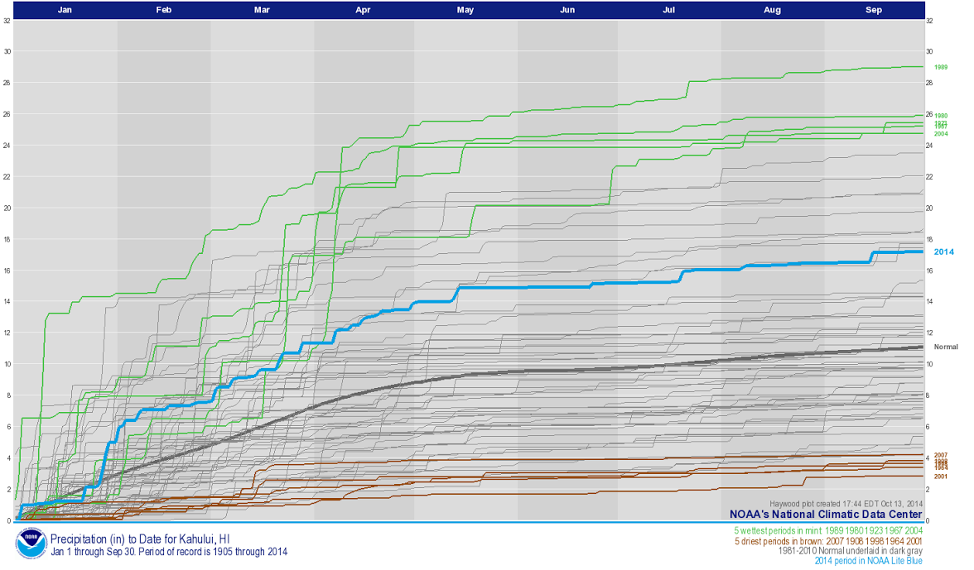

Figure 1. Plot showing the precipitation accumulation plot to date using in-situ precipitation estimates. This plot was generated by NOAA and is shown here as an example of similar plots that the team will generate using the CMORPH Climate Data Record.

***End-User Benefit:***

The partner organization and science advisors will utilize the end products from this project to help quantify precipitation accumulation amounts for the USAPI in data sparse locations (typically the outer islands). The project will provide the partners and science advisors with near real time precipitation accumulations amounts for each 8km pixel within the USAPI. The partners will be able to estimate precipitation accumulations for a specific region and during a specific time frame and will be able to compare the current year-to-date rainfall against the long-term averages and ENSO-period averages.

**Project Timeline & Previous Related Work**

***Project Timeline:*** 2 Terms: 2015 Summer (Start) to 2016 Summer (Completion)

***Multi-Term Objectives:***

* **Term 1:** 2015 Summer (NOAA NCEI) – Pacific Water Resources
  + A 30-year climatology of PERSIANN-CDR based precipitation for the USAPI was produced in addition to ENSO-based precipitation estimates for the region. Communication with the partner was difficult because of the time difference but was still successful. The first term highlighted the possibilities of using satellite-based precipitation for the USAPI.
* **Term 2 (Proposed Term):** 2016 Summer (NOAA NCEI) – Pacific Water Resources II
  + The proposed project will provide the partners and science advisors with high resolution precipitation estimations and accumulation amounts using the C-MORPH CDR. The higher resolution and near real time precipitation estimates will build upon the previous term results. The maps, figures, and R tool generated by the team and provided to the partners and science advisors will greatly enhance the partner’s ability to estimate precipitation for their region. Additionally, the precipitation estimates will be more accurate than the previous precipitation estimates from the PERSIANN CDR. The partners will be able to provide these estimations to local water resource managers.

**Project Needs/Requests**

***Participants Requested:*** 3

***Software & Scripting:***

ArcGIS – Data visualization

R – Data processing and statistical analysis

**Notes & References:**

***Notes:*** The previous summer project received great feedback from the end-users about the final products. Additionally, the previous summer project has received a lot of attention from the NOAA NCEI and has led to two article publications.