**NASA DEVELOP National Program**



NASA Marshall Space Flight Center

*Spring 2016*

Lake Victoria Water Resources II

Developing an Automated, Near Real Time System Using NASA Earth Observations to Monitor Aquatic Vegetation over the Winam Gulf in Lake Victoria

 **Technical Report**

Rough Draft – Feb 18, 2016

Jeanné le Roux (Project Lead)

Daryl Ann Winstead

Christina Fischer

Sara Amirazodi

Dwight Tigner

Dr. Jeffrey Luvall, NASA at NSSTC (Science Advisor)

Dr. Robert Griffin, The University of Alabama in Huntsville (Science Advisor)

Africa Flores, SERVIR (Science Advisor)

Dr. Joseph Ortiz, Kent State University (Science Advisor)

Dulci Avouris, Kent State University (Science Advisor)

Previous Contributors:

Austin Vacek

# I. Abstract

[Placeholder - do not put anything here until the final draft submission. The abstract in the project summary is where the working draft of the abstract should “live”]

**Keywords**

Remote Sensing, Water Resources, Invasive Species, Water Quality, Lake Victoria

# II. Introduction

With a surface area of 68, 800 km² in a catchment area of 194, 200 km², Lake Victoria is the largest of Africa’s great lakes. The lake is shared by Kenya, Uganda, and Tanzania and serves as the main reservoir of the Nile River. The drainage basin area is shared by Kenya, Uganda, Tanzania, Rwanda, and Burundi (Odada et al. 2006).

Millions of people depend directly on the lake for survival, utilizing it as a source of drinking water and food. Commercial fishing on the lake is also a vital part of the economy, as it provides a source of income for individuals and families (Kayombo and Jorgensen 2006). Consequently, the water quality in Lake Victoria has rapidly degraded during the past century due to rising human activity. Sewage, industrial, and agricultural runoff have resulted in disturbances in the chemical balance of the lake. Excess nutrients in the water have caused eutrophication, a process which feeds rapid plant and algae growth while subsequently depleting the available oxygen in the water. Chemical runoff from herbicides and pesticides not only pose a threat to human health, but the deoxygenated water resulting from nutrient dumping activities is also a threat for species living in the lake (Kolding et al. 2008).

Once a thriving biodiversity hotspot, Lake Victoria has experienced a rapid decline in endemic fish species since the introduction of the invasive Nile Perch in the early 1960’s (Nkalubo et al. 2014). The introduction *of Eichhornia crassipes*, or water hyacinth, has also had adverse impacts on the region by blocking boating access to the important fishery the lake provides and by providing a breeding ground for disease carrying insects and snails (Kayombo and Jorgensen 2006). *Schistosomiasis*, also known as snail fever, is a parasitic disease carried by freshwater snails which thrive on water hyacinth. Water hyacinth provides physical attachment surfaces, shade, reduced temperature fluctuations, and food for snails carrying the parasite, serving as a breeding ground. Swimming, bathing, fishing and even domestic chores, such as laundry and herding livestock, in affected waters can put people at risk of contracting the disease. Furthermore, nutrient runoffs from increasing populations, agriculture, and industry in the region contribute to conditions which encourage hyacinth blooms (Kiage and Obuoyo 2011).

This study focused on the Winam Gulf, in the Kenyan portion of the lake, as noted in Figure 1. The gulfs isolated geography, shallow waters, and close proximity to some of the most densely populated areas in Africa have made it a target for water pollution, resulting in massive algal blooms and water hyacinth outbreaks.

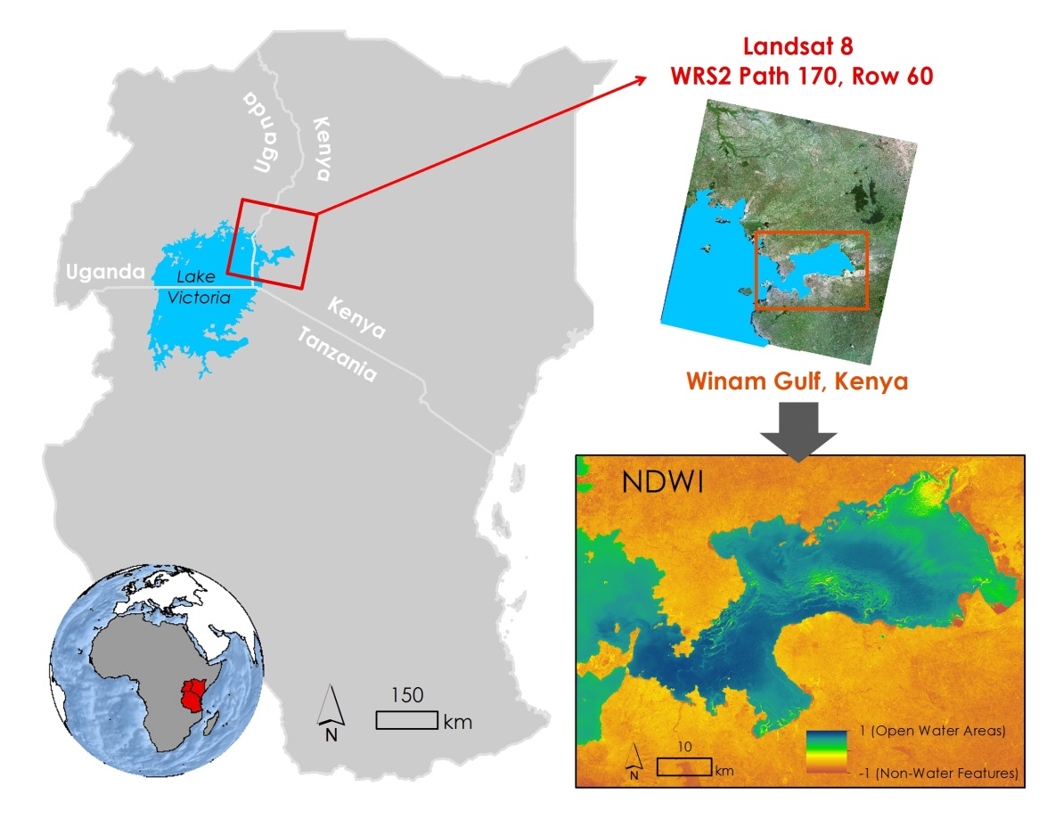

Figure 1: Image indicating location of Winam Gulf in Lake Victoria

Despite the challenges that come with managing such a large body of water, several organizations have been making an effort to improve water quality, control invasive species, and facilitate collaboration on these issues among the nations which thrive off of Lake Victoria. SERVIR -The Regional Visualization and Monitoring System is a joint venture between NASA and the U.S. Agency for International Development (USAID), providing satellite-based Earth monitoring, imaging, and predictive models to help improve environmental decision-making among developing nations with hubs in Africa, the Hindu-Kush region of the Himalayas, and the lower Mekong River Basin in Southeast Asia. The SERVIR – East Africa hub, located in Kenya, has been collaborating with the Regional Centre for Mapping of Resources for Development (RCMRD) as well as the Department of Geomatics and Land Management at Makerere University in Uganda to monitor certain water quality parameters, as well as hyacinth extent, in Lake Victoria via satellite remote sensing techniques. Current efforts include mapping chlorophyll concentration, water surface temperature, and turbidity for Lake Victoria using the Moderate Resolution Imaging Spectrometer (MODIS) sensor on the Aqua satellite. In addition, preliminary efforts have been made to map the extent of the water hyacinth in the Winam Gulf using Landsat imagery.

This was the second term of an ongoing project. The previous term focused on developing a Hyacinth-Vegetation Detection Algorithm using Landsat imagery to help determine areas where water hyacinth may be present. Time Series Maps of Aquatic Vegetation, spanning from August 2000 to October 2015, were generated to provide a historical context of water hyacinth extent and algal blooms in the gulf. This data and corresponding methodologies were handed over to RCMRD and SERVIR to complement their current efforts. A positive response from the project partners garnered interest in automation of the methodology from the previous term, as well as incorporation of additional data sources for improved temporal coverage. This goal was accomplished by writing a Python script which automatically downloaded the most up to date Landsat 8 and Sentinel-2 data over the study area, and applied the Hyacinth-Vegetation Detection Algorithm developed during the Fall 2015 term. Collaboration with members from the SERVIR Coordination Office, the SERVIR East Africa Team, RCMRD, and Makerere University was facilitated to reach this goal.

This project addressed NASA’s national water resources application area by researching water quality and invasive aquatic plant species within the Winam Gulf in Lake Victoria. Continuous, up to date monitoring of water hyacinth and other aquatic macrophytes in the Winam Gulf provides spatial awareness of water conditions which can prompt more aggressive mitigation efforts in affected areas.

# III. Methodology

**Data Acquisition**

Landsat 8 OLI Level 1 GeoTIFFs were downloaded from an Amazon Web Services website using The DEVELOP National Program Python Module (dnppy) package, an open source package containing various scripts created by geoinformatics fellows from the DEVELOP Program. Sentinel-2 MSI Level 1-C JP2000s were downloaded from the European Space Agency’s Scientific Data Hub website using an open source github script (Note: Will reference github script once completed). Imagery from this data product were atmospherically corrected and converted to surface reflectance (?? - unsure if this will happen as of right now).

**Data Processing**

* Describe script writing process
* Describe methodology applied

By using the “datetime” module in python, the functions “date.today()” and “timedelta()” were used to set variables pertaining to the computer operating system’s current date, and fifteen days prior to the current date. These determined variables were then used as inputs for the “fetch_Lansat8” function within the “Download” module from dnnpy, so that Landsat 8 images acquired over the study area up to fifteen days prior to the time the script is run are automatically downloaded. The script specified that only bands 3, 4, 5, and 6 were downloaded, since these were the only Landsat 8 bands required for analysis.

A script was developed using arcpy to automate a method to extract aquatic vegetation features over the gulf. First, a Modified Normalized Difference Water Index, or MNDWI, was calculated on the Landsat imagery automatically downloaded in the previous step. The MNDWI was calculated with the following general equation:

$$\text{MNDWI=}\frac{\text{(green-SWIR)}}{\text{(green+SWIR)}}$$

where, *green* = surface reflectance green band

and, *SWIR* = surface reflectance short wave infrared band

A similar script was developed for Sentinel-2 data.

**Data Analysis**

* Improved accuracy assessment of Landsat 8
  + Describe how the accuracy assessment has been improved from last term
* Accuracy assessment on Sentinel-2
* Testing the script

# IV. Results & Discussion

* Analysis of Results:
* Errors & Uncertainty:
  + Describe possible issues with the script
  + Downloading process of Sentinel data due to data being large
  + Inaccuracies in the study area shapefile
* Future Work:
  + Revising the script to be completely open source

# V. Conclusions

Final conclusions. Word count: 200-600 (~a page).

# VI. Acknowledgments

The Lake Victoria Water Resources team would like to thank the mentors and partners who provided their time and support to make this project possible:

Mentors/Advisors

* Dr. Jeffrey Luvall, NASA at National Space Science and Technology Center
* Dr. Robert Griffin, the University of Alabama in Huntsville
* Africa Flores, NASA SERVIR Coordination Office at MSFC
* Dr. Joe Ortiz, Kent State University
* Dulci Avouris, Kent State University

Partners

* James Wanjohi Nyaga, RCMRD
* Dr. Robinson Mugo, SERVIR - Eastern and Southern Africa Hub
* Dr. Anthony Gidudu, Makerere University Department of Geomatics and Land Management

Other

* Leigh Sinclair, NASA DEVELOP
* Timothy Klug, the University of Alabama in Huntsville

This material is based upon work supported by NASA through contract NNL11AA00B and cooperative agreement NNX14AB60A.

# VII. References

Kayombo S. and Jorgensen S. E. “Lake Victoria: experience and lessons learned brief” International Lake Environment Committee, Lake Basin Management Initiative. February 27, 2006, Kusatu, Japan. Web.

Kiage, Lawrence M., and Joyce Obuoyo (2011) “The Potential Link Between El Nino and Water Hyacinth Blooms in Winam Gulf of Lake Victoria, East Africa: Evidence from Satellite Imagery.” Water Resources Management, Vol. 25 , No.14, 3931–45. Web.

Kolding et al. (2008) “Are the Lake Victoria fisheries threatened by exploitation or eutrophication? Towards an ecosystem-based approach to management.” The ecosystem approach to fisheries, 309 – 350. Print.

Odada, E., Daniel O. Olago, and W. Ochola. “Environment for Development: An ecosystems assessment of lake Victoria basin environmental and socio-economic status, trends and human vulnerabilities” United Nations Environment Programme (UNEP) and Pan African START Secretariat (PASS). 2006, Nairobi, Kenya. Web.

# VIII. Content Innovation

AudioSlides

Interactive Map Viewer

Featured Multimedia for this Article

# IV. Appendices

To be determined.