NASA DEVELOP National Program

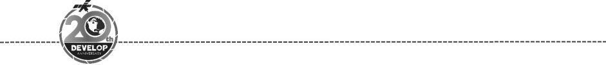
Maryland – Goddard
Spring 2018

Kenai Ecological Forecasting
Mapping Treeline Rise and Wetland Conversion to Supplement Resource Management Actions in a Changing Alaskan Climate


Technical Report
Final Draft – March 29th, 2018

Brendan McAndrew (Project Lead)
Kate Hess
Victor Lenske
Dr. Sara Lubkin
Megan Maloney
Helen Plattner

Dr. John Bolten, NASA Goddard Space Flight Center (Science Advisor)
Dr. Adrianna Foster, Universities Space Research Association(Science Advisor)
Dr. Joseph Spruce, Science Systems and Applications, Inc. (Science Advisor)

1. Abstract
Rising temperatures alter growing conditions for vegetation that result in changes to habitat distribution and abundance. In Alaska, these ecological changes present challenges to land managers planning to accommodate species of interest such as Dall’s sheep and ptarmigan. NASA DEVELOP partnered with the Kenai National Wildlife Refuge (KENWR) to identify areas of wetland afforestation and treeline rise on the Kenai Peninsula from 1989 to 2016 and to forecast these trends into 2050 and 2100. The DEVELOP team generated historical land cover classification maps for the Kenai Peninsula from Earth observations acquired by Landsat 4 Thematic Mapper and Landsat 8 Operational Land Imager. We performed supervised classification of the Landsat imagery by training a maximum likelihood image classifier. We selected training areas for the classifier by referencing the USGS National Land Cover Database for 2001 and 2011 along with visual verification. We then analyzed the historical land cover maps to identify areas of wetland conversion and treeline rise. The team then created forecast maps of these trends to 2050 and 2100 using TerrSet Land Change Modeler (LCM) which can provide KENWR staff with a better understanding of how rates of afforestation vary across the landscape and inform future land management strategies.

Keywords
Remote sensing, Landsat, forest-tundra, alpine, land cover, landscape, afforestation

2. Introduction
  - Background Information
The six-million acre Kenai Peninsula, located south of Anchorage, Alaska, encompasses an ecotone that ranges from Pacific coastal rainforest to alpine tundra (Figure 1). Nearly one-third of the region is managed by the Kenai National Wildlife Refuge (KENWR) with the goal of preserving the region’s extensive ecological, cultural, and economic value. Over the past 60 years, mean temperatures in Alaska have increased by 1.6°C, resulting in a range of observable changes across ecosystems (Berg, McDonnell Hillman, Dial, & DeRuwe, 2009). As temperatures rise, increased evapotranspiration dries Alaskan wetlands and alters the ecosystem processes that shape community assemblages (Klein, Berg, & Dial, 2005). At higher elevations, this warming trend expands the upper margins of habitable range for many species as conditions become more tolerable (Körner & Paulsen, 2004; Lenoir, Gegout, Marquet, de Ruffray, & Brisse, 2008). Such changes in ecosystem conditions potentially allow for the colonization of historically stable communities by species from adjacent ecotones. On the Kenai Peninsula, this process of colonization has been observed in both treeline advance into alpine tundra (primarily white spruce and mountain hemlock), and the colonization of drying wetlands by woody plants (primarily black spruce). These vegetative changes affect the quantity and quality of habitat available to faunal species on the peninsula. For example, alpine-dependent species (e.g. dall sheep, caribou, and ptarmigan) may lose alpine habitat due to increasing forest encroachment, while species associated with treeline forests may find new habitat available to them at higher elevations (Olson, 2013). Abiotic processes such as fire regimes are also affected by changes in plant community composition. Spruce forests, for example, are becoming more abundant and contiguous and fire regime patterns may be exacerbated. It is important to monitor ecosystem changes influenced by rising temperatures so that they may be accounted for in the development of land management plans.

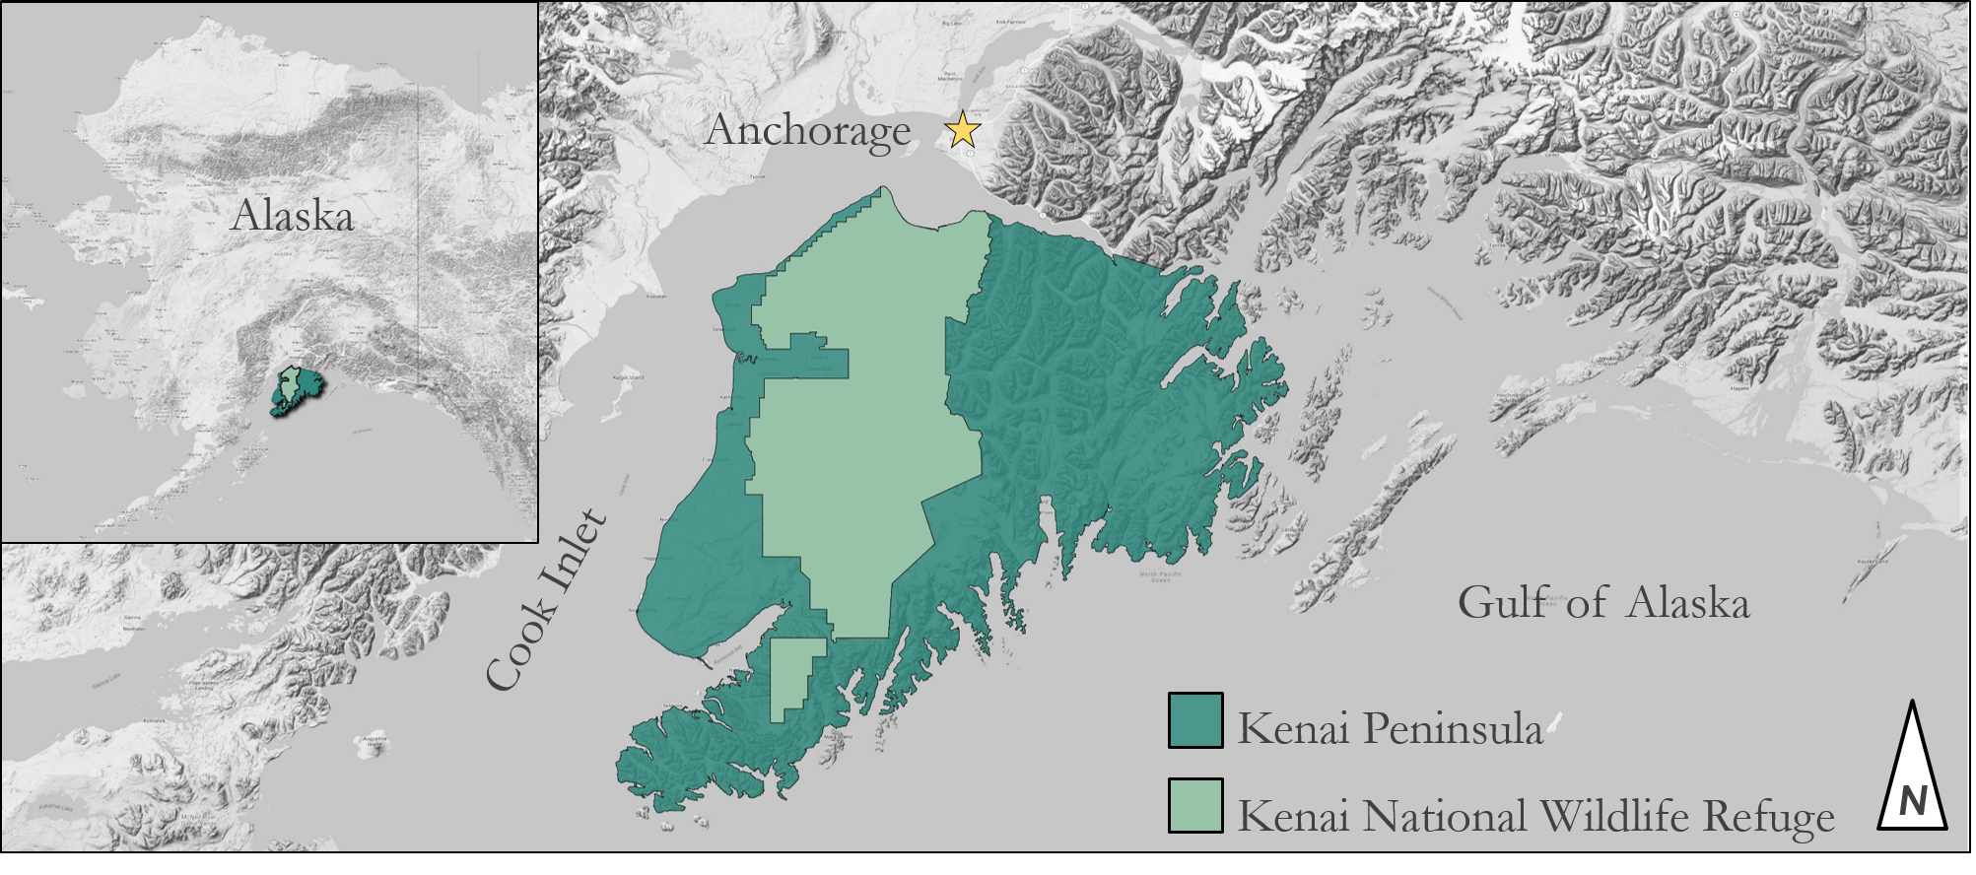
Figure 1. Map of the Kenai Peninsula with Alaska inset. The Kenai National Wildlife Refuge is shown in light green.

We created land cover change detection maps and forecasting products to inform the KENWR biology staff of historical and projected land cover change throughout the peninsula landscape. We used Interferometric Synthetic Aperture Radar (IFSAR) Alaska elevation data (5m), Landsat 4 Thematic Mapper (TM), and Landsat 8 Operational Land Imager (OLI) multispectral Earth observation datasets (30m) to classify and measure woody encroachment into wetlands and alpine tundra. The study area covered the entirety of the Kenai Peninsula as KENWR managers seek to include changes in the landscape beyond the boundaries of the refuge in their decision-making processes. To identify historical changes in land cover, data from 1989 and 2016 was compared. Based on this analysis, potential future changes to land cover were then forecast to 2050 and 2100. Data resolutions and time series were chosen to best allow verification of land class and capture the rates of treeline change, which has been proposed to gain ~1.5-10 m/decade (Dial, Berg, Timm, McMahon, & Geck, 2007).

  - Project Partners & Objectives
The end user of this project is the Kenai National Wildlife Refuge, which is administered by the U.S. Fish & Wildlife Service. The KENWR has a legislative mandate under the Refuge System Improvement Act to maintain the biological integrity, diversity, and health of the ecosystems they manage. The refuge cooperates with the Alaska Department of Fish and Game to set game harvest levels that meet these goals. To support this mission, biological surveys such as the Long Term Ecological Monitoring Program (LTEMP) are conducted in concert with the Forest Inventory and Analysis (FIA) National Program plots to monitor the abundance and stability of species and habitat. The KENWR seeks to adapt their management strategies to anticipate the impacts of accelerated warming and subsequent redistribution of species and habitat. This includes variable localized responses and shifts in disturbance regimes, such as wildfire and infestation.

Currently, the refuge monitors alpine species whose harvest levels are set by the Alaska Department of Fish and Game. Current game management frameworks do not consider transforming habitat conditions, therefore, population decline could lead to ineffective management strategies in the future. The refuge’s biology staff needs to understand how treeline rise is changing habitats across the landscape to make recommendations regarding harvest to the Board of Fish & Game.

The objectives of this project were to map afforestation of wetlands and alpine tundra from 1989-2016 to highlight trends in wetland conversion and treeline advance on the Kenai Peninsula. These analyses were then used to generate forecasts of afforestation trends to 2050 and 2100. The methodologies we developed to generate change detection maps and future forecasts may be adapted by KENWR staff to support land and wildlife management strategies.

3. Methodology
3.1 Data Acquisition
Landsat Surface Reflectance (SR) scenes covering the Kenai Peninsula were acquired from the Landsat Surface Reflectance Tier 1 collection. We selected the Landsat SR products because this imagery is pre-processed to minimize atmospheric distortion and is therefore considered analysis ready. Furthermore, the SR products include 36 years of imagery from the now-retired Landsat 4 TM through Landsat 8 OLI) that was launched in 2013 (Masek et al., 2006; Vermote, Justice, Claverie, & Franch, 2016). By browsing Landsat SR collections hosted on USGS’ Earth Explorer data portal, we found that the orbital paths of the Landsat satellites traverse the Kenai Peninsula longitudinally along Worldwide Reference System (WRS) path 69, with a majority of the land area captured in WRS rows 17, 18, and 19. These scenes were captured consecutively which allowed us to create mosaics from scenes that were captured on the same day. As we searched through the available imagery, we learned that much of the imagery available for the Kenai Peninsula was unusable due to significant cloud cover. The lack of cloud-free imagery was also a challenge faced during the creation of the National Land Cover Database (NLCD) maps (Jon Dewitz, 2016). We eventually selected scenes captured on 07/10/1989 and 08/29/2016 because they were acquired near peak growth (mid/late-summer), contained comparatively low cloud cover, and cover a temporal range of 27 years between acquisition dates. Metadata for the Landsat scenes used in this study are presented in Table 1.

Table 1.
Metadata for the Landsat Surface Reflectance scenes used in this study
Landsat Product | Acquisition Date | Path | Row | Landsat Scene Identifiers
Landsat 4 Thematic Mapper Surface Reflectance | 07/10/1989 | 69 | 17 | LT40690171989191XXX04
 |  |  | 18 | LT40690181989191XXX02
 |  |  | 19 | LT40690191989191XXX06
Landsat 8 Operational Land Imager Surface Reflectance | 08/29/2016 |  | 17 | LC80690172016242LGN01
 |  |  | 18 | LC80690182016242LGN01
 |  |  | 19 | LC80690192016242LGN01

Google Earth Engine, a cloud-based geospatial computing platform, allows users to use simple JavaScript to quickly and easily manipulate geospatial datasets (Gorelick et al., 2017). This platform also hosts an extensive library of geospatial and remote sensing datasets including Landsat SR imagery. To build mosaics from our target scenes we first used the Draw a shape tool to create a crude polygon around the Kenai Peninsula in the interactive mapping pane (Figure 2a). We then imported both the Landsat 4 Surface Reflectance Tier 1 and Landsat 8 Surface Reflectance Tier 1 image collections, filtered each collection by WRS row and path as well as the target dates, and merged the images using the mosaic function (Google Developers, 2017). A true color visualization of the resulting mosaic is shown in Figure 2b below. Each mosaic was then exported to a Google Drive using the toDrive function with the parameters of scale set to 30 m, crs of “EPSG:32605” (WGS 84, UTM zone 5N), and a maxPixels value of “1e9” or 1 billion pixels (Google Developers, 2018). Each mosaic was then downloaded from Google Drive for further processing. Surface Reflectance products from Landsat 4-8 can also be acquired from the USGS Earth Explorer data portal in the “Landsat Collection 1 Level-2” dataset. The individual scenes were then mosaicked together using the Merge tool.

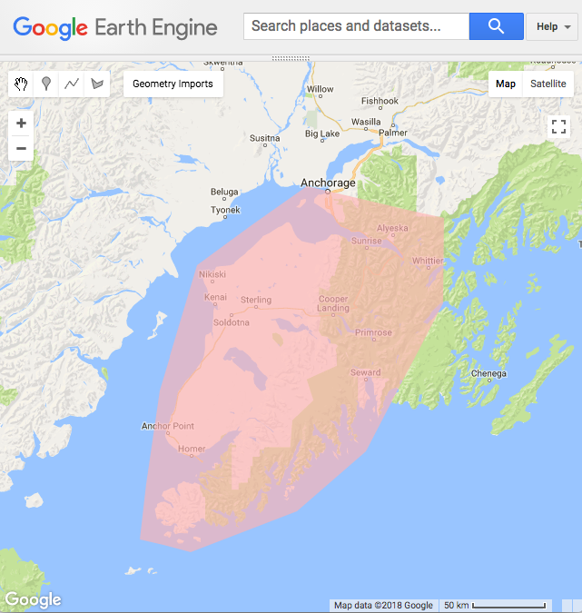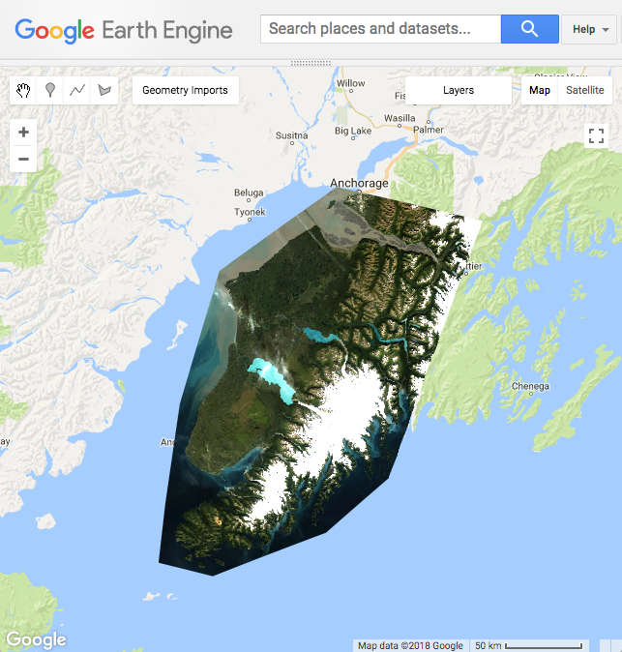
Figure 2. The Google Earth Engine interactive mapping pane showing (a) a crude, hand drawn polygon around the Kenai Peninsula and (b) a mosaic of the Landsat 8 SR scenes created in Google Earth Engine and clipped to the same polygon.

To aid in land cover classification, we collected land cover classification maps from the NLCD for the years 2001 and 2011, the only years for which maps of Alaska were produced (Homer et al., 2007; Homer et al., 2015). Digital elevation models used to estimate change in treeline elevation were acquired from the Polar Geospatial Center ArcticDEM dataset, which were created from DigitalGlobe, Inc. imagery and funded under National Science Foundation awards 1043681, 1559691, and 1542736. Historical climate data for the Kenai Peninsula used in forecasting were acquired from the ClimateNA v5.10 software package, available at http://tinyurl.com/ClimateNA, based on methodology described by Wang et al. (2016).

Partners at the Kenai National Wildlife Refuge also provided ancillary data including US Forest Service Inventory and Analysis (FIA), vegetation classification maps for KENWR, Long Term Ecological Monitoring Project data from the 2004 and 2006 surveys of KENWR, fire history polygons for KENWR, and forest health survey polygons spanning from 1989 to 2010 created by the Alaska Department of Natural Resources. The land cover datasets provided by KENWR were used in conjunction with the NLCD maps to create the land cover classification training set to help identify the cover type present at a particular location. Lastly, the fire history and forest health survey datasets were helpful in identifying areas where ecosystem conversion may have resulted from wildfire or pest outbreak.

3.2 Data Processing
Each mosaic was first clipped to a shapefile of the shoreline of the Kenai Peninsula (see Figure 1) using the gdal translate command line utility included with the free and open-source Geospatial Data Abstraction Library (GDAL). These clipped mosaics formed the basis of our analysis imagery, however, they still contained pixels by obscured clouds, cloud shadows, and terrain shadows. We elected to mask these pixels from the mosaics using the pixel qa band included with Landsat SR products. During the land cover classification trial-and-error process, we found that the spectral reflectance of glacial lakes and shallow pothole lakes confounded the classification of open water, so we decided to include pixels containing water in the mask. Lastly, we masked pixels containing snow and ice to further reduce the variability in spectral signatures within the mosaics. Each mosaic was masked band by band using the Raster Calculator in QGIS. The resulting mosaics contained less variation in reflectance, which increased accuracy and speed of image classification.

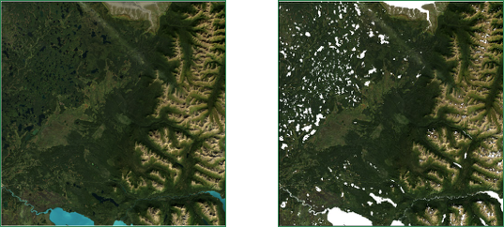
a) b)
Figure 3. (a) Raw Landsat 8 Operational Land Imager Surface Reflectance image visualized with a true-color band stack (4-3-2); (b) the same image with clouds, cloud shadows, water, snow/ice, and terrain shadows masked (shown in white) using the pixel_qa band.

Using QGIS, we then calculated a Normalized Difference Vegetation Index (NDVI) and an Enhanced Vegetation Index (EVI) for each mosaic (Figure 4). Land cover classification tutorials provided by Boston Education in Earth Observation Analysis (http://beeoda.org/) suggest that including vegetation indices can improve classification accuracy. These vegetation indices were then stacked with the masked spectral bands to form the classification images using the gdal merge command line utility. A summary of the band stack contained in the classification images is presented below in Table 2.

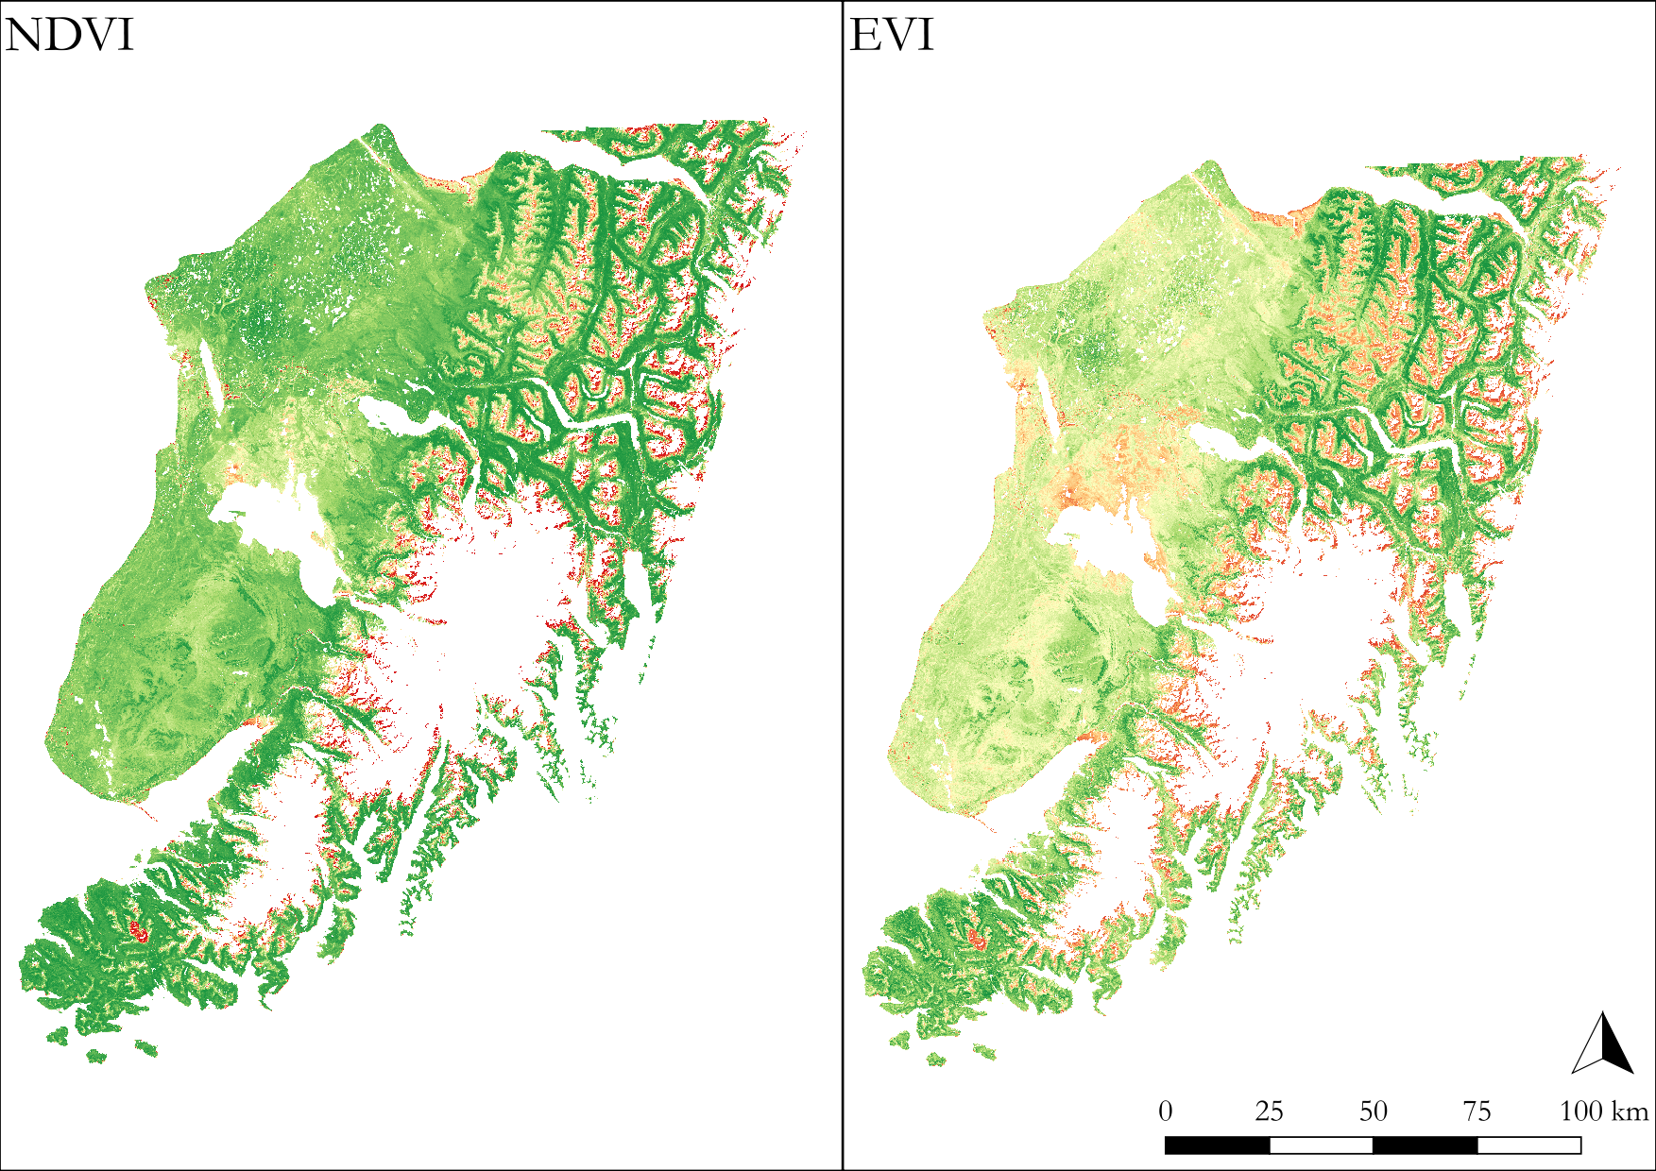
Figure 4. Normalized Difference Vegetation Index (NDVI), left, and Enhanced Vegetation Index (EVI), right, calculated from the 2016 Landsat SR mosaic of Kenai Peninsula. The color ramp represents density of plant material with dark green representing thick vegetation and red indicating very sparse vegetation.

Table 2.
Image band stack used in land cover classification. The bands listed below were merged into a single multi-band raster for each year with spectral bands in bands 1-7 of each image and vegetation indices in bands 8 and 9.
Band Number | 1989 Classification Stack | 2016 Classification Stack
1 | Blue | Ultra Blue/Coastal Aerosol
2 | Green | Blue
3 | Red | Green
4 | Near-infrared | Red
5 | Short-wave Infrared 1 | Near-infrared
6 | Thermal Infrared | Short-wave Infrared 1
7 | Short-wave Infrared 2 | Short-wave Infrared 2
8 | Normalized Difference Vegetation Index
9 | Enhanced Vegetation Index

Climate variables, such as moisture availability and growth season characteristics, were chosen to represent drivers of habitat suitability for vegetation. The metrics implemented included mean annual temperature, mean warmest month temperature, mean coldest month temperature, mean annual precipitation, May to September precipitation, degree-days above 5°C, number of frost-free days, the day of the year on which FFP begins and the day on which it ends, Hargreaves reference evaporation, and mean annual relative humidity. Annually aggregated climate variables were downloaded as point data for each analysis year in the time series and forecast years and the five preceding years (e.g. for 1989, annual data were collected from 1984 through 1989). The data were averaged together when converted to rasters using the ESRI ArcGIS Point Statistics tool, prepared for intake in TerrSet by matching the dimensions of the land cover datasets using the ArcGIS Resample and Clip tools, and exported as GeoTIFFs.

3.3 Land Cover Classification
Supervised land cover classification of the 1989 and 2016 mosaics were carried out in QGIS using the Semi-Automatic Classification Plugin (Condego, 2016). This plugin, freely available through the “Manage and Install Plugins...” menu, provides fairly comprehensive image classification functionality from image acquisition and preprocessing through training dataset creation and final classification. Step-by-step instructions for the use of the Semi-Automatic Classification Plugin (SACP) for supervised land cover classification can be found in tutorials provided by the plugin’s creator (https://fromgistors.blogspot.com) as well as NASA’s Applied Remote Sensing Training (ARSET) training resources (https://arset.gsfc.nasa.gov/).

Our use of preprocessed SR imagery allowed us to skip image pre-processing and create the training data for the classifier using the SCP Dock. We created regions of interest (ROIs) using the Active ROI Pointer and Create a ROI Polygon tools to identify contiguous groups of pixels in the Landsat imagery that contain a particular land cover class (i.e., forest). In order to simplify the classification process, we opted to classify land cover based on a subset of the aggregated NLCD “Level 1” categories that would allow us to focus on afforestation trends: (1) forest, (2) wetlands, (3) shrubland, and (4) unvegetated. These aggregated land cover classes served as the Masterclass Info (also referred to as MC Info) input value in the ROI Creation menu of the SCP Dock when creating ROIs (Figure A1).

In order to visually identify cover type in the ROI creation process, we alternated between true color and false color band combinations and compared what we saw to the NLCD map nearest each study year. Land cover datasets provided as ancillary data by the KENWR were also used to aid in cover type identification. Image classification is an iterative trial-and-error process that requires careful refinement of the training data to improve classification accuracy. We used the SACP “Preview” tool to accelerate this process. This tool generates a preview of the final classification on a subset of the image wherever the user clicks on the map. If the classification is insufficiently accurate, users can continue to add more training ROIs to improve the training dataset or users can inspect the spectral signature of each ROI to identify ROIs that may be confounding the classifier. We followed this process until the classification results identified our target land cover classes with reasonable accuracy. We then generated a final classification of the full image. The settings we selected for the classification algorithm are shown in Figure A2. Due to time limitations, we were unable to generate an accuracy assessment for our classifications, however the SACP does provide some functionality to perform this assessment.
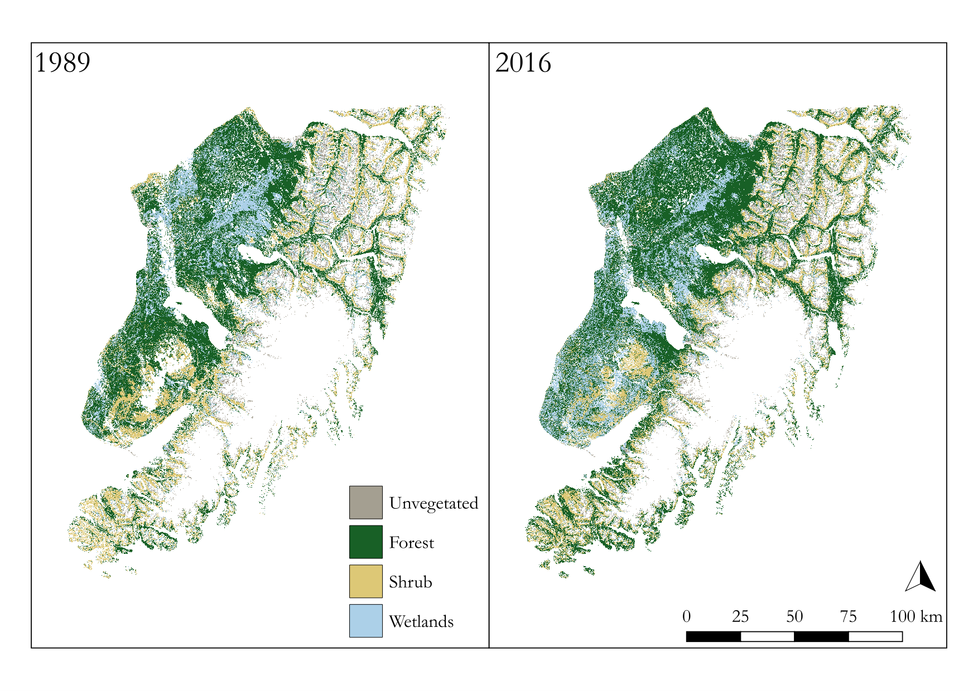
Figure 5. The final output of our land cover classification maps of the Kenai Peninsula for the years 1989 and 2016.

3.4 Change Detection Analysis and Forecasting
We measured land cover transitions and forecasted change predictions using TerrSet’s Land Change Modeler module. The 1989 land cover classifications, produced from Landsat 4 and 8 imagery, were compared to those from the 2016 summer months. ArcticDEM (5m) elevation data was applied as ancillary data. The eleven climate drivers were evaluated for their ability to explain the change and incorporated into the land cover class transition potentials. The model was then used to predict changes out to 2050 and 2100 and produce maps of forecasted land cover. The historical and forecasted data were differenced to produce change detection maps that illustrated trends in the amount and location of transitions between land cover types.

Treeline rise was measured using quartile sampling (Dial et al., 2007) to capture infilling and irregularity. We converted forest polygons from the classified images to points centered in each 30 m cell and extracted ArcticDEM (5m) elevation values to the points. We excluded points below 450 m above sea level (ASL) as literature suggests this is well below observed treeline elevation. We calculated the upper quartile cutoff and average to characterize and compare treeline elevation between years (Dial et al., 2007).

4. Results & Discussion
4.1 Analysis of Results
The change detection map we generated shows afforestation extending in the northwest lowlands of the peninsula, while the southwest showed widespread conversion of forest to wetlands (Figure 6). We attribute the inverted trend in the south to disturbance regimes. Records of wildfire extents in the region corresponded to wetlands classification at several locations where grassland succession is likely being misclassified as wetlands. The change observed in the southwest region also overlaps with documented spruce bark beetle infestations which defoliate tree canopies and expose understory vegetation.

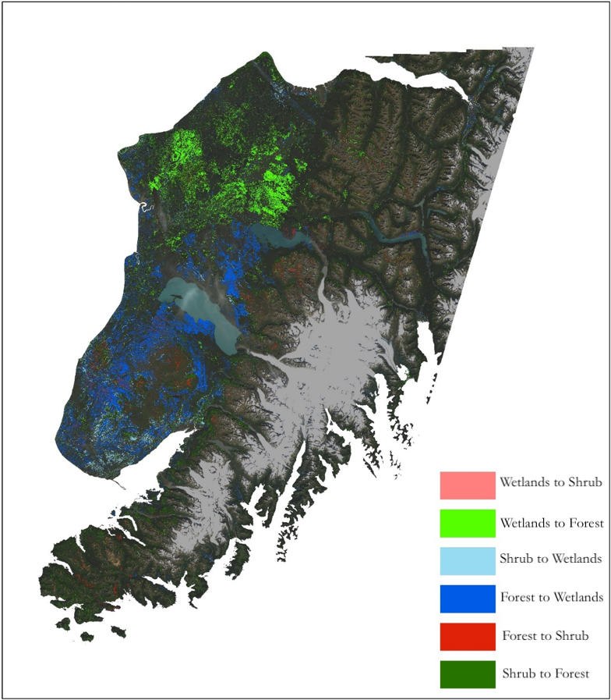
Figure 6. Change detection map showing ecosystem conversion between wetlands, forest, and shrubs from 1989 to 2016 on the Kenai Peninsula.

In the mountains, we did not find consistent treeline rise when using the upper quartile analysis. In the 1989 classification, the upper quartile cutoff for forest points was 712 m ASL with an average elevation of 818 m and maximum of 1361 m. This was all higher than the 2016 forest cover, which generated an upper quartile of 685 m ASL with a mean elevation of 800 m and maximum of 1275 m (Figure 7). The classification identified more tree cover overall in 1989 as well.

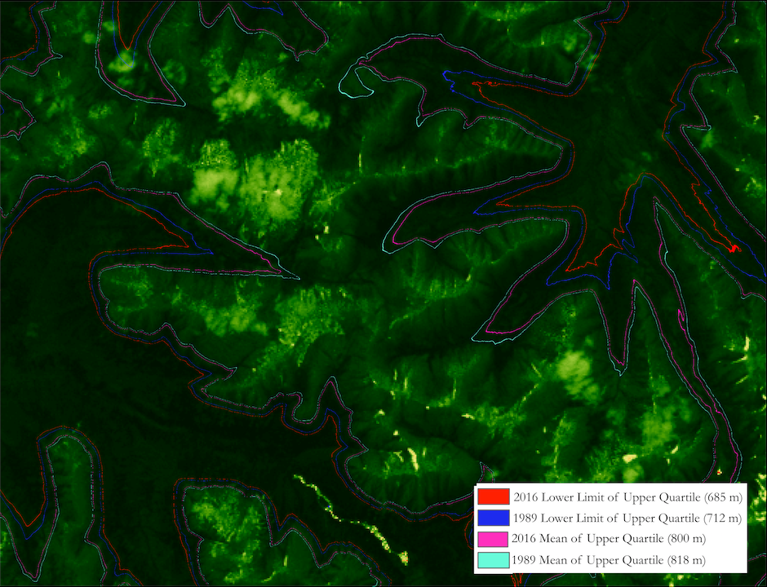
Figure 7. An example of the results of our treeline rise analysis that visualizes the lower limit of the upper quartile of treeline elevation and the mean of the upper quartile of treeline elevation for each study year. These results suggest our classification does not effectively capture treeline rise.

We hypothesize that a combination of the spatial resolution and the classification methods inhibited us from detecting the treeline rise that has been observed on the ground. Other potential causes include training data independently for each image, which could have resulted in less compatible categorization, or surface reflectance of the Landsat images potentially included differing atmospheric interference that disrupted accurate classification. Alternatively, the Landsat 4 TM sensor and the Landsat 8 OLI sensor produce comparable but slightly different bandwidth subsets, which may have the same effect.

However, treeline gain may occur without detection at this resolution due to a distinction in the category definition and our ability to classify it at this resolution. Our historical time series covered a 27-year period between 1989 and 2016. Dial et al. (2007) found a treeline increase in open woodland patches of approximately 7.8 m/decade over a similar time period, 1951 to 1996, in the southcentral Alaska Kenai mountains. This would suggest an approximate 21 m rise in treeline could have occurred during our time period, for which we considered the 30 m spatial resolution of Landsat imagery sufficient to detect. However, while that may be accurate for open woodland treelines, the closed canopy timberline rose only ~1.5 m/decade (Dial et al., 2007). Closed canopy forest is more easily classified at a 30 m resolution. Closed canopy is also unlikely to be excluded due to spectral mixing as open woodland, which mixes with other habitat types.

To investigate this, we examined the statistics of the change detection map in TerrSet and found the “Unclassified” category was the most dynamic type of land cover classification. It included large gains and large losses in 2016, meaning that approximately 266,000 more hectares were unclassified in the 2016 imagery than in 1989, and some of these areas were not the same areas that were previously unclassified. The largest loss to the “Unclassified” category came from the “Forest” category, suggesting that at least ~113,000 ha were excluded in 2016. The ecotone areas that were excluded due to land cover mixing may have included pixels needed to depict the 7.8 m/decade treeline rise, while the 1.5 m/decade rise would be too subtle for our imagery resolution. Additionally, the overall forest loss to unclassified mixing, atmospheric effects, and disturbance regimes may diminish any signal of gain.

Our forecasting results, unfortunately, resulted in a severe banding error which we were unable to sufficiently troubleshoot. The banding was not visible in any layer of the raw imagery or the classified images, which suggests that the error was generated by TerrSet during the forecasting process. The bands may also be the result of TerrSet’s interaction with climate data that was resampled from a coarser spatial resolution than that of the underlying imagery. Further research is needed to effectively forecast these changes into the future.

4.2 Future Work
The results presented here can be improved upon in a variety of ways. Land cover classification, particularly with regard to wetlands, may be improved by including additional covariate bands on top of the vegetation indices we included. Inclusion of data that is decoupled from vegetative cover may help improve classification of wetlands, which often contain a mixture of plant types including herbaceous grasses, shrubs, and trees. Including both slope data and soil moisture data could also improve classification accuracy (Rodriguez-Galiano, Ghimire, Rogan, Chica-Olmo, & Rigol-Sanchez, 2012). Classification accuracy may also be improved by performing land cover classification on subsets of the imagery that contain a more limited range of land cover classes. More sample sites should be selected by experts familiar with local cover types and topography in order to training the dataset used in image classification. We would also recommend testing other supervised classification algorithms (i.e., support vector machine (SVM), random forest, etc.) to explore their classification results. Higher resolution imagery could improve treeline rise analysis, although this comes at the cost of temporal resolution and processing resources. DigitalGlobe’s Worldview series of satellites, for example, are capable of producing imagery at up to 0.3 m/pixel resolution, however, the catalog of imagery only extends back to 2008. The higher resolution imagery may allow for greater differentiation between trees and shrubs at the treeline boundary.

The produced maps, methods, datasets, and literature summary will support the planned Maryland – Goddard DEVELOP summer 2018 Kenai Disasters project. The ancillary data provided by KENWR staff delineating fire damage can be used to subset the deliverables of this product to support more refined classifications. Species succession could be investigated in concert with fire regime impacts, and whether those impacts are expected to shift with further afforestation and wetland drying. The deliverables can be used for further ecological investigation of habitat. Plant functional type classes could further mask multispectral Landsat data to refine classification to identify species of interest, for example, the conifer layers could identify spruce species which may be vulnerable to insect or fire damage, and examine trends in succession. The forecasts may also aid in additional forecasting products and simulations which could impact fire and fuel management, land use planning, and support for species distribution studies.

5. Conclusions
Our preliminary results suggest that ecosystem conversion has occurred on the peninsula between 1989 and 2016. The majority of this conversion appears to be related to disturbances from wildfire and insect infestation events that have thinned forests across large swaths of the peninsula. Further refinement of the methodology will be needed to improve the accuracy of the land cover classification maps that were used for our change detection analysis. The methodology described in this report may be used to support the KENWR’s investigation into the impact of warming temperatures on the peninsula’s ecological communities. NASA Earth observations can provide KENWR managers with a landscape level view of the changes occurring in Kenai’s wetlands, forests, and other ecosystems of interest. This perspective will allow land managers to plan further studies to qualify and quantify the changes as they are occurring on the ground and potentially discriminate ecosystem conversion driven by warming from that caused by disturbance.

6. Acknowledgments
We would like to thank the following people and organizations for their support and involvement:
- Dr. Keith Gaddis, NASA
- Dr. Dawn Magness, US Fish and Wildlife Service, Kenai National Wildlife Refuge
- Sean McCartney, Science Systems & Applications, Inc.

This material contains modified Landsat 4 and 7 data, processed by ESRI ArcGIS and QGIS. Research here also relied on control datasets for fire, wetlands, and land cover as well as high resolution imagery provided by the KENWR biological staff.

Any opinions, findings, and conclusions or recommendations expressed in this material are those of the author(s) and do not necessarily reflect the views of the National Aeronautics and Space Administration.

This material is based upon work supported by NASA through contract NNL16AA05C and cooperative agreement NNX14AB60A.

Geospatial support for this work provided by the Polar Geospatial Center under NSF OPP awards 1043681 & 1559691.

DEMs provided by the Polar Geospatial Center under NSF OPP awards 1043681, 1559691 and 1542736.

7. Glossary
Afforestation – Establishment of forest where it did not exist in the considered historical record
Alpine – Montane, in this context associated with open tundra and a lack of closed-canopy forest, woodland, or shrub vegetation
ArcGIS – Commercial Geographic Information System software from Esri
Change detection – Comparing one or more datasets over time to identify differences that may indicate trends
Classification – Separating data into disparate categories which can then be treated and compared as groups
Earth observations – Satellites and sensors that collect information about the Earth’s physical, chemical, and biological systems over space and time
GDAL – Geospatial Data Abstraction Library, a free and open source software library for the manipulation of geospatial data such as rasters and vectors
KENWR – Kenai National Wildlife Refuge
Landsat – A joint program from NASA and USGS that provides continuous remote sensing data of the Earth’s land surface that began in 1972
NASA – National Aeronautics and Space Administration
QGIS – Free and open-source Geographic Information System software
Remote sensing – The scanning of the Earth by aircraft or satellites to obtain information
ROI – region of interest; a polygon outlining a contiguous group of pixels of one land cover class
SACP – Semi-Automatic Classification Plugin for QGIS; an image classification tool for remote sensing analysis
Stack/Band Stack – a raster image containing multiple bands
Treeline – The elevation at which forest transitions to open woodland
USFWS – The United States Fish & Wildlife Service

8. References
Berg, E. E., McDonnell Hillman, K., Dial, R., & DeRuwe, A. (2009). Recent woody invasion of wetlands on the Kenai Peninsula Lowlands, south-central Alaska: a major regime shift after 18000 years of wet Sphagnum-sedge peat recruitment. Canadian Journal of Forest Research, 39(11), 2033-2046. https://doi.org/10.1139/X09-121

Wang, T., Hamann, A., Spittlehouse, D.L., & Carroll, C. (2016). Locally downscaled and spatially customizable climate data for historical and future periods for North America. PLoS One 11(6): e0156720. https://doi.org/10.1371/journal.pone.0156720

Congedo, L. (2016). Semi-Automatic Classiﬁcation Plugin Documentation. Release 6.0.1.1. https://doi.org/10.13140/RG.2.2.29474.02242/1

Dial, R. J., Berg, E. E., Timm, K., McMahon, A., & Geck, J. (2007). Changes in the alpine forest-tundra ecotone commensurate with recent warming in southcentral Alaska: Evidence from orthophotos and field plots: Tree Line Changes in Southcentral Alaska. Journal of Geophysical Research: Biogeosciences, 112(G4). https://doi.org/10.1029/2007JG000453

Jon Dewitz. (2016, September). Capturing land cover change in Alaska over the last 10 years with the National Land Cover Database: Status and Plans. Retrieved from https://alaska.usgs.gov/science/geography/CRSS2016/posters_and_talks/Jon_Dewitz_US_NALCMS.pdf

GDAL Development Team. (2018). Geospatial Data Abstraction Library (GDAL) (Version 2.2.4). Retrieved from http://gdal.osgeo.org/

Gorelick, N., Hancher, M., Dixon, M., Ilyushchenko, S., Thau, D., & Moore, R. (2017). Google Earth Engine: Planetary-scale geospatial analysis for everyone. Remote Sensing of Environment, 202, 18–27. https://doi.org/10.1016/j.rse.2017.06.031

Google Developers. (2017, October 31). Compositing and Mosaicking | Google Earth Engine API. Retrieved from https://developers.google.com/earth-engine/ic_composite_mosaic

Google Developers. (2018, February 6). Exporting Data | Google Earth Engine API. Retrieved from https://developers.google.com/earth-engine/exporting

Homer, C., Dewitz, J., Fry, J., Coan, M., Hossain, N., Larson, … Wickham, J. (2007). Completion of the 2001 National Land Cover Database for the Conterminous United States. Photogrammetric Engineering and Remote Sensing, 73(4), 337-341.

Homer, C.G., Dewitz, J.A., Yang, L., Jin, S., Danielson, P., Xian, G., … Megown, K., (2015). Completion of the 2011 National Land Cover Database for the conterminous United States-Representing a decade of land cover change information. Photogrammetric Engineering and Remote Sensing, 81(5), 345-354.

Klein, E., Berg, E. E., & Dial, R. (2005). Wetland drying and succession across the Kenai Peninsula Lowlands, south-central Alaska. Canadian Journal of Forest Research, 35(8), 1931–1941. https://doi.org/10.1139/x05-129

Körner, C. (2012). Treelines will be understood once the functional difference between a tree and a shrub is. AMBIO, 41(S3), 197–206. https://doi.org/10.1007/s13280-012-0313-2

Körner, C., & Paulsen, J. (2004). A world-wide study of high altitude treeline temperatures. Journal of Biogeography, 31(5), 713–732. https://doi.org/10.1111/j.1365-2699.2003.01043.x

Lenoir, J., Gegout, J. C., Marquet, P. A., de Ruffray, P., & Brisse, H. (2008). A significant upward shift in plant species optimum elevation during the 20th century. Science, 320(5884), 1768–1771. https://doi.org/10.1126/science.1156831

Masek, J. G., Vermote, E. F., Saleous, N. E., Wolfe, R., Hall, F. G., Huemmrich, K. F., … Lim, T.-K. (2006). A Landsat surface reflectance dataset for North America, 1990–2000. IEEE Geoscience and Remote Sensing Letters, 3(1), 68–72. https://doi.org/10.1109/LGRS.2005.857030

Olson, N. (2013, November 21). Refuge Notebook: Dall sheep in a changing world. Retrieved from http://peninsulaclarion.com/outdoors/2013-11-21/refuge-notebook-dall-sheep-in-a-changing-world

Rodriguez-Galiano, V. F., Ghimire, B., Rogan, J., Chica-Olmo, M., & Rigol-Sanchez, J. P. (2012). An assessment of the effectiveness of a random forest classifier for land-cover classification. ISPRS Journal of Photogrammetry and Remote Sensing, 67, 93–104. https://doi.org/10.1016/j.isprsjprs.2011.11.002

Vermote, E., Justice, C., Claverie, M., & Franch, B. (2016). Preliminary analysis of the performance of the Landsat 8/OLI land surface reflectance product. Remote Sensing of Environment, 185, 46–56. https://doi.org/10.1016/j.rse.2016.04.008

9. Appendices
Appendix A.
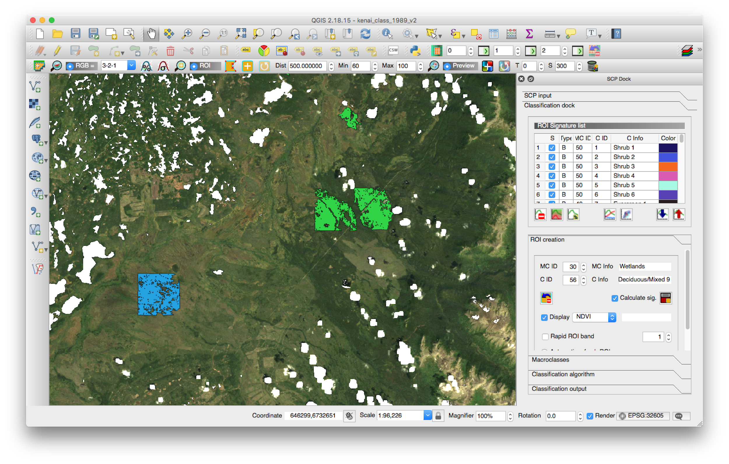
Figure A1. Screenshot of QGIS with the Semi-Automatic Classification Plugin’s SCP Dock open in the panel on the right side of the screen. In the map canvas, polygons representing regions of interest (ROIs) associated with a given land cover class are shown overlaid on a true-color visualization of the 1989 mosaic of Kenai.

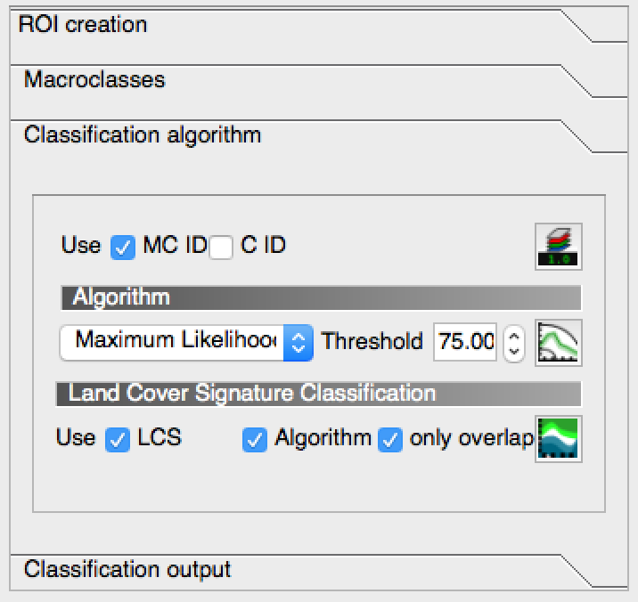
Figure A2. The Classification algorithm pane of the SCP Dock showing the settings we selected for our final land cover classification. LCS stands for “Land Cover Signature” and is an algorithm included with the Semi-Automatic Classification Plugin.

