**NASA DEVELOP National Program**

****NASA Langley Research Center

**Summer 2016**

**Short Title: CALIPSO Cross-Cutting**

**Subtitle:** Enhancing the Usability of *Visualization of CALIPSO* (VOCAL) Through a Test-Case-Driven Approach

**VPS Title:** Cutting Through the Noise to Find a Rhythm: Displaying CALIPSO Data

**Project Team & Partners**

**Project Team:**

Kathleen Moore (Project Co-Lead), kathleen.d.moore@nasa.gov

Ahmad Aburizaiza (Project Co-Lead), ahmad.o.aburizaiza@nasa.gov

Andrea Martinez

Adama Ba

Joseph Driscoll

**Advisors & Mentors:**

Grant Mercer (University of Nevada, Las Vegas)

Dr. Kenton Ross (NASA DEVELOP National Program)

**Past or Other Contributors:**

Grant Mercer

Nathan Qian

Ashna Aggarwal

Jordan Vaa

**Partner Organizations:**

|  |  |  |  |
| --- | --- | --- | --- |
| **Organization** | **POC (Name, Position/Title)** | **Partner Type** | **Boundary Org?** |
| NASA CALIPSO Science Team | Dr. Charles Trepte | End-User | No |

**Project Details**

**Applied Sciences National Applications Addressed:** Cross-Cutting, Health & Air Quality

**Study Area:** Global

**Study Period:** May 2006 – June 2016; near real-time

**Earth Observations & Parameters:**

Cloud-Aerosol LiDAR and Infrared Pathfinder Satellite Observations (CALIPSO), CALIOP – vertical profile of atmospheric backscattering and depolarization data

**Software Utilized:**

* Python 2.7 (Anaconda) – software development
* Sqlite3 – database management
* ccplot – CALIPSO HDF interpretation and formatting

**Project Overview**

**80-100 Word Objectives Overview:**

The LiDAR instrument on the CALIPSO satellite measures backscattering and depolarization information in cross-sections of the atmosphere, enabling scientists to distinguish clouds and potential aerosols (sulfates, smoke, burning biomass, etc.). We have built *Visualization of CALIPSO* (VOCAL), software that visualizes this data and enables easy inspection and annotation of regions of interest in the data – attributes that can then be saved to a database. We are updating VOCAL to accept the latest data product from the satellite, creating use-cases that demonstrate VOCAL’s potential to aid in aerosol identification, and extending the visualizer for simultaneous, multi-format viewing.

**Abstract:**

The relationship that exists between cloud nuclei and aerosols plays a vital role in earth’s climate system.  For the purposes of detection, the Cloud-Aerosol Light Detection and Ranging (LiDAR) and Infrared Pathfinder Satellite Observations (CALIPSO) satellite offers scientists the ability to better understand the relationship between clouds, aerosols, and climate by measuring the backscatter created by embedded atmospheric aerosols. The standard visualizer for CALIPSO satellite data is limited in its extensibility by the proprietary programming language in which it is written.  Hence, development of a new, enhanced visualizer, *Visualization of CALIPSO* (VOCAL), has been in development by NASA DEVELOP teams since spring 2015. Written in Python, VOCAL displays CALIPSO curtain Hierarchical Data Format (HDF) files for both backscattered and depolarized Level 1, Version 3 data. In addition, the user can draw polygons overlaying the displayed data, to mark potential regions-of-interest. Subsequently, these regions can be tagged with attributes and notes. VOCAL can export to a database or to JavaScript Object Notation (JSON) files any shapes that the user may want to save. This term, the CALIPSO Cross-Cutting team added support for the newest CALIPSO data product (Version 4), alternative viewing options for the data in VOCAL, as well as a suite of use-cases for the software.

**Keywords:**

Aerosols, Graphical User Interface, NASA Langley Research Center, Health, Air Quality

**Community Concerns:**

* Aerosols contribute, in varying degrees, to the cooling and warming of the Earth, compounding climate changes.
* Difficult-to-use visualization software has impeded scientists’ ability to track aerosols and collaborate with one another.

**Current Management Practices & Policies**:

Our end-users currently utilize a CALIPSO data visualizer that is written in an obscure, proprietary programming language, and this impedes any effort to modify or tailor the software further as the scientists deem necessary. They manually annotate regions-of-interest on the image and share information in an ad-hoc, unilateral fashion. Furthermore, they have little flexibility in running the software, as the current software only runs on the Windows operating system.

**Decision Support Tools & Benefits:**

|  |  |  |  |
| --- | --- | --- | --- |
| **End-Product** | **Earth Observations Used** | **Benefit & Impact** | **Software**  **Release** |
| Improved Visualization of CALIPSO (VOCAL) software | CALIPSO | VOCAL facilitates collaboration among Earth scientists by enabling the tagging of aerosols with attributes, storing them to a database. | 4 |

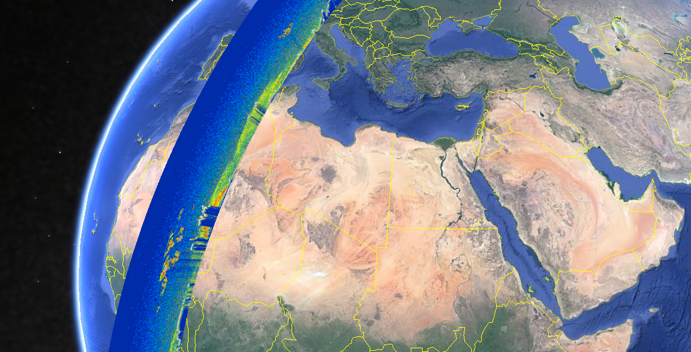**Project VPS/Booklet Imagery**

**Caption:** An overlay of a CALIPSO curtain data file in Google Earth, which is used in identifying regions of aerosols from within VOCAL. Image Credit: CALIPSO Cross-Cutting Team.

**Image:** 2016Sum_LaRC_CALIPSOCross-Cutting_vpsImage.jpg