**NASA DEVELOP National Program**



University of Georgia

*Spring 2016*

Perú Climate II

Monitoring and Forecasting Shifting Climate and Land Change Impacts in Perú’s Parque de la Papa for Enhanced Agricultural Management

 **Technical Report**

Final Draft – March 31, 2016

Caren Remillard (Project Lead)

Brandon Hays

Benjamin Page

Adam Salway

Sam Weber

Xuan Zhang

Dr. Kenton Ross, NASA DEVELOP National Program (Science Advisor)

Dr. Marguerite Madden, University of Georgia Center for Geospatial Research (Science Advisor)

Previous Contributors:

Rebekke Muench

Kayla McDonald

Ryan Murphy

Michael Sclater

Richard Rose

Dajon Begin

# I. Abstract

Agricultural systems in tropical montane regions are particularly vulnerable in the face of global climate change. Anecdotal evidence from Parque de la Papa, located in the Peruvian Andes, indicates that farmers following traditional practices have moved potato crops to higher elevations seeking suitable growing conditions for the potato varieties they have cultivated for centuries. The primary threat to native potatoes is increased mortality rates stemming from pests and diseases. In particular, rising temperatures have led to increases in the population and habitat range of the Andean potato weevil, *Premnotrypes spp*. To assess support for the anecdotal evidence, we quantified changes in potato field elevation over the past three decades using Landsat imagery. This cultivation time-series analysis, slope and elevation data from ASTER, and historical changes in precipitation and temperature will all be incorporated into a crop suitability model. This model will be used to predict optimal areas for potato cultivation and will be given to the International Center for Potatoes (CIP) for use in a management plan to inform the farming efforts of the indigenous communities within Parque de la Papa.

**Keywords**

Remote Sensing, Landsat, ASTER, Operational Land Imager, Suitability Model, Climate, Pan-sharpening

# II. Introduction

**Background**

Shifting precipitation patterns and increases in average global temperatures due to climate change are likely to impact agricultural systems around the world. Tropical montane regions such as the Andean Highlands will be especially affected (Jamieson et al., 2002). Vuille et al. (2000) demonstrated a distinct warming trend throughout the Andes from 1979 onwards, as much as 0.32-0.34 °C per decade, and it is predicted that these warming trends will continue into the future (Thibeault et al., 2010).

These changes in temperature and precipitation have altered growing patterns (Daccache et al., 2011) and increased the presence of insect damage (David Ellis, CIP, personal communication, September 22, 2015). Subsequently, research has shown that from 1982 to 2012, potato cultivation in the Andes ascended 150 m higher in elevation (Shaw & Kristjanson, 2013). These changes threaten the continued use of traditional farming practices and indigenous crop varieties.

Potatoes are a relatively hardy crop, but they are increasingly being affected by changes in climate. In Perú, where potatoes originated and were first cultivated by humans, they are now becoming increasingly difficult to grow. As average temperatures increase, suitable habitat for pests and diseases also increases, forcing farmers to plant at higher elevations. However, the only suitable cropland remaining is wedged between the warm pest-ridden lower elevations and the frost-prone higher elevations. It is becoming increasingly difficult to find land warm enough to grow potatoes but not so warm as to support devastating pests and diseases.

Generally, locations suitable for potato cultivation are determined by biotic and abiotic factors as well as economic and social conditions. With respect to climate, potato production must occur during a time period that is both “heat free” and “frost free,” (Haverkort et al. 2013). Risk of frost increases below 3°C, and tuber production decreases at mean temperatures above 22°C (Hijmans et al, 2000). In addition to regulating plant growth, temperature also affects insect growth and development (Jamieson et al., 2002). Warming temperatures may also increase vulnerability of plants to insect damage, especially if water availability is reduced (Jamieson et al., 2002).

Potato weevils are one of the most prevalent pests for potatoes cultivated in the high Andean mountains (Cisneros, 1999). An increase in Andean weevil populations can be attributed to the rise in temperatures over time in Perú (Parsa, 2010). These pests cause irreparable damage to crops as well as surrounding fields. Weevil eggs are laid at the base of potato plants (Parsa et al., 2012), in the upper twenty centimeters of the soil profile (Rios, 2010) for a period of twelve to fourteen weeks (Cisneros, 1999). Larvae bore through tubers for eleven to seventeen weeks, then abandon these tubers and pupate in surrounding soil (Cisneros, 1999). The emergence of overwintering adult weevils lasts eight to fourteen weeks and coincides with the onset of rain (Cisneros, 1999). Infestations are then exacerbated by the travel of weevils to nearby potato fields (Parsa et al., 2012).

Potato planting within Parque de la Papa occurs from October to November, depending upon rainfall. The two species primarily grown within Parque de la Papa are bitter potato, *Solanum juzepczukii,* and the ‘Irish’ potato, *Solanum tuberosum*. There are more than 4,000 varieties of potato around the world; most are found in the Andes. Globally, potatoes are the third most important food crop in terms of human consumption (CIP). Conservation of this genetic and cultural diversity will depend on a clear understanding of the effects a changing climate has on crop suitability.

Remote sensing and Geographic Information Systems (GIS) have emerged as new tools to assess agricultural suitability (Rahman, 2008) and monitor the distribution of crops over large areas (Panigrahy & Chakraborty, 1998). The goal of this project was to use NASA Earth observations to document recent changes in cropland distribution and altitude, temperature, and precipitation. These results will inform a potato suitability model designed to identify areas with the most potential for future agricultural use.

**Study Area**

This project was conducted in the Parque de la Papa (Figure 1), located in the Cusco region of Southeastern Perú. The Parque de la Papa is an Indigenous Biocultural Heritage Area collectively owned by six local communities belonging to the Quechua people. It is located roughly 25 km away from Cusco, the nearest city, and is 8,661 ha in size ranging from 3,200-5,000 m above sea level. The indigenous communities consist of some 7,000 people who pursue traditional lifestyles and agricultural cultivation as practiced in the region for centuries (Argumedo, 2008).

The park is managed by the local communities with input from two NGO’s: the International Center for Potatoes (CIP) and Association for Nature and Sustainable Development (ANDES). The primary objective is to preserve the cultural and agricultural traditions of the indigenous people living within the park. This includes following centuries old farming practices and propagating some 300 varieties of potato that have been cultivated in this region for hundreds of years (Argumedo).

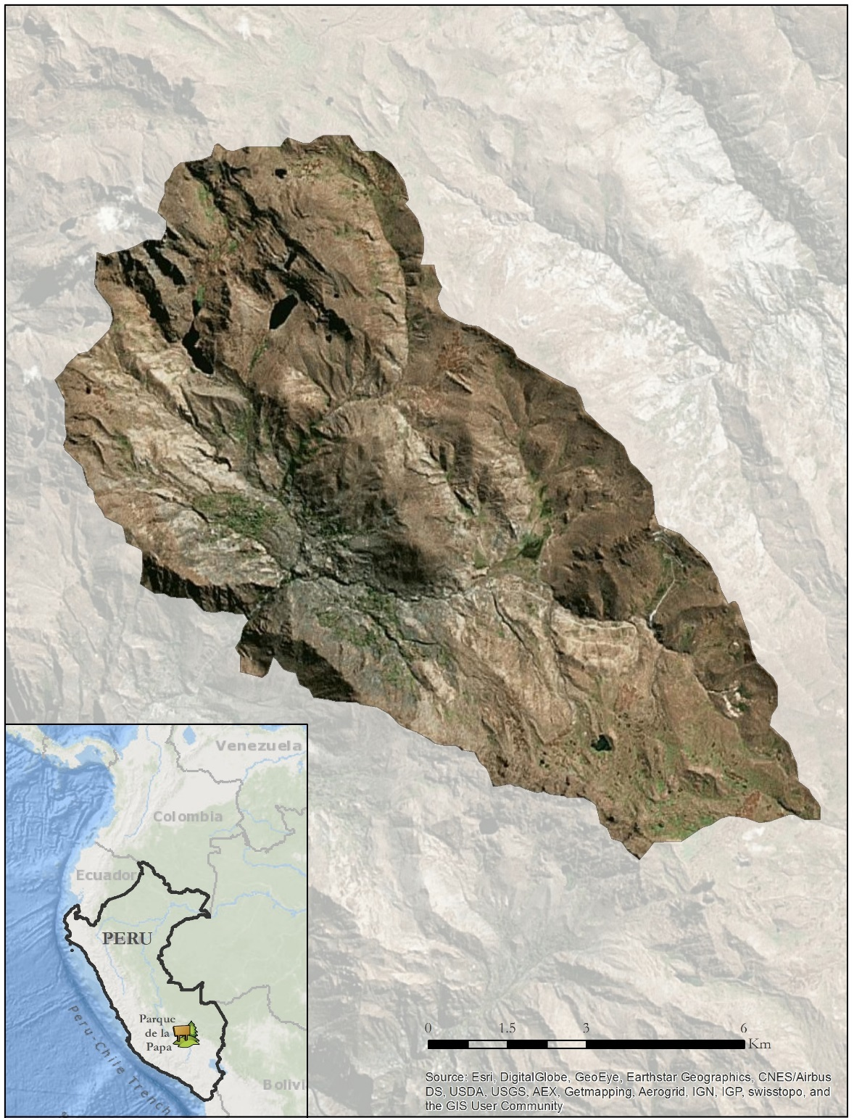

Figure 1: Study Area: the Parque de la Papa, Perú

**Study Period**

Landsat imagery from the month of May between 1985 and 2015 were collected and analyzed. This span represents the earliest publically available remotely sensed data at 30 meter resolution up to the present.

**Objectives**

Our objectives were to quantify changes in growing conditions and climatic patterns within the park and to create a predictive model to assess areas for optimal potato cultivation.

**National Application Areas**

Our work incorporated precipitation, temperature, topography, and habitat requirements for both potatoes and their pests in order to create a forecasting model for an important agricultural product. As such, this project falls under multiple categories in NASA’s Applied Science Applications, including: climate, agriculture, and ecological forecasting.

**Project Partners**

We collaborated with ANDES and CIP. These NGO’s work with the indigenous communities within the Parque de la Papa and help them to translate field data and scientific research into management plans that they can implement. Currently there is only anecdotal evidence of shifting crop suitability. Confirming changing planting and climate patterns will allow park management to conduct outreach activities and better convey the difficulties associated with changing climates. A crop suitability model for potatoes will enable these organizations to direct farmers’ planting efforts to the optimal growing areas and improve their production of an important subsistence crop under changing climatic conditions.

# III. Methodology

**Data Acquisition**

*Meteorological Data*

Weather data, including precipitation and temperature, were collected from the National Climatic Data Center’s (NCDC) Global Summary of the Day (GSOD) interface. The weather station used was located at the Teniente Alejandro Velasco Astete International Airport in Cusco, located at 3310 m above sea level and 25 km away from the park. Temperature, light intensity, relative humidity and dew point data were also provided by the CIP partners from HOBO data logging units placed at different locations throughout the park. These units, from which hourly weather data were extracted, are placed at higher elevations than the airport. The HOBO data falls within distinct time ranges from 2012-2013, 2013-2014 and 2014-2015.

*Satellite Data*

An Advanced Spaceborne Thermal Emission and Reflection Radiometer (ASTER) Global Digital Elevation Model (DEM) was downloaded from the USGS EarthExplorer server with coordinates -13.5, -71.5. This dataset was processed in 2011 and is globally available at 1 arc-second resolution.

Level 1 GeoTIFF imagery from 1985 to present for Landsat 5 Thematic Mapper (TM), 7 Enhanced Thematic Mapper+ (ETM+), and 8 Operational Land Imager (OLI) were downloaded from the United States Geological Survey (USGS) GloVis server for path 4, row 69. All imagery was collected from the month of May, just before the harvest and thus a time of maximum reflective vegetation. If more than 10% of the study area was covered with clouds, the image was excluded.

**Data Processing**

*Meteorological Data*

The weather station data collected from the NCDC Interface contained a relative few null values which were omitted. The remaining data were processed into monthly averages. Additionally, the HOBO hourly temperature data were transformed into daily temperature in order to compare to and further validate the weather station data.

*DEM*

The ASTER images were re-projected to UTM Zone 18N to match the Landsat projection, and clipped to the study area’s shapefile. ASTER pixels represent a 30.8 m2 area compared to Landsat’s 30 m2 spatial resolution. Therefore, the Landsat images were resampled to match ASTER quality.

*Satellite Image Processing*

Prior to image analysis and classification, noise influenced by the atmosphere was removed. Landsat Level 1 GeoTIFF products were first converted from their 16-bit digital number (*DN*) format (8-bit for LS4, 5) to top of atmosphere *(TOA)* reflectance from the radiometric calibration coefficients provided in the .MTL metadata file and then normalized for the earth-sun distance:

(1)

# where *ML* and *AL* are the multiplicative and additive factors for band *i,* respectively, *d*  is the earth-sun distance, and *ESUN* is the downwelling extraterrestrial solar irradiance. Rayleigh scattering can attribute to almost 50% of the total signal reached by the sensor in the coastal and blue bands with an exponential decrease across the rest of the spectrum. Therefore, its contribution *(ρr)* was determined and removed from the *TOA* reflectance (Gordon et al. 1988):

(2)

where *r* is the Rayleigh optical thickness (Hansen and Travis, 1974), *Pr* is the Rayleigh scattering phase function (Doerffer, 1992), and *θo* and *θv* are the Sun and satellite zenith angles. Aerosol type was determined by utilizing the short-wave infrared (SWIR) band to find the maximum pixel value in a clear water body. Water has a large absorption window in the SWIR band so any reflectance signal received is due to the multiple scattering aerosol effects in the atmosphere. This aerosol contribution *(ρa)* value (or two values when using Landsat 8’s two SWIR bands) is then extrapolated across the visible and near-infrared (VNIR) bands and then subtracted from the Rayleigh corrected reflectance images:

(3)

where *λ* is the band center wavelength and *ε* is the aerosol type, determined as the negative of the slope of the straight line between the two SWIR channels used or was set to a value of one when only one SWIR channel was used. Finally, the images were divided by the two-way diffuse transmittance to retrieve final surface reflectance *ρs* product:

(4)

**Data Analysis**

*Meteorological Data*

The weather station data from Cusco was extrapolated to the park using a standard environmental lapse rate equation based on changes in elevation. A moist-adiabatic lapse rate of 6°C/km was determined to be most appropriate for a mountainous region such as the Parque de la Papa. In the equation below, *THadj* is the extrapolated temperature for a give pixel within the park in degrees Celsius, *Elev H* is the elevation above mean sea level of the Cusco weather station, *Elev* *S* is the elevation above mean sea level of a given pixel according to DEM data in meters, and *TH* is the recorded temperature from the Cusco weather station.

(5)

First, daily average temperatures were created to compare with HOBO data and validate the environmental lapse rate equation. Following this validation, a series of sixteen rasters representing the eight monthly average minimum and eight monthly average maximum temperatures. Collectively these comprised the first component of the suitability model.

*DEM*

From the ASTER data, raster images of elevation and slope were created using the slope tool in ArcGIS. These were the second component of the suitability model.

*Classification*

Two sets of classifications were performed on true color composite Landsat images (bands 3,2,1 for Landsat 5 and 7, bands 4,3,2 for Landsat 8). For the crop suitability model, an unsupervised classification was performed in ENVI Image Analysis Software. An iso-cluster classification produced 14 different initial classes. These were subsequently grouped into three major classes using local knowledge of the landscape provided by project partners. The final three classes corresponded to unsuitable, marginally suitable, and most suitable land for potato cultivation. This would serve as the third component for the crop suitability model.

The second set of classifications was applied to a time series of Landsat images taken in May approximately every five years between 1989 and 2011. Ground control points and local knowledge contributed by project partners were used in conjunction with high resolution QuickBird imagery from 2007 to create a set of training data used to classify a Landsat scene from May of 2007. Only land above 3900 m was classified, as potatoes are not cultivated below this elevation within the park.

This supervised classification scheme was in turn used along with local knowledge to create training sets for Landsat imagery from May of 1989, 1994, 1998, 2002, 2007, 2011. The resulting classifications rasters were associated with DEM values and exported as .csv files. This file represented a time series of pixels within the park with their associated elevations and changes in land cover. Afterwards, confidence intervals of average elevation of pixels classified as agriculture were created using R statistical software to test if the data were significantly similar.

*NDVI*

To further evaluate changes in agriculture over time, a normalized difference vegetation index (NDVI) was applied to all imagery available during the time of peak greenness, late February and early March. NDVI is a ratio of the difference between reflectance in the near infrared and red portions of the spectrum to their sum.

NDVI = (RNIR – RRed)/(RNIR + RRed) (6)

NDVI values range from -1 to 1. Since green vegetation reflects NIR light strongly and absorbs most red light, numbers closer to 1 represent vegetation; specifically, healthy vegetation generally falls between 0.3 and 0.8.

*Suitability Model*

In order to assign suitability scores to the pixels, each of the five input layers was reclassified based on their relative suitability for potato growth. Each layer contained three bins with values of one, two, and three, with one being the least suitable value range and three being the most suitable value range.

The minimum temperatures were reclassified as:

|  |  |
| --- | --- |
| **Temperature (Fahrenheit)** | **Reclassified Value** |
| 30 - 35 | 1 |
| 35 - 39 | 2 |
| 39 - 47 | 3 |

The maximum temperatures were reclassified as:

|  |  |
| --- | --- |
| **Temperature (Fahrenheit)** | **Reclassified Value** |
| 59 - 68 | 1 |
| 68 - 71 | 2 |
| 71 - 74 | 3 |

The slopes were reclassified as:

|  |  |
| --- | --- |
| **Slope (Degrees)** | **Reclassified Value** |
| 45 - 90 | 1 |
| 30 - 45 | 2 |
| 0 - 30 | 3 |

The elevations were reclassified as:

|  |  |
| --- | --- |
| **Elevation (Meters)** | **Reclassified Value** |
| 3310 - 3900 | 1 |
| 3900 - 3950 | 2 |
| 3950 - 4500 | 3 |
| 4500 - 4550 | 2 |
| 4550 - 7000 | 1 |

The land covers were reclassified as:

|  |  |
| --- | --- |
| **Temperature (Fahrenheit)** | **Reclassified Value** |
| Least Suitable | 1 |
| Marginally Suitable | 2 |
| Most Suitable | 3 |

A weighted overlay was then performed using the Raster Calculator tool in ArcGIS, using the following equation:

$$Suitability Score=\frac{\left(T_{max}*0.08\right)+\left(T_{min}*0.32\right)+\left(S*0.1\right)+\left(E*0.18\right)+(LC*0.4)}{3}$$

The suitability score was divided by three to normalize the score, giving the score a scale of zero to one.

# IV. Results & Discussion

*Meteorological Data*

Yearly averages were computed from all historical data available from the NCDC station in Cusco. There was an approximately 0.5 °C increase in tempearture from 1980 to 2015 (Figure 2).

Figure 2. Average yearly temperature for all years available from the Cusco airport showing an increasing trend of ~0.5 °C.

In addition, five year averages were computed to examine longer term trends (Figure 3 and Figure 4). The absolute differences between 1981 and 2015 were small relative to the variability show across the entire time span. However, as show in Figure 4, the temperature variability between months increased from 1981 to 2015, particularly in the growing season around November and December.

Figure 3. Five year monthly temperature averages from 1981-2015 as a line graph.

Figure 4. Five year monthly temperature averages from 1981-2015 by month as a bar graph.

Figures 5 shows the raw weather station data compared with local HOBO data as daily averages. The weather station at a lower elevation shows the same trends at a higher temperature, corresponding to our expectations. Figure 6 shows the transformed data from the environmental lapse rate against the HOBO data, again as daily averages. The lapse rate is a close approximation of temperatures recorded within the park by the HOBO data loggers, justifying the use of the environmental lapse rate equation to produce temperature rasters for the suitability model.

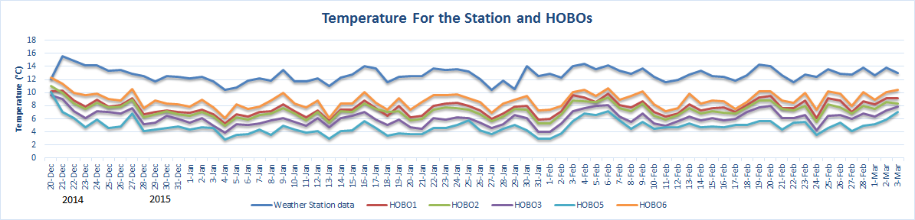

Figure 5: Comparison of daily temperatures within and outside of Parque de la Papa

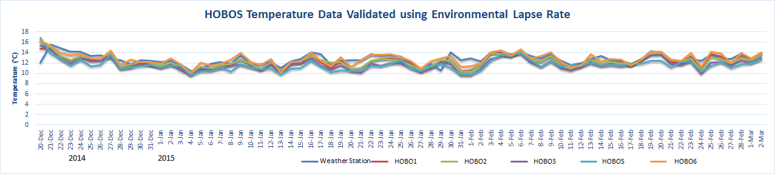

Figure 6: Validation of airport data using standard environmental lapse rate on HOBO data

The rasters of average monthly temperature extrapolated into the park are displayed in Figure 7, showing temperature trends across the park throughout 2015.

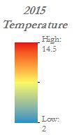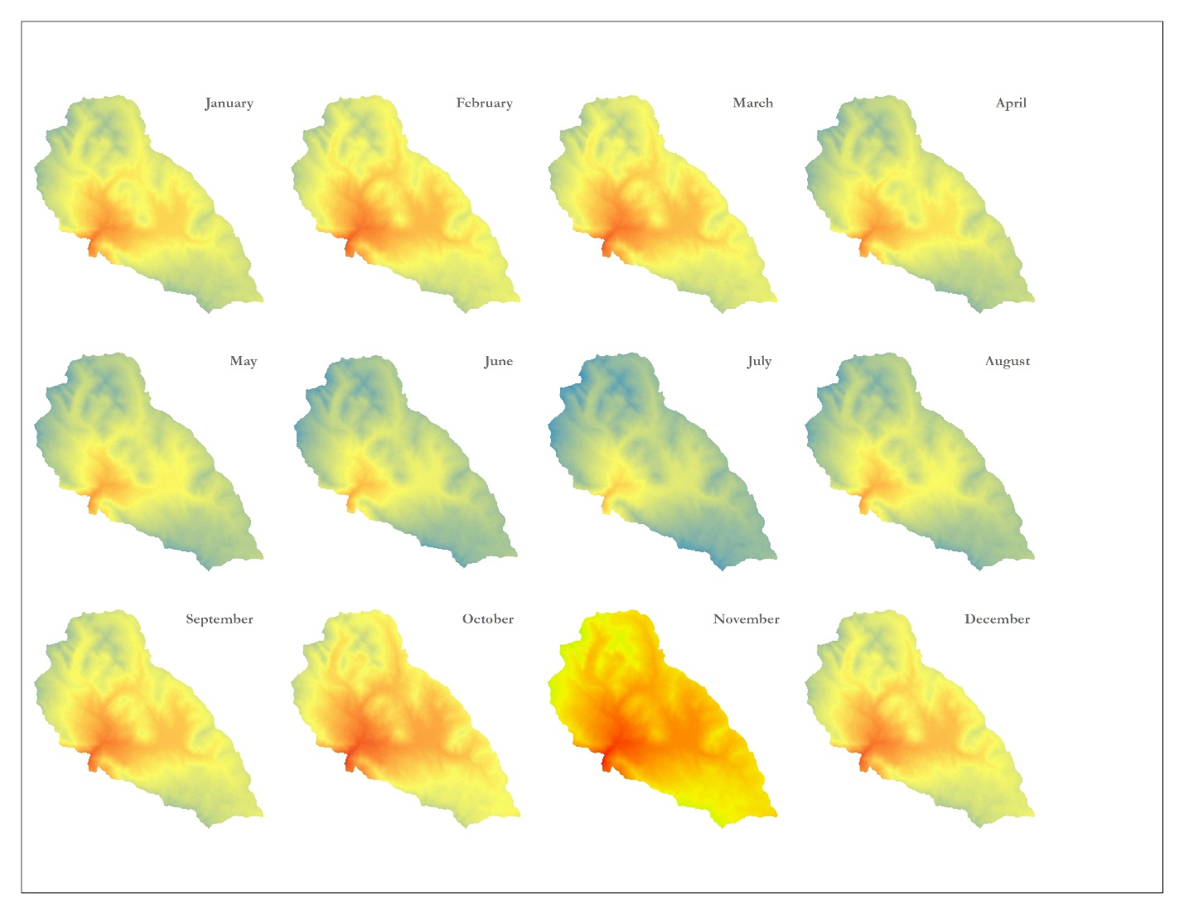

Figure 7. Average monthly temperature extrapolated to cover the Parque de la Papa using the environmental lapse rate

*DEM*

The ASTER DEM data was used to create input rasters of elevation (Figure 8) and slope (Figure 9) for the suitability model.

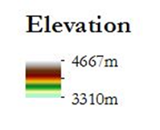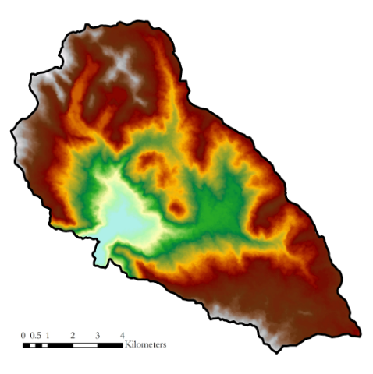

Figure 8. A raster of elevation and slope within the park, derived from ASTER DEM data

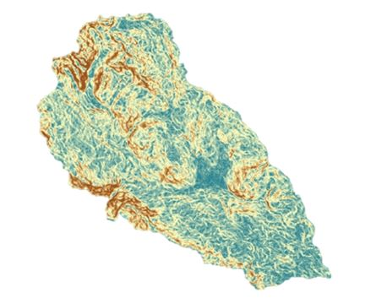

Figure 9. A raster of slope within the park, derived from ASTER DEM data

*Classification*

The output of the unsupervised classification is presented in Figure 10, reclassified to show land cover types as one of three categories.

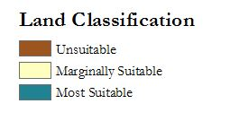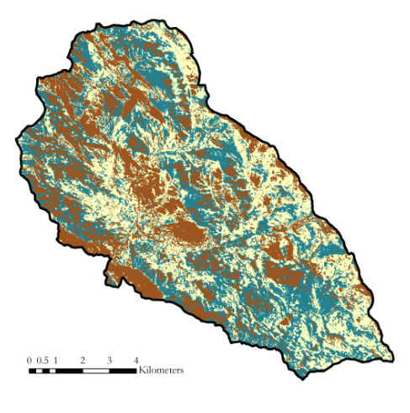

Figure 10. Output of unsupervised classification, showing land as either unsuitable, marginally suitable, or most suitable.

The two images from the time series classifications are presented in Figure 11. An increase in bare earth in the NW corner of the park in 2007 is noteworthy, along with increased agriculture under cultivation in the northern section.

1989 Classification 2007 Classification

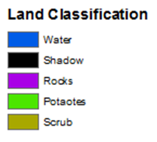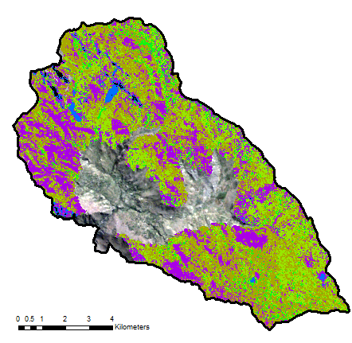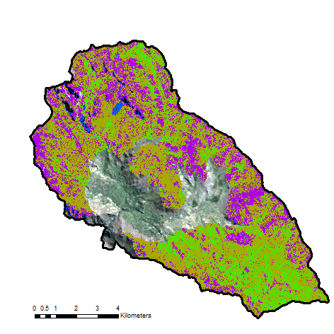

Figure 11. Two classified images, with all land over 3900m classified and all land below remaining as the original Landsat imagery.

Although some qualitative trends were observed between the classified images, the average elevation of pixels classified as agriculture did not appear to vary significantly. The confidence interval bars show the range within which 95% of the data falls. With the exception of 1994 and 1998, the other years overlap with each other and thus can’t be said to differ significantly. The average for 1998 was significantly higher, though this may be due to the occurrence of a strong El Nino event that year.

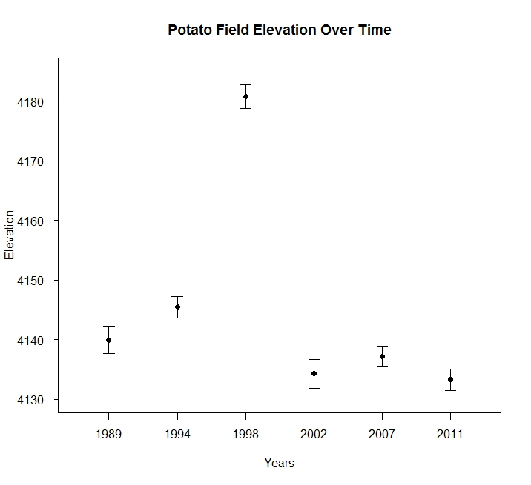

Figure 12. Confidence intervals of average elevation of pixels classified as agriculture/potatoes does not show the trend anticipated based on anecdotal evidence.

Furthermore, when the data are presented by percent of total park area classified as agriculture in a given year, we did not discern any distinct trends (Figure12).

Figure 13. Bar graph showing percent area classified as agriculture/potatoes in 100m classes throughout the park by year.

*NDVI*

Confidence interval plots of average NDVI calculated at 3 elevation ranges – the low, middle, and high ends of the viable growth range for potatoes - are presented in Figure 14. NDVI is significantly higher for 2007 at the high end of the range, as would be expected if increase planting is occurring because these areas are becoming more available with increasing temperatures. However NDVI at the middle of the range is significantly lower in 2007, where we would expect it to be approximate the same or higher. At the low end of the range NDVI for 2007 is significantly lower.

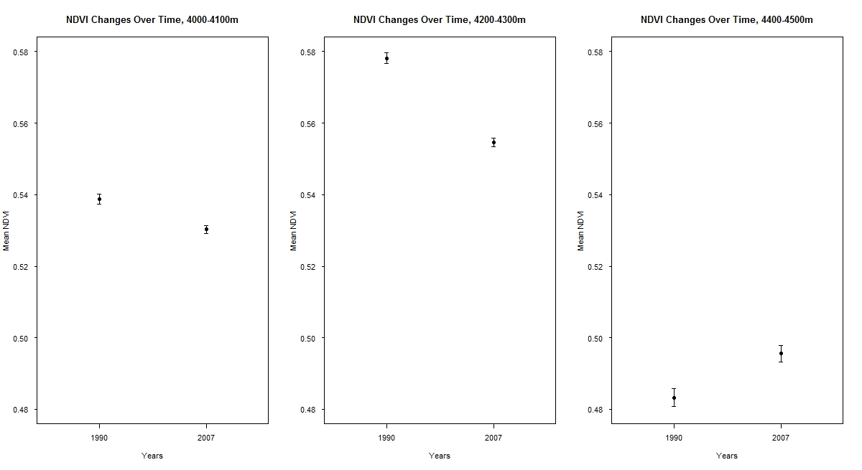

Figure 14. Confidence interval plots at three different elevation ranges – low, middle, and high ends of potato growth range - for 1990 and 2007 during late February-early March, the time of peak greenness.

*Suitability Model*

The final output of the suitability model is shown in Figure 15. Areas which are highly probably to be suitable for potato cultivation are shown in green and areas of low probability are show in brown. The areas towards the center of the park at lower elevations have low probability. The areas at higher elevations with gentler slopes that are not rocky and are not currently under cultivation have the highest probability.

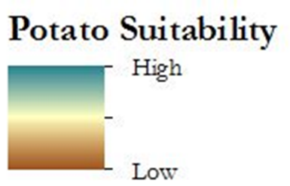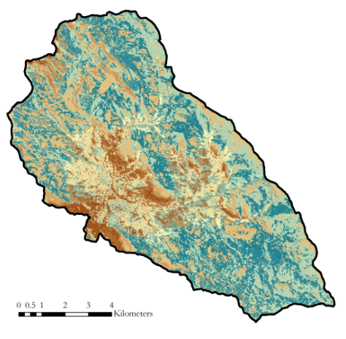

Figure 15. Final Crop suitability model showing areas of high and low suitability for potato cultivation

# V. Conclusions

Comparing the classifications from 1989 to 2007, there were not any substantial changes in planting pattern of cultivated lands. Although there were yearly changes in both the quantity and spatial distribution of cultivated lands, this variation is not indicative of a long term conversion from one land cover type to another. Approximately a half degree Celsius rise in yearly average temperature was observed over the course of the last 35 years in the region. Although half of a degree may seem like a small increase, the time period over which it occurred could indicate rapidly changing climactic conditions.

This study was limited by sparse weather networks, small spatial targets, and persistent cloud cover. There were not any long term weather stations within the park, necessitating the use of climate data from outside of the park. Although this was not the ideal data set to represent the park’s climate data, it was the best alternative available. In addition, potato fields are often smaller than a Landsat pixel, making them not only tough to classify, but difficult to differentiate from other leafy objects. Landsat image collection was limited by persistent cloud cover over the tropical region, particularly during the peak greenness months around March, just before harvest. This project succeeded in producing a crop suitability model for potatoes in Parque de la Papa, and with the guidance of CIP and ANDES, the model will be refined and iteratively corrected to produce more accurate results. A forward predicting model will also be created using projected climate conditions for the near and far future.

# VI. Acknowledgments

We would like to thank our science advisors, Drs. Marguerite Madden and Kenton Ross, for their help crafting and executing this project.

Additional thanks go to the International Potato Center (CIP) for the input and help, including Genesis Abreu, Alejandro Argumedo, Noelle Barkley, David Ellis, and Rene Gomez.

We would also like to acknowledge the contributions of the Perú Climate I team: Rebekke Muench, Kayla McDonald, Michael Sclater, Richard Rose, Dajon Begin.

Any opinions, findings, and conclusions or recommendations expressed in this material are those of the author(s) and do not necessarily reflect the views of the National Aeronautics and Space Administration.

This material is based upon work supported by NASA through contract NNL11AA00B and cooperative agreement NNX14AB60A.

# VII. References

Argumedo, A. (2008). The Potato Park, Peru: Conserving agrobiodiversity in an Andean

indigenous biocultural heritage area. *Protected Landscapes and Agrobiodiversity Values. Volume 1 in the series, Protected Landscapes and Seascapes, IUCN & GTZ*, 45.

Cisneros, F. (1999). Controlling the Andean potato weevil through integrated pest

management. *Horizon International Solutions Site*. Retrieved from http://www.solutions-site.org/node/90/

Haverkort, A. J., De Ruijter, F. J., van Evert, F. K., Conijn, J. G., & Rutgers, B. (2013).

Worldwide sustainability hotspots in potato cultivation. 1. Identification and mapping. *Potato research*, 56(4), 343-353.

Hijmans, R. J., Forbes, G. A., & Walker, T. S. (2000). Estimating the global severity of

potato late blight with GIS‐linked disease forecast models. *Plant Pathology*, 49(6), 697-705.

Jamieson, M. A., Trowbridge, A. M., Raffa, K. F., & Lindroth, R. L. (2012). Consequences

of climate warming and altered precipitation patterns for plant-insect and multitrophic interactions. *Plant physiology*, *160*(4), 1719-1727.

NOAA/National Weather Service. Storm Prediction Center. Environmental Temperature

Lapse Rates. http://www.spc.noaa.gov/

Panigrahy, S., and M. Chakraborty. "An integrated approach for potato crop

intensification using temporal remote sensing data." *ISPRS journal of photogrammetry and remote sensing* 53.1 (1998): 54-60.

Parsa, S. (2010). Native herbivore becomes key pest after dismantlement of a traditional

farming system. *American Entomologist*, 56(4), 242.

Parsa, S., Ccanto, R., Olivera, E., Scurrah., Alcazar, J., & Rosenheim, J. A. (2012).

Explaining Andean potato weevils in relation to local and landscape features: a facilitate ecoinformatics approach. *PLoS One,* 7(5).

Rios, Alfred Arturo. (2010). *Land Use, Spatial Ecology and Control of the Andean Potato*

*Weevil in the Central Andes of Peru* (Doctoral Dissertation). Retrieved from

ProQuest Dissertations Publishing. (3447056)

Shaw A, Kristjanson P. 2013. Catalysing learning for development and climate change:

an exploration of social learning and social differentiation in CGIAR. CCAFS Working Paper No. 43. Copenhagen, Denmark: *CGIAR Research Program on Climate Change, Agriculture and Food Security (CCAFS)*.

Thibeault J.M., Seth A., Garcia M. (2010). Changing climate in the Bolivian Altiplano:

CMIP3 projections for temperature and precipitation extremes. *J Geophys Res* Vol. 115

Vuille M, Bradley R (2000) Mean annual temperature trends and their vertical structure

in the tropical Andes. *Geophysical Research Letters* 27(23): 3885–3888.

# VIII. Content Innovation

Glossary Viewer: 2016Spring_UGA_PeruClimateII_Glossary.docx

Data Profile: 2016Spring_UGA_PeruClimateII_Dataprofile.xml

VPS : 2016Spring_UGA_PeruClimateII_VPS.mp4