User Manual/Tutorial
Surface Aquatic Vegetation Detection Toolbox
The following tutorial will explain how to execute the python script and two python script tools created by the Lake Victoria Water Resources II project during the Spring 2016 term. These model outputs will be used to help distinguish water features from non-water features in Lake Victoria.
Initial toolbox setup
The zipfile will contain the “SAVDT.tbx”, “Landsat8SurfaceReflectance.py”, “Sentinel-2.py”, “Landsat_8_download.py”, “StudyAreaPrj.zip”, “Libraries.zip”, and “dnppy-master.zip”. First, unzip the “StudyAreaPrj.zip” and “Libraries.zip” zip files.
SAVDT.tbx Setup
Before you can use the SAVDT toolbox, there are some initial setup steps. First, open ArcMap.10.x and locate the “Catalog” tab selection. Your screen should look like the picture below:
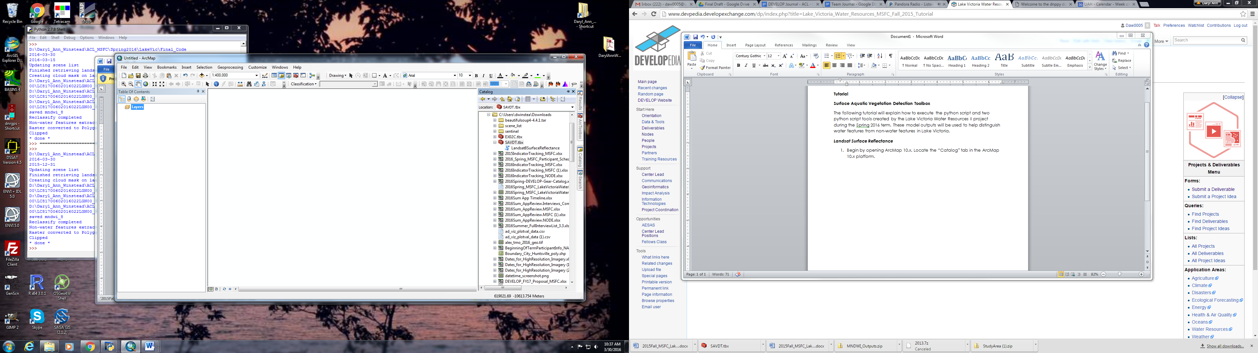
Now, right-click on the “Landsat8SurfaceReflectance” script tool and select the “Properties” option.
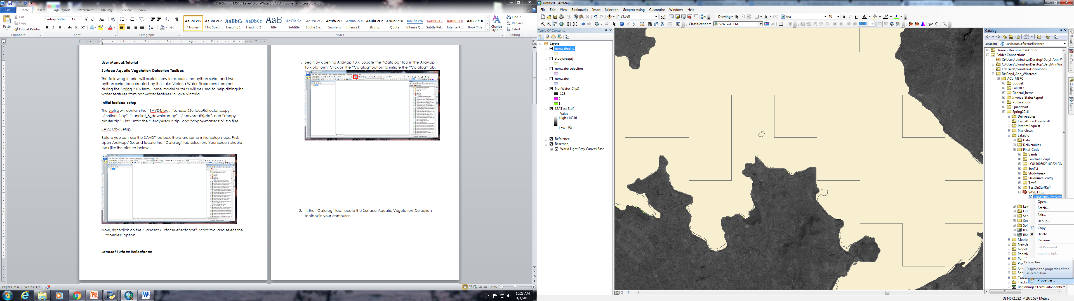
A properties box will pop up, navigate to the “Source” tab. In the “Script File” box, navigate to the location of the “Landsat8SurfaceReflectance” script from the unzipped “SAVDT.zip” file. Select “Open”, then hit “Apply”.
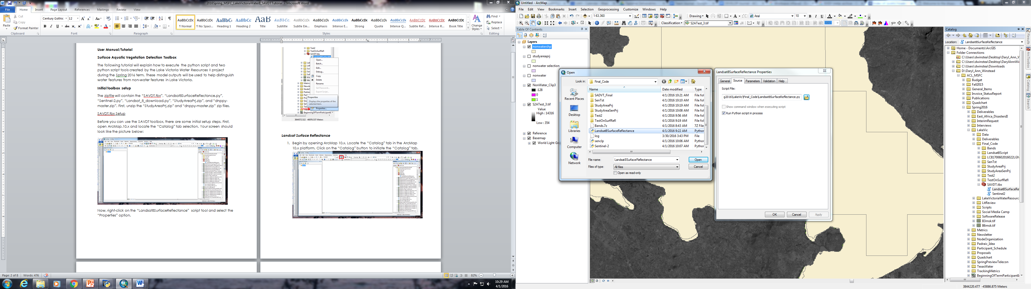
Repeat for the “Sentinel-2” script tool. Now you are ready to run the tool.

Landsat_8_download.py script setup
First, you will need to setup the DEVELOP National Program Python Package (dnppy-master.zip). In order to do this you will need to navigate the “Python27” folder on your computer. Do this by accessing the “Computer” window through the start menu and then searching for “Python27” in your local hard drive. An example can be seen below.
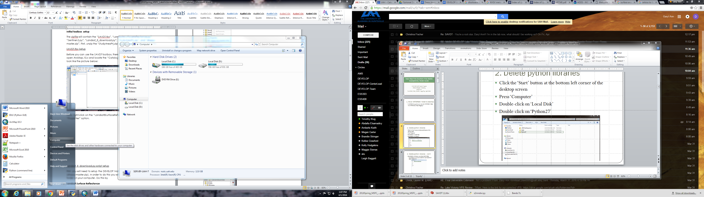
Once you find the “Python27” folder, double-click to open the folder. Double-click on the most up to date ArcGIS folder. Note, if there is a folder for an older version of ArcGIS that is not being used, delete that folder. In the “ArcGIS10.x” folder, there will a folder called “Lib”, double click on this folder. Now in the “Lib” folder, double-click on the “site-packages” folder. Navigate to and delete the following folders: “h5py”, “numpy”, “osgeo”, “scipy”. Don’t worry; the most up to date versions will be redownloaded later on in the setup process.
Now navigate back to the SAVDT folder with the original scripts, toolbox, and zipped files. Double-click on the “Libraries” folder. Within the “Libraries” folder, navigate to the “dnppy-master” folder and right-click to copy this folder. Navigate back to the “site-packages” folder as mentioned previously and paster the “dnnpy-master” folder here. Still in the “site-packages” folder, double-click on the “dnnpy-master” folder and navigate to the “setup.py” and double-click on this python script and follow the prompt. Once finished, navigate to the “dnppy” folder and click copy. Go back to the “site-packages” folder and paste the “dnppy” folder here. You more than likely will have to repeat the step that is listed in red. This is due to dnppy installing these libraries incorrectly. Now navigate back to the “Libraries” folder in the “SAVDT” folder. Copy the ‘h5py’, ‘numpy’, ‘osgeo’, and ‘scipy’ folders and paste them into the “site-packages” folder. Now you are ready to continue and use the Landsat_8_download.py script!
Now navigate to the “Landsat_8_download.py” in the “SADVT” folder. Right-click and select “Edit with IDLE” it will pop up a window that looks like this:
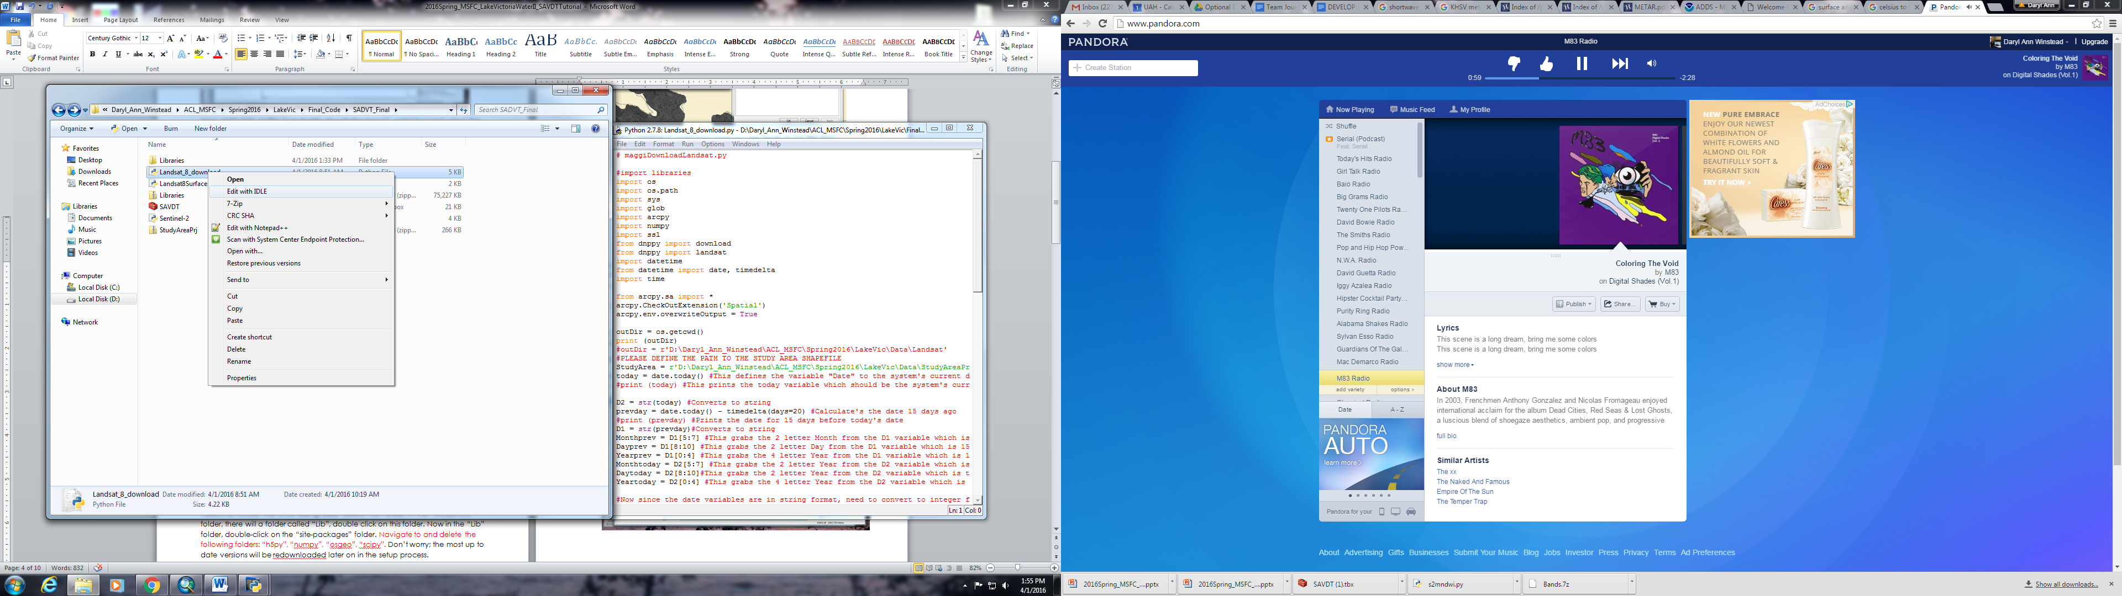
In the new window, navigate to the line that is highlighted in the image below. (Line 21)
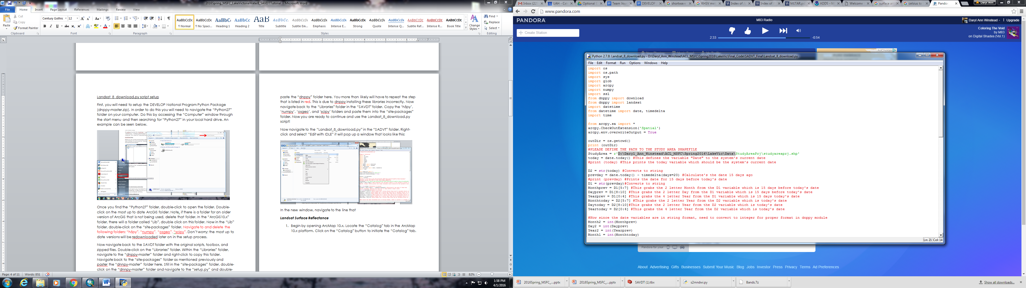
The current pathway is “r'D:\Daryl_Ann_Winstead\ACL_MSFC\Spring2016\LakeVic\Data\StudyAreaPrj\studyareaprj.shp'”. You will need to change this to the pathway of the “StudyAreaPrj.shp” shapefile in the “StudyAreaPrj” folder in the “SADVT” folder. You can find the pathway by clicking on the box while in the “StudyAreaPrj” folder as indicated in the image below.
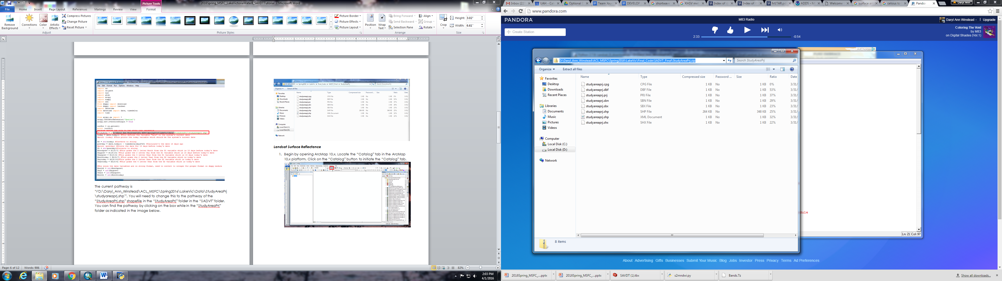
Now go to “File” and click on the “Save” option.
Now you are ready to execute the script! Stay in the same window and select “Run” from the taskbar. From there, select the “Run Module” option. The script is executing. Note: If you happen to get an error, it is in the syntax of the pathway to the “studyareaprj.shp” file, so go back and try inserting it again.
After the script has completed, it will have downloaded the most up to date Landsat 8 images for the Winam Gulf in Lake Victoria for the past 15 days. Note: you might have to broaden the range to get data since the Amazon Web Server does not update as quick as the USGS Landsat Servers. This can be in line 26 of the code by simply changing the number 15 to the desired date range. After the script downloads the Landsat images, it will initiate running the Modified Normalized Difference in Water Index and then run through the process of pulling out the aquatic vegetation on the surface of the water in the Winam Gulf in Lake Victoria. The desired file will be named ‘NonWater.shp’. The downloaded Landsat files will be in a created folder in the “SAVDT” folder and the processed images will be within said Landsat folder. Due to the nature of the script, it is best to relocate the download Landsat images and processed images to a different location outside of the “SAVDT” folder.

Landsat Surface Reflectance
- Begin by opening ArcMap 10.x. Locate the “Catalog” tab in the ArcMap 10.x platform. Click on the “Catalog” button to initiate the “Catalog” tab.

- In the “Catalog” tab, locate the Surface Aquatic Vegetation Detection Toolbox in your computer.
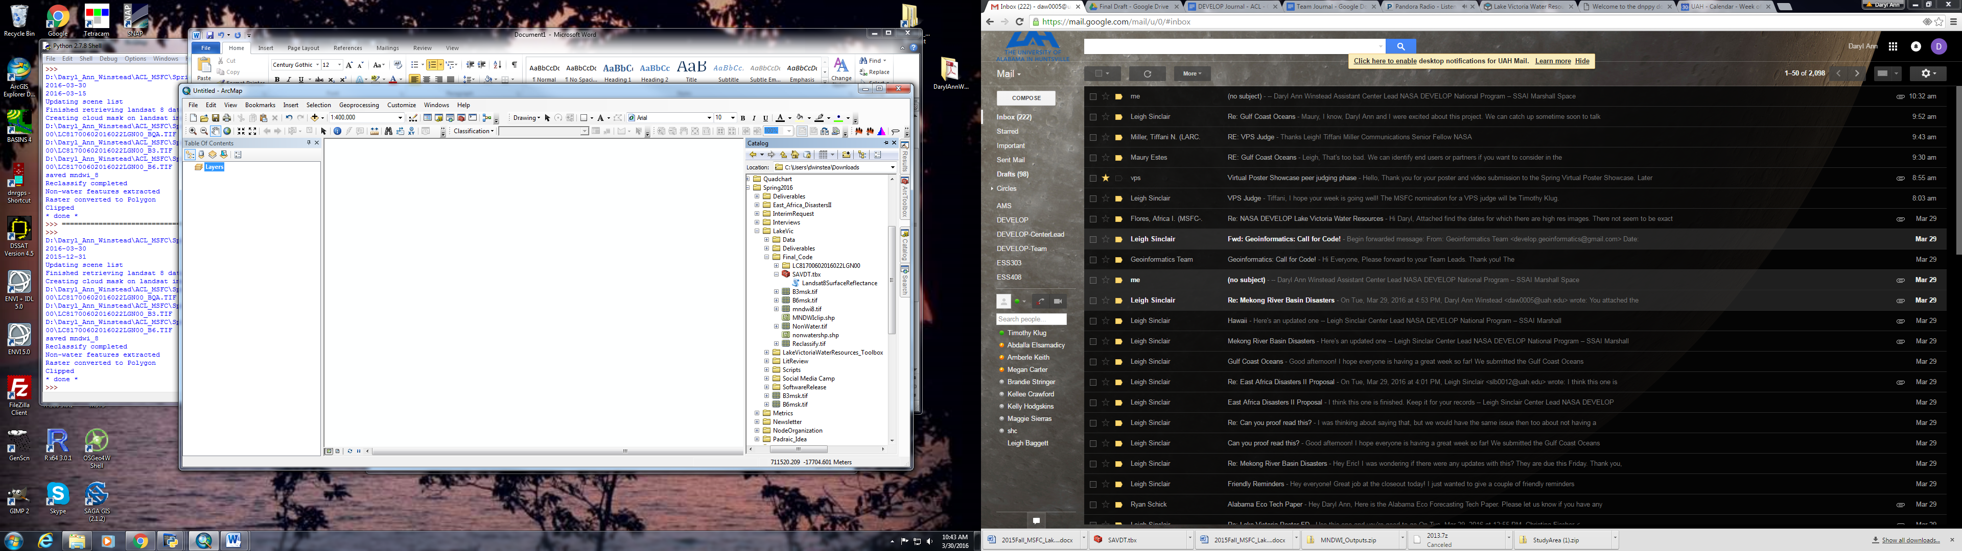

- Double click on the “LandsatSurfaceReflectance” script in the toolbox. A new window will pop up.
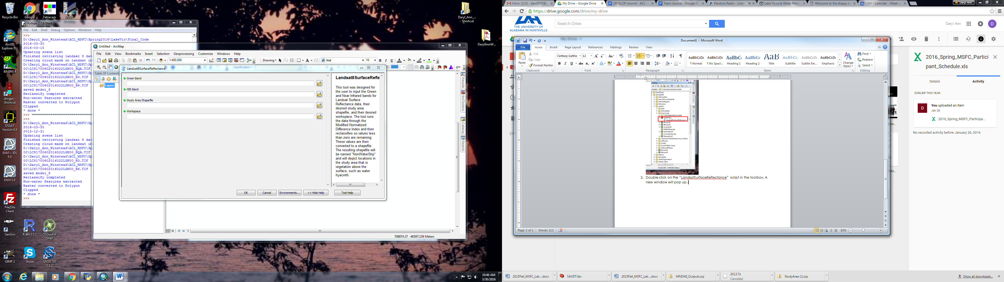
- In the new window, insert the appropriate raster bands for your product in the “Green Band” box. An example is given in the following image.
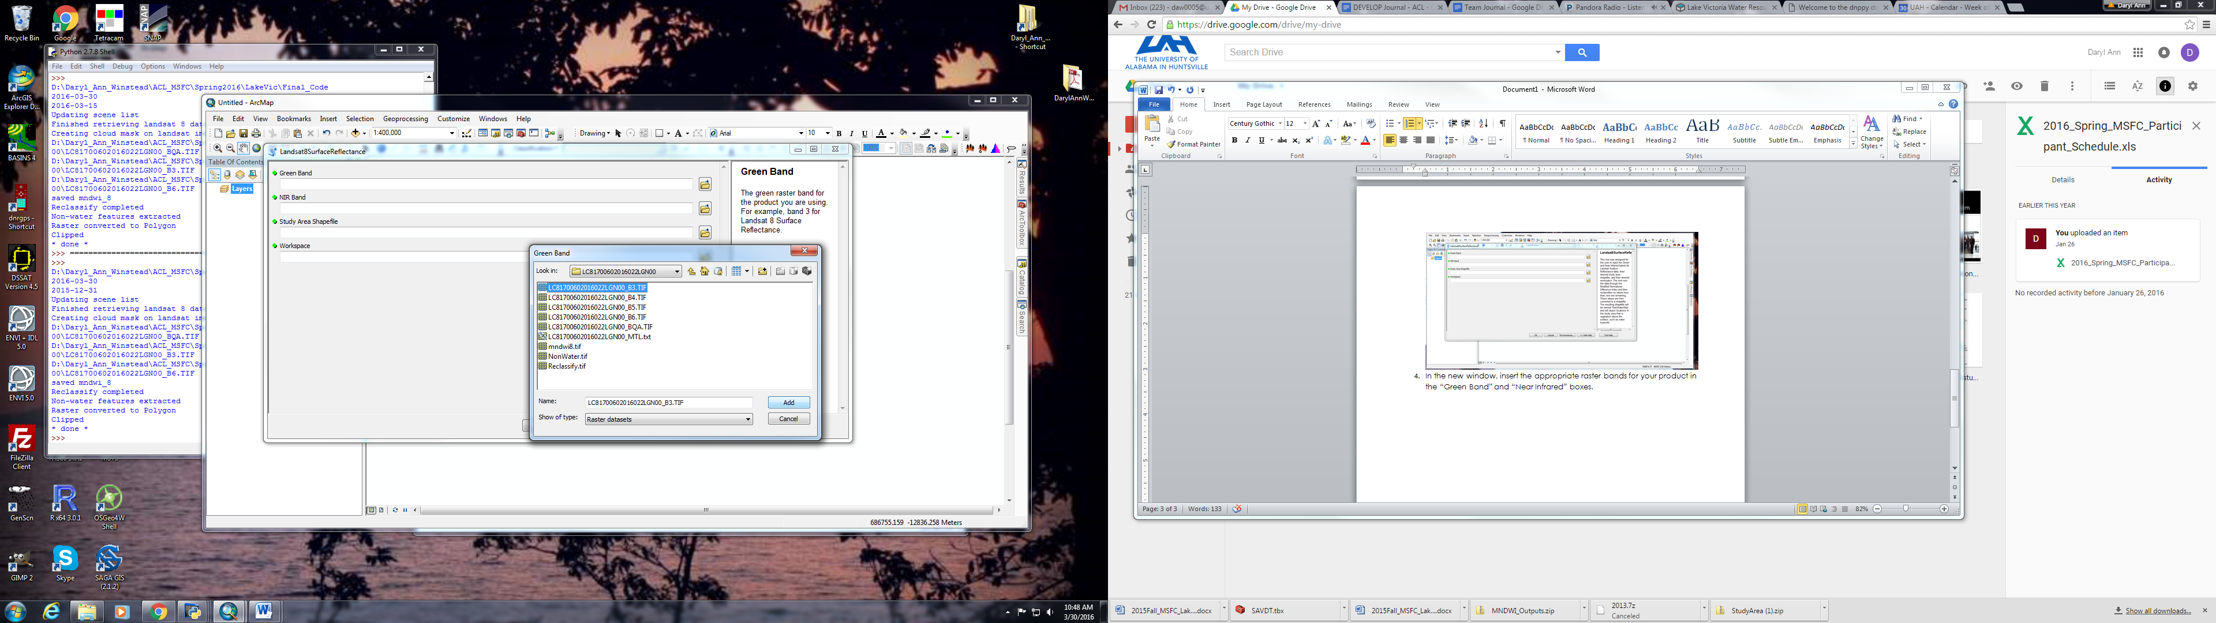
- Repeat for the “SWIR Band”, “Study Area Shapefile”, and “Workspace” boxes.
- Once all boxes have the appropriate information, hit “OK”. The results will be created in the folder defined in the “Workspace” box. The results will consist of the “MNDWI” raster, “NonWater” raster, “Reclassify” raster, and a “NonWaterShp” shapefile. The “NonWaterShp” is the final result. However, there is one last step to get the correct values.
- In order to get the correct values extracted from the “NonWaterShp” the user must input the dataset into ArcMap 10.x. The layer should look similar to nature as in the image below.
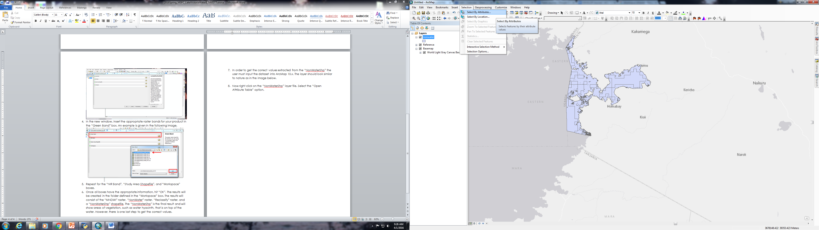
- Now click on the “NonWaterShp” layer file to ensure the layer is highlighted. Now select “Selction” from the top toolbar and select tge “Select By Attributes” option.

- A box will pop up. Complete the following steps in order for the “SELECT” box to be the same as the picture below. 1.) Double-click “GRIDCODE”. 2.) Select “Get Unique Values”. 3.) Select “=”. 4.) Double-click “1”. Now hit “Apply”
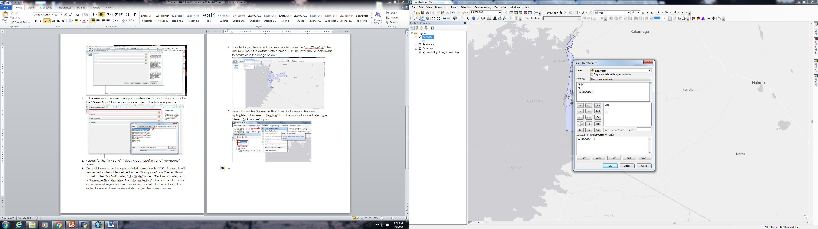

- You image will now have areas highlighted in blue. Right-click on the “NonWaterShp” layer and move your mouse over the “Secltion” option. Now select “Create Layer from Selected Features” option. A new layer will be added to the Data Frame in ArcMap10.x. This is the final output and will show areas of vegetation, such as water hyacinth, that is on top of the water.
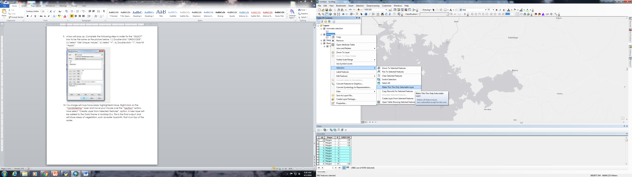

Final layer:
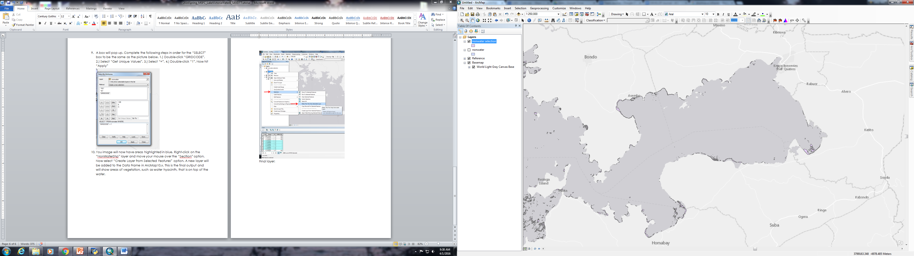

Sentinel
Please refer to the “2016Spring_MSFC_LakeVictoriaWaterResources_SentinelTutorial.pptx” for the Sentinel script portion of the SAVDT toolbox.

