**NASA DEVELOP National Program**

****NASA Goddard Space Flight Center

**Fall 2016**

**Short Title: Kenya Ecological Forecasting**

**Subtitle:** Estimating Carbon Sequestration within Global Environment Facility Funded Protected Areas in Kenya to Aid Future Policy

**VPS Title:** Keeping Deforestation *Out of Africa*: Kenya’s Protected Areas

**Project Team & Partners**

**Project Team:**

Madeline Ruid (Project Lead), madeline.ruid@gmail.com

Erin Glennie

Heather Mitchell

Perry Oddo

Alison Thieme

**Advisors & Mentors:**

Dr. Compton J. Tucker (NASA GSFC)

**Partner Organizations:**

|  |  |  |  |
| --- | --- | --- | --- |
| **Organization** | **POC (Name, Position/Title)** | **Partner Type** | **Boundary Org?** |
| Global Environment Facility- Independent Evaluation Office | Anupam Anand, Evaluation Officer | End-User | Yes |

**Project Details**

**Applied Sciences National Applications Addressed:** Ecological Forecasting

**Study Area:** Kenya

**Study Period:** January 1995 - December 2030

**Earth Observations & Parameters:**

Landsat 5, Thematic Mapper (TM) – land cover classification using multispectral bands

Landsat 7, Enhanced Thematic Mapper Plus (ETM+) – land cover classification using multispectral bands

Landsat 8, Operational Land Imager (OLI) – land cover classification using multispectral bands

Shuttle Radar Topography Mission (SRTM) – land cover classification using digital elevation model

QuickBird-2 – accuracy assessment of land cover classifications

GeoEye-1 – accuracy assessment of land cover classifications

WorldView-2 – accuracy assessment of land cover classifications

**Ancillary Datasets Utilized:**

* WorldClim – annual mean temperature, annual total precipitation
* OpenStreetMap – roads and rivers
* WorldPop – human population density adjusted to United Nations national estimates
* Food and Agriculture Organization of the United Nations (FAO) agriculture data – animal agriculture density for cattle, goats, and chickens

**Models Utilized:**

* TerrSet Land Change Modeler (LCM) – generating future land cover projections

**Software Utilized:**

* Google Earth Engine – acquisition, processing and classification of satellite imagery
* TerrSet – estimating biomass and carbon sequestration with Land Change Modeler
* ESRI ArcGIS – image visualization

**Project Overview**

**80-100 Word Objectives Overview:**

Decades of deforestation in Kenya decreased closed canopy forest cover from the original 12% coverage to only 2% by 2010. In order to decrease deforestation and protect biodiversity, the Global Environment Facility (GEF) funded the creation of 12 protected areas (PAs) throughout the country. These PAs may also provide a co-benefit of climate change mitigation through increased carbon sequestration. By analyzing changes in land cover, the team provided GEF with past and projected biomass and above-ground carbon stock estimates to aid in future policy and programmatic decisions.

**Abstract:**

Global deforestation continues to pose a major environmental problem that threatens biodiversity and increases the number of species facing extinction. In Kenya and worldwide, agriculture is the main driver of forest conversion. Each year, Kenya loses 12,000 hectares (ha) of forest out of its total 4.34 million ha. In order to increase forest cover and protect biodiversity, the Global Environment Facility (GEF) funded projects to establish 12 protected areas (PAs) within Kenya from 1995-2008. Currently, GEF utilizes a global dataset to track only change in forest cover in the PAs. Creating maps of past and forecasted above-ground carbon estimates will enable GEF to gain a better understanding of how the PAs are both conserving biodiversity and addressing climate change mitigation through carbon sequestration. Using Landsat 5 TM, Landsat 7 ETM+, and Landsat 8 OLI imagery from 1995-2016, land cover in each PA was classified to map past changes in forest cover and above-ground carbon stock. Additionally, these maps were processed with ancillary datasets in TerrSet Land Change Modeler to forecast above-ground carbon stocks for 2020 and 2030, given current deforestation rates. Final maps of past and forecasted above-ground carbon estimates will aid GEF in future policy and program decisions.

**Keywords:**

Remote sensing, random forest, support vector machine, Landsat, carbon sequestration, protected areas, Land Change Modeler, Google Earth Engine

**Community Concerns:**

* Kenya’s forest cover spans 4.34 million ha. Each year, the country loses an estimated 12,000 ha to deforestation, with agriculture being the primary driver of land conversion.
* Between 1960 and 2010, deforestation in Kenya decreased closed canopy forest cover from 12% to only 2%.
* Endemic species have seen decreased population sizes associated with loss of habitat.
* Climate models show Kenya’s annual temperature increasing with estimated seasonal temperature increases of 1.5-3◦C+ by 2100. Hotter summer months will also be accompanied by drier conditions due to a weakening of the Somali Jet and Indian Monsoon.
* Investing in protected areas does not necessarily lead to an increase in co-benefits.
* Establishing methods to consistently evaluate the status of protected areas and quantify their associated benefits will aid policy makers, funders, and implementing partners in assessing their progress and planning future projects.

**Current Management Practices & Policies**:

GEF currently evaluates the effects of protected areas on land cover using the Hansen et al. (2013) Global Forest Change dataset. The Hansen dataset leverages remotely-sensed data from Landsat 4, 5, 7, and 8 satellites to produce globally-resolved land cover change estimates at 30-meter resolution. Each GEF protected area includes a 25km buffer, and considers three land degradation indicators: (1) vegetation density, (2) forest land cover, and (3) forest fragmentation. This current method produces forest change estimates (e.g. percent forest loss or gain) from 2000 through 2012. While the Hansen analysis provides a useful benchmark for understanding forest cover change on a global scale, it is less suited to local applications. GEF notes that the current method is most appropriately used for identifying potential areas of concern at a low cost, but should not be used to drive project-level decision-making without additional information. The Hansen dataset does not include any geospatial information prior to 2000, so protected areas that were established earlier do not have a baseline.

**Decision Support Tools & Benefits:**

|  |  |  |  |
| --- | --- | --- | --- |
| **End-Product** | **Earth Observations Used** | **Benefit & Impact** | **Software**  **Release** |
| Past and forecasted above-ground carbon estimates for 2000, 2011, 2016, 2020, and 2030 | Landsat 5 TM, Landsat 7 ETM+, Landsat 8 OLI, QuickBird-2, WorldView-2, GeoEye-01 | Enhances GEF’s future decision making by understanding positive effects of PAs beyond biodiversity and forest conservation | 1 |
| Biomass estimate (change detection) maps for 2000, 2011, and 2016 | Landsat 5 TM, Landsat 7 ETM+, Landsat 8 OLI, QuickBird-2, WorldView-2, GeoEye-01 | Highlights how biomass has changed within the PAs in order to have a baseline for forecasting and comparing above-ground carbon estimates | 1 |
| Forecasted biomass estimate (change prediction) maps for 2020 and 2030 | Landsat 5 TM, Landsat 7 ETM+, Landsat 8 OLI, QuickBird-2, WorldView-2, GeoEye-01 | Enhances GEF’s future decision making by forecasting PAs with high and low biomass | 1 |

**Project VPS/Booklet Imagery**

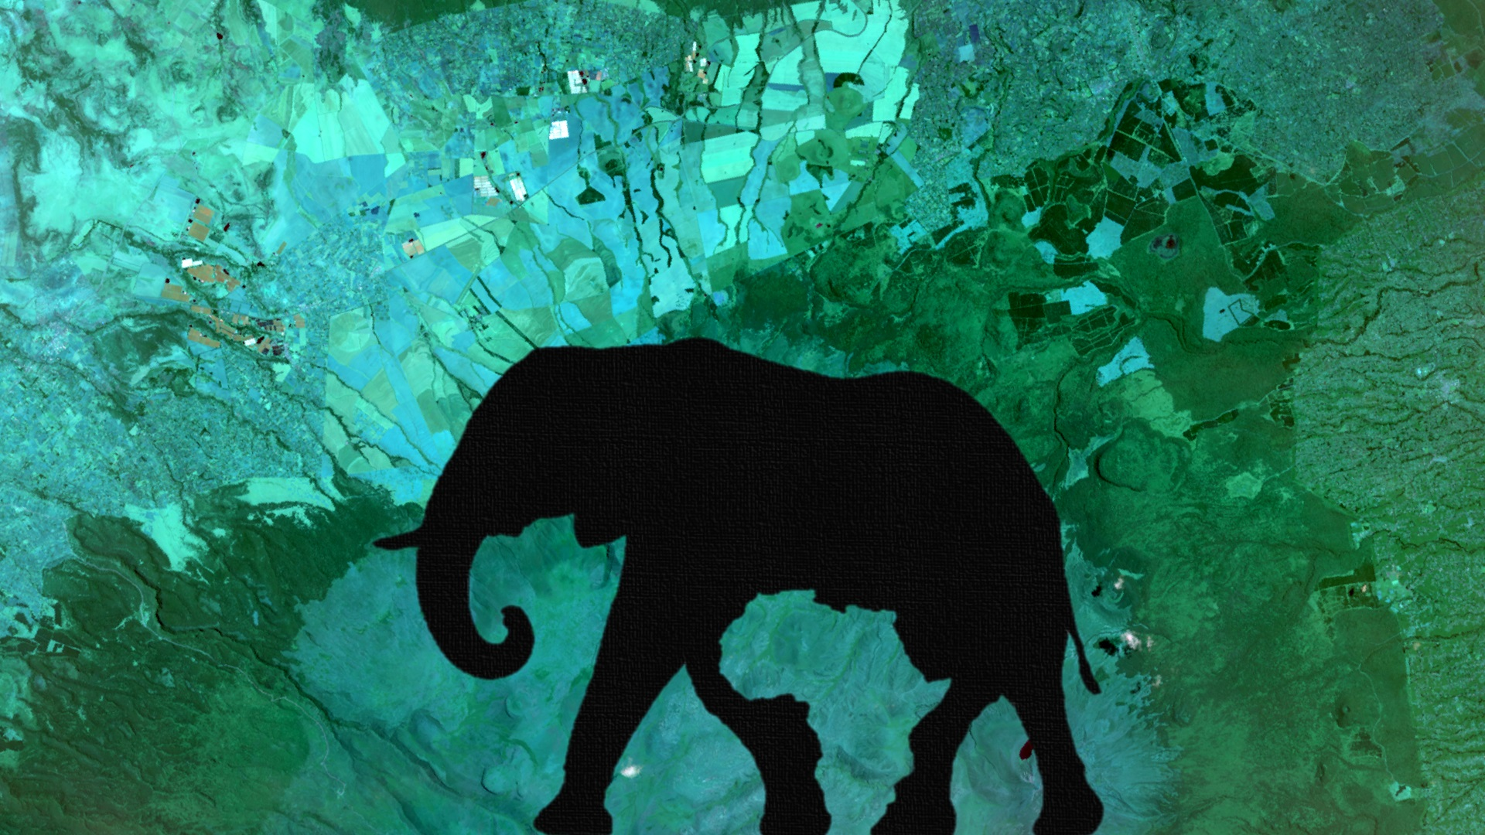

**Caption:** Mount Kenya, a biodiverse landscape, represented in a composite of Landsat 8 Operational Land Imager multispectral bands that have been atmospherically corrected. Image Credit: Kenya Ecological Forecasting Team.

**Image:** 2016Fall_GSFC_KenyaEcoForecasting_VPSimage.jpg