**NASA DEVELOP National Program**



BLM at Idaho State University GIS TReC

*Summer 2017*

Southern Idaho Disasters

Enhancing Pre- and Post-Wildfire Vegetation Type Characterization using NASA Earth Observations

 **Technical Report**

Final Draft – August 10, 2017

Austin Counts (Project Lead)

Nicholas Olsen

Cassidy Quistorff

Caitlin Toner

Courtney Ohr

Keith Weber, ISU GIS TReC (Science Advisor)

Joseph Spruce, Science Systems & Applications, Inc (Science Advisor)

# 1. Abstract

Increasing wildfire frequency has emphasized the importance of post-wildfire recovery efforts in southern Idaho’s sagebrush-steppe ecosystem. The changing fire regime favors annual invasive grass species while hindering native grasses and sagebrush habitat regeneration, causing a positive feedback cycle of invasive plants. Due, in part, to this undesirable process, the sagebrush-steppe ecosystem is one of the most endangered in the US. In this project, the Idaho NASA DEVELOP team partnered with the Bureau of Land Management, Idaho Department of Fish and Game, and the US Department of Agriculture to characterize ecosystem recovery following the 2006 Crystal fire. Vegetation recovery following the Crystal fire (2006) was observed from 2001 to 2016 using NASA Earth observations Landsat 5 Thematic Mapper (TM), Landsat 8 Operational Land Imager (OLI), Aqua and Terra Moderate Resolution Imaging Spectroradiometer (MODIS), and the Shuttle Radar Topography Mission (SRTM). In addition, significant factors affecting recovery were identified, and recovery of the landscape’s carbon sequestration capacity was assessed. Key variables analyzed included biomass production, seasonally accumulated precipitation, max seasonal temperature, and elevation including slope and aspect. These factors affect land management by driving the success or failure of recovery efforts.

**Keywords****:** Sagebrush-steppe, wildfire recovery, invasive species, remote sensing, cheatgrass, carbon sequestration, MODIS

# 2. Introduction

***2.1. Background Information***

The sagebrush-steppe ecosystem is the most widespread ecosystem type in the United States (Flerchinger et al., 2004). While often appearing barren and lifeless, this ecosystem teems with life, such as large game species like pronghorn (*Antilocapra americana*) and mule deer (*Odocoileus hemionus*). The sagebrush-steppe ecosystem is also home to a bird found nowhere else in the world - the greater sage-grouse (*Centrocercus urophasianus*) (Blomberg et al., 2012). In the winter, the diets of native wildlife are largely made up of sagebrush (*Artemisia tridentata*) from the sagebrush-steppe (Dahlgren et al., 2015).

The Big Desert in Idaho’s Snake River plain, where the 2006 Crystal fire occurred, has both recreational and economic value, especially for hunters pursuing big game. According to Idaho’s Department of Fish and Game, hunting and fishing contributes nearly 7% of Idaho’s gross state product, with $1.2 billion going into the economy per year (Torrell et al., 2014). In addition, rangelands within the Big Desert provide grazing ground for cattle, aiding in the ranching economy of the West. In the spring and summer associations such as the Bureau of Land Management rent out rangelands for domestic livestock foraging. During this time, over 95% of forage for Idaho livestock came from the Bureau of Land Management and state rangelands (Torrell et al., 2014). After a wildfire, these lands are typically no longer available for foraging until they are considered recovered. While wildfire is a historically prominent part of the sagebrush-steppe, the increasing amount of fires combined with the invasion of annual grasses puts this area at risk of becoming unrecognizable (Davies et al., 2012).

As wildfires grow more frequent and as invasive species continue to spread, identifying key variables to aid in wildfire recovery is ever more important. In 2006, there was a wildfire count of 2,094 in the Western US- the highest seen in a 67 year time span (1950-2016) (BLM, 2013). Previously, small intermittent fires helped with native perennial grass seeding at small scales, and ended with a healthy plant diversity between shrub and grassland (Knick, 1999). Currently, cheatgrass (*Bromus tectorum*) has taken over much of the once sagebrush-dominated landscape. As an invasive, non-native annual plant, cheatgrass has disturbed sagebrush communities by outcompeting native vegetation. Cheatgrass also easily burns and grows back quickly, promoting more frequent wildfires (Eiswerth et al., 2006).

***2.2 Ecosystem Services: Carbon Sequestration***

Ecosystem Services are the benefits humans derive from natural systems. Ecosystem service studies establish methods for estimating their monetary and non-monetary value. These studies create comparisons of costs and benefits, which develops a framework for decision making and understanding human impacts on landscapes. Shifts in vegetation for the sagebrush-steppe are occurring due to changes in climate, livestock grazing, urbanization, and the introduction of non-native species (Miller & Tausch, 2001). When sagebrush is outcompeted by cheatgrass, it reduces the aboveground carbon pools and reduces the normal 20 – 90 year fire return interval (Miller & Tausch, 2001) which further reduces carbon pools (Rau et al. 2011). Wildfire disturbances rapidly releases carbon into the atmosphere and resets carbon-sequestration pathways throughout an ecosystem (Running, 2008). Belowground carbon accumulations can also be affected when cheatgrass becomes the dominant species in a sagebrush-steppe ecosystem. Monitoring carbon storage and sequestration changes may help with understanding the described impacts on a landscape. The Carbon Storage and Sequestration: Climate Regulation model inside the spatial explicit modeling tool, Integrated Valuation of Ecosystem Services and Tradeoff (InVEST), provides an analysis of change in carbon storage and calculates the value of carbon.

***2.3 Project Partners & Objectives***

Partners for this project included the Bureau of Land Management’s (BLM) Boise District Office and Pocatello Field Office, USDA Agricultural Research Service (ARS), Northwest Watershed Research Center, Idaho Department of Fish and Game (IDFG) Pocatello Office and Upper Snake Region, and the NASA Rehabilitation Capability Convergence for Ecosystem Recovery (RECOVER) Science Team. Their responsibilities include husbandry management, noxious and invasive plant species removal, and native reseeding programs that attempt to revitalize native sagebrush-steppe species after a fire occurs, and recovery monitoring (BLM, 2006). The responsibilities of our partners are relevant to NASA’s Disasters application area as they seek to monitor and reduce the negative effects of the increasingly frequent and disastrous wildfires. Currently, remote sensing techniques such as vegetation health indices are used for recovery monitoring, but they are not the primary techniques.

The Southern Idaho Disasters team utilized NASA Earth observations along with other ancillary datasets to monitor recovery after the 2006 Crystal wildfire and to decipher variables responsible for ecosystem recovery. The objectives of this project included:

1. Discerning whether the ecosystem within the Crystal fire perimeter has reached pre-fire biomass conditions

2. Determining if post-fire recovery maintains native vegetation and if reseeding efforts increased overall recovery and native vegetation retention

3. Identifying key variables responsible for post-fire recovery

4. Simulating where targeted grazing could have helped or hindered recovery

5. Establishing carbon sequestration change temporally and estimate its monetary value.

# 3. Methodology

***3.1 Data Acquisition***

In order to monitor recovery in the Crystal fire perimeter, the team utilized NASA Earth observations from Landsat 5 Thematic Mapper (TM), Landsat 8 Operational Land Imager (OLI), and the Moderate Resolution Imaging Spectroradiometer (MODIS) aboard Terra. Climate variables were obtained from the AgriMet weather stations located in Aberdeen, Idaho (ABEI). The AgriMet climate variables include 15 minute Average Temperature, Incremental Precipitation, Daily (24 hour) Precipitation, Daily Average Wind Speed, Daily Average Wind Direction, Minimum Daily Air Temperature, Maximum Daily Air Temperature, Mean Daily Air Temperature. Elevation data were products of the Shuttle Radar Topography Mission (SRTM) collected at 1 arc second (NASA JPL, 2013).

The Crystal fire occurred in 2006, and therefore Landsat 5 TM satellite imagery acquired during peak growth (April-August) from 2001 to 2011 were used. Landsat 5 completed its mission in May 2012, so the imagery for years 2012 to 2016 were collected by Landsat 8. Both Landsat 5 and Landsat 8 have a 16-day return cycle and therefore all imagery collected was limited to this acquisition cycle. The team excluded days where high cloud cover limited study area view. All Landsat scenes are Level-1 Collection-1 data downloaded from the USGS Earth Explorer online tool, and then further processed in TerrSet to remove Mie and Rayleigh scattering using the Cos(t) model correction tool and to convert the raw Digital Numbers (DNs) into surface reflectance.

A number of vegetation products were provided by *ForWarn,* a dataset hosted by the US Forest Service. MODIS NDVI-based (Normalized Difference Vegetation Index) vegetation phenology monitoring products produced by *ForWarn* were downloaded from the *ForWarn*-provided access link (Hargrove et al., 2010). Two data products were used from the *ForWarn* data. The NDVI Maximum position was used to identify the time when vegetation reached peak growth during the growing season. The second data product used was Left 20% Position to identify earlier blooming (Hargrove et al., 2010).

The carbon storage data product, Total Ecosystem Carbon Stock (TECS), for 2000 to 2017 was collected from the USGS’s General Ensemble Biogeochemical Modeling systems (GEMS). Carbon (C) in both biomass and soil were estimated based upon land use and land cover change (LULCC), disturbances, ecosystem mortality and growth rates, and climate conditions (Zhu et al., 2010). The USGS used three models and three LULCC change scenarios to create multiple TECS datasets. The TECS dataset with scenario B1 and the Century model were chosen for this project. The B1 LULCC scenario is a conservative scenario that reflects a population that is introducing more sustainable technologies and has an economy focused on the service and information sectors of society. The Century model uses STATSGO soil data and the inter-agency LANDFIRE database for the relationship between vegetation height and biomass carbon.

***3.2 Data Processing***

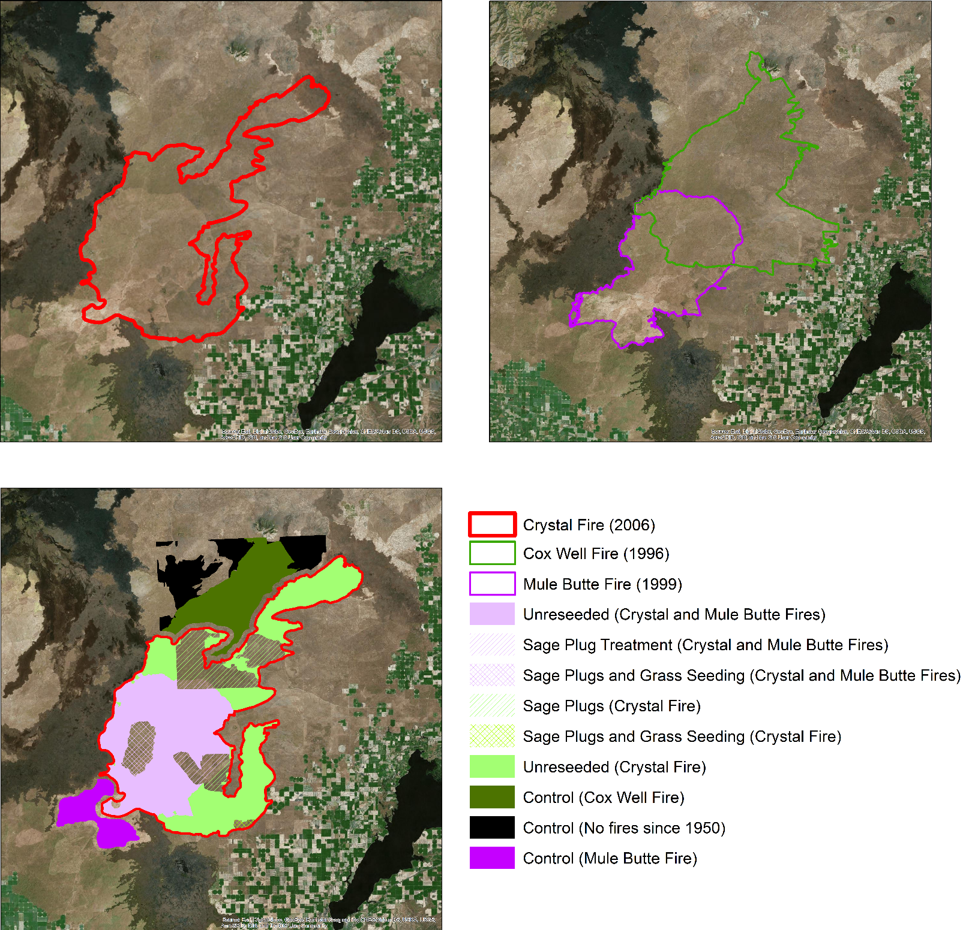**3.2.1 Post-Fire Recovery**

All raster images and data products derived from satellite imagery were clipped to the extent of the nine regions shown in Figure 1. To determine the effect of the Crystal fire on Idaho's Big Desert ecosystem, the area within the fire was divided into two regions; the part of the Crystal fire which also burned during the 1999 Mule Butte fire and the part that did not. Each is roughly half of the total area. This split was made in response to visible differences between the two regions, noticed during previous analyses that failed to show any trends in the data. Outside the Crystal fire three control groups were chosen: one that burned during the 1999 Mule Butte fire, another that burned during the 1996 Cox Well fire (which burned large portions of the Crystal fire area), and a third with no documented fires since 1950. The first two were chosen because they reflected similar conditions to the two major regions within the Crystal fire, and the no burn region was chosen to examine long term effects of fire on the landscape.

Crystal Fire (2006)

Cox Well Fire (1996)

Mule Butte Fire (1999)

Unreseeded (Crystal & Mule Butte Fires)

Sagebrush Plug treatment (Crystal & mule Butte Fires)

Sagebrush Plug and Grass Seeding (Crystal & Mule Butte Fires)

Sagebrush Plugs (Crystal Fire)

Sagebrush Plugs and Grass Seeding (Crystal & Mule Butte Fires)

Unreseeded (Crystal Fire)

Control (Cox Well Fire)

Control (No Fires since 1950)

Control (Mule Butte Fire)

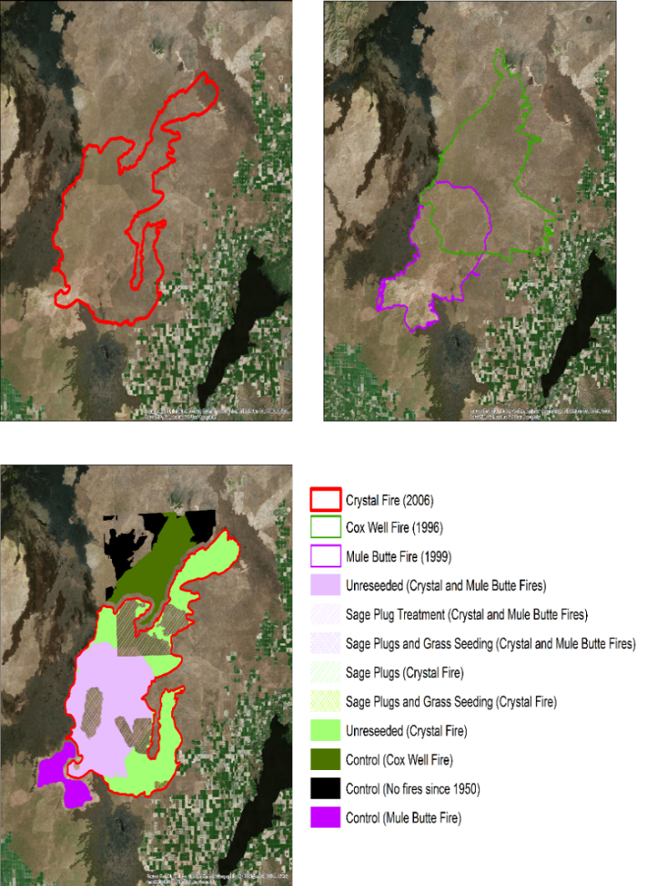

Kilometers

0

10

20

Source: Esri, DigitalGlobe, GeoEye, Earthstar Geographics, CNES/Airbus DS, USDA, USGS, AeroGRID, IGN, and the GIS User Community

Both Crystal fire regions contained some area that had received two broad styles of reseeding treatments. These treatments were sagebrush plugs and grass seeding. The exact reseeding strategy (drill type, grass type, etc.) used is unknown. Each fire history region within the Crystal fire area was further subdivided into three regions: one for each reseeding treatment and a third untreated area. All nine regions were utilized in each analysis.

*Figure 1*. Red, green, and purple outlines show each fire boundary. The nine shaded areas show each individual region of study.

Locally, cheatgrass’ greening periods take place earlier in the growing year when compared to native sagebrush-steppe vegetation, thus indicating potentially infested areas based on timing of green-up. Green-up was closely examined because cheatgrass germinate earlier than plants native to Idaho's sagebrush-steppe ecosystem. This enabled detection of cheatgrass as the areas dominated by the invasive grass produce higher NDVI values during the earlier parts of the growing season. This earlier green-up means the graphed data shows a peak in NDVI values during the early part of the growing season, and can also help predict where cheatgrass is located.

The overall phenology of the study areas was observed using *ForWarn* data products. Maximum NDVI and left 20% position data[1] from the *ForWarn* dataset, using the MODIS satellite, were used to look for this bimodality. These two data products were graphed for each of the nine treatment areas with the percentage of pixels experiencing maximum or early season 20% of maximum NDVI on each day of the growing season. When bimodality in vegetation growth was discerned within the growing season it acted as an indicator of cheatgrass infestation. These data were also used to establish thresholds for the timing of cheatgrass and native blooms within each year. Shifting toward earlier blooming is hypothesized to indicate increasing cheatgrass infestations in the post-fire ecosystem. Finally a third data product, the 16-Day L3 Global 250m (MOD13Q1) NDVI values (1) from the MODIS Terra satellite were used to graph the median NDVI over the 2001-2016 study period and the difference between median NDVI in the Crystal fire and control regions.

$\text{NDVI = }\frac{\text{NIR-RED}}{\text{NIR+RED}}$ (1)

A multilinear regression analysis within the TerrSet Geospatial Monitoring and Modeling System was used to test correlation between the determined independent variables and recovery of vegetation between 2006 and 2016. The significance (r2 values) of each variable were tested to determine which independent variables are important for driving recovery. Elevation, slope, aspect, distance from major roads, and years since previous fire were run as static variables, as these variables were a constant across the study period. Climatic variables such as yearly precipitation, maximum temperature, average temperature, and growing degree days were run separately as dynamic variables.

To prepare the data for linear regression analysis, raster data for all of the independent variables was re-projected to 1984 UTM Zone 12N (WGS 1984 Datum and Spheroid). These re-projected raster files were then resampled to approximately 30 meter pixel resolution, matching cell size values similar to SRTM elevation data. Data derived from the MODIS satellites including 16-Day NDVI (MOD13Q1) and the *ForWarn* phenology data products were also re-projected and resampled to the same specifications.

Available large-scale raster datasets of precipitation were found to vary significantly (>20 mm for all years) from locally measured values. To solve this, a network of seven local Cooperator Precipitation Gauges (Aberdeen, Arco, Blackfoot, Craters of the Moon, Fort Hall Indian Agency, Idaho Falls, and Pocatello Airport) managed by NOAA’s National Weather Service were used for precipitation data. The temperature readings were collected from six local weather stations: Pocatello Regional Airport, Blackfoot, Idaho Falls, Craters of the Moon, and Massacre Rocks State Park. The precipitation and temperature point datasets were interpolated with ordinary co-kriging to make sure that elevation was considered during the prediction process. Soil moisture was examined as a relative annual index because there were too many soil types to interpolate soil moisture across the study area.

Originally, Landsat 5 and Landsat 8 imagery were planned as the dependent variables of recovery. However, as Landsat lacked the temporal resolution of MODIS data, early season data were often unavailable for Landsat data due to heavy cloud cover during the appropriate dates. Additionally, Landsat 8 is known to record higher vegetation index values than Landsat 5, making it more difficult to draw a direct comparison of vegetation greenness using the two satellites. Thus, MODIS NDVI data was utilized for the dependent variable as it allowed a clear comparison throughout the study period and was able to detect early cheatgrass growth.

To assess change in vegetation greenness, maximum value NDVI products were used in conjunction with a proportion change index in which the proportion of NDVI values evident after the wildfire was compared on a per pixel basis to the average pre-fire maximum NDVI values from 2003 through 2005. This change value showed the similarity of maximum NDVI values present during each year after the fire, with a value of one equating to no difference between pre- and post-fire vegetation peak greenness conditions. The NDVI proportional change values (equation 2) were calculated for 3 year intervals for years 2007 through 2016. These values were then averaged across a rolling three year time period, starting with 2007, 2008, and 2009.

$\text{NDVI Proportional Change= }\frac{\text{NDVI Max Post-fire}}{\text{NDVI Max Pre-fire}}$ (2)

**3.2.3. Ecosystem Services: Carbon Sequestration**

In order to determine the change in total carbon storage post-fire recovery and its associated monetary value over time, a valuation formula (equation 3) was adopted from the Carbon Storage and Sequestration: Climate Regulation model within InVEST (Sharp et al. 2016). Carbon was estimated in above ground biomass and belowground biomass with two USGS LandCarbon products, the Biomass Carbon Stock and the Soil Organic Carbon Stock (Zhu et al. 2010). These products predicted baseline carbon storage and sequestration from Land-Use and Land-Cover mapping, the classifications for these maps closely follow the National Land Cover Database (NLCD).

The value of carbon sequestration over time for a given pixel x is:

${value}_{{seq}_{x}}=V\frac{{sequest}_{x}}{{yr}_{fut}-{yr}_{cur}}\sum_{t=0}^{{yr}_{fut}-{yr}_{cur}-1}{\frac{1}{{(1+\frac{r}{100})}^{t}{(1+\frac{c}{100})}^{t}}}$ (Sharp et al., 2016)(3)

Where *V* is the value of sequestered ton of carbon (a conservative $ 43.00 / ton of elemental carbon), *r* is the market discount rate or the reflected preference society has for immediate benefits over future benefits (7 %), and *c* is the annual rate of change in the price of carbon (set at 0 % to reflect the societal and political shifts of values).

# 4. Results & Discussion

***4.1. Post-fire Recovery***

The Crystal fire region was roughly separated into two major regions: 1) the area influenced by the Mule Butte fire of 1999, and 2) the remaining area that was unaffected by the Mule Butte fire. Even in 2006, prior to the Crystal fire, visible scarring remained from the Mule Butte fire, ending along a dirt road stretching from Mosby Well to Craters of the Moon National Monument in the northern Mule Butte fire boundary. Evidence of the Mule Butte burn scar persists even after the Crystal fire, suggesting that individual fires are not isolated events or that the second fire represented a "reset" on the landscape (Figure 2).

Image 2: ForWarn phenology data product image, reclassified to show peaking before and after day 140. This shows areas more likely to be cheatgrass as light green and native vegetation as dark green.

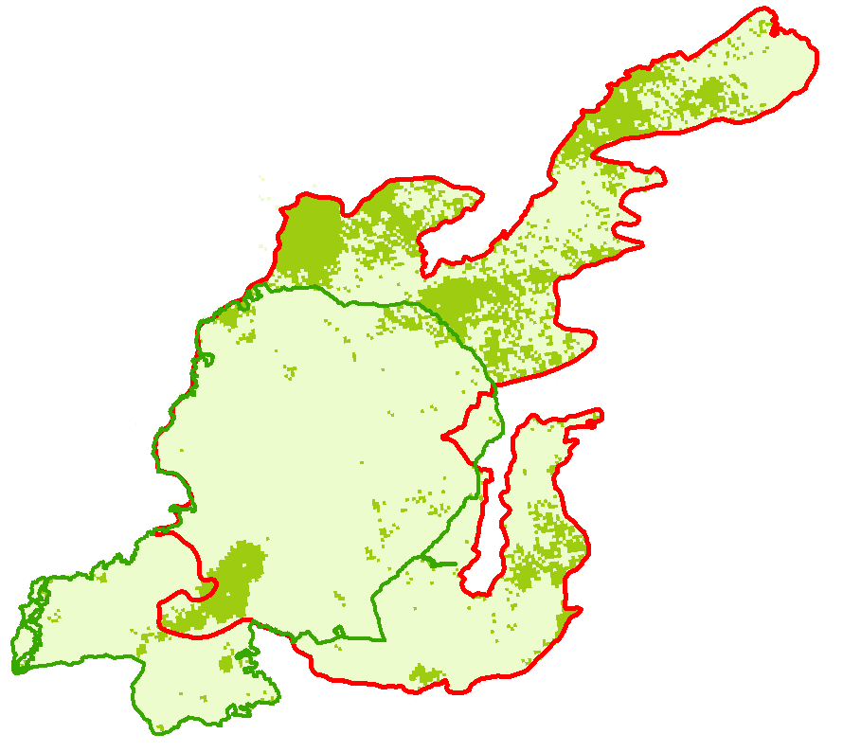

Peak NDVI before Day 140

Peak NDVI after Day 140

Crystal Fire Boundary

Mule Butte Fire Boundary

2013 *ForWarn*

Phenology



0

10

20

*Figure 2*. *ForWarn* phenology data was reclassified to detect peak NDVI before and after day 140 in 2013. Areas of likely high cheatgrass cover are in light green, while native vegetation is displayed as dark green.

Three control areas outside of the Crystal fire were chosen, including one that had not burned since 1950, one that last burned in the 1996 Cox Well fire, and one that burned in the 1999 Mule Butte fire. Within the Crystal fire a division was made between the area that burned in the Mule Butte fire, and the area that did not. These two areas were further subdivided by the reseeding treatments they had received during the Crystal fire recovery efforts. During the 2001 to 2006 growing seasons the median NDVI within the Mule Butte control area exceeded the Cox Well control area which exceeded the unburned control area. Figures 3 and 4 depict the Mule Butte control area experiencing green-up earlier in the growing season than the Cox Well control. Together these results suggest the Mule Butte fire area was experiencing a significant cheatgrass infestation prior to 2006.

*Figure 4*. The percentage of pixels that are experiencing 20% of peak NDVI for the year on a given day.



Mule Butte + Crystal Fires: Grass Seeding

No Burn Since 1950

Mule Butte + Crystal: Unreseeded

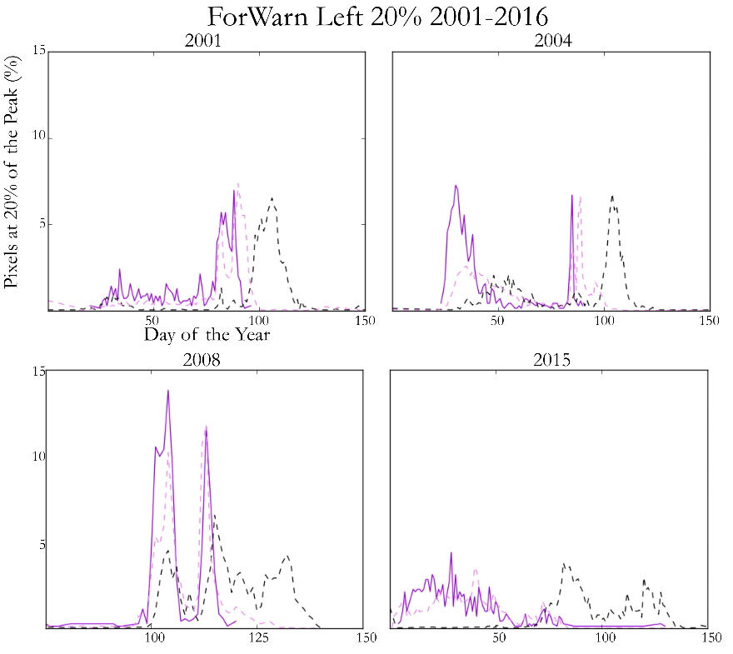

*Figure 3*. The percentage of pixels that are experiencing peak NDVI for the year on a given day.

Mule Butte: Unreseeded

Crystal Fire: Unreseeded

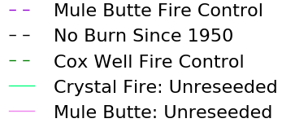

Mule Butte Fire Control

No Burn Since 1950

Cox Well Fire Control

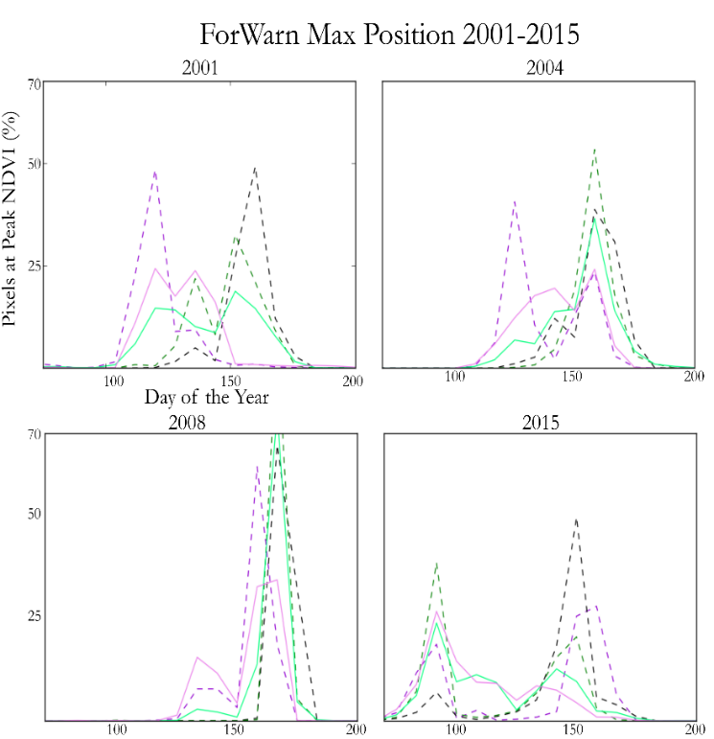

In Figure 5, the grass and sagebrush plug reseeding treatment did not appear to benefit biomass production (NDVI), with treated areas generally greening-up concurrently with their unreseeded counterparts. However, the success of the reseeding effort are unknown and therefore the concurrent growth may be the result of failed reseeding. The regions treated exclusively with sagebrush plugs similarly show little to no effect. Due to the slow growth of sagebrush, the plant may not be expected to fully grow back even a decade after the fire.

*Figure 5*. These graphs indicate the percentage of pixels that have achieved 20% of their maximum NDVI for that year for each day of the year over four selected years of the study period. Areas that received a grass reseeding treatment are compared with areas that received no treatment.

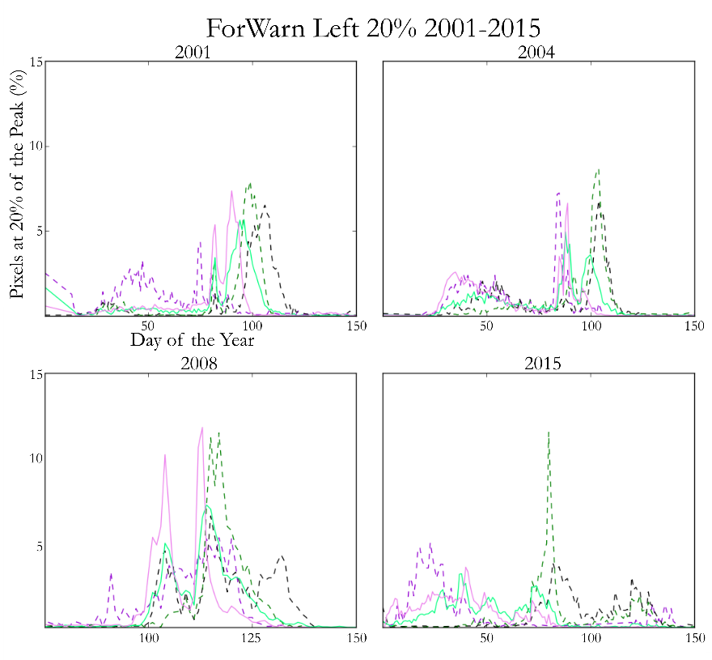

Mule Butte Fire Control



No Burn Since 1950

Cox Well Fire Control

Mule Butte: Unreseeded

Crystal Fire: Unreseeded

Some years did not show bimodal peaks, making it difficult to identify the earlier green-up of cheatgrass. In 2007, the year immediately following the fire, there was a single large peak in the maximum position data in every treatment region, including the no burn since 1950 control region. Interestingly the 20% green up data shows a distinct bimodal behavior in 2007, which it did not exhibit prior to the fire.

***4.2 Variables of Recovery***

Variables accessed during this term showed little correlation to the proportional recovery of vegetation within the Crystal fire. Static variables had less correlation to recovery than the dynamic/climatic variables (Table 1). This was expected as elevation changes within the study area are relatively small and gradual. Though not shown to be strongly correlated to recovery, slope variables almost always exhibited a negative correlation coefficient. This suggests that areas characterized by steep hill/mountain sides may have a negative impact on vegetation recovery following a wildfire.

Below is an example of the analyses performed on the variables (Table 1). This chart shows dynamic variable statistics for the entire Crystal fire area, the Crystal fire area where grass and sage plugs were planted, and the Crystal fire unseeded area. As shown below, the highest average was 0.29. This means that in the crystal-sage plugs, the variables we tested can only account, or predict, for about 29% of the vegetative productivity over the years tested. When looking at each variables’ individual predictability, the results were too low to rely on.

Table 1

Statistical analysis of dynamic variables are shown for each study area. This table shows the statistics of the adjusted R2 values, as determined for each time period.

|  |  |  |  |  |  |  |  |
| --- | --- | --- | --- | --- | --- | --- | --- |
| Crystal Wildfire Area | | Crystal Area with Grass/Sage Plugs | | Crystal Area Seeded with Sage | | Crystal Area Unseeded | |
| Mean | 0.26 | Mean | 0.28 | Mean | 0.3 | Mean | 0.22 |
| Standard Error | 0.03 | Standard Error | 0.07 | Standard Error | 0.02 | Standard Error | 0.04 |
| Median | 0.27 | Median | 0.2 | Median | 0.31 | Median | 0.25 |
| Standard Deviation | 0.1 | Standard Deviation | 0.18 | Standard Deviation | 0.06 | Standard Deviation | 0.11 |
| Sample Variance | 0.01 | Sample Variance | 0.03 | Sample Variance | 0 | Sample Variance | 0.01 |
| Kurtosis | -0.92 | Kurtosis | 2.51 | Kurtosis | 0 | Kurtosis | -1.13 |
| Skewness | -0.49 | Skewness | 1.62 | Skewness | -0.28 | Skewness | -0.61 |
| Range | 0.28 | Range | 0.55 | Range | 0.19 | Range | 0.27 |
| Minimum | 0.11 | Minimum | 0.11 | Minimum | 0.21 | Minimum | 0.07 |
| Maximum | 0.38 | Maximum | 0.67 | Maximum | 0.4 | Maximum | 0.34 |
| Sum | 2.05 | Sum | 2.2 | Sum | 2.43 | Sum | 1.57 |
| Count | 8 | Count | 8 | Count | 8 | Count | 7 |

Dynamic variables were found to have a consistently higher correlation when compared to static variables. This was demonstrated when yearly maximum temperature exhibited the highest correlation coefficient of any other independent variable, throughout most years. Maximum temperature was negatively correlated with wildfire recovery. In other words, the higher the maximum temperature, the lower the vegetation productivity. However, most variables were inconclusive to be considered a reliable predictor of recovery.

***4.3 Ecosystem Services: Carbon Sequestration***

Figure 6. Carbon Storage from 2000-2016 does not appear to be affected by fire disturbances.

The carbon (C) stock had increased storage from the years of 2003 to 2006, followed by stagnation until 2008, as shown in Figure 6. This could be the result of the Crystal fire and if so the results of the wildfire may not be long lasting when concerning C storage, since storage began to increase again two years post-Crystal fire. There was also a steady decrease of C storage from 2000 to 2003, which could be an effect of the Mule Butte fire. However, we do not have data that precludes other influences of C storage, therefore wildfires may not be the only factor affecting carbon sequestration. Overall, total C storage from 2000 to 2017 increased by 71.11 TgC (teragram of C) and the overall present value of C storage from past to current has a market value of $2,071,291,965.84, when valuation is calculated in US ton of C. The C stock datasets used in this analysis were estimates based on other datasets which will have affect the results of valuation and C storage, and therefore should be further discussed. For instance, the soil data is generalized because the C stock model used STATSGO. The above ground biomass was estimated from existing vegetation type maps created by the LANDFIRE database. LANDFIRE’s vegetation datasets are made with classification and regression trees using extensive field-referenced data and satellite imagery. In addition, the Century model included a higher carbon sequestration rate than other models, which would affect estimated C through time. Included in the model were disturbances, and therefore the Century model was able to account for loss of biomass. However, the percent loss of vegetation due to disturbances may not have been included in the datasets. The datasets could be improved with further explanation on how disturbance is accounted and increased soil details. These datasets are conservative in their C estimates and include field datasets located within the study area and therefore are ideal for a general C analysis.

***4.4 Future Work***

The second term of this project will complete analyses of sagebrush-steppe ecosystem recovery following the Jefferson, Henry’s Creek, and Soda wildfires. During the term, the Southern Idaho Disasters II team will use the methods and results developed during this initial term in order to detect recovery, cheatgrass progression, and important variables to recovery. This will include analyzing how the importance of these ecological variables differ depending on spatial location (i.e. supported ecosystem and aerial extent of the perimeter footprints). Additionally, the team can then identify when these disturbed habitats can once again support cattle husbandry and selected species habitats.

# 5. Conclusions

Analysis of the *ForWarn* MODIS NDVI phenology products revealed that areas within the Crystal fire showed an increased percentage in the total area that was experiencing early season peak NDVI. This is indicative of a sagebrush-steppe landscape that is being negatively impacted by cheatgrass. Throughout the study period there are substantial differences between the area within the Crystal fire and the no burn control, suggesting that a full recovery did not take place during the observed post fire period. The reseeded areas within the Crystal fire do not exhibit substantially different phenology than the untreated areas. This suggests that the reseeding treatments require more time to exhibit an impact, or that reseeding does not impact cheatgrass in the short term (i.e. observed post fire period).

Regression analysis of the Crystal wildfire study area did not effectively identify important variables of vegetation recovery within the study area. Though some minor trends could be observed, none of the independent variable combinations were able to accurately predict areas of high or low regeneration. Some of the lower than expected correlations may be due in part to the relative sparseness of weather station locations used to derive climatic variables. Though the regression analyses were ineffective in our study area, such analyses may result in a better correlation in areas with more topographic variability. The importance of these variables may change due to increased variation in elevation, road density, and fire frequency of the area. Further analysis of additional wildfire-affected areas is needed to determine if such suspected key variables can have a significant correlation with recovery metrics such as vegetation greenness after a fire.

# 6. Acknowledgments

The Southern Idaho Disasters team would like to thank Courtney Ohr, Pocatello's NASA DEVELOP Center Lead, for her overall project facilitation. An additional thanks to our partners: Karen Kraus, from the Bureau of Land Management; Dr. Patrick E. Clark, USDA Agricultural Research Service range scientist; Scott Bergen and Ryan Walker, Idaho Department of Fish and Game.

A special thanks to our Science advisor Keith Weber, ISU GIS Director and NASA RECOVER collaborator, for his shared knowledge of Idaho’s wildfire recovery programs and arid environment GIS application throughout the project.  Finally, thank you to the US Forest Service for providing the *ForWarn* MODIS NDVI phenology products that were heavily utilized in the project and the DEVELOP NPO for providing use of *ForWarn* data application advisor, Joseph Spruce, to assist in the project.

Any opinions, findings, and conclusions or recommendations expressed in this material are those of the author(s) and do not necessarily reflect the views of the National Aeronautics and Space Administration. This material is based upon work supported by NASA through contract NNL16AA05C and cooperative agreement NNX14AB60A.

# 7. Glossary

**Carbon sequestration** – The storage of carbon in biomass or soils, removing it from the atmosphere

**Dependent variable** – A variable or indices which can ideally be explained by other variables

**Husbandry** –The raising and breeding for livestock for the use of meat and dairy produce

**Earth observations** – Satellites and sensors that collect information about the Earth’s physical, chemical, and biological systems over space and time

**Independent variable** – A variable which does not depend on or is not explained by another variable

**Invasive Species** – Non-native organisms which prosper in the ecosystem due to ecological advantages not found in native species, while harming the health or prosperity of native species

**MODIS** – Moderate resolution Imaging Spectroradiometer

**NDVI** – Normalized Difference Vegetation Index

**RECOVER** – Rehabilitation Capability Convergence for Ecosystem Recovery

**Recovery** – The return/growth of native vegetation in an area after a wildfire has occurred, decreasing native vegetation cover

**Reseeding** – the placement of native seeds by land manager in attempt to re-establish native vegetation after wildfire event

**Sagebrush-Steppe** – A sparsely vegetation ecosystem composed of sagebrush and various grasses in semi-arid environments

**Wildfire regimes** – The combination of fire frequency, predictability, intensity, seasonality, and size characteristics of fire in a particular ecosystem

# 8. References

Blomberg, E. J., Sedinger, J. S., Atamian, M. T., & Nonne, D. V. (2012). Characteristics of climate and landscape disturbance influence the dynamics of greater sage-grouse populations. *Ecosphere, 3(*6), Article 55.

Bureau of Land Management (BLM). (2013) Fire History Polygon (DATASET). http://www.blm.gov/or/gis/data.php

Burt, J. E., Barber, G. M., & Rigby, D. L. (2009). *Elementary Statistics for Geographers* (3rd ed.). New York: Guildford Press.

Dahlgren, D. K., Thacker, E. T., & Messmer, T, A. (2015). What does a Sage-Grouse Eat? *USU Extension Fact Sheet.*

Davies, G.M., Bakker, J.D., Dettweiler-Robinson, E., Dunwiddie, P.W., Hall, S.A., Downs, J., & Evans, J. (2012). Trajectories of change in sagebrush steppe vegetation communities in relation to multiple wildfires. *Ecological Applications, 22*(5), 1562-1577.

Didan, K. (2015). MOD13Q1 MODIS/Terra Vegetation Indices 16-Day L3 Global 250m SIN Grid V006. NASA EOSDIS Land Processes DAAC. doi:10.5067/modis/mod13q1.006

Eiswerth, M. E. & Shonkwiler, S. J. (2006). Examining post-wildfire reseeding on arid rangeland: A multivariate tobit modelling approach. *Ecological Modelling 192*(1-2), 286-298.

Flerchinger, G.N. & Hardegree, S.P. (2004). Modelling near-surface soil temperature and moisture for germination response predictions of post-wildfire seedbeds, *Journal of Arid Environments, 59,* 369-385.

Hargrove, W. W., Spruce, J. P., Norman, S. P., Christie, W. M., Grulke, N., & Lee, D C. (2010). MODIS NDVI Forest Change Products 2000-2016. Accessed: 06/01/2017. https://forwarn.forestthreats.org/products/near-real-time

Knick, S. (1999). Requiem for a Sagebrush Ecosystem? *Northwest Science, 73*(1), 53-57.

Myneni, R., Knyazikhin, Y., & Park, T. (2015). MCD15A2H MODIS/Terra+Aqua Leaf Area Index/FPAR 8-day L4 Global 500m SIN Grid V006. NASA EOSDIS Land Processes DAAC.  
doi: 10.5067/MODIS/MCD15A2H.006

NASA JPL. (2013). NASA Shuttle Radar Topography Mission Global 1 arc second [Data set]. NASA EOSDIS Land Processes DAAC. doi: 10.5067/MEaSUREs/SRTM/SRTMGL1.003

Sharp, R., Tallis, H.T., Ricketts, T., Guerry, A.D., Wood, S.A., Chaplin-Kramer, R., Nelson, E., Ennaanay, D., Wolny, S., Olwero, N., Vigerstol, K., Pennington, D., Mendoza, G., Aukema, J., Foster, J., Forrest, J., Cameron, D., Arkema, K., Lonsdorf, E., Kennedy, C., Verutes, G., Kim, C.K., Guannel, G., Papenfus, M., Toft, J., Marsik, M., Bernhardt, J., Griffin, R., Glowinski, K., Chaumont, N., Perelman, A., Lacayo, M. Mandle, L., Hamel, P., Vogl, A.L., Rogers, L., Bierbower,W., Denu, D., and Douglass, J. 2016. InVEST +VERSION+ User’s Guide. The Natural Capital Project, Stanford University, University of Minnesota, The Nature Conservancy, and World Wildlife Fund.

Torrell, L. A., Rimbey, N. R., Tanaka, J. A., Taylor, D. T., Ritten, J.P., Foulke, T.K. (2014). Ranch-level Economic Impacts of Altering Grazing Policies on Federal Land to Protect the Greater Sage-Grouse. *University of Wyoming Extension, June 2014.*

Vicente-Serrano, S. M., Saz-Sánchez, M. A., & Cuadrat, J. M. (2014). Comparative analysis of interpolation methods in the middle Ebro Valley (Spain): Application to annual precipitation and temperatures. *Climate Research, 24*, 161-180.

Webster, R., & Oliver, M. A. (2007). Statistics in Practice. In *Geostatistics for environmental scientists* (2nd ed.). Chichester: Wiley.

Zhu, Zhiliang, ed., Bergamaschi, Brian, Bernknopf, Richard, Clow, David, Dye, Dennis, Faulkner, Stephen, Forney, William, Gleason, Robert, Hawbaker, Todd, Liu, Jinxun, Liu, Shuguang, Prisley, Stephen, Reed, Bradley, Reeves, Matthew, Rollins, Matthew, Sleeter, Benjamin, Sohl, Terry, Stackpoole, Sarah, Stehman, Stephen, Striegl, Robert, Wein, Anne, and Zhu, Zhiliang, 2010, A method for assessing carbon stocks, carbon sequestration, and greenhouse-gas fluxes in ecosystems of the United States under present conditions and future scenarios: U.S. Geological Survey Scientific Investigations Report 2010–5233, 188 p. (Available [from USGS](http://pubs.usgs.gov/sir/2010/5233/)).

# 9. Appendices

**A. Interpolation with Ordinary Kriging**

This section has been included as an in-depth explanation of kriging. Measured point data are utilized in a mathematical function to create a continuous prediction of data values; this is called interpolation (Burt, Barber, & Rigby, 2009). Common interpolation methods utilized for climate data include inverse distance weighting, kriging, and spline (Vicente-Serrano et al., 2003). Ordinary kriging is based on two assumptions. The first assumption is that the data can be continuous across a spatial extent. The second assumption is that the mean is unknown and therefore the prediction of unknown values cannot count on the mean (shown in Equation 3) (Webster & Oliver, 2007). This kriging process also relies on stationarity, meaning the distribution of the recorded precipitation has attributes which are assumed to be the same everywhere else.

$\hat{Z}\left(x_{0}\right)=\sum_{i=1}^{n}{λ_{i}z(x_{i})}$ (3)

With the assumptions that we do not know the mean and that the precipitation data are stationary; the weights of each known point can be furthered so that the variations across space can be used as more meaningful predictors for the unknown values. The rules for weighting are based upon the distance and surrounding values. For instance, points close by will have more weight than more distant ones; however these weights will change if the points are clustered or the distance at which points are correlated is great, than the weighting values will decrease for values located within a cluster or values which are closer to the unknown value (Webster & Oliver, 2007). Autocorrelation is found through a semivariogram model, this shows the spatial correlation structure within the data. As aforementioned the data weights are based upon the autocorrelation or more importantly the structure of the data.

**B. ForWarn NDVI Results**

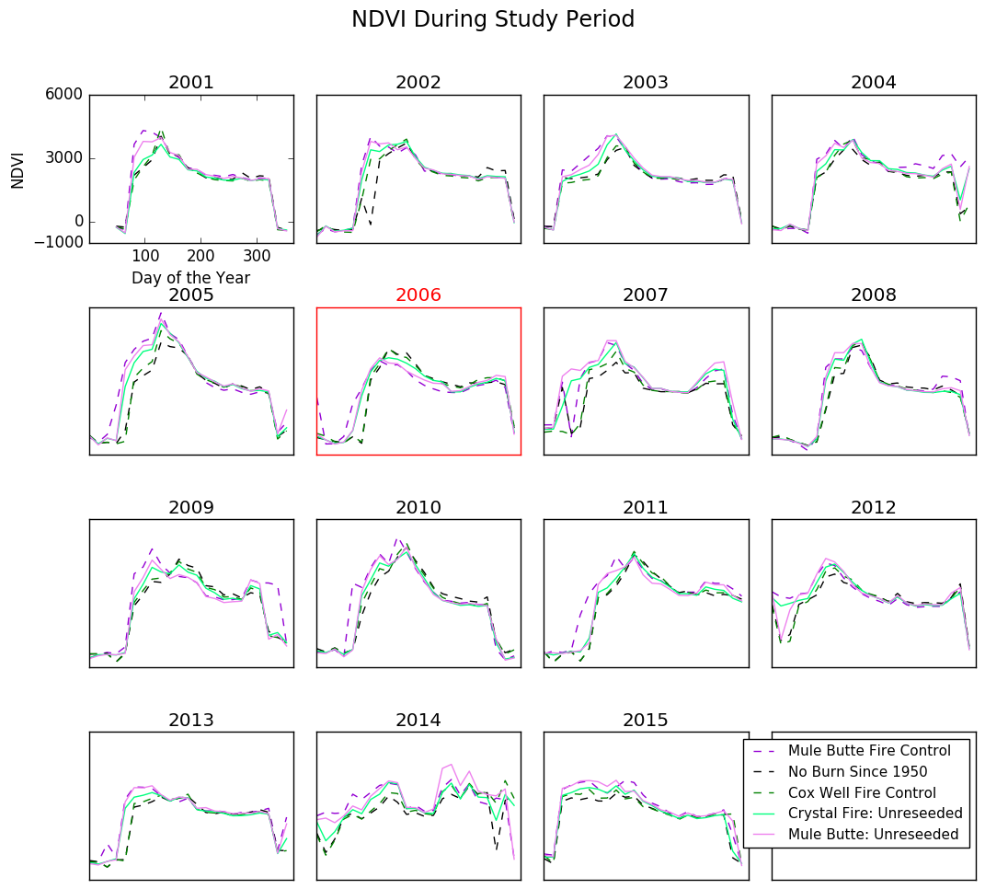*Figure B1.* NDVI over the entire year for each year of the study period. 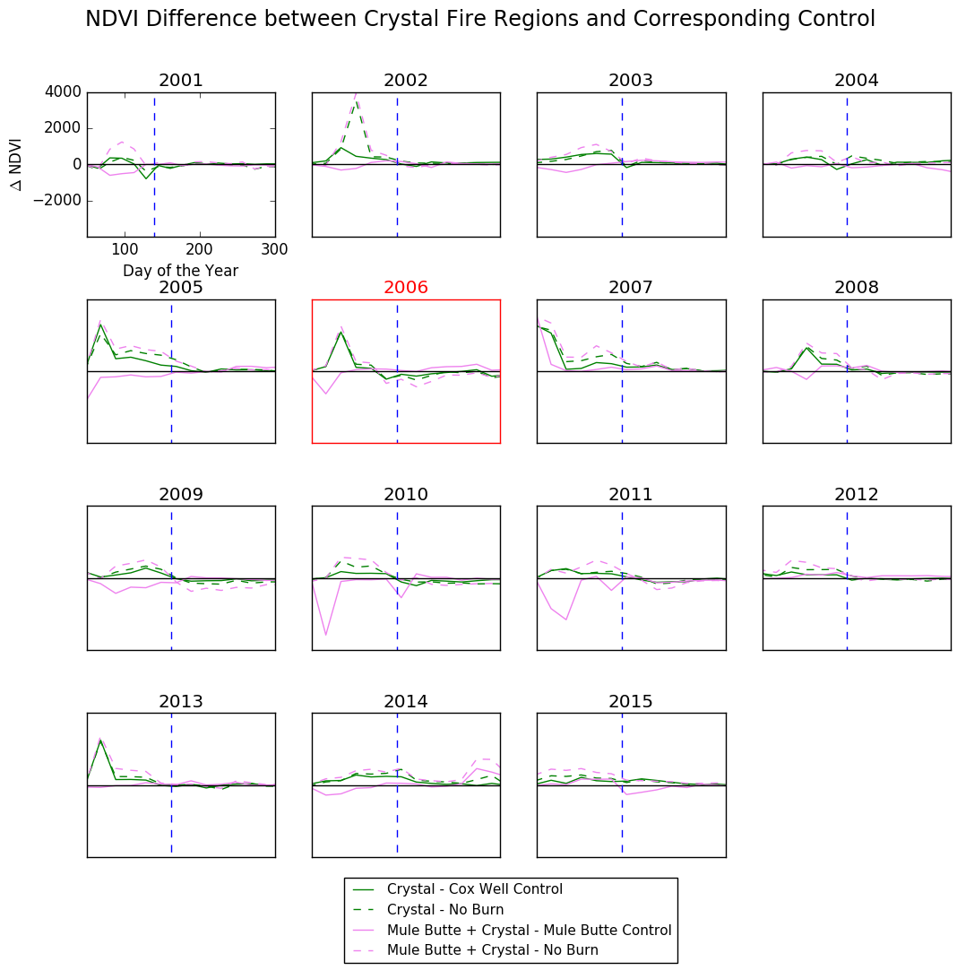*FiFigure.*

*Figure B2.* The NDVI from each of the two unseeded fire regions subtracted from their corresponding controls over the entire year, for each year of the study period. The horizontal black line represents the y=0 line. Points that fall on this line indicate no difference between the compared datasets. The vertical dashed blue line represents day 140, which divides the two peaks found in the Forwarn max position dataset. This is to give an indication regarding which peaking season was more influenced by the fire.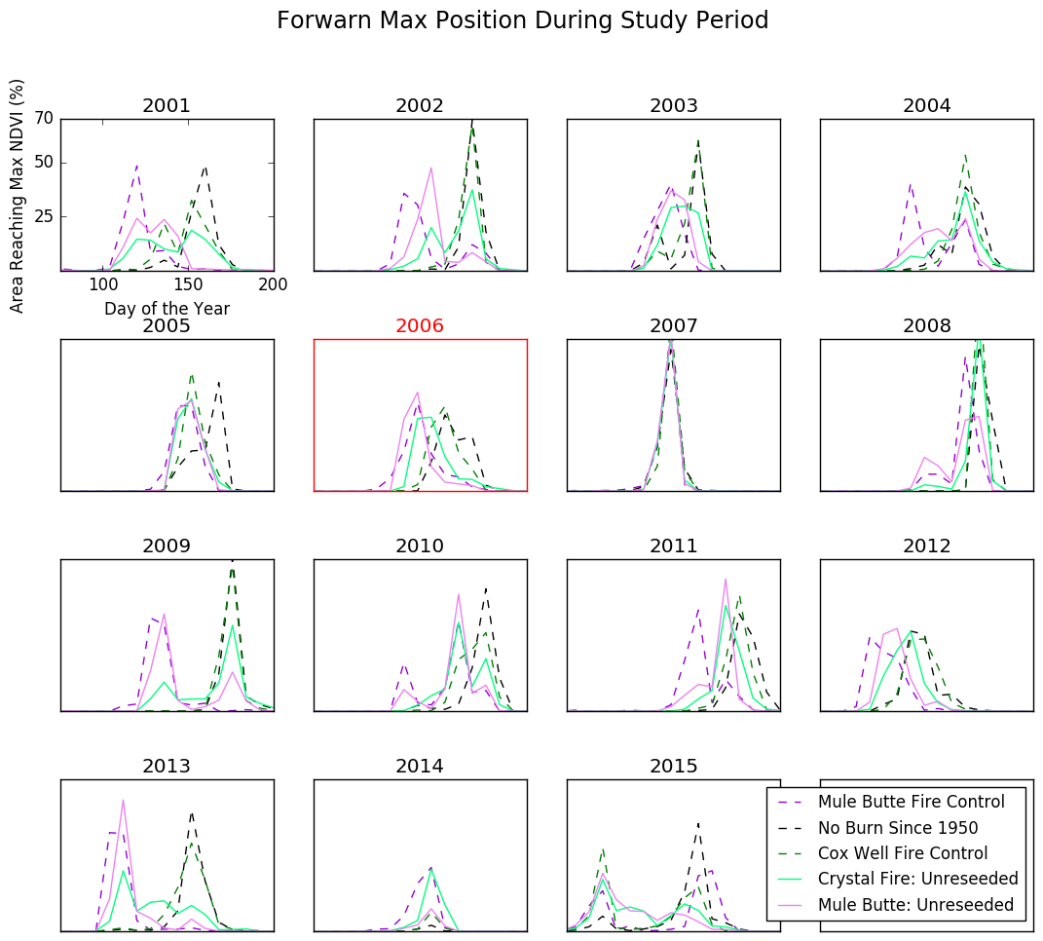 *Figure B3.* For all years of the study period the percentage of pixels that are experiencing an NDVI peak on a given day.

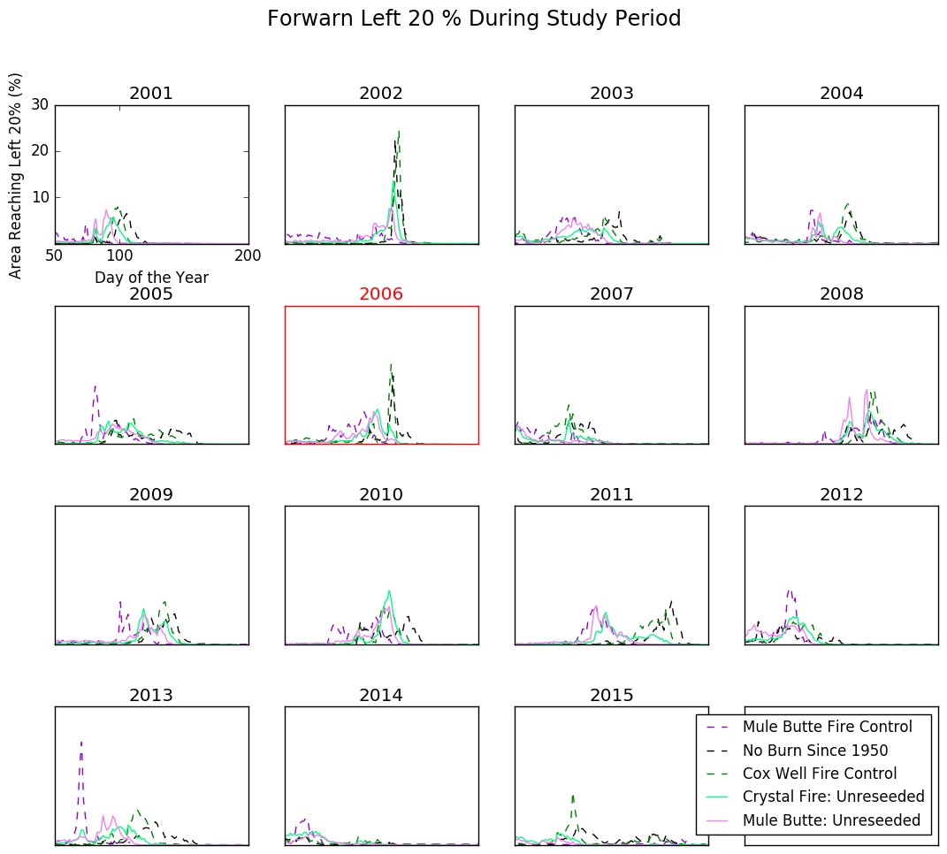

*Figure B4.* For all years of the study period the percentage of pixels that are experiencing 20% of their peak NDVI on a given day.

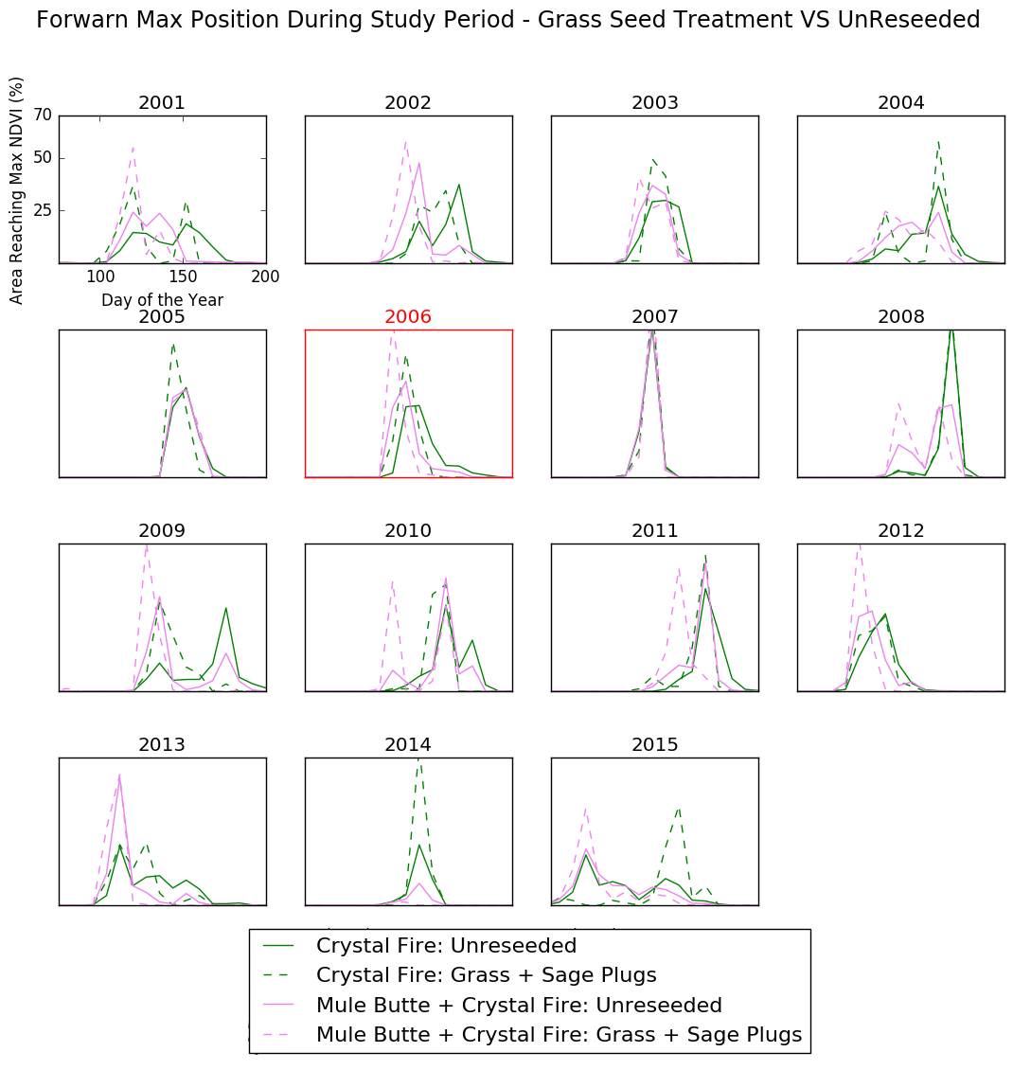

*Figure B5.* For all years of the study period the percentage of pixels that are experiencing their peak NDVI on a given day. In this graph, regions that received grass seed and sagebrush plug treatments are compared with the unreseeded areas.

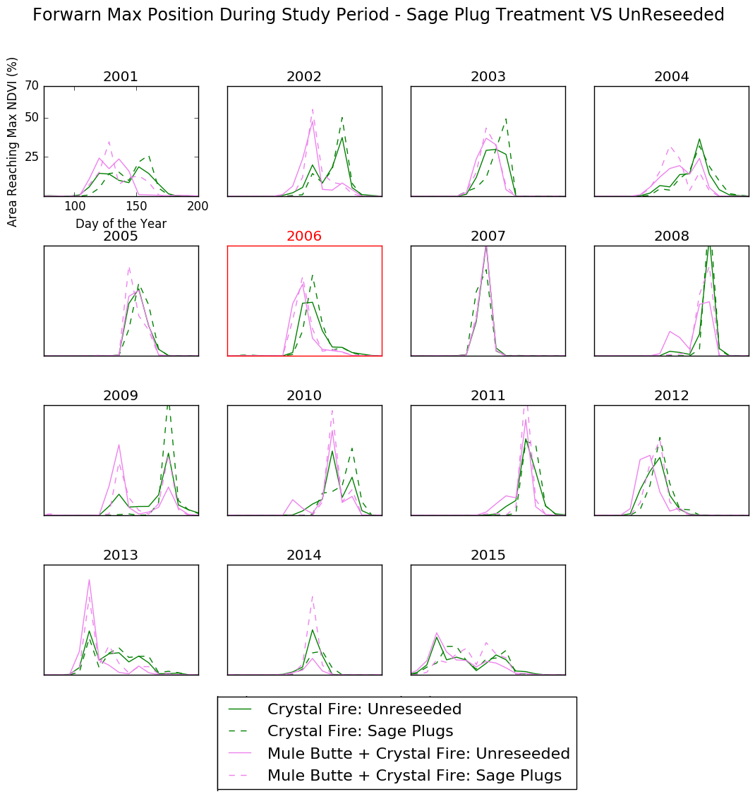 *Figure B6.* For all years of the study period the percentage of pixels that are experiencing their peak NDVI on a given day. In this graph, regions that received sagebrush plug treatments are compared with the unreseeded areas.

1. The *ForWarn* left 20% position product indicates the day of the year that each pixel achieved 20% of its maximum NDVI at the start of the growing season. It is primarily used to determine at what time of the year vegetation growth has started.