Talamanca-Osa Ecological Forecasting
Determining Habitat Suitability to Establish a Jaguar Corridor between the Talamanca Mountains and the Osa Peninsula in Costa Rica


Technical Report
Final Draft – April 4th, 2019

Hikari Murayama (Project Lead)
Brooke Bartlett
Ryan Palmer
Samuel Furey

Dr. Marguerite Madden (University of Georgia)
Steve Padgett-Vasquez (University of Georgia)

Abstract
Costa Rica houses many diverse environments, including La Amistad International Peace Park in the Talamanca Mountains and Corcovado National Park on the Osa Peninsula. Jaguars (Panthera onca) can be found throughout these two parks, but urbanization and agricultural development have fragmented habitats, isolating these populations. As a result, this apex predator and keystone species, is endangered throughout the country. NASA DEVELOP partnered with the Arizona Center for Nature Conservation – Phoenix Zoo and Osa Conservation to design a jaguar corridor between these two protected areas to connect isolated populations by linking habitat fragments, facilitating movement. This project used Landsat 5 Thematic Mapper (TM), Landsat 8 Operational Land Imager (OLI) and PlanetScope satellite imagery to assess historical vegetation health and classify current land use and land cover. Forecasting classifications to 2030 identified potential risk areas for agricultural expansion, increased development, preserved habitat fragments, and human-jaguar conflict. This land use trend analysis informed a suitability assessment for the implementation of a jaguar corridor.

Keywords
jaguar, corridor, Costa Rica, Osa Peninsula, land use change, Landsat, Normalized Difference Vegetation Index, Enhanced Vegetation Index

2. Introduction

  - Background Information
Costa Rica, a small, tropical country, only covers one-hundredth of a percent of Earth’s total mass, yet it is one of the most biologically diverse regions of the world, containing five percent of all living species (Sánchez-Azofeifa, Rivard, Calvo, & Moorthy, 2002). The southern Puntarenas Province shelters a vast number of ecosystems because of extreme elevation differences between the Caribbean and Pacific coasts and the resulting microclimates. Preserving these ecosystems is a matter of global importance since tropical deforestation, especially in mountainous regions, is the leading cause of biodiversity decline worldwide (Sánchez-Azofeifa et al., 2002). Between the early 1940s and 1980s, Costa Rica saw one of the highest tropical deforestation rates in the world (Sánchez-Azofeifa, Daily, Pfaff, & Busch, 2003), with a 42 percent deforestation rate and a 21 percent decrease in forest cover (Zahawi, Duran, & Kormann, 2015). By the late 1990s, deforestation rates in Costa Rica had slowed due to economic factors, reforestation, and conservation legislation. Since then, Costa Rica has become a pioneer in environmental policies, becoming one of the first countries to establish a Payment for Ecosystem Services (PES) program under Forest Law 7575. Although this helps restore vital habitats, the identification of high-risk areas, proper fund allocation, and increased monitoring are needed to enhance program effectiveness.

Protected areas are important tools for preserving wildlife habitats and maintaining biodiversity. Presently, 25 percent of the total land in Costa Rica has been set aside for national parks and reserves. Corcovado National Park (referenced as Corcovado from this point on) on Costa Rica’s Osa Peninsula is the only public conservation area on the peninsula and is also the only protected region of Tropical Wet forest on the Pacific slopes of Central America (Figure 1), including a significant number of endangered, threatened and potentially undiscovered species (Sánchez-Azofeifa et al., 2002). In the highlands above the Osa Peninsula is La Amistad International Peace Park (referenced as La Amistad from this point on), a United Nations Educational, Scientific and Cultural Organization (UNESCO) World Heritage Site (Figure 1). La Amistad contains diverse ecosystems and is the largest block of natural forest in Central America (UNESCO World Heritage Centre, 2019). Between these two parks resides Piedras Blancas National Park (referenced as Piedras Blancas from this point on) which was formerly part of Corcovado National Park until 1991 (Figure 1). The geographic location of Piedras Blancas makes it an ecological stepping stone for wildlife, creating a conducive environment for movement from one protected park to another (INOGO, 2015). However, the deforestation and habitat fragmentation surrounding these protected areas have turned them into isolated ecological islands, contributing to their vulnerability and limiting wildlife movement beyond park boundaries (Sanchez-Azofeifa et al., 2002).

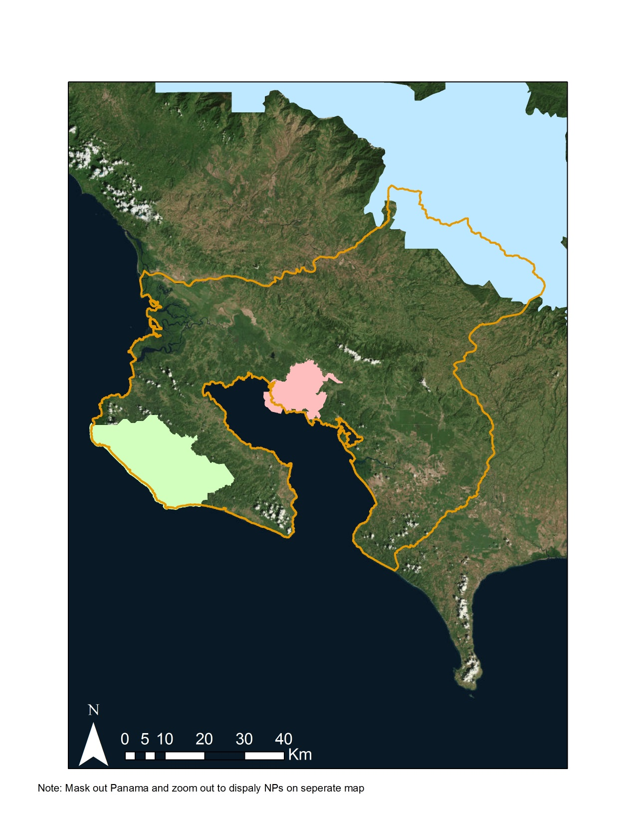
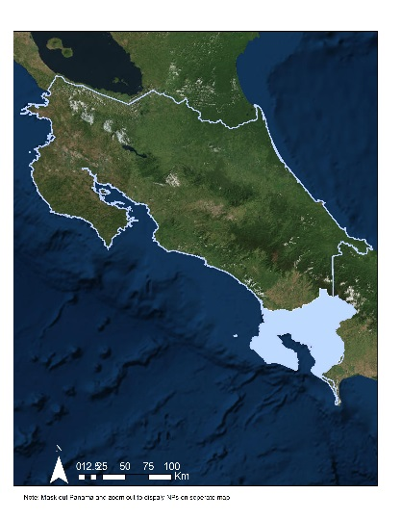




N
Costa Rica
0
km
10
20
30
40

Study area

Corcovado National Park

Piedras Blancas National Park

La Amistad National Park

Figure 1. The Study Area in the Southern Puntarenas Province of
Costa Rica within the Osa, Golfito, Coto Brus, and Corredores Districts

The jaguar (Panthera onca), an apex predator and keystone species, maintains forest ecosystem health by controlling populations of herbivorous species (Etse et al., 2011). Jaguars are highly adaptable and opportunistic, with a diet consisting of 85 species, ranging from birds to small mammals. (Quigley et al., 2017). Herbivores profoundly influence landscapes by altering forest floor plant allocation patterns, quality and quantity of leaf litter, and through compaction and excrement distribution. Predators, like the jaguar, reverse these effects through trophic cascades (Estes et al., 2011). However, jaguars are especially impacted by development and are endangered throughout Costa Rica (Quigley et al., 2017). Jaguar populations inhabiting La Amistad and the Corcovado National Park have become genetically isolated as individuals face several barriers to movement. This isolation has led to population decline and an increased likelihood of inbreeding (Thompson & Velilla, 2017). In conjunction with deforestation rates, jaguar populations are estimated to have declined by 20 to 25 percent between 2002 and 2015 (Quigley et al., 2017).

Habitat diminution has also caused prey species decline (Quigley et al., 2017). White-lipped peccary (Tayassu pecari) populations, a common prey for the jaguar, have been declining, with a 30 percent reduction in the past 18 years (Keuroghlian et al., 2013). This decrease in prey pushes jaguars to venture outside of their typical range in search of additional resources (Gese, Terletzky, Cavalcanti & Neale, 2018), increasing opportunities for livestock-jaguar and human-jaguar conflict (Quigley et al., 2017). Local cattle ranchers and farmers often mistakenly blame jaguars for livestock deaths and shoot jaguars to avoid future economic losses, placing many jaguars that venture into agricultural lands at risk of retaliatory hunting (Quigley et al., 2017). Designating a cohesive natural environment for jaguars to move through would limit human-jaguar conflicts and increase genetic diversity among these populations.

Wildlife corridors can link protected areas to act as habitat continuation, therefore maximizing gene flow and conserving biodiversity (Sanchez-Azofeifa et al., 2002). The proposed Talamanca-Osa corridor would designate priority areas for reforestation, PES and educational outreach efforts. A case study evaluating local support levels from landowners in Sonora, Mexico in relation to jaguar conservation illustrated that strategic economic incentives can deter farmers from retaliatory hunting (Rosas-Rosas & Valdez, 2010). In Belize, clear policies, consistent communication with locals, and protected areas have been shown to be the driving components towards jaguar conservation (Steinberg, 2016). These components can be used to help establish a corridor to aid in jaguar movement between isolated regions. The Calakmul-Laguna de Términos corridor in Mexico has aided in jaguar conservation by increasing movement and has shown the functionality of the corridor and its possible expansion (Hidalgo-Mihart, Contreras-Moreno, Cruz & Juárez-López, 2017). In order to inform efforts to design a jaguar corridor between Corcovado and La Amistad, NASA DEVELOP partnered with Arizona Center for Nature Conservation and Osa Conservation.

  - Project Partners & Objectives
NASA DEVELOP collaborated with the Arizona Center for Nature Conservation and Osa Conservation, two non-profit organizations who share a common goal of protecting biodiversity and ecosystem health in the southern Puntarenas Province of Costa Rica. The Arizona Center for Nature Conservation has been focusing on jaguar preservation by using field monitoring methods, educational outreach and promoting wildlife-friendly agriculture. Osa Conservation has worked in the Osa Peninsula region since 2003, protecting the area through ecosystem monitoring, habitat restoration, outreach, and wildlife protection, including the Healthy Rivers program, an initiative that focuses on restoring riparian areas, which are core habitats for jaguars (Quigley et al., 2017).

Both organizations are working alongside other non-profit organizations such as the National University of Costa Rica (UNA) and ProCAT that have established a jaguar monitoring program in Costa Rica through the use of a Camera Trap Network. The organizations use images from these camera traps in conjunction with ground survey data to monitor jaguar population density and distribution. Both partners have used basic geospatial analysis techniques, but they are limited in their remote sensing capabilities as a consequence of software, hardware and expertise restrictions and therefore, are unable to perform advanced imaging analysis. The use of NASA Earth observations can benefit the organizations by systemizing land use classifications and vegetation health forecasting to determine plausible locations for corridors.

The project assessed vegetation health over time, classified land use and land cover for 2018 through 2019 and used forecasting to predict land use and land cover to 2030 to begin the process of designating a jaguar corridor that allows for species movement while limiting human-jaguar conflicts. With expert input provided by our two partner organizations, the study area for the jaguar corridor was determined based on the number of fragmented forests between La Amistad and Corcovado, the delineation of watersheds in the area between the parks, physical barriers such as the Inter-American Highway and the national border. Osa Conservation and the Arizona Center for Nature Conservation will use these results internally, in order to come to an informed decision on implementation of a corridor. They will use corridor models and updated land use and land cover classifications in their collaborative effort to establish a jaguar corridor between La Amistad and Corcovado in order to reduce human-jaguar conflict, especially in upland agricultural areas. Osa Conservation will also use these classifications to delineate priority watersheds and to further assess the effectiveness of Forest Law 7575 of 1996 on riparian deforestation and reforestation.

3. Methodology

3.1 Data Acquisition
Our team used the Google Earth Engine (GEE) API to collect and process Surface Reflectance Tier 1 Landsat 5 Thematic Mapper (TM) and Landsat 8 Operational Land Imager (OLI) data. Landsat 5 TM was used for 1987 and 1997, while Landsat 8 OLI was used for 2017 through March 2019. Additionally, we used high temporal (daily) and spatial resolution (3 meter) PlanetScope imagery to analyze critical regions in more detail. Collectively, the data from these sensors allowed us to evaluate vegetation health by utilizing the Normalized Difference Vegetation Index (NDVI) and the Enhanced Vegetation Index (EVI). Additionally, the data from these sensors gave us the ability to investigate land use and land cover changes (Figure 2). We also used topographic information from Advanced Land Observing Satellite Digital Surface Model (ALOS DSM) to classify land use and land cover with increased accuracy.

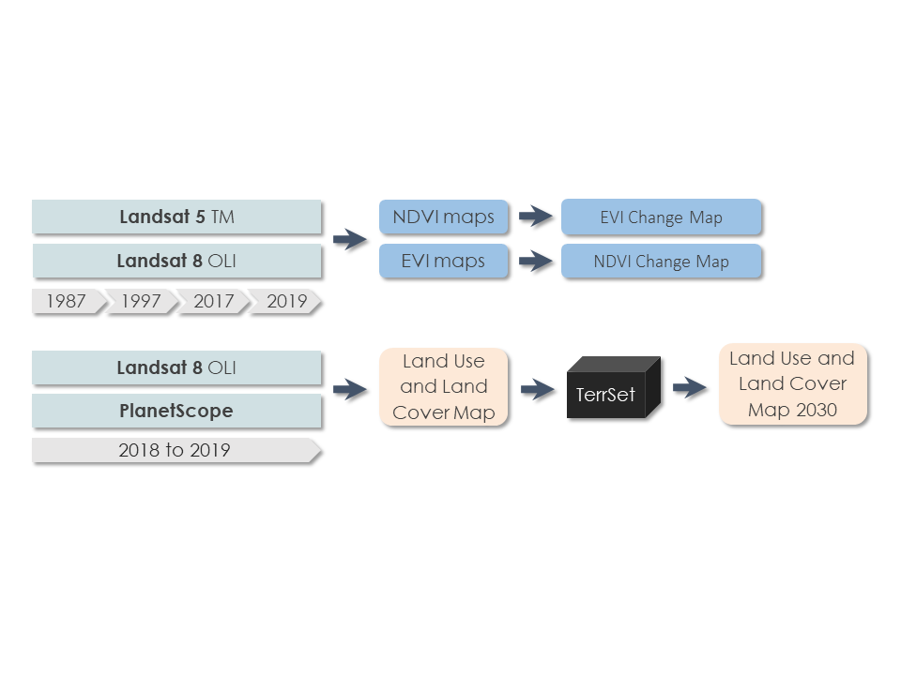
Figure 2. Overview of Project Methodology

To verify our classifications, we also downloaded 2012 RapidEye land use and land cover classification files from Iniciativa Osa y Golfito (INOGO) and a 2012 GeoEye forest cover classification map from Gesellschaft für Internationale Zusammenarbeit (GIZ). The high spatial resolution (5 meter) of these datasets made them extremely useful for assessing classification accuracy.

Using the 2008 and 2014 Digital Atlas of Costa Rica, we downloaded regional data for boundaries, protected lands, roads, rivers, watersheds, habitat fragments, and population distribution. These data were used in conjunction with regional national park shapefiles to delineate our study area.

3.2 Data Processing
Using Google Earth Engine, Landsat 5 Tier 1 bands 1, 3, and 4 were selected for 1987 and 1997, while Landsat 8 Tier 1 bands 2, 4, and 5 were selected for 2017 through March 2019. Specific wavelengths for these bands are specified in Appendix A. Since the study area is in a tropical region with frequent cloud cover, we used the quality assurance band (pixel_qa) to remove clouds and cloud shadows from the imagery. Data gaps resulting from the cloud masking process were filled in by taking the greenest value for each pixel in a year-long image collection. The greenest pixel function we used employs NDVI to capture plants at their greenest point, maximizing differences in land cover classes. After applying quality assurance and the greenest pixel function to each year of interest, bands 3 and 4 from Landsat 5 and bands 4 and 5 from Landsat 8 were used to calculate NDVI (Equation 1); Bands 1, 3 and 4 from Landsat 5 and bands 2, 4 and 5 from Landsat 8 were used to calculate EVI (Equation 2). We used the results of the NDVI and EVI calculations to evaluate vegetation distribution and health over time.
$\text{NDVI = }\frac{\text{NIR - Red}}{\text{NIR + Red}}$ (1)

$\text{EVI = 2.5 ×}\frac{\text{NIR - Red}}{\text{NIR + 6 × Red - 7.5 × Blue + 1}}$ (2)

We also calculated Normalized Difference Built Index (NDBI), Normalized Difference Moisture Index (NDMI), Normalized Difference Water Index (NDWI), Tasseled Cap Brightness (TCB), Tasseled Cap Greenness (TCG), Tasseled Cap Wetness (TCW), and Gray-Level Co-occurrence Matrix (GLCM) for our land use and land cover classifications. The equations for these calculations can be found in Appendix B.

3.3 Data Analysis
To investigate vegetation changes, we analyzed NDVI and EVI from January 1987 to March 2019. We compared vegetation index maps for 1987, 1997, 2017 and 2018 through 2019 to identify the effects of Forest Law 7575 and inform our forecasting model with historical trends. To better understand shifts in vegetation over the past 33 years, we also created change maps for both vegetation indices.

To identify vital land cover classes and assess jaguar habitat suitability, we used various bands from Landsat 8 (B1 through B9) to create a land use and land cover map for 2018 through 2019. To further differentiate between vegetation types, we also utilized additional calculated parameters (NDVI, EVI, NDBI, NDMI, NDWI, TCB, TCG, TCW, and GLCM) in conjunction with slope and aspect data from ALOS. We also trained our algorithm utilizing ground truth data points to identify parameter values for each class. Using an 80/20 split for training and validating, respectively, we applied the Random Forest 100 decision algorithm (Breiman, 2001) to ingest class-specific data to classify land usage across the study area. To determine accuracy, a confusion matrix was set up to output a kappa coefficient. We further increased classification accuracy by conducting elevation cut-offs for particular classes, as some land cover types were restricted to a certain range (Appendix C). In addition to our vegetation health analysis and land use and land cover classification, we created a forecasting tutorial for TerrSet for future work on the project to further assist our partners in anticipating potential barriers that may or may not impact the ability to implement a jaguar corridor within the study area.

4. Results & Discussion

4.1 Analysis of Results
NDVI time series maps for 1987, 1997, 2017, and 2018 through 2019 were the initial products that we used to analyze vegetation health in our study region. However, noticeable oversaturation was observed, especially in heavily vegetated areas in the Talamanca Mountains and on the Osa Peninsula (Figure 3). Because of this oversaturation, we also created EVI time series maps for the same years (Figure 4). These maps allowed us to verify our results and better assess vegetation trends in heavily vegetated areas. There was a noticeable difference between the NDVI and EVI maps in terms of oversaturation, as EVI values were less extreme in the aforementioned Talamanca and Osa Peninsula regions.
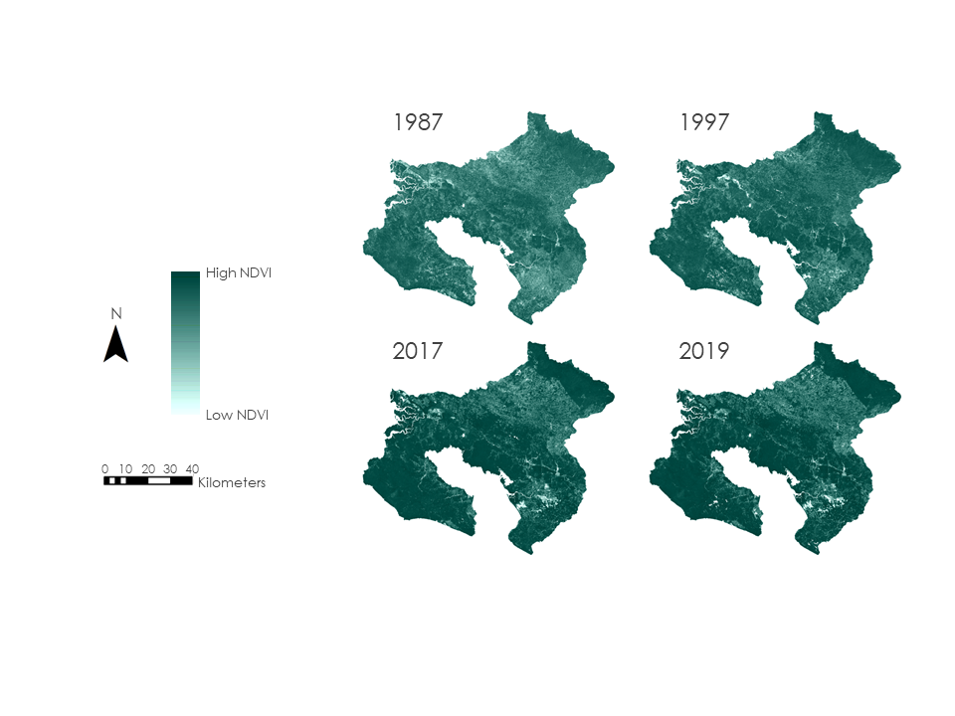
Figure 3. NDVI maps for 1987, 1997, 2017 and 2018 through 2019. High vegetation values are shown in dark green.

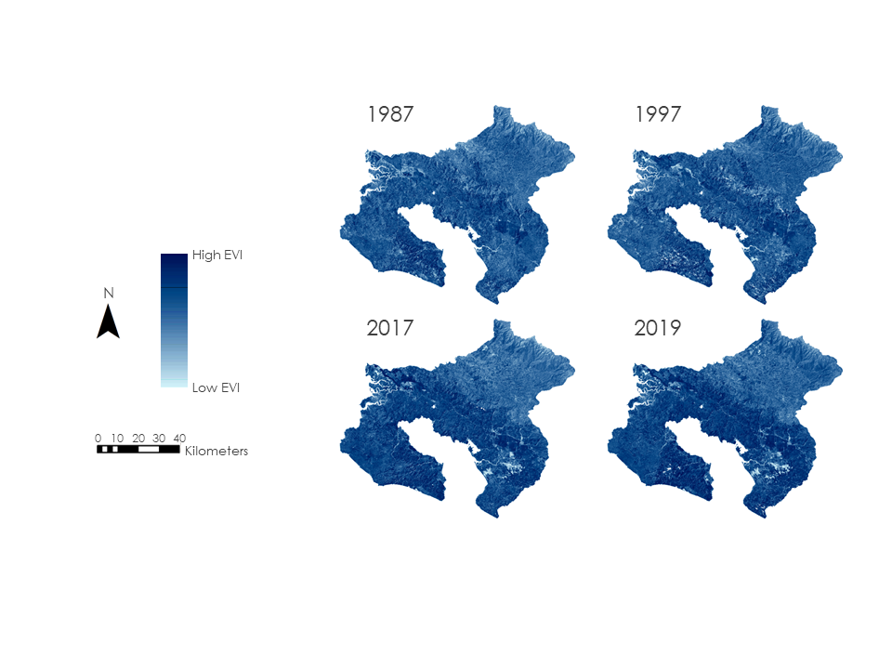
Figure 4. EVI maps for 1987, 1997, 2017 and 2018 through 2019. High vegetation values are shown in dark blue.

Both NDVI and EVI exhibited similar patterns in vegetation health. There was a general increase in vegetation for our study area, with a 17.62 percent rise in NDVI and a 6.84 percent rise in EVI between January 1987 and March 2019. To further examine how NDVI and EVI differed in their estimations of vegetation health, we produced a graph of annual median greenest pixel values for both indices (Figure 5). For NDVI, this graph shows a moderately strong trend of increasing vegetation over time, while for EVI, it shows a more modest upward trend. It is also important to note that the median NDVI values come close to the maximum possible value of 1.0, especially in later years, and that they remain consistently higher than their EVI counterparts. This further illustrates the tendency of NDVI to oversaturate and the ability of EVI to avoid oversaturation.

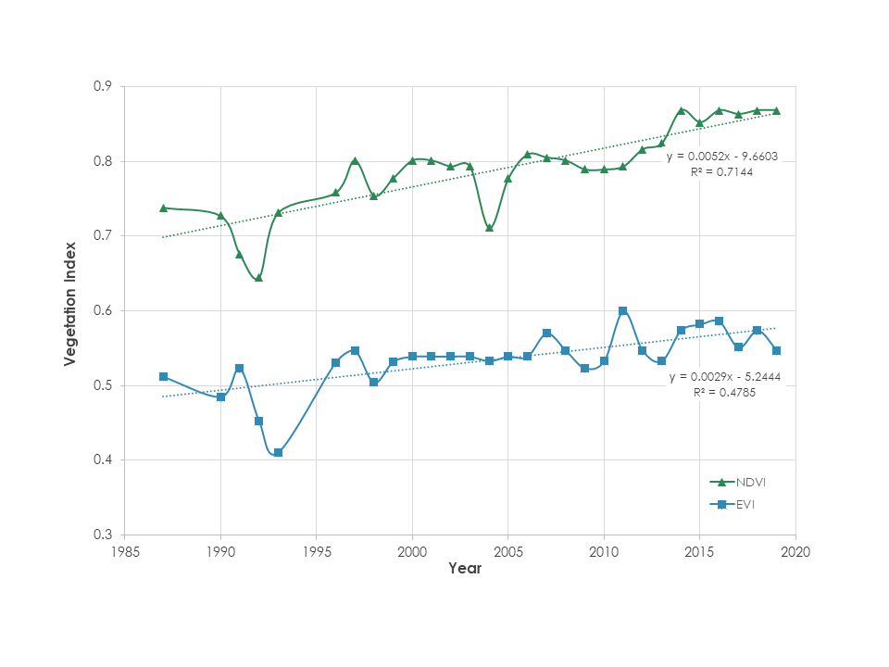
Figure 5. Annual EVI (blue) and NDVI (green) median greenest pixel over time

To gain a better understanding of 33 years of vegetation health trends, 1987 to 2018 through 2019 change maps for NDVI and EVI were created as well. Analysis of these maps revealed a sharp gain in vegetation east of Terraba Sierpe, in the northwestern portion of the study area, and a sharp loss in vegetation in the southeastern portion of the study area. The majority of the Osa Peninsula region, including Corcovado National Park, showed an overall rise in vegetation as well (Figure 6). Collectively, the protected areas of Corcovado, Piedras Blancas, and La Amistad National Parks experienced a 12.91 percent increase in EVI. However, some lands outside of these protected areas experienced decreases in vegetation, particularly a large region spanning much of the northeastern portion of the study area (Figure 7). A subset of this region, stretching from the mountains northeast of Piedras Blancas National Park to the border of La Amistad National Park (Appendix D), showed a 6.25 percent decrease in EVI. This negative trend in vegetation is notable because it applies to a part of the study area that will be especially crucial for the development of a jaguar corridor.
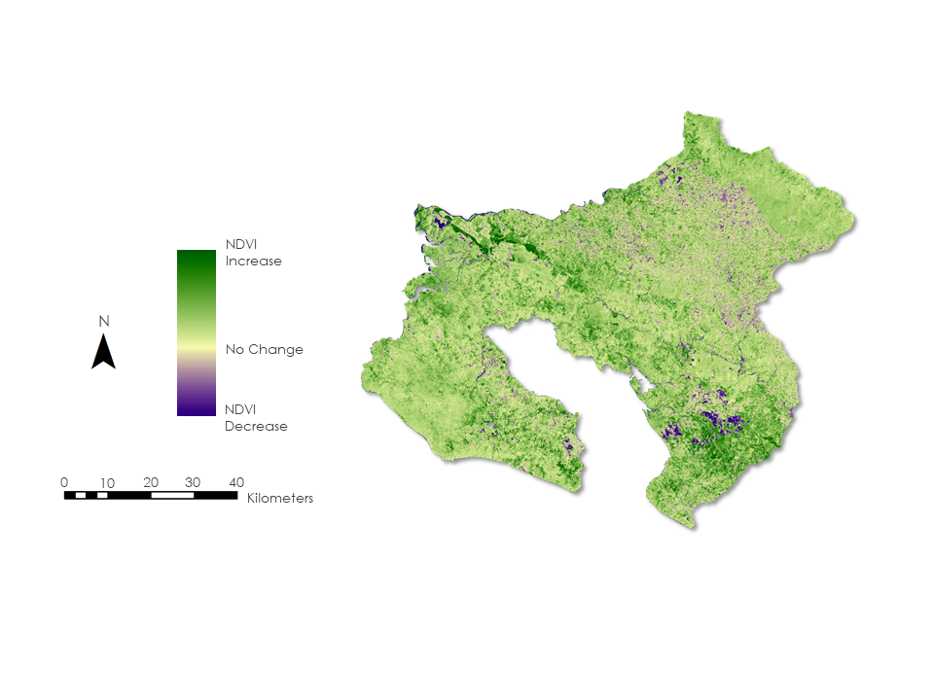
Figure 6. Change in NDVI between 1987 and 2018 to 2019. Areas in green reflect increases in vegetation while purple reflects decreases in vegetation

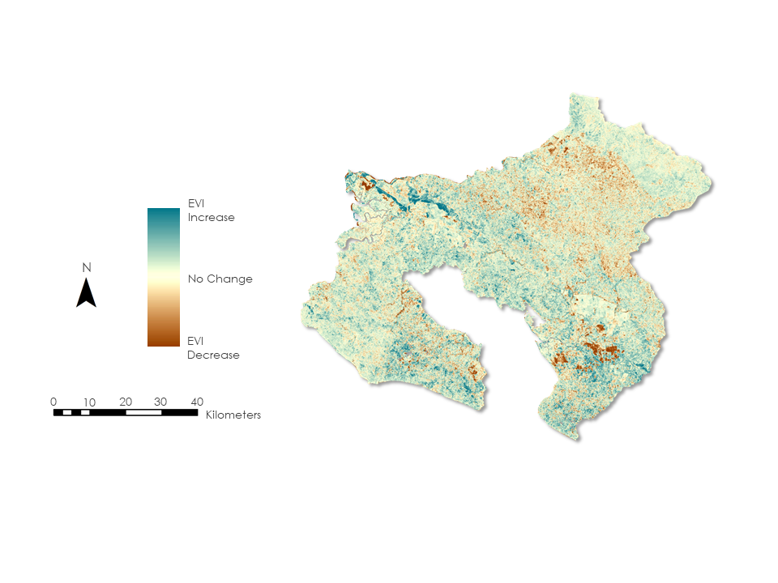
Figure 7. Change EVI between 1987 and 2018 to 2019. Areas in blue reflect increases in vegetation while brown reflects decreases in vegetation.

Our land use and land cover classifications confirmed our NDVI and EVI analyses, with an overall upward trend in vegetation density over time and the largest areas of increase occurring around protected areas. Secondary forests increased within protected areas, while secondary and old growth forests declined outside of these areas, particularly in the southeastern region of our study area where urbanization and exposed soil rapidly expanded (Figure 8). There was a slight rise in the number of melina and teak plantations, but this plateaued as they were replaced with African oil palm plantations. The number of oil palm plantations also rapidly increased along the Inter-American Highway, which may account for the sharp increase in EVI east of the Terraba Sierpe Wetlands (Figure 7) and highlights the need for conservation in the Osa Region. Between La Amistad and Piedras Blancas National Parks, habitat fragmentation and agriculture increased, while forest cover decreased as a result of a gradual rise in coffee and grasslands or pastures. Pineapple plantations also appeared in the northern region, below the Talamanca Mountains (Figure 8).
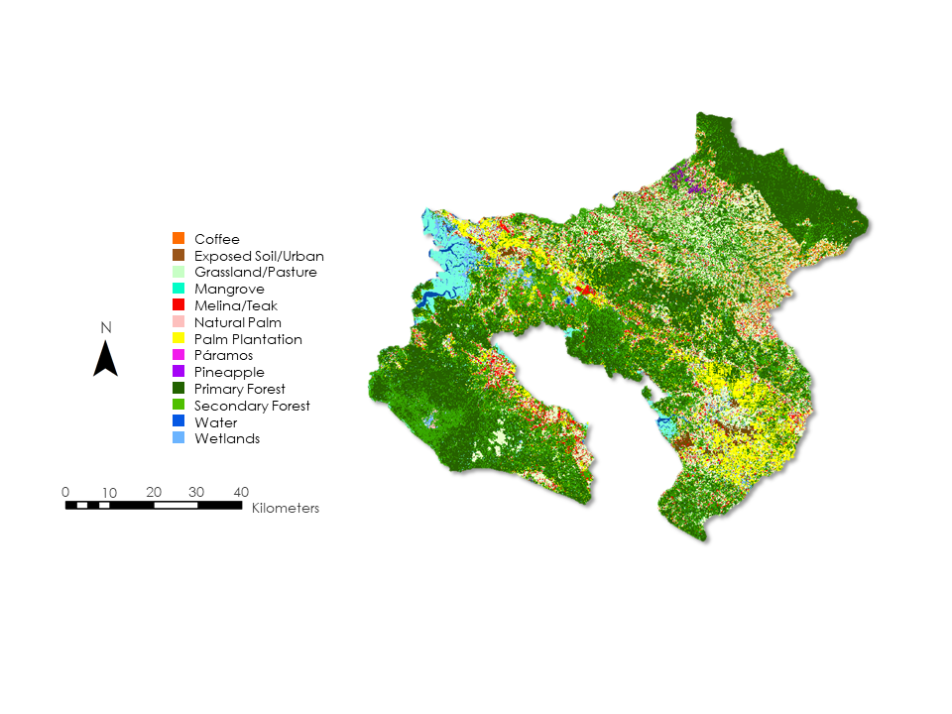
Figure 8. 2018 through 2019 land use and land cover classification
Grasslands and pastures, as well as oil palm plantations, saw the most prevalent increase of all the land use and land cover types. Our 2018 through 2019 analysis showed grasslands and oil palm plantations respectively making up 16.54 percent and 8.99 percent of land cover throughout the study area (Table 1). The other non-natural classes combined only constituted 8.73 percent of land cover, with exposed soil and urbanization at 2.46 percent, coffee at 1.71 percent, melina and teak at 4.24 percent, and pineapple at 0.32 percent cover. Palm plantations and pineapple act as the prominent barriers to jaguar movement due to their linear rows and lack of brush (Appendix E). Despite agricultural and urban expansion, natural land cover classes constitute 65.75 percent of the study area (Table 1), with the majority of these cover types occurring in protected areas. Some secondary forests may have been misclassified as old growth forests, but both classes provide ample cover and habitats for jaguars.

Table 1. 2018 through 2019 land use and land cover percentages of the study area by class
Class | Description | Percent of study area
1 | Palm Plantation | 8.99%
2 | Mangrove | 2.83%
3 | Water | 0.84%
4 | Grassland/Pasture | 16.54%
5 | Exposed Soil/Urban | 2.46%
6 | Old Growth Forest | 31.86%
7 | Secondary Forest | 27.11%
8 | Wetland | 3.03%
9 | Coffee | 1.71%
10 | Melina/Teak | 4.24%
11 | Natural Palm | 0.07%
12 | Paramos | 0.01%
13 | Pineapple | 0.32%

4.2 Future Work
The second iteration of the project will forecast land use and land cover changes to 2030 using the geospatial modeler TerrSet’s Land Change Modeler (LCM). Using the transition potential modeling as a basis, the model feeds in historical land cover layers and team-designated possible landscape change factors, such as road proximity. The model uses a combination of logistic regression, K-nearest neighbor (KNN) and a multi-layer perceptron (MLP) neural network to identify factor correlations. The LCM itself uses Markov Chain analysis to predict the quantity of change to output a land allocation model (Clark Labs, 2018). Outside factors such as reservation areas, infrastructure changes, and urbanization are recommended to include in this analysis to further inform the model. We created a TerrSet tutorial for Talamanca-Osa II which outlines proposed methodologies for forecasting.

In addition, based on partner feedback and expertise, the next term will model potential jaguar corridors to help inform the partner organizations as they attempt to narrow the focus of their restoration efforts. Using CIRCUITSCAPE and Linkage Mapper, the team will be able to assess model input parameters and identify the best path between La Amistad International Peace Park and Corcovado National Parks. These proposed habitat regions will be overlaid with current jaguar location data from the Arizona Center for Nature Conservation and Osa Conservation network of camera traps for the entire study area. The conjunction of these potential habitat regions and current habitats will further inform our partners about the feasibility of the corridor.

Additional work can also be conducted to refine our current land use and land cover classifications. Instead of solely using Landsat 8 data to classify 2018 through 2019 land use and land cover, Sentinel-2, which is also available on Google Earth Engine, can be composited to fill in regions that lack data due to cloud cover. 2007 maps from Landsat 7 data could also be created using available banding algorithms. Moreover, additional training data for the classification algorithms and additional comparisons to other land classification datasets will help increase the certainty of classification accuracy.

5. Conclusions

Our NDVI vegetation change analyses showed an overall 17.62 percent increase in vegetation between 1987 and 2019 with larger increases occurring in protected areas. In comparison, our EVI analyses indicated a 6.84 percent increase. Moreover, our land use and land cover analysis reflected this with secondary forests expanding most within these protected areas. This trend is indicative of current conservation efforts to preserve ecosystems within national parks. NDVI had a tendency to oversaturate and remove important details in areas of high vegetation, which accounts for the difference between NDVI and EVI. Therefore, EVI is a better vegetation index to use in tropical areas such as our study area. The region between Piedras Blancas and La Amistad National Parks, a crucial development area for the corridor, experienced a decrease in vegetation and an increase in habitat fragmentation between 1987 and 2019. Here, grasslands and pastures and coffee slowly replaced forest cover. Other localized NDVI and EVI decreases can be attributed to urbanization and exposed soil, primarily in the southeastern region, flanking the Inter-American Highway. On the other hand, palm plantations dominating the area exhibit a sharp increase in EVI, highlighting the need for focused restoration efforts in the region.

Increases in agriculture outside of protected areas are decreasing the dense vegetation in the crucial corridor region, limiting jaguar movement; this fragmentation pushes jaguars to venture outside of their typical range in search of additional resources, increasing opportunities for human-jaguar conflict. Increasing habitat fragmentation causes jaguar population isolation and decline which risks ecosystem health by imbalancing predator-prey ratios.

The partners can use these findings even though a jaguar corridor is yet to be proposed. They can focus their efforts in key areas such as near the Inter-American Highway and the key corridor region north of the highway up to the Talamanca Mountains. Educational outreach, strengthening collaborations with other local non-profit organizations, monitoring jaguar population size and health, and protecting existing habitat fragments in the area can benefit future corridor establishment even as the Talamanca-Osa Ecological Forecasting II team continues this study.

6. Acknowledgments

We would like to thank our project partners, research director Dr. Jan Schipper and research assistants Annie Johnson, Chelsey Tellez, and Andrew Martinez at the Arizona Center for Nature Conservation - Phoenix Zoo, as well as our partner Hilary Brumberg at Osa Conservation. Their enthusiasm, expertise in their fields and thoughtful discussions were vital for the completion of this term’s project. The team would also like to acknowledge Dr. Marguerite Madden at the University of Georgia’s Center for Geospatial Research for her support, knowledge, and guidance. Steve Padgett-Vazquez, a current Ph.D. student in Geography and Integrated Conservation at the University of Georgia, also provided vital support throughout the term with his specialty in corridor modeling. In addition, we would like to acknowledge the Osa Peninsula Water Resources II team members, Suravi Shrestha and Taufiq Raushid, for their help in land classifications. Dr. Sergio Bernardes, the Associate Director of the Center for Geospatial Research, also provided vital tips for our Google Earth Engine tool’s success. Finally, we could not have done this without node support from our Center Lead, Marie Bouffard, and Project Coordination Fellow, Shelby Ingram. Their positive spirits and constructive feedback throughout the term was essential in our success.

Any opinions, findings, and conclusions or recommendations expressed in this material are those of the author(s) and do not necessarily reflect the views of the National Aeronautics and Space Administration.

This material is based upon work supported by NASA through contract NNL16AA05C.

7. Glossary

Biodiversity – the variety of native species in a concentrated area
Circuit theory – utilizes electronic circuit theory algorithms to determine resistance values for wildlife movement across a landscape and identify potential movement corridors
Earth observations – satellites and sensors that collect information about the Earth’s physical, chemical and biological systems over space and time
Enhanced Vegetation Index (EVI) – atmospheric and ground surface distortion corrected measurement of vegetation density and health to differentiate heavily vegetated areas
Ground truth data – data collected on location to verify image analysis
Habitat – the natural home of a species
Habitat fragmentation – an umbrella term used to describe the cause of habitat loss around protected areas and isolating said protected areas from other protected habitats
Kappa coefficient (K) – a measurement of error that factors in the possibility of an agreement by chance
Land cover – the physical material found on the surface of the earth. This includes vegetation and urban features
Land use – the management of natural resources and modification of the environment to fit a specified role
Markov Chain analysis – a stochastic, memoryless system that is governed by probabilistic rules that causes transitions from one state to another
Normalized Difference Built Index (NDBI) – an index that calculates large values for likely urban and built-up areas
Normalized Difference Moisture Index (NDMI) – an index that calculates the measure of leaf moisture content removing internal structure and dry matter distortions
Normalized Difference Vegetation Index (NDVI) – a measurement of vegetation density and health
Normalized Difference Water Index (NDWI) – an index calculated to measure water content in vegetation
PlanetScope – a constellation of satellites that provide high spatial resolution data and daily coverage
Random forest classifier – a machine learning algorithm that determines which class a pixel belongs to based on training data
Remote sensing – imagery of the earth obtained through satellite scans for information and analysis
Tasseled cap – differentiates between vegetation pixels, using weighted sums of individual Landsat bands and calculates greenness, brightness, and wetness
Training data – Points or polygons used to familiarize the classifier what a class should be in terms of band and indices values
Watershed – section of land where collected water drains into a common outlet

8. References

ALOS Research and Application Project of EORC, JAXA. (2018). Advanced Land Observing Satellite Digital Surface Model (ALOS DSM) [Data file]. Retrieved From: https://www.eorc.jaxa.jp/ALOS/en/aw3d30/index.htm

Avelino, J., Barboza, B., Araya, J.C., Fonseca, C., Davrieux, F., Guyot, B., & Cilas, C. (2005). Effects of slope exposure, altitude and yield on coffee quality in two altitude terroirs of Costa Rica, Orosi and Santa Marıa de Dota. Journal of the Science of Food and Agriculture, 85, 1869-1876. https://doi.org/10.1002/jsfa.2188

Breiman, L. (2001). Random Forests. Machine Learning, 45(5). https://doi.org/10.1023/A:1010933404324

Clark Labs. (2018). TerrSet Brochure [Brochure]. Worcester, MA: Author. Retrieved from https://clarklabs.org/terrset/

Data Basin. (2006). World Wildlife Fund (WWF) HydroSHEDS (BAS) - South America drainage basins (watershed boundaries) at 30s resolution [Data File]. Retrieved from https://databasin.org/datasets/b38b6e6dfbea4e39b92a31e43bf0344f

Estes, J.A., Terborgh, J., Brashares, J.S., Power, M.E., Berger, J., Bond, W.J.,…Wardle, D.A. (2011). Trophic Downgrading of the Planet Earth. Science, 333(6040), 301-306. https://doi.org/10.1126/science.1205106

Gese, E.M., Terletzky, P.A., Cavalcanti, S.M.C., & Neale, C.M.U. (2018). Influence of behavioral state, sex, and season on resource selection by jaguars (Panthera onca): Always on the prowl? Ecosphere, 9(7), 1-16. https://doi.org/10.1002/ecs2.2341

Gesellschaft für Internationale Zusammenarbeit (2012). GeoEye imagery. [Data File].

Hidalgo-Mihart, M. G., Contreras-Moreno, F. M., Cruz, A. J., & Juárez-López, R. (2017). Validation of the Calakmul–Laguna de Terminos corridor for jaguars Panthera onca in south-eastern Mexico. Oryx, 52(2), 292-299. https://doi.org/10.1017/s0030605316001083

INOGO (2015). Final Evaluation Report an Exploration of Scenarios for a Sustainable Future. Stanford Woods Institute for the Environment: Stanford University. Retrieved from http://inogo.stanford.edu/sites/default/files/Informe_Final_Osa_mayo2016.pdf

Jiménez, J. A. (2016). Bogs, Marshes, and Swamps of Costa Rica. Costa Rican Ecosystems. Retrieved from https://www.researchgate.net/publication/305806769_Bogs_Marshes_and_Swamps_of_Costa_Rica

Kappelle, M., & Horn, S. P. (2016). The Paramo ecosystem of Costa Rica's highlands. Costa Rican Ecosystems, Retrieved from https://www.researchgate.net/publication/308777838_The_Paramo_Ecosystem_of_Costa_Rica's_Highlands

Holl, K., & Quiros-Nietzen, E. (1999). The effect of rabbit herbivory on reforestation of abandoned pasture in southern Costa Rica. Biological Conservation, 87(3), 391-395. https://doi.org/10.1016/S0006-3207(98)00051-2

Keuroghlian, A., Desbiez, A., Reyna-Hurtado, R., Altrichter, M., Beck, H., Taber, A., & Fragoso, J.M.V. (2013). Tayassu pecari. The IUCN Red List of Threatened Species 2013. http://doi.org/10.2305/IUCN.UK.2013-1.RLTS.T41778A44051115.en

Morton, J. F. (1987). Pineapple. Fruits of warm climates, Retrieved from https://hort.purdue.edu/newcrop/morton/pineapple.html

Osa Peninsula Water Resources I and II Georgia-Athens, Spring and Summer. (2018). Land use and land cover datasets (1987, 1997 and 2017) [Data file].

Quigley, H., Foster, R., Petracca, L., Payan, E., Salom, R. & Harmsen, B. (2017). Panthera onca (errata version published in 2018). The IUCN Red List of Threatened Species 2017. https://doi.org/10.2305/IUCN.UK.2017-3.RLTS.T15953A50658693.en

Rosas-Rosas, O.C. & Valdez, R. (2010). The role of landowners in Jaguar conservation in Sonora, Mexico. Conservation Biology, 24(2), 366-371. https://doi.org/10.1111/j.1523-1739.2009.01441.x

Sánchez-Azofeifa, G. A., Rivard, B., Calvo, J., & Moorthy, I. (2002). Dynamics of tropical deforestation around national parks: Remote sensing of forest change on the Osa Peninsula of Costa Rica. Mountain Research and Development, 22(4), 352-358. doi:10.1659/0276-4741(2002)022[0352:DOTDAN]2.0.CO;2

Sánchez-Azofeifa, G. A., Daily, G. C., Pfaff, A. S., & Busch, C. (2003). Integrity and isolation of Costa Rica’s national parks and biological reserves: Examining the dynamics of land-cover change. Biological Conservation, 109(1), 123-135. https://doi.org/10.1016/s0006-3207(02)00145-3

Sistema Nacional de Areas de Conservacion (SINAC). Corcovado National Park and Piedras Blancas National Park in Costa Rica [Data file]. Retrieved from http://www.sinac.go.cr/EN-US/Pages/default.aspx

Steinberg, M.K. (2016). Jaguar conservation in southern Belize: Conflicts, perceptions, and prospects among mayan hunters. Conservation and Society, 14(1), 13-20. https://doi.org/10.4103/0972-4923.182801

Thompson, J.J. & Velilla, M. (2017). Modeling the effects of deforestation on the connectivity of jaguar Panthera onca populations at the southern extent of the species’ range. Endangered Species Res, 34, 109-121. https://doi.org/10.3354/esr00840

UNESCO World Heritage. Programme Réserves de la cordillère de Talamanca–La Amistad / Parc national La Amistad [Data File]. Retrieved from https://whc.unesco.org/en/list/205

UNESCO World Heritage Centre (2019). Talamanca Range-La Amistad Reserves / La Amistad National Park. Retrieved February 21, 2019, from https://whc.unesco.org/en/list/205

U.S. Geological Survey Earth Resources Observation and Science Center. (2015). Provisional Landsat ETM+ Surface Reflectance [Image Collection]. US Geological Survey. https://doi.org/10.5066/F7Q52MNK

U.S. Geological Survey Earth Resources Observation and Science Center. (2012). Provisional Landsat TM Surface Reflectance [Image Collection]. US Geological Survey. https://doi.org/10.5066/F7KD1VZ9

U.S. Geological Survey Earth Resources Observation and Science Center. (2014). Provisional Landsat OLI Surface Reflectance [Image Collection]. US Geological Survey. https://doi.org/10.5066/F78S4MZJ

Zahawi, R.A., Duran, G., & Kormann, U. (2015). Sixty-seven years of land-use change in southern Costa Rica. PLoS ONE, 10(11). https://doi.org/10.1371/journal.pone.0143554

9. Appendices

Appendix A.
Table A1. Surface reflectance bands and wavelengths used to calculate NDVI and EVI
Surface Reflectance | Landsat 5 TM |  | Landsat 8 OLI
 | Band | Wavelength (μm) | Band | Wavelength (μm)
Blue | 1 | 0.45 - 0.52 | 2 | 0.452 - 0.512
Red | 3 | 0.63 - 0.69 | 4 | 0.636 - 0.673
NIR | 4 | 0.77 - 0.90 | 5 | 0.851 - 0.879

Appendix B.

Normalized Difference Built Index (NDBI)

$\text{NDBI = }\frac{\text{SWIR - NIR}}{\text{SWIR + NIR}}$ (B1)

Normalized Difference Moisture Index (NDMI)

$\text{NDMI = }\frac{\text{NIR - SWIR}}{\text{NIR + SWIR}}$ (B2)

Normalized Difference Water Index (NDWI)

$\text{NDWI = }\frac{\text{Green - NIR}}{\text{Green + NIR}}$ (B3)

Tasseled Cap Brightness (TCB)
$\text{TCB= }\text{(0.2043*BLUE)+(0.4158*GREEN)+(0.5524 * RED)+(0.5741 * NIR)+(0.3124 * SWIR1)+(0.2303 * SWIR2})$
(B4)

Tasseled Cap Greenness (TCG)
$\text{TCB= }\text{(-0.1603*BLUE)+(0.2819*GREEN)+(-0.4934*RED)+(0.7940*NIR)+(-0.0002*SWIR1)+(-0.1446 * SWIR2)}$ (B5)

Tasseled Cap Wetness (TCW)
$\text{TCB= }\text{(0.0315*BLUE)+(0.2021*GREEN)+(0.3102*RED)+ (0.1594*NIR)+(-0.6806*SWIR1)+(-0.6109*SWIR2)}$ (B6)

Appendix C.

Table C1. Partner and literature sources for elevation cut offs for land use and land cover classification
Class | Elevation Restrictions in Code | Elevation Range from Literature | Partner Source | Literature Source
Grassland/Pasture | Less than 2000m | ~1500 m | Dr. Jan Schipper | Holl & Quiros-Nietzen, 1999
Paramos | Greater than 2000m | 3100 to 3300 m | Dr. Jan Schipper | Kappelle & Horn, 2016
Coffee | Greater than 870m | 1000 to 1300 m | Dr. Jan Schipper | Avelino et al., 2005
Mangrove | Less than 500m | less than 200 m | Jiménez, J. A. 2016 | Jiménez, J. A., 2016
Pineapple | Greater than 500m | 496 to 944 m | Dr. Jan Schipper | Morton, 1987
Melina/Teak on the Osa Peninsula | Less than 120m | N/A | Hilary Brumberg | N/A
Wetland | Less than 500m | less than 200 m | Jiménez, J. A. 2016 | Jiménez, J. A., 2016

Appendix D.

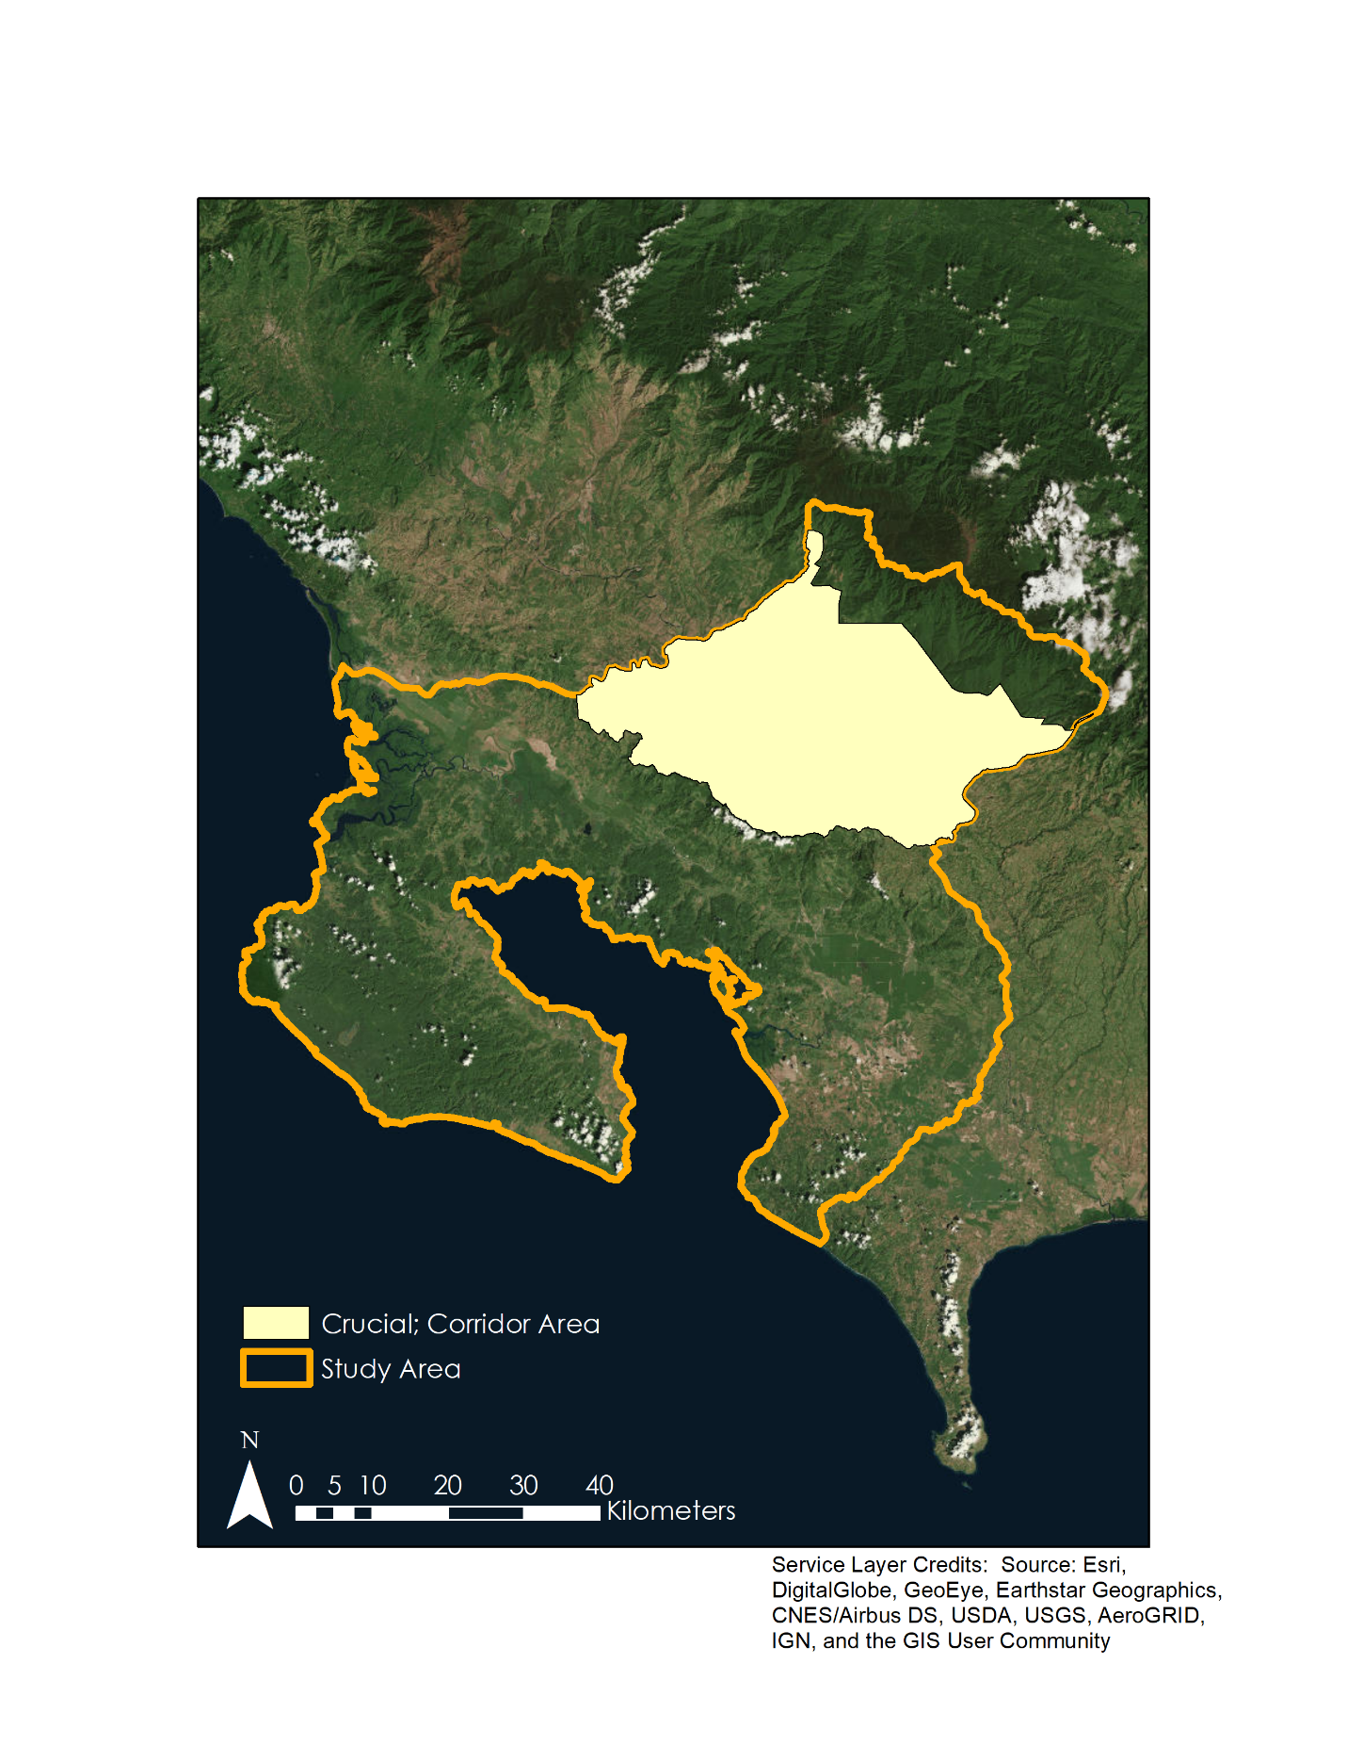
Figure D1. The crucial corridor area within the overall study area

Appendix E.
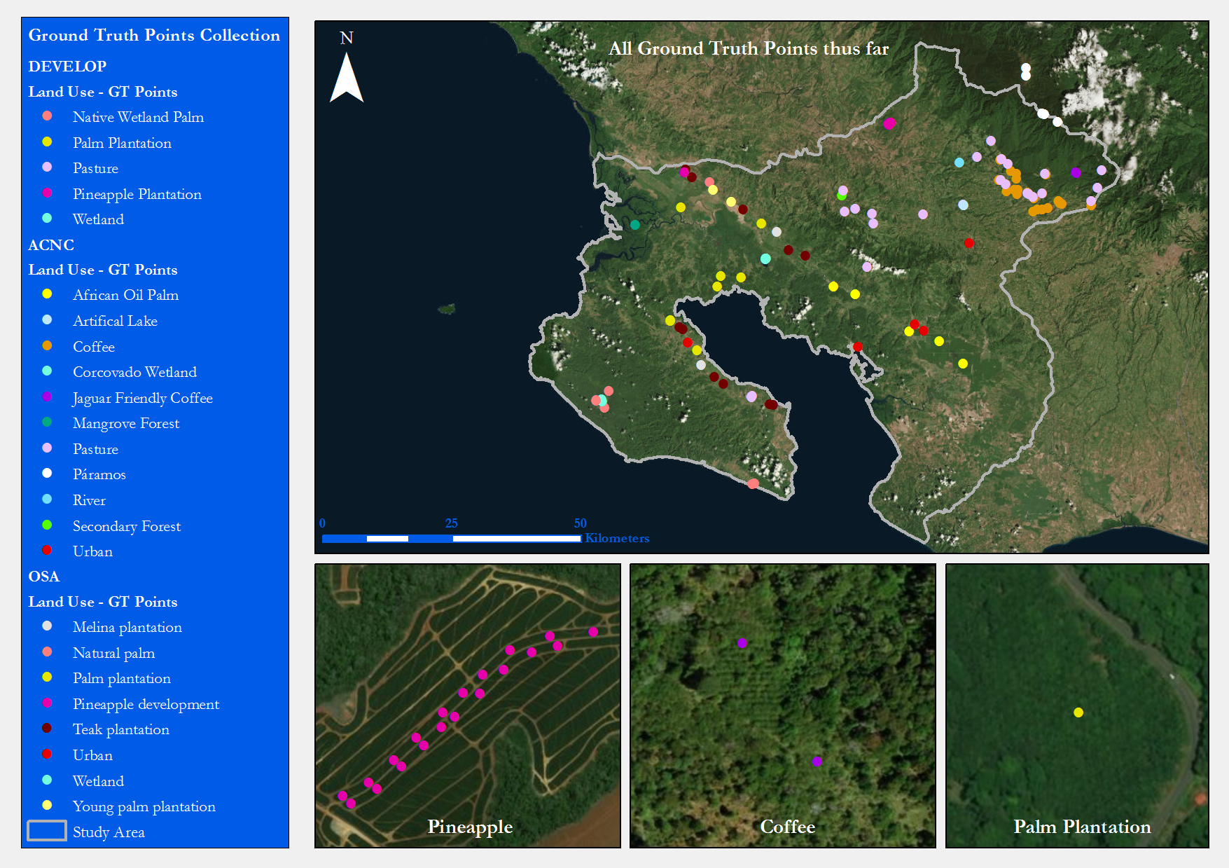
a)
b)
c)

Figure E1. Aerial view of land classes that are crucial in determining jaguar movement: coffee (a), palm plantation (b), and pineapple (c). Image is derived from World Imagery in ArcMap using Landsat 8 OLI.

