Asheville Urban Development

Using NASA Earth Observations to Quantify the Impact of Urban Tree Canopy Cover on Urban Heat and Identify Community Vulnerability in Asheville, North Carolina

 **Technical Report**

Final Draft – November 21st, 2019

Darcy Gray (Project Lead)

Amiya Kalra

Amy Kennedy

Scott Stevens, North Carolina Institute for Climate Studies, NOAA National Centers for Environmental Information (Science Advisor)

# 1. Abstract

Asheville, North Carolina has had a population growth of approximately 10 percent over the past decade, while the city’s tree canopy cover has simultaneously decreased by 6.4 percent. A well-known benefit of urban tree cover is the mitigation of the effects of urban heat islands through factors including shade and evapotranspiration. Thus, as Asheville’s population grows, the presence of trees and their cooling effects is crucial. The Asheville Urban Forestry Commission advises the City Council on issues pertaining to urban development with policies centered on tree cover preservation and growth. The Asheville Urban Development team partnered with the Urban Forestry Commission to complete a study using NASA Earth observations and ancillary datasets to explore relationships between changes in land surface temperature and tree cover over the last 10 years. The team used Landsat 5 Thematic Mapper (TM) and Landsat 8 Operational Land Imager (OLI) to calculate Land Surface Temperature (LST) changes from 1984 to 2018. The team also used socioeconomic data on the census block group level to create a heat vulnerability index in order to identify communities at risk. The team included tree cover and LST data in this index to represent exposure and adaptive capacity as factors in heat vulnerability. The end products illustrated a significant correlation between tree cover and LST in Asheville and identified vulnerable communities to support the Urban Forestry Commission’s decisions about tree planting and preservation.

**Keywords**

heat vulnerability, land surface temperature, Landsat, urban forests, urban heat island effect

# 2. Introduction

* 1. ***Background Information***

An urban heat island (UHI) is an urban area where temperatures are typically higher than the surrounding rural areas, impacting human health, energy costs, and local weather patterns. With the global population rapidly urbanizing, the intensity of extreme heat events and their repercussions on public health will be exacerbated (Clarke, 1972; United Nations Department of Economic and Social Affairs, 2018). Trees provide several services for resilience to the UHI effect and can contribute to the cooling of urban microclimates due to shading, reflectance rates, and evapotranspiration (Georgi & Zafiriadis, 2006; Qiu et al, 2013). However, tree cover is often inequitably distributed, which contributes to neighborhood-level differences in the intensity of the UHI effect (Zhu & Zhang, 2008). Often, the communities that are most exposed to the UHI effect are also those with higher sensitivity to heat extremes due to factors including the age of residents, lack of health insurance, and lack of access to cooling centers and air-conditioned spaces (Solecki et al., 2005).

Asheville is a medium-sized city in the Mountain region of North Carolina with an area of 117.2 km² (*Figure 1*). Like many cities in the United States, Asheville is rapidly growing; in the last 30 years, the city’s population grew 50% to reach 92,000. Since 2008, the population has increased by 10% while tree cover has decreased an estimated 6.4%, raising concerns for the exposure of residents to heat (Davey Resource Group, 2019).

Remote sensing can be a valuable tool for understanding and mitigating the UHI phenomenon, and combining Earth observations with high resolution imagery can yield informative and accurate representations of UHIs and related factors (Lo, Quattrochi, & Luvall, 1997; Pongracz, Bartholy, & Dezso, 2006). Previous studies have used satellite data to identify heat-vulnerable communities, observe trends, and make recommendations for sustainable planning (Coutts et al., 2016). Although the City of Asheville has conducted a spatial assessment of heat vulnerability, neither temperature nor tree cover data have been included in these analyses (The City of Asheville North Carolina & UNC Asheville National Environmental Modeling & Analysis Center, 2018). The team examined the UHI effect in Asheville using NASA Earth observations, National Oceanic and Atmospheric Administration (NOAA) datasets, high-resolution tree cover data, and socioeconomic data from the 2015 American Community Survey. The team analyzed trends in these data and generated heat vulnerability maps in order to inform tree planting and preservation decisions made by the Asheville Urban Forestry Commission.

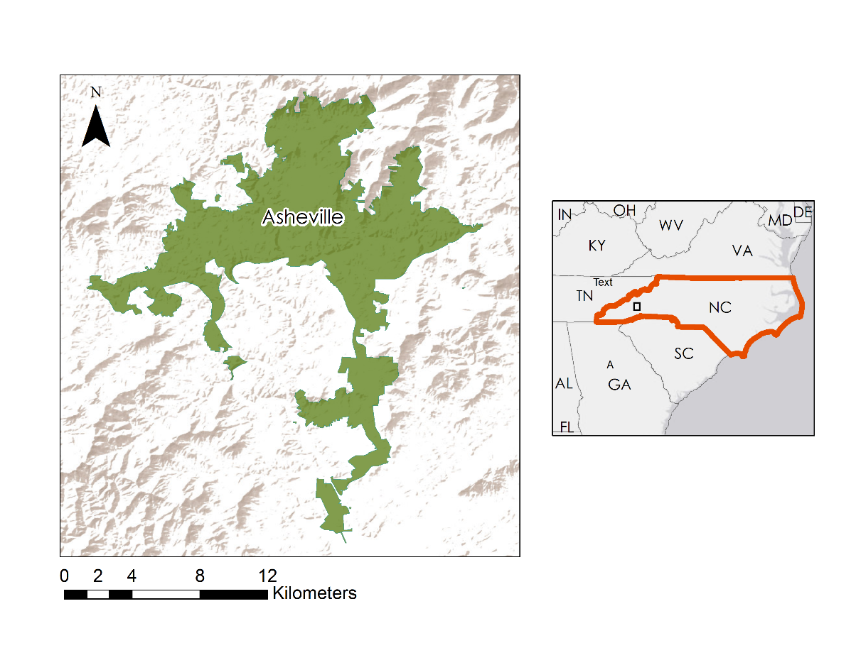

Figure 1. Map of the project study area: Asheville, North Carolina administrative boundaries.

* 1. ***Project Partners & Objectives***

The City of Asheville Urban Forestry Commission acknowledges the existence of UHIs in Asheville and the problems they cause, including stormwater runoff, extreme heat, air pollution, and a loss of aesthetic appeal (Walton, 2019). Of primary concern are the changes in temperature and tree cover the city has witnessed over the last few decades and how those changes are distributed across different areas and populations in the city. The Commission’s current goals are the creation of an Urban Forester position within the City Development Service Staff and the development of a Comprehensive Urban Forest Master Plan to guide future work with trees in the city (City of Asheville Urban Forestry Commission, 2019). Their work on a monthly basis includes educating residents of Asheville on the importance of tree cover and advising the city on issues related to tree planting and preservation. The team’s temperature and vulnerability data analyses will enable the Urban Forestry Commission to focus their tree cover planting and preservation efforts in the parts of the city most vulnerable to UHIs and will assist them in their continued work to educate the Asheville public.

The team’s primary goals for this project were to investigate the spatial correlations between land surface temperature (LST) and tree cover during warm months in Asheville and to create a heat vulnerability index (HVI) for Asheville using socioeconomic data in conjunction with LST and tree cover data. The team highlighted the changes in LST in Asheville between 1984 and 2018 and then created maps of LST for each time period, as well as maps of LST change for the Urban Forestry Commission to use in their outreach and decision-making. The team also created a social vulnerability index on population age and poverty level and used this index in combination with LST and tree cover data to create an HVI. The Urban Forestry Commission will be able to use the HVI to identify areas in Asheville that require more immediate attention with regard to tree cover.

# 3. Methodology

***3.1 Data Acquisition***

*3.1.1 Land Surface Temperature Data Sources*

Using Google Earth Engine, the team accessed Landsat 5 Collection 1 Tier 1 raw scenes with the Thematic Mapper (TM) instrument and Landsat 8 Collection 1 Tier 1 raw scenes with the Operational Land Imager (OLI) instrument, both with 30-meter resolution. Landsat 5 TM and Landsat 8 OLI are commonly used for retrieving LST data because of their high resolution and easy accessibility, which is useful for identifying UHIs (Liu & Zhang, 2011). The team used Landsat 5 for imagery from 1984 to 2011 and Landsat 8 for imagery from 2013 to 2018. For both collections, the team used imagery from warm months only (May 1st to September 30th). These months are typically the hottest of the year; therefore, they provide the best analysis for LST change over time. The team did not use data for the summer of 2012 due to electronic degradation on the Landsat 5 TM instrument during that time.

*3.1.2 Tree Cover Data sources*

The team accessed 2018 60-cm resolution tree data taken from the United States Department of Agriculture (USDA) National Agriculture Imagery Program (NAIP), which Davey Resource Group (Davey) processed to generate an Urban Tree Canopy (UTC) Assessment in Asheville. Davey gave DEVELOP access to additional maps and quantitative data, including tree cover change by census block group. The tree data Davey processed is from 2008 and 2018.

*3.1.3 Heat Vulnerability Index Data Sources*

In a previous heat vulnerability study for the City of Asheville Climate Resilience Plan, the authors identified areas of Asheville vulnerable to heat using satellite data as a proxy for tree canopy cover data along with data on the percentage of the population above the age of 65 or living below the poverty level (The City of Asheville North Carolina & UNC Asheville National Environmental Modeling & Analysis Center, 2018). The City of Asheville Urban Forestry Commission, along with other city representatives, requested that the DEVELOP study aligns with this aspect of the first heat vulnerability study, in order to ensure consistency in future decision-making based on the studies. Age and poverty are both commonly used variables in similar heat vulnerability indices (Bao, Li, & Yu, 2015; Weber, Sadoff, Zell, & de Sherbinin, 2015). Healthy adults cope with increases in temperature effectively, but younger and older people have more difficulty because of differences in their thermoregulatory systems (Balbus & Malina, 2009; Kovatz & Hajat, 2008). Epidemiological evidence does not show an increase in child mortality during heat waves (Balbus & Malina, 2009; Kovatz & Hajat, 2008); with that in mind, the team only used age data for elderly populations in the heat vulnerability index. Additionally, people with lower incomes are more likely to live in poor housing conditions, often without air conditioning, have difficulty accessing material and information resources, and have chronic illness or other medical concerns (Aubrecht & Özceylan, 2013; Balbus & Malina, 2009; Kovatz & Hajat, 2008). Because of that, the team chose to include poverty data in the heat vulnerability index as well. The team chose not to include other socioeconomic data in the index because age and poverty provided a nearly comprehensive view of social vulnerability in Asheville and adding in other variables could have resulted in some factors being unequally weighted in the final index.

The team accessed Topologically Integrated Geographic Encoding and Referencing (TIGER) shapefiles and demographic data from the US Census Bureau containing information on age and poverty at the census block group level, which is the finest resolution available for those data. The team also used data on the boundaries of census block groups that Davey clipped to the Asheville city limits in order to ensure that the boundaries were the same across all analyses. The data on age and poverty came from 2017 American Community Survey (ACS) five-year estimates, which were the most recent estimates available. Five-year estimates are the most accurate option for socioeconomic data from the American Community Survey when the data are applied to smaller geographical areas like Asheville (United States Census Bureau, 2017).

***3.2 Data Processing***

*3.2.1 Processing Land Surface Temperature and Tree Cover Data*

As per Jiménez-Muñoz & Sobrino’s (2003) single-band method, the team calculated top-of-atmosphere (TOA) brightness temperature from TOA radiance of the thermal infrared band, used NDVI to assign surface emissivity values, and derived LST from the resulting measurements. The following equation (Equation 1) was used to calculate LST in Kelvin (K).

$\text{LST = }{\text{T}}_{\text{sensor}}\text{ / ((1 + λ * }{\text{T}}_{\text{sensor}}\text{ / α) * ln(ε))}$ (1)

where ${\text{T}}_{\text{sensor}}$ represents at-sensor brightness temperature in Kelvin, λ represents the wavelength in meters and $α$ =1.438 × $10^{-2}$ mK. $ε$ represents surface emissivity. For more information on how ${\text{T}}_{\text{sensor}}$ and $ε$ were calculated, see Appendix A.

The team utilized a JavaScript code within the Urban Heat Island Toolkit in the NASA DEVELOP Google Earth Engine (GEE) repository to apply this equation to the Landsat 5 and 8 raw scenes (Heslin, Dialesandro, Heck, & Lin, 2018). The team then converted the temperature from Kelvin to Fahrenheit using the standard conversion (Equation 2).

$\text{°F=K x}\frac{\text{9}}{\text{5}}\text{-459.67}$ (2)

Within GEE, the team then applied a mask to eliminate cloudy pixels. Since the median temperatures for non-cloud images did not fall below 55°F, this was used as a threshold below which pixels were masked. The team then reduced these LST images into a median for 1984 to 1986, 2007 to 2009 and 2017 to 2019. The team used 3-year medians for a larger sample size and to account for unusually hot or cold images in the data. The median LST images were then clipped to the extent of Asheville and exported from GEE as Tagged Image File Format (TIFF) files.

In order to conduct statistical tests between the tree data and LST data, the team used the Zonal Statistics to Table tool in ArcMap 10.6.1 to calculate average LST values per census block group for 2007 to 2009 and 2017 to 2019, which aligned with the range of the Davey tree data. The team used the census block groups clipped to Asheville from Davey to allow for a comparison between the tree and LST data. The result was two tables containing mean values for 83 of the 85 census block groups in Asheville. Two were missing due to their area being smaller than the 30-meter resolution of the LST data when they were clipped to the Asheville boundaries.

The team then joined these tables with the census block group tree data and exported the resulting table to Microsoft Excel as a Database File. Once in Excel, the team created a new column showing the change in mean LST from 2007 to 2009 to 2017 to 2019. They did this by subtracting the column containing mean LST values of the earlier years from the column containing mean LST values of the later years.

*3.2.2 Processing data for use in the Heat Vulnerability Index*

To calculate an appropriate value of LST to be used in the HVI, the team used maximum values rather than medians, since the index investigated the potential risk of extreme heat exposure. After the LST values were calculated following the methods described above, the image collection was reduced in GEE by the maximum value, instead of the median, for the 2017 to 2019 images. In GEE, the values were then assigned the value of 1 if they were above the 90th percentile of the maximum LST data and 0 otherwise. Using the Zonal Statistics to Table tool in ArcMap, the team calculated the mean value for each census block group, and this value represented the percentage of pixels in the census block group whose maximum LST value was above the 90th percentile.

The team accessed the 2017 ACS five-year estimates from the US Census Bureau online file transfer protocol (FTP) server in a geodatabase containing tables with information on population age distribution and poverty status. The US Census Bureau measures poverty by finding whether a family’s income is above or below a set threshold, which is decided by considering the number and age of family members (United States Census Bureau, 2019). The poverty information contained in the geodatabase tables is the ratio of income to poverty level in the past 12 months at the household level, with values ranging from below 0.50, meaning families’ incomes are less than half of their given threshold, to above 2.00, meaning families’ incomes are more than twice their given threshold. Because the team was interested in finding people living below the poverty line, they chose to include only families whose ratio of income to poverty level was less than 1.00.

In ArcMap, the team joined the tables to Davey’s census block group boundaries, using the unique GeoID assigned to each census block group as the common value between the tables. After combining these tables in ArcMap, the team created two new attributes for each census block group, one containing the percentage of the population over the age of 65 and the other containing the percentage of the population living under the poverty level. To create the attribute relevant to age, the team divided the values in the ACS tables showing the number of people over the age of 65 in each census block group by the total population of each census block group. For the poverty attribute, the team divided the ACS table values showing the number of households with a ratio of income to poverty level less than 1.00 in each census block group by the total number of households in each census block group.

*3.2.3 Normalizing and Aggregating Variables for the Heat Vulnerability Index*

Following the example from Weber et al. (2015), the team defined vulnerability as a combination of exposure, sensitivity, and adaptive capacity (Equation 3). They used LST to represent exposure since it was the closest they could get to observing the range of temperature highs and lows the Asheville population experiences each warm season. They used age and poverty as a measure of population sensitivity, as discussed previously; tree cover represented adaptive capacity due to the known cooling effects of trees, including shade and evapotranspiration (Gulliver, Erickson, & Weiss, 2010; Qiu et al., 2013; Takakura, Kitade, & Goto, 2000; US Environmental Protection Agency, 2017).

$\text{vulnerability} \text{=} \text{exposure} \text{+} \text{sensitivity} \text{+} \text{adaptive capacity}$ (3)

In order to combine the variables representing exposure, sensitivity, and adaptive capacity, the team normalized each variable and aggregated them to find a final index value for each census block group; this is a common approach to building vulnerability indices (Appendix B) (Aubrecht & Özceylan, 2013; Bao, Li, & Yu, 2015). Normalizing each variable’s value to a relative position between 0 and 1 without weighting any variables avoids potential subjectivity in the construction of the index (Aubrecht & Özceylan, 2013; Bao, Li, & Yu, 2015). The team first normalized the values given for the percentage of pixels over the 90th temperature percentile from the original LST data. This process can be done in Microsoft Excel using Equation 4, where x is the given percent value for a census block group, max is the maximum percent value out of all census block groups in the area in question, and min is the minimum percent value out of all census block groups. The team completed the normalization process for the LST data in Microsoft Excel and brought the table back into ArcMap, so each census block group had one normalized LST value associated with it, which would later be used in the creation of the final heat vulnerability index.

$\frac{\text{x - min}}{\text{max - min}}$ (4)

In order to ensure that the variables representing sensitivity were equal in weight to the exposure and adaptive capacity variables, the team created a social vulnerability index from age and poverty and normalized it to include in the final heat vulnerability index. Using Equation 4 in Microsoft Excel, they normalized the values for the percentage of population above the age of 65 and the percentage of the population living below the poverty line for each census block group. They aggregated those values to create a social vulnerability index with values ranging from 0 to 2, with the least socially vulnerable being 0 and the most being 2. The team then normalized the social vulnerability index so that each census block group in Asheville had one value between 0 and 1 representing both age and poverty within that census block group.

The final variable the team normalized was the tree cover percentage data from Davey. Because the normalized value needed to show lower adaptive capacity and, therefore, higher vulnerability as it approached 1, the team used Equation 5 rather than Equation 4 during the normalization process. This ensured that a higher percentage of tree canopy cover in a census block group led to a normalized value closer to 0 instead of 1.

$\frac{\text{max}{\text{- x}}}{\text{max}{\text{- min}}}$ (5)

The final step in the construction of the analysis was the aggregation of all three normalized variables, as shown in Equation 3. This addition resulted in one value between 0 and 3 per census block group in Asheville, with 0 representing the lowest possible vulnerability and 3 representing the highest possible vulnerability. The team split the results into four quartiles based on their index value, with an equal number of census block groups in each quartile. These quartiles facilitated a better understanding of the locations of vulnerable areas in Asheville on the index map.

***3.3 Data Analysis***

Using the Landsat-derived LST, the team displayed the LST for each time period and subtracted the 1980s LST from the present LST to identify and quantify temperature changes. In addition to seeing how LST changed over time in Asheville, the team wanted to see if there was a correlation between LST and tree cover. Within Microsoft Excel, they created three scatterplots using LST and tree cover percentage data by census block group from 2008 and 2018, as well as the change between those years. From these scatterplots, the team found the correlation coefficient of tree cover and LST by census block group for all three scenarios.

# 4. Results & Discussion

***4.1 Land Surface Temperature Over Time***

The results of the temperature change analysis demonstrated a large variation in LST values across the city within each time period (*Figure 2*). This geographic variation reflects the urban heat island effect. The analysis also found that LST changed over time, and more areas experienced high temperatures in 2017 to 2019 than in both 1984 to 1986 and 2007 to 2009. LST increased by as much as 31° F in some areas of Asheville. The average change in LST per pixel was 4.4 ° F and the most change in LST occurred around the downtown area in the center of Asheville and in the southern part of town near the airport (*Figure 3*).

Because cloudy pixels were masked, the median LST values are based on different numbers of pixels, which may be a source for error in the analysis. Since the comparison between the 1980s and present-day data compares Landsat 5 data with Landsat 8, there are potential differences between these LST products, although adjustments in the LST formula do account for these differences. Additionally, using LST rather than air temperature allows for high resolution investigation of the urban microclimate, but may not be as precise to the actual perceived temperature of the city as air temperature measured by thermometers.

*Figure 2*. Three-year median daytime land surface temperature values for warm months (May to September) in Asheville, North Carolina over three different time periods.

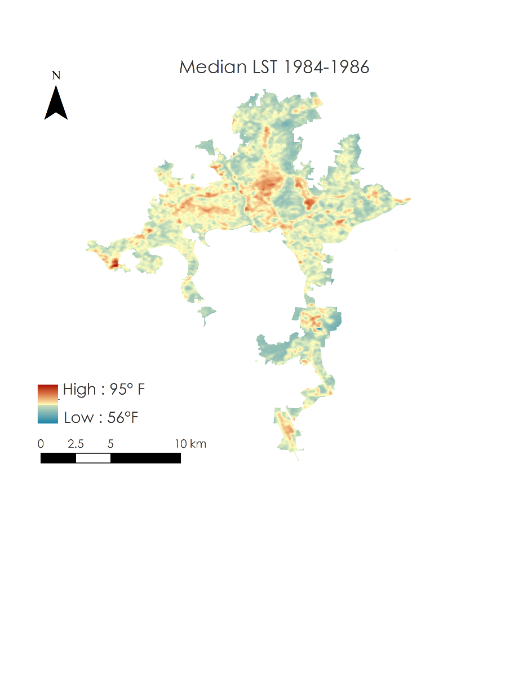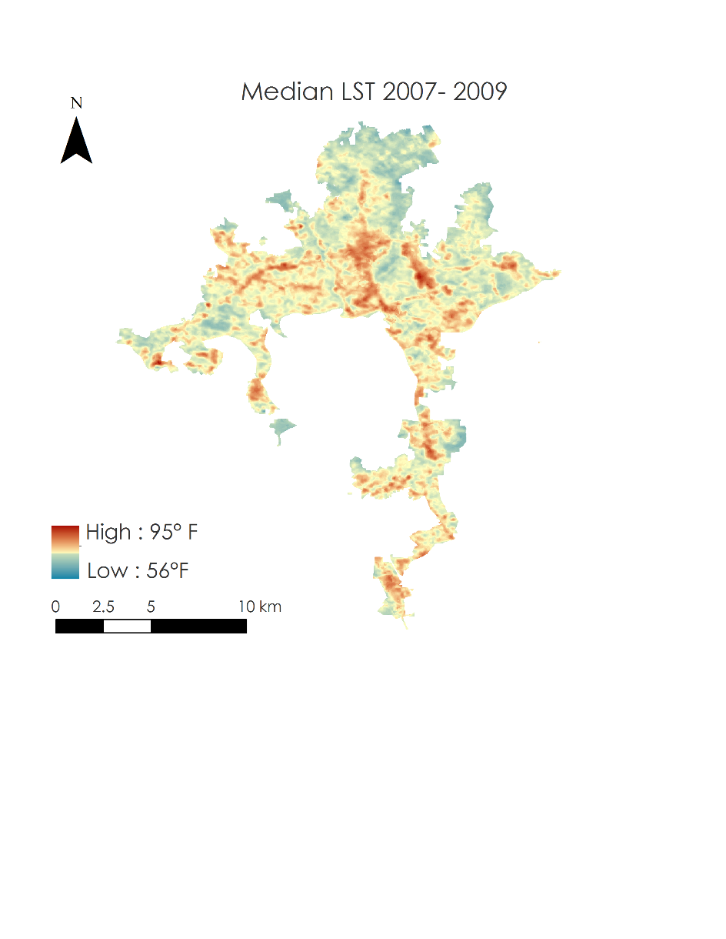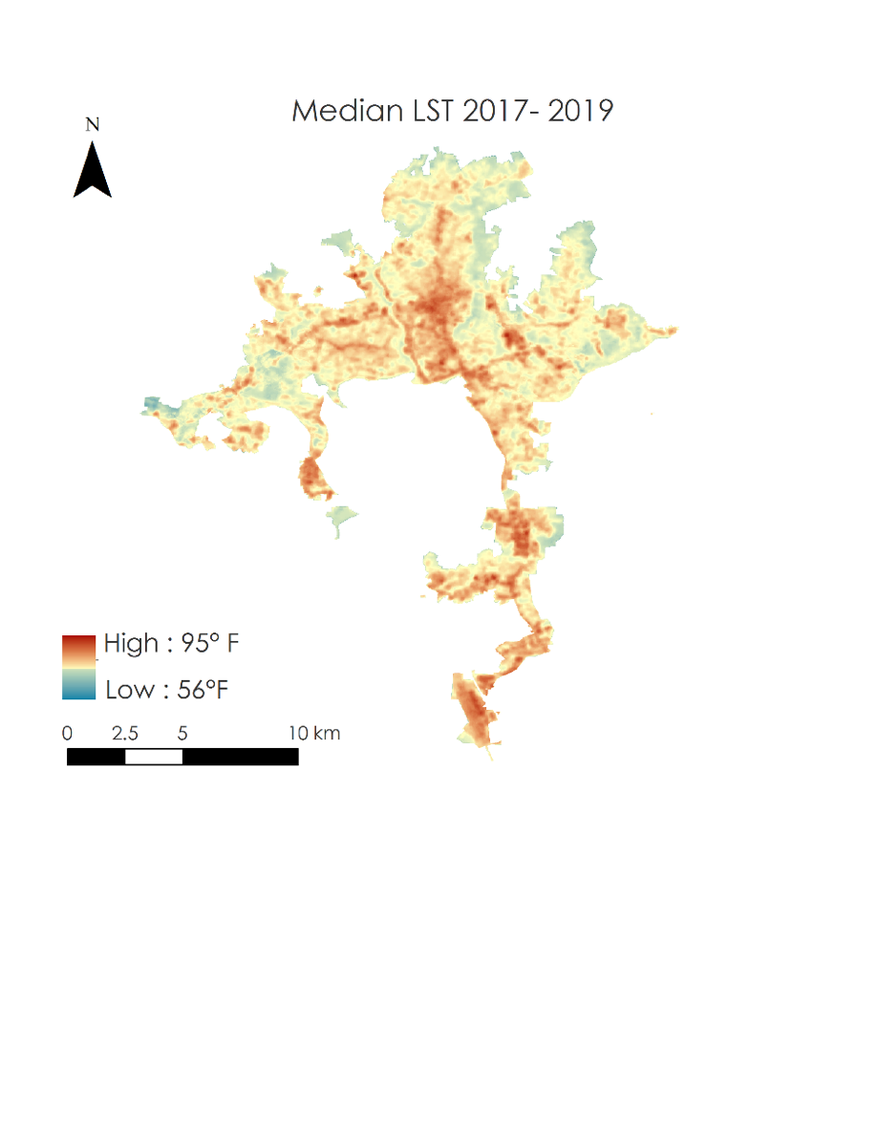

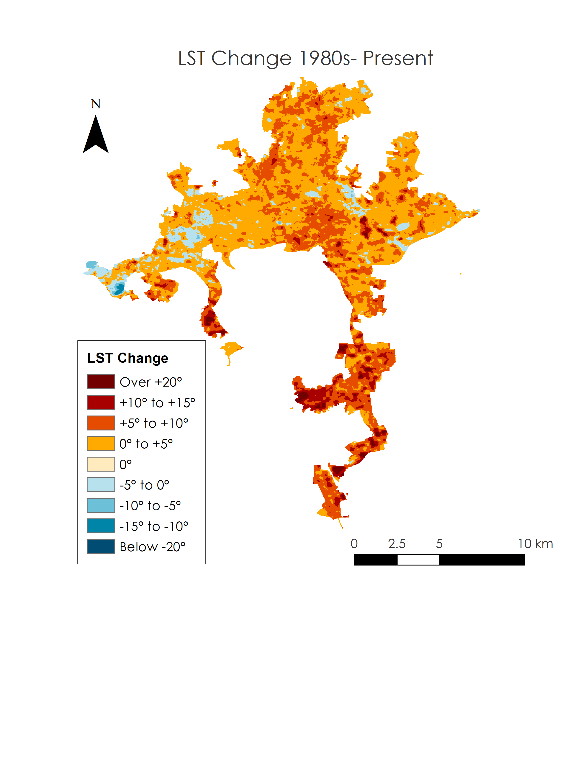***4.2 Land Surface Temperature and Tree Cover Scatterplots***

Figure 3. Changes in three-year median daytime LST values (°F) from 1984 to 2019.

For the present-day plot showing tree cover percent by census block group in 2018 and mean LST from 2017 to 2019, the team found an r-squared value of 0.5374 with a linear equation of y = -0.1225x+82.785 (*Figure 4*). For the correlation between tree cover percent by census block group in 2008 and mean LST from 2007 to 2009, the team found an r-squared value of 0.5869 and a linear equation of y = -0.1472x+82.142 (*Figure 5*). Both of these r-squared values indicated a strong correlation between tree cover and LST in the respective timeframes. For the third scatterplot, using tree cover percent change from 2008 to 2018 and LST change from this time period and shoulder years, the team found an r-squared value of 0.0593 and a linear equation of y = -0.0291x + 2.0006 (*Figure 6*). This correlation coefficient is extremely low and shows little to no significance of a relationship between change in tree cover and LST.

One possible reason for the weak correlation between change in LST and change in tree cover is that some areas may have been fairly developed with low tree cover in 2008, preventing significant tree loss during further development. Further development could have built upon existing impervious surfaces or added impervious surfaces while removing little to no tree cover. This would increase LST without resulting in a large loss of trees, especially if there were not many to begin with. Census block groups of different size might show similar changes in percent tree cover when the actual change in physical tree cover was significantly different. Additionally, census block groups that fall on boundaries of the city could have experienced temperature change due to tree cover change immediately adjacent to them but outside their boundaries, which may have influenced LST in ways that the Davey tree cover data could not account for.



Figure 4. Tree cover and LST correlation by census block group, 2018.



Figure 5. Tree cover and LST correlation by census block group, 2008.



Figure 6. Tree cover and LST correlation by census block group, 10-year change.

***4.3 Heat Vulnerability Index***

The team visualized the individual normalized values for LST, social vulnerability, and tree cover on maps of Asheville’s 85 census block groups (*Figure 7*). On the maps of LST and social vulnerability, darker colors indicate higher LST or social vulnerability, and on the map of tree cover, darker colors indicate higher amounts of tree cover. The team also visualized the heat vulnerability index on a similar census block group map with each census block group shown in one of four colors, with the darkest color indicating the highest vulnerability (*Figure 8*). The four colors correspond to the four quartiles into which the team divided the index results for ease of understanding; there is an equal number of census block groups included in each quartile.

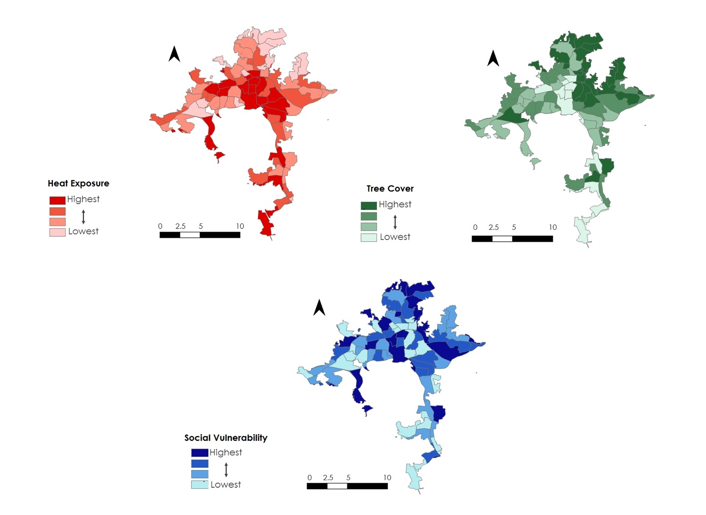

Figure 7. Maps showing the individual normalized values for census block groups in Asheville for land surface temperature (in red, upper left), tree cover (in green, upper right), and social vulnerability (in blue, bottom).

*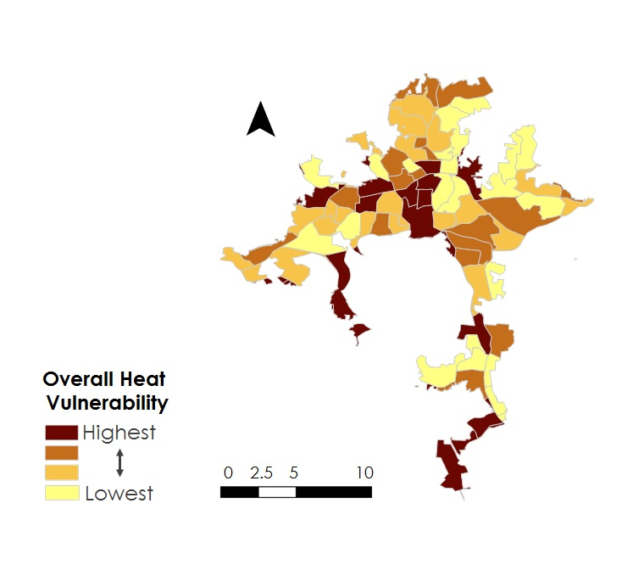Figure 8*. Map showing the overall heat vulnerability index for Asheville by census block group. The darkest brown indicates the highest vulnerability, and the lightest yellow indicates the lowest vulnerability.

The heat vulnerability index data shows that the most vulnerable part of Asheville is the downtown area, while the least vulnerable is part of West Asheville near the Asheville School. Other parts of the city marked as highly vulnerable in the index map include the South Slope neighborhood and the areas around the outlet mall in the southwest and the airport in the southeast (*Figure 8*). Examination of the maps of individual normalized values in relation to the overall heat vulnerability index map shows that the index labels census block groups as vulnerable for different reasons (Appendix C). The downtown area has high normalized values for LST, social vulnerability, and tree cover, which led to its overall high index value, but other census block groups exhibit more variety. Some census block groups have a high normalized value for social vulnerability but low values for LST and tree cover, while others have high values for LST and tree cover and low values for social vulnerability. Viewing the overall heat vulnerability index map while taking into consideration the three individual normalized value maps makes it possible to understand why any given census block group has been marked as vulnerable or not vulnerable.

Davey’s census block groups were clipped to the city limits, although many census block groups extend beyond Asheville boundaries, while American Community Survey socioeconomic data represents census block groups as a whole and cannot be divided to represent smaller geographic areas. In order to create the heat vulnerability index for Asheville, the team assumed that the socioeconomic data for each census block group was representative of only the sections included within the city limits. This assumption may have led to some error in the formation of the social vulnerability values in the overall heat vulnerability index.

***4.4 Future Work***

The Urban Forestry Commission and other interested community members have generated many questions and ideas in response to the DEVELOP team’s project and results. Future work could include using thermometer measurements of ambient temperatures rather than LST for a more accurate reading of what people feel on a day-to-day basis. Studies can also explore the possible relationship between violence and crime, heat, and tree cover, or investigate the potential correlations between mental health, happiness, and green spaces within Asheville. Hospital and emergency room data could be included to take a finer look at heat-related illnesses, especially in conjunction with the team’s heat vulnerability index. A mapping project of cooling centers in relation to the hottest spots in town could be provided with the hospital and heat vulnerability index data as a way of itemizing options for people to escape the extreme heat.

With regard to future work based on the results from this project, policy-makers in the city may use the end products to quantify the effects on temperature of planting or removing trees in certain locations. By using the scatterplots and associated linear equations for the present-day, one can estimate how much temperature may change when adding or removing a certain percentage of trees in a census block group. City officials can use the heat vulnerability index to pinpoint locations where tree planting efforts should be focused.

# 

# 5. Conclusions

# In the absence of field-collected fine-scale temperature data, NASA Earth observations can be used to construct urban heat vulnerability indices based on US Census data and high-resolution tree cover data. The team was able to use these data to determine that median LST for warm months has increased by up to 31°F in parts of Asheville over the last 30 years, and was able to visually display this change. As has been shown for many cities, the results and literature review demonstrate that Asheville’s urban tree canopy has a cooling effect which can mitigate the urban heat island effect. Heat vulnerability varies drastically between neighborhoods based on LST, tree cover, age, and poverty. The Asheville Urban Forestry Commission can use the team’s heat vulnerability index to inform decisions about tree planting and preservation.

# 6. Acknowledgments

The Asheville Urban Development team would like to thank their science advisor Scott Stevens and fellow Andrew Shannon for their knowledge and guidance throughout this project. The team would also like to thank their partners from the Asheville Urban Forestry Commission, including Ed Macie, Dawn Chávez, Stephen Hendricks, Amy Smith, and others. They further recognize representatives from the National Environmental Modeling and Analysis Center, National Centers for Environmental Information, the City of Asheville, and others for their assistance in the completion of this project.

Any opinions, findings, and conclusions or recommendations expressed in this material are those of the authors and do not necessarily reflect the views of the National Aeronautics and Space Administration.

This material is based upon work supported by NASA through contract NNL16AA05C.

# 

# 7. Glossary

**Earth observations** – Satellites and sensors that collect information about the Earth’s physical, chemical, and biological systems over space and time

**Urban Heat Island Effect** – A phenomenon that occurs when there is a temperature difference between a metropolitan area and surrounding non-urban spaces, in which the metropolitan space holds more heat

**Land Surface Temperature (LST**) – For satellite purposes, the temperature of the Earth’s surface or whichever object a satellite sensor detects before reaching the Earth’s surface (such as a cloud, the top of a tree, a building). This differs from the air temperature by which humans reference daily weather.

**Evapotranspiration (ET)** – The combination of water surface evaporation, soil moisture evaporation, and plant transpiration, wherein water is transported through a plant from its roots and into the surrounding air through the plant’s leaves

**Remote Sensing** – The science of obtaining information about objects or areas from a distance, typically from aircraft or satellites

# 8. References

American Community Survey. (2017). *American Community Survey 2017 5-Year Estimates for North Carolina Block Groups* [Data file]. Retrieved on October 30, 2019, from https://www2.census.gov/geo/tiger/TIGER_DP/2017ACS/

Aubrecht, C., & Özceylan, D. (2013). Identification of heat risk patterns in the U.S. National Capital Region by integrating heat stress and related vulnerability. *Environment International*, *56*, 65-77. http://dx.doi.org/10.1016/j.envint.2013.03.005

Balbus, J., & Malina, C. (2009). Identifying vulnerable subpopulations for climate change health effects in the United States. *Journal of Occupational and Environmental Medicine*, *51*, 33-37. doi:10.1097/JOM.0b013e318193e12e

Bao, J., Li, X., & Yu, C. (2015). The construction and validation of the heat vulnerability index, a review. *International Journal of Environmental Research and Public Health*, *12*(7), 7220-7234. doi:10.3390/ijerph120707220

Clarke, J. F. (1972). Some effects of the urban structure on heat mortality. *Environmental Research*, *5*(1), 93-104. https://doi.org/10.1016/0013-9351(72)90023-0

City of Asheville Open Data Portal (2019). *City of Asheville Boundaries* [Data set]. Accessed on October 8, 2019, from https://data-avl.opendata.arcgis.com/search?tags=census

City of Asheville Urban Forestry Commission. (2019). Asheville Tree Commission Annual Report. Asheville, NC. Retrieved from https://drive.google.com/file/d/1A9v72lCHXgKbzzlm27gIeFC1BvWYP4W1/view

Coutts, A. M., Harris, R. J., Phan, T., Livesley, S. J., Williams, N. S.G, & Tapper, N. J. (2016). Thermal infrared remote sensing of urban heat: Hotspots, vegetation, and an assessment of techniques for use in urban planning. *Remote Sensing of Environment*, *186*, 637-651. <https://doi.org/10.1016/j.rse.2016.09.007>

Davey Resource Group (2019). Urban Tree Canopy Study: Asheville, North Carolina.

Davey Resource Group (2019). *Asheville Urban Tree Canopy* [Data set]. Accessed October 8, 2019.

Georgi, N. J., & Zafiriadis, K. (2006). The impact of park trees on microclimate in urban areas. *Urban Ecosystems*, *9*(3), 195-209. https://doi.org/10.1007/s11252-006-8590-9

Gulliver, J.S., Erickson, A.J., & Weiss, P.T. (editors). (2010). Stormwater treatment: Assessment and maintenance. University of Minnesota, St. Anthony Falls Laboratory. Minneapolis, MN. Retrieved on October 30, 2019, from http://stormwaterbook.safl.umn.edu/

Jiménez-Muñoz, J.C., & Sobrino, J.A. (2003). A generalized single-channel method for retrieving land surface temperature from remote sensing data. *Journal of Geophysical Research, 108*(D22), 4688. doi: 10.1029/2003JD003480

Kautz, S. (2017). Landsat 4-5 Thematic Mapper (TM) Level-1 [Data set]. U.S. Geological Survey. https://doi.org/10.5066/f7n015tq

Kautz, S. (2018). Landsat 8 OLI (Operational Land Imager) and TIRS (Thermal Infrared Sensor) [Data set]. U.S. Geological Survey. https://doi.org/10.5066/f71835s6

Kovatz, R., & Hajat, S. (2008). Heat stress and public health: a critical review. *Annual Review of Public Health*, *29*, 41-55. doi:10.1146/annurev.publhealth.29.020907.090843

Heslin, J., Dialesandro, J., Heck, M, & Lin, Chenxi. (2018.) [Google Earth Engine Code for LST retrieval from Landsat 5 TM and Landsat 8 OLI]. *Washoe County Urban Development Landsat LST*. Code accessed from Google Earth Engine NASA DEVELOP repository.

Liu, L., & Zhang, Y. (2011). Urban heat island analysis using the Landsat TM data and ASTER data: A case study in Hong Kong. *Remote Sensing*, *3*(7), 1535-1552. https://doi.org/10.3390/rs3071535

Lo, C. P., Quattrochi, D. A., & Luvall, J. C. (1997) Application of high-resolution thermal infrared remote sensing and GIS to assess the urban heat island effect. *International Journal of Remote Sensing*, *18*(2), 287-304. https://doi.org/10.1080/014311697219079

Pongracz, R., Bartholy, J., & Dezso, Z. (2006). Remotely sensed thermal information applied to urban climate analysis. *Advances in Space Research*, *37*(12), 2191-2196. https://doi.org/10.1016/j.asr.2005.06.069

Qiu, G.-Y., Li, H.-Y., Zhang, Q.-T., Chen,W., Liang, X.-J., & Li, X.-Z. (2013). Effects of evapotranspiration on mitigation of urban temperature by vegetation and urban agriculture. *Journal of Integrative Agriculture*, *12*(8), 1307-1315. https://doi.org/10.1016/S2095-3119(13)60543-2

Solecki, W. D., Rosenzweig, C., Parshall, L., Pope, G., Clark, M., Cox, J., & Wiencke, M. (2005). Mitigation of the heat island effect in urban New Jersey. *Global Environmental Change Part B: Environmental Hazards*, *6*(1), 39-49. https://doi.org/10.1016/j.hazards.2004.12.002

Takakura, T., Kitade, S., & Goto, E. (2000). Cooling effect of greenery cover over a building. *Energy and Buildings*, *31*(1), 1–6. doi: 10.1016/s0378-7788(98)00063-2

The City of Asheville North Carolina, & UNC Asheville National Environmental Modeling & Analysis Center. (2018). Planning for climate resilience in the City of Asheville, North Carolina: Final assessment report. Retrieved October 8, 2019 from https://www.ashevillenc.gov/department/sustainability/sustainability-initiatives/climate-resilience/

United States Census Bureau. (2017). *American Community Survey Information Guide*. Retrieved on October 30, 2019, from https://www.census.gov/content/dam/Census/programs-surveys/acs/about/ACS_Information_Guide.pdf

United States Census Bureau. (2019). How the Census Bureau measures poverty. Retrieved on October 30, 2019, from https://www.census.gov/topics/income-poverty/poverty/guidance/poverty-measures.html

United Nations Department of Economic and Social Affairs. (2018). *2018 Revision of World Urbanization Prospects*. *2018 Revision of World Urbanization Prospects*. Retrieved on November 8, 2019, from https://www.un.org/development/desa/publications/2018-revision-of-world-urbanization- prospects.html

United States Census Bureau. (2019). TIGER Census Tracts [Data file]. Retrieved on October 8, 2019, from https://www.census.gov/cgi-bin/geo/shapefiles/index.php?year=2019&layergroup=Census+Tracts

U.S. Environmental Protection Agency. (2017). Healthy Benefits of Green Infrastructure in Communities. *Healthy Benefits of Green Infrastructure in Communities*. Retrieved on November 14, 2019, from https://www.epa.gov/sites/production/files/2017- 11/documents/greeninfrastructure_healthy_communities_factsheet.pdf

Walton, D. (2019, March 9). Urban forestry proposals aim to save Asheville’s trees. *Mountain XPress*. Retrieved from https://mountainx.com/

Weber, S., Sadoff, N., Zell, E., & de Sherbinin, A. (2015). Policy-relevant indicators for mapping the vulnerability of urban populations to extreme events: a case study of Philadelphia. *Applied Geography*, *63*, 231-243. https://doi.org/10.1016/j.apgeog.2015.07.006

Zhu, P., & Zhang, Y. (2008). Demand for urban forests in United States cities. *Landscape and urban planning*, *84*(3-4), 293-300. https://doi.org/10.1016/j.landurbplan.2007.09.005

# 9. Appendices

***Appendix A***

For calculation of Land Surface Temperature from Landsat Raw Scenes, the team used the same methods as Henlin et all, 2018, which were the following:

We employed a widely used method that was introduced in the Landsat Handbook for LST retrieval. In this method, only TOA radiance and NDVI are required. According to the handbook, the TOA radiance of thermal infrared band is converted to TOA (or at-sensor) brightness temperature based on the formula (Equation 1) (Chander et al., 2009):

${\text{T}}_{\text{sensor}}\text{ = K1 / ln (K2 / (Lλ + 1))}\text{. }$ (1)

where Tsensor is the at-sensor brightness temperature in Kelvin (K) and L $λ$ is the TOA radiance in W/m2srum. For Landsat-5 TM, K1 is 607.76 W/(m2srμm) and K2 is 1260.56 K; for Landsat-7 ETM+, K1 is 666.09 W/(m2srμm) and K2 is 1282.71 K; and for Landsat-8 TIRS, K1 is 774.89 W/(m2 srμm) and K2 is 1321.08 K for band 10 (USGS, n.d.).

The following equation (Equation 2) calculates the LST based on the brightness temperature obtain previously (Artis & Carnahan, 1982).

$\text{LST = }{\text{T}}_{\text{sensor}}\text{ / ((1 + λ * }{\text{T}}_{\text{sensor}}\text{ / α) * ln(ε))}\text{. }$ (2)

where LST is the land surface temperature in Kelvin (K), λ is the wavelength in meters and $α$ =1.438 × $10^{-2}$ mK. $ε$ represents the surface emissivity which differs from various land cover types (Shen, Huang, Zhang & Wu, 2016). For ε, water (NDVI < 0) was assigned a value of 0.9925, urban impervious areas and bare soil (0 =< NDVI < 0.15) were assigned a value of 0.923, and vegetation (NDVI > 0.727) was assigned a value of 0.986. Otherwise, there was a modeling relationship with the NDVI values through the following equation:

$\text{ε = 1.0094 + 0.047 * ln(NDVI)}\text{. }$ (3)

***Appendix B***

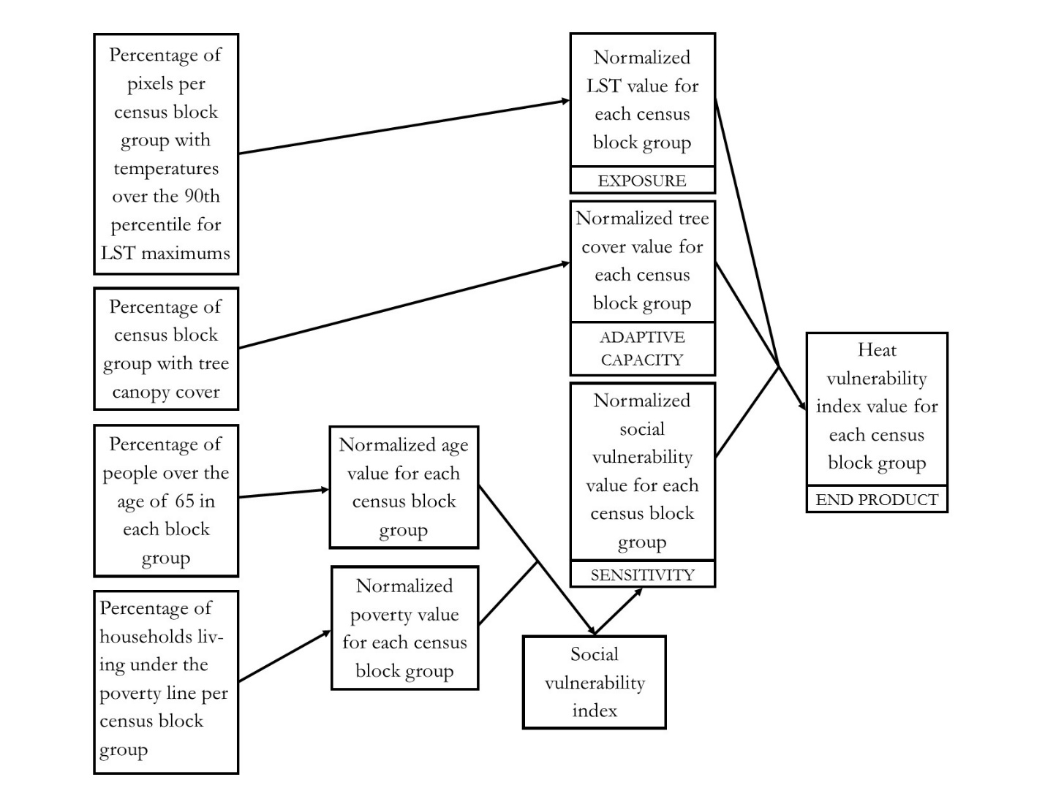

Figure B1. This flowchart shows the progression of normalization and aggregation for the creation of the heat vulnerability index.

***Appendix C***

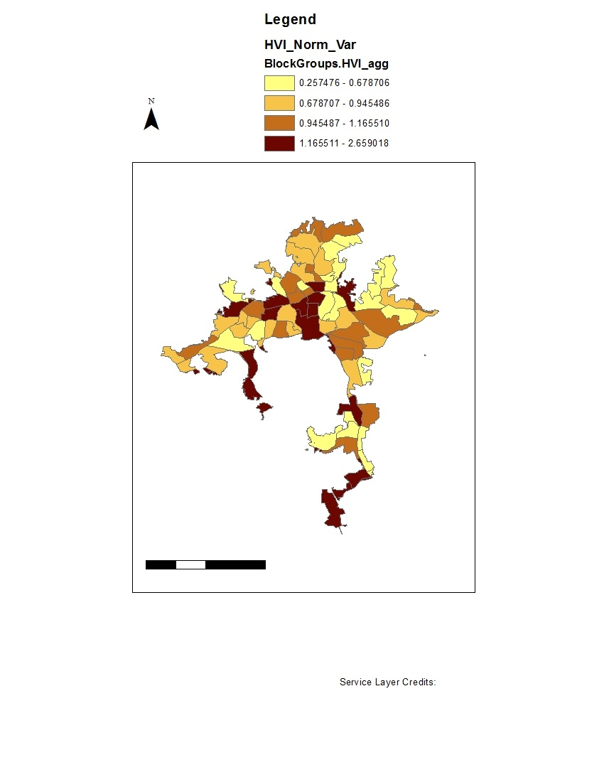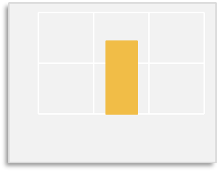

Lack of Tree Cover

LST

Social

0.5

1.0

0.0

Gorman Bridge

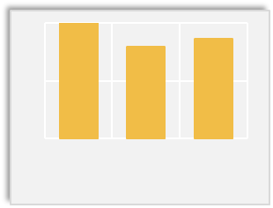

Lack of Tree Cover

LST

Social

0.5

1.0

0.0

Downtown

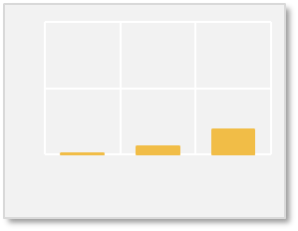

Lack of

Tree Cover

LST

Social

0.5

1.0

0.0

Asheville School



0 2.5 5 10 km



Highest

Lowest

**Heat Vulnerability**

Figure C1. This heat vulnerability index map includes bar graphs displaying the components of the index calculation for the downtown area, the area around Gorman Bridge in the northwest, and the area near Asheville School in the southwest.