**NASA DEVELOP National Program**

****Wise County Clerk of Court’s Office

**Fall 2015**

**Short Title: African Great Lakes Weather**

**Subtitle:** Utilizing NASA Earth Observations to Identify Indicators to Help Predict Deadly Storms over African Great Lakes

**VPS Title:** Victoria’s Secrets – Examining weather data over the Lake Victoria region

**Project Team & Partners**

**Project Team:**

Will Wilson (Project Lead), will.h.wilson@gmail.com

Annabel White

Grant Bloomer

Juan Antonio Chacon Castro

**Advisors & Mentors:**

Dr. Kenton Ross (NASA DEVELOP National Program)

Kristopher Bedka (NASA Langley Research Center – Climate Science Branch)

Dr. DeWayne Cecil (Global Science & Technology, Inc.)

Robert VanGundy (University of Virginia’s College at Wise)

Melanie Salyer (NASA DEVELOP WC)

**Partner Organizations:**

Kenya Meteorological Department (End-User/Boundary Organization), POC: Jon Mungai, Senior Meteorologist.

**Project Details**

**Applied Sciences National Applications Addressed:** Weather, Disasters, Ecological Forecasting

**Study Area:** Regions of Kenya, Tanzania, and Uganda

**Study Period:** 20 specific storm events taken from 2005 - 2013

**Earth Observations & Parameters:**

TRMM, LIS – lightning detections at ‘group’ level

MERRA IAU 2D atmospheric single-level diagnostics – gridded data on geopotential height, wind compnents, temperature, humidity, vertical pressure velocity, surface skin temperature

Meteosat, SEVIRI – infrared monitor

**Ancillary Datasets Utilized:**

* NASA Langley Research Center - Hazardous Storm Event Database

**Software Utilized:**

MATLAB R2015a – processing of data within Hazardous Storm Event Database

ArcMap 10.1 – NetCDF data import and image visualization

Python – conversion of data types/formats, batch processing in ArcGIS

**Project Overview**

**80-100 Word Objectives Overview:**

This project assists research at the NASA Langley Research Center’s Climate Science Branch with regards to storm origination and development over the East African Great Lakes, especially Lake Victoria. At intensity levels chosen to highlight extreme activity, measurements of certain environmental aspects were compiled from MERRA products and TRMM satellite data for each sample day. Statistical tests and reports for these days were generated and scrutinized in an effort to narrow down strong indicators that may be used in forecasting efforts.

**Abstract:**

The African Great Lakes lie along the East African rift valleys and play an important role in the economy and culture of the millions of people in the region. The regional governance of the lakes’ climate and weather, while less understood, is just as profound. Intense storms occur around the lakes with little warning and can create life-threatening hazards to unsuspecting fisherman, causing their fishing vessels to capsize or wreck. Finding correlations between climatic indicators that precede the onset of these storm events will aid the Kenya Meteorological Department in their ability to improve the forecasting efforts of local and regional authorities. Utilizing the overshooting top (OT) detections within the Hazardous Storm Event Database (derived from the SEVIRI sensor on the METEOSAT satellite), certain times of heightened detection were used as temporal study areas around which an assortment of meteorological data was compiled. MERRA products and TRMM LIS data were used in this term project as mediums of analysis for which intensity levels of OT frequency were compared statistically and spatially.

**Community Concerns:**

* The storms along the African Great Lakes can bring torrential rainfall, lightning, hail, and/or high winds, producing hazards which pose a major threat to the population and infrastructure of the surrounding countries.
* The areas affected by these storms have the highest population density in all of Africa because the lakes provide vital economic opportunities in the fields of fishing, tourism, and agriculture, for millions of people.
* Families in nearby countries depend on the African Great Lakes as a major food source. Fish caught in the lakes can account for up to 70% of the protein consumed by families in some areas.
* Approximately 5,000 people are killed every year by storms on Lake Victoria alone. Most of the victims are fishermen who depend on the lakes for their livelihood.
* No early warning system is in place to inform the public of storm events. This prevents fisherman and others from being able to adequately prepare for the dangers associated with the storms.

**Current Management Practices & Policies**:

Atmospheric monitoring practices in the East African Great Lakes are a collaborative effort between meteorological agencies from Kenya, Uganda, and Tanzania. Most of their work revolves around the forecasting of weather patterns from a series of ground-based meteorological observation sites. Recording temperature, pressure, relative humidity, and precipitation amounts, these sites forward information (at 15 minute to 1 hour intervals) to central forecasting offices in near real-time so that surface conditions can be assessed and mapped. Based on this information, the prospects of severe thunderstorms are included in both 24 hour and 4-day forecasts. Daily forecasts are also obtained from regional meso-scale models adapted from more global forecasting systems. These models do not take into account aforementioned surface data and are often uniform over large areas.

Forecast information is often circulated over a patchwork system of television reports, radio, and print media. A mobile text message alert system pilot program established in 2011 provided daily forecasts and other hazard information, but at that time did not cover the whole extent of the lake.

**Decision Support Tools & Benefits:**

|  |  |  |
| --- | --- | --- |
| **End-Product** | **Earth Observations Used** | **Benefit & Impact** |
| Statistical document highlighting correlations and ranges in values | TRMM – LIS  Compiled data from MERRA | Creates a foundation for future terms of this project, highlights significances in data |

**Project Imagery**

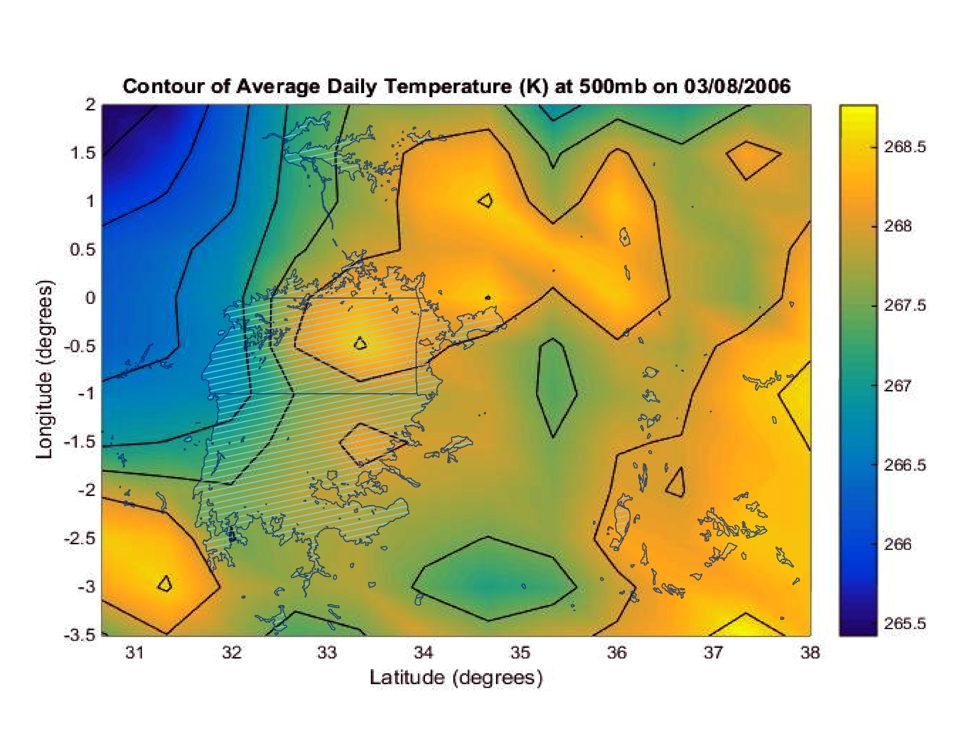

**Caption:** MERRA data processed and displayed as a contour image using MATLAB R2014b. Lake Victoria and surrounding lakes shown for reference and relevance.

**Image Credit:** Africa Great Lakes Weather Fall 2015 Team

**Image:** 2015Fall_WC_AfricanGreatLakesWeather_VPSImage_FD.jpg

**Software Release Requirements**

Category II