**NASA DEVELOP National Program**



University of Georgia

*Fall 2015*

Antarctica Climate

Applying NASA Earth Observations to Assess the Seasonal and Inter-annual Variability of Sea Ice Dynamics in McMurdo Sound, Ross Sea, Antarctica

**Technical Report** 

Rough Draft – October 8, 2015

Elizabeth Benyshek (Project Lead)

Christopher Cameron

Caren Remillard

Eduardo Rendon

Dr. Sally Walker, Department of Geology, University of Georgia (Science Advisor)

Dr. Adam Milewski, Department of Geology, University of Georgia (Science Advisor)

# I. Abstract

[Placeholder - do not put anything here until the final draft submission. The abstract in the project summary is where the working draft of the abstract should “live”]

**Keywords**

ICESat, MODIS, McMurdo Sound, Ross Sea, Sea Ice Topography, Remote Sensing

# II. Introduction

**Background**

In 2041, the Antarctic Treaty will be modified, and the environmental protection of the continent may be at risk. Due to the difficulty and high cost of conducting survey work in Antarctica, alternative methods are both necessary and of great value. The Ice, Cloud and land Elevation Satellite (ICESat) mission and the Moderate Resolution Imaging Spectroradiometer (MODIS) onboard Terra collected sea ice and temperature measurements that have been used to monitor changes in Antarctica (Zwally et al., 2008; Price et al., 2012; Price et al., 2013; Kern and Spreen, 2015). Previous research has shown these datasets are useful for characterizing local sea ice dynamics in conjunction with field data.

Waters surrounding Antarctica are rich in economically-important species, yet little is known about ecosystem interactions in relation to climate change. In particular, sea ice is integral to the health of Antarctic ecosystems. Decreased sea ice can lead to a decrease in nutrient supply, directly affecting productivity and population densities. Antarctica is unique in that the Ross Sea area has experienced a positive trend in sea ice extent and negative trend in sea surface temperature (Comiso et al., 2010; Drucker et al. 2011; Price et al., 2012; Price et al., 2013). However, other studies show significant warming trends over the West Antarctic ice sheet suggesting overall influences of the increasing atmospheric greenhouse gases on a long‐term basis (Comiso et al., 2011). Scientists working in this region have observed a gradual decrease in sea ice coverage since then (Price et al., 2013). Additional work related to changing ice conditions within the Ross Sea is needed to understand recent ice variability.

**Project Objectives**

The objective of this project is to examine historical and current ICESat and MODIS data to characterize seasonal and inter-annual variability in sea ice parameters including sea ice thickness, sea surface temperature, snow depth on sea ice, and sea ice extent. Additionally, the project will evaluate potential spatio-temporal correlations between these parameters along the coast of western McMurdo Sound, Antarctica. Particular attention will be paid to project partner field sites in Explorers Cove, Bay of Sails, and Ferrar Glacier.

**Study Area and Study Period**

To date, more is known about Arctic than Antarctic sea-ice volume and fundamental gaps in knowledge regarding environmental conditions remain. This project is focused on examining historical and current ICESat and MODIS data products to characterize seasonal and inter-annual variability in sea ice parameters including sea ice thickness, sea surface temperature, snow depth on sea ice, and sea ice extent in western McMurdo Sound, Antarctica (Figure 1).

Located within the Ross Sea, McMurdo Sound is an area of particular interest as it is the only sector in the Antarctic which has experienced a significant increase in sea ice extent during the satellite period (Comiso et al., 2010). The project’s study period coincided with the ICESat data coverage spanning from October 2003-October 2008. NASA’s Operation IceBridge, which collects data similar to ICESat, will be utilized to expand the temporal coverage of our dataset to examine more recent trends.

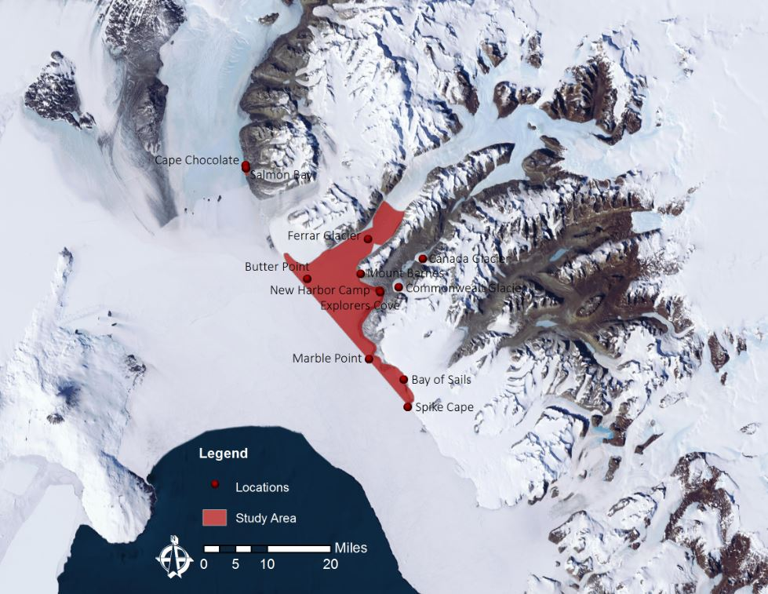

*Figure 1: Study Area Map including locations of interest*

**National Application Area**

NASA climate variability data is centered around providing global scale observational data sets on oceans and ice and their interactions within broader Earth systems. This study used these data to evaluate changes on a seasonal to decadal timescale to improve understanding of the role of sea ice in McMurdo Sound. Previous investigations have linked changes in the multiyear sea ice area of McMurdo

Sound, Antarctica (from 1213 km2 in 2003 to 4923 km2 in 2005) to the passage of large tabular icebergs preventing the annual sea ice breakout (Price et al., 2013). This maximum coverage then gradually diminished, by 2009 covering 1453 km2 (Price et al., 2013). This project will concentrate on the project partner’s field sites in Explorers Cove, Bay of Sails, and Ferrar Glacier.

**Project Partners**

Project partners at the Wadsworth Center and the University of Georgia believe the results of this project will be critical in helping them achieve their goal of expanding knowledge of processes in the Antarctic region. Currently, field collection is the only method project partners have for surveying ecological populations in association with sea ice dynamics. Remote sensing data provided to NSF Polar Programs and scientists, including project partner Dr. Sam Bowser, will supply baseline data to model ecosystems and aid in assessing ecological risk in response to climate change. To date, NASA products have not been tied to ecological impacts by directly measuring sea ice dynamics. However, these data can be used for long-term monitoring of Antarctic ecosystems and resource management decisions, essential for supporting Antarctica’s environmental conservation. For the first time, partners will have seasonal and inter-annual understanding of local sea ice conditions and will be able to visualize differences in sea surface conditions through the years. The spatial and temporal relationships of sea ice variables will help them understand conditions in McMurdo Sound outside of the field season.

# III. Methodology

**Data Acquisition**

The Ice, Cloud and land Elevation Satellite (ICESat) was utilized for this project. The Geoscience Laser Altimeter System (GLAS) onboard ICESat acquired a large volume of data between 2003 and 2008 using three laser sensors. These data have been applied to detect changes in Greenland and Antarctic ice sheets, sea ice freeboard heights, and the distribution of cloud and aerosols (Wang et al., 2011). ICESat is particularly valuable for polar studies, since its orbit inclination ensured a high concentration of observations at the high latitudes (Gunter et al. 2009). Sea-ice volume is an important parameter in identifying the impact of climate change at these higher latitudes, as has been shown for the Arctic (Schweiger et al., 2011).

ICESat provided measurements of polar ice sheet elevations using 1064 nanometers laser channel for surface altimetry that measures the time delay between the transmission of the laser pulse and the detection of the echo waveform from the surface (Zwally et al., 2008). The precision of ICESat measurements of mean surface elevations of flat surfaces is 2 centimeters over 70 meter laser footprints spaced at 172 meters, providing a powerful tool for studying sea ice freeboard and thickness (Zwally et al., 2008). The ICESat orbit extends to polar latitudes of 86°, and provides coverage of all sea ice in the Southern Ocean surrounding Antarctica and most of the sea ice in the Arctic Ocean (Zwally et al., 2008).

The interpolated, gridded ICESat data for each of the thirteen campaigns (Table 1) were downloaded from the Cryosphere Science Research Portal hosted by the NASA Goddard Space Flight Center. Point data for sea ice freeboard and thickness within McMurdo Sound was extracted in ArcGIS. This process was repeated for each ICESat campaign dataset to represent sea ice trends between the years 2003-2008. These ICEsat datasets are the result of an interpolation of mean sea ice values and represented by stereographic data with a 25 kilometer resolution.

|  |  |  |  |  |
| --- | --- | --- | --- | --- |
| **Year** | **February/March** | **March/April** | **May/June** | **October/November** |
| 2003 |  |  |  | X |
| 2004 | X |  | X | X |
| 2005 | X |  | X | X |
| 2006 | X |  | X | X |
| 2007 | X |  |  | X |
| 2008 | X | X |  | X |

*Table 1: ICESat campaign data coverage*

The Moderate Resolution Imaging Spectroradiometer (MODIS) is one of five instruments aboard NASA’s Terra Earth Observing System (EOS) platform launched in December 1999 (Platnick et al., 2003). MODIS provides datasets of sea ice extent, ice surface temperature, and sea surface temperature. MODIS products are based on the normalized difference between a visible and a shortwave-infrared band. Daytime sea ice extent and ice surface temperature were downloaded from the National Snow and Ice Data Center (NSIDC) data platform. These MODIS datasets contain tiles of daily 1 kilometer resolution sea ice extent and ice surface temperature. MODIS thermal infrared bands are used to derive temperature estimates of the top millimeter of the 1 kilometer pixel (EOS Data Products Handbook). Sea surface temperature data were downloaded from NASA GIOVANNI’s Ocean Color Radiometry Online Visualization and Analysis data browser.

**Data Processing**

The ICESat campaign data were downloaded as ASCII text files. This information was extracted and opened in text editor software then converted to spreadsheet format. This allowed us to display the coordinate points that contain the freeboard and ice thickness data in our study area. The ICESat data was organized in tables where a new column was created to eliminate the -999 values corresponding to data estimated on land. Using different ArcGIS tools, the ICESat point grids were clipped appropriately and symbolized according to temporal datasets. Our study area is covered by approximately 100 points and they were used to create interpolation maps using an inverse distance weighted (IDW) technique in ArcGIS.

Using ENVI 5.0, sea surface temperature data was rotated 270o and transposed to the correct orientation. Data was georeferenced to datum WGS-84 from -180E to 90N. The pixel size was adjusted for ease of analysis between datasets. For our study area, sea surface temperature was only available for the austral summer months (approximately December-March) during melt-out and ice surface temperature was used for the rest of the year.

**Data Analysis**

Historical and current ICESat and MODIS datasets were analyzed to characterize seasonal and inter-annual variability in sea ice parameters including sea ice thickness, sea surface temperature, snow depth on sea ice, and sea ice extent. The team also evaluated potential spatio-temporal correlations between these parameters.

# IV. Results & Discussion

Preliminary graphics from ICESat Data:

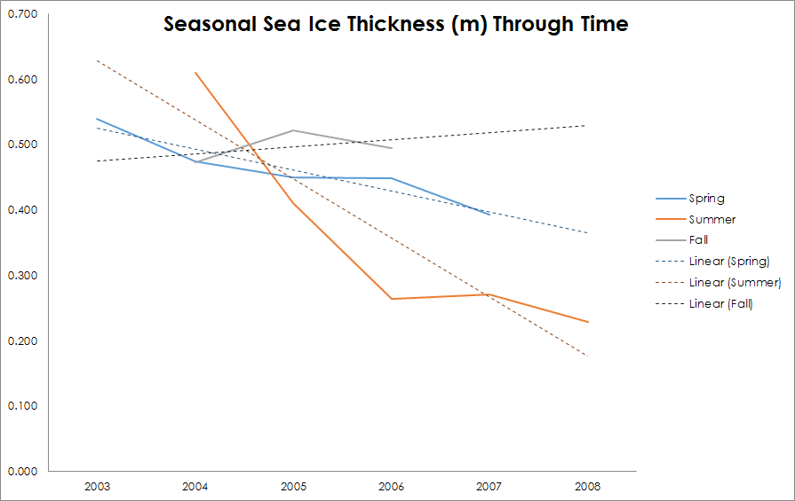

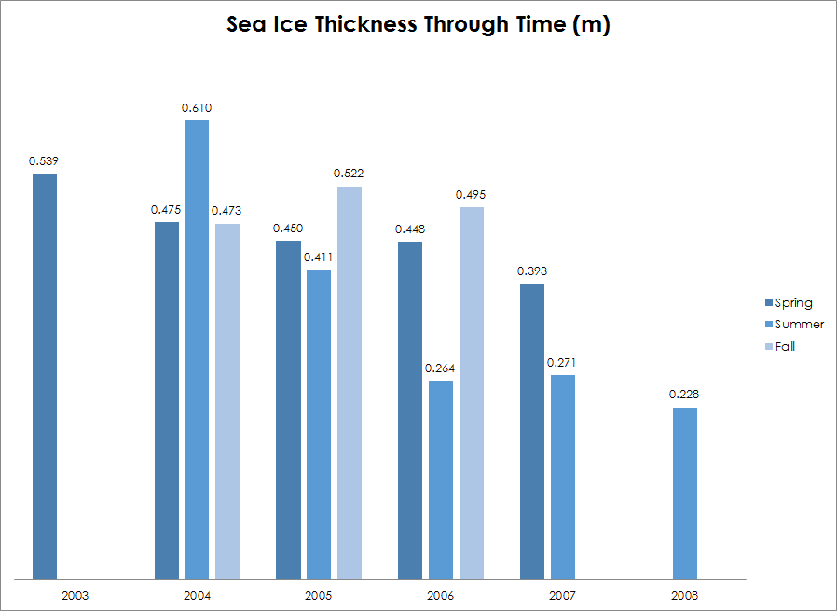

# V. Conclusions

# VI. Acknowledgments

Any opinions, findings, and conclusions or recommendations expressed in this material are those of the author(s) and do not necessarily reflect the views of the National Aeronautics and Space Administration.

This material is based upon work supported by NASA through contract NNL11AA00B and cooperative agreement NNX14AB60A.

# VII. References

Comiso, J., Kwok, R., Martin, S., & Gordon A. (2011). Variability and trends in sea ice

extent and ice production in the Ross Sea. *Journal of Geophysical Research*, 116, 1-19.

Drucker, R., Martin,S., and Kwok, R. (2011). Sea ice production and export from coastal

polynyas in the Weddell and Ross Seas. *Geophysical Research Letters,* 38, 1-4.

*EOS Data Products Handbook: Volume 1.* Retrieved from

http://eospso.nasa.gov/sites/default/files/publications/data_products_1.pdf

Gunter, B., Urban, T., Riva, R., Helsen, M., Harpold, R., Poole, S., Nagel, P., Schultz, B., &

Tapley, B. (2009). A comparison of coincident GRACE and ICESat data over Antarctica. *Journal of Geodesy*, 83 (11), 1051-1060.

Platnick, S., King, M.D., Ackerman, S. A., Menzel, W. P. , Baum, B. A. , Riedi, J. C., Frey, R.

(2003). The MODIS cloud products: algorithms and examples from Terra. *IEEE Geoscience and Remote Sensing,* 41 (2), 459-473.

Price, D., Rack, W., Haas, C., Langhorne, P. J., & Marsh, O. (2012). Assessment of sea ice

freeboard and thickness in McMurdo Sound, Antartica, derived by ground validated satellite altimeter data. *International Archives of the Photogrammetry, Remote Sensing and Spatial Information Sciences,* 39, 585-590.

Price, D., Rack, W., Haas, C., Langhorne, P. J., & Marsh, O. (2013). Sea ice freeboard in

McMurdo Sound, Antarctica, derived by surface-validated ICESat laser altimeter data. *Journal of Geophysical Research*, 118, 3634–3651.

Schweiger, A., Lindsay, R., Zhang, J., Steele, M., Stern, H., & Kwok, R. (2011). Uncertainty

in modeled Arctic sea ice volume. *Journal of Geophysical Research*, 116, 1-21.

Wang, X., Cheng, X, Gong, P., Huang, H., Li, Z., and Li, X. (2011). Earth science

applications of ICESat/GLAS: a review. *International Journal of Remote Sensing*, 32 (23), 8837–8864.

Zwally, H. J., Yi, D., Kwok, R., Zhao, Y. (2008). ICESat measurements of sea ice freeboard

and estimates of sea ice thickness in Weddell Sea. *Journal of Geophysical Research,* 113, 1-17.

# VIII. Content Innovation

In preparation for DEVELOP’s coming microjournal, please select three content innovation features to support your paper. For each item, please list the name of the feature, and include the tool itself if possible (eg. glossary terms and definitions). If the tool does not work in Microsoft Word (eg. Interactive MATLAB Figure Viewer), please list the file name and upload the related file to the DEVELOP Exchange. If you choose to use Inline Supplementary Material, please also include where the material should appear in the text.

**Some options include:**

AudioSlides

Database Linking Tool

Data Profile

Executable Papers

Featured Author Videos

Featured Multimedia for this Article (video and podcast options)

Glossary Viewer

Inline Supplementary Material (figures, tables, computer code)

Interactive Map Viewer

Interactive MATLAB Figure Viewer

Interactive Plot Viewer

Nomenclature Viewer

# IV. Appendices

Insert here