**Study Area Shapefile Deliverable Guidelines**

**Purpose**: study area shapefiles are used in impact maps and for reporting to higher-ups. This deliverable allows us to show NASA Headquarters how our program benefits the taxpayer, giving insight into where we are increasing workforce development and building capacity to use NASA Earth observations. Maps are used by NASA’s Applied Sciences program when reporting to members of Congress, so it is thus **extremely important** that these maps accurately reflect the extent of our projects’ impacts.

**Guidelines**:

* Create polygon shapefile of your study area
* Shapefile should contain only one feature
* Attribute table should contain a “Project” field where the project short title is listed
* Shapefile must be zipped and saved using standard nomenclature
* Final zipped shapefiles must be submitted via sharing or emailing directly with your PC point of contact.

**Specifications**:

* **Coordinate system**: GSC_WGS_1984
* **Shapefile nomenclature**: YYYYTerm_NODE_ProjectTitle_StudyArea.shp
* **Zip file nomenclature**: YYYYTerm_NODE_ProjectTitle_StudyArea.zip
* **Attribute table**:
  + **Field name**: Project
  + **Field type**: Text
  + **Content of field**: Write project short title (e.g., Lake Anna Water Resources)

**Instructions**:

* Submit ONE shapefile – if your study area is more than one location, please merge all study area sites into one shapefile.
* Shapefiles should contain only ONE feature – if your shapefile has more than one feature (check in attribute table), please merge them into one (Use Editor Toolbar > Merge)

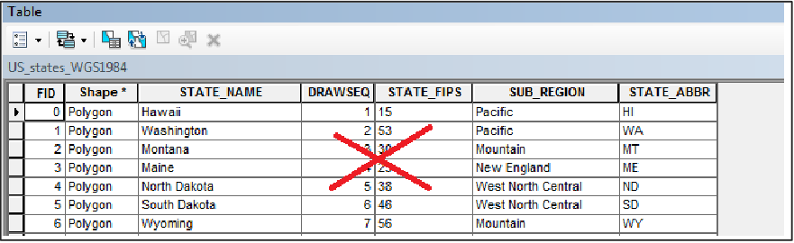

If your shapefile has multiple features, as in the example above, merge them into one.

* Attribute table should have one field called “Project,” with a field type of “Text,” with your project short title written in the field
  + *FID/OID ad Shape are required fields that you should not (cannot) delete. Delete all other attribute fields.
  + 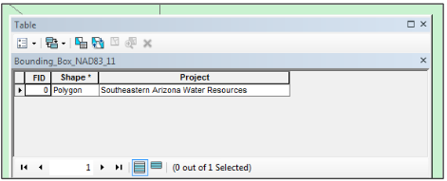Tip: Add your “Project” field before deleting your extra fields. Shapefiles must have at least one attribute field in addition to the required FID/OID and Shape fields so you will not be able to delete all of the unnecessary fields beforehand.

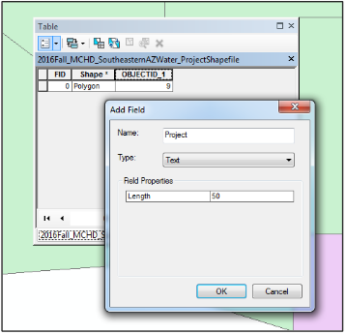

Left: ArcGIS screenshot of how to add the “Project” field

Above: Completed attribute table for submission

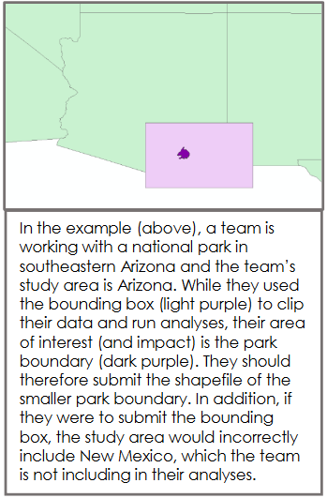

**Creating Your Shapefile**: While many teams make use of bounding boxes or an entire scene/tile of data to complete analyses (for ease, to avoid edge effects, etc.), for our purposes of showing impacts, please send us a shapefile that represents your ***actual area of interest, not a bounding box used for analysis, unless they are actually the same.***

**Regional and Larger Study Areas**: Only submit the entire state or country borders if your study area was that entire unit; otherwise, provide the subset of county, region, province, etc. boundaries of interest.

*\*\*****Important: Your shapefile must match the study area listed on your Project Summary. If through the course of the project, your study area changes to include additional states/countries not originally listed, ALL deliverabels must be updated to reflect that change (even after a final draft has been submitted).***