New York City Transportation & Infrastructure
Assessing Urban Heat Island Effects at Bus Stops in New York City’s Boroughs to Support Cooling Interventions


Technical Report
March 31st, 2023

Thomas Schindelman (Project Lead)
Emily Culling
Gianna Méndez Germán
Janna Chapman

Advisors:
Dr. Kenton Ross, NASA Langley Research Center (Science Advisor)
Lauren Childs-Gleason, NASA Langley Research Center (Science Advisor)
Dr. Medhi Heris, Hunter College (Science Advisor)

Fellow:
Julianne Liu (Virtual Environmental Justice)

1. Abstract
New York City, the most populous city in the United States, is threatened by exacerbated heat exposure due to the urban heat island (UHI) effect induced by its heavily urbanized environment and limited tree canopy cover. Decades of racist policy and planning have led extreme heat to disproportionately impact people of color and low-income residents, especially in the context of public transportation by bus. This NASA DEVELOP project partnered with Transportation Alternatives to identify the most heat vulnerable populations in the city, characterize the extent of urban heat, and complete an individual bus stop analysis. We utilized NASA Earth observations, including Landsat 8 Thermal Infrared Sensor (TIRS) and Landsat 9 TIRS-2 to determine UHI extent and anomalies. Leveraging data from the City of New York and the American Community Survey (ACS), we constructed a transportation-specific heat vulnerability index to understand intersecting social and economic vulnerabilities by performing a Principal Component Analysis. After identifying major hotspots in the Bronx, Queens, and Brooklyn, we modeled mean radiant temperature at the hottest and highest ridership bus stops identified by our UHI analysis to estimate thermal comfort using the Urban Multi-scale Environmental Predictor’s SOLWEIG tool. Our end products will be incorporated into Transportation Alternative’s Spatial Equity NYC dashboard and inform their community engagement strategies as they organize with residents to advocate for cooling interventions.

Key Terms: Environmental Justice, urban heat islands, public transportation, vulnerability

2. Introduction
2.1. Background Information
This study focuses on what is federally recognized as New York City (NYC), New York, on the ancestral lands of the Lenape people (Lenapehoking), during the period from 2017 to 2022. NYC is the most populous urban area in the United States, and is composed of five boroughs: the Bronx, Brooklyn, Manhattan, Staten Island, and Queens. The city covers a total area of 300 miles², and contains about 8.5 million people, with a diverse population of 31.9% White, 23.4% Black, 14.2% Asian, 28.9% Hispanic/Latino, and 0.5% Native American: the largest urban Indigenous population in the US (US Census Bureau, n.d.). This area remains of great importance to the Lenape people, as well as the population of over 100,000 other Indigenous people who live in the city (The Lenape Center, n.d.; NYC CHR, n.d.; Barnard, 2019).

NYC is recognized for its wide variety of transportation options, including one of the world’s oldest subway systems and extensive bus system, both administered by the Metropolitan Transportation Authority (MTA). The bus system receives 2.2 million riders per weekday along 300 bus routes and 16,000 stops across the five boroughs (MTA, 2020; USAWelcome, n.d.). While intended to improve service, the ongoing process to redesign bus networks takes years, leaving some stops and routes exposed to the elements or inaccessible, especially in historically redlined minority neighborhoods (MTA, 2022; Stacy et al., 2020). Oppressive public policies, as well as the displacement of Indigenous people and other minority groups, have perpetuated inequities in shade distribution and heat exposure, a disparity that has only further intensified with climate change induced extreme heat (Hoffman et al., 2020).

2.1.1 The Urban Heat Island Effect

The Urban Heat Island (UHI) effect is the phenomenon in which urban areas experience higher temperatures than surrounding rural and exurban areas due to the higher concentration of solar radiation-absorbing impervious surfaces (roads and buildings) and the lack of green space and canopy cover (EPA, n.d.). Exposure to extreme heat can lead to dangerous health effects including heat stroke, kidney disease, cardiovascular disease, and even death, especially when accompanied by air pollutants such as PM2.5 or surface-level ozone (Anenberg et al., 2020; Ebi et al., 2021). The UHI effect has serious implications on transportation accessibility as people are exposed to extreme heat while walking to and waiting for buses. Shade infrastructure, such as shelters and trees, can significantly reduce the impact of urban heat around bus stops (Park et al., 2021). However, urban greening can also have a gentrifying effect on minority and poor neighborhoods in the absence of policy intervention (Cool Neighborhoods NYC, n.d.; Gould and Lewis, 2018).

2.1.2 Urban Planning Background
Racist policy and planning practices of the past, and present, have shaped NYC’s inequitable geography (Sze, 2006). Black communities have been displaced from their homes due to redlining, decades of disinvestment, and forced removal due to urban ‘renewal’ projects (Fullilove, 2001; Sze, 2006). This displacement reinforced segregation, amplifying existing spatial inequities that still impact the city today (Fullilove, 2001; NYC Housing Preservation and Development, n.d.). Consequently, urban heat is experienced disproportionately, with Black and low-income New Yorkers facing the greatest impacts to their health (NYC Environment and Health, n.d.). Structural racism and income inequality diminishes access to the healthcare and cooling resources necessary to endure heat, and those who are linguistically isolated face additional barriers during extreme heat events (Hoffman et al., 2020).

2.1.3 Heat Vulnerability Index
Previous research has investigated urban heat and contextualized its effects with population data, canopy coverage, and other social factors to create vulnerability indices that indicate areas and populations most affected by the UHI effect (Corburn, 2009; Nayak et al., 2018; Van Der Hoeven et al., 2018; Hammer et al., 2020). Building off past DEVELOP projects such as Milwaukee Urban Development II, Yonkers Urban Development II, and Tempe Urban Development II (Keyes et al., 2022, Walechka et al., 2022, Boogaard et al., 2020), we analyzed vulnerable populations in NYC, incorporating socioeconomic, environmental and transportation factors.

2.2 Project Partners & Objectives
Transportation Alternatives (TA) is a non-profit organization with a fifty-year legacy of advocacy and community organizing for the reclamation of public space from cars in New York City. Originally focused on increasing bike accessibility, their mission has expanded to creating safer, more equitable streets and most recently, urban heat. Alongside collaborators at the Massachusetts Institute of Technology, TA built Spatial Equity NYC, an interactive dashboard that visualizes data related to public health, mobility, and environmental conditions. This accessible dashboard effectively communicates transportation-related data and its associated disparities, empowering grassroots change for better transportation within the city.
Our team conducted an urban heat island analysis to identify areas with the greatest heat exposure, incorporating satellite imagery from Landsat 8 TIRS and Landsat 9 TIRS-2. We then constructed a vulnerability measure working off NASA DEVELOP’s UHEAT 2.0 (Urban Heat Assessment Tool) (Agrawal et al., 2022) to identify five high vulnerability bus stops and routes. These map layers can be included in TA’s dashboard and our findings will inform their future advocacy for just distribution of cooling interventions as bus stops are redesigned.

3. Methodology
3.1 Environmental Justice Principles
We drew from the First National People of Color Environmental Leadership Summit’s Principles of Environmental Justice (1991) and the Jemez Principles of Democratic Organizing (1996) to create guiding principles for our research. As such, our research:
- Is based on mutual respect and justice for all peoples
- Emphasizes self-determination and bottom-up organizing
- Affirms the need for urban policies to rebuild our cities in balance with nature and provide fair access for all to the full range of resources
- Will operate through a community-centered lens
- Is committed to building strong relationships through transparency, accessibility, and reciprocity.
These principles guided our research interests, work with our community partners, and considerations in creating our vulnerability analysis.

3.1.1 Data Acquisition
We acquired NASA Earth observations from Landsat 8 TIRS, Landsat 9 TIRS-2, and ISS ECOSTRESS to calculate UHIs, as outlined in Table 1. We used Google Earth Engine (GEE) script written by the Fall 2022 Virtual Environmental Justice (VEJ) Milwaukee Urban Development II team (Keyes et al., 2022) to acquire daytime land surface temperature (LST) from Landsat 8 TIRS and Landsat 9 TIRS-2. To derive nighttime LST, our team requested Level 2 ISS ECOSTRESS imagery for LST (ECO2LSTE.001) and cloud masked (ECO2CLD.001) using the NASA Application for Extracting and Exploring Analysis Ready Samples (AppEEARS) for our study area and period.

Our team incorporated a range of ancillary datasets as captured in Tables 2 and 3. To obtain census tract level demographic information for NYC, we used the US Census Bureau’s American Community Survey Application Programming Interface (API). Following our analysis of UHIs and the creation of the vulnerability analysis, we used transit variables, as listed in Table 3, to determine vulnerable bus stops. We then acquired a 1-foot Digital Elevation Model (DEM), 6-inch Land Cover raster, and 1-foot Digital Surface Model data (Table 2) for NYC to model mean radiant temperature at the 5 high vulnerability stops.

Table 1
NASA Earth observations collected for Land Surface Temperature (LST) analysis
Source | Sensor | Product ID | Purpose | Image Dates | Acquisition Method | Spatial Resolution
Landsat 8 | TIRS | LANDSAT/TIRS/L T08/C02/Level-2 | Calculate daytime LST to identify and map urban heat islands. | 5/1/17 - 9/30/21 | GEE | 100-meter
Landsat 9 | TIRS-2 | LANDSAT/LC09/C02/T2_L2 | Calculate daytime LST to identify and map urban heat islands. | 5/1/22 - 9/30/22 | GEE | 100-meter
ISS | ECOSTRESS | ECO2LSTE.001 | Calculate nighttime LST to identify and map urban heat islands at nighttime. | 5/1/18 – 9/30/22 | AppEEARS | 70-meter

Table 2
Ancillary datasets collected for processing at different geographic levels and modeling with SOlar and LongWave Environmental Irradiance Geometry model (SOLWEIG)

Dataset | Source | Use | Year(s) | Data Type
City Council District Boundaries | City of New York | Analyze urban heat by city council districts | 2022 | Geographic boundary
Community Board District Boundaries | City of New York | Analyze urban heat by community board districts | 2022 | Geographic boundary
New York City Shapefile | City of New York | Define study area | – | Shapefile
Census Tract Boundary | US Census Bureau | Geographic unit for vulnerability analysis | _ | Geographic boundary
NYC Topobathymetric LiDAR Highest Hit Digital Surface Model (DSM) | New York State | Generate Building and Tree Digital Surface Models (DSM) to model T_{MRT} in SOLWEIG | 2017 | Raster
1 Foot Digital Elevation Model (DEM) | City of New York | Input to SOLWEIG to model T_{MRT} | 2022 | Raster
Land Cover Raster (6-inch resolution) | City of New York | Input into SOLWEIG to model T_{MRT} | 2017 | Raster
ERA5 Meteorological Data | Copernicus Climate Change Service | Input to SOLWEIG for continuous meteorological data | 2020 | Text

Table 3
Ancillary datasets collected for constructing vulnerability and transit stop analysis

Dataset | Source | Dates | Data Type
Bus Report Cards | Bus Turnaround Coalition | 2022 | Transit variable
NYC Bus GTFS (General Transit Feed Specification) | Open Mobility Data | 2022 | Transit variable
Bus Stops and Routes | City of New York | 2022 | Transit variable
Subway Stops | City of New York | 2020 | Transit variable
Ferry Stops | City of New York | 2020 | Transit variable
Annual Bus Ridership | Metropolitan Transportation Authority | 2017-2022 | Transit variable
Census Tract Boundary | US Census Bureau | 2021 | Geographic boundary
American Community Survey Demographic Information | US Census Bureau | 2017- 2021 | Sociodemographic variables
Average PM2.5 Concentrations | City of New York | 2008-2019 | Health and air quality variable
Existing Bus Shelters | City of New York | 2022 | Transit variable
Tree Canopy Cover | National Land Cover Database (NLCD) | 2011 | Environmental Variable
Population Working from Home per Census Tract | US Census Bureau | 2017-2021 | Sociodemographic variable

3.2 Data Processing
3.2.1 Heat Data
The UHI effect is measured by the factor of difference in heat between heavily urbanized areas and exurban, forested spaces. Following previous DEVELOP project methodologies, Yonkers Urban Development and San Diego Urban Development (Walechka et al., 2021; Dialesandro et al., 2021), we created a rural reference shapefile compositing approximately 30 miles², about one-tenth of the total area of NYC, from Wharton State Forest, Bass River State Forest, and Swan Bay. These nearby forested areas have similar climates and elevation ranges to NYC, making them a strong proxy for what land surface temperatures would be in NYC if it were not urbanized. We processed Landsat 8 TIRS, Landsat 9 TIRS-2, and ECOSTRESS imagery for both our rural reference and NYC shapefiles.

Using GEE, we derived daytime LST from Landsat 8 TIRS and Landsat 9 TIRS-2 data. We specified our study years as 2017-2021 for Landsat 8 TIRS and appended VEJ Milwaukee Urban Development II’s script (Keyes et al., 2022) to include more recent imagery from Landsat 9 TIRS-2 for 2021-2022. The code masked cloud, cloud shadow, and water pixels to generate median daytime LST rasters for land pixels only and converted LST from Kelvin to Fahrenheit. By using AppEEARS to acquire ECOSTRESS data, the imagery was subset and gridded prior to download. We subsequently filtered available data for nighttime hours, 0:00 to 5:00 Eastern Daylight Time, and masked clouds and cloud shadows pixels in ArcGIS Pro using code written by the VEJ Milwaukee Urban Development II team (Keyes et al., 2022).

3.2.2 Demographic Data
We obtained the demographic data for the PCA from the 2017-2021 5-year American Community Survey (ACS) in NYC using the Tidycensus package in R. We used the established code to obtain variables for percent minority, median household income, poverty status, percent population over 65, and percent over 65 living alone. We created additional variables for the number of people that commute to work by bus and the number of people that work from home. Each variable, except for median income, was converted to a percentage by dividing the value by the total population.
Additional environmental variables were collected and cleaned to include in the PCA. A 300 m raster of Particulate Matter (PM2.5) concentrations was downloaded from the City of New York. Using the extract function from the raster package in R, average PM2.5 values were collected per census tract. We downloaded a 30 m Tree Canopy Cover raster from the 2011 National Land Cover Database (NLCD), and the average values were also extracted to the census tract shapefile in R. Additionally, we downloaded a bus stop shelter vector layer from the City of New York and imported this shapefile and the census tract boundaries into ArcGIS Pro. We performed a spatial join between the census tracts and the bus stop shelters to get the number of shelters per tract. Finally, the number of bus transfers was extracted from the General Transit Feed Specification (GTFS) and spatially joined to a census tract layer. This result was saved as a CSV and was imported into R. The demographic and environmental variables were merged into a final dataset in R which was imported into a python script in Google Colaboratory to run the PCA, outlined in section 3.3.2.

3.2.3 Transit Data
To analyze heat vulnerability at the individual bus stop level, we looked at our UHI factor (as outlined in 3.3.1), proximity to other transportation, bus speed, bus reliability and presence of bus shelters. We generated UHI factor for each stop by processing a spatial join (nearest neighbor) for each bus stop, as based on the census tract level of analysis. To determine transit proximity for each stop, we obtained bus stop, subway stop, and ferry stop data from the City of New York and merged them into one layer. Then, we did a count within a 5-minute walking distance (0.25 miles) for each bus stop to create our Transit Proximity Index (TPI). Bus shelter data was joined by attribute to all bus stops, to identify which stops did or did not have shelters. Finally, route data was taken from the Bus Turnaround Coalition’s Bus Route report cards (which assigned scores to routes as a measure of speed, reliability, bus bunching and wait time). From the report card, letter grades were changed to numerical scores. These scores were joined by attribute to bus stops as based on the first stop listed. All these metrics were then used to determine study areas of interest, detailed in section 3.3.3.

3.2.4 SOLWEIG
Mean radiant temperature (T_{MRT}) is an essential metric of human thermal comfort that can provide a better indication of a bus rider’s felt experience while at a bus stop. It is determined by the temperature of surrounding surfaces and whether those surfaces, such as buildings or trees, provide shade (Rakha et al., 2017). After identifying the 6 study spots of interest, we estimated T_{MRT} using the SOLWEIG (SOlar LongWave Environmental Irradiance Geometry) model as a plug-in in QGIS. Landcover data, Digital Surface Models and a Digital Elevation Model for NYC were downloaded from the City of New York via NYC Open Data. For each study area determined from analysis in section 3.3.3, we used GDAL’s clip raster by extent in QGIS to create smaller extents for each of these 3 initial inputs. Then, we used raster calculator to create building only and tree only DSMs. For each selected bus stop, Urban Multi-scale Environmental Predictor’s (UMEP) Pre-Processing toolbox was used to generate a wall aspect, wall height, sky view factor, and re-classified land cover raster using the clipped DEM, DSM of surrounding trees, and DSM of buildings and clipped land cover raster.

3.3 Data Analysis
3.3.1 Identifying NYC’s Urban Heat Islands
After acquiring the median daytime LST raster for NYC during our study period, we generated zonal statistics on the rural reference vector in ArcGIS Pro to calculate the mean rural reference temperature. This provided a single reference point temperature from which we calculated the difference in daytime LST per pixel in NYC to ultimately visualize the UHI factor. We intended to repeat this process using the median nighttime LST rasters generated from processing ECOSTRESS data, however, the ECOSTRESS imagery for our study period appeared patchy and distorted. After significant troubleshooting, we were unable to diagnose the issue and could not quality check the data. We adjusted our methodology to focus on the daytime UHI factor, which was more pertinent to the analysis as bus ridership is significantly higher during daytime hours.

3.3.2 Principal Component Analysis
To create the vulnerability analysis, we ran a Principal Component Analysis (PCA) following the methods of the UHEAT 2.0 tool by the Spring 2022 Pop-Up Project (PUP) Urban Development DEVELOP team (Nisbet-Wilcox et al., 2020). The UHEAT 2.0 package contains a Python script for a PCA that compiles variables into related components to reduce dimensionality in the data. We first ran three separate PCAs from environmental, social, and transportation variables, each consisting of one principal component that was used to create an index. After some unexpected results, we shifted to using only one variable for the bivariate analysis. From these principal components, we selected the variable that explained most of the variability within that component. These selected variables were aggregated to the community district level using a spatial join in ArcGIS Pro. From the community district level layer, we generated a series of bivariate maps showing the relationships between land surface temperature and the selected environmental, social, and transportation variables for NYC. Lastly, we created layers at the route level to include in our map package.

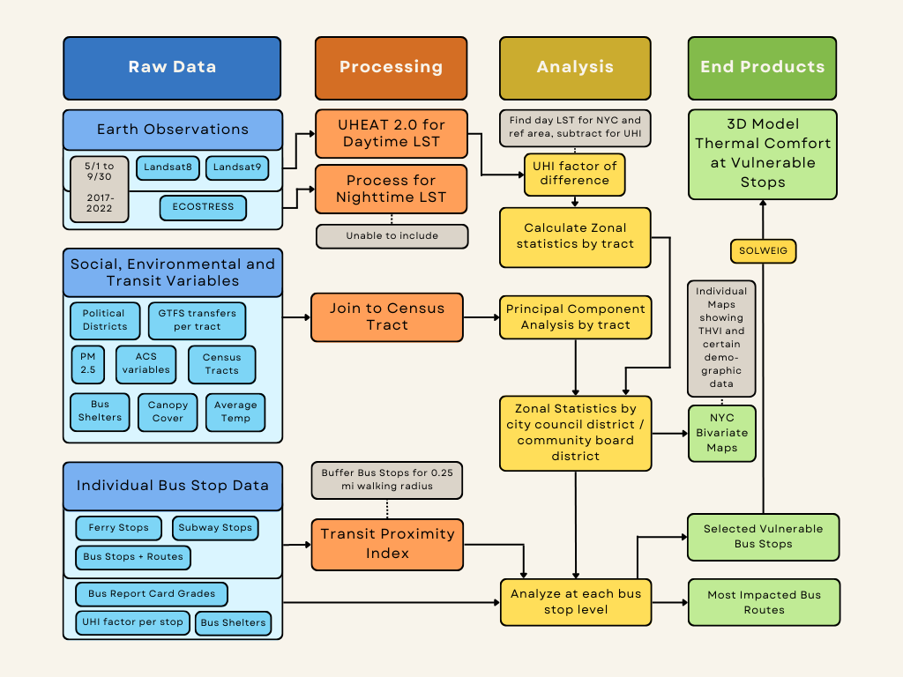
Figure 1. Flowchart outlining methodologies for data processing, data analysis, and end product creation.

3.3.3 Finding the Most Vulnerable Bus Stops and Routes
Utilizing the UHI factor, bus shelter data, bus report card grade and TPI score, we were able to identify vulnerable stops of interest. We narrowed down the data for each factor, only including stops in the 90th percentile of UHI factor, 10th percentile of TPI, unsheltered, and having received a D or F for route grade (see Appendix A for full city layers). Parsing through these reduced stops, we determined stops fitting all 4 criteria for each borough.

3.3.4 Mean Radiant Temperature (T_{MRT}) and 3D Modeling the Most Vulnerable Stops
We input the components listed in 3.2.4 into UMEP’s Mean Radiant Temperature (SOLWEIG) tool. Additionally, we input downloaded average meteorological data for the summer of 2019 via the ERA5 Python API created by the Copernicus Climate Change Service, following instructions in the SOLWEIG manual. Additionally, we used the default albedo and emissivity values and changed Physiological Equivalent Temperature (PET) parameters to better represent more socially vulnerable bus riders (elderly, female). Following this, we input our SOLWEIG file into UMEP’s SOLWEIG analyzer, generating maps, GIFs (Graphics Interchange Format) and charts reflecting mean radiant temperature and thermal comfort.

4. Results & Discussion
4.1 Analysis of Results
4.1.1 UHI Analysis
Median LST values ranged from 58°F to 128°F (Figure 2A). LSTs in NYC were 6.4°F hotter on average than the rural reference during our study period. However, UHI factors were highly unequal across the city with per pixel values ranging from 42°F to -25°F, with a median value of 7.5°F (Figures 2B and 3). Some districts were up to 5.6 °F cooler on average than the rural reference, such as in Central Park, and others up to 13.3 °F hotter, such as in parts of Queens and the Bronx. The hottest city council districts are 17, 21, 12, 14, and 16; the hottest community districts are Mott Haven/Melrose, Belmont/East Tremont, Hunts Point/Longwood, Morris Park/Bronxdale, and Kingsbridge Heights/Bedford. These districts experience the UHI effect most severely (Figures 5 A and B). The distribution of heat is highly inequitable, with districts that are largely lower income and have higher percentages of residents of Color experiencing the greatest median LST and UHI values during our study period.

A. B.
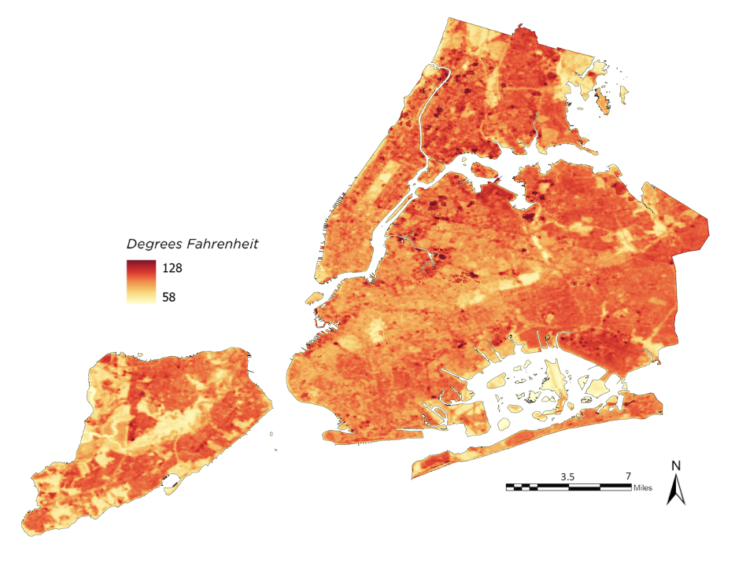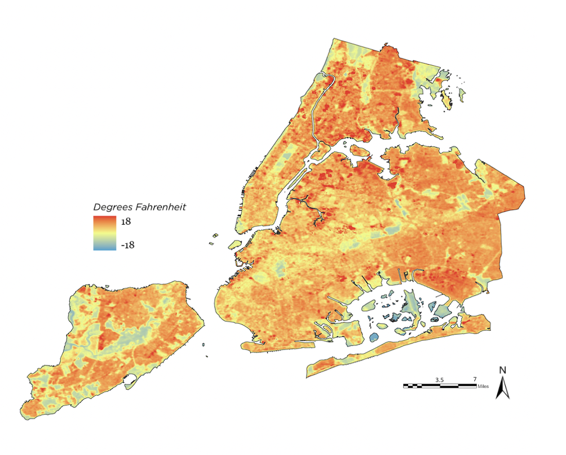
Figure 2. (A). Median LST Values for NYC. Dark red pixels indicate higher LST, light yellow pixels indicate lower LST. (B.) UHI Factor of Difference per pixel in NYC. Dark red pixels indicate high UHI, light yellow pixels indicate no UHI effect, blue pixels indicate cooling effect.
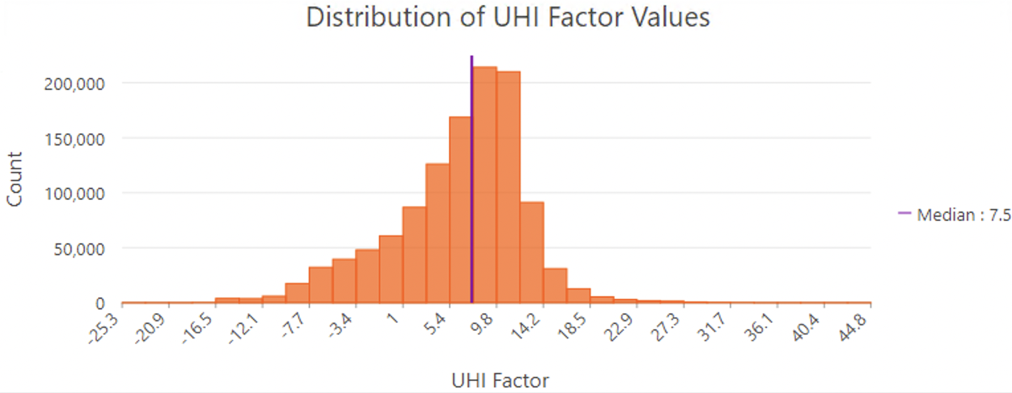
Figure 3. The Distribution of UHI Factor Values. Median is plotted in purple.

A. B.
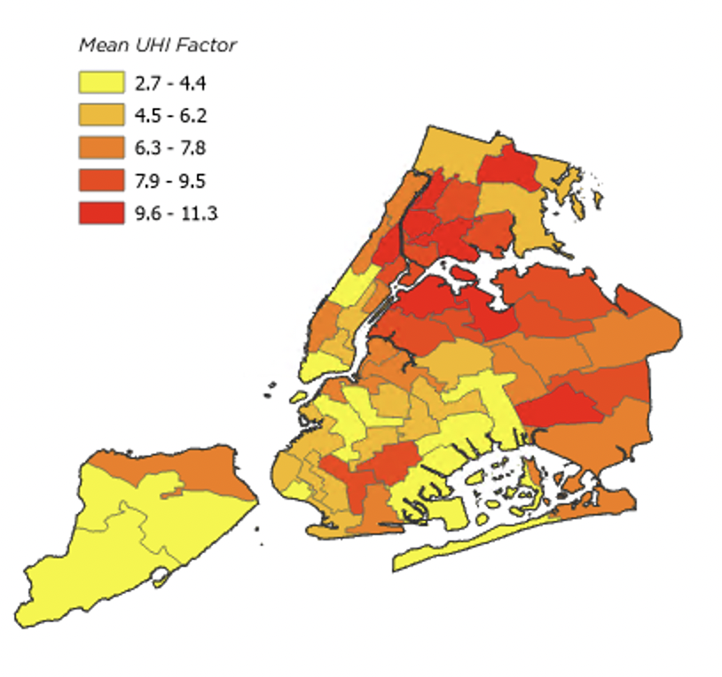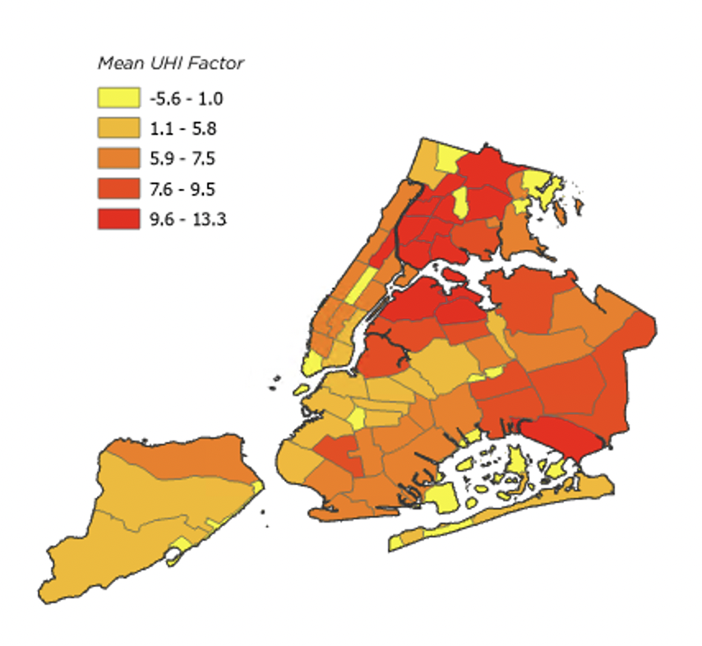
Figure 5. (A.) Average UHI Factor per City Council District. (B.) Average UHI Factor per Community Board District.

4.1.2 Principal Component Analysis and Heat Vulnerability Analysis
We ran three PCAs, creating one principal component each based on the demographic, environmental and transportation related variables established in 3.2.2. We made bivariate choropleth maps of these variables with LST. An example is shown in Figure 6A below. In this map we see districts in low vulnerability in the Bronx and districts with high vulnerability in Manhattan. Both observations are the opposite of what we expect based on the literature. Upon further analysis and discussions with our partners, we decided to modify our analysis to better represent patterns of vulnerability in NYC.
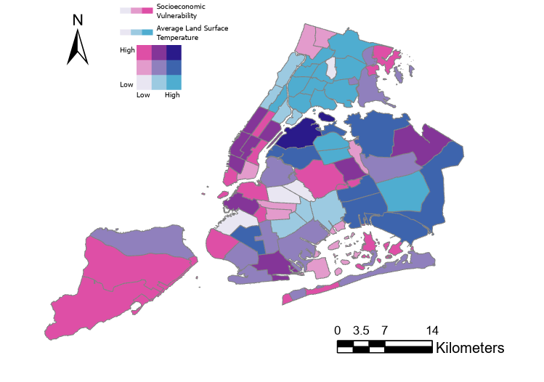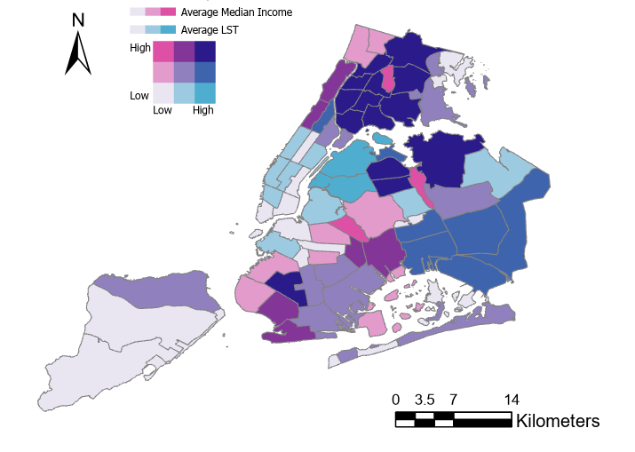
Figure 6. (A.) Bivariate Choropleth Map of Average LST and the Social Vulnerability Index. (B.) Bivariate Choropleth Map of Average LST and Average Median Income.
Based on these discussions, for each principal component from each run of the PCA, we selected the variable that explained the most variability in the data. Average median income, average canopy cover and percent of people that commute to work by bus were selected and explained 84%, 83% and 72% of the variability from the demographic, environmental and transportation PCAs, respectively. After aggregating these variables from the census tract level to the community district level, the variables were mapped in ArcGIS Pro. Based on the assumption that lower income populations are more vulnerable to heat, we find that the most vulnerable populations are in the Bronx and the least vulnerable populations are in Manhattan (Figure 7). Also based on a similar assumption, the greater commuters to work by bus are located in the Bronx and Staten Island and represent vulnerable populations in terms of transportation (Figure B2). In an opposite pattern, lower canopy cover represents higher vulnerability to heat and these areas are located in Manhattan and Brooklyn (Figure B1).
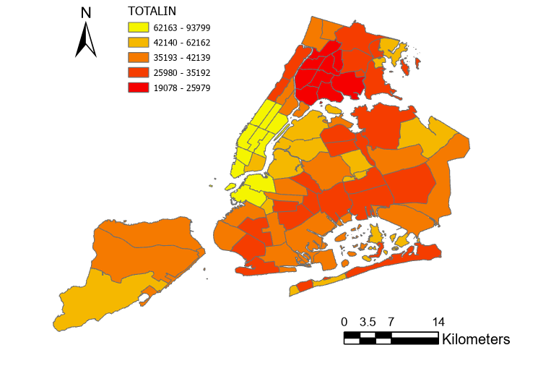
Figure 7. Choropleth map of the Average Median Household Income per Community District.
To further demonstrate the relationship between vulnerable populations and land surface temperature, we created bivariate choropleth maps of the three selected variables per community district. Here, we focus on the most vulnerable districts and those that experience higher land surface temperatures. For average median income these vulnerable districts are mainly located in the Bronx and the least vulnerable populations are in Staten Island and Manhattan. This pattern also applies to the relationship between bus commuters to work and LST (Figure C2). The most vulnerable districts in terms of canopy cover are located in sections of Queens, Brooklyn and the Bronx (Figure C1).
4.1.3 Identifying High Vulnerability Bus Stops and Routes
By compiling layers for bus stops in the 90th percentile of UHI factor, bus stops within the 10th percentile of TPI, unsheltered bus stops and bus stops with D or F report cards, we were able to identify which stops included all 4 vulnerability criteria and select five high vulnerability study stops (Figure 8). We selected one stop for each borough: Halleck St/Spofford Av off of the Bx6/Bx6+ in the Bronx, 60 St/16 Av off of the B9 in Brooklyn, Merrymount St/Travis Av off of the S61/S91 in Staten Island, Junction Bl/37 Av in Queens off of the Q72 and E 128 St/3 Av off of the M125 in Manhattan. Additionally, we identified the routes with the highest UHI factor across the entirety of the route (Figure 9). The five routes with the highest UHI factor were: BX41/BX41+, Q18, Q66, Q101, Q102. Four out of five routes were in Queens, which makes sense as these routes through the some of the City Council Districts with the highest UHI factors, as identified in Figure 5A.

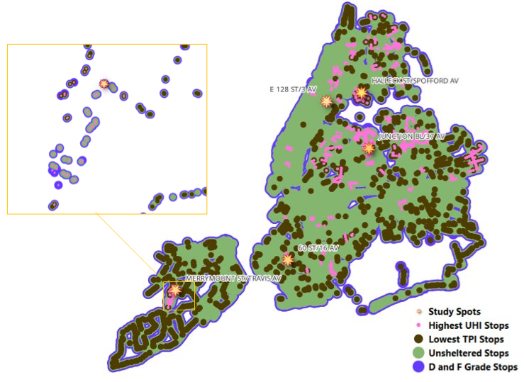
Figure 8. High vulnerability stops for UHI factor, shelter, TPI and bus report card and identified study spots that fit all 4 criteria.

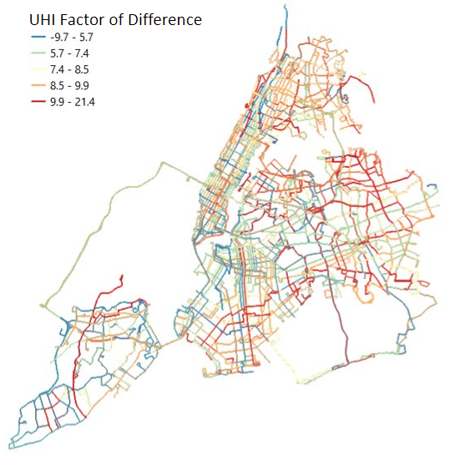
Figure 9. Bus routes by UHI factor of difference averaged across their entire line.

4.1.4 Modeling High Vulnerability Bus Stops
SOLWEIG modeling and post processing in SOLWEIG Analyzer for each stop resulted in maps that illuminate how each stop experiences heat throughout the day (Figure 10). Figure 11 highlights where existing shade infrastructure helps as well as where future shade infrastructure is sorely needed. Additionally, SOLWEIG modeling underscores how urban heat affects bus riders throughout both day and night (Figure 12). Figures for the other study stops can be found in Appendix D. Some study spots chosen did not exemplify heat exposure as we had anticipated, pointing to the need for further nuance in our transit modeling methodology.

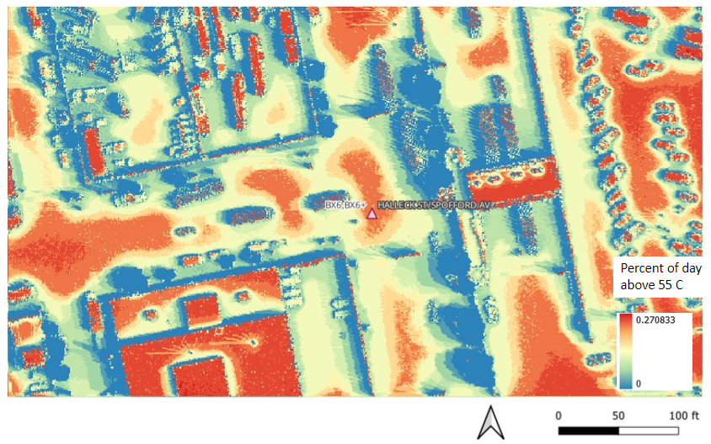
Figure 10. Percent of day each pixel in Halleck St/Spofford Av Bus Stop was above 55 degrees Celsius T_{MRT}.

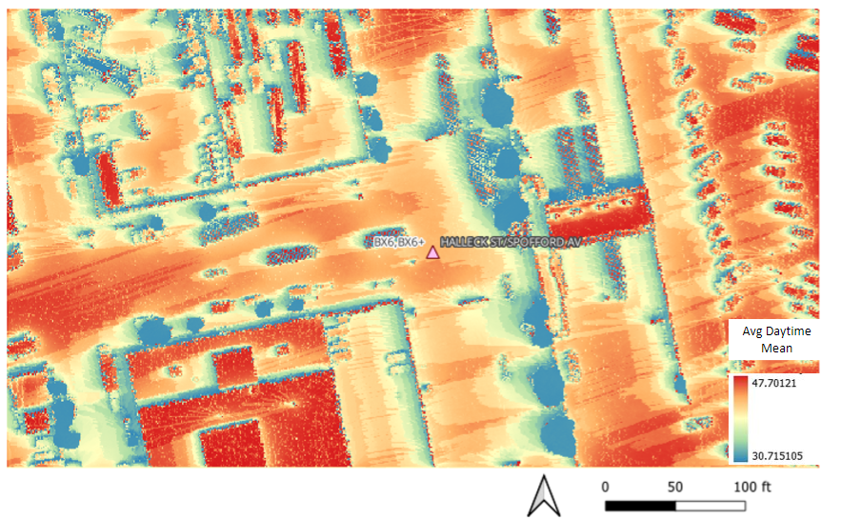
Figure 11. Average Daytime Mean T_{MRT} in Celsius for Halleck St/Spofford Av Bus Stop.
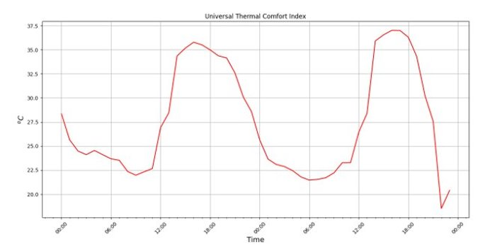
Figure 12. Universal Thermal Comfort Index for Halleck St/Spofford Av Bus Stop in Celsius.

4.1.5 Limitations & Uncertainties
While vulnerability indices can be invaluable tools for providing an overarching picture of issues like urban heat exposure, we acknowledge the shortcomings inherent to aggregating data and the ensuing loss of important nuance that comes with it (Corburn, 2009). As mentioned previously, ISS ECOSTRESS data was patchy and unusable for our study area and study period, reducing the ability for our modeling to include nighttime urban heat. Regarding the vulnerability index, we address limitations in our understanding of the underlying social, transportation and environmental factors that may affect the PCA and our interpretation of the results. Additionally, metrics for identifying vulnerable stops were rudimentary, being limited both by time and expertise in processing and analyzing transit data. Measures of bus wait time and bus bunching could have been more comprehensive in our analysis, as the Bus Turnaround Coalition’s Bus Report Card did not give an exact value and had missing data for some routes. Finally, our lack of expertise in using SOLWEIG led us to use base values for certain metrics, influencing the quality and nuance of the model.

4.2 Future Work
Given the difficulty and uncertainty with assessing vulnerability, future work should focus on determining why we see our given results and if the results are reversed as hypothesized. Refining the variables that are used in the analysis could aid in the optimization of the PCA. It would also be helpful to explore other methods of creating vulnerability indices to compare for accuracy. Further investigation into the errors that arose from capturing ECOSTRESS data could be helpful for future analyses of LST in NYC. Additionally, further analysis using SOLWEIG could aid TA in identifying stops and routes to focus on in their advocacy.

5. Conclusions
Using Landsat 8 TIRS and Landsat 9 TIRS-2 NASA Earth observation data, we determined the hottest community board and city council districts in NYC based on LST and UHI factors. Landsat imagery proved to be a useful data source for the creation of UHI anomaly rasters in comparison with the rural reference due to its spatial and temporal resolution. We attempted to create an index of vulnerable districts in NYC, however, the preliminary results might not accurately reflect the patterns of public transit, socioeconomic and environmental vulnerabilities in the city. These unexpected results from the analysis highlight the complexity of vulnerability indices in their creation and how they are interpreted. The results we were able to obtain from the vulnerability analysis using raw data demonstrate that vulnerable populations in the Bronx have the highest risk of heat exposure. Through basic analysis, we determined vulnerable bus stops and routes within the city, which aligned with existing social vulnerabilities. We then were able to model thermal comfort at these vulnerable stops using SOLWEIG, highlighting the importance of shade infrastructure and transit amenities in mitigating urban heat creating to visualize what community members are already experiencing:

Thankfully the bus stops near me have shelters. Although they protect you from the rain, they offer no shade—good for the winter, but bad for the summer. As a result, I have to stand behind the shelter or under a big nearby tree. Which means I don't have access to seating and I have to remain vigilant to make sure the bus driver sees me and doesn't skip the stop. I'm glad that summertime heat is being looked into more because it's a serious issue for bus riders.
Samuelito, Southeast Queens

With further refinement, these results can support TA’s advocacy for cooling interventions in the most heat vulnerable locations in the city through their Spatial Equity NYC dashboard or as part of their 25x25 campaign.

6. Acknowledgments

- Philip Miatkowski - Director of Research, Transportation Alternatives
- Em Friedenberg - Senior Research Coordinator, Transportation Alternatives
- Samuelito – Community Member, Transportation Alternatives
- Dr. Mehdi Heris – Science Advisor, Hunter College
- Dr. Kenton Ross – Science Advisor, NASA Langley Research Center
- Lauren Childs-Gleason – Science Advisor, NASA Langley Research Center
- Julianne Liu – DEVELOP Fellow, SSAI
- Cecil Byles – DEVELOP Project Coordination Senior Fellow, SSAI
- Lisa Tanh – DEVELOP Project Coordination Fellow, SSAI

Any opinions, findings, and conclusions or recommendations expressed in this material are those of the author(s) and do not necessarily reflect the views of the National Aeronautics and Space Administration. This material is based upon work supported by NASA through contract NNL16AA05C.

7. Glossary

American Community Survey (ACS) - US Census Bureau demographics survey, providing more regularly gathered data than the 10-year census
Digital Elevation Model (DEM) - raster of earth’s surface (does not include trees, buildings or anything besides topography)
Digital Surface Model (DSM) - raster of earth surface and trees, buildings and any other natural or artificial features
Earth observations – Satellites and sensors that collect information about the Earth’s physical, chemical, and biological systems over space and time
GDAL – translator library in QGIS used for processing raster and vector data
General Transit Specification Feed (GTFS) - Real time and static transit data published by public transportation agencies
Land Surface Temperature (LST) - temperature of earth’s surface as measured by earth observations such as Landsat 8 and Landsat 9
Mean Radiant Temperature (T_{MRT})- measure of the radiant heat felt by a human by their surroundings. It is related to thermal comfort and provides a more accurate picture of felt experience.
Particulate Matter 2.5 (PM2.5) - Tiny particles in the air that are less than 2.5 microns in width which can cause serious respiratory damage.
Physiological Equivalent Temperature (PET) - Thermal comfort index based on a model of human energy balance
Principal Component Analysis (PCA) - mathematical method of reducing the number of variables a data set has by grouping variables that correlate with each other and that explain most of the variability in the data. QGIS – free and publicly available geographic information system software, used for processing vector and raster geographic data
Redlining – A practice of denying buyers housing and banks loans from certain neighborhoods as based on Home Owner’s Loan Corporation’s racist neighborhood ranking system
SOLWEIG (SOlar and LongWave Environmental Irradiance Geometry model) - Model that simulates T_{MRT} in complex urban settings, providing modeling of thermal comfort, shade and other metrics of heat.
Transit Proximity Index (TPI) - number of other public transportation options (subway stops, ferry stops, other bus stops) within a 5-minute walking distance (0.25 mi) for each bus stop.
Universal Thermal Comfort Index (UTCI) - Thermal comfort index based on wind, air temperature, relative humidity and T_{MRT}
Urban Heat Island (UHI) - The phenomenon of urbanized spaces experiencing heat more intensely than their exurban or rural counterparts
Urban Multi-scale Environmental Predictor (UMEP) - Series of tools for analyzing climate data, including SOLWEIG
Urban Renewal – A tool by local governments to ‘revitalize’ parts of cities that are poorer and/or minority-majority; uprooting and displacing communities of color

8. References
Agrawal, A., Machuca, V., Cho, M., & Farid, Z. (2022). Increasing Capabilities and Updating the Urban Heat Exposure Assessment for Tempe (UHEAT) Tool. [Unpublished Manuscript]. NASA DEVELOP National Program, Pop Up Project.
Anenberg, S. C., Haines, S., Wang, E., Nassikas, N., & Kinney, P. L. (2020). Synergistic health effects of air pollution, temperature, and pollen exposure: A systematic review of epidemiological evidence. Environmental Health, 19(1), 130. https://doi.org/10.1186/s12940-020-00681-z
Boogaard, S., Dialesandro, J., Steiner, B., & Pang, Y. S. A. (2020). Tempe Urban Development II: Establishing an Urban Heat Exposure Severity Score for Infrastructure Prioritization in Tempe, Arizona, Using NASA Earth Observations and LiDAR. [Unpublished Manuscript]. NASA DEVELOP National Program, Arizona – Tempe. https://ntrs.nasa.gov/citations/20205011643
Burrows, E. G., & Wallace, M. (1998). Gotham: A History of New York City to 1898. In Gotham: A History of New York City to 1898 (pp. xi–13).
Bus Network Redesign. (n.d.). MTA. Retrieved February 7, 2023, from https://new.mta.info/project/bus-network-redesign
CCHR Land Acknowledgment. (n.d.). New York City Commission on Human Rights (NYC CHR). Retrieved February 7, 2023, from https://www.nyc.gov/site/cchr/about/cchr-land-acknowledgment.page
Corburn, J. (2009). Cities, Climate Change and Urban Heat Island Mitigation: Localising Global Environmental Science. Urban Studies, 46(2), 413–427. https://www.jstor.org/stable/43197961
Cool Neighborhoods NYC: A Comprehensive Approach to Keep Communities Safe in Extreme Heat (pp. 5–43). (2017). The City of New York.
Dialesandro, J., Kruskopf, M., Marvin, M. C., & Vargas, M. (2021). San Diego Urban Development: Utilizing NASA Earth Observations to Identify Drivers of Extreme Urban Heat and Generate a High-Resolution Vulnerability Index for Urban Planning and Climate Resiliency in San Diego, California. [Unpublished Manuscript]. NASA DEVELOP National Program, Arizona – Tempe. https://ntrs.nasa.gov/citations/20210015142
Earth Resources Observation And Science (EROS) Center. (2013). Collection-2 Landsat 8-9 OLI (Operational Land Imager) and TIRS (Thermal Infrared Sensor) Level-2 Science Products [Data set]. U.S. Geological Survey. https://doi.org/10.5066/P9OGBGM6
Ebi, K. L., Capon, A., Berry, P., Broderick, C., Dear, R. de, Havenith, G., Honda, Y., Kovats, R. S., Ma, W., Malik, A., Morris, N. B., Nybo, L., Seneviratne, S. I., Vanos, J., & Jay, O. (2021). Hot weather and heat extremes: Health risks. The Lancet, 398(10301), 698–708. https://doi.org/10.1016/S0140-6736(21)01208-3
Fullilove, M. T. (2001). Root shock: The consequences of African American dispossession. Journal of Urban Health : Bulletin of the New York Academy of Medicine, 78(1), 72–80. https://doi.org/10.1093/jurban/78.1.72
Gould, K. A., & Lewis, T. L. (2018). From Green Gentrification to Resilience Gentrification: An Example from Brooklyn. City & Community, 17(1), 12–15. https://doi.org/10.1111/cico.12283
Hammer, J., Ruggieri, D. G., Thomas, C., & Caum, J. (2020). Local Extreme Heat Planning: An Interactive Tool to Examine a Heat Vulnerability Index for Philadelphia, Pennsylvania. Journal of Urban Health, 97(4), 519–528. https://doi.org/10.1007/s11524-020-00443-9
Hoffman, J. S., Shandas, V., & Pendleton, N. (2020). The Effects of Historical Housing Policies on Resident Exposure to Intra-Urban Heat: A Study of 108 US Urban Areas. Climate, 8(1), Article 1. https://doi.org/10.3390/cli8010012
Hook, S., Hulley, G. (2019). ECOSTRESS Land Surface Temperature and Emissivity Daily L2 Global 70 m V001 [Data set]. NASA EOSDIS Land Processes DAAC. Accessed 2023-02-22 from https://doi.org/10.5067/ECOSTRESS/ECO2LSTE.001
Interactive heat vulnerability index. (n.d.). NYC Environment & Health Data Portal. Retrieved February 6, 2023, from https://a816-dohbesp.nyc.gov/IndicatorPublic/beta/key-topics/climatehealth/hvi/
Jemez Principles for Democratic Organizing. (1996). Southwest Network for Environmental and Economic Justice. https://www.ejnet.org/ej/jemez.pdf
Keyes, N., McLaren, C., Phan, N. and Vasquez, D., 2022, December. Milwaukee Urban Development II: Assessing the Drivers of Urban Heat Vulnerability in Milwaukee Using NASA Earth Observations​. [Unpublished Manuscript]. NASA DEVELOP National Program, Virtual Environmental Justice.
Nayak, S. G., Shrestha, S., Kinney, P. L., Ross, Z., Sheridan, S. C., Pantea, C. I., Hsu, W. H., Muscatiello, N., & Hwang, S. A. (2018). Development of a heat vulnerability index for New York State. Public Health, 161, 127–137. https://doi.org/10.1016/j.puhe.2017.09.006
New York City Public Buses—How to Get Around NYC by Bus. (n.d.). Retrieved February 6, 2023, from https://www.newyorkwelcome.net/explore/what-to-know/public-buses.htm
Nisbet-Wilcox, B., Meltzer, S., Nelson, S., Wagner, C., & Hondula, D. (2020). Assessing Land Surface Temperature, Vegetation Cover, and Compounding Vulnerability Factors to Identify High Priority Areas for Cooling Initiatives in Philadelphia, Pennsylvania. [Unpublished manuscript]. NASA DEVELOP National Program, Arizona – Tempe.
Park, Y., Guldmann, J.-M., & Liu, D. (2021). Impacts of tree and building shades on the urban heat island: Combining remote sensing, 3D digital city and spatial regression approaches. Computers, Environment and Urban Systems, 88, 101655. https://doi.org/10.1016/j.compenvurbsys.2021.101655
Principles of Environmental Justice. (1991). First National People of Color Environmental Leadership Summit. https://ejnet.org/ej/principles.html
Rakha, T., Zhand, P., & Reinhart, C. (2017, August 7). A Framework for Outdoor Mean Radiant Temperature Simulation: Towards Spatially Resolved Thermal Comfort Mapping in Urban Spaces. Proceedings of Building Simulation 2017: 15th Conference of IBPSA. https://doi.org/10.26868/25222708.2017.677
Stacy, C., Su, Y., Noble, E., Stern, A., Blagg, K., Rainer, M., & Ezike, R. (n.d.). Access to Opportunity through Equitable Transportation: Lessons from Four Metropolitan Regions.
Subway and bus facts 2019. (2020, April 14). MTA. https://new.mta.info/agency/new-york-city-transit/subway-bus-facts-2019
Sutton, M. (2016, June 3). Flood Damage to Trees after Hurricane Sandy: Lessons and Surprises. New York State Urban Forestry Council. https://nysufc.org/flood-damage-trees-hurricane-sandy-lessons-surprises/2016/06/03/
Sze, J. (2006). Environmental Justice, Urban Planning and Community Memory in New York City. In S. H. Washington, H. Goodall, & P. Rosier, Echoes from the Poisoned Well: Global Memories of Environmental Injustice (pp. 171–183). Lexington Books.
The Lenape Center—Lenapehoking. (n.d.). Lenape Center. Retrieved February 7, 2023, from https://thelenapecenter.com/
Urban Renewal. (n.d.). NYC Housing Preservation and Development. Retrieved February 6, 2023, from https://www.nyc.gov/site/hpd/services-and-information/urban-renewal.page
U.S. Census Bureau QuickFacts: New York city, New York. (n.d.). Retrieved February 2, 2023, from https://www.census.gov/quickfacts/newyorkcitynewyork
US EPA. (2014, February 28). Heat Island Effect [Collections and Lists]. https://www.epa.gov/heatislands
Van Der Hoeven, F., & Wandl, A. (2018). Hotterdam: Mapping the social, morphological, and land-use dimensions of the Rotterdam urban heat island. Urbani Izziv, 29(1), 58–72. https://www.jstor.org/stable/26446683
Walechka, J., Bills, T., Greenler, K., Sabrin, S., & Scarmuzza, J. (2021). Yonkers Urban Development: Utilizing NASA Earth Observations to Identify Environmental and Social Drivers of Urban Heat Vulnerability and Model Urban Cooling Interventions in Yonkers, New York [Unpublished manuscript]. NASA DEVELOP National Program, Arizona – Tempe.

9. Appendices

Appendix A: Maps included in high vulnerability bus stop analysis

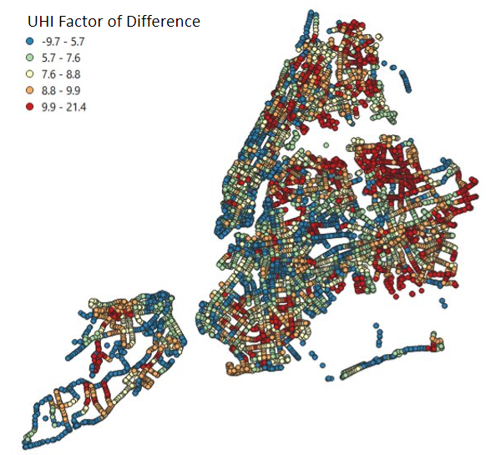
Figure A1. NYC Bus stops by our generated UHI factor of difference.

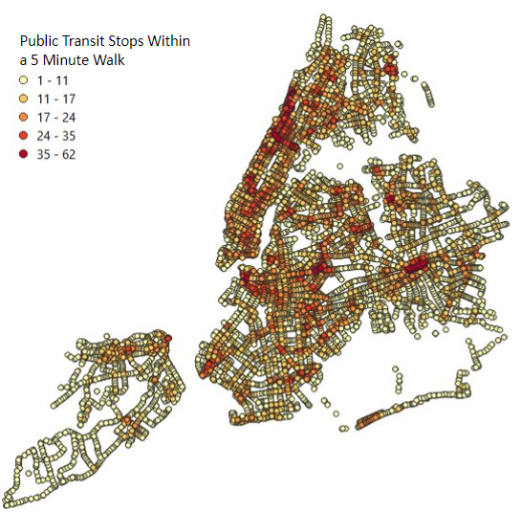
Figure A2. Bus stops by the number of public transportation stops (subways, other buses, ferries) within a 5-minute walking distance (0.25 miles).
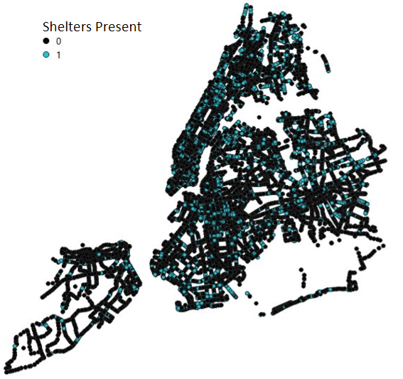
Figure A3. NYC bus stops with and without shelters.
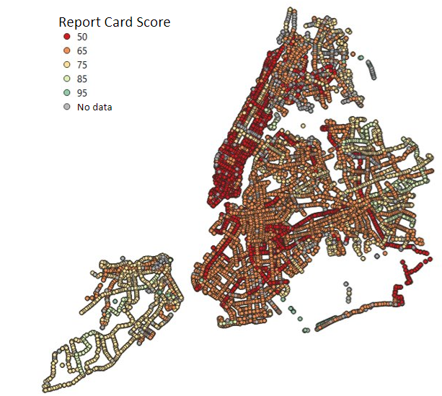
Figure A4. NYC bus stops by Bus Turnaround Coalition report card grade.

Appendix B: Additional Choropleth Maps
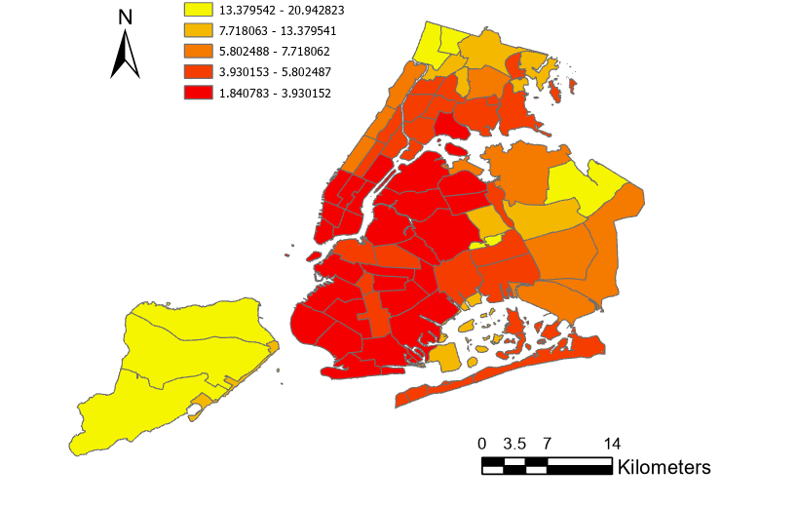
Figure B1. Choropleth map of the Average Tree Canopy Cover per Census Tract.
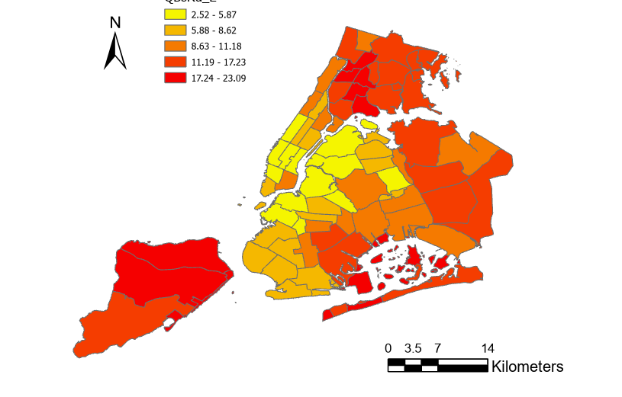
Figure B2. Choropleth map of the Percent of Commuters to Work by Bus per Census Tract.

Appendix C: Additional Bivariate Choropleth Maps
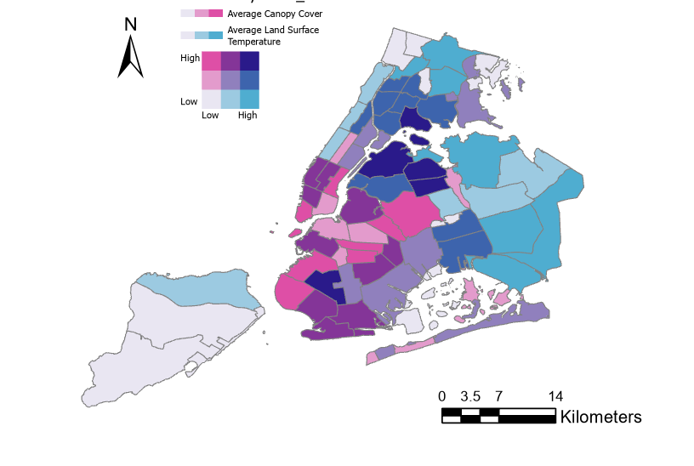
Figure C1. Bivariate Choropleth Map of Average LST and Average Canopy Cover.

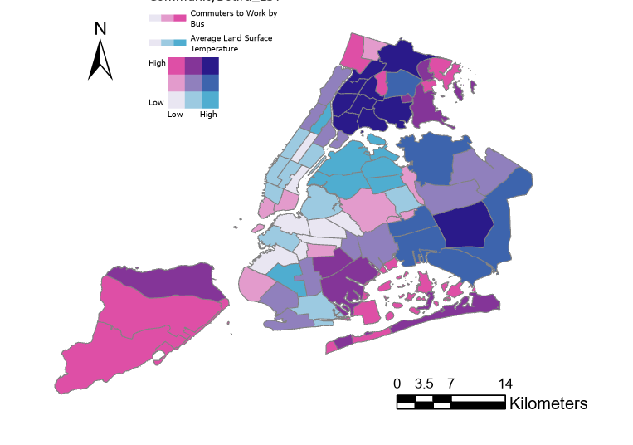
Figure C2. Bivariate Choropleth Map of Average LST and the Percent of Commuters to Work by Bus.

Appendix D: Additional SOLWEIG processing for each stop
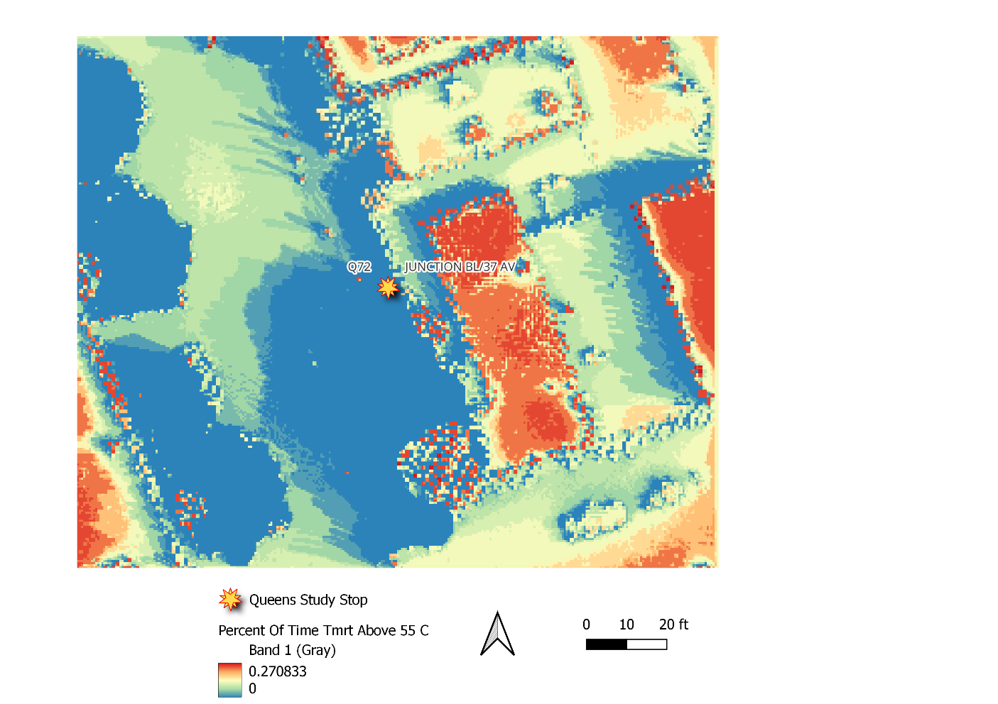
Figure D1. Percent of day each pixel in Junction Bl/37 Av Bus Stop was above 55 degrees Celsius T_{MRT}.
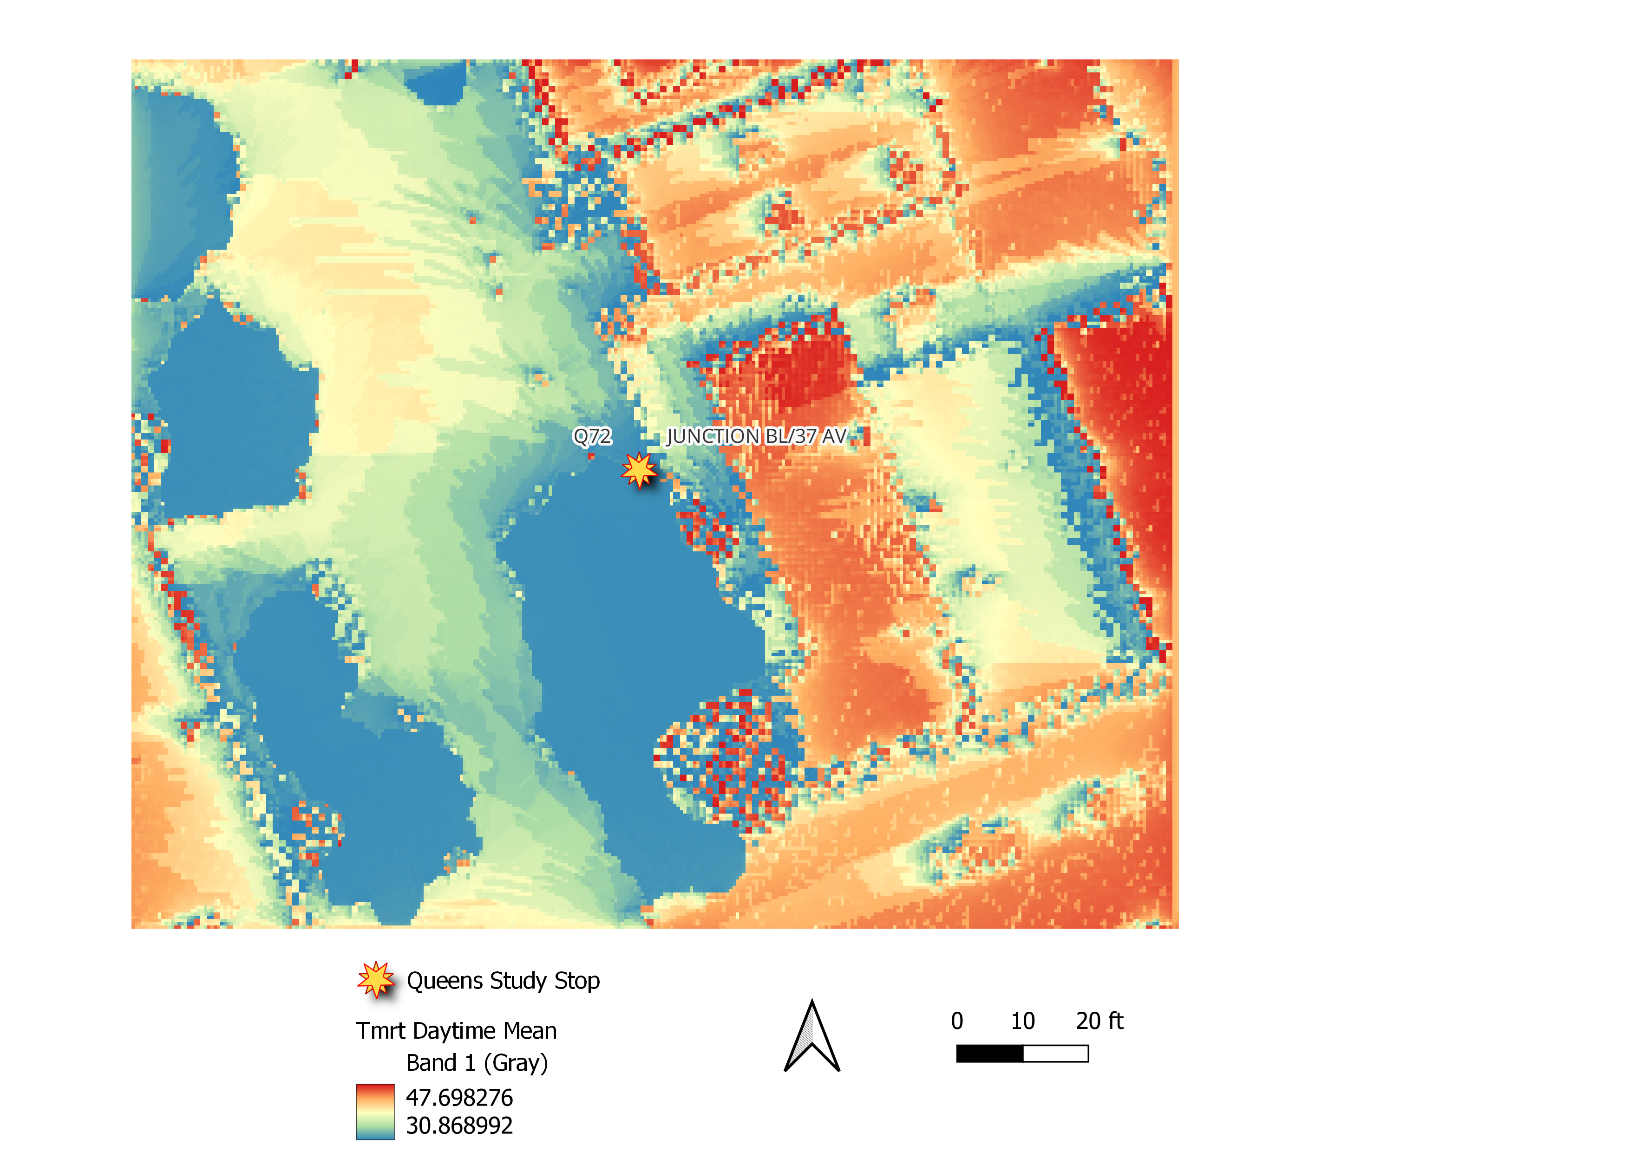

Figure D2. Average Daytime Mean T_{MRT} in Celsius for Junction Bl/37 Av Bus Stop.

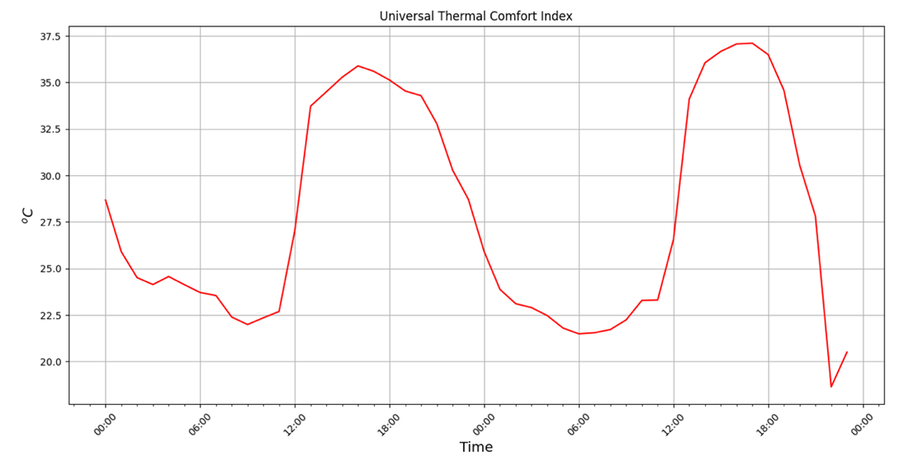

Figure D3. Universal Thermal Comfort Index for Junction Bl/37 Av Bus Stop in Celsius.

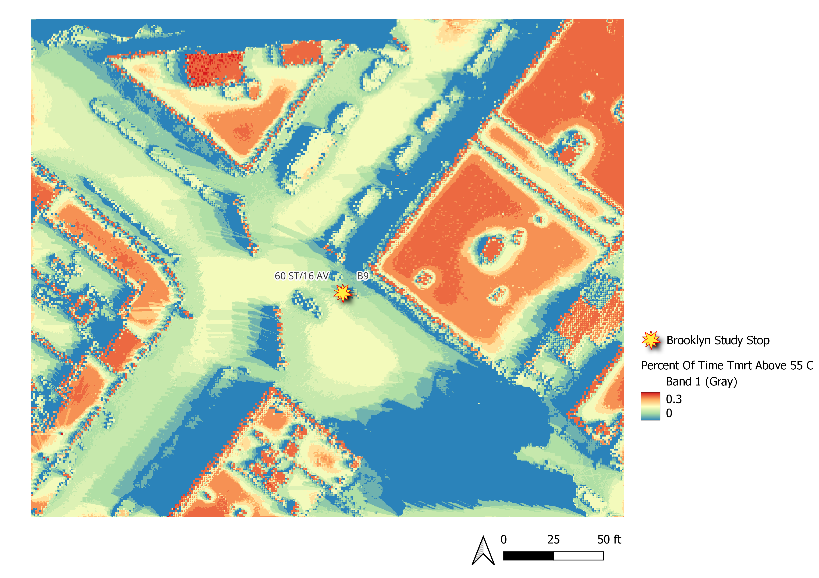
Figure D4. Percent of day each pixel in 60 St/16 Av Bus Stop was above 55 degrees Celsius T_{MRT}.

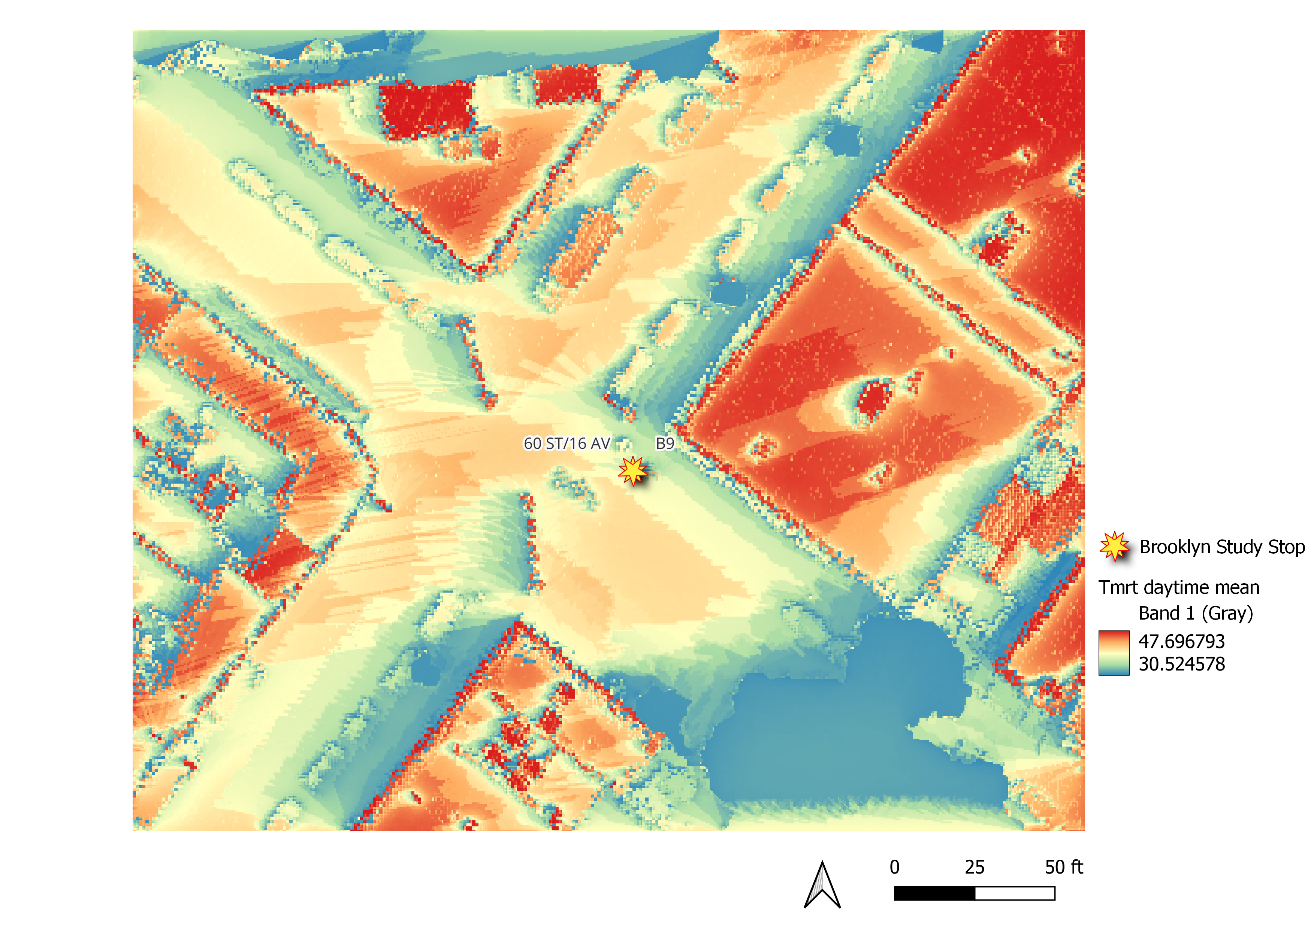
Figure D5. Average Daytime Mean T_{MRT} in Celsius for 60 St/16 Av Bus Stop.

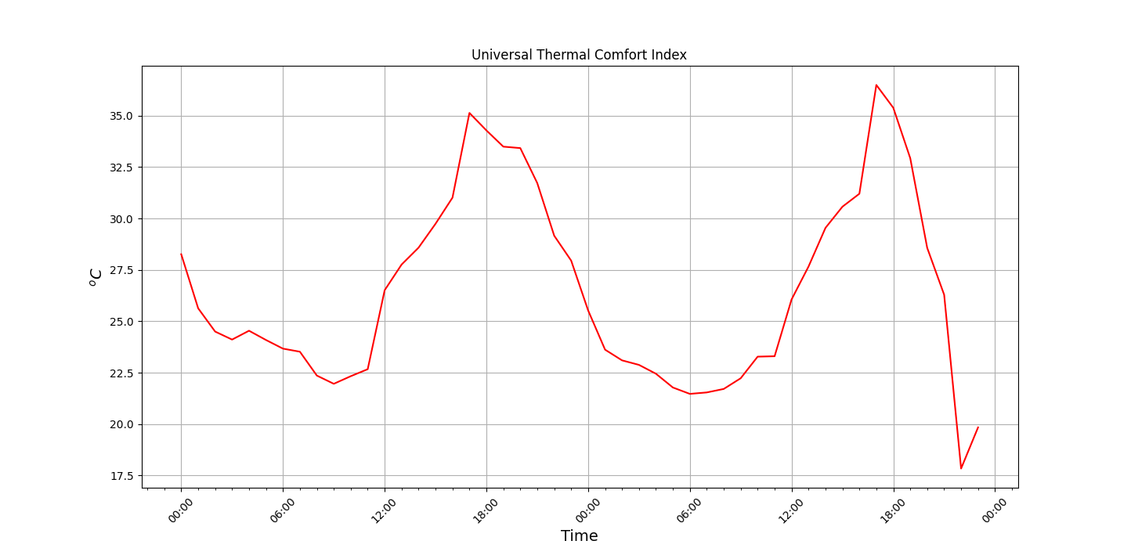

Figure D6. Universal Thermal Comfort Index for 60 St/16 Av Bus Stop in Celsius.

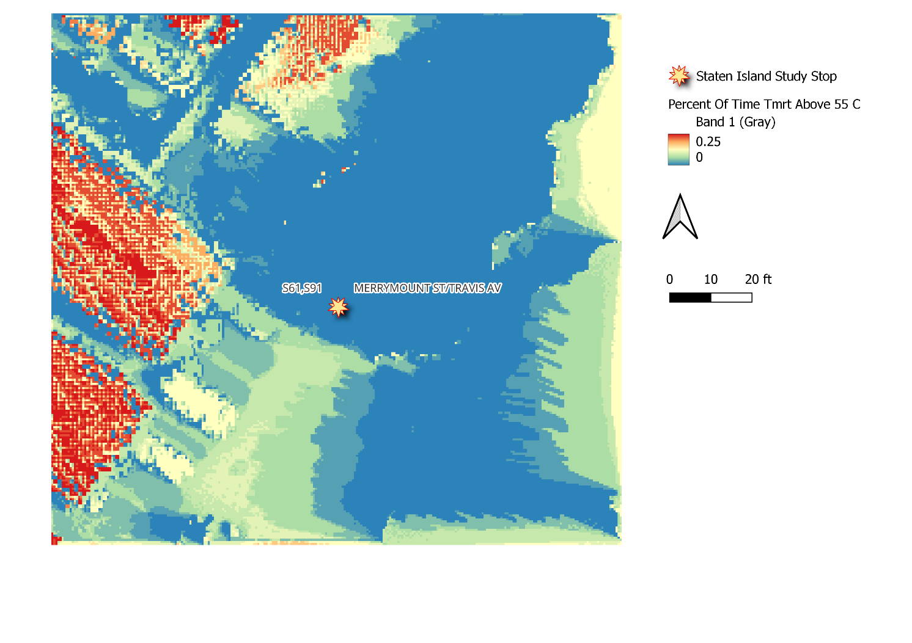
Figure D7. Percent of day each pixel in Merrymount St/Travis Av Bus Stop was above 55 degrees Celsius T_{MRT}.

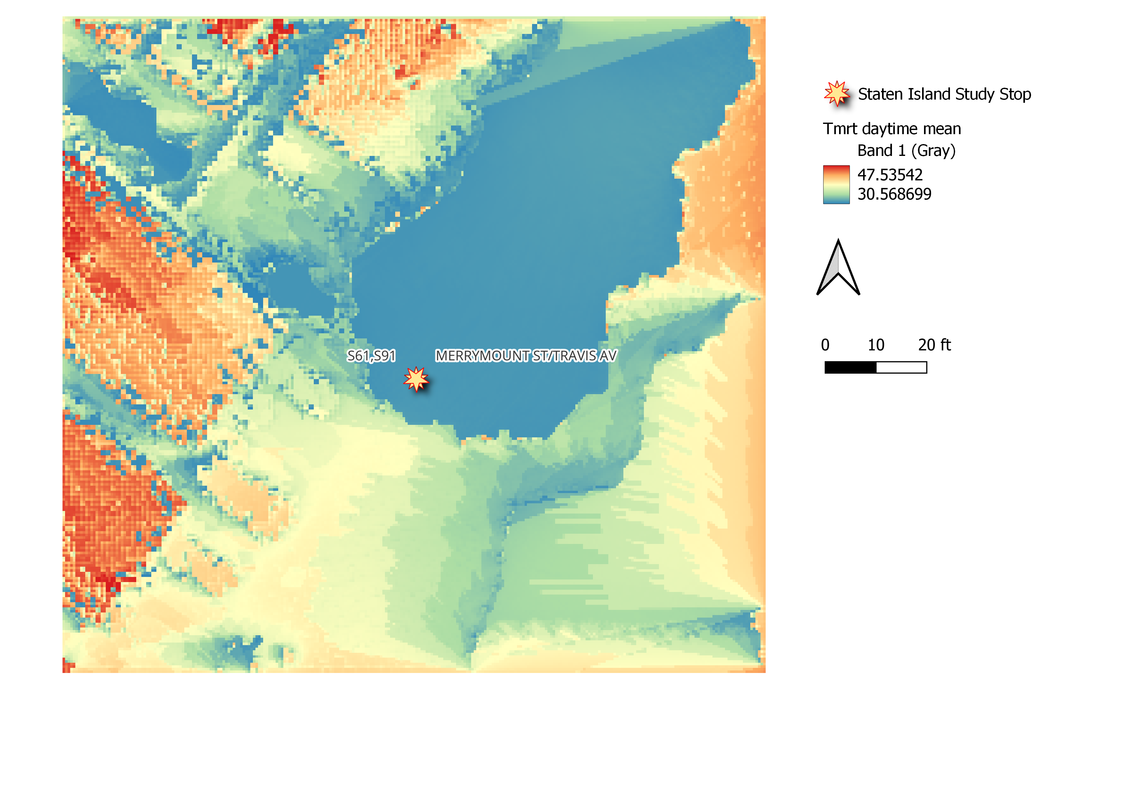
Figure D8. Average Daytime Mean T_{MRT} in Celsius for Merrymount St/Travis Av Bus Stop.

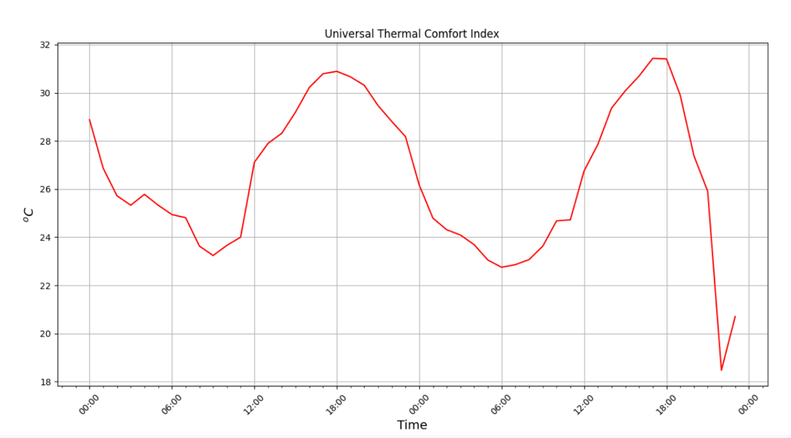
Figure D9. Universal Thermal Comfort Index for Merrymount St/Travis Av Bus Stop in Celsius.

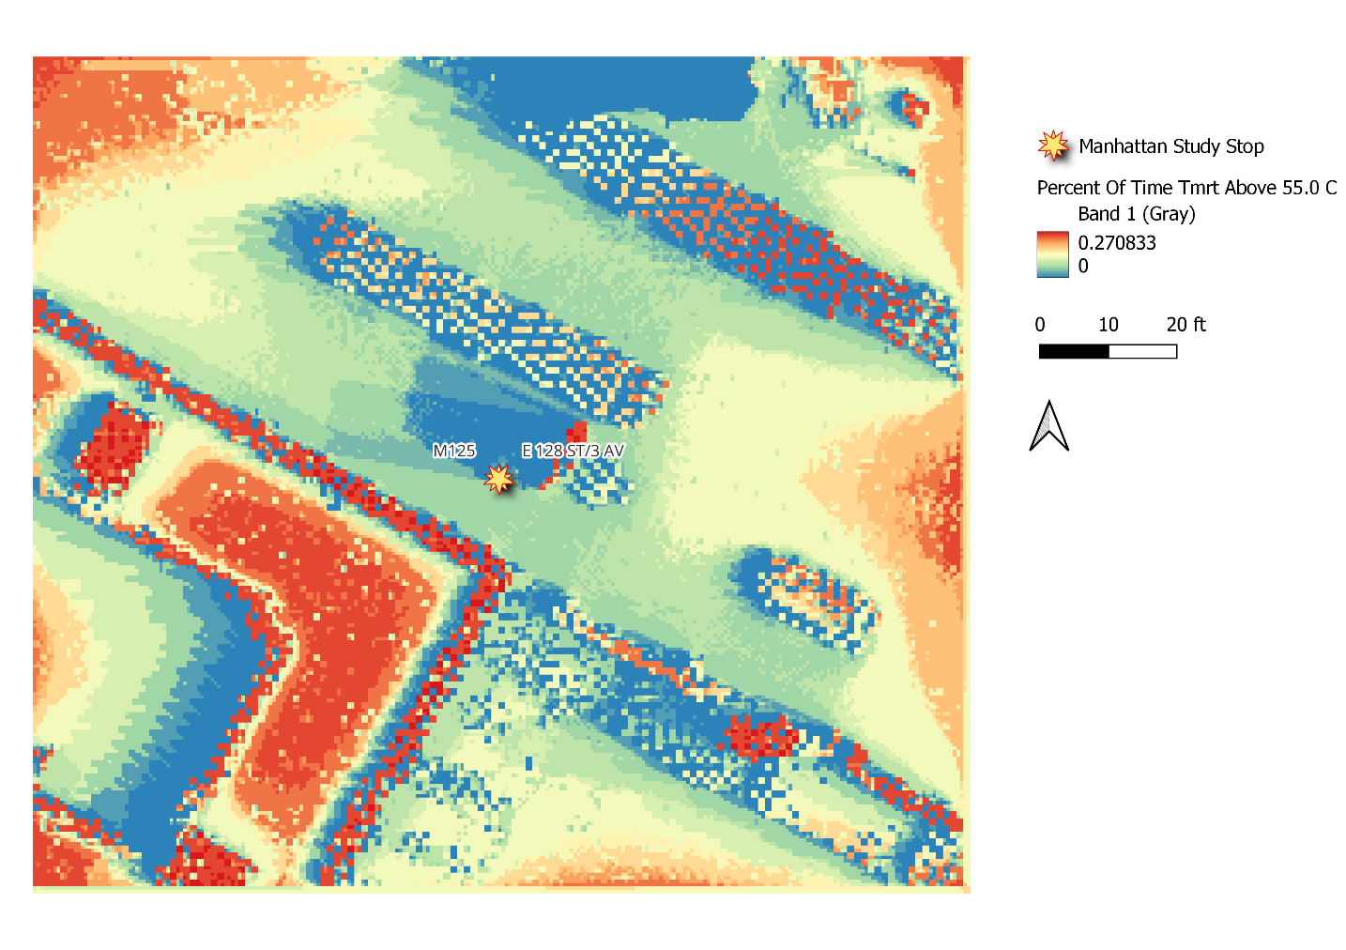
Figure D10. Percent of day each pixel in 128 St/3 Av Bus Stop was above 55 degrees Celsius T_{MRT}.

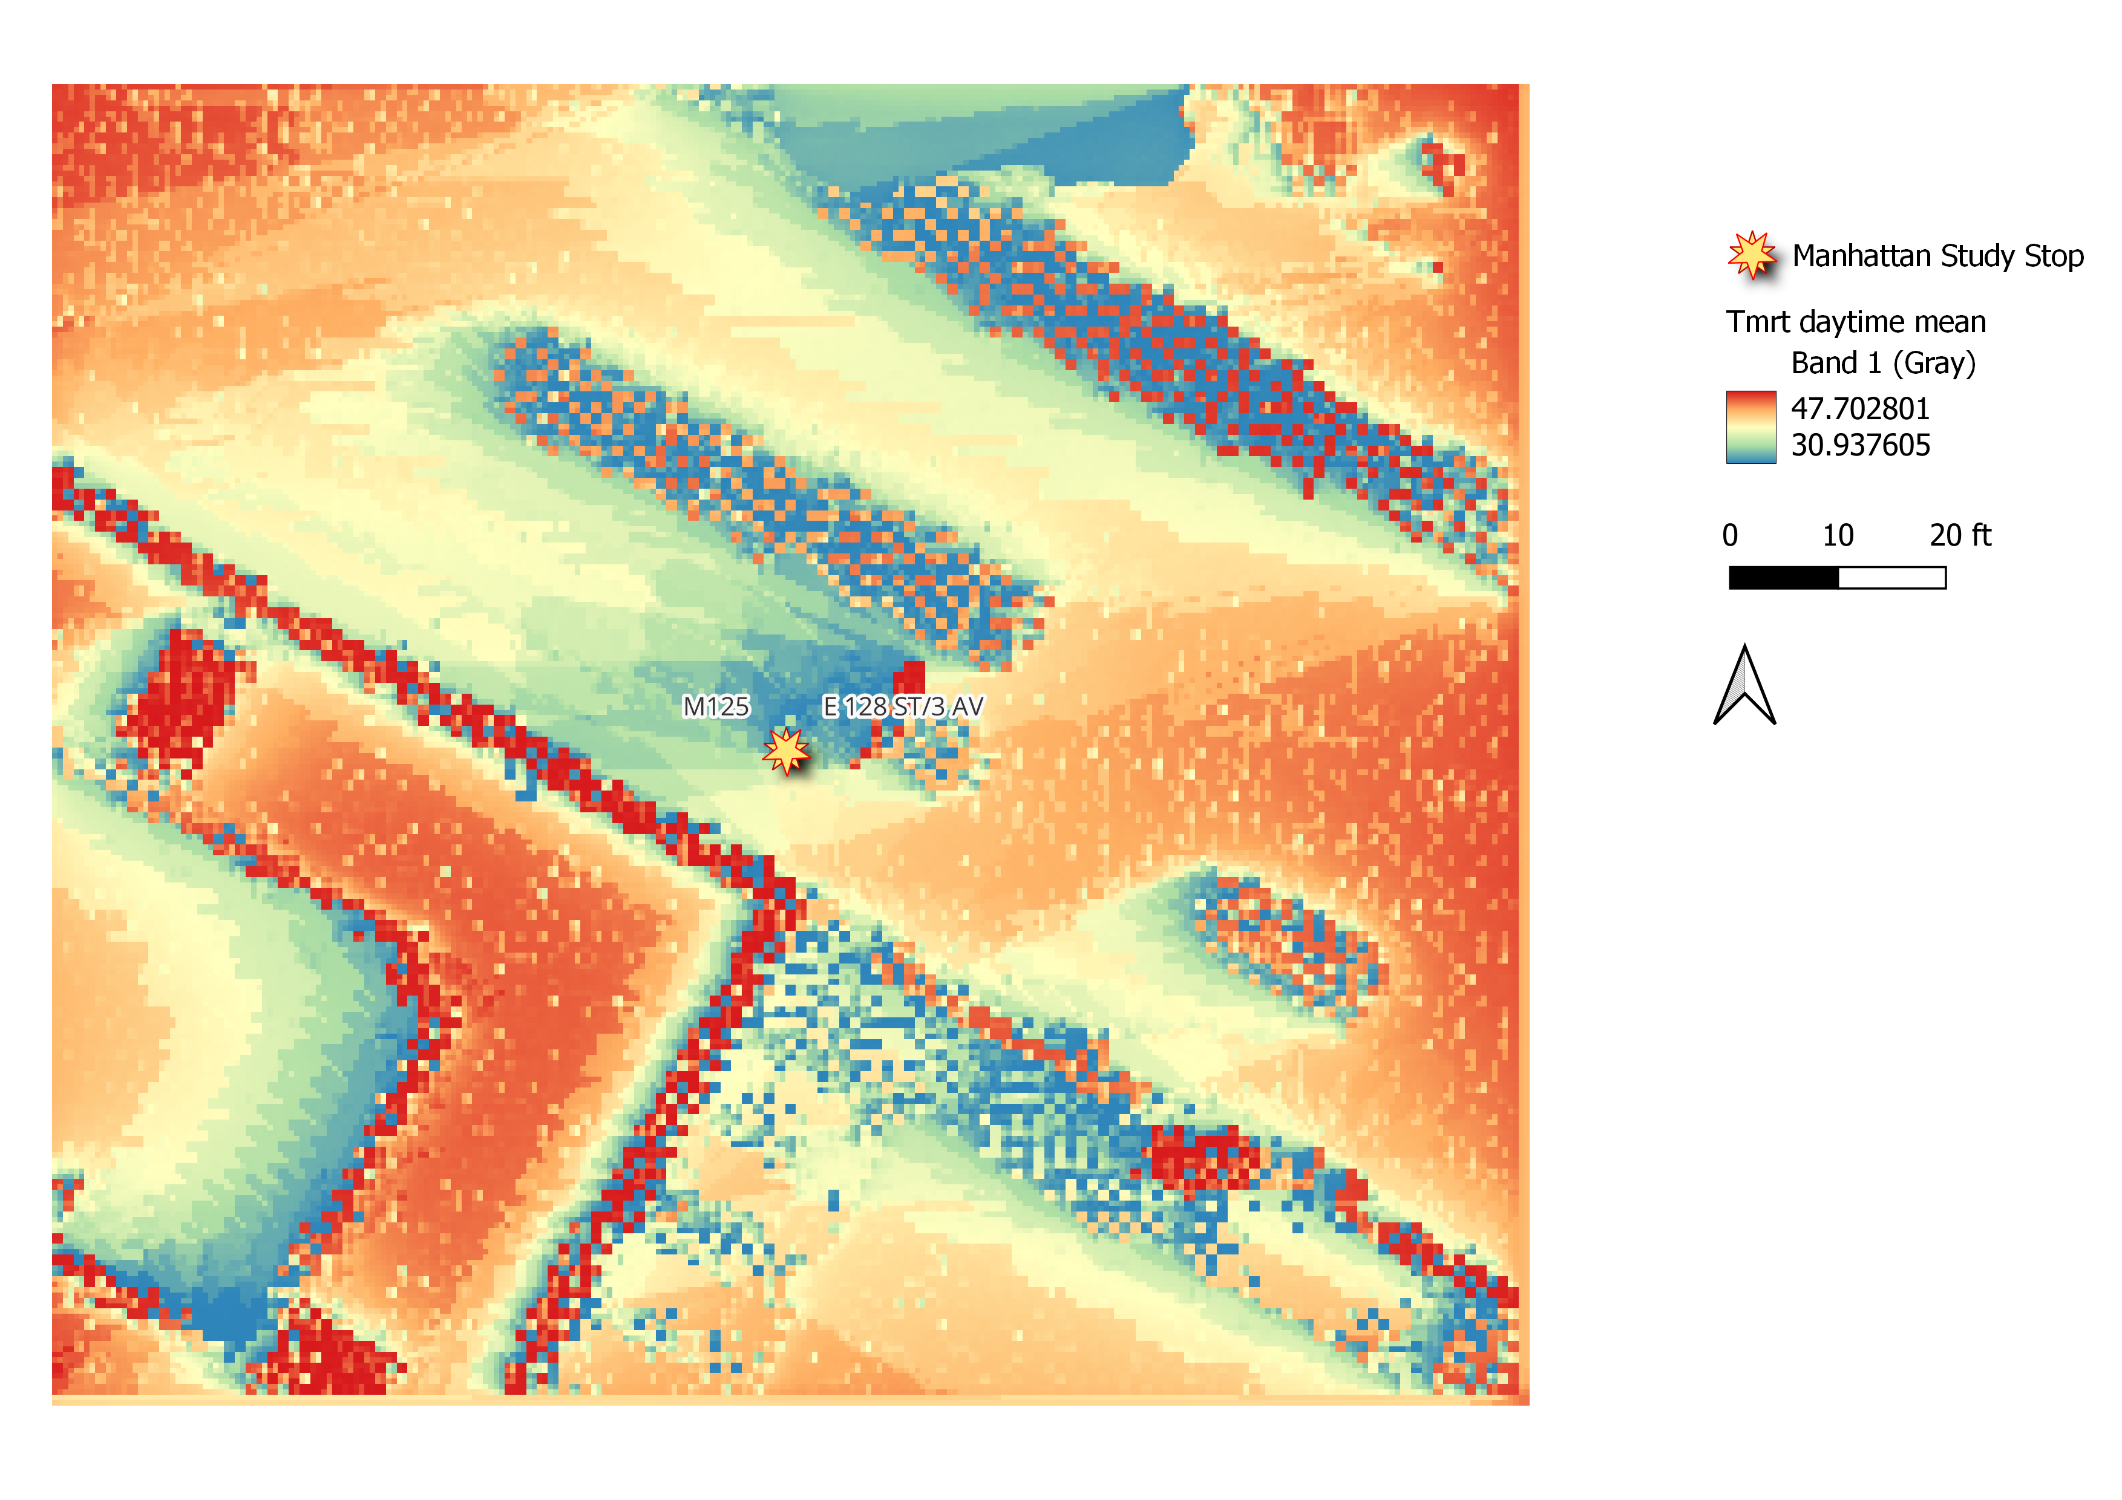Figure D11. Average Daytime Mean T_{MRT} in Celsius for 128 St/3 Av Bus Stop.

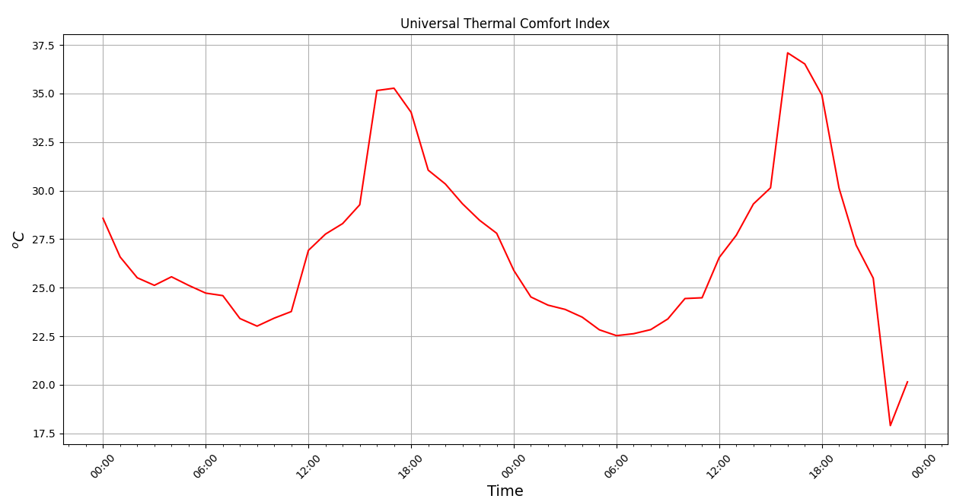
Figure D12. Universal Thermal Comfort Index for 128 St/3 Av Bus Stop in Celsius.

