**NASA DEVELOP National Program**

****NASA Langley Research Center

**Summer 2015**

**Short Title: Texas Water Resources**

**Subtitle:** Utilizing NASA Earth Observations to Monitor Drought Severity in Texas for Wildfire Mitigation Support

**VPS Title:** Breaking the Ring of Fire: Preparing for Drought Disasters in Texas

**Project Team & Partners**

**Project Team:**

Megan Buzanowicz (Project Lead), megan.e.buzanowicz@nasa.gov

Laura Lykens

Zacary Richards

Jeff Close

**Advisors & Mentors:**

Dr. Kenton Ross (NASA DEVELOP National Program)

Dr. Venkat Lakshmi (University of South Carolina)

**Past or Other Contributors:**

DEVELOP Stennis Space Center’s Texas Disasters, 2015 Summer

**Partner Organizations**

Texas Forest Service, Boundary Organization and End-User, POC: Curt Stripling and Tom Spencer

**Project Details**

**Applied Sciences National Applications Addressed:**

Water Resources

**Study Area:** Texas (TX), United States

**Study Period:** 2010 - 2011, 2014 - 2015

**Earth Observations & Parameters**

Aqua and Terra, MODIS – Land Surface Temperature (LST), Normalized Vegetation Differentiation Index (NDVI)

**Ancillary Datasets Utilized**

* NOAA Multisensory Precipitation Estimate (MPE) – Precipitation data
* NASA North American Land Data Assimilation System (NLDAS) – Soil moisture

**Software Utilized**

ArcGIS – Raster Manipulation/Analysis, Image Enhancement and Map Creation of Aqua/Terra MODIS

Python – Drought Severity Index

**Project Overview**

In a cooperative effort with the John C. Stennis Space Center (SSC) DEVELOP location, our team at DEVELOP Langley assisted the Texas Forest Service (TFS) in preparing for future wildfires by expanding upon a drought severity index (DSI) created during the summer 2013 term. This will allow the TFS to identify what geographical locations within the state are most prone to wildfire disasters and where water resources may be concentrated in order to fight them efficiently. Our team also assessed the accuracy of the DSI by comparing it to live fuel moisture data from the National Fuel Moisture Database.

**Abstract**

The 2011 wildfire season was one of the most destructive wildfire seasons in Texas history. The combination of a wet 2010 growing season, which allowed vegetation to prosper, followed by an extremely dry year in 2011 provided the worst case scenario for wildfires. The purpose of this project was to expand upon a drought severity index (DSI) created during the summer 2013 Great Plains Agriculture project. A risk map of potential wildfire areas that contain dry fuels was also created; specifically, how dry the fuels are. To accomplish this, data that measure specific factors contributing to drought conditions and dry vegetation were acquired, including land surface temperature and the Normalized Difference Vegetation Index (NDVI) from the Moderate Resolution Imaging Spectrometer (MODIS) instrument onboard the Aqua and Terra satellites, precipitation from the Multi-Sensor Precipitation Estimate (MPE), and soil moisture from the North American Land Data Assimilation System (NLDAS). Data for these four factors were compiled through ArcGIS in order to assemble a risk map. The accuracy of the DSI was correlated to live fuel moisture data supplied by the Texas Forest Service (TFS). Methods and results produced for determining drought conditions were presented to the TFS for future use throughout the state; the benefit of which was a high-resolution drought index that can be easily constructed with little cost to the end-user.

**Community Concerns**

* Wildfires pose a constant risk for many regions across the state; for example, in November 2010 through September 2011 there were 23,835 fires reported which burned 3.8 million acres, approximately 2.2% of the total acreage of the state
* Ability to accurately monitor drought conditions is vital to forecasting wildfire risk, in particular in grassland regions, where fires often spread rapidly

**Current Management Practices & Policies**

* The TFS currently uses products from the Landscape Fire and Resource Management Planning Tools, LANDFIRE program, and the National Predictive Services Unit. The National Predictive Services Unit uses the Palmer Drought Severity Index, Climate Prediction Center Soil Moisture Model, USGS Weekly Streamflow, Standardized Precipitation Indicator, and object indicator blends to classify the drought severity. KBDI, Keetch-Byram Drought Index, which has inputs from NOAA NEXRAD is also used. Texas A&M is leading another effort using AVHRR with NEXRAD to determine drought locations and severity. The LANDFIRE program is designed to help the TFS support fire planning, analysis, and budgeting to evaluate fire management alternatives and is used to supplement strategic and tactical planning for fire operations. More information about the spatial coverage of drought conditions will allow decision makers at TFS to better allocate resources to mitigate the spread of wildfires.

**Decision Support Tools & Benefits**

|  |  |  |
| --- | --- | --- |
| **End-Product** | **Earth Observations Used** | **Benefit & Impact** |
| Drought Severity Index Maps | MODIS, MPE, and NLDAS | Provides estimation of water stress to vegetation; impacts where TFS will allocate resources in preparation for wildfires |
| Live fuel moisture comparison graph | DSI, National Fuel Moisture Database | Determine the accuracy of the Drought Severity Index by comparing it to live fuel moisture data; validation for the Drought Severity Index; impacts where TFS will allocate resources in preparation for wildfires |

**Project Imagery**

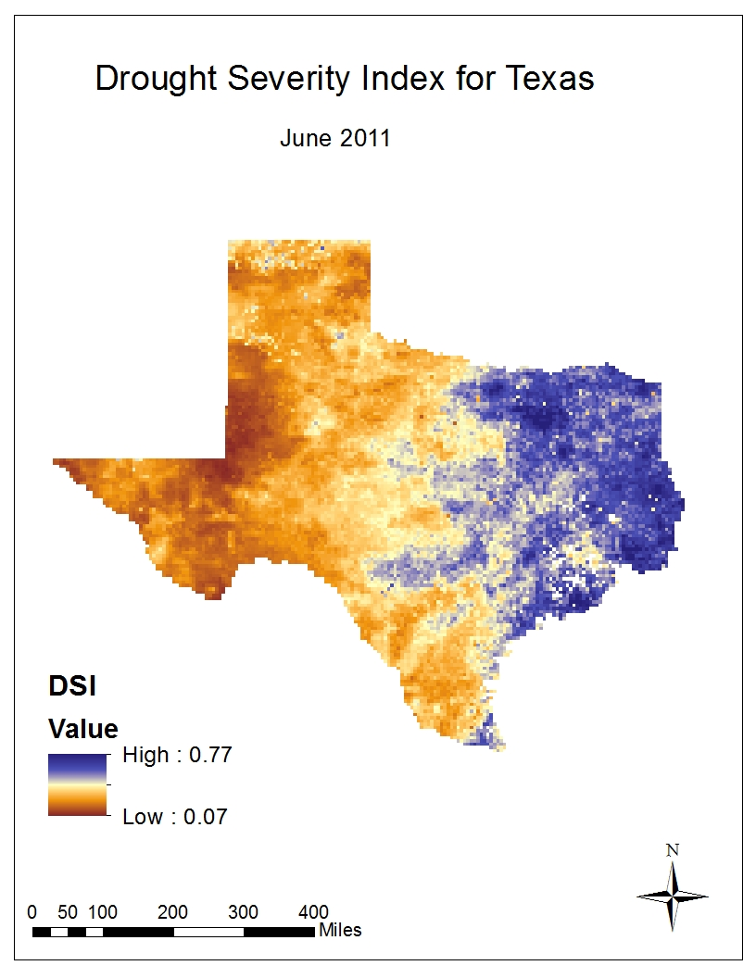

**Image:** June 2011 Drought Severity Index.jpg

**Image Credit:** Texas Water Resources Team

**Caption:** Drought Severity Index for the state of Texas in June 2011. Lower values (browns) represent areas of more significant drought conditions, while higher values (blues) indicate areas less affected by drought. The DSI was designed to range the values of drought severity from no less than zero to no higher than one. When viewing this map, it is clear that the drought conditions increased in severity from central to west Texas. East Texas, however, remained relatively wet.