NASA DEVELOP National Program
NASA Langley Research Center
Summer 2016

Everglades Ecological Forecasting
Improving the Capacity of Everglades National Park to Monitor Mangrove Extent Using NASA Earth Observations


Technical Report
August 11, 2016

Donnie Kirk (Project Lead)
Caitlin Toner
Rachel Cabosky
Emily Gotschalk
Brad Gregory
Candace Kendall

Dr. Kenton Ross, NASA DEVELOP National Program (Science Advisor)
Dr. Marguerite Madden, University of Georgia (Science Advisor)

1. Abstract
Mangroves act as a transition zone between fresh and salt water ecotones by moderating salinity levels. This transition gives way to marshlands that depend on larger quantities of freshwater. Furthermore, mangroves offer specialized habitats for endemic species and provide shoreline stabilization, critical to a region besieged by tropical storms. In an attempt to restore a measure of the earlier balance in the Everglades coastal wetlands, effort has been made to return a portion of freshwater flow that had been diverted from the ecosystem. The National Park Service requires a way to track the resulting changes in growth and distribution. The DEVELOP research team utilized Google Earth Engine and satellite imagery from Landsat 5 and 8 to select, classify, and map mangrove and marsh regions between 1995, 2005, and 2015. These maps will aid in the creation of forecasted models.

Keywords
Remote Sensing, Google Earth Engine, Transition, Landsat, JavaScript, Coastal Ecosystem, Ecotone, Marsh

2. Introduction

  - Background Information

The Everglades National Park (ENP) is one of the largest freshwater transitions from marsh to mangrove on the North American continent (Schneider, 1966). This ecotone from freshwater marshland to saltwater ocean habitat is dependent on the elevation gradient, salinity, and soil type, as well as the hydrologic components of the area in order for this transition to occur (Ross et al., 2000; Simard et al., 2006). Mangroves in particular are ecologically vital to the coastline and provide many ecosystem services; their large root systems stabilize the coastline and enhance deposition by trapping sediment in response to rising sea-levels (Ball, 1980). Furthermore, mangroves store carbon, act as a blockade during storms, and provide homes for various birds and other wildlife that inhabit the Everglades (Smith, 2013).

Extensive human alterations to the hydrological components of the park have changed the drainage structure and quantity of water reaching the mangroves. In order to decrease flooding, the park re-routed water into four major canals (Doren et al., 1999; Todd et al., 2010). This resulted in the entire ecosystem undergoing unnatural fluctuations in water levels, ultimately changing the structure and composition of plant communities. The marsh to mangrove transition concerns park managers because the shift significantly affects plant communities and coexisting species (Simard et al., 2006).

Understanding the state of the mangroves within the ENP may provide insight to the overall ecosystem (Zweig and Kitchens, 2008). The changing status of mangrove presence is indicative of a potential change in salinity, soil type, elevation, and other environmental variables (Ball, 1980), which could lead to a change in ecosystem stability and resilience. However, the presence of mangroves has increased over the past few decades while the adjacent marshlands have decreased (Smith, 2013). Further investigation into this trend could provide insight into some of the causes of the increasing mangrove population. Additionally, understanding the causes of this trend will aid in ecological forecasting of the ENP (Zweig and Kitchens, 2008). Research has been conducted to evaluate the change in mangrove extent over the past several decades, which concluded that the northward expansion of mangroves is correlated to increasing winter minimum temperatures and fewer extreme cold events during the winter (Stevens et al., 2006; Krauss et al., 2011; Peterson and Bell 2012; Osland et al., 2013; Cavanaugh et al., 2014). These studies have not expanded to include the transitions that have been observed in response to past and proposed changes in hydrology; as a result, it is imperative to understand how mangroves have reacted to past hydrologic changes (Doren et al., 1999).

By using NASA Earth observations, a subset of the mangrove-marsh transition zone was monitored on the Everglades coastline. This subset was in accordance with what the NPS could utilize to relate the ecological variables of mangrove-marsh extent to the hydrological phenomenon that is currently in play, as well as other variables (Smith et al., 2013). The study period for this project spanned from 1995 to 2015 and utilized a decadal scale to capture vegetation changes over the past 20 years. The objective was to provide a methodology for mapping of the mangrove-marsh extent such that NPS personnel could continually monitor the health and transitions of the mangrove forests within ENP.

  - Project Partners & Objectives

This project addresses the Ecological Forecasting application area because this study creates a methodology that can be utilized to forecast marsh-mangrove transition. Researchers and land managers at ENP identified the marsh-mangrove transition as one of the most pressing concerns for their future management efforts-- future water routing plans intend to divert up to 80% of westerly freshwater flow towards the eastern side of the park. Although significant research is being conducted regarding environmental variables that may be affecting the mangrove-marsh transition, and mangroves in general, the mangrove extent map currently used by park staff has not been updated since the early 2000’s. This project will update the current mangrove extent map within the ecotones selected in this study, and will provide a replicable process for the park staff to expand in upcoming years.

3. Methodology

3.1 Data Acquisition

The team examined the change in mangrove to marsh transition zones within ENP using Google Earth Engine (GEE) to access the archive of Landsat imagery. For the first term of this project, the team collected Landsat images for the years 1995, 2005, and 2015 that contained ENP. Due to the decadal scale of our study period, Landsat 5 Thematic Mapper (TM) imagery data was available for 1995 and 2005, and Landsat 8 Operational Land Imager (OLI) was available for 2015. The 16-day delay between Landsat images yields collections of over 20 images per year. Images produced by the Landsat satellites have a 30 m by 30 m pixel resolution. Access to multiple Landsat images allowed the team to minimize cloud coverage by utilizing a cloud masking algorithm and aggregating the data within GEE editor.

The majority of the ENP can be seen within two Landsat scenes. To ensure that the 1995, 2005, and 2015 images covered the same area of the park, the team documented path and row for both images based on the World Reference System (WRS) for Landsat data collections. The southernmost image occupied the southern tip of the Everglades (path 15 and row 43) while the northernmost image contains the majority of the ENP (path 15 and row 42). Keeping both images in the same path minimized mosaicking alignment issues but leaves the northwest section of the park out of the display. The team decided that the most effective way to display the data would be to crop all applicable images to the Everglades park boundaries.

To better identify vegetation within the study area, the team referenced vegetation maps and Google Earth. The 1995 and 1999 vegetation maps created by the University of Georgia, along with an ENP 2015 ecological map, provided information of where mangroves and marshes were located within the park. Referencing these maps increased the team’s ability to recognize mangroves and marshes in satellite images. The enhanced spatial resolution of GE and its ability to rapidly change scale made it a viable option for training. For example, if the Landsat 5 image appeared to be a predominantly green area, zooming into the same area using GE helped identify which areas were forestDense and where the green transitioned into forestScrub. Google Earth data helped the team to verify the training points and increase the overall accuracy of the classification.

3.2 Data Processing

End users at the ENP provided boundary layers defining the park extent, as well as a sampling scheme that divided the region into gridded ecotone sections via shapefiles. Using the stratified random sampling tool within ArcMap, the team selected five ecotones to represent the study area. These ecotones represented approximately 10-15% of the coastline. The shapefiles were then converted into KML files and uploaded into Google Earth Engine (Figure 3.2a).

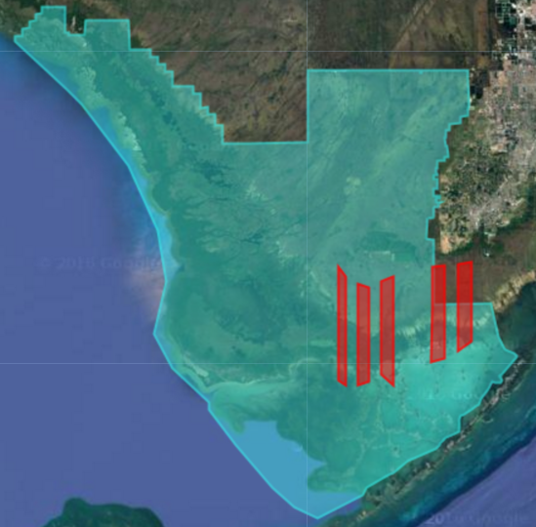
Figure 3.2a: Satellite image of the southern tip of Florida. The turquoise shapefile indicates the ENP boundary, while the red shapefiles indicate the ecotone sample regions.

The “USGS Landsat 5 TOA Reflectance (Orthorectified) with Fmask” collection was utilized to create the 1995 and 2005 Everglades mangrove extent map, while the “USGS Landsat 8 TOA Reflectance (Orthorectified) with Fmask” collection was used to create a map for 2015. Clipped to the park boundaries, the 1995, 2005, and 2015 Landsat data produced three maps that could begin to illustrate decadal transitions within the region. However, given the cloudy nature of tropical areas, it was necessary to develop a methodology that could provide a clearer image of the park. The Fmask function was applied to eliminate cloud cover on each image in the region for the year.

The image collection below (Figure 3.2b) displays the cloud reduction process of the Fmask application. The study area had high levels of cloud coverage, therefore one Landsat image would not provide enough land cover information to be accurate. Fmask removes the clouds in an image, but this meant there would be significant gaps, or “holes” in the data. To resolve this issue, the team aggregated a year’s worth of masked Landsat images, producing a clear image with no missing data.

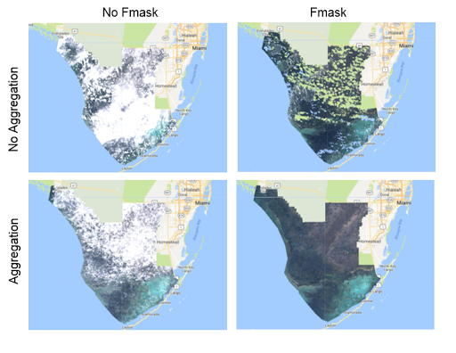
Figure 3.2b: Visualization of cloud cover removal technique. (From left to right, top to bottom) 2015 Landsat 8 images: single month image of cloud cover, single month image with Fmask applied, year aggregation with cloud cover, year aggregation with Fmask applied.

For classification purposes, the team used a variety of methods to identify vegetation types. For Landsat 5 and 8 images, different bands were used to illustrate a true color composite (R-G-B), vegetation false color using near infrared (NIR-R-G), and land/water false color (NIR-SWIR1-R). Vegetation false color was particularly useful in distinguishing between land and water, which proved difficult in true color alone, and also highlighted dense areas of vegetation (Figure 3.2c). Use of different bands helped to distinguish different land cover characteristics for a region. The team referenced ENP vegetation maps created by the University of Georgia and high resolution Google Earth Engine images. These maps assisted the team identify and categorize land cover types for classification in Google Earth images (Figure 3.2d).

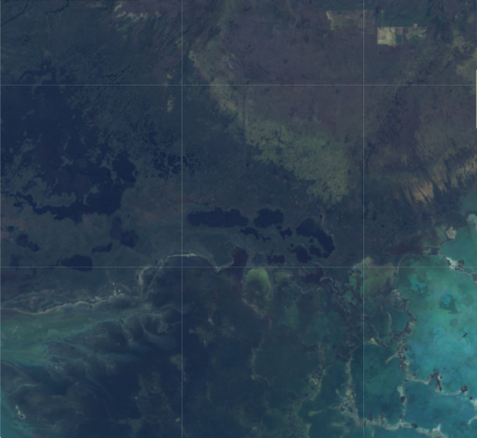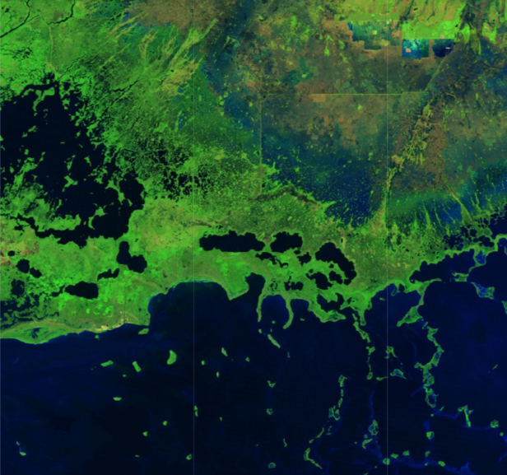
Figure 3.2c: Side by side comparison of Landsat imagery in true color composite (R-G-B), and vegetation false color composite (NIR-SWIR1-R). In the second image it is much easier to distinguish land and water.

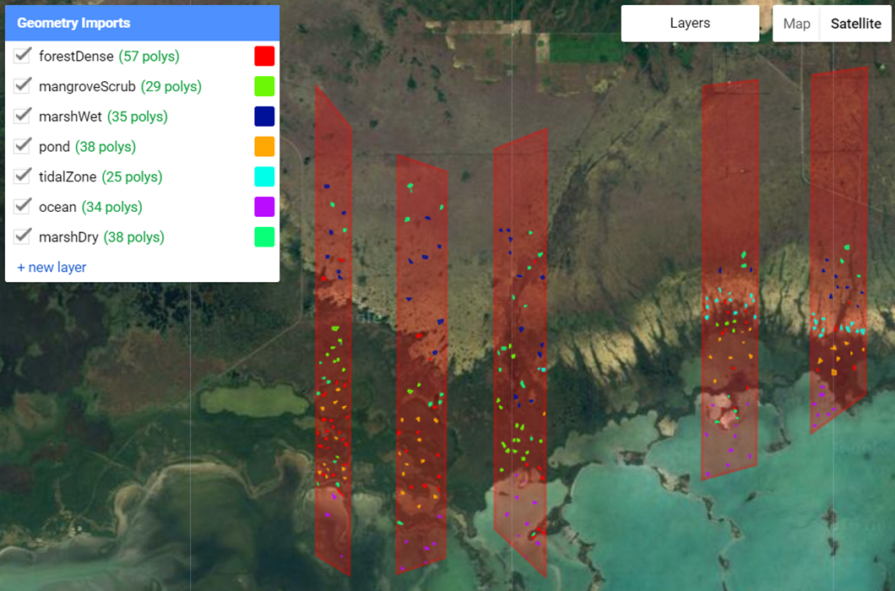
Figure 3.2d: Classification polygons of the seven class land cover types. These training points were arranged within the intersection of the park boundaries and ecotone samples. Here the polygons are overlaid on a true color satellite image.

3.3 Data Analysis

To analyze the Landsat imagery, the team utilized a supervised classification in GEE. This classification was conducted on the 1995, 2005, and 2015 images after they were processed to remove clouds and cloud shadows. The land cover could be broken into three main types: forest, marsh, and water. The specific classes created were forestDense, forestScrub, marshWet, marshDry, ocean, pond, and tidalZone. Without in situ data, the team used “forest” to include tree types that may not be mangroves. At least thirty training points were made for each classification.

For visualization purposes, the seven classification types were merged to five; ocean, ponds, and tidal zones were combined on the classification maps as “water.” Based on the training points created by the team, GEE was able to display supervised classification images and include all five class types within the sample regions.

Classification training points were placed in the predetermined sample regions and analyzed by GEE until a base error matrix could be returned with a minimum of 85% total accuracy. A base error matrix is an algorithm that computes the percent error of a classification scheme; it is calculated by taking the number of pixels correctly categorized and dividing it out of the total pixel count. For this matrix, ninety percent of the points created were used for training, and ten percent were kept separate for testing accuracy. A random ten percent was tested three times for each matrix. With these points assessed as correctly categorized, the team used the classification tool to extrapolate the classification to all of the pixels in the image and produce a mangrove-marsh extent map for all of ENP.

To further analyze changes in mangroves over the study period, the classification images from GEE were imported into TerrSet’s Land Change Modeler to identify trends on a decadal and twenty year scale. The model was run on classification images with the original seven land cover classes, as well as combined landcover classification images in which the forest classes (forestDense and forestScrub), marsh classes (marshWet and marshDry), and water classes (pond, ocean, and tidalZone) were combined for a total of three classes. The resulting images were then edited within TerrSet to only show changes in the forest class over the study period.

4. Results & Discussion

4.1 Analysis of Results
This project tested the applications of GEE to determine whether the platform was feasible for the purpose of vegetation monitoring in the Everglades. The methodology produced to test the feasibility of GEE took into account several factors: clear and cloudless images of the region, consistent classification, an accuracy test that attains an accuracy of 85% or higher, and the capability to extract the data for further analysis. Addressing these factors would illustrate the changes the region experienced on a decadal scale, and would determine whether it would be worthwhile to proceed using GEE for the purposes of the project.

With cloud cover removal in place, it was possible to classify in GEE without the risk of mislabeling land cover as cloud or cloud shadow. This was then extrapolated to the entire park (Figure 4.1a and Figure 4.1b). While this shows a larger area to track change, the accuracy decreases in accordance with distance from sample areas. Additionally, without in situ data, all classifications were created based on visual analysis and have a higher likelihood for human error, particularly between vegetation types. The team designated training points based off of 1995 and 1999 vegetation maps and from 2016 imagery in Google Earth. Testing points were 10% of the training points, meaning these points have an equal amount of human error as the training points.

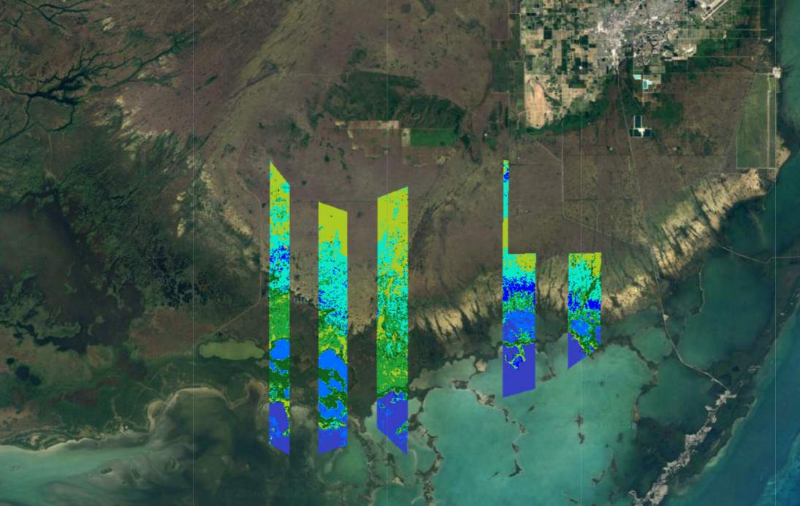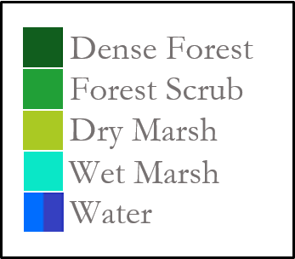
Figure 4.1a: Classification of 2005 Everglades sample regions.

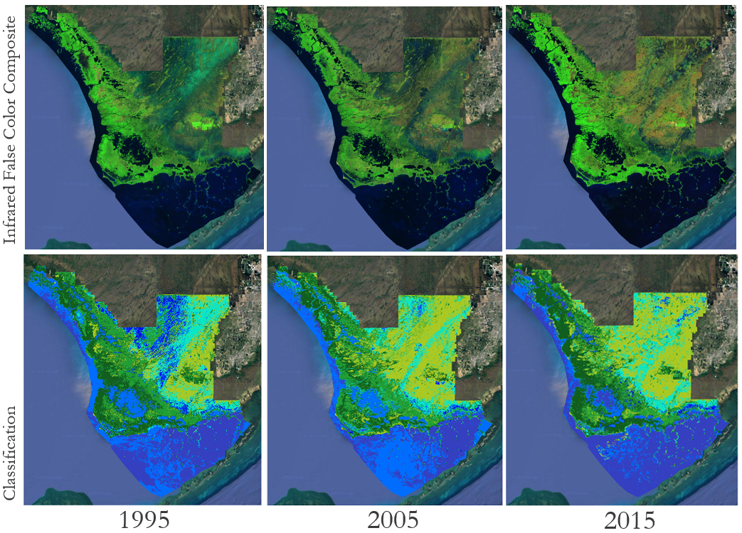Figure 4.1b: Infrared vegetation false color composite (Row 1) side by side with extrapolated classification scheme (Row 2) for 1995, 2005, and 2015.

One of the largest changes visible in the classification transitions between 1995, 2005, and 2015 (Figure 4.1b) is in the northern central region. At this location, there is a transition between wet and dry marsh, which acts in accordance with ENP rerouting the waterway directions as well as changes in precipitation. In particular, 1995 shows a significantly higher coverage of wet marsh and water cover. Personnel at ENP noted that this year had some of the highest rainfall levels experienced by the park, correlating with it being an El Niño year. Another distinct difference is the quantity of dense forest in 2005—it appears lower than in 1995 and 2015. The region seems to shift from dense forest to scrub forest. Given the knowledge that four hurricanes passed over the Florida coast during that year, including Hurricanes Wilma and Katrina, this could account for the sparser vegetation. Damaged trees can take years to recover, and stripped greenery would show up with less vibrancy in band combinations than trees in full health. (Redwine 2016). Another possibility that could be attributed to this difference is seasonality; since each year is aggregated imagery, the differences in vegetation are more likely to see variation within seasonal cycles (marshes will have wet and dry seasons according to annual precipitation, for example). However, mangroves are “in season” year-round, meaning these regions will have a higher likelihood of accuracy.

Three error matrices were for each year’s classification. The 1995 accuracy averaged 83% (Table 4.1c), 2005 accuracy averaged 88% (Table 4.1d), and 2015 accuracy averaged 84% (Table 4.1e), with an overall accuracy of 85% for the classification scheme. This level of accuracy suggests that Google Earth Engine is a viable platform to perform supervised classification on vegetation for Landsat images of Everglades National Park. However, 85% accuracy only refers to the sample area, which accounts for 10-15% of the ENP coastline. The team produced images that display supervised classification across the entire park, but currently have no means of measuring the accuracy outside the selected sample regions. The ENP noted that most of the changes to the region were occurring near this sample. The overall accuracy can be further examined with more robust averages as only three error matrices were run for each year (ten or twenty matrices averaged will produce a more accurate determination of whether or not 85% is truly representative).
Table 4.1c: Error matricies for 1995, averaged 82% accuracy overall.. The diagonal (dark grey) indicates the number of pixels that were correctly classified by class type. Total accuracy is the averave accuracy for that year. Each column and row corresponds to a specific class, i.e. forestDense, forestScrub, etc.
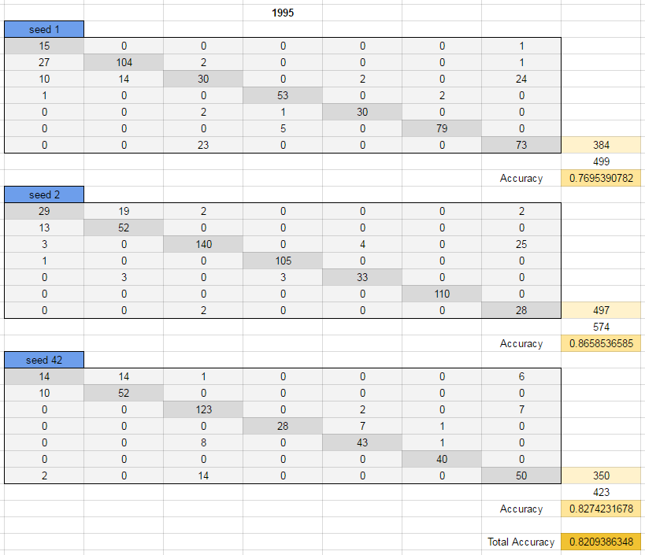

Table 4.1d: Error matricies for 1995, averaged 82% accuracy overall

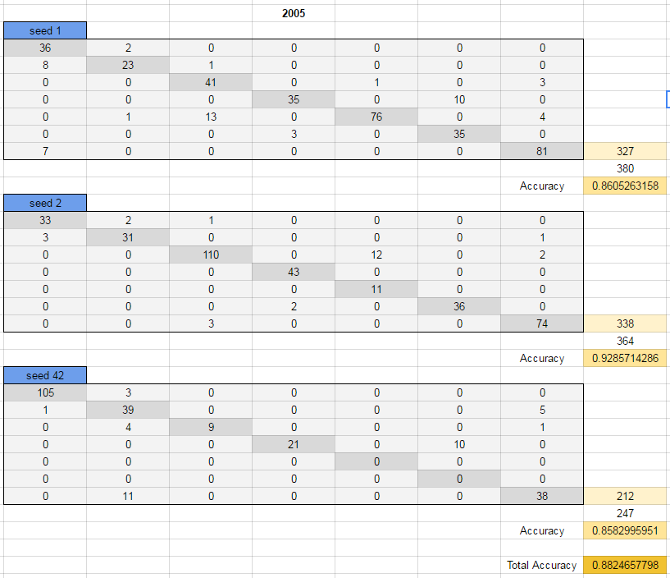

Table 4.1e: Error matricies for 1995, averaged 82% accuracy overall

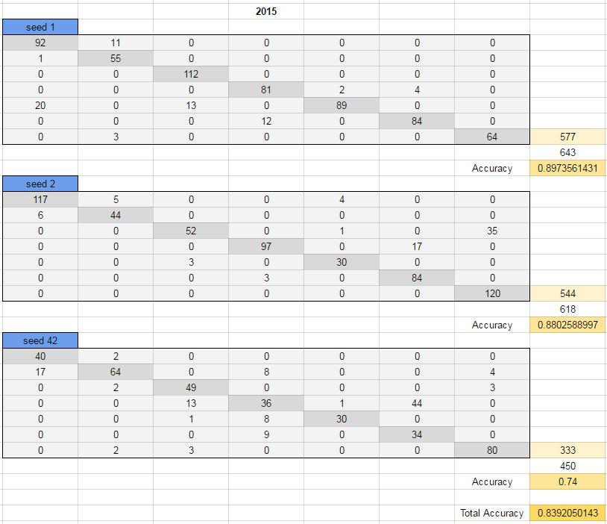

In each of the error matrices, the total number of pixels analyzed differed (for example, in Table 4.1e, the total number of pixels in seed 1 is 643, seed 2 has 618, and seed 42 has 450). This is because 10 percent of the polygons were kept separate, but each polygon might be of a different size and contain a different number of pixels. So, one random 10% collection may include larger polygons than the next. This creates an inconsistency within the comparisons of accuracy.

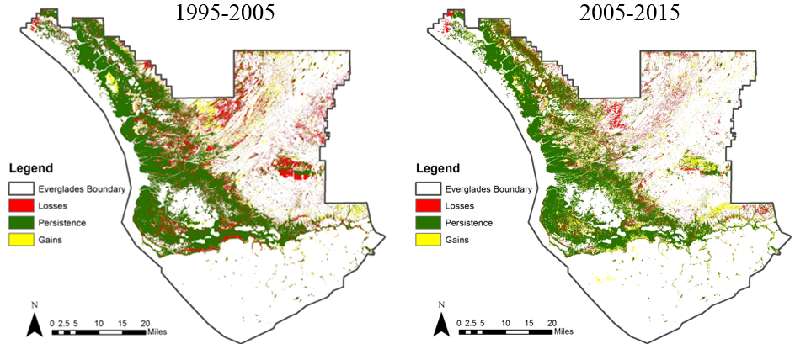
Figure 4.1f: Transition maps created within TerrSet showing the losses (red) and gains (yellow) of forest in ENP. The left image shows the change between 1995 and 2005, and the right image shows the change between 2005 and 2015.

Based on the classification products, two images were produced from TerrSet’s Land Change Modeler to analyze forest change between 1995 and 2005, and 2005 to 2015 (Figure 4.1f). These images show losses, persistence, and gains in forest cover over each half of the study period. In particular, there are greater losses along the southern coast of the park in the 1995-2005 image, whereas there are greater gains and persistence in the 2005-2015 image in the same region. The increased presence of losses in the 1995-2005 image is likely related to increased hurricane presence during 2005, which could have negatively impacted mangrove extent during that time period. Although there are visible trends in the western region of the coastline, since these images are based on the classifications produced in GEE and are beyond the sample region, they were not examined further given the unknown confidence in those portions of the images.

4.2 Future Work
This project will continue with a focus on the ecological forecasting of vegetation within ENP. Having developed a methodology for classification this term, the scheme can be improved and expanded in the next term. The production of 1995, 2005, and 2015 classified images was accomplished to prove that selected years could be evaluated to examine transitions. These three images show decadal change, but finding additional years will increase the accuracy of vegetation trends in the region. Additionally, the sample regions could be expanded to include a wider area, which would provide a more reliable accuracy analysis. Using GRTS instead of ecotone samples would provide further unification for ENP as other research projects of the park have been predominantly using GRTS rather than ecotones. Random Forest is another function within GEE that could be utilized to provide an accuracy intensity score for classified regions.
In addition to looking at more years, examining seasonal time frames will increase the accuracy. Instead of performing supervised classification on an aggregated year, looking at an aggregation of the winter months over a series of years will show more precise changes because it has taken into account how vegetation will change throughout the year. This can better isolate causes coming from changing climatic conditions rather than seasonal change.

In the future, it is also advised that the team use in situ training points to test accuracy, as this dataset will contain verified knowledge of the surface vegetation. ENP would also like to focus on connecting the region’s transitions to their potential causes, or disturbance correlations. This could take into account fire damage from sources like frequent lightning strikes, as well as an analysis of before and after tropical storms.

5. Conclusions

Throughout the course of this project, the team was able to create a classification methodology that yielded 85% overall accuracy in the training regions. Three vegetation extent maps for 1995, 2005, and 2015 were produced based on this process, and highlighted potential aftereffects of drastic weather changes. Furthermore, initial steps were taken to begin the forecasting process by creating transition maps between the decades of study.

The methodology that was developed has proven to be effective for the creation of updated mangrove extent maps for Everglades National Park. The main focus of the methodology was to determine whether classification processes would be run through Google Earth Engine (GEE); this was prioritized because of the open access of the platform and because it is free for all users. Furthermore, files can be easily shared and co-edited within the platform. GEE also proved to be very convenient for data collections. The platform already has images from multiple satellites, years, and locations existing within the cloud so that anyone can access them. This saves significant time in downloading files, especially in early stages of the project when determining what data sets will be most useful. GEE already had Landsat 8 and Landsat 5 image datasets, accessing these images from the USGS website would have taken longer because the team would have to request all the images individually.
As with most tropical regions, many of the collected images had significant cloud cover that would have reduced the accuracy of a supervised classification. Specific Landsat collections provided by GEE already had the Fmask function built in, and could be referenced and applied with only a few lines of code. As a result, it was determined that GEE could effectively remove cloud cover produce clear images for classification.
Supervised classification worked successfully within the platform. Geometry imports allowed the team to produce their own training points. The layers tool allowed the user to look at multiple color composites to verify the training points being produced and allowed the user to compare the base maps to the final classification for analysis. Having the capacity to separate the polygons into training and testing data allowed the team to run error matrices that verified the accuracy and then improve the classification. For finished products, the platform allowed the team members change the color palette to allow users to distinguish between mangroves and marshes.
The methodology for creating an updated map in Google Earth Engine proved to be successful, but can also be improved to reduce both human and experimental error. Focusing on one season rather than a year aggregate will reduce inaccuracy caused by seasonality. Access to in situ data will aid in testing accuracy and further improve the error matrix. Producing more error matrices and averages will yield a more robust accuracy result. Furthermore, examining additional years at more frequent intervals will help to avoid error in interpolation.

6. Acknowledgements

The team would like to recognize and give sincere thanks to our contributors for all their time and assistance with this project. First, thank you to Mr. Jed Redwine of the Everglades National Park, and Dr. Hans-Peter Plag of Mitigation and Adaptation Research Institute and Group for Earth Observations Blue Planet Initiative, without whom there would be no project and for all their support and partnership throughout this process. Many thanks to our past contributor, Ms. Marguerite Madden for the genesis of this project. Thank you to Brittany Zajic, DEVELOP Geoinformatics, and Vishal Arya, Fellow Project Coordinator, for their assistance with project methodology. Thank you to Dr. Kenton Ross, whose advice and direction led the team to their success. Many thanks to Noel Gorelick of Google Earth Engine Developers for all his assistance in understanding coding in GEE. Lastly, a special thank you Langley Research Center Leads Emily Gotschalk, Tyler Rhodes, Katie Moore, and Carrie Kelley for facilitating partner interactions, managing deliverables, and for their unwavering encouragement.

Any opinions, findings, and conclusions or recommendations expressed in this material are those of the author(s) and do not necessarily reflect the views of the National Aeronautics and Space Administration. This material is based upon work supported by NASA through contract NNL11AA00B and cooperative agreement NNX14AB60A.

7. References

Ball, M. C. (1980). Patterns of secondary succession in a mangrove forest of southern Florida. Oecologia, 44(2), 226-235.
Cavanaugh, K. C., Kellner, J. R., Forde, A. J., Gruner, D. S., Parker, J. D., Rodriguez, W., & Feller, I. C. (2014). Poleward expansion of mangroves is a threshold response to decreased frequency of extreme cold events. PNAS 111(2), 723-727.
Doren, R. F., Rutchey, K., & Welch, R. (1999). The Everglades: A perspective on the requirements and applications for vegetation map and database products. Photogrammetric Engineering and Remote Sensing, 65(2), 151-161.
Florida Coastal Everglades (1995). 1995 SFWMD Landuse [Land cover map]. Retrieved from http://fcelter.fiu.edu/data/GIS/interactive_map/

Krauss, K. W., From, A. S., Doyle, T. W., Doyle, T. J., & Barry, M. J. (2011). Sea-level rise and landscape change influence mangrove encroachment onto marsh in the Ten Thousand Islands region of Florida, USA. Journal of Coastal Conservation 15(4), 629-638.
Osland, M. J., Enwright, N., Day, R. H., & Doyle, T. W. (2013). Winter climate change and coastal wetland foundation species: salt marshes vs. mangrove forests in the southeastern United States. Global Change Biology 19, 1482-1494.
Peterson, J. M., & Bell, S. S. (2012). Tidal events and salt-marsh structure influence black mangrove (Avicennia germinans) recruitment across an ecotone. Ecology 93(7), 1648-1658.
Redwine, J (2016, August 5). Phone interview.
Ross, M. S., Meeder, J. F., Sah, J. P., Ruiz, P. L., & Telesnicki, G. J. (2000). The southeast saline everglades revisited: 50 years of coastal vegetation change. Journal of Vegetation Science, 11(1), 101-112.
Schneider, W. J. (1966). Water resources in the everglades. Photogrammetric Engineering and Remote Sensing, 32(6), 958-965.
Simard, M., Zhang, K., Rivera-Monroy, V. H., Ross, M. S., & Ruis, P. L. (2006). Mapping height and biomass of mangrove forests in everglades national park with SRTM elevation data. Photogrammetric Engineering and Remote Sensing, 72(3), 299-311.
Smith III, T. J., Foster, A. M., Tiling-Range, G., & Jones, J. W. (2013). Dynamics of mangrove-marsh ecotones in subtropical coastal wetlands: Fire, sea-level rise, and water levels. Fire Ecology, 9(1), 66-77.
Stevens, P. W., Fox, S. L., & Montague, C. L. (2006). The interplay between mangroves and saltmarshes at the transition between temperate and subtropical climate in Florida. Wetlands Ecology and Management 14, 435-444.
Todd, M. J., Muneepeerakul, R., Pumo, D., Azaele, S., Miralles-Wilhelm, F., Rinaldo, A., & Rodriguez-Iturbe, I. (2010). Hydrological drivers of wetland vegetation community distribution within Everglades National Park, Florida. Advances in Water Resources, 33(10), 1279-1289.
University of Georgia (1999). UGA Vegetation Map. [Vegetaion map]. Retrieved from http://fcelter.fiu.edu/data/GIS/interactive_map/

Zweig, C. L., & Kitchens, W. M. (2008). Effects of landscape gradients on wetland vegetation communities: Information for large-scale restoration. Wetlands, 28(4), 1086-1096.

8. Content Innovation

Content Innovation #1
Tutorial
Emailed to Lauren.M.Childs@nasa.gov with filename
2016Sum_LaRC_EvergladesEco_Tutorial

Content Innovation #2
Glossary Viewer
Appendix 9.1

Content Innovation #3
Virtual Poster Session
“A Legend in the Making; Mapping Mangroves in the Florida Everglades”
Emailed to Lauren.M.Childs@nasa.gov with filename
2016Sum_LaRC_EvergladesEco_VPS

Content Innovation #4
Inline Supplementary Material
- Figure 3.2a, Shapefile boundaries
- Figure 3.2b, Fmask
- Figure 3.2c, Color composites
- Figure 3.2d, Classification training
- Figure 4.1a, Classification ecotones
- Figure 4.1b, Classification extrapolation
- Table 4.1c, Error Matrix 1995
- Table 4.1d, Error Matrix 2005
- Table 4.1e, Error Matrix 2015
- Figure 4.1f, Forest transitions

9. Appendices

9.1 Glossary
- Aggregation- Collection of images of fractions of images that are overlaid to create a unified image.
- ArcMap- Main component of ESRI’s ArcGIS suite, used for map creation and geospatial analysis.*
- Ecotone- Gridded sampling method shapefile that features large rectangular polygons along the ENP coastline, contains 42 polygons.
- Endemic- With reference to a plant or animal, a species that is unique to a specific region.
- False color composite – A color scheme that is different to the human eye but helps distinguish different land cover types.
- Fmask- A function that contains cloud removal capabilities. Operates by removing data from cloud covered areas, “cutting” the cloud from the image.
- forestDense- One of the classes in the classification scheme created by the team. This class is characterized by a bright green in vegetation false color composite. Along the coast, this signifies the location of mangroves.
- forestScrub- One of the classes in the classification scheme created by the team. Characterized by patchy regions of vibrant green color in vegetation false color composite, typically adjacent to forestDense.
- Google Earth Engine- A cloud-based platform used for GIS (remote sensing) analysis and map creation.
- GRTS- “generalized random tessellation stratified” Gridded sampling method shapefile commonly used by ENP, contains 1024 small polygon regions covering the park.
- In situ- Referring to institute, or ground, data that has been verified in person by NPS officials.
- KML files- “Keyhole Markup Language” park boundary and sampling shapefiles sent by ENP were run through ArcMap to convert to this file type so it would be compatible with GEE.
- Landsat (5 and 8)- Satellites from NASA EOs, equipped with 7 and 11 bands respectively whose various combinations provide information on land cover types beyond the visible spectrum.
- marshDry- One of the classes in the classification scheme created by the team. Most commonly found in the central and northern regions of the park, is characterized in the false color composite by an orange/tan color. In true color, appears as grassland.
- marshWet- One of the classes in the classification scheme created by the team. Most commonly found in the central and northern regions of the park, is characterized in the false color composite by a green/bluegreen color. In true color, appears as grassland.
- NIR-R-G- Band combination, stands for Near Infrared-Red-Green
- Ocean- One of the classes in the classification scheme created by the team. Appearing blue in false and true color, includes the region of water surrounding the Florida peninsula. Later merged with all bodies of water.
- Orthorectified- With reference to a Landsat collection, meaning geometrically corrected to have consistent translation from a spherical view to a two dimensional plane
- Path- Part of WRS-2 latitude/longitude converter for Landsat images. Converts a specific coordinate into the scene boundary it is encompassed by. Signifies latitude.
- Pond- One of the classes in the classification scheme created by the team. Refers to an inland closed body of water but is not characterized by salinity. Appears dark blue in vegetation false color composite but can be blue, green, or brown in true color. Later merged with all bodies of water.
- R-G-B- Band combination, stands for Red-Green-Blue
- Row- Part of WRS-2 latitude/longitude converter for Landsat images. Converts a specific coordinate into the scene boundary it is encompassed by. Signifies longitude.
- Shapefiles- Data file format that contains geospatial information that is classified by points, lines, and polygons rather than pixels (raster files).
- Supervised Classification- A process by which the user specifies the training land cover types and locations, and is then applied to all pixels within the selected boundaries.
- NIR-SWIR1-R- Band combination, stands for Near Infrared-Short Wave Infrared-Red
- TerrSet- Software system used for geospatial modeling and known for its ability in ecological forecasting.
- Testing [points]- Ten percent of the created polygons that were kept separate, and not used for the creation of the classifier. Keeping the points separate allowed them to be reclassified by the classifier and compared to for accuracy.
- tidalZone- One of the classes in the classification scheme created by the team. This class appears to be sandy soil in true color, but in vegetation false color appears as water. Later merged with all bodies of water.
- TIF files (TIFF)- “Tagged Image Format File,” used when exporting highly detailed images from Google Earth Engine to ArcMap.
- Training [points]- Ninety percent of the created polygons, used for the creation of the classifier. These points were created from visual analysis of the region.
- True color composite –A color scheme that matches what one would see with the human eye. Red band, green band, and blue band are used to create this composite.

