**NASA DEVELOP National Program**

Mobile County Health Department

**Summer 2016**

**Short Title: Mobile Bay Ecological Forecasting and Water Resources II**

**Subtitle:** Monitoring Marsh Conditions in Coastal Alabama Using NASA Earth Observations to Support the Alabama Coastal Foundation’s Restoration and Conservation Initiatives

**VPS Title:** The Dark Side of the Marsh: Forecasting Marsh Health in Alabama

**Project Team & Partners**

**Project Team:**

Darius Hixon (Project Lead), dhixonl91@gmail.com

Austin Clark

Tyler Lynn

Manoela Rosa

**Advisors & Mentors:**

Kenton Ross Ph.D. (NASA Langley Research Center)

Just Cebrian Ph.D. (Dauphin Island Sea Lab)

Bernard Eichold, M.D., Dr. PH (Mobile County Health Department)

**Past or Other Contributors:**

Saranee Dutta

Vishal Arya

Jeanett Bosarge

Courtney Kirkham

**Partner Organizations:**

|  |  |  |  |
| --- | --- | --- | --- |
| **Organization** | **POC (Name, Position/Title)** | **Partner Type** | **Boundary Org?** |
| Alabama Coastal Foundation (ACF) | Mark Berte, Executive Director | End-User | Yes |
| Dauphin Island Sea Lab | Dr. Just Cebrian, Senior Marine Scientist III | Collaborator | No |

**Project Details**

**Applied Sciences National Applications Addressed:** Ecological Forecasting, Water Resources

**Study Area:** Mobile and Baldwin Counties, AL

**Study Period:** Jan 1987- April 2016; Forecasting to Dec 2030

**Earth Observations & Parameters:**

Landsat 5, Thematic Mapper (TM) – land cover, land use

Landsat 7, Enhanced Thematic Mapper Plus (ETM+) – land cover, land use

Landsat 8, Operational Land Imager (OLI), Thermal Infrared Sensor (TIRS) – land cover, land use

Aqua/Terra, Moderate Resolution Imaging Spectroradiometer (MODIS)-Marsh phenology, marsh health

**Ancillary Datasets Utilized:**

* Alabama Coastal Foundation Watershed Data –Delineation of study area
* NOAA Coastal Change Analysis Program (C-CAP) – Validation and supplementation of land cover data
* ForWarn Forest NDVI change – Marsh Phenology Data
* USGS National Land Cover Dataset (NLCD) – Land cover analysis

**Models Utilized:**

* TerrSet Geospatial Monitoring and Modeling System Land Change Modeler

**Software Utilized:**

* ArcGIS 10.4.1, 2015 – Raster manipulation/analysis, image enhancement and map creation
* ERDAS IMAGINE 15.0, 2015 – Land classification of Landsat imagery
* PyCharm Community Edition 2016.1.4, 2016 – Coding for models
* IDRISI TerrSet – Modeling future marsh health
* Impervious Surface Analysis Tool – Run in Arcmap to estimate impervious surfaces in the study area

**Project Overview**

**80-100 Word Objectives Overview:**

The objective was to apply NASA Earth observations to assess marsh health and patterns in Mobile and Baldwin counties, emphasizing historical and current marsh conditions within priority watersheds. Accomplishing this task required utilizing USDA Forest Service ForWarn data and Landsat imagery alongside land use/land cover databases to assess marsh health, extent, and anthropogenic influence. Objectively, this required the land cover classification of marshes and wetlands as well as the generation of z-scores in order to assess the overall trends and current status of these areas.

**Abstract:**

The marshlands fringing Mobile and Baldwin counties collectively comprise one of the most dynamic ecosystems in the Northern Gulf of Mexico. Coastal Alabama wetlands are an important ecological region providing a number of important ecosystem support services, such as breeding and nursing habitats, creating buffer zones for storm surge, and water filtration. However, many marsh areas have deteriorated both in health and extent due to a combination of anthropogenic and natural stressors, including nutrient pollution, turbidity, and urbanization. This study used NASA Earth observations to investigate the present and future health of wetlands in coastal Alabama. The datasets were derived from the United States Department of Agriculture Forest Service ForWarn Normalized Difference Vegetation Index (NDVI), which uses imagery captured by Moderate Resolution Imaging Spectroradiometer (MODIS). Additionally, data from Landsat satellites 5, 7, and 8 were used to provide higher resolution imagery over larger temporal scales to aid in land use and land cover classifications. The NDVI was then used in conjunction with data from the Coastal Change Analysis Program to classify marsh type, health, and extent over several decades. The data were then used for modeling of future marsh health using TerrSet Geospatial Monitoring and Modeling System Land Change Modeler software. Collectively, these analyses provided a holistic assessment of current and future marsh health for select watersheds over wide temporal and spatial scales. The Alabama Coastal Foundation can use these results to more efficiently direct restoration efforts to the most critically impaired watersheds.

**Keywords:**

Remote Sensing, ForWarn, MODIS, Landsat, NDVI, Coastal Wetlands, Urbanization

**Community Concerns:**

* Marsh extent and health - About 40% of Alabama’s shoreline is composed of marshland. Continued decline of these areas could compromise the ecological health of the region.
* Ecological diversity - Marshes play a big role in creating shallow, mixed-water habitats. Mobile bay is an important habitat for thousands of fish, bird, shrimp and oyster species. Marsh reduction may result in decline in breeding areas for sensitive species.
* Economic costs - Marshes provide important ecosystem services such as nutrient cycling and are also viable habitat for shrimp and oyster, which are important for the seafood industry in the area.
* Urbanization - Increasing levels of urbanization in many watersheds have resulted in habitat loss, major disruption to hydrological cycles, and increases in flash flooding and subsequent stormwater pollution.
* Erosion and Sedimentation - Increasing erosion and sedimentation from flash flooding and other sources has been linked to coastal marshland decline. They have also been associated with severe disruption of marsh health and aquatic environments.

**Current Management Practices & Policies**:

Currently, many watersheds in the study area are managed by a consortium of government and civilian groups including the Alabama Department of Environmental Management (ADEM), Mobile Bay National Estuary Program (MBNEP), and the Alabama Coastal Foundation (ACF). ADEM has implemented a number of initiatives in recent years to aid in conservation efforts including publishing environmental best management practices, enforcing regulations, designating priority watersheds, and setting up numerous long term monitoring stations throughout most watersheds in the area. ACF and MBNEP supplement these efforts by sponsoring numerous clean up initiatives, educational outreach, community outreach, and environmental monitoring programs. ACF and MBNEP also partner with the Dauphin Island Sea Lab to collaborate and publish environmental information pertinent to the ecological health of the region.

**Decision Support Tools & Benefits:**

|  |  |  |  |
| --- | --- | --- | --- |
| **End-Product** | **Earth Observations Used** | **Benefit & Impact** | **Software**  **Release** |
| Marsh Health Trend Analysis Maps | MODIS | This data can be used in the formulation of restoration and conservation strategies tailored to each individual watershed based on the growing patterns and trend direction in response to particular events. | 1 |
| Marsh Health Forecast Maps | MODIS | Prediction of future marsh health will allow for the tracking of overall marsh well-being as well as the identification and classification of future marshes endangered by the effects of continued habitat and environmental change. | 1 |
| Marsh Extent Maps | Landsat 5 (TM), Landsat 7 (ETM+), and Landsat 8 (OLI) | Identification and classification of marsh size and changes from both natural and artificial processes can help to focus remediation and conservation efforts towards threatened marshes. | 1 |
| Marsh Extent Forecast Maps | Landsat 5 (TM), Landsat 7 (ETM+), and Landsat 8 (OLI) | Maps of current Land Use Land Cover Landsat 8 (OLI) data to be used as the input for TerrSet’s Land Change Modeler. This simulation generates the expansion or contraction of marsh size based upon current habitat and environment conditions. | 1 |
| Land Cover Trend Analysis Maps | Landsat 5 (TM), Landsat 7 (ETM+), and Landsat 8 (OLI, TIRS) | Land cover trends distinguish expanding urbanization from established urbanization allowing for the identification of both previously and newly threatened watersheds in regards to health and extent. | 1 |
| Land Cover Forecast Maps | Landsat 5 (TM), Landsat 7 (ETM+), and Landsat 8 (OLI, TIRS) | Forecasted land cover using TerrSet’s Land Change Modeler forecasting the trends in anthropogenic land cover allowing for the reclassification of potential threatened marshes based on population growth and migration patterns. | 1 |

**Project VPS/Booklet Imagery**

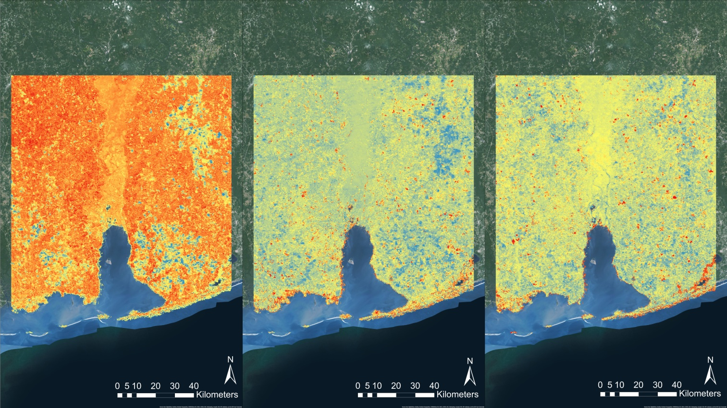

**Z-score**

**Z-score**

**Z-score**

**High**

**Low**

**High**

**Low**

**High**

**Low**

September, 2014

March, 2014

June, 2014

**Caption:** MODIS eight day composite NDVI images of study area captured by Aqua/Terra Satellites January-September 2014. NDVI analyses are useful in pinpointing areas of stressed vegetation. Image Credit: Mobile Bay Ecological Forecasting and Water Resources II Team.

**Image:** 2016Sum_MCHD_MobileBayEcoForecastingII_FinalImagery.jpg