**NASA DEVELOP National Program**



NASA Goddard Space Flight Center

*Spring 2016*

Great Lakes Ecological Forecasting

Utilizing NASA Earth Observations to Monitor and Forecast the Spread of *Phragmites australis* in the Great Lakes Basin

 **Technical Report**

Final Draft – March 16, 2016

C. Issac Kinton (Project Lead)

Peter Jacobs

Sean McCartney

Laura Bourgeau-Chavez, Michigan Tech Research Institute (Science Advisor)

Kurt Kowalski, USGS Great Lakes Science Center (Science Advisor)

# I. Abstract

*Phragmites australis* is an invasive species that threatens wetland habitats in the Great Lakes and St. Lawrence River basin. Governments in both Canada and the United States recognize that Phragmites detection is the first line of defense in limiting the spread of this species. Left untreated, *Phragmites australis* outcompetes native regional wetland species, resulting in monotypic stands of invasive Phragmites. As a result, habitat for native fish and wildlife becomes unsuitable, fire risk grows, and elevation of the landscape increases due to an expansion of below-ground biomass, depriving wetlands of nutrients needed by native flora and fauna. Project goals included identifying relevant drivers of the extent of Phragmites and forecasting near-term Phragmites extent throughout the Great Lakes Basin. Research from this project will help the Great Lakes and St. Lawrence Cities Initiative in its goal to distribute Phragmites information to local policymakers in both the U.S and Canada. Earth observations (EO) utilized included Shuttle Radar Topography Mission (SRTM), Tropical Rainfall Measuring Mission (TRMM), and Global Precipitation Measurement (GPM). Ancillary datasets known to correlate with Phragmites were also used as model variables. Land use/land cover (LULC) maps were created using TerrSet Land Change Modeler. MaxEnt habitat suitability modeling used environmental variables and LULC classifications to forecast Phragmites habitat suitability extent through the year 2020. Forecasting results will help local governments to enact policies that plan for and mitigate the spread of *Phragmites australis*. Challenges and limitations included finding an alternative to mapping Phragmites using radar data, and acquiring current LULC maps of the study area.

**Keywords**

Earth Observations, Invasive Species, *Phragmites australis*, Great Lakes, St. Lawrence River, Ecological Forecasting, Maxent

# II. Introduction

**Background Information**:

*Phragmites australis* subsp. *australis*, also known as the common reed, is an invasive freshwater or brackish-tidal wetland perennial grass native to Eurasia. It is one of the most widely distributed flowering plants, occurring on every continent but Antarctica (Gucker, 2008). *Phragmites australis* subsp. *americanus* is a native haplotype found in North America,though it spreads less vigorously than its non-native Eurasian cousin (Tulbure et al., 2007). Henceforth, all references to Phragmites will be referring to the non-native subspecies*.* Phragmites has been a concern in the Great Lakes and St. Lawrence River Basin due to its ability to outcompete and displace native wetland flora (Catling, 2011). Left untreated, Phragmites will result in monotypic stands (Bourgeau-Chavez et al., 2012) creating unsuitable habitat for native fish and wildlife, decreased biodiversity (Ailstock et al., 2001), increased fire risk (OMNR, 2011), and increased elevation of the landscape (Chambers et al., 1999). Once Phragmites is established in an area, it is difficult to eradicate, necessitating extensive application of herbicides, mowing, prescribed burning, flooding, tarping, and grazing (Ailstock et al., 2001; Carlson et al., 2009). Invasive non-native species such as Phragmites are estimated to cause over $5 billion USD in ecological and economic damages in the Great Lakes region every year (Federal, Provincial, and Territorial Governments of Canada, 2010).

Previous work related to mapping Phragmites in the Great Lakes basin has been achieved with varying degrees of success using remotely sensed data (Bourgeau-Chavez et al., 2012; Lantz et al., 2013; Pengra et al., 2007). Work completed by the Michigan Tech Research Institute (MTRI) created a land cover map of the 10 km coastal zone for the entire Great Lakes Basin using the Japan Aerospace Exploration Agency’s (JAXA) Phased Array type L-band Synthetic Aperture Radar (PALSAR) data (Bourgeau-Chavez et al., 2012; Bourgeau-Chavez et al., 2015). However, creating a current extent map using this methodology is prohibited by the lack of non-commercial L-band radar data for more recent years. Previous work in generating suitability maps of Phragmites in the Great Lakes Basin was completed on the U.S. side by researchers from Bellarmine University and the USGS Great Lakes Science Center by *Mazur et al.* (2014). Using a basin-scale map of Phragmites distribution in the U.S. coastal zone provided by MTRI, along with environmental data and climate predictions for 2050, suitable coastal habitat was modeled and forecast to 2050. This analysis was undertaken for the U.S. side of the Great Lakes alone.

**Project Objectives**:

The first objective of this project was to model a risk map based on habitat suitability for Phragmitesthroughout the Great Lakes and St. Lawrence River Basin. The second objective was to model changes in driver variables through 2020 for Phragmites and create a forecasted risk map. These objectives were met by examining different explanatory variables, including: LULC (e.g. proximity to agriculture and development) proximity to roads, topography, soil type, temperature and precipitation in combination with *in situ* Phragmites location data.

**Study Area and Study Period**:

The study area for this project is the Great Lakes and St. Lawrence River Basin, encompassing Lakes Superior, Huron, Michigan, Ontario, and Erie, as well as the St. Lawrence River (Figure 1). Together, these lakes form the largest group of freshwater lakes on Earth, containing 84% of North America's surface fresh water, and 21% of the world's surface fresh water by volume (EPA, 2015). The basin encompasses land in the U.S. states of Illinois, Indiana, Michigan, Minnesota, New York, Ohio, Pennsylvania, and Wisconsin, as well as the Canadian provinces of Ontario and Quebec.

The study utilized LULC maps and environmental variables from 1996 to 2011, with ecological forecasting completed to 2020. Climate observations from 1985 - 2015 were used, and 2020 values were extrapolated from current trends.

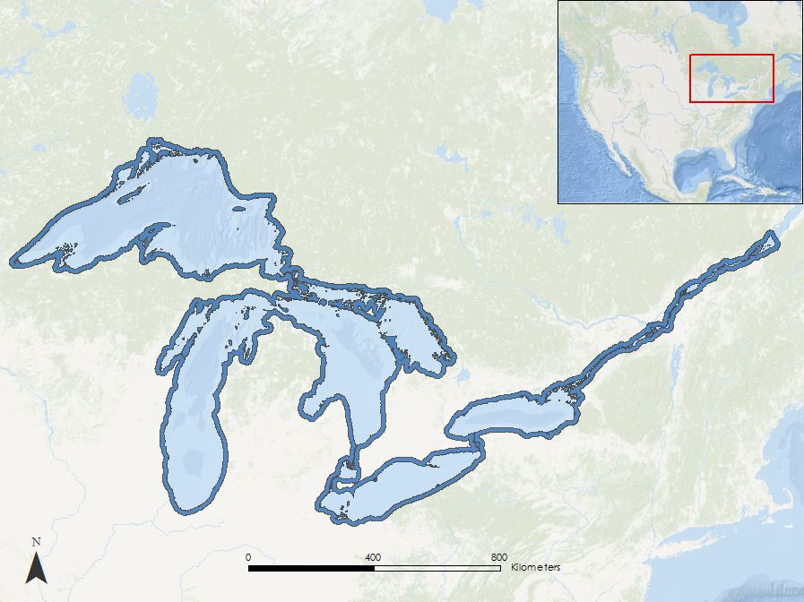

Coastal Area

Great Lakes St. Lawrence River

*Figure 1. Study area map of the coastal zone for the Great Lakes and St. Lawrence River.*

**National Application Addressed:**

This project addressed the Ecological Forecasting Application Area within NASA’s Applied Sciences Program. This project utilized NASA Eo to create driver variables for current and forecast Phragmites risk maps based on habitat suitability. The information provided by this project will augment current decision-making practices regarding Phragmites management in the Great Lakes and St. Lawrence River Basin.

**Project Partners**:

The project partners included the Michigan Tech Research Institute (MTRI) and the Great Lakes and St. Lawrence Cities Initiative (GLSLCI). MTRI was a collaborator on the project and has been heavily involved in the remote sensing of Phragmites in the Great Lakes using Phased Array type L-band Synthetic Aperture Radar (PALSAR) data, as well as collecting *in situ* data of Phragmites locations (Bourgeau-Chavez et al., 2012; Bourgeau-Chavez et al., 2015). Dr. Bourgeau-Chavez served as the point of contact (POC) at MTRI and was also a science advisor for this project. MTRI was interested in this research as it provided a forecast risk map of Phragmites for 2020 and showcased an alternative method of Phragmites mapping that does not rely on commercial satellite data. The GLSLCI was a boundary organization encompassing a binational coalition of over 120 U.S. and Canadian mayors and local officials working to advance the protection and restoration of the Great Lakes and St. Lawrence River in both the U.S. and Canada. The goal of the GLSLCI is to work with mayors and municipal staff to protect and preserve the Great Lakes and St. Lawrence region at the local, regional, and basin-wide levels. Laura Bretheim and Simon Belisle served as POC for the GLSLCI. The GLSLCI was interested in distributing forecast risk maps to its member cities. In this way, informed policy decisions based on Phragmites risk can be made.

# III. Methodology

**Data Acquisition:**

In order to model Phragmites extents, multiple raster and vector layers were needed as inputs for the Maximum Entropy (Maxent) modeler and Land Change Modeler (LCM). Proximity to roads is a known Phragmites explanatory variable (Mazur et al., 2014) and these data were obtained from ESRI ArcGIS and TeleAtlas North America. The roads file was downloaded in vector format as an ESRI shapefile in a World Geodetic System (WGS) 1984 coordinate system. Queries were run to select a subset of only primary and secondary roads within both Canada and the U.S. These road classifications are known to positively correlate with Phragmites (Carlson et al., 2009).

LULC maps for the U.S. Great Lakes were obtained in raster format from the National Oceanic and Atmospheric Administration’s (NOAA) Coastal Change Analysis Program (C-CAP) (NOAA, 2015). C-CAP products inventory coastal intertidal areas, wetlands, and adjacent uplands with the goal of monitoring changes in these habitats, on a one-to-five year repeat cycle. C-CAP products are derived from Landsat Thematic Mapper (TM) images with a 30 meter spatial resolution. They come georeferenced to the North American Datum (NAD) of 1983 and projected to Albers Conical Equal Area. The LULC maps include 21 classes and were obtained for the years 1985, 2005, and 2010.

On the Canadian side of the Great Lakes, LULC maps were obtained in raster format from the Canada Center for Remote Sensing (CCRS) Natural Resources Canada (NRC) data portal (NRC, 2015). LULC maps were derived from Moderate Resolution Imaging Spectroradiometer (MODIS) imagery in 250 meter spatial resolution, and came georeferenced to the Geodetic Reference System (GRS) of 1980 and projected in Lambert Azimuthal Equal-Area. The LULC maps include 25 classes and were obtained for the years 2000 - 2011. These LULC maps were used as inputs to the Land Change Modeler and used to derive proximity to agriculture and developed lands.

Shuttle Radar Topography Mission (SRTM) Interferometric Synthetic Aperture Radar (IFSAR) maps were downloaded in raster format from the USGS EarthExplorer data portal as Void Filled and came georeferenced using the WGS 1984 coordinate system (Table 1). These data were used to obtain slope and to create topographic roughness for variables to be used in Maxent. SRTM Void Filledelevation data are the result of additional processing using interpolation algorithms in conjunction with other sources of elevation data. The resolution for SRTM Void Filled data are ~30 meter spatial resolution for the United States and Canada.

|  |  |  |  |  |
| --- | --- | --- | --- | --- |
| **Platform** | **Source** | **Resolution** | **Product** | **Date Acquired** |
| SRTM | USGS Earth Explorer | 30 m | Land Use/  Land Cover | February 2000 |
| TRMM | Giovanni  (IMERG) | 0.25° | Precipitation | Monthly  1998 - 2015 |
| GPM | Giovanni  (IMERG) | 0.25° | Precipitation | Monthly  2014 - 2015 |

*Table 1. Earth observations used in deriving environmental variables for running models.*

Precipitation data were taken from the Tropical Rainfall Measurement Mission (TRMM) and Global Precipitation Measurement (GPM) missions (Table 1). These combined missions provide near global estimates of rainfall rates using microwave imaging. The data came georeferenced to the WGS 1984 coordinate system, at a 0.25° spatial resolution. Near surface (2m) air temperature data were taken from the NASA Modern Era Reanalysis for Research and Applications Version-2 (MERRA-2) reanalysis, which uses Goddard Earth Observing System Data Assimilation System Version 5 (GEOS-5) to assimilate disparate satellite data products into a single observational product. These data came referenced in the WGS 1984 coordinate system, at a 0.50° spatial resolution.

Great Lakes soil classifications were necessary for determining the soil drainage of areas within the basin. Data were acquired from the United States Department of Agriculture (USDA) STATSGO program in vector format and came georeferenced to the WGS 1984 coordinate system. Data came referenced as GCS North American 1983 was used to determine soil drainage for the U.S. Natural Resources Canada (NRC) National Soil Database (NSDB) was used for Canada. Table 2 (Appendix) summarizes the variables used, their time period, and their source to model Phragmites habitats using Maxent modeling software.

**Data Processing**

All datasets were projected into the North American Datum 1983 Contiguous Albers USA reference system, converted to raster files, and mosaicked to produce continuous datasets. Files were processed to the same number of columns, rows, and geographical extent. A 10 km coastal zone around the Great Lakes Basin was used to subset each dataset to the study area. To normalize land cover data, LULC categories were aggregated and reclassified with the same naming convention.

The Digital Elevation Model (DEM) acquired from the SRTM was converted into a topographical roughness variable using the following equation:

$$\frac{(meanDEM – DEM)}{rangeDEM}$$

Soil drainage was created using the USDA STATSGO and NRC NSDB soil classifications following the methods described in *Mazur et al.* (2014).

Proximity variables from roads, agriculture, and developed land were created using the Euclidian distance tool in ArcGIS, where high proximity to these variables was seen as a positive influence on Phragmites. Proximity to roads data were created by selecting all primary and secondary road classifications within the Great Lakes Basin on both the U.S. and Canadian borders. The variables proximity to developed land, and proximity to agriculture, were found using LULC classifications as defined by NOAA C-CAP in the U.S. and by NRC for the Canadian portion of the Basin.

Previous research has identified bioclimatic variables as important to the habitat and growth of Phragmites (Guo et al., 2013; Mazur et al. 2014). Bioclimatic variables are comprised of the combination of temperature, precipitation, and seasonality/time of year, which together often have greater biological and ecological saliency than either variable insolation (Nix, 1986; Hijmans, 2004). Following *O’Donnell and Ignizio* (2012), quarterly values were calculated using 3 month averages over two year periods. For example, the driest 3 month average values for the years 2010 and 2011 were identified in the TRMM+GPM precipitation data. Then the mean temperature over those months was calculated using the MERRA-2 temperature data. This produces the “DryTemp” bioclimatic variable, or the temperature during the driest quarter. In addition to “DryTemp”, the temperature during the coldest quarter (“ColdTemp”), precipitation during the warmest quarter (“WarmPrecip”), precipitation during the coldest quarter (“ColdPrecip”) and precipitation during the driest month (“DriestPrecip”) were created using the combination of TRMM+GPM and MERRA-2 data.

To estimate values for the 2020 bioclimatic data, the underlying decadal trend in the observations was added to the 2010 values. First, the bioclimatic data were converted to monthly anomalies by subtracting the mean values for each month over a baseline period (2000-2009 and 1981-1995 for TRMM+GPM and MERRA-2 respectively) from each grid cell. Seasonal and/or annual averages were then created (depending on the variable) to reduce autocorrelation. Ordinary least squares (OLS) regression was used to calculate the decadal trends.

Presence locations for Phragmites were obtained from the MTRI and the Global Biodiversity Information Facility (GBIF). MTRI collected *in situ* data at randomly selected locations within a 10 km coastal zone on the US side of the Great Lakes. Dates of collection were from May to October in 2010 and 2011 (Bourgeau-Chavez et al., 2012). GBIF presence locations were downloaded from their website (http://www.gbif.org/) with collection dates ranging from 2012 to 2014. All *in situ* data was aggregated and used. To compensate for spatial autocorrelation, *in situ* data within a 0.25 km distance of one another were removed leaving n = 292 (Figure 2, Appendix).

# IV. Results

**Land Change Modeler**

Land Change Modeler was run to determine the change of land classifications in order to forecast land classes to the year 2020. Results from LULC from 1985 – 2010 showed that the classes of forest (-505 hectares), agriculture (-450 ha), water (-77 ha), and grassland (-22 ha) declined over this time frame while development (850 ha) and scrubland (150 ha) expanded. Development can be further split into categories of low intensity (325 ha), managed open spaces (230), medium intensity (195), and high intensity (105). While all development expanded during this time, it is important to note that the more urbanized an area is, the lower its growth rate during this time. Development of suburban and managed open spaces showed the largest increases, while urban cities exhibited slower growth rates. Finally, wetlands (16 ha) exhibited a very small growth during this time. While this growth is small, it is important for Phragmites as the vast majority of Phragmites (159 points out of 292) *in situ* data collected was from areas classified as wetlands.

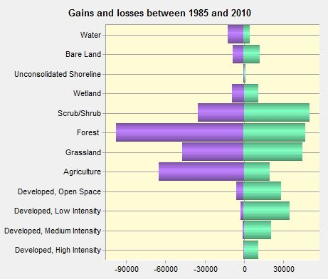

*Figure 3: The following graph show the Gains and Losses after running Land Change Modeler between the dates 1985 and 2010.*

*Figure 4: The following graph show the Net Land Cover Change in the US in km2 between the dates 1985 – 2010.*

LCM results from figures 3 & 4 show that agricultural lands are decreasing at the expense of managed open space and suburban development. Maxent results described below show that Phragmites presence is more closely linked to agricultural lands than development. Therefore, there is an overall slight decrease in suitable Phragmites habitats over time. However, the temporal trend of Phragmites expansion with increasing development and decline in areas where agriculture is declining results in a concentration of Phragmites around populated areas.

**Maxent 2010**

Maxent modeling for 2010 was done with the before mentioned explanatory variables on Phragmites presence points and output their contribution to the model. The 2010 model percent contribution for the top five variables are shown below in table 3.

|  |  |
| --- | --- |
| **Explanatory Variable** | **Percent contribution** |
| Topographic roughness | 28 |
| Driest season temperature | 17.7 |
| Coldest season temperature | 17.1 |
| Soil drainage | 13 |
| Distance from agriculture | 12.5 |

*Table 3: Maxent 2010 Percent Contribution for each environmental variable*

Topographic roughness was by far the most contributing factor. Topographic roughness is the standard deviation of elevation in an area. For this project, a 50 cell radius of standard deviation for a cell was used. Topographic roughness can be thought of as the relative consistency or variability of slope in an area. As Phragmites is known to inhabit wetland areas that are of similar elevation, their topographic roughness value is known to be low. Conversely, areas of high topographic roughness, such as mountainous terrain that has varied elevations, are known to negatively impact Phragmites growth as there are generally fewer areas of pooled water in which Phragmites thrives. Similar studies have found topographic roughness to be the most contributing factor for Phragmites modeling, so this result is not surprising.

Driest season temperature is the average temperature over the 3 month quarter that sees the lowest precipitation rates. In the Great Lakes Basin, GPM + TRMM define the driest 3 months as January, February, and March. Coldest season temperature is defined as the average temperature over the coldest quarter. MERRA-2 data showed that December, January, and February are the coldest months in the study region. The importance of these variables in the Maxent model suggests that during these months, Phragmites growth is often temperature-limited.

Soil drainage is the measurement of how slowly or quickly water is drained from the soil. Areas with low soil drainage are characterized as wetlands due to water pooling as a result of low drainage classes. Phragmites is therefore correlated with areas of low soil drainage. Conversely, areas of high drainage where water rarely pools are seen as poor habitats for Phragmites as the common reed thrives in inundated areas.

Finally, distance from agriculture was the fifth most explanatory variable. Previous research (Mazer et al., 2015) found that proximity to agriculture was a strong predictor of Phragmites growth due to 1) fertilizer runoff such as phosphorus and nitrogen, and 2) the use of agricultural machinery, which often destroys biodiverse areas, leading to monotypic Phragmites taking over these new areas.

Figure 5 shows Phragmites risk classified into five categories of risk for the US side of the Great Lakes Basin. In general, the southern lakes such as Erie, Ontario, and southern parts of Michigan demonstrated higher risk than northern areas. Phragmites risk was also located in populated areas and less common in very rural places. The border west of Cleveland on Lake Erie demonstrated the highest risk area for the US border.

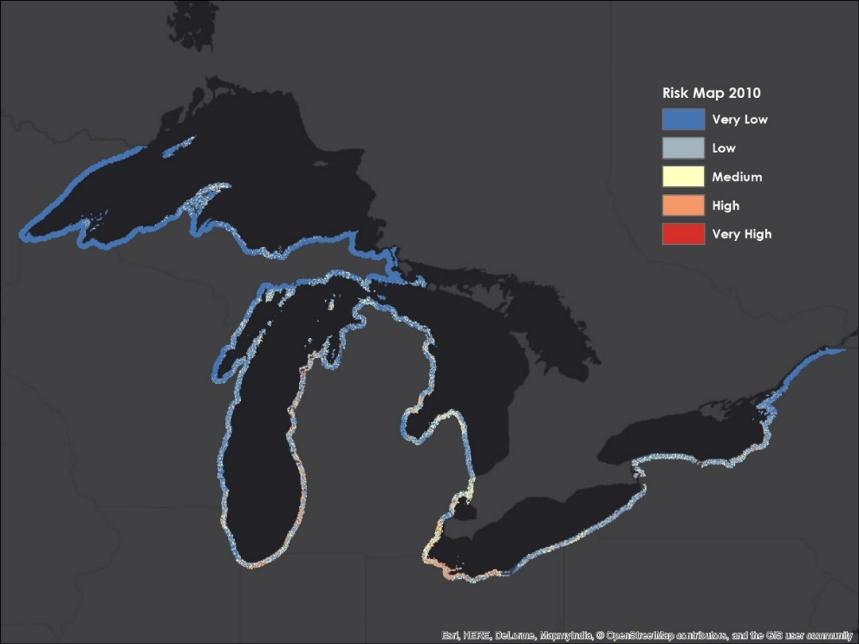

*Figure 5: The following map show the risk of Phragmites in the US for 2010*

Maxent was re-run using variables that did not have correlation coefficients greater than 0.7 so as not to over fit the model. Table 4 (appendix) shows the correlation coefficients of the explanatory variables used when compared to each other. In general, bioclimatic variables dry season temperature and cold season temperature were highly correlated. Proximity variables such as distance from agriculture and distance from development were also highly correlated. After eliminating variables with high correlation coefficients, the resulting variables included: dry temperature, topographic roughness, proximity to agriculture, and soil drainage.

Figure 6 (Appendix) shows the Area Under the Curve (AUC) for the Maxent output for 2010 in the US after running the model with the previously mentioned four variables. Area under the curve is a measurement of how accurately the model preforms in measuring its observed variable. An AOC of 0.5 means the model is no better than random, while an AOC of 1.0 means the model perfectly measures distribution. The model for 2010 Phragmites risk gave an AOC of 0.85, which is an acceptable model that still has room for improvement. Table 5 shows the percent contribution to the model when Maxent was re-run using only these four variables.

|  |  |  |
| --- | --- | --- |
| **Variable** | **Percent contribution** | **Permutation Importance** |
| Dry season Temperature | 38.1 | 48.8 |
| Topographic Roughness | 32 | 30.9 |
| Distance from Agriculture | 15.6 | 10.9 |
| Soil Drainage | 14.3 | 9.5 |

*Table 5: The following table shows the four environmental variables and their contributions to the Maxent model in 2010 in the US: dry temperature (2010), topographic roughness, proximity to agriculture, and soil drainage.*

**Maxent 2020**

To forecast risk of Phragmites to the year 2020, Maxent was used in combination with Land Change Modeler. Land Change Modeler gave the projected land classifications for the year 2020. These 2020 land classes were used to generate forecasted proximity to agriculture and proximity to development variables. Bioclimatic variables were also forecast to 2020 by adding their projected decadal trend. DryTemp has seen an increase in temperature of ~0.15 degrees Celsius per decade, and ColdTemp has seen an increase in temperature across this season as ~0.27 degrees Celsius per decade. With these forecasted environmental variables, Maxent was re-run to output a 2020 Phragmites risk assessment map (Figure 7).

Figure 8 (Appendix) shows the AUC for the 2020 Maxent model, while table 6 shows the percent contribution for the four explanatory variables of dry temperature, topographic roughness, distance from agriculture, and soil drainage.

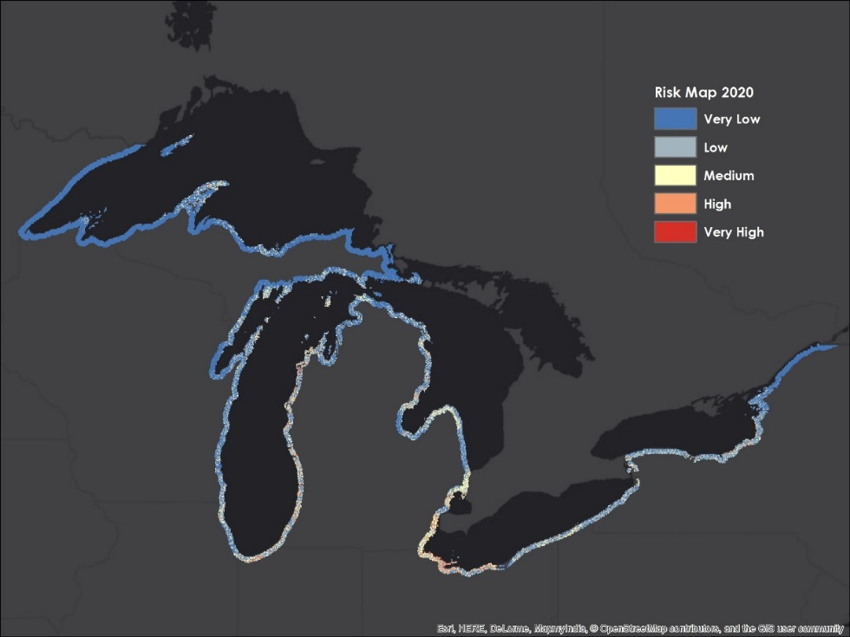

*Figure 7: The following map show the risk of Phragmites in the US for 2020*

**Future Work:**

Future modeling could be greatly improved upon by having yearly *in situ* datasets for Phragmites locations. Having yearly datasets would allow further model accuracy and would allow end users a glimpse into how their preventative efforts are effecting Phragmites growth.

Modeling with U.S. and Canadian government datasets proved incompatible due to differences in spatial resolution of remotely sensed imagery. If datasets were normalized across the region, then Basin wide (as opposed to U.S. vs. Canadian) findings could be acquired.

Given the apparent competition between trends in agriculture and development for future Phragmites risk, a natural extension of this work could focus on generating future scenarios spanning a range of high and low intensity agricultural use, development expansion, and climatic change. Coupling such biophysical scenario generation with economic analyses could further benefit stakeholders in the region seeking to protect their communities against Phragmites invasion. Unfortunately, the risk posed by Phragmites is far from unique to the Great Lakes region. Our methods could in theory be applied to any area at risk for Phragmites invasion, provided relevant driver variables and Phragmites training/validation data are available.

# VI. Conclusions

*Phragmites australis* in the Great Lakes is a serious threat to native wetlands and has been shown to negatively impact communities throughout the region. As Phragmites expands, native wetlands are at risk of being taken over by monotypic stands, which lowers biodiversity in previously diverse wetlands. From a community concerns prospective, Phragmites is very costly to remove and also lowers lakefront property values by limiting access to the water.

With a combination of Maxent and Land Change Modeler software’s, Phragmites habitats are shown to be changing with the environment. As developed land expands at the expense of agricultural and forested land, Phragmites habitats are shifted to be more concentrated around areas of human activity. Policy makers in the Great Lakes Basin must therefore focus their preventative efforts towards areas marked for future development if they wish to slow the growth of Phragmites. This information will give policy makers the knowledge of where to best focus their efforts on stopping Phragmites expansion in at-risk areas.

# VII. Acknowledgments

The Great Lakes Ecological Forecasting team would like to thanks the mentors, advisors, and partners who contributed time and assistance with making this project possible.

Mentors & Advisors

* Dr. Laura Bourgeau Chavez, The Michigan Technical Research Institute
* Dr. Kurt Kowalski, USGS

Partners

* Laura Bretheim, The Great Lakes and St. Lawrence Cities Initiative
* Simon Belisle, The Great Lakes and St. Lawrence Cities Initiative
* David Ullrich, The Great Lakes and St. Lawrence Cities Initiative

All opinions, findings, and conclusions expressed in this article are those of the authors and do not necessarily reflect the views of the National Aeronautics and Space Administration.

This material is based upon work supported by NASA through contract NNL11AA00B and cooperative agreement NNX14AB60A.

# VIII. References

Ailstock, S. M., Norman, M. C., & Bushmann, P. J. (2001). Common Reed *Phragmites australis*: Control and Effects Upon Biodiversity in Freshwater Nontidal Wetlands. *Restoration Ecology,* *9*(1), 49-59

Bourgeau-Chavez, L. L., Kowalski, K. P., Mazur, M. L., Scarbrough, K. A., Powell, R. B., Brooks, C. N., . . . Riordan, K. (2012). Mapping Invasive *Phragmites australis* in the Coastal Great Lakes with ALOS PALSAR Satellite Imagery for Decision Support. *Journal of Great Lakes Research*, 39, 65-77.

Bourgeau-Chavez, L., Endres, S., Battaglia, M., Miller, M., Banda, E., Laubach, Z., & Marcaccio, J. (2015). Development of a Bi-National Great Lakes Coastal Wetland and Land Use Map Using Three-Season PALSAR and Landsat Imagery. *Remote Sensing*, 7(7), 8655-8682. Retrieved January 28, 2016, from

http://www.mdpi.com/2072-4292/7/7/8655/htm

Carlson, M. L., Kowalski, K. P., & Wilcox, D. A. (2009). Promoting Species Establishment in a Phragmites-dominated Great Lakes Coastal Wetland. *Natural Areas Journal,* *29*(3), 263-280.

Catling, Paul M., & Gisèle Mitrow. (2011). The Recent Spread and Potential Distribution of Phragmites australis subsp. australis in Canada. *Canadian Field-Naturalist* 125, 95–104.

Chambers, R. M., Meyerson, L. A., & Saltonstall, K. (1999). Expansion of *Phragmites australis* into Tidal Wetlands of North America. *Aquatic Botany,* *64*, 261-273.

Federal, Provincial and Territorial Governments of Canada. (2010). Canadian Biodiversity: Ecosystem Status and Trends 2010. Canadian Councils of Resource Ministers. Ottawa, ON. vi + 142 p

Gucker, Corey L. (2008). Phragmites australis. In: Fire Effects Information System, [Online]. U.S. Department of Agriculture, Forest Service, Rocky Mountain Research Station, Fire Sciences Laboratory (Producer). Available: http://www.fs.fed.us/database/feis/ [2016, February 18].

Guo, W.-Y., Lambertini, C., Li, X.-Z., Meyerson, L. A. and Brix, H. (2013). Invasion of Old World *Phragmites australis* in the New World: precipitation and temperature patterns combined with human influences redesign the invasive niche. *Global Change Biology*, 19: 3406–3422.

Hijmans, R. J. (2004). Arc Macro Language (AML®) version 2.1 for calculating 19 bioclimatic predictors: Berkeley, Calif, Museum of Vertebrate Zoology, University of California at Berkeley. Available: http://www.worldclim.org/bioclim [2016, February 18].

King, M. D. (2006). *Earth Science Reference Handbook - A Guide to NASA's Earth Science Program and Earth Observing Satellite Missions* (C. L. Parkinson & A. Ward, Eds.). Washington, D.C.: National Aeronautics and Space Administration.

Lantz, N. J., & Wang, J. (2013). Object-based classification of Worldview-2 imagery for mapping invasive common reed, *Phragmites australis*. *Canadian Journal of Remote Sensing,* *39*(4), 328-340.

Mazur, M. C., Kowalski, K., & Galbraith, D. D. (2014). Assessment of suitable habitat for *Phragmites australis* (common reed) in the Great Lakes coastal zone. *Aquatic Invasions AI*, *9*(1), 1-19. Retrieved February 17, 2016, from http://www.aquaticinvasions.net/2014/AI_2014_CarlsonMazur_etal.pdf

NOAA (2013), NOAA's Coastal Change Analysis Program (C-CAP) 1996 to 2010 Regional Land Cover Change Data - Coastal United States,

https://coast.noaa.gov/dataregistry/search/collection/info/ccapregional, NOAA's Ocean Service, Office for Coastal Management (OCM), Charleston, SC.

Natural Resources Canada (NRC) (2015), Characterization and Monitoring Change of Canada's Land Surface. Retrieved February 18, 2016, from http://www.nrcan.gc.ca/earth-sciences/land-surface-vegetation/land-cover/north-american-landcover/9146#_North_American_Land

Nix, H. A. (1986). A biogeographic analysis of Australian elapid snakes, in Longmore, Richard, ed., *Atlas of elapid snakes of Australia: Canberra, Australian Flora and Fauna Series 7*, Australian Government Publishing Service.

O’Donnell, M.S., and Ignizio, D.A. (2012). Bioclimatic predictors for supporting ecological applications in the conterminous United States: U.S. Geological Survey Data Series 691.

Ontario Ministry of Natural Resources (OMNR), Invasive Phragmites – Best Management Practices, Ontario Ministry of Natural Resources, Peterborough, Ontario. Version 2011. 17p.

Pengra, B. W., Johnston, C. A., & Loveland, T. R. (2007). Mapping an invasive plant, *Phragmites australis*, in coastal wetlands using the EO-1 Hyperion hyperspectral sensor. *Remote Sensing of Environment,* *108*, 74-81.

Tulbure, M. G., Johnston, C. A., & Auger, D. L. (2007). Rapid Invasion of a Great Lakes Coastal Wetland by Non-native Phragmites australis and Typha. *Journal of Great Lakes Research, 33*(3), 269-279. Retrieved February 14, 2016.

# IX. Content Innovation

VPS

Inline Supplementary Material

Interactive Map Viewer: Three Map Files

1. Spring2016_GSFC_GreatLakesEcoForecast_ContentInnovation_MapViewer_Racine_WI.kmz
2. Spring2016_GSFC_GreatLakesEcoForecast_ContentInnovation_MapViewer_Gary_IN
3. Spring2016_GSFC_GreatLakesEcoForecast_ContentInnovation_MapViewer_Milwaukee_WI

# X. Appendix

Table 2. Variables used to model Phragmites in the Great Lakes Basin.

|  |  |  |  |
| --- | --- | --- | --- |
| Category | Variable | Time Period | Source |
| Climate | Temperature | 1981-2015 | MERRA-2 |
|  | Precipitation | 1998-2015 | TREMM+GPM |
| Disturbance | Proximity to roads | 1992 | DIVA-GIS |
|  | Proximity to agriculture | 2001, 2005, 2010 (U.S); 2000-2011 (Canada) | NOAA C-CAP (U.S), DUC CWI, OMNR OGLCWA, and MODIS 250m Land Cover, Natural Resources Canada (Canada) |
|  | Proximity to developed land | 2001, 2005, 2010 (U.S); 2000-2011 (Canada) | NOAA C-CAP (U.S), DUC CWI, OMNR OGLCWA, and MODIS 250m Land Cover, Natural Resources Canada (Canada) |
| Topography | Elevation | 2000 | NASA SRTM Plus Void-Filled |
| Soil | Soil drainage class | 2006 | Food and Agricultural Organization United Nations (FAO UN) World Resource Base Map of Soil Resources |

Figure 2. The graph below shows the frequency of *in situ* data in each land cover category within the US. Data was collected by MTRI.

Table 4. Correlation matrix for the 9 original Environmental Variables. Coefficients > 0.7 were used to remove variables and create the most parsimonious model.

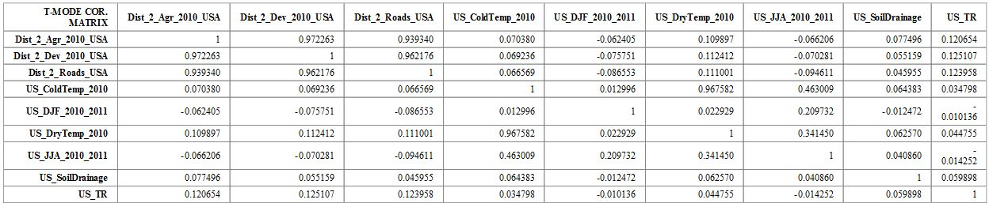

Figure 6: AUC Maxent 2010

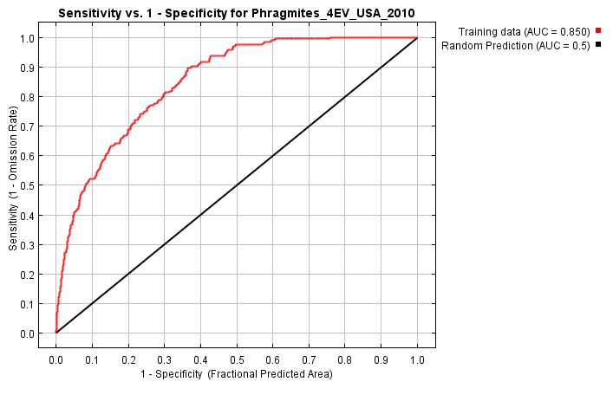

Figure 8: The following graph shows the Area Under the Curve (AUC) for the Maxent output for 2020 in the US after running the model with four environmental variables: Dry Temperature (2020), Topographic Roughness, Proximity to Agriculture (2020), and Soil Drainage.

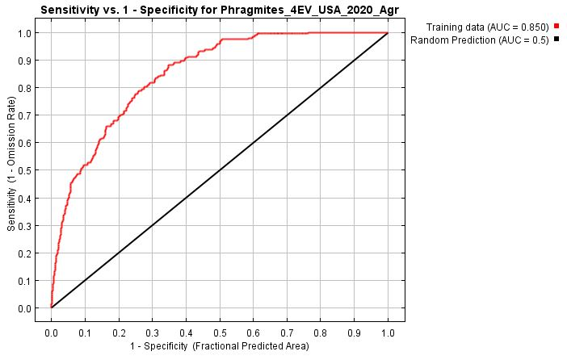

Table 6: The following table shows the four environmental variables and their contributions to the Maxent model in 2020 in the US: Dry Temperature (2020), Topographic Roughness, Proximity to Agriculture, and Soil Drainage.

|  |  |  |
| --- | --- | --- |
| **Variable** | **Percent contribution** | **Permutation Importance** |
| Dry season Temperature | 37.9 | 48.9 |
| Topographic Roughness | 31 | 30.2 |
| Distance from Agriculture | 16.3 | 10.5 |
| Soil Drainage | 14.8 | 10.3 |