Idaho Wildfires II

Assessing the Relationship Between Drought Indicators and Wildfire Risk to Enhance Hazard Modeling and Inform Mitigation Planning

 **Technical Report**

Final – November 14th, 2022

Talissa Cota (Project Lead)

Dana Drinkall

Tyler Morvant

Ryan Healey

***Advisors:***

Keith Weber, GIS Training and Research Center, Idaho State University (Science Advisor)

***Previous Contributors:***

Ford Freyberg

Brenner Burkholder

Jessica Hiatt

Carson Schuetze

***Fellow:***  
Brandy Nisbet-Wilcox (ID-Pocatello)

# 1. Abstract

The western United States has experienced twenty years of increased and prolonged drought which have exacerbated wildfire hazards. These jeopardize population centers through increased risks to ecosystem services, local economies, and livelihoods. The Idaho Office of Emergency Management, Water Resources, and Department of Lands are seeking methods to dynamically monitor these conditions and update models that inform hazard mitigation planning and resource allocation. Towards this, these agencies partnered with NASA DEVELOP to produce drought-enhanced wildfire hazard models. Part of a two-term project, the two teams revised the state’s static wildfire hazard model with refined data layers and remotely-sensed data to reflect dynamic ecosystem responses to drought conditions and wildfire potential. Our team distinguished between rangeland and forestland ecosystems and investigated relationships between drought metrics and vegetation condition using TerrSet Earth Trends Modeler. This analysis determined that total precipitation at a 5-month lag interval (r2 = 0.72) along with the Evaporative Stress Index (r2 = 0.69); and precipitation at a 5-month interval (r2 = 0.42) were important drivers in rangeland and forestland, respectively. These driver variables were incorporated into a temporally dynamic wildfire hazard map. Our team used linear regression to correlate hazard ratings with wildfire frequency. For the year 2020, neither the enhanced hazard model (p < 0.10, r2 = 0.01) nor the state’s static model (p < 0.05, r2 = 0.03) were strongly correlated with actual wildfire frequency as they expressed an inverse relationship between wildfire hazard and frequency. This suggests wildfire occurrence is complex and not necessarily driven by the variables used.

**Key Terms**

wildfire, drought, MODIS, Landsat, hazard management, NDVI, ESI, landscape-scale modeling

# 2. Introduction

***2.1 Background Information***

Wildfire and drought in the western United States have not only become more frequent but are also producing larger wildfires (Weber & Yadav, 2020; Gamelin et al., 2022). An increase in drought typically drives a greater incidence of wildfire due to the increase of drying fuels (Riley et al., 2013). In turn, greater wildfire occurrence can lead to increased drought through more landscape coverage of wildfire-burned environments (Margolis et al., 2011). However, while hotter and drier conditions and wildfire prone environments are spatially and temporally related, this relationship is non-linear and complex (Brown et al., 2022). Variations in fuel and land management, biophysical structure and condition, past disturbance, climatic oscillation, and the stochastic nature of ignition all interact to create profound complexity when determining drivers of wildfire and drought (Littell et al., 2016; Halofsky et al., 2020; Taylor et al., 2013). As hotter and drier conditions persist, informed management is essential to reduce ecosystem vulnerability to large-scale wildfire disturbances and threats to human health and population centers interfacing with fire prone ecosystems (Prichard et al., 2021; Burke et al., 2021; Wilhite et al., 2014; Xi et al., 2019). Managers need improved, scalable, and dynamic models with enough statistical power to reliably predict drought and wildfire occurrence and interaction to inform proactive management decisions.

To address this need in the state of Idaho, the summer 2022 NASA DEVELOP team enhanced the Idaho Department of Lands (IDL) static wildfire hazard model (SWHM) with remotely sensed drought metrics of Evaporative Drought Demand Index (EDDI), Evaporative Stress Index (ESI) and Normalized Difference Vegetation Index (NDVI), in an effort to better predict wildfire susceptible conditions in the Palouse Prairie ecoregion of north-central Idaho. Using these data, wildfire season (6/1 – 9/30) and growing season (3/1 – 6/1) baselines were established to temporally constrain functionality within these models. The first term incorporated each metric (EDDI, ESI, NDVI) into three separate enhanced versions of the SWHM and assessed the efficacy of these drought-enhanced wildfire hazard models (DEWHM) using a confusion matrix analysis for dry and wet year case study periods. They compared wildfire burned pixel capture rates between the DEWHM and the SWHM. This analysis found that the DEWHM reduced false predictions of wildfire through reduced false positives and increased true negatives but were unable to produce increased predictions of true wildfire areas and underpredicted areas where wildfire occurred in dry years (Table A1). They hypothesized that this was due to overprediction of the SHWM – a trend potentially indicated in that predictions by the SHWM did not change between wet and dry years.

The previous term highlighted avenues where model performance could be enhanced to better reflect ecological responses of drought and incorporate these remotely-sensed data to create dynamic modeling capacity. The goal for the fall 2022 DEVELOP team was to further explore functionality of these and additional drought indicator variables, such as the modified soil-adjusted vegetation index (MSAVI2), in improving the SHWM’s performance and dynamic capability, and expand the study area to incorporate the entire state of Idaho. The first term analyzed drought and wildfire trends in north central Idaho, an area that includes the economically important Palouse Prairie ecoregion and contains a diversity of ecoregions, for the years 2013–2021. This term’s team expanded the study area to the entirety of the state of Idaho and broadened the study period from 2010–2020 (Figure 1).

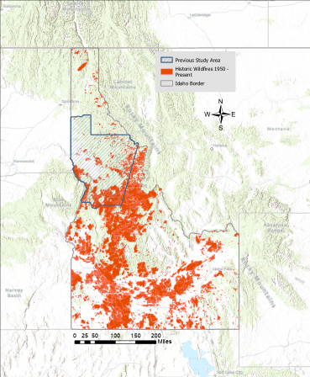

*Figure 1.* The state of Idaho with historical fires from 1950–2021 illustrated in red, the Palouse ecoregion case study region in hashed blue area, Blaine County case study area bordered in blue, and the state of Idaho bordered in gray.

***2.2 Project Partners & Objectives***

The project partners were state government land and emergency management personnel within the Idaho Department of Water Resources (IDWR), Idaho Department of Lands (IDL) and the Idaho Office of Emergency Management (IOEM). These agencies coordinate hazard mitigation decision-making and planning with private, local, and federal authorities through the Idaho State Hazard Mitigation Plan (2018). This document in part summarizes both the Idaho Statewide Implementation Strategy for the National Fire Plan (2006) and the Idaho Drought Plan (2001) and assesses wildfire hazard to guide mitigation approaches under the objectives of creating wildfire-resistant and -adapted landscapes, reducing possible ignition and fuel sources (including rehabilitation of invasive species-dominated wildlands), increasing public awareness, and reducing risk to human health, lives, property, and natural resources (IOEM, 2018).

These objectives are confounded by challenges associated with the uncertainty of predicting wildfires (Pacheco et al., 2015). A pressing concern is how increasing wildfire frequency and size imposes risks to local communities (Tedim et al., 2018) from the adverse effects of wildfire smoke on the human respiratory system (Reid & Maestas, 2019) and increases of economic and ecological costs associated with damage and recovery (Stavros et al., 2014). The partners currently use a SWHM to predict wildfire susceptibility, a capacity that is at odds to variable spatiotemporal dynamics intrinsic to wildfire (Linn, 2019) and drought (Diaz et al., 2020) conditions. Therefore, the partners are concerned with adapting their monitoring capabilities to gain capacity in responding to dynamic conditions as they occur across the state with the goal of effectively allocating resources over space and time. To achieve this capacity, the partners wish to incorporate Earth observation data of drought conditions into their wildfire hazard modeling for the state of Idaho.

In this study, our team analyzed the relationships between vegetation quality and drought indicators across the state of Idaho to identify statistically significant variables for inclusion into a DEWHM. Our team incorporated these identified drought-vegetation quality relationships as variables into the SWHM to enhance its capacity to produce spatiotemporally dynamic wildfire hazards. We then assessed these DEWHM for their efficacy in predicting wildfire frequencies across the state. Our team identified key areas for future research to optimize the model’s performance and compiled a detailed tutorial for ArcGIS Pro ModelBuilder for our partners to recreate the model and maintain for future use.

# 3. Methodology

***3.1 Data Acquisition***

This project is a continuation from the summer 2022 term. Preprocessed remotely-sensed data used in this study was acquired from the GIS Training and Research Center (GIS TReC) at Idaho State University (ISU). The content in this section describes the online sources of data as well as acquisition for ancillary datasets used in this study.

The summer 2022 team acquired EDDI: 4-week Daily CONUS 13km data product and ESI: 4-week Daily Global 5km data from the National Oceanic and Atmospheric Administration (NOAA) Physical Sciences Laboratory (PSL) and the NASA SERVIR Climate SERV Application, respectively, and downloaded these for weekly intervals during the study period, 2013–2021. This data was only specific to the Palouse region of Idaho. Our team used preprocessed EDDI, ESI, temperature, and precipitation datasets acquired from Keith Weber to expand the study area to the entire state of Idaho.

To process MSAVI2, we utilized the previous term’s composited Landsat 8 OLI scenes (covering path 42 rows 27 and 28 with less than 30% cloud cover) and preprocessed Terra Moderate Resolution Imaging Spectroradiometer (MODIS) 16-day 250m data that were clipped to the western United States and projected into the USA Contiguous Albers Equal Area Conic (WKID 102039) coordinate system. Most satellite products were acquired for the wildfire season (6/1–9/30) and growing season (3/1–6/1) specified by the summer 2022 term team. Landsat data was generated using the Earth Explorer website hosted by the USGS and later with USGS/EROS Machine-to-Machine API. Keith Weber of ISU provided our team with pre-processed science-ready MODIS and NOAA datasets for temperature, precipitation, EDDI, NDVI, and ESI. The EDDI data was downloaded from NOAA’s Physical Sciences Laboratory while the cumulative precipitation and temperature data was downloaded from NOAA’s National Center for Environmental Information (NCEI). The ESI data was collected from NASA’s MSFC/SPoRT through SERVIR ClimateSERV. Lastly, the NDVI data was collected from MODIS. These data products were used to expand resolution of our data to a state-wide study area for the years 2010–2020. Table 1 provides a complete listing of Earth observation data used in this study.

Our team acquired the most recent version of the SWHM from IDL that was enhanced during this term (Figure A1) which included the 2022 Wildland Urban Interface (WUI). We also used high resolution 10-m NASA RECOVER products for elevation, slope degrees, and aspect to generate continuous topographic data. We also used the Historical Fire Database (HFD) which records the fire occurrence between 1950–2021 for all federally recognized fires in the Continental United States (Weber, 2020).

A python script that produces an equal interval hexbin layer was executed using an ArcGIS Pro 3.0.1 Jupyter notebook (Robertson, 2022). The hex-bin analysis was used to divide the state into 30-km equal area hexagonal polygons which reduced sampling bias during the final validation process of the DEWHM. These areas allowed our team to generate statistical relationships between enhanced hazard ratings and wildfire frequencies and granted the capacity to analyze the entire state of Idaho. Lastly, an Existing Vegetation Type (EVT) layer was used to segment the state into forestland or rangeland classifications (LANDFIRE, 2020). Table 2 provides a complete listing of ancillary datasets used in this study.

Table 1

*List of NASA sensors and data products utilized for this project*

|  |  |  |  |
| --- | --- | --- | --- |
| **Platform and Sensor** | **Data Product** | **Dates** | **Acquisition Method** |
| Landsat 8 OLI | Landsat 8 Operational Land Imager and Thermal Infrared Sensor Collection 2 Level-1 | Mar. 1–Sep. 30, 2013–2021 | Earth Explorer download & USGS/EROS Machine-to-Machine API |
| Aqua/Terra MODIS | MOD13Q1 v006- MODIS/Terra Vegetation Indices 16-Day L3 Global 250m SIN Grid | Feb. 28–Oct. 3, 2013–2021 | From Keith Weber, ISU |

Table 2

*List of ancillary datasets utilized for this project*

|  |  |  |  |
| --- | --- | --- | --- |
| **Source** | **Data Product** | **Dates** | **Acquisition Method** |
| Idaho Department of Lands | Static Wildfire Hazard Model (SWHM) | 2022 | Provided by Tyre Holfeltz, IDL, with permission |
| NOAA – PSL | Evaporative Demand Drought Index (EDDI): 4-week Daily CONUS 13km | 2013–2021 | Downloaded from NOAA data archive |
| GIS Training and Research Center at Idaho State University and USGS | NASA RECOVER value added National Elevation Dataset | 2016 | Provided by Keith Weber, ISU GIS TReC, with permission, via NASA RECOVER |
| NASA - NCEI | Monthly Cumulative Precipitation Data | 1985–2022 | Provided by Keith Weber, ISU GIS TReC, with permission from Scott Stephens at NCEI |
| GIS Training and Research Center at Idaho State University | Historical Fires Database | 1950–2021 | Provided by Keith Weber, ISU GIS TReC, with permission |
| FEMA Hazard Mitigation Plan | Wildland Urban Interface (WUI) | 2022 | Provided by Tyre Holfeltz, IDL, with permission |
| NASA MSFC/SPoRT | Evaporative Stress Index (ESI): 4-week Daily Global 5km | 2013–2021 | SERVIR ClimateSERV Application |
| LANDFIRE, Earth Resources Observation and Science Center | LANDFIRE Existing Vegetation Type, Fuel Characteristic Classification, Fuel Disturbance | 2020 | Downloaded from LANDFIRE archive |
| Hex-bin Python Script | Python code for generating equally sized hexagonal polygons across the entirety of Idaho for running analysis over equal areas | 2022 | Provided by Wilma Robertson, ID Info Tech Services, with permission |
| Idaho State Boundary | Shapefile of the state of Idaho | 2018 | From ISU Center for Ecological research and Education, via Idaho State Tax Commission |
| US Ecomap | Feature class containing ecological section polygons geographically delineating ecological relationships into units across the conterminous United States | 2007 | USDA Forest Service |

***3.2 Data Processing***

The data used in this project was largely preprocessed by the summer team and Keith Weber. Our team performed additional processing of this data in ArcGIS Pro before they were ready for analysis. We reprojected the data into the USA Contiguous Albers Equal Area Conic USGS coordinate system (WKID 102039) and resampled each of the raster images into the same pixel size as the SWHM’s 30-m resolution using the Project Raster tool. We then clipped the imagery to our Idaho study area using the Clip Raster geoprocessing tool before either incorporating this data into the SWHM or exporting each image layer into TerrSet. Imagery that was loaded into TerrSet was processed using the CONCAT module to concatenate the image layers to the same bounding coordinates for further analysis.

The NDVI and ESI data were prepared in ArcGIS Pro before we were able to perform our time series analysis in TerrSet. One of the first steps in this process was to use the Clip Rasters tool in batch mode to simultaneously clip multiple rasters to the study area at once. This ensured a smooth transition into Terrset by removing NoData pixels from our data. From here, the new rasters were reprojected into USA Contiguous Albers Equal Area Conic USGS coordinate system (WKID 102039) using the Project Raster geoprocessing tool in order to give all the data layers a common spatial reference system. The tool was run using bilinear interpolation and lossless compression (LZW) to preserve all raster cell values. Finally, all datasets were resampled in order to standardize the spatial resolution of the datasets. Note that the NDVI products were transformed into integer space using a scaling factor of 0.001 to reduce of the size of the files and increase performance.

The precipitation, maximum temperature, and minimum temperature datasets also needed to be preprocessed within ArcGIS Pro in order to import this data to TerrSet for analysis. To accomplish this, the Make NetCDF Raster tool and the Export Raster tool was used to save as a permanent TIF. Once complete, these TIF files were imported into TerrSet where the GDAL Conversion Utility was used to create one layer per band within the TIF file. These raster files were then exported out of TerrSet as TIFs and imported into ArcGIS Pro. These TIF files were then clipped and projected using an iterator in ModelBuilder.

Once the spatial resolution and spatial reference system for precipitation, EDDI, ESI, NDVI, and temperature datasets were standardized, the data was imported into TerrSet to perform the time series analysis. All of the TIF files were stored in separate folders specific to the corresponding dataset which enabled raster group files to be easily created in TerrSet. Raster group files are paramount when working with hundreds of files in TerrSet because group files allow changes to be made to the entire group. This is a significant time-saver considering that TerrSet defaults the reference system to the file name which can easily be resolved by creating a raster group file for all files and using the MetaUpdate module to change the reference system to plane. After changing the reference system for all of the files within each time series, the datasets were ready for analysis in TerrSet.

***3.3 Data Analysis***

*3.3.1 Drought Indicator Analysis*

Earth Trends Modeler (ETM) in TerrSet provides great utility in assessing relationships between variables and determining temporal trends within a time series by enabling the user to analyze copious amounts of temporal-sensitive data through a variety of statistical analyses. ETM offers seven types of analyses for a time series file and three of which were incorporated for this study. The Series Trend Analysis tool provides a variety of statistical measures, such as linear correlation or Mann-Kendall significance, to analyze long-term trends. The Seasonal Trend Analysis tool provides great utility for the analysis of seasonal trends since the tool begins with an initial stage of harmonic analysis of each year in the time series to extract the annual and semi-annual harmonics, which are then analyzed using a robust median-slope procedure (Eastman et al., 2009). Finally, the Linear Modeling tool is a multiple regression tool developed for analyzing lag relationships over time.

Time series groups were created in TerrSet for EDDI, ESI, NDVI, precipitation, and maximum and minimum temperature datasets for 2010–2020, which were deseasoned to generate climatology values for each time series. Deseasoned datasets are especially useful in determining long-term trends within a time series because it removes seasonality by subtracting the climatology value from each image to identify anomalies in the data (Weber, 2022). Each time series group were analyzed using the Seasonal Trend Analysis, Interannual Trend Analysis, and Linear Modeling tools to explore seasonal and long-term trends within the drought-indicators as well as relationships between vegetation health.

To explore long-term trends, our team performed linear correlation on the original and deseasoned time series using the Series Trend Analysis tool. Since the data files were comprised of data for the continental United States, a binary mask of the state of Idaho was created so that the analyses would solely run on the study area. Following the initial series trend analysis, our team analyzed each dataset using the Seasonal Trend Analysis tool which calculates trends in seasonal parameters by modeling each year’s seasonal curve and analyzing trends in the mean annual signal, the annual cycle, and the semi-annual cycle (Weber, 2022). The outputs from this analysis consisted of a series of Contextual Mann-Kendall (CMK) probability maps and significance images as well as composites for the phases and amplitudes of each dataset. Statistically significant areas in the composites were then identified by running a logical expression (<=0.05) in the Image Calculator module.

To investigate the relationship between the variables and vegetation health and ultimately determine which variables would be most effective to incorporate into the DEWHM, each time series was run through the Linear Modeling tool. The Linear Modeling tool is useful for identifying independent variables and determining their collective effect upon the dependent variable (Weber, 2022). Incorporating time lags into the regression analyses can also be especially fruitful for determining when the effect of a driver variable is expressed in the dependent variable. Therefore, each variable was tested between 0–5-month time lags.

Following our team’s initial investigation of driver variables in TerrSet and communication with our partners, our team used the LANDFIRE Existing Vegetation Type dataset to classify the state into forestland and rangeland. We used the vegetation lifeform identifier to classify shrub, herb and sparse categories into rangeland and the tree category into forestland. All other categories, e.g., agriculture, barren, developed, snow-ice, and water, were considered non-burnable and were not included in this level of analysis.

The Linear Modeling tool was rerun on all drought and vegetation variables using the rangeland and forestland as masks in the TerrSet Earth’s Trends Modeler, see Tables B1. Following this regression analysis, the forestland mask was further divided into low elevation forestland and high elevation forestland using the median elevation within state forestland as a breakpoint, (Figure B1, Table B2).

*3.3.2 Wildfire Hazard Modeling*

The SWHM was built in ArcGIS Pro ModelBuilder and incorporated weighted raster layers of landcover, topography and wildfire history to produce a summed hazard value for the entire state (Table 3). At its core functionality, this model employs the Raster Calculator geoprocessing tool using simple addition of the weighted input rasters to generate summed scores which are then classified into a quintile-based wildfire hazard with the Reclassify tool (Figure A1).

To enhance this schema, our team incorporated remotely sensed drought and vegetation metrics found to be significant in our ETM analysis. These metrics were reclassified (Table 4) and were input in the Raster Calculator geoprocessing tool at the core of the SWHM’s functionality. These inputs augmented the scoring used in the SWHM to produce hazard ratings. Ratings were created that tracked with variations that occurred within these remotely sensed conditions and mirror variations in vegetation condition and drought as they changed on the ground.

Table 3

*Classification scheme of static variables weights, as specified, within the drought-enhanced wildfire hazard model. Column headers indicate given values used. N refers to aspect North, E to aspect East, S to aspect South, and W to aspect West. The columns 0-6 indicate the weight assigned to the value ranges listed in each row of the column.*

|  |  |  |  |  |  |  |  |
| --- | --- | --- | --- | --- | --- | --- | --- |
| **Variable** | **0** | **1** | **2** | **3** | **4** | **5** | **6** |
| Slope (degrees) | - | 0–10 | 10–20 | > 20 | - | - | - |
| Aspect (degrees) | Flat | N (0–45, 315–360) | E (45–135) | S, W (135–315) | - | - | - |
| Burn density (acres/acre) | 0 | 0–0.5 | 0.5–1.0 | > 1.0 | - | - | - |
| WUI | - | Is not WUI | - | Is WUI | - | - | - |
| Vegetation Class (Forestland) | - | Grass | Grass-Tree | Grass-Shrub | Shrub | Shrub-Tree | Tree |
| Vegetation Class (Rangeland) | - | Shrub | Grass-Shrub | Grass-Tree | Grass | - | - |

Table 4

*Classification scheme of remotely-sensed variables as incorporated within the drought-enhanced wildfire hazard model.*

|  |  |  |  |  |  |  |  |  |
| --- | --- | --- | --- | --- | --- | --- | --- | --- |
| **Earth Observation Data** | **Variable Determinations** | | | | | | | |
| Evaporative Stress Index | Given Weight | -6 | -4 | -2 | 1 | 2 | 4 | 6 |
| Class | -100 – 5.00 | -4.99 – -3.00 | -2.99 – -0.5 | -0.49 – 0.49 | 0.50 – 2.99 | 3.00 – 4.99 | 5 – 100 |
| Normalized Difference Vegetation Index | Given Weight | 1 | 2 | 3 | 4 | 5 | 6 | - |
| Class | < 0 | 0 - 1999 | 2000 – 3999 | 4000 – 5999 | 6000 – 7999 | 8000 – 10000 | - |
| Precipitation | Given Weight | 0 | 1 | 3 | 4 | - | - | - |
| Class | < 0 | 0 – 49 | 50 – 100 | 101 – 1000 | - | - | - |

Within the classification schemes of Table 4, ESI used standard deviations above and below to represent xeric and mesic conditions, respectively, such that xeric ESI values increased a pixel potential to burn while mesic values reduced them. The introduction of NDVI further compounded this scoring method by operating as a metric of fuel loading, with differences in peak growing and peak dormancy vegetation periods being expressed as approximate fuel accumulation, doubling in weight to mirror fuel increase. Precipitation quantified total rainfall, adding no value at pixels where no rainfall occurred and increasing with pixel saturation.

*3.3.2 Wildfire Hazard Model Validation*

To assess predictive efficacy of the DEWHM, our team performed regression analysis to explore relationships of our final wildfire hazard outputs with wildfire occurrence. This was accomplished by using the hexbin layer as the input raster in the Zonal Statistics as Table geoprocessing tool in ArcGIS Pro, which enabled statistics to be generated for 30-km equal area hexagons. Segmenting this validation process in this way reduced sampling bias. The mean hazard rating and the area burned within each hexagon were calculated and regression analysis was performed on those results to determine how well the DEWHM predicted wildfires that had occurred.

All statistical data, for each hexbin, were generated by the Zonal Statistics as Table geoprocessing tool. These data were input into R Studio, where our team performed regression analysis. Regression analysis utilized the mean wildfire hazard rating from the output models and the sum wildfire frequency, wildfire area and lack of wildfire occurrence. The DEWHM was validated for the years 2018 and 2020 as well as IDL’s 2022 SWHM, for comparative purposes.

# 4. Results & Discussion

***4.1 Analysis of Results***

*4.1.1 ETM Analysis*

ETM analysis in TerrSet allowed our team to explore trends and compare various environmental parameters and Earth observation data to determine which of these datasets are the strongest predictor of vegetative health. The Series Trend Analysis tool, which investigates long-term trends, produced weak results for all datasets when running linear correlation, with the highest r2 value 0.25 for maximum temperature (Table 1C). Rerunning the analysis on the deseasoned datasets produced an r2 value of 0.42 for NDVI and 0.25 for minimum and maximum temperature.

The initial regression analysis for the entire state, using the Linear Modeling tool and vegetative health as the dependent variable, produced the strongest r2 result for ESI at 0.69 closely followed by precipitation at a 3-month time lag of 0.68 (Table 2C). Interestingly, precipitation was the only variable to benefit from applying a time lag, likely a by-product of the temporal aspect of hydrological flow through ecosystems. After classifying the state into rangeland and forestland, linear modeling was repeated; ESI still showed a strong correlation of 0.69 for the rangeland mask but dropped to 0.29 for the forestland mask. Additionally, results indicated that precipitation provided utility for both rangeland and forestland masks. Precipitation at a 5-month lag produced an r2 value of 0.72 for rangeland and a r2 value of 0.51 at a 4-month lag and 0.42 at a 5-month lag for forestland (Tables B1).

The results from running the Earth Trends Modeler Linear Modeling tool on the high and low elevation forestland masks produced results that varied only slightly when compared to the initial forestland mask, so variable selection for the DEWHM were based on the results from the Linear Modeling regression analysis for the original forestland and rangeland masks.

*4.1.2 Drought-Enhanced Wildfire Hazard Model*

After the data layers were selected and loaded into ArcGIS Pro, ModelBuilder was used to create the DEWHM (Figure A2). In terms of dynamic performance, incorporation of drought-enhancements introduced greater intra-annual temporal variability (Figure A3). The DEWHM predicted wildfire conditions differently than the SWHM (Table 7). Unenhanced, the SWHM maintained a high degree of statistical confidence but low explanatory power in predicting wildfire frequency (p < 0.05, r2 = 0.03) and wildfire absence (p = 0.001, r2 = 0.04). The SWHM also predicted poorly for wildfire size (p = 0.780, r2 = 0.02). The DEWHM had variable performance, but remained uniformly reduced in terms of both explanatory and statistical power for wildfire frequency for the year 2020 (p = 0.090, r2 = 0.01) and 2018 (p = 0.440, r2 = 2.0E-3) and wildfire absence for the year 2020 (p = 0.033, r2 = 0.02) and 2018 (p = 0.41, r2 = 2.0E-3). However, for the year 2018, the DEWHM vastly increased the statistical performance of the model for predicting wildfire size (p = 0.050) compared with the SWHM (p = 0.780) and the 2020 DEWHM (p = 0.700). All models had negative model coefficients associated with wildfire frequency and wildfire size, and all models had positive model coefficients associated with wildfire absence.

Table 7

*Results from analyzing the mean wildfire hazard rating and corresponding wildfire frequency using regression analysis in R Studio*

|  |  |  |  |  |  |  |  |  |  |
| --- | --- | --- | --- | --- | --- | --- | --- | --- | --- |
|  | Wildfire Size | | | Wildfire Frequency | | | No Wildfire Occurrence | | |
| Model | P-value | R-value | coefficient | P-value | R-value | coefficient | P-value | R-value | coefficient |
| SWHM | 0.780 | 0.02 | -1E-05 | 0.003 | 0.03 | -0.44 | 0.001 | 0.04 | 0.52 |
| DEWHM 2018 | 0.050 | 0.01 | -3E-06 | 0.440 | 2.0E-3 | -0.09 | 0.410 | 2.0E-3 | 0.11 |
| DEWHM 2020 | 0.700 | 5.0E-04 | 2.6E-06 | 0.090 | 0.01 | -0.24 | 0.033 | 0.02 | 0.31 |

***4.2 Discussion***

We found strong relationships occurring between the Evaporative Stress Index (ESI), total accumulated precipitation, and the Normalized Difference Vegetation Index across the entire state of Idaho. The strength of which varied based on vegetation cover, but generally these explained landscape-scale biophysical responses to drought very well for the state. This result standalone is significant, both in terms of their degrees and that these data can be used to help quantify drought risks as they manifest across the state (Bushra et al., 2019) as the results presented in this paper indicate that these variables have considerable explanatory power for describing biophysical conditions across the entire state. In context, biophysical setting can play a role in driving wildfire potential (Wolf et al., 2021), such that integration of these identified variables could drastically improve performance of future landscape-scale wildfire modeling.

Incorporating spatially and temporally dynamic processes into wildfire modeling is integral in addressing the equally dynamic ecological and climatological interactions that drive wildfires (Loehman et al., 2020). Flexibility of models to account for variability in fuel interactions with wildfire weather (Li et al., 2020; Taylor et al., 2013) under changing regimes, are vital to achieve proactive land management with resiliency objectives (Halofsky et al., 2020). Well documented historical relationships between drier climates and greater wildfire incidence (Littell et al., 2016) reinforce the suitability of incorporating current hydrological data into predictive wildfire modeling. This conclusion is further reinforced by previous studies which have indicated the promise of using these remote-sensing derived hydrological data for predicting drivers of wildfire burn potential within prone landscapes (McEvoy et al., 2019; Sazib et al., 2022). Further, the readily available nature and power of this data may provide enhanced utility and increased capability for decision-making processes in response to real-time wildfire conditions, improving the ability of managers to spatiotemporally manage the risks associated with wildfires (Pacheco et al., 2015).

The DEWHM created by the team incorporates both temporal and spatial dynamic capabilities and operates on a monthly interval, and in that capacity, outperforms the SWHM. During the validation process, the initial expectation was that by incorporating dynamic drought and vegetation indicators into the SWHM, the model would have stronger statistical power explaining dynamic wildfire processes. Yet, our validation results indicated that this was not the case which might be due to a multitude of reasons. For example, the SWHM operates on an annual basis, whereas the DEWHM operates on a monthly basis and to validate the former requires using the wildfire occurrence from the beginning of the year to the model's vintage – or month of production – instead of the annual wildfire frequency, which was used for the SWHM, which may produce discrepancies arising from data availability and sample size. Another factor is that wildfire susceptibility does not necessarily correspond to wildfire occurrence, due to the stochastic nature of wildfire ignition. Given this non-linear nature of ignition, areas that are rated low susceptibility could burn given that an ignition event occurred, and vice versa. The incorporation of ignition source predictions into the DEWHM could increase the utility and statistical validity of the model. However, the SWHM did have the surprising result of negative model coefficients which indicates an inverse relationship between increased hazard rating and wildfire frequency. This data shows that the SWHM performs counter to its set objective, of predicting wildfire occurrence, and as the DEWHM reduced not only in its significance and explanatory power, but also the degree of this negative relationship, suggests that incorporation of these data and the DEWHM as created by the team is progressing the nature of the model towards a performance aligned with the objectives of our partners.

***4.3 Limitations and Future Work***

The team identified key areas of future investigation that could enhance the DEWHM’s performance and optimize its ability to predict wildfire occurrence across the state. At its core functionality, the model is driven by both variable selection and the degree to which these variables are assigned power for describing wildfire potential. Determining what aspects of the landscape, and the degree with which they impact interactions of drought and wildfire, are a principal area to continue research to increase this performance. In respect to this, our investigations and discussions with our partners highlighted key aspects.

In terms of abiotic landscape features, investigation and incorporation of lightning-based ignition into the DEWHMs performance has been identified as a priority variable of potential importance. The role of time in drought as it effects soil properties, and potential roles it plays in both wildfire burn potential and associated hazards, has also been identified as a potential key variable. Towards this, investigation of additional vegetation indices such as NDMI or MSAVI-2 could give these DEWHM greater explanatory power for describing impact from drought or the potential for wildfires. Our team spent considerable time preprocessing MSAVI-2 data to investigate in TerrSet and potentially incorporate into the model, however, we determined that incorporating MSAVI-2 was not feasible for this study due to data gaps in Landsat 8 for our study area between 2010–2020.

Ecological investigations should consider the roles of fuels and wildfire return interval as drivers of wildfire burn potential. The role of wildfire disturbance in forests, the nature and impact of disease and pest burdens, and the impact of increasing and decreasing grazing animals on fuel loading could also prove valuable avenues for future inquiry which could drastically alter the DEWHM’s performance. Human agriculture and interactions between irrigated and non-irrigated crops have also been identified as key drivers for wildfire burn potential, and should be considered a priority for future research. Further considerations of the impacts of human land use could also prove effective enhancements for the DEWHM, including updating the Wildland Urban Interface data layer to prioritize areas where humans more often impose greater ignition risks. Along with lightning predictions, this prioritization of higher anthropogenic hazard areas and de-prioritization of lower anthropogenic hazard areas could enhance predictions of wildfire ignitions – as human-caused wildfire accounts for 72% of wildfire ignition sources, of which 21% are caused by campfires (Idaho Office of Emergency Management, 2018).

From a technical aspect, adding a level of automation to the DEWHM would increase its efficiency. Programming with a language such as Python or R could be used to automate the model with minimal input from the user. ArcGIS Pro has a notebook feature that allows for coding directly in the program using the same tools as the model builder. Transferring the model over to one of these notebooks would allow for an increased level of automation. Earth observation data can be automatically collected over a set time interval and added directly into a user’s cart using an application programming interface. Having consistently up-to-date imagery to plug into an automated model would not only speed up the modeling process but also drastically improve its useability.

The DEWHM would benefit from investigating alternative validation processes for determining its efficacy in relation to wildfire occurrence, as some methods may be more appropriate or robust than others. Our team validated the DEWHM and SWHM by running regression analyses on interactions of mean wildfire hazard ratings and wildfire occurrence within equal hexbins, which consistently produced low r2 values. This is likely a reflection of the complexities of wildfire occurrence, where a combination of events is required for a wildfire to ignite. Within this relationship, a primary driver of wildfire occurrence is the presence of an ignition source, a stochastic event (Taylor et al., 2013) for which predictions of which was not incorporated into the SWHM. Lacking these data, the low statistical power of the model is unsurprising given that its efficacy was based on whether the model predicted accurately where wildfires did and did not occur. Potential avenues to more appropriately validate the efficacy of the model’s performance would be to perform a field validation where hazard areas in Idaho are visually scored by experts. This could provide a sure way of determining the efficacy of the model since there are so many variables to account for when sitting behind a computer screen, especially since some of these key variables are not well understood. Another method to identify key variables could be to integrate the results of longer-term model predictions incorporating diverse model compositions, e.g., with diverse array of variable inputs and machine-learning processes (Taylor et al., 2013) – which have proven robust for landscape scale modeling (Loehman et al., 2020) for the entire state. This process may identify variables effective for wildfire occurrence predictions.

# 5. Conclusions

The general objectives of this project were to investigate the interactions between drought and wildfire occurrence, incorporate these variables to build an DEWHM for the state that has more dynamic capabilities, and create a tutorial that describes how to replicate the DEWHM and acquire new data for future input, so that our partners can continue to make more informed decisions in regard to wildfire management and post-wildfire restoration. Towards these, we were able to identify broadly applicable and statistically significant variables for the state of Idaho (Table 6). By incorporating these variables in conjunction with the static model’s core functionality, we were able to create a wildfire hazard model that dynamically changed in both time and space across the state (Figure A3). By utilizing a simplistic modeling framework (Figure A4) this method achieved an adaptable process that is able to be augmented to incorporate the inputs of new data products and new research, as it is made available. This is a vital component derived from this research, as climatological and ecological variability at landscape scales is constant.

To relate this information and model to the partners, our team constructed a detailed tutorial on how to rebuild this DEWHM in ArcGIS Pro to help the state decision-makers manipulate and augment the end product as desired, and use the product under their own powers to devise updated drought and wildfire mitigation plans for Idaho. This newly enhanced model will allow our partners to continually update their DEWHM on a monthly basis. This use of dynamic earth observation data provides a snapshot of the wildfire potential for the entire state. Aiding our partners in assigning and deploying resources to areas of high wildfire potential at a given time.

The changes made to the Idaho SWHM outlined in this report and described in the model tutorial are to be used by the partners to create a DEWHM and inform updates to the Idaho Drought Plan. Our team worked with the partners throughout the duration of the project to address specific needs, achieve desired model functionality, and establish end product ergonomics. Aside from making a model that was more dynamic, including the addition of more data from previous years, our team also expanded the study area from the Palouse Prairie ecoregion to the entire state of Idaho. Doing so helped the partners facilitate public awareness of temporally evolving wildfire hazards, and reduce wildfire risk to human lives, property, and the destruction of natural resources through enhanced resource allocation. Our team and the partners ultimately progressed towards creating more wildfire-resistant and adapted landscapes.

# 6. Acknowledgments

The authors would like to thank our Fellow, Brandy Nisbet-Wilcox, Science Advisor, Keith Weber, and ISU’s GIS TReC for guiding us in our research with their superb knowledge and expertise. We would also like to thank the project partners Susan Cleverly, Mary Mott, & Lottie Pahl (IOEM), David Hoekema (IDWR), and Tyre Holfeltz (IDL) for guiding our research to its highest potential. Finally, our team would like to thank Wilma Roberston for allowing us to use her hexbin Python script which proved to be paramount for validation purposes.

Any opinions, findings, and conclusions or recommendations expressed in this material are those of the author(s) and do not necessarily reflect the views of the National Aeronautics and Space Administration.

This material is based upon work supported by NASA through contract NNL16AA05C.

# 7. Glossary

**ArcGIS Pro** –A desktop GIS software that replaces ArcMap. Allowing the user to explore, visualize, and analyze data to be able to create 2D maps and or 3D scenes.

**CMK** – A pixel-based measure that uses contextual information to correct cross–correlation.

**DEM** –Digital Elevation Model; represents the bare ground surface of the Earth, excluding trees, buildings, and any other surface objects.

**E0** –Evaporative Demand; represents the potential ET in a non-surface moisture limited system.

**Earth observations** – Satellites and sensors that collect information about the Earth’s physical, chemical, and biological systems over space and time.

**Ecoregion** –An ecologically and geographically defined area which contains characteristic, geographically distinct assemblages of natural communities and species.

**EDDI** –Evaporative Demand Drought Index; indicates the anomaly of evaporative demand (E0) summed over a specified time period and ranked in comparison to previous years before being incorporated into an inverse normal approximation.

**ESI** –Evaporative Stress Index; indicates the anomaly of ET composited over a specified time window.

**ET** –Evapotranspiration; the sum of the evaporation from the land surface plus transpiration from plants.

**ETM** –An application within Terrset that supplies the user with a variety of tools for the analysis of trends.

**Fuel Loading** –The amount of fuel (usually dry) present in a given area that is quantitively expressed by weight of fuel per unit.

**LANDSAT** –A series of Earth-observing satellite missions managed jointly by NASA and the U.S. Geological Survey.

**Mesic** –an environment or habitat containing a moderate amount of moisture.

**MODIS** –Moderate Resolution Imaging Spectroradiometer; An instrument abroad NASA’s Terra and Aqua satellites.

**MSAVI2** –Minimizes the effect of bare soil on the Soil Adjusted Vegetation Index. Used to detect uneven

seed growth in a given area exposing the correlation between extreme weather and vegetation health.

**NDVI** –Normalized Difference Moisture Index; A spectral vegetation index using near infrared and shortwave infrared wavelengths to estimate vegetation moisture.

**TerrSet** –A software that allows the user to integrate geographic information and remote sensing software for the analysis of geospatial information.

**Vegindex** –a tool that allows the calculation of one or more vegetation indices using the reflectance data within the input file.

**Xeric** –an environment or habitat containing little moisture; very dry.

# 8. References

Brown, C. F., Brumby, S. P., Guzder-Williams, B., Birch, T., Hyde, S. B., Mazzariello, J., Czerwinski, W., Pasquarella, V. J., Haertel, R., Ilyushchenko, S., Schwehr, K., Weisse, M., Stolle, F., Hanson, C., Guinan, O., Moore, R., & Tait, A. M. (2022). Dynamic World, Near real-time global 10 m land use land cover mapping. *Scientific Data*, *9*(1), 251. <https://doi.org/10.1038/s41597-022-01307-4>

Burke, M., Driscoll, A., Heft-Neal, S., Xue, J., Burney, J., & Wara, M. (2021). The changing risk and burden of wildfire in the United States. *Proceedings of the National Academy of Sciences,* 118(2). <https://doi.org/10.1073/pnas.2011048118>

Bushra, N., Rohll R.V., Lam, N.S.N., Zou, L. Mostafiz, F.B., & Mihunov V. (2019). The relationship between the Normalized Difference Vegetation Index and drought indices in the South Central United States. *Natural Hazards,* 96: 791 – 808. <https://doi.org/10.1007/s11069-019-03569-5>

Diaz, V., Corzo Perez, G. A., van Lanen, H. A. J., Solomatine, D., & Varouchakis, E. A. (2020). An approach to characterise spatio-temporal drought dynamics. *Advances in Water Resources*, *137*. <https://doi.org/10.1016/j.advwatres.2020.103512>

Eastman, R.J., Sangermano, F., Ghimire, B., Zhu, H., Chen, H., Neeti, N., Cai, Y., Machado, E.A., & Crema, S.C. (2009). Seasonal trend analysis of image time series. *International Journal of Remote Sensing,* 30(10), 2721-2726. <https://doi.org/10.1080/01431160902755338>

Gamelin, G.L., Feinstein, J., Wang, Bessac, J., Yan, E., & Kotamarthi, V.R. (2022). Projected U.S. drought extremes through the twenty-first century with vapor pressure deficit. *Scientific Reports,* 12, 8615. <https://doi.org/10.1038/s41598-022-12516-7>

Halofsky, J.E., Peterson, D.L., & Harve, B.J. (2020). Changing wildfire, changing forests: The effects of climate change on fire regimes and vegetation in the Pacific Northwest, USA. *Fire Ecology,* 16(4). <https://doi.org/10.1186/s42408-019-0062-8>

Hobbins, M. T., Wood, A., McEvoy, D. J., Huntington, J. L., Morton, C., Anderson, M., & Hain, C. (2016). Evaporative Demand Drought Index CONUS 1980-2022 [Data set]. NOAA Physical Sciences Laboratory. Retrieved from <https://downloads.psl.noaa.gov/Projects/EDDI/CONUS_archive>

Idaho Department of Lands (2022). Wildland Urban Interface. [Unpublished dataset].

Idaho Office of Emergency Management. (2018). *State of Idaho Hazard Mitigation Plan 2018 Chapter 3.1 Risk Assessment: Wildfire*. <https://ioem.idaho.gov/preparedness-and-protection/mitigation/state-hazard-mitigation-plan/>

LANDFIRE (2020). LANDFIRE 2020 Existing Vegetation Type CONUS LF 2020 [Data set]. U.S Department of Agriculture Forest Service/U.S. Department of the Interior. Retrieved October 10th, 2022 from <https://www.landfire.gov>

Landsat Missions (n.d.) *Landsat Normalized Difference Vegetation Index.* U.S. Geological Survey. <https://www.usgs.gov/landsat-missions/landsat-normalized-difference-vegetation-index>

Li, L., Girguis, M., Lurmann, F., Pavlovic, N., McClure, C., Franklin, M., ... & Habre, R. (2020). Ensemble-based deep learning for estimating PM2. 5 over California with multisource big data including wildfire smoke. *Environment international*, *145*, 106143.

Linn, R. (2019). Fluid dynamics of wildfires. In *Physics Today* (Vol. 72, Issue 11, pp. 70–71). American Institute of Physics Inc. <https://doi.org/10.1063/PT.3.4350>

Littell, J.S., Peterson, D.L., Riley, K.L., Liu, Y., & Luce, C.H. (2016). A review of the relationships between drought and forest fire in the United States. *Global Change Biology,* 22, 2353-2369. <https://doi.org/10.1111/gcb.13275>

Loehman, R.A., Keane, R.E. & Holsinger, L.M. (2020). Simulation modeling of complex climate, wildfire, and vegetation dynamics to address wicked problems in land management. *Frontiers in Forests and Global Change* 3(3). <https://doi.org/10.3389/flgc.2020.00003>

Margolis, E.Q., Swetnam, T.W., & Allen, C.D. (2011). Historical stand-replacing fire in upper montane forests of the Madrean Sky Islands and Mogollon Plateua, Southwestern USA. *Fire Ecology,* 7(3), 88-108. <https://doi.org/10.4996/fireecology.0703088>

McEvoy, D.J., Hobbins, M., Brown, T.J., VanderMolen, K., Wall, T., Huntington, J.L., & Svoboda, M. (2019). Establishing relationships between drought indices and wildfire danger outputs: a test case for the California-Nevada drought early warning system. *Climate* 7(52). <https://doi.org/10.3390/cli7040052>

MTBS Direct Download: National Burned Areas Boundaries Dataset (2022) MTBS Project (USDA Forest Service/U.S. Geological Survey). Retrieved October 18th, 2022, from <https://www.mtbs.gov/direct-download>

Pacheco, A. P., Claro, J., Fernandes, P. M., de Neufville, R., Oliveira, T. M., Borges, J. G., & Rodrigues, J. C. (2015). Cohesive fire management within an uncertain environment: A review of risk handling and decision support systems. In *Forest Ecology and Management* (Vol. 347, pp. 1–17). Elsevier B.V. <https://doi.org/10.1016/j.foreco.2015.02.033>

Prichard, S.J., Hessburg, P.F., Hagmann, R.K., Povak, N.A., Dobrowski, S.Z., Hurteau, M.D., Kane, V.R., Keane, R.E., Kobziar, L.N., Koldsen, C.A., North, M., Parks, S.A., Safford, H.D., Stevens, J.T., Yocom, L.L., Churchill, D.J., Gray, R.W., Huffman, D.W., Lake, F.K., & Khatari-Chhetri, P. (2021). Adapting western North American forests to climate change and wildfires: 10 common questions. *Ecological Adaptions,* 31(8). <https://doi.org/10.1002/eap.2433>

Reid, C. & Maestas, M. (2019). Wildfire smoke exposure under climate change impact on respiratory health of affected communities. *Current Opinion in Pulmonary Medicine, 25*(2), 179-187. <https://doi.org/10.1097/MCP.0000000000000552>

Riley, K. L., Abatzoglou, J. T., Grenfell, I. C., Klene, A. E., & Heinsch, F. A. (2013). The relationship of large fire occurrence with drought and fire danger indices in the western USA, 1984–2008: The role of temporal scale. *International Journal of Wildland Fire*, *22*(7), 894. <https://doi.org/10.1071/WF12149>

Robertson, W. (2022). *Create hexbin layer for Idaho* [Unpublished python script used with permission].

Sazib, N., Bolten, J.D.& Mladenova I.E. (2022). Leveraging NASA soil moisture active passive for assessing fire susceptibility and potential impacts over Australia and California. *IEEE Journal of Selected Topics in Applied Earth Observations and Remote Sensing* 15, 779 – 787. <https://doi.org/10.1109/JSTARS.2021.3136756>

SERVIR Global Data Catalogue (2022). *Evaporative Stress Index (ESI).* [Data set]. SERVIR Global. <https://gis1.servirglobal.net/geonetwork/srv/eng/catalog.search#/metadata/97082c3e-a136-4689-bcdf-517a4bb6907f>

Stavros, E. N., Abatzoglou, J., Larkin, N. K., McKenzie, D., & Steel, E. A. (2014). Climate and very large wildland fires in the contiguous western USA. *International Journal of Wildland Fire*, *23*(7), 899-914.

Taylor, S.W., Woolford, D.G., Dean, C.B., & Martell, D.L. (2013). Wildfire prediction to inform fire management: Statistical science challenges. *Statistical Science,* 28(4), 586-615. <https://doi.org/10.1214/13-STS451>

Tedim, F., Leone, V., Amraoui, M., Bouillon, C., Coughlan, M. R., Delogu, G. M., Fernandes, P. M., Ferreira, C., McCaffrey, S., McGee, T. K., Parente, J., Paton, D., Pereira, M. G., Ribeiro, L. M., Viegas, D. X., & Xanthopoulos, G. (2018). Defining extreme wildfire events: Difficulties, challenges, and impacts. *Fire*, *1*(1), 1–28. <https://doi.org/10.3390/fire1010009>

Didan, K. (2015). MOD13Q1 MODIS/Terra Vegetation Indices 16-Day L3 Global 250m SIN Grid V006 [Data set]. NASA EOSDIS Land Processes DAAC. Retrieved October, 10th, from <https://doi.org/10.5067/MODIS/MOD13Q1.006>

U.S. Geological Survey (2021). Path/row 042/028:042/027 (3/1/2013 - 9/30/2021), Landsat 8 Operational Land Imager and Thermal Infrared Sensor Collection 2 Level-1 [Data set]. Retrieved July 11th, 2022, from <https://earthexplorer.usgs.gov/>

U.S. Geological Survey (2021). Landsat 9 Operational Land Imager (OLI-2) Collection 2, Tier 1 Top-of-Atmosphere Reflectance [Dataset]. Earth Engine Data Catalog/USGS. Retrieved October 2022, from [https://doi.org/10.5066/P9OGBGM6](https://doi.org/10.5066/P9OGBGM6%20%20%20)

Vose, Russell S., Applequist, S., Squires, M., Durre, I., Menne, M. J., Williams, C.N., Fenimore, C., Gleason, K., & Arndt, D. (2014): NOAA Monthly U.S. Climate Gridded Dataset (NClimGrid), Version 1. [Precip, Tmax, Tmin]. NOAA National Centers for Environmental Information. Retrieved from <https://doi.org/10.7289/V5SX6B56>

Weber, K. T., Idaho State University GIS Training and Research Center (2020). Historic Fires Database (HFD) version 3.0 [Data set]. Retrieved from <https://giscenter.isu.edu/research/Techpg/HFD/>

Weber, K. T., Idaho State University GIS Training and Research Center (2020). Historic Fires Database (HFD) version 3.0 [Data set]. Retrieved from <https://giscenter.isu.edu/research/Techpg/HFD/>

Weber, K. T., & Yadav, R. (2020). Spatiotemporal trends in wildfires across the Western United States (1950–2019). *Remote Sensing*, *12*(18), 2959. <https://doi.org/10.3390/rs12182959>

Weber, K.T. GIS Training and Research Center, Idaho State University and USGS (2016). Elevation.tif. [Data set]. Retrieved September 29th, 2022, from <https://www.sciencebase.gov/catalog/file/get/5314a105e4b06e877c2c54df?f=__disk__b3%2F38%2F4f%2Fb3384f45cda1c852c67a84db7954947aa93322ee&transform=1&allowOpen=true>

Wilhite, D.A., Sivakumar, M.V.K., Pulwarty, R. (2014). Managing drought risk in a changing climate: The role of national drought policy. *Weather and Climate Extremes,* 3, 4-13. <https://doi.org/10.1016/j.wace.2014.01.002>

Wolf, K.D., Higuera, P.E., Davis, K.T., & Dobrowski, S.Z. (2021). Wildfire impacts on forest microclimate vary with biophysical context. *Ecosphere* 12(5) e03467. <https://doi.org/10.1002/ecs2.3467>

Xi, D.D.Z., Taylor, S.W., Woolford, D.G., Dean, C.B. (2019). Statistical models of key components of wildfire risk. *Annual Review of Statistics and Its Application,* 6, 197-222. <https://doi.org/10.1146/annurev-statistics-031017-100450>

# 9. Appendices

**Appendix A**

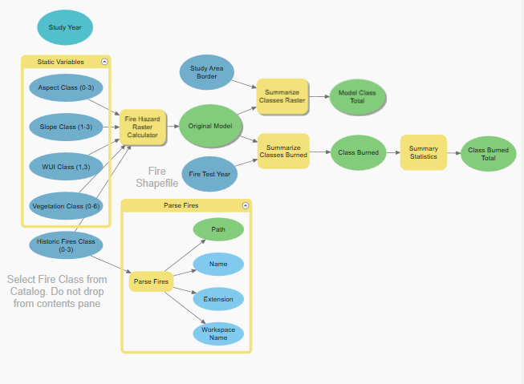

*Figure A1.* The Idaho Department of Lands most recent version of wildfire hazard model as rebuilt by the previous DEVELOP term and unenhanced by remotely sensed drought metrics

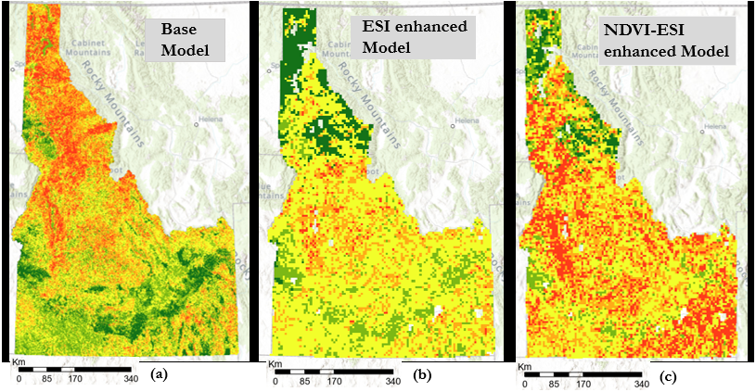

*Figure A2.* Comparison between raster images generated by the static Idaho Department of Lands Wildfire Hazard Model (a), and the NASA DEVELOP team drought-enhanced wildfire models (b, c). The latter two models’ performance reflects real-world drought conditions on October 15, 2010, and illustrates the dynamic capability of incorporating remotely sensed data into these models

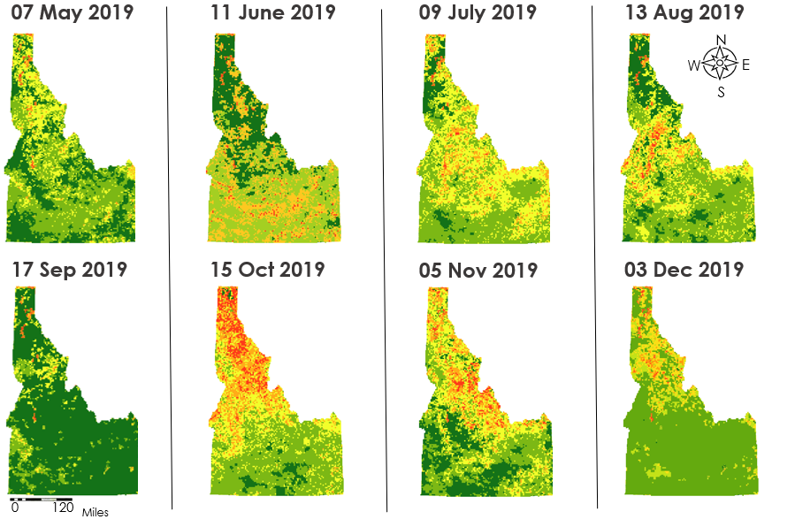

*Figure A3.* Temporal and spatial resolution of the DEWHM for the year 2019. Each return interval of the remotely-sensed product produces a new hazard rating that reflects conditions as they existed during this period

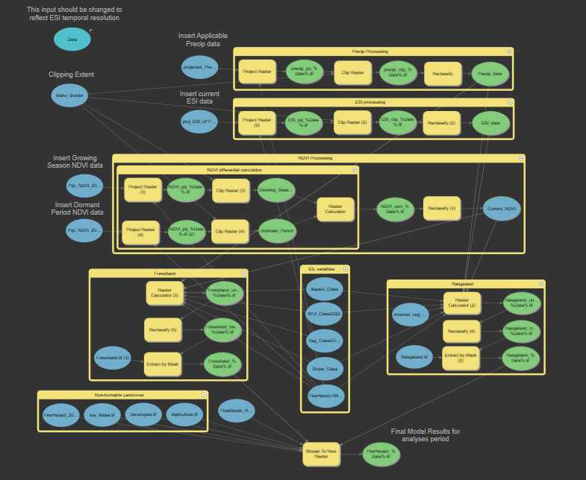*Figure A4.* The ArcGIS ModelBuilder workflow as produced by this term’s team to create drought-enhanced wildfire hazard model (DEWHM). This workflow is to be related to the partners as tutorial, so that it can be recreated

Table A1

*Accuracy statistics for the previous term's drought-enhanced models for the study years the dry year 2015 and the wet year 2016. Note that True Positive% and False Negative% for 2016 models rounded to 0.0% at one decimal place*

|  |  |  |  |  |
| --- | --- | --- | --- | --- |
| **Model** | **True Positive %** | **True Negative %** | **False Positive %** | **False Negative %** |
| **2015 Original** | 3.7% | 23.8% | 72.0% | 0.5% |
| **2015 EDDI** | 3.5% | 25.5% | 70.2% | 0.7% |
| **2015 ESI** | 2.9% | 40.5% | 55.3% | 1.4% |
| **2015 NDVI** | 3.0% | 41.3% | 54.7% | 1.3% |
| **2016 Original** | 0.0% | 23.8% | 76.2% | 0.0% |
| **2016 EDDI** | 0.0% | 42.2% | 57.8% | 0.0% |
| **2016 ESI** | 0.0% | 42.2% | 57.8% | 0.0% |
| **2016 NDVI** | 0.0% | 46.7% | 53.2% | 0.0% |

**Appendix B**

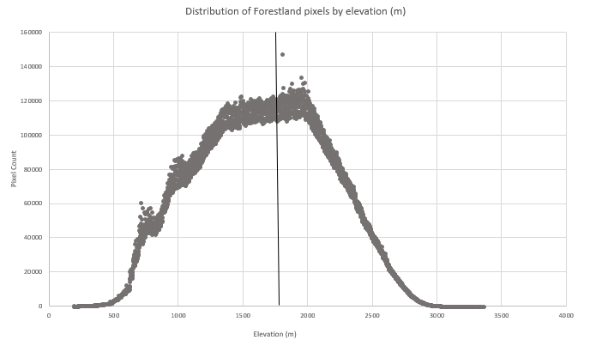*Figure B1.* Elevational distribution of forestland cover across the state of Idaho. The median and mean value within these normally distributed data is both approximately 1715 meters, illustrated with a horizontal line

Table B1

*R2 values from Linear Modeling in Terrset Earth Trends Modeler using the Normalized Vegetation Index a dependent variable, conducted for Forestland and Rangeland landcover over the state of Idaho*

|  |  |  |  |
| --- | --- | --- | --- |
| **Independent Variable** | **Monthly Time Lag** | **Rangeland** | **Forestland** |
| **r2 value** | **r2 value** |
| EDDI | 0 | 0.13 | 0.13 |
| ESI | 0 | 0.69 | 0.29 |
| Precipitation | 0 | 0.19 | 0.24 |
| Maximum Temperature | 0 | 0.33 | 0.24 |
| Minimum Temperature | 0 | 0.43 | 0.30 |
| EDDI | 1 | 0.15 | 0.15 |
| ESI | 1 | 0.26 | 0.26 |
| Precipitation | 1 | 0.29 | 0.24 |
| Maximum Temperature | 1 | 0.16 | 0.15 |
| Minimum Temperature | 1 | 0.19 | 0.15 |
| EDDI | 2 | 0.1 | 0.17 |
| ESI | 2 | 0.39 | 0.39 |
| Precipitation | 2 | 0.43 | 0.37 |
| Maximum Temperature | 2 | 0.16 | 0.15 |
| Minimum Temperature | 2 | 0.2 | 0.23 |
| EDDI | 3 | 0.1 | 0.10 |
| ESI | 3 | 0.18 | 0.11 |
| Precipitation | 3 | 0.68 | 0.31 |
| Maximum Temperature | 3 | 0.14 | 0.14 |
| Minimum Temperature | 3 | 0.2 | 0.21 |
| EDDI | 4 | 0.15 | 0.15 |
| ESI | 4 | 0.1 | 0.12 |
| Precipitation | 4 | 0.65 | 0.51 |
| Maximum Temperature | 4 | 0.16 | 0.11 |
| Minimum Temperature | 4 | 0.25 | 0.15 |
| EDDI | 5 | 0.14 | 0.14 |
| ESI | 5 | 0.1 | 0.12 |
| Precipitation | 5 | 0.72 | 0.42 |
| Maximum Temperature | 5 | 0.1 | 0.08 |
| Minimum Temperature | 5 | 0.13 | 0.11 |

Table B2.

*R2 values from Linear Modeling in Terrset Earth Trends Modeler using the Normalized Difference Vegetation Index (NDVI) conducted for low elevation and high elevation forestland landcover for the state of Idaho*

|  |  |  |  |
| --- | --- | --- | --- |
| **Independent Variable** | **Monthly Time Lag** | **High Elevation Forestland** | **Low Elevation Rangeland** |
| **r2 value** | **r2 value** |
| EDDI | 0 | 0.08 | 0.13 |
| ESI | 0 | 0.24 | 0.33 |
| Precipitation | 0 | 0.18 | 0.24 |
| Maximum Temperature | 0 | 0.16 | 0.16 |
| Minimum Temperature | 0 | 0.15 | 0.18 |
| EDDI | 1 | 0.1 | 0.10 |
| ESI | 1 | 0.17 | 0.16 |
| Precipitation | 1 | 0.13 | 0.07 |
| Maximum Temperature | 1 | 0.14 | 0.12 |
| Minimum Temperature | 1 | 0.1 | 0.10 |
| EDDI | 2 | 0.9 | 0.13 |
| ESI | 2 | 0.13 | 0.16 |
| Precipitation | 2 | 0.37 | 0.29 |
| Maximum Temperature | 2 | 0.12 | 0.14 |
| Minimum Temperature | 2 | 0.16 | 0.21 |
| Precipitation | 3 | 0.23 | 0.16 |
| Precipitation | 4 | 0.37 | 0.26 |
| Precipitation | 5 | 0.42 | 0.32 |

**Appendix C**

Table 1C

*R2 results from the TerrSet Earth Trends Modeler Series Trend Analysis conducted for remotely sensed variables across the state of Idaho*

|  |  |
| --- | --- |
| **Data Layer** | **Highest** r2 **Value** |
| **EDDI** | 0.06 |
| **ESI** | 0.06 |
| **NDVI** | 0.14 |
| **Precipitation** | 0.05 |
| **Minimum in Temperature** | 0.12 |
| **Maximum Temperature** | 0.25 |
| **EDDI (anomaly)** | 0.09 |
| **ESI (anomaly)** | 0.08 |
| **NDVI (anomaly)** | 0.42 |
| **Precipitation (anomaly)** | 0.05 |
| **Minimum in Temperature (anomaly)** | 0.25 |
| **Maximum Temperature (anomaly)** | 0.25 |

Table 2C.

*Results of TerrSet Earth Trends Modeler Linear Modeling using NDVI as the dependent variable.*

|  |  |  |
| --- | --- | --- |
| **Earth Trends Modeler Linear Modeling** | | |
| EDDI (anomaly) |  | r2 value |
| Time Lag (months) | 0 | 0.13 |
| 1 | 0.15 |
| 2 | 0.13 |
| ESI (anomaly) | | |
| Time Lag (months) | 0 | 0.69 |
| 1 | 0.26 |
| 2 | 0.39 |
| Precipitation (anomaly) | | |
| Time Lag (months) | 0 | 0.24 |
| 1 | 0.15 |
| 2 | 0.43 |
| 3 | 0.68 |
| Minimum Temperature (anomaly) | | |
| Time Lag (months) | 0 | 0.22 |
| 1 | 0.17 |
| 2 | 0.21 |
| Maximum Temperature (anomaly) | | |
| Time Lag (months) | 0 | 0.16 |
| 1 | 0.14 |
| 2 | 0.16 |