Confidential manuscript submitted to *Journal of Advances in Modeling Earth Systems*

**Assessing Detection of Invasive Species Using NASA Earth Observations within the Colorado National Monument**

**Z. Peloquin[1], J. Ficklin[2], K. Rini[3]**

Geographic Information Science for Development and Environment at Clark University, Worcester, Massachusetts, USA 2 Earth and Environmental Science and Mathematics at Virginia Wesleyan University, Norfolk, Virginia, USA 3 Geographic Science at James Madison University, Harrisonburg, Virginia, USA

Correspondence to: Zachary Peloquin

[zacpeloquin1@gmail.com](mailto:zacpeloquin1@gmail.com)

**Key Points:**

* Invasive species, particularly cheatgrass, severely impact the Colorado National Monument.
* High resolution satellite imagery can be used to analyze early season vegetation of invasive species but ground truthing is needed.
* Results from the study can be used to assist the National Park Service to further manage the distribution of cheatgrass and other invasive plant species.

**Abstract**

# *Bromus tectorum*, otherwise known as cheatgrass, is an invasive grass from Europe that has increased its presence all over the world by out-competing native grasses due to its adaptability and lifecycle. During the end of its life cycle, typically occurring in the summer, its flammable remains often create the conditions for forest fires to start early in the season. This alters native wildlife’s previous response to wildfires and increases the overall frequency of fires. As a result, cheatgrass often disrupts the necessary recovery time for native wildlife after habitat destruction. This NASA DEVELOP project utilized Landsat 5 TM, Landsat 8 OLI and TIRS, Terra MODIS, and Sentinel-2 MSI data to study the spread of cheatgrass throughout the Colorado National Monument and the surrounding area to determine locations at risk of being invaded by cheatgrass. The results of the study included historical and current cheatgrass population maps, multi-criteria evaluation (MCE), MCE analysis, and forecasted early season activity spread. The MCE analysis assessed the factors and constraints that contribute to the vulnerability to cheatgrass invasion. The results from this project will assist the National Park Service in improving their monitoring and management efforts and help contribute to the prevention of cheatgrass in Colorado National Monument.

# Introduction

* 1. Background Information

The Colorado National Monument is located on the eastern portion of the Colorado Plateau, encompassing 32 square miles of vast geological formations, with some rocks dating back to the Triassic age, and elevations ranging from 4,700 feet to greater than 7,000 feet (Desert USA, 2017). A majority of the park consists of juniper and pinyon pine trees. In addition, these trees thrive in a variety of soil textures, including gravel and clay. The landscape is characterized by a well-developed understory, with abundant vegetation below the forest canopy but above the forest floor. This vegetation is vital for species whose habitats depend on shade, and trees that have slow but long-lasting growth. The biome contains wildlife that is very resilient to the extreme conditions in which they inhabit. However, due to external environmental factors, the wildlife that makes up the park is under threat from invasive species in the area.

The Rocky Mountain region of the United States has been invaded by cheatgrass (*Bromus tectorum*)*.* Cheatgrass is native to Europe and Asia but first arrived in the United States through a grain shipment in 1850. The species is an early season annual invasive, reaching maturity in the early spring and dying in early summer. Since its arrival, it has increasingly spread throughout the country because of its ability to propagate up to 3 km of land in one season. Bradley and Mustard’s 2006 study showed that cheatgrass is likely to spread outward from its current location up to 150 meters. Due to their extensive root system, these plants are able to flourish by out-competing native plants’ access to necessary nutrients. In the summer when it releases its seeds, cheatgrass leaves behind dry remains that increase the area’s susceptibility to fires (Mealor, et al, 2013). Wildfires are a natural disturbance to an ecosystem and the fauna and flora within the Colorado National Monument are able to recover after a time period following a wildfire. However, due to the large accumulation of highly flammable biomass associated with cheatgrass, the frequency at which wildfires occur has increased to a rate the native environment is not adapted to, altering the ecosystem’s fire regime. These changes have the potential to leave this region without sufficient time for recovery after the frequent disturbances.

* 1. Study Area

A wildfire occurred in July 1945 that destroyed 360 hectares of land within the Colorado Plateau. In the years since the fire, there have been reports that the speed for reproduction of some of the shrub species have been altered by the presence of cheatgrass. The impacts of cheatgrass that can be felt are that the likelihood of increased fire means that native vegetation may not be able to recover quickly from a cheatgrass-induced fire. The increased risk of fire makes cheatgrass a direct threat to the natural ecosystems of the Colorado National Monument. A decline in native vegetation means detrimental impacts on the local ecosystem, as their loss contributes to a decrease in biodiversity, and an increase in soil erosion and other environmental degradation (Billings, n.d). The Colorado National Monument has managed cheatgrass in the past with herbicides and looks to improve their management with the utilization of remote sensing technology.

Our study examined satellite imagery between February and September from 2008 to 2017., We utilized data from Landsat 5 Thematic Mapper (TM) for the years 2008-2011, Landsat 8 Operational Land Imager (OLI) and Thermal Infrared Sensor (TIRS) for years the 2013-2016, and Sentinel-2 MSI for the years 2016-2017. Additionally, Terra Moderate Resolution Imaging Spectroradiometer (MODIS) data were used to identify peak greenness of cheatgrass for each of the years. Using these data, cheatgrass growth was forecasted for the years 2018 to 2023.

* 1. Project Partners

The partners for this project were the National Park Service (NPS) Colorado National Monument and Colorado Mesa University. Colorado Mesa University is seeking to expand their own knowledge on the general distribution of cheatgrass and will use these results to better understand the cheatgrass invasive species issue within the region.

1.4 Objectives

The objectives of this project were to create maps for the National Park Service detailing the current location of cheatgrass in the park and the surrounding area, the historical movements and trends of cheatgrass in the area, and areas at high risk of invasion by cheatgrass. The results of this project will assist in detecting the early season invasive species present within the monument. In addition to detection, it is possible to project future cheatgrass extent and where the spread of early season greening is occurring. As a result, this project falls into the Ecological Forecasting category of NASA’s national application areas because of concerns of future cheatgrass invasion.

# Methodology

* 1. Data Acquisition

In order to gain an understanding on long term cheatgrass growth, the team utilized a map from the National Park Service, “Known, Long Term Cheatgrass Populations,” (Figure 1) that indicates past long term locations of cheatgrass in Colorado National Monument. We also received information on vegetation types from the park.

We retrieved land cover data from the United States Geological Survey National Land Cover Database (NLCD) for elevation and to locate cultivated lands around the area. We acquired information on hydrographic channels from the United States Geological Survey National Hydrography Dataset (NHD). In addition, we used the United States Census Bureau TIGER dataset in order to get road and census data for developed areas.

From these resources, the team created three shapefiles of cheatgrass locations by using Esri’s ArcMap software. In addition, this project utilized remotely sensed data that were acquired from 2008 to 2017, as listed below in Table 1.

|  |  |  |  |  |  |
| --- | --- | --- | --- | --- | --- |
| **Platform & Sensor** | **Source** | **Product Level** | **Years** | **Start Dates** | **End Dates** |
| Landsat 5 TM | USGS EarthExplorer | Collection 1 Level 1 | 2008-2011* | Varies between April to June | Varies between June to July |
| Landsat 8 OLI and TIRS | USGS EarthExplorer | Collection 1 Level 1 | 2013-2016** | Varies between April to June | Varies between June to July |
| Sentinel-2 MSI | USGS EarthExplorer | Level-1C | 2016 | May 2016 | July 2016 |
| Terra MODIS | AppEEARS | NDVI and EVI | 2003-2017 | January, 1st 2003 | June, 14th, 2017 |

**Table 1**

Table of Satellite imagery utilized with source accessed, years used, and start & end dates; *2007 & 2010 excluded due to cloud cover; **2012 excluded due to technical difficulties with Landsat 7.

From Earth Explorer, we accessed Landsat and Sentinel imagery, as featured in Table 1. We used the AppEEARS application from the Land Processes Distributed Active Archive Center (LP DAAC) for accessing the Terra MODIS Satellite tool MYD13Q1.006. For this process, we extracted a shapefile with the areas containing long term cheatgrass presence and uploaded each of these shapefiles with the dates from 1/01/2003 (the earliest record) to 6/14/2017 (the date accessed). We used the Normalized Difference Vegetation Index (NDVI) and the Enhanced Vegetation Index (EVI) to sense regions with heavy biomass. NDVI was chosen because it was standard when it comes to vegetation indices and was easily to replicate using ArcGIS.

We recorded each year’s NDVI layer for peak vegetation and die-off amounts. The imagery corresponded to areas within the park boundaries and surrounding areas with cheatgrass.

* 1. Data Processing

A project area shapefile was developed to include areas surrounding the park in addition to land within park boundaries (Figure 1). The boundaries outside of the park extend 3 miles to provide a buffer that could be used to track cheatgrass expansion in areas adjacent to the park and in areas that are deemed to be critical. These boundaries were determined by communication with the Colorado National Monument officials.

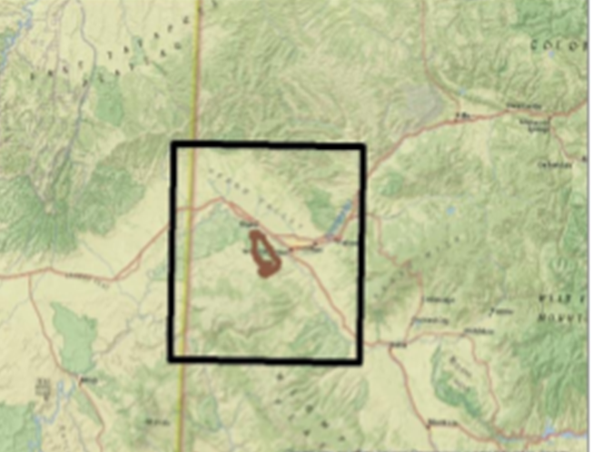

**Figure 1**: Study area outlined, with park boundaries *shown*.

In order to ensure conformity for all images, the projection of each scene was checked and as needed projected to UTM12N under WGS 1984. Any cloud cover in the imagery distorted our vegetation indices. In order to lessen the effects, we extracted images that just had the cloud cover for each file, and then clipped each file in order to remove them from the image. We then determined the range of values in each image that were primarily cloud shadows, and then removed those ranges of data from the images. For each scene across the Landsat platforms, only the red band and near infrared band were used. The formula used to calculate NDVI is below as Equation 1.

**Equation 1.** NDVI = $\frac{\text{(NIR - RED)}}{\text{(NIR + RED)}}$

We used the Raster Calculator tool to configure the NDVI for all images from 2008 to 2017. Since the bands were in integer format, we had to convert them to floating variables following Equation 2.

**Equation 2.** NDVI = $\frac{\frac{\text{Float(NIR Band)}}{\text{20000}}\text{ - }\frac{\text{Float(Red Band)}}{\text{20000}}}{\frac{\text{Float(NIR Band)}}{\text{20000}}\text{ +}\frac{\text{ Float(Red Band)}}{\text{20000}}}$

2.3 Data Analysis

The data were analyzed through several different methodologies. The first method was differencing the two NDVI images (Equation 3) and developing a threshold value for the early season activity. In order to define the threshold, we examined 50 points each year that were in areas that were known to contain cheatgrass, and then calculated the standard deviation of these points. This value was then subtracted from the median of these points to calculate the minimum value for cheatgrass. The standard deviation was then doubled and added to the median to calculate the maximum value. It was doubled to provide a larger range of values in order to avoid excluding any early season activity.  
 **Equation 3. $Vegetation Difference = Peak Greenness – Dieoff$**

The second method of analysis was a multi-criteria evaluation. The evaluation assessed the vulnerability of the landscape based on several factors from established literature. Based upon research by Bradley et al., 2006, the factors and constraints were identified. The authors identified elevation, aspect, and distance to hydrologic channels, cultivated areas, roads, and power lines as factors that influence an area’s susceptibility to cheatgrass invasion. The constraint that limited cheatgrass invasion was elevations above 2200 m.

After we determined the variables, we turned them into factors by using the TerrSet software’s Fuzzy module. This module is based on human reasoning with various levels of possibilities and deals with uncertainty. Two different function types were used to assess the relationship. The first type of function used was a monotonically decreasing sigmoidal function. The second type of function used was a symmetric function. The only factor to use the symmetric was crops. This is based on the work of Bradley and Mustard (2006) that highest probability of cheatgrass presence occurred from 2-3 km from crops. The result of the fuzzy operation was an image with a range of real values from 0 to 1. The function shape was set for each variable based on the literature results. The control points where then based on the values determined by the previous study (Bradley, et al., 2006). The ranges used for our study were expanded by half of the determined values to account for natural difference between the two sites. The fuzzy images represent the relative amount that each factor will contribute as a factor to the multi-criteria evaluation of vulnerability to invasion.

A multi-criteria evaluation (MCE) was performed to define the model constraints and factors using the TerrSet software (Figure 2). The factors were assessed in an additive method, meaning that each factor increases vulnerability of the area. The method of MCE analysis was a weighted linear combination and these factors were found to increase the likelihood of cheatgrass invasion due to a previous study (Bradley, et al, 2006). The factors were given weights that reflected this ordering. Each factor was then assigned a weight that was relative to the factors above and below its position.

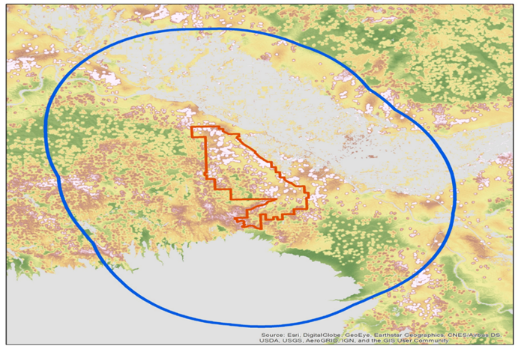

**Figure 2**. Multi-Criteria Evaluation result within the park and surrounding area of the buffer, determined by factors including early season activity, developed areas, hydrographic channels, elevation, aspect, roads, and crops.

Several factor weights were experimented with to see which weights would give the best possible vulnerability index. The module WEIGHT in TerrSet was used to assess the consistency of the factor weight values. The module WEIGHT uses a pairwise comparison method between the factors listed in the columns versus the row. The pairwise comparison method rates the row variable relative to the column variable. The pairwise comparison is on a continuous rating scale from 1, extremely less important, to a value of 9, extremely more important. The designated factors were all assigned a position on the scale. The weights were then calculated and the consistency ratio of the weights was checked. The consistency ratio was improved until it was lower than or equal to 0.1. When the consistency is above 0.1, than a matrix is generated with deviations. The deviations represent how far the value is from the expected values if the weights were perfectly consistent. The consistency is improved by editing the most inconsistent rating. A positive deviation would indicate that the value should be move up the scale while a negative value indicates that the value should be moved down the scale. Based on the TerrSet manual there is little appreciable difference after a consistency of 0.1 has been achieved, thus once that consistency was achieved the weights were considered sufficient.



**Figure 3.** Multi-Criteria Assessment Factors utilizing Terrset software showing the influences on cheatgrass vulnerability. Early season activity identifies where peak greenness appeared; Developed areas, indicates the proximity to urbanized areas; Hydrographic channels, such as waterways and channels; Elevation, between 1400 m and 1700 m for ideal elevation for cheatgrass growth; Aspect refers to slope angle for growth; Roads contribute to development affecting cheatgrass spread; Crops and cultivated areas assist the distribution of cheatgrass.

The next step in the analysis was to forecast the expansion of early season activity. The future scenarios were forecasted using the module GEOMOD in TerrSet. The GEOMOD module is a land use change model that simulates transitions from a particular land use to another land use. The module simulates the change between only two land use classes. The simulation was run with the NDVI results of 2017 as the starting point. A mask of the areas excluded from analysis was inputted. The time specification was for 2017 through 2023. The neighborhood search mode was constrained to a nine by nine grid search mode. The multi-criteria evaluation (MCE) was used as a suitability image for the simulation. The MCE serves a proxy for the suitability for invasion. Next the number of pixels at end of the time period must then be specified. The module automatically calculates the number of pixels for each land use at the start of the simulation. We then projected the number of expected pixels to at the end of the forecasting scenarios. This was done by calculating the number of pixels that are expected at end date for each scenario. The end amount of pixel growth is compounded annually, meaning that the amount of growth is updated at the end of each year rather than using the starting amount. The expected number of pixels for the end were then inputted into the simulation and that will for the simulation to determine where the early season activity expands to.

Another method utilized was Optimized Hot Spot Analysis used in ArcMap software. We applied this application tool to better recognize cheatgrass locations for all historical years, and current cheatgrass locations based on years 2014, 2016, and 2017. The Hot Spot analysis tool is based on statistics and allowed us to view statistically significant clusters of early season activity within and surrounding the park area. Since the tool transfers pixels into point data, there is a huge range of values in the studied area. However, many of these points show no early season activity. These points could influence the final result, and make areas seem falsely significant. Therefore, we created one set of maps taking into account all the range of points including ones with a value of 0 and one set that did not include points with a value of 0. The map that did not include 0 is more likely to miss significant areas and the map that did include 0 is more likely to have statistical anomalies.

# 3 Analysis of Results

We determined that vegetation detected by the satellite imagery utilized was not 100% cheatgrass. While there were some areas confirmed by the National Park Service to contain cheatgrass, there are other species with early season activity that are present at the detected locations. Some of these early season species are native vegetation while others are other invasive species that contribute to modifying the landscape. Ground truthing is needed to determine the exact species of vegetation within the areas detected with early season activity.

**Figure 4**: Hot Spot Analysis of Cheatgrass Locations 2008 to 2017.

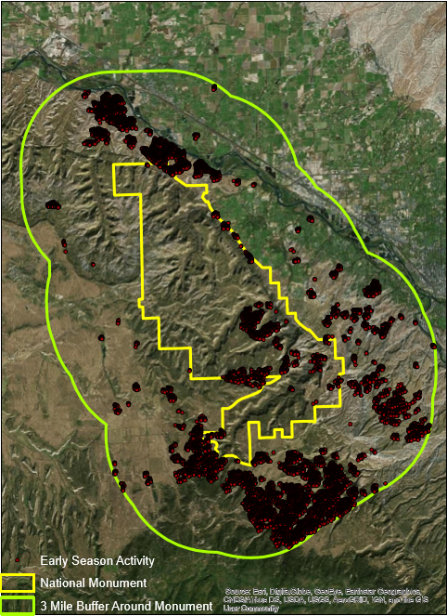

From 2008 to 2013, a majority of early season activity lied within the southern area of the park and within the 3 mile boundary. In the hot spot analysis map (Figure 4), the clusters are easily seen on the southern and eastern portions of the park. By using this analysis, we were able to see areas of intense clustering of points. We found that those points with a high z-score and a low p value clustered within a given area while those points with a low, negative z-score and low p value exhibited little clustering. For the past 8 years, the locations of early season of activity have primarily been in spots along the southwest portion of the park boundary.

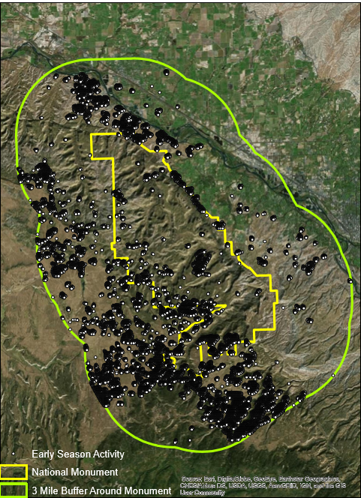

**Figure 5:** Early Season Activity Locations from 2014 to 2017 utilizing Hot Spot Analysis to showcase areas of concentration.

Based on satellite imagery, we found variations in vegetation distribution from the time period 2008 to 2017. Early season vegetation is scattered within the 3 mile buffer outside of the park on the western and southern sides. There was scattering of vegetation outside the eastern boundary of the park. As evidenced in a hot spot analysis of years 2008 to 2017, a majority of vegetation locations are within the outskirts of the park within the 3 mile buffer on the northern, and southwestern region. Historically, cheatgrass has expanded to the southwest region of the park.

When we first identified the three areas believed to have cheatgrass, our partners verified these locations, which allowed us to focus on these areas of the park to use as a reference in identifying other areas containing cheatgrass. Within the park, you can see a cluster of vegetation patches along the southwest side of the park boundary. A majority of the clusters are scattered along the western side of the 3 mile buffer and along the southern portion of the buffer, as shown in Figure 6. These are the current locations of cheatgrass locations based on MODIS imagery.

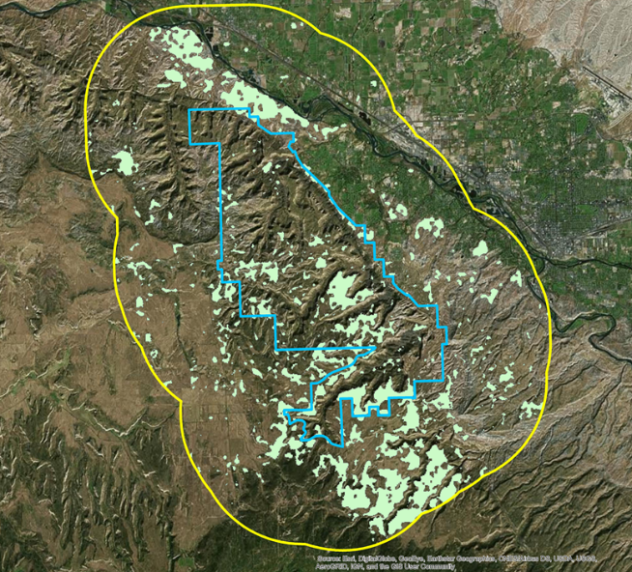

**Figure 6**:Early Season Activity Locations from 2008 to 2013

For our future projections, we predict that early season activity will likely continue to expand in the southern and eastern portions of the park. We used three different growth rates based on environmental conditions, such as extreme weather at the time or the ease at which the National Park Service can manage cheatgrass populations. Using the MCE, the areas highlighted to show vulnerable areas indicated that in 2023, vegetation will likely continue to expand in the southern and eastern portions of the park with a 4% growth rate. There were three scenarios that were developed for the forecasting into the future. The scenarios used were 1.0%, 2.5%, and 4%. These were used to represent the low, median and high growth rates of early season activity.

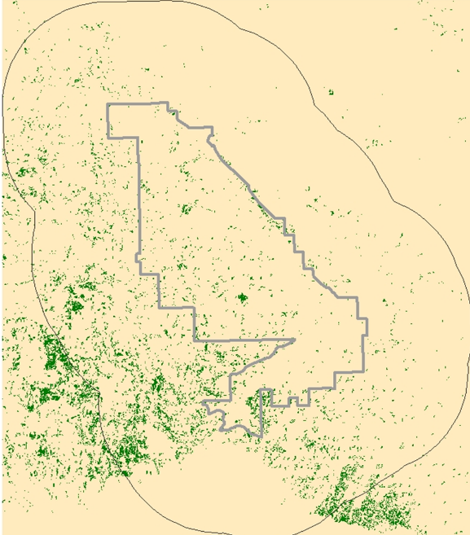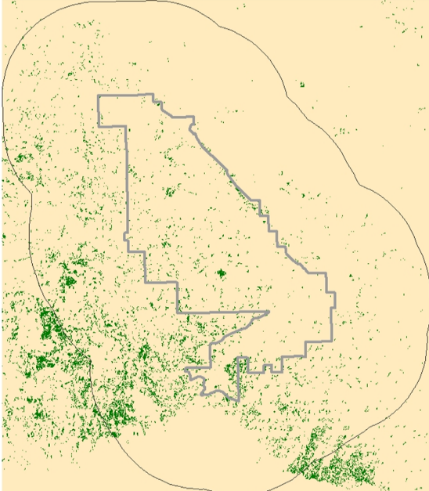

2017

2023



**Figure 7.** 2017 Cheatgrass Locations and **Figure 8**. 2023 Cheatgrass Forecast, respectively. These maps show the forecasted growth of cheatgrass with 4% compounded annually.

**4 Conclusions**

4.1 Project Conclusions

Cheatgrass is a persistent invasive species throughout the United States. Many of its characteristics allow it to easily spread and out-compete native species. In particular, it is detrimental to the Colorado National Monument, due to the area’s old growth woodland which is vulnerable to fires. It is not feasible to monitor the movement of cheatgrass by hand due to the elevation and extensive size of the park, so the application of remote sensing is valuable in order to identify areas containing or vulnerable to cheatgrass.

The park has previously used herbicides as a measure to contain and prevent further cheatgrass spread. In addition, the park has also tested the technology of remote sensing with Colorado Mesa University but has not been able to utilize it fully to a larger extent. Our project’s goal was to utilize our resources and understanding of remote sensing in order to analyze historical trends of cheatgrass compared to their current locations. From these two results, we were able to determine areas deemed susceptible for cheatgrass growth to forecast further expansion. The map deliverables created were of cheatgrass historical trends for years 2008 to 2013, current cheatgrass locations based on years 2014, 2016 and 2017, and projected cheatgrass expansion for the years 2020 and 2023. The intention of these maps is to help the Colorado National Monument improve their management of cheatgrass within the park and to prevent it from spreading further in the area. We found that there are heavy concentrations of early season activity within the northeast and southwest areas of the park. While the Colorado National Monument staff confirmed that some of these areas did contain cheatgrass, many of the areas contained other early-season activity vegetation detected by the satellites. As stated previously, ground truthing would be needed to determine which areas actually contain cheatgrass. Due to the varying environmental conditions year to year, we discovered that vegetation with early season activity can alternate years. This reasoning explains why cheatgrass is present during one year but is not present another year. Our MCE shows that the east and southwest areas of the park have the greatest vulnerability and careful monitoring of these areas by the National Park Service would help prevent further spread of cheatgrass

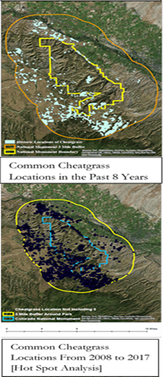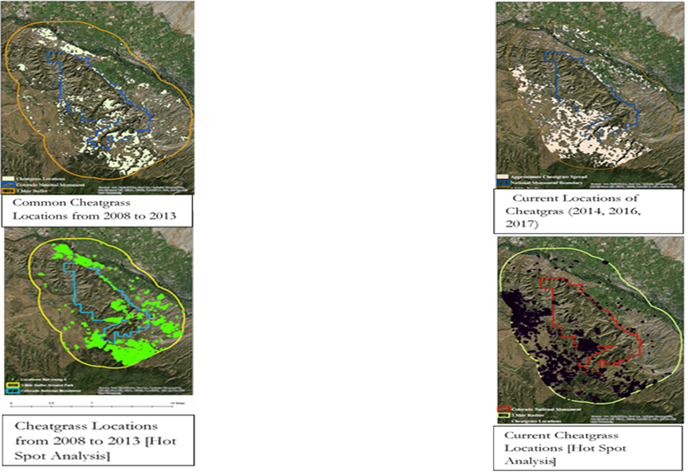

**Figure 9.** Cheatgrass Distribution maps. a) Historical Cheatgrass locations for years 2008 to 2013 with Hot Spot Analysis; b) Common Cheatgrass locations in the past 8 years for years 2008 to 2017 with Hot Spot Analysis; c) Current locations based on years 2014, 2016 and 2017 with Hot Spot Analysis.

c)

b)

a)

The three rates of growth used to provide the NPS will a variety of scenarios that need could occur. The scenarios are based on the results that Bradley & Mustard (2006) observed. The Bradley & Mustard (2006) result showed that cheatgrass expanded by an annual rate of 2.5%, this was designated as the expected rate. The 1.0% scenarios is meant to serve as a low growth year. The low growth rate could be cause by adverse condition occurring or by active removal by the NPS. The 4% growth scenario is meant to serve as a high growth scenarios, representing favorable growing conditions and/or a failure to remove cheatgrass. The variety of scenarios is meant to provide the NPS with a wide-range of resources in managing cheatgrass.

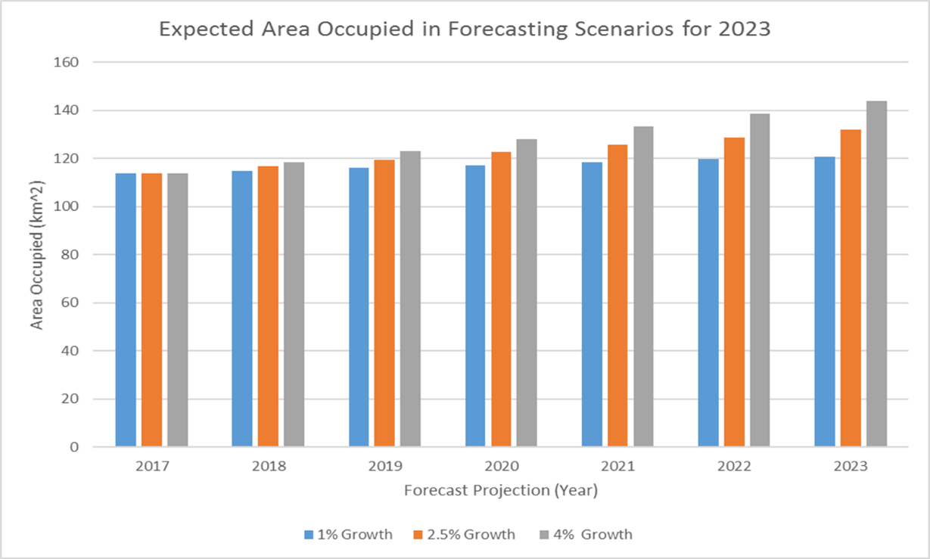

**Figure 10.** Graph depicting differentiating scenarios for 2023 forecasting, for 1% growth, 2.5% growth, and 4% growth.

4.2 Future Work

Since our imagery identified early season activity, ground truthing is needed to identify specific areas of cheatgrass. Ground truthing is essential to understand how accurate our forecasting model is in predicting areas vulnerable to cheatgrass. Our project focused MCE criteria on human impact factors, such as crops, hydrographic channels, and developed areas. Future work can be focused on looking into the MCE results and conducting another MCE with environmental criteria, such as the influences of meteorological conditions affecting an area’s susceptibility to cheatgrass. Future work can be dedicated to investigating areas we outlined with our detections, and seeing what areas actually contain cheatgrass patches within or close to the areas detected. By looking into these areas, we can see if these patches are occurring in vulnerable areas or outside of the areas we outlined. In addition, future work can be focused on detecting if cheatgrass greens early enough in the year, if it is an understory species, and if it can be found under canopies of juniper trees. Furthermore, we can see if the season type (wet or dry) correlates with the early season activity detected.

# Acknowledgments

We would like to thank Dr. Kenton Ross from the National Aeronautics and Space Administration (NASA) Langley Research Center located in Hampton, Virginia for helping us determine the best tools to utilize in this project. We would also like to thank Emily Gotschalk from the NASA DEVELOP program office for inspiring us and coordinating this project. Finally, we would also like to thank our partners, the National Park Service at Colorado National Monument and Colorado Mesa University, for providing us with data and information throughout this project.

Any opinions, findings, and conclusions or recommendations expressed in this material are those of the author(s) and do not necessarily reflect the views of the National Aeronautics and Space Administration.

This material is based upon work supported by NASA through contract NNL16AA05C and cooperative agreement NNX14AB60A.

# References

Banks, E. R., & Baker, W. L. (2011). Scale and pattern of cheatgrass (*Bromus tectorum*) invasion in Rocky Mountain National Park. *Natural Areas Journal, 31(4)*, 377-390. Retrieved from http://www.bioone.org/doi/full/10.3375/043.031.0408

Billings, W. D. (n.d.). Ecological impacts of cheatgrass and resultant fire on ecosystems in the Western Great Basin. Retrieved from https://www.fs.fed.us/rm/pubs_int/int_gtr313/int_gtr313_022_030.pdf

Bradley, B. A., & Mustard, J. F. (2006). Characterizing the landscape dynamics of an invasive plant and risk of invasion using remote sensing. *Ecological Applications, 16(3),* 1132-1147. Retrieved from: http://www.planetary.brown.edu/pdfs/3419.pdf

National Park Service (2017). Colorado National Monument History and Culture. Retrieved from: https://www.nps.gov/colm/learn/historyculture/freedom-flies-high

European Space Agency. (2015). Sentinel-2 Data (Version 1.0) [Data set]. Geoscience Australia. https://doi.org/10.4225/25/566a407cd2e2b

K. Didan. (2015). MYD13Q1 MODIS/Aqua Vegetation Indices 16-Day L3 Global 250m SIN Grid V006. NASA EOSDIS Land Processes DAAC. https://doi.org/10.5067/modis/myd13q1.006

Mealor, B. A., Maelor, R. D., Kelly, W. K., Bergman, D. I., Burnett, S. A… (2013). University of Wyoming & Colorado State University. Cheatgrass Management Handbook: Managing an invasive annual grass in the Rocky Mountain region. Retrieved from http://www.wyomingextension.org/agpubs/pubs/B1246.pdf

Miller, R. F., & Tausch, R. J. (2001). The Role of Fire in Juniper and Pinyon Woodlands: A Descriptive Analysis. Allen Press. Retrieved from https://www.researchgate.net/publication/252794877_THE_ROLE_OF_FIRE_IN_JUNIPER_AND_PINYON_WOODLANDS_A_DESCRIPTIVE_ANALYSIS

MODIS Science Team. (2017). MOD02QKM MODIS/Terra Calibrated Radiances 5-Min L1B Swath 250m [Data set]. NASA Level 1 and Atmosphere Archive and Distribution System. https://doi.org/10.5067/modis/mod02qkm.061

National Park Service. (2015). Pinyon-Juniper Woodlands-Introduction & Distribution. Retrieved from https://www.nps.gov/articles/pinyon-juniper-woodlands-distribution.htm.

Ridd, M.K. (1995). Exploring a V-I-S (vegetation-impervious surface soil) model for urban ecosystem analysis through remote sensing: comparative anatomy for cities. *International Journal of Remote Sensing, 16(12),* 2165-2185. Retrieved from: https://www.academia.edu/520729/Exploring_a_VIS_vegetation-impervious_surface soil_model_for_urban_ecosystem_analysis_through_remote_sensing_comparative_anatomy_for_cities

U.S. Geological Survey Earth Resources Observation And Science Center. (2012). Provisional Landsat TM Surface Reflectance [Data set]. U.S. Geological Survey. https://doi.org/10.5066/f7kd1vz9

U.S. Geological Survey Earth Resources Observation And Science Center. (2014). Provisional Landsat OLI Surface Reflectance [Data set]. U.S. Geological Survey. <https://doi.org/10.5066/f78s4mzj>

1.
2.
3.