NASA DEVELOP National Program
NOAA National Centers for Environmental Information
Spring 2016

Levant and Central American Climate
Monitoring Precipitation and Drought to Enhance U.S. Air Force Predictions and Decision-Making in the Levant and Central America


Technical Report

Alec Courtright (Project Lead)
Christie Stevens
Hayley Hajic

L. DeWayne Cecil, Global Science & Technology, Inc. (Science Advisor)
Major Ryan Harris, 14th Weather Squadron (Mentor)
Raymond Kiess, 14th Weather Squadron (Mentor)
Rob Blevins, Meteorological Connections, LLC (Mentor)

I. Abstract

Keywords
Climate, Water Resources, Vegetation, Drought Vulnerability, Agricultural Stress, Civil Conflict, El Niño

II. Introduction
Due to significant climate variations, several regions of the world are experiencing more frequent and extreme droughts and heavy precipitation events. These extreme events often result in food scarcity and economic hardship, and act as catalysts for civil unrest. Such weather-related disasters have consequently resulted in forced migrations reported at 22.5 million people globally every year from 2008 to 2014 (Martinez 2016). Periods of extreme drought leading up to the beginning of the 2011 Syrian Crisis gave way to significant agricultural failure and civil conflict (Martinez 2016). It is imperative that monitoring and predictive modeling of highly vulnerable regions occur to better prepare policy makers and the general public for future droughts and heavy precipitation events. The Levant and Central American regions have been recognized as highly vulnerable regions that continue to experience the consequences of these extreme weather events (Maddocks et al. 2015).

For centuries, the Middle East has been considered one of the most arid climates in the world. Out of 167 countries, 33 will face extremely high water stress by 2040; 33% of those countries are located in the Middle East – see figure 1 (Maddocks et al. 2015). Recent weather extremes have diminished the region’s already limited water resources (Kaniewski et al. 2011). In the Levant region, comprised of Syria, Lebanon, Jordan, Israel, and Iraq, an increasing population and diminishing water supply have created an unstable and competitive environment. As villages run out of water, their populations are moving to large urban areas (Voss et al. 2013). These urban areas become overpopulated and water stress is compounded. Corrupt government allocation of resources in these countries results in alarmingly poor water management (Kelley et al. 2014). This environment of distrust and desperation breeds hostility and is a significant contributor to civil unrest in the region.

Central America endures issues similar to the Levant as several countries experience change in duration, intensity, and frequency of drought and precipitation events (Maurer et al. 2009). The “dry corridor” in Central America is dramatically impacted by these climate extremes and spans across Honduras, El Salvador, Guatemala, and Nicaragua (Watson 2015). During 2015, particularly strong El Niño Southern Oscillation (ENSO) events exacerbated the already delicate state of Central America’s climate by prolonging severe dry weather (Becker 2015). Due to the drastic changes, farmers are losing the majority, if not all, of their crops or cattle each growing season (Marengo et al. 2014). In 2011, flooding from Tropical Depression 12E cost El Salvador $840 million in damages (Gourmelon 2015). This was equivalent to 4% of the country’s Gross Domestic Product, ruining an approximate 60% of El Salvador’s corn and bean production (Gourmelon 2015). Farming practices in both study regions are not always efficient and governments are not encouraging efficient irrigation practices to reduce water loss (Vidal 2015). The governments allow wealthier residents to dig their own wells, which tap into aquifers (Vidal 2015). These wells are not regulated, leading to over pumping and water pollution as a result of improper use (Vidal 2015). The lack of government assistance for farmers, in addition to the overall poor water management, has consequently contributed to a growing water crisis that is leading to malnutrition and hunger for the Central American population. The Food and Agricultural Organization of the United Nations’ (FAO) 2015 Hunger Map reveals the proportion of undernourished people to the total population. 12.2% of Honduras’ population is undernourished, 12.4% of El Salvador, 15.6% of Guatemala’s population, and 16.6% of Nicaragua’s population remains undernourished.

This research project focuses on the Levant and Central American regions from June 1981 to December 2014. The project addresses NASA’s National Application Areas of Climate, Water Resources, and Agriculture. The Levant and Central American water supplies are heavily impacted by conditions surrounding drought and dense precipitation. This project evaluates water resources and agriculture by examining the influence of water stress on resource management and agricultural production.

Both the Levant and Central America are in need of more consistent in situ monitoring and remote sensing to prepare their governments and population for the inevitable future changes in water availability. This project seeks to enhance the United States Air Force 14th Weather Squadron's monitoring of heavy precipitation and drought in these two vulnerable regions through analysis of Normalized Difference Vegetation Index (NDVI). The 14th Weather Squadron collects, protects, and exploits climate data to utilize in military operations and planning. They seek to assist the Department of Defense and other partner organizations in planning for long-range climatic changes in all regions of the world. The Squadron will use this project as the foundation for a comprehensive assessment of variables typically less focused upon in these regions to indicate the extent of drought and precipitation. Their goal is to optimize monitoring and analysis techniques utilizing data findings in environmentally sensitive regions of the world as they face crucial societal challenges and decision-making.

This project uses NDVI data from NOAA’s Climate Data Record to achieve the following objectives: 1) create comprehensive climatologies in both regions to be incorporated into the 14th Weather Squadron’s current drought monitoring efforts, 2) examine the effects of extreme weather events on vegetation with a primary focus on the El Niño of 1997-1998 and the 2007-2010 drought 3) categorize data by NDVI signature classes, and 4) analyze linear trends in NDVI over the study period to enhance the 14th Weather Squadron’s decision making capabilities. These results will help to reveal more about the relationship between conflict, unrest and climatic changes.
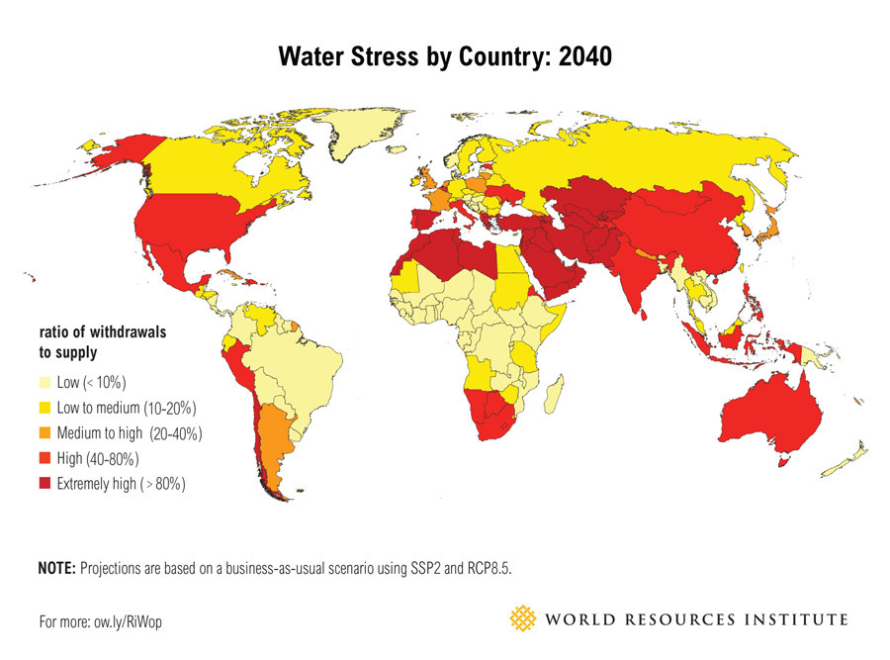

Figure 1 World Resource Institute ranking of future water stress for 167 countries by 2040. The map shows the average exposure of water users in a given country to the ratio of total withdrawals to total renewable supply in the given area. A higher percent indicates there are more water users competing for fewer supplies.

III. Methodology
Data Acquisition
NOAA’s Advanced Very High Resolution Radiometer (AVHRR) preprocessed Normalized Difference Vegetation Index (NDVI) data was downloaded from the NOAA Climate Data Record (CDR). The data has a spatial resolution of 0.05 degrees by 0.05 degrees and a daily temporal resolution. Data from June 1981 to December 2014 was used in this study (refer to data table below). The data is derived from seven different NOAA polar orbiting satellites, NOAA-7, -9, -11, -14, -16,-17, and -18.

The project also utilized Moderate Resolution Imaging Spectroradiometer (MODIS) near real-time data from NASA’s Terra satellite, with a spatial resolution of 1km, and monthly temporal resolution (refer to data table below). Preprocessed NDVI data from this source was acquired for the study regions from 2000 to 2016.

Data Table

Data Set | Spatial Resolution | Temporal Resolution | Available Study Period
NOAA NDVI | 0.05 degrees | Daily | June 1981-December 2014
NASA MODIS NDVI | 1 km | Monthly | 2000-2015

Data Processing
The AVHRR daily data sets and MODIS NDVI data sets were processed using an R code script. The daily data files were converted from NetCDF files to GeoTIFF files and cropped to the study regions’ bounding boxes.
Study Region Bounding Box Coordinates
Position | Central America  (Latitude, Longitude) | Levant  (Latitude, Longitude)
Upper left | 18.895, -93.021 | 37.788, 33.508
Upper right | 18.1895, -82.364 | 37.789, 48,750
Lower left | 12.533, -82.364 | 28.110, 33.508
Lower right | 12.533, -93.021 | 28.110, 48.750

Data Analysis
Daily and monthly climatologies were made by averaging pixel values over the study period, June 1981- December 2014, using R statistical programming to analyze data. The team used R code to create daily and monthly climatologies by averaging NDVI values over the 33-year study period. Daily 33-year averages were aggregated to create the monthly climatologies. Non-applicable, or missing data values, were omitted when calculating the averages. The team used ArcGIS to create climatology maps of the monthly averages for both regions.

Using the average NDVI value for each month over 33-years, we converted raster data to point feature classes in ArcGIS. From this point data, the NDVI values were separated into five classes for each month based on characteristic NDVI signatures and their corresponding NDVI value ranges (see NDVI signature class table below). From the separated classes, percentages were calculated based on the number of points in each class and the whole region. Graphs displaying months, classifications, and percentages were created for the Levant and Central America (“Normalized… , ” 2016).
NDVI Signature Class Table
 | NDVI Signatures | NDVI Value Range
Class 1 | Barren rock, sand, snow | -1 to 0.1
Class 2 | Soil | 0.1 to 0.2
Class 3 | Shrub & grassland | 0.2 to 0.3
Class 4 | Dense vegetative canopy | 0.3 to 0.6
Class 5 | Temperate/ tropical rainforests | 0.6 to 0.8

Further classification was created to assess overall aridity and healthy vegetative activity. NDVI values ranging from -1 to 0.2 were categorized as little to no vegetation, whereas values ranging from 0.2 to 1 were categorized as high vegetation. With ArcGIS we created maps to display these new designations through different temporal and spatial scales.
The percent difference for specific years was found using ArcGIS raster calculator. The difference between the month in question and the baseline 33-year average was found and divided by the absolute value of the baseline 33-year average and then multiplied by 100. The minimum and maximum percent difference values were set to
-100% and 100%. All values higher or lower than these percent ranges were excluded in order to eliminate extreme outliers. The percent differences for the 1997 to 1998 El Niño event were found in order to examine any significant NDVI changes from the baseline climatology. The same process was applied to the severe drought from 2007-2010 in the Levant.

Using R code the team calculated the linear trends in NDVI of each pixel within both study regions over the 33-year study period. First, NDVI data was separated by month for every year and combined into a single data frame. Next, a linear regression was calculated for each pixel, with “NA” or empty values omitted. The team created new data frames containing the slope coefficient of each linear regression, r-squared values, and p-values. These new data frames were used to create trend maps in ArcGIS, which were then displayed by months in 90-day seasons (Summer, Spring, Autumn, and Winter).

IV. Results
We created daily and monthly climatology maps and NDVI classification graphs and maps for both regions to provide basic NDVI displays for the 14th Weather Squadron. Trend maps and percent difference maps were also created to demonstrate the changes in NDVI through different seasons and years.

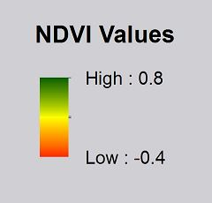
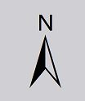
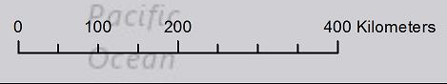

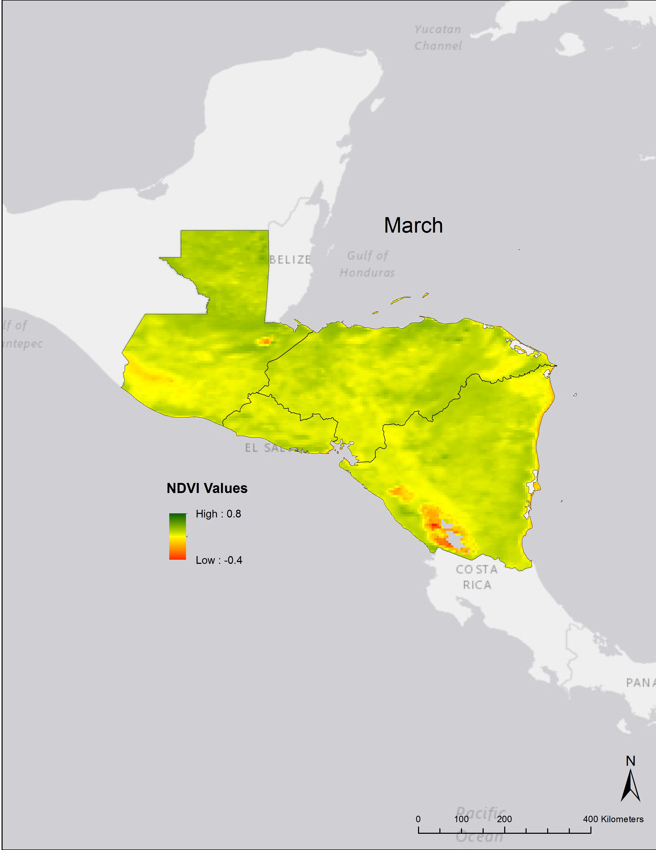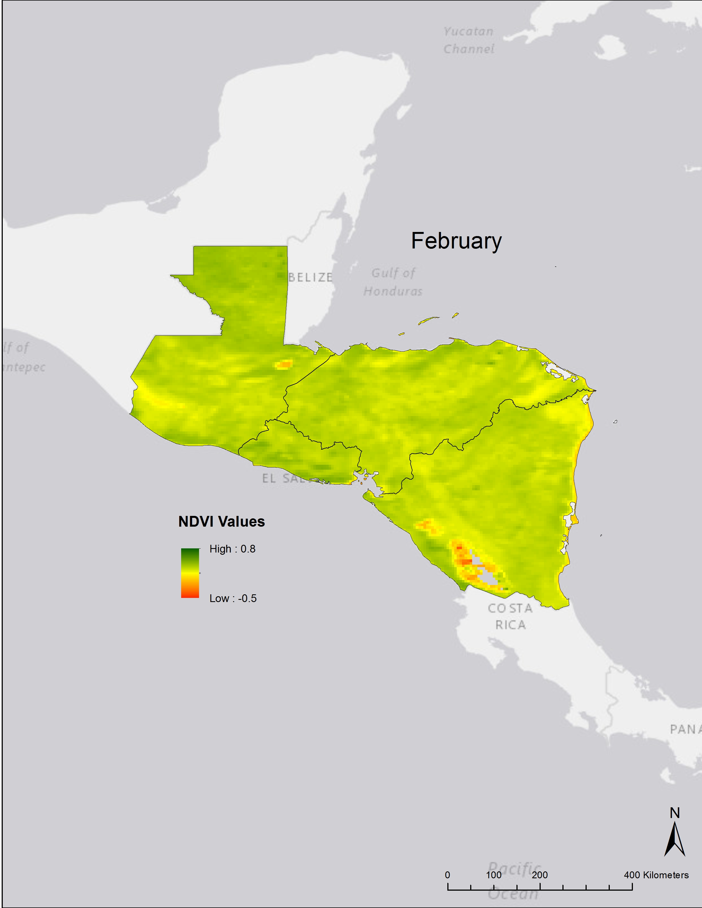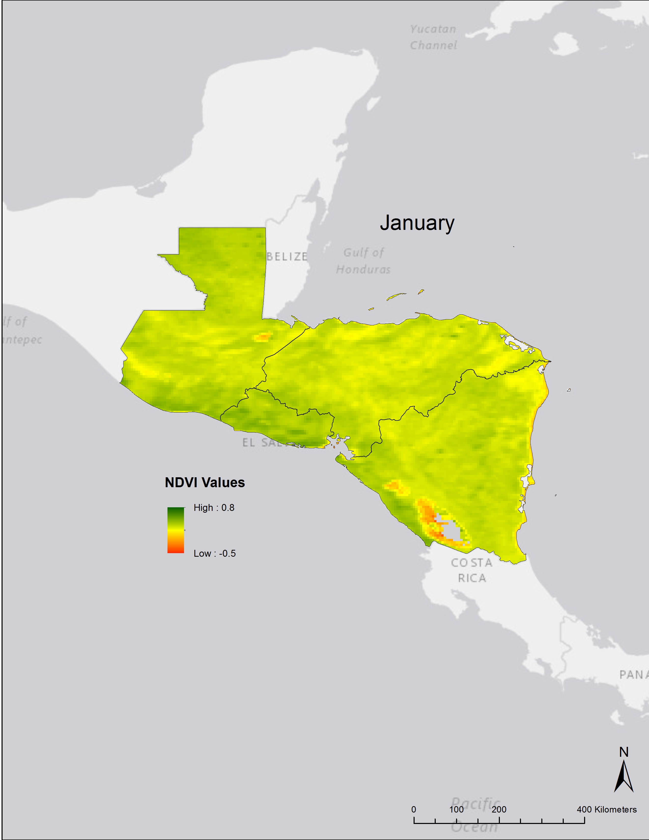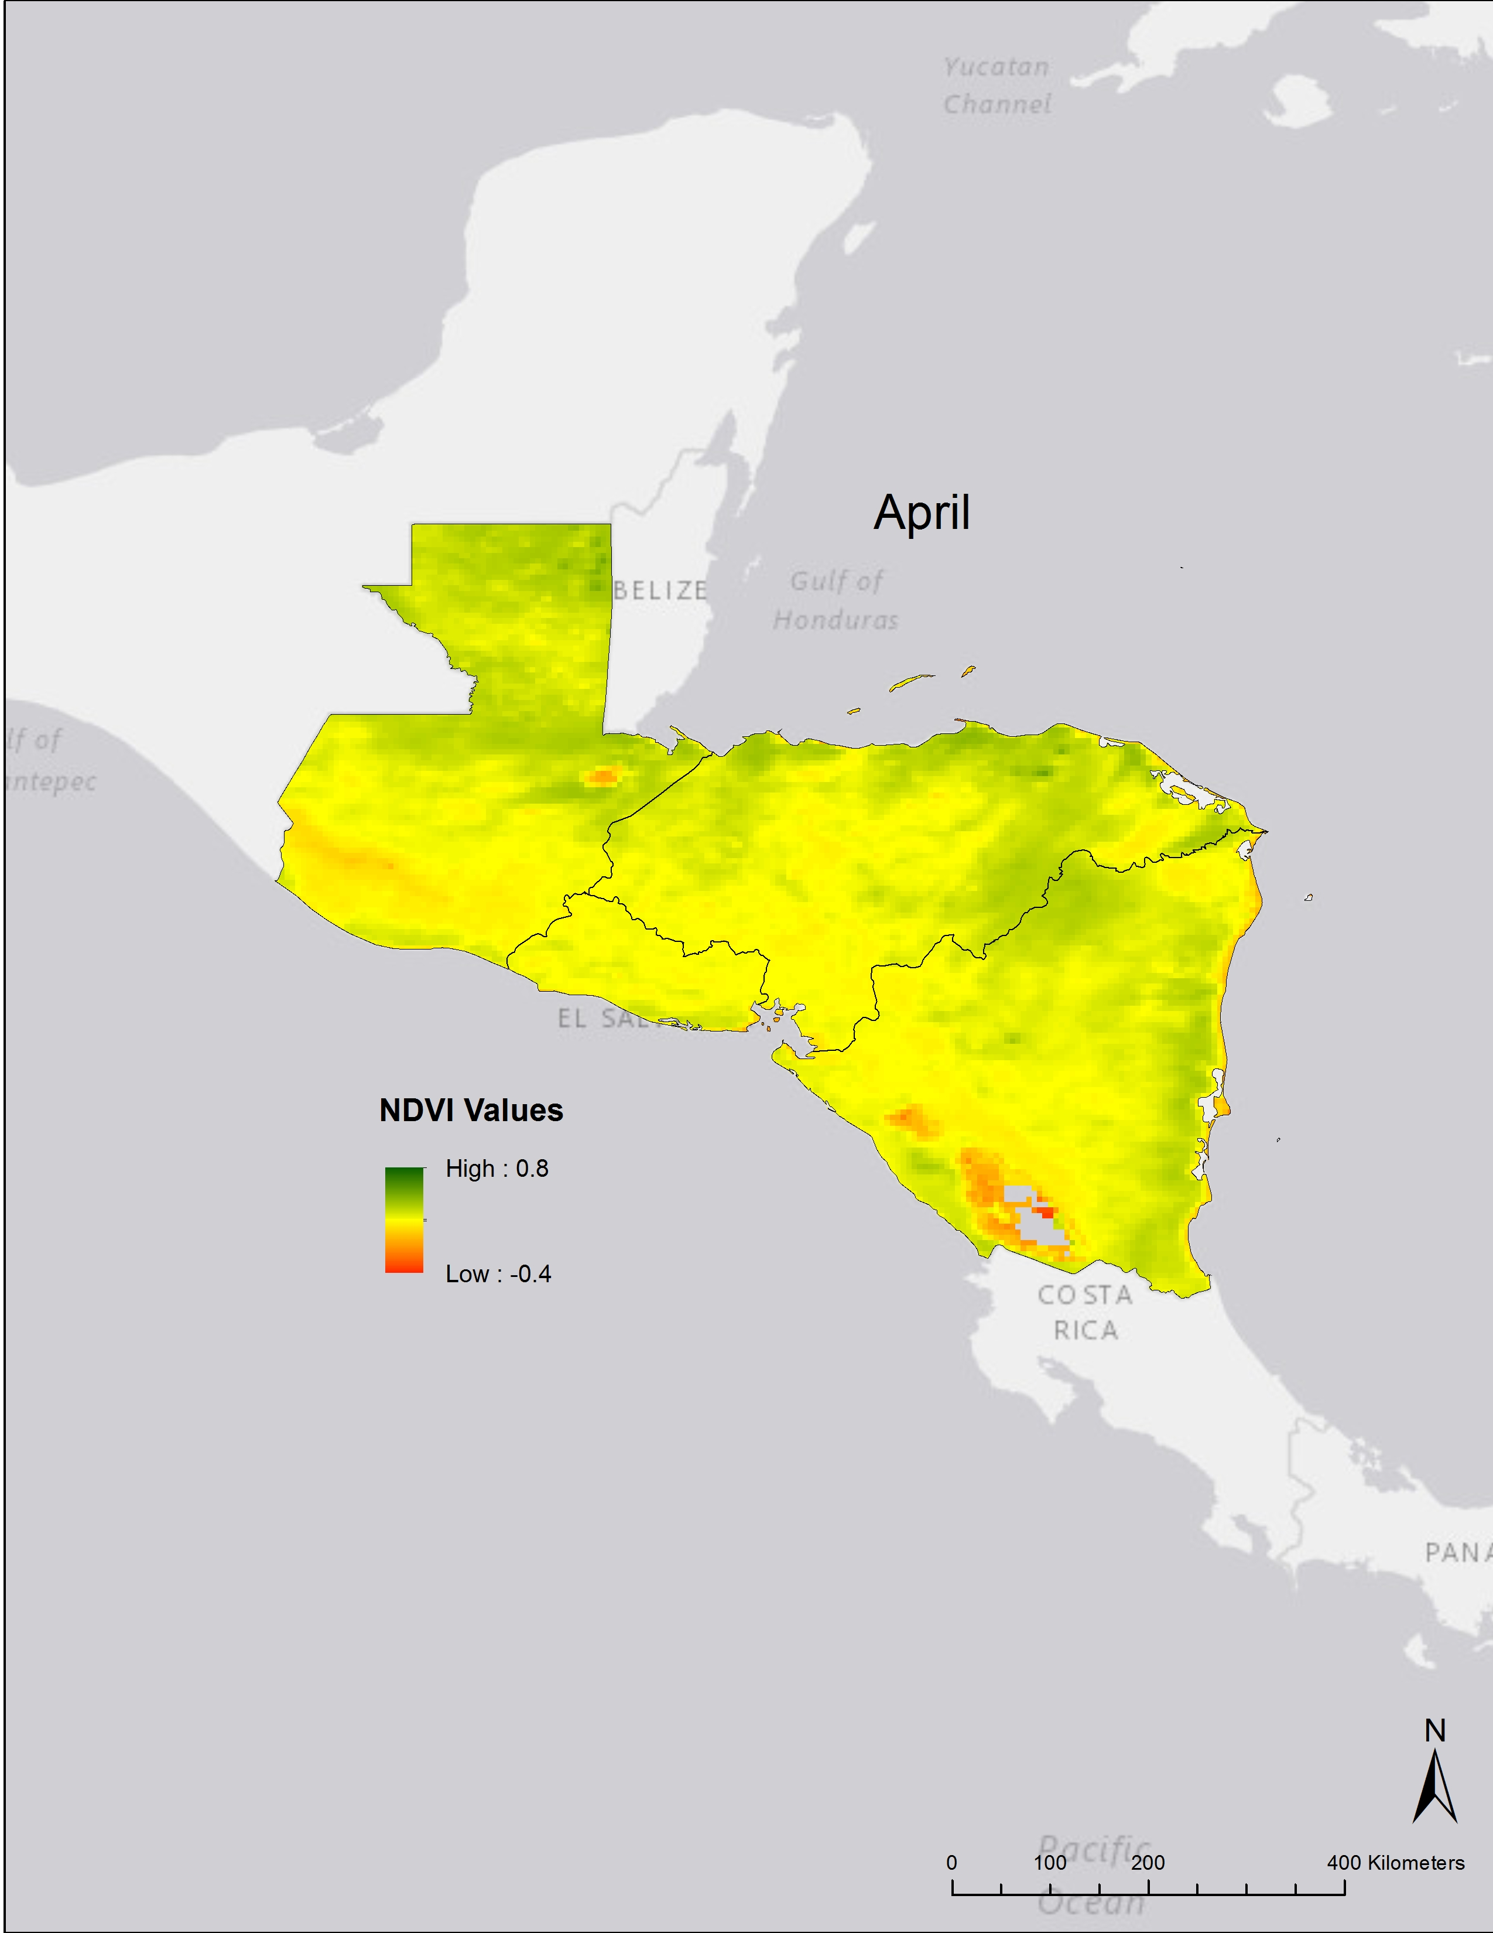
Climatologies

January
March
April
February

Figure 2 NDVI monthly climatology maps for Central America, displaying January through April NDVI monthly averages from 1981 - 2014.

Classification Graphs and Maps

Figure 3 NDVI signature classification graphs for the Levant, displaying monthly averages over the 33-year study period.

Figure 4 NDVI signature classification graphs for Central America, displaying monthly averages over the 33-year study period.
Figure 3 shows the Levant’s average NDVI values for each month from 1981 – 2014 separated into five signature classes. Throughout the months, the Levant is primarily comprised of soil. Soil reaches as high as 85% of the region’s NDVI classifications in March’s averages. In November, December, and January, barren rock, sand, and snow have a high or higher pixel percentage than the presence of soil in the region.
Figure 4 shows the average NDVI values for each month from 1981 – 2014 for Central America. Shrub and grassland is the primary classification throughout the months, followed by a stronger presence of dense vegetative canopy from January to March. Shrub and grassland reach a high percentage of close to 65% with a low throughout the months of 45%. Soil’s much lower presence in Central America when compared with the Levant creates a stark contrast for the two vastly different climates.
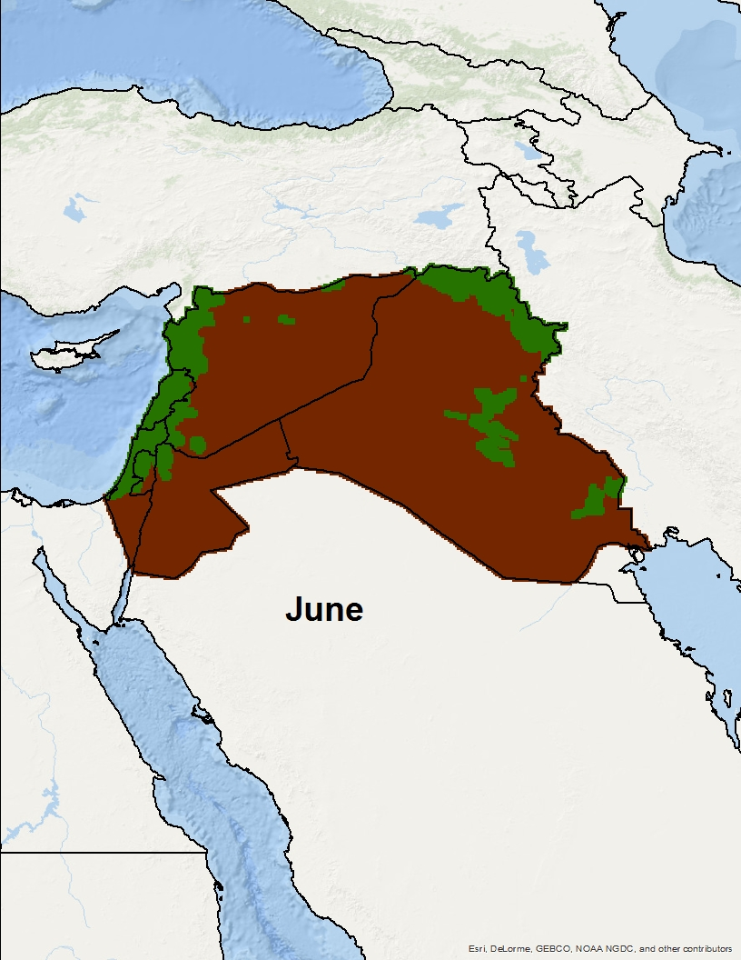
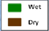

Low
High

Figure 5 NDVI high vegetation and little to no vegetation classifications for the Levant displaying June averages from 1981 – 2014.
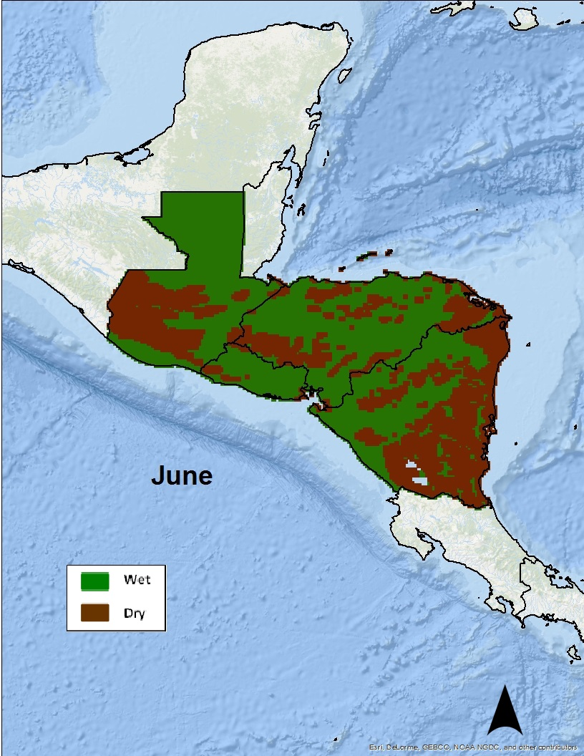

High
Low

Figure 6 NDVI high vegetation and little to no vegetation classifications for Central America, displaying June averages from 1981 – 2014.
Figure 5 displays further classification for the Levant, separating the NDVI signature classes and percentages into a simple 2-category classification of wet and dry. Throughout the 33-year study period the Levant is typically comprised of lower NDVI values, signified in brown as dry classification. Dry (brown) signifies NDVI values ranging from -1 to 0.2, whereas wet (green) signifies values ranging from 0.2 to 1. The map displays the region’s NDVI averages for the month of June from 1981 – 2014. When cross-referenced with figure 3, it is clear to see that soil makes up 80% of June’s vegetation.
Figure 6 displays further classification for Central America, separating the NDVI signature classes and percentages into a simple 2-category classification of wet and dry. The map displays the region’s NDVI value averages for the month of June from 1981 – 2014. Dry (brown) signifies NDVI values ranging from -1 to 0.2 and wet (green) signifies values ranging from 0.2 to 1. For Central America in June there remains a strong presence of wet vegetation, with much less of an unadorned difference between wet and dry than in the Levant in figure 5. Figure 4 displays in more detail this dispersion of wet and dry for the month of June. Shrub and grassland is approximately 55% of the region during this month, while soil is approximately 25%.

Percent Difference Maps
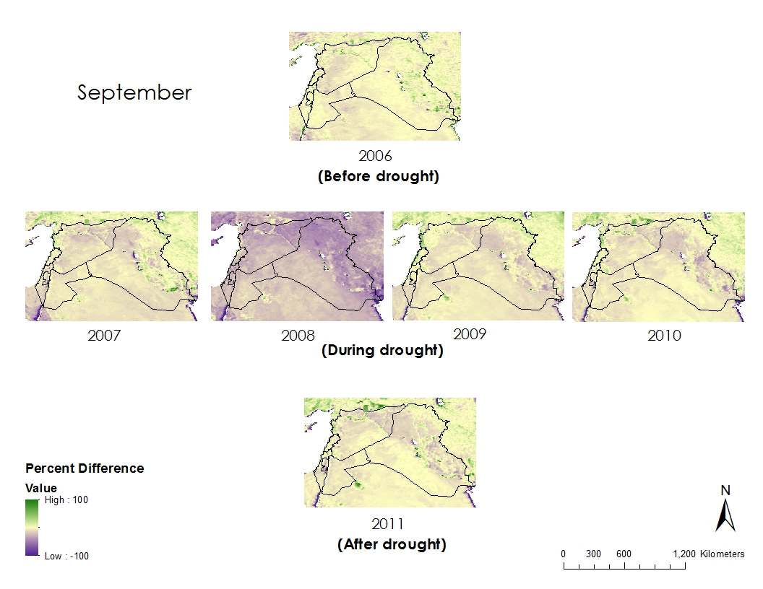
Figure 7 NDVI percent difference for the Levant during the month of September during the 2007-2010 severe drought and the year prior and after the drought.
Figure 7 represents the severe drought the Levant experienced from 2007 to 2010. The percent difference NDVI values during the drought, the year before the drought and the year after the drought were mapped to show the decrease in NDVI values experienced during the drought. During 2008, the Levant experienced the greatest decrease in NDVI values. September was the month graphed because it showed the very extreme nature of the drought during 2008. Other months during the drought period also demonstrated that 2008 was the year NDVI was most effected by drought but did not show as drastic a change in percent difference NDVI values as September.
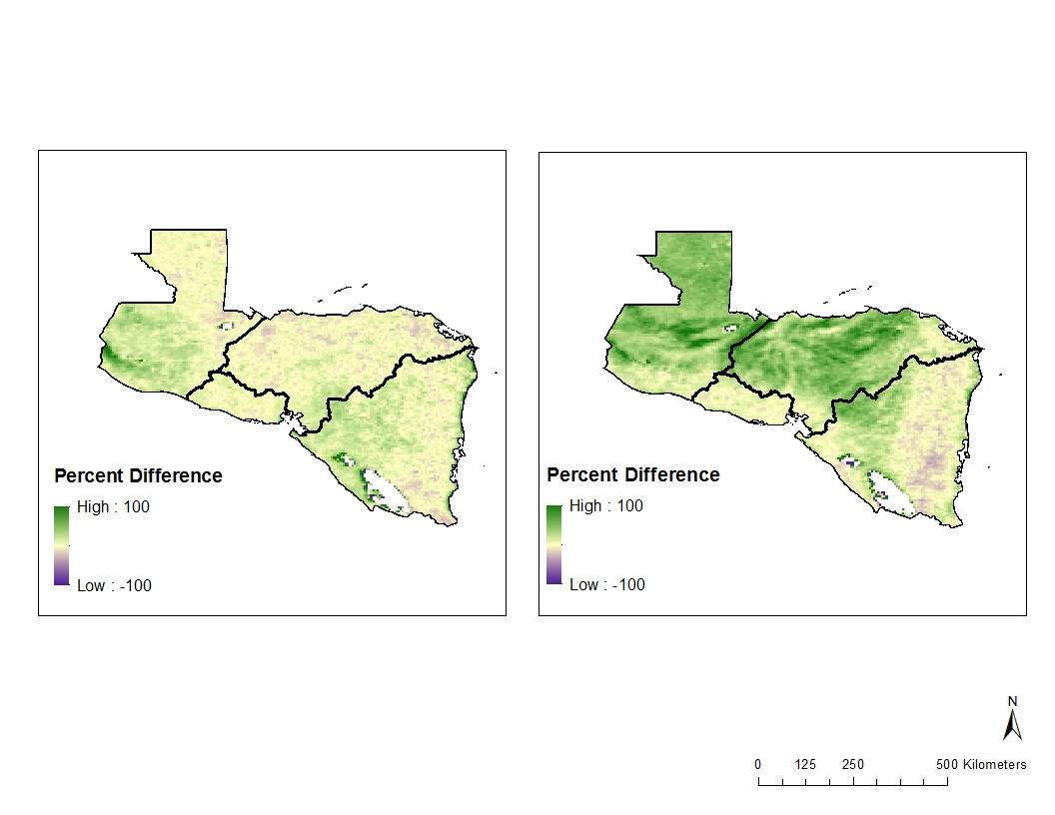
Strong El Niño
Weak La Niña
1996
1998
February
Figure 8 NDVI percent difference for Central America during February of the 1997-1998 strong El Niño year.
Figure 8 is an example of NDVI percent difference for Central America during the strong El Niño of 1997 to 1998. In the spring of 1998 there was an increase in percent difference in NDVI as seen by the large amount of green in the map. This increase in NDVI was seen throughout the beginning of 1998 when global temperatures were higher than normal and the El Niño had peaked the months prior. In1996, it is apparent that NDVI values increased throughout most of the region compared to a non El Niño year. The year prior to the El Niño also happened to be a weak La Niña year. There was very little NDVI change during Feburary 1996, espeically when compared to the El Niño years.

Trend Maps
Figure 9 and 10 below show the linear trends in NDVI from 1981-2014 during the winter months in both regions. These trends represent the typical increase or decrease in NDVI per year over the study period as derived from a linear regression calculation. Graphics similar to figures 8 and 9 were made for all four seasons in both regions and will be provided to the end-users for reference. P-values and r-squared values were calculated and stored in data frames for further reference by our end-users. Overall the p-values validated the significance of these trends.
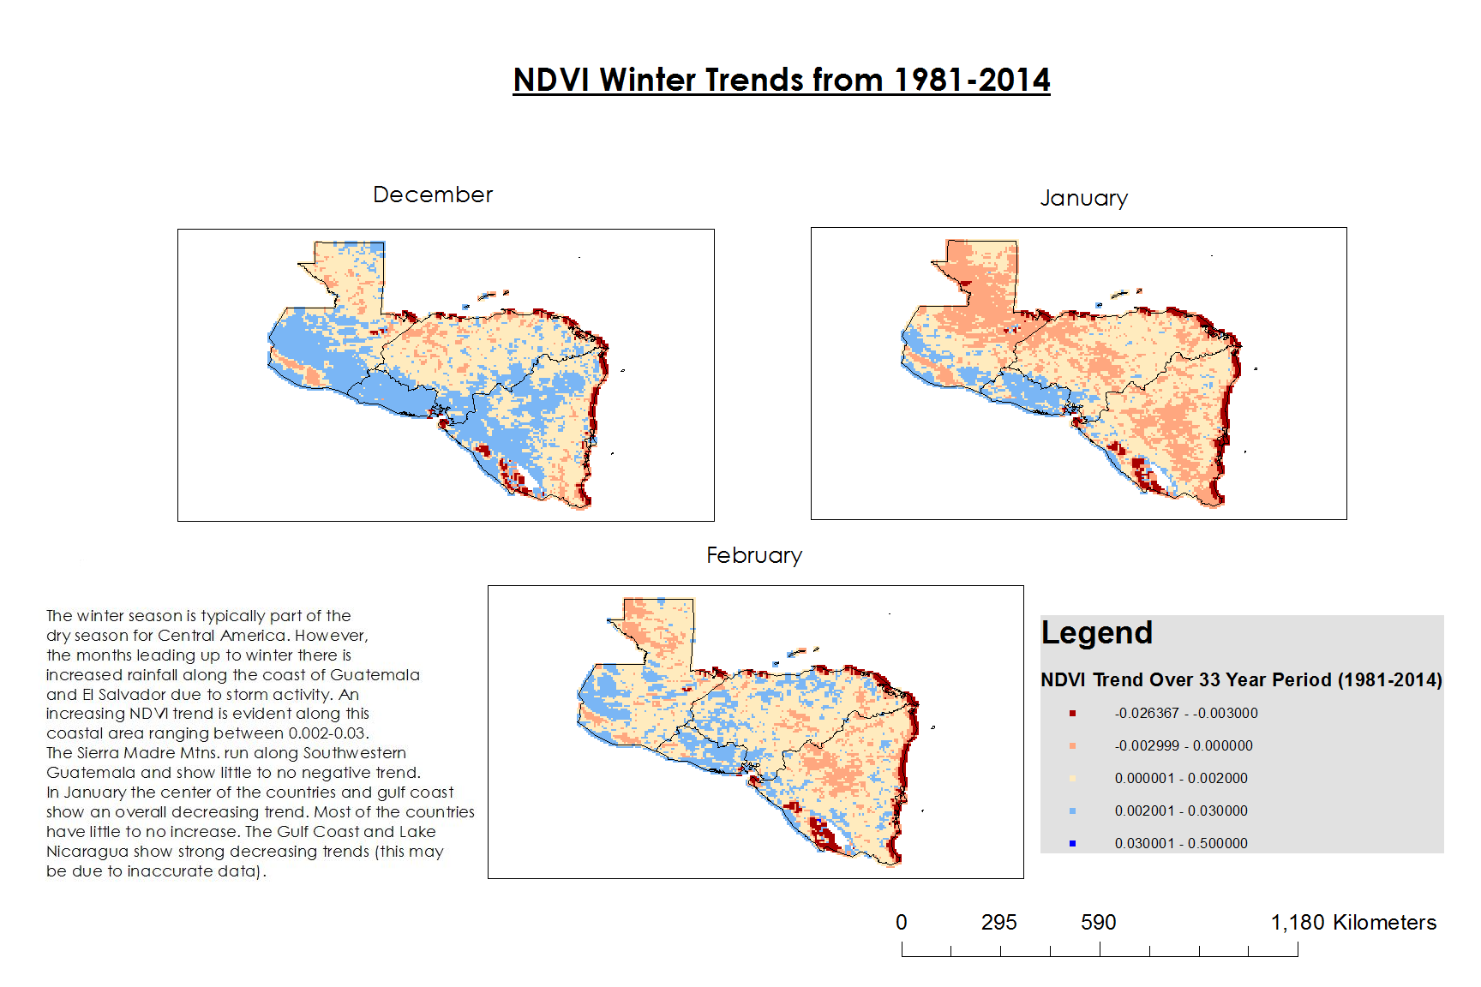
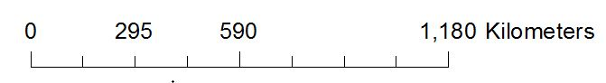
Figure 9 shows that the Southwest coast along Guatemala and El Salvador is increasing in NDVI over the winter season (Values along the Gulf Coast and within Lake Nicaragua are most likely outliers due to water influencing surface reflectance data). Figure 10 shows how linear trends in the Levant are smaller than in Central America, meaning that most of the Levant is experiencing a smaller range of increases and decreases in NDVI than Central America. The majority of the Levant seems to have experienced a very slight decrease over the study period. The most drastic NDVI changes in the Levant can be seen along the Northwestern Mediterranean coast (along Syria and Lebanon) with increasing trends present for most of the year.
NDVI winter Trends from 1981-2014
NDVI Trend Over 33-year Period
0.030 – 0.500
-0.0264 – (-0.003)
-0.003 – 0.000
0.000 – 0.002
0.002 – 0.030
NDVI winter Trends from 1981-2014

January
December

February
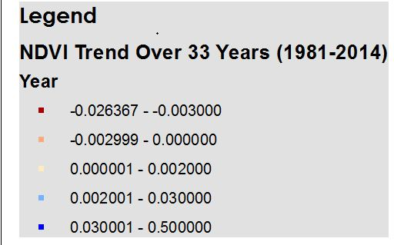

Figure 9 Linear trends per pixel for the Central American region during “Winter” Season.
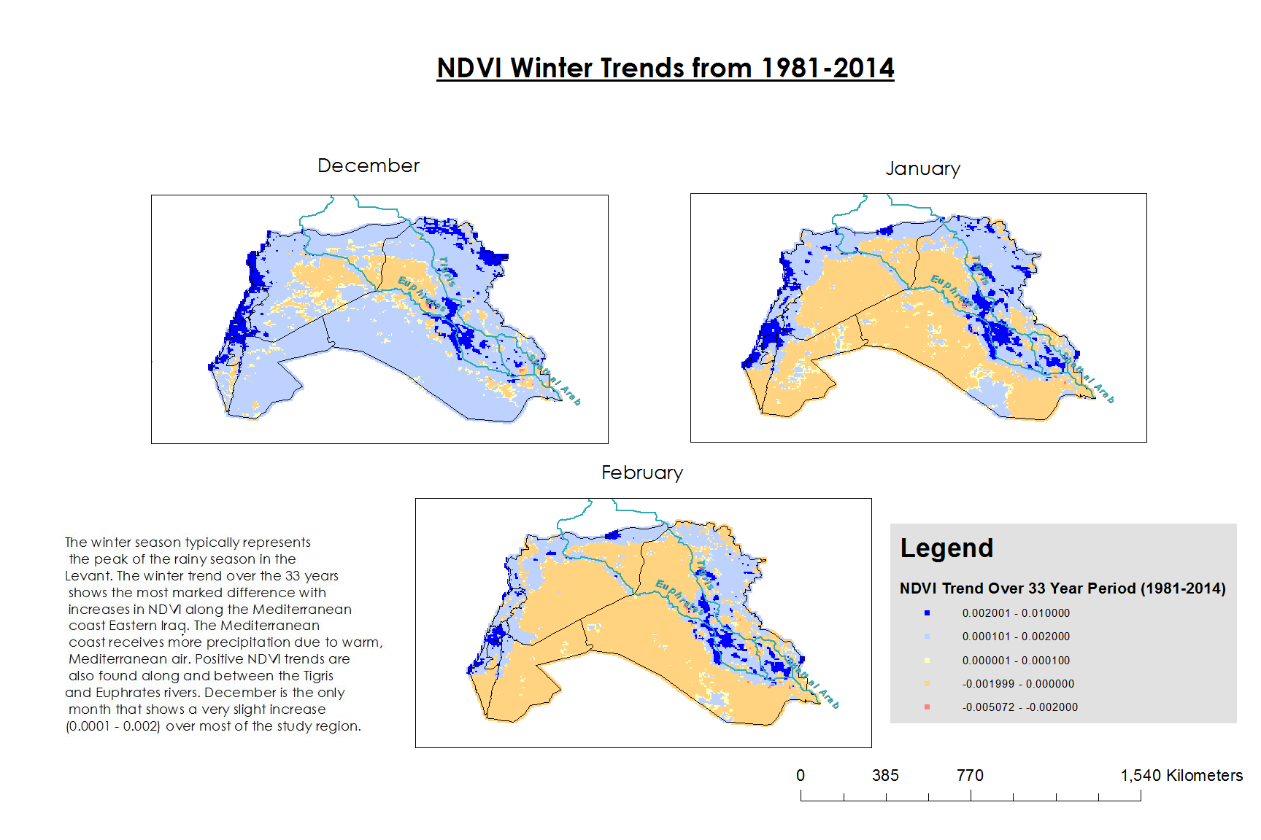

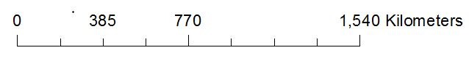
Legend
NDVI Trend Over 33-year Period
-0.005 – (-0.002)
-0.002 – 0.000
0.002 – 0.010
0.0001 – 0.002
0.000 – 0.0001
NDVI winter Trends from 1981-2014
December
February
January

Figure 10 Linear trends per pixel for the Levant region during winter Season.

V. Conclusions
NDVI values for Central America accurately depicted the wet and humid climate by having the majority of NDVI values in the shrub and grassland classification as well as dense vegetation canopy. The Levant desertification is seen in the majority of NDVI values falling in the soil classification for the region. Through the climatologies made, it was seen, primarily in Central America, that many of the agricultural regions had the highest NDVI values during the rainy season. NDVI data and climatologies were also found to mirror typical precipitation and temperature patterns. The percent difference maps proved that NDVI data and the results of this project respond properly to periods of interest including drought events and ENSO occurrences. Significant linear trends indicate that the Levant is seeing a slight decrease in vegetation through most of the year except for the northern Mediterranean Coast. Central America’s NDVI trends reveal shifting increases and decreases throughout the year with the most consistent vegetation increases occurring along the Pacific coast of Guatemala and El Salvador.

VI. Acknowledgments
We wish to thank our center lead Jessica Sutton, assistant center lead Emma Baghel, and our science advisor Dr. DeWayne Cecil for their guidance and expertise through the entire project. We would also like to thank all of the people at NCEI who gave us advice along the way (list people here).

Any opinions, findings, and conclusions or recommendations expressed in this material are those of the author(s) and do not necessarily reflect the views of the National Aeronautics and Space Administration.
This material is based upon work supported by NASA through contract NNL11AA00B and cooperative agreement NNX14AB60A.

VII. References
Becker, Emily. 2015. September 2015 El Niño Update and Q&A. National Oceanic and
Atmospheric Administration, https://www.climate.gov/news-features/blogs/enso/september-2015-el-ni%C3%B1o-update-and-qa.

Gleick, Peter. 2014. Water, Drought, Climate Change and Conflict in Syria. American
Meteorological Society, 6, 331-340.

Gourmelon, Gaelle. 2015. Who Will Pay for Central America’s Climate Change Losses?
Worldwatch Institute. http://blogs.worldwatch.org/who-will-pay-for-central-americas-climate-change-losses/.

Kaniewski, David, Van Campo, Elise, and Weiss, Harvey. 2011. Drought is a recurring
challenge in the Middle East. PNAS, 109 (10), 3862-3867.

Kelley, Colin. et al. 2014. Climate change in the Fertile Crescent and implications of the
recent Syrian drought. PNAS, 112 (11), 3241-3246.

Maddocks, Andrew, Young, Samuel and Reig, Paul. 2015 Ranking the World’s Most
Water-Stressed Countries in 2040. World Resources Institute. http://www.wri.org/blog/2015/08/ranking-world%E2%80%99s-most-water-stressed-countries-2040.

Maregno, Jose et al. 2014. Climate Change in Central and South America: Recent Trends, Future Projections, and Impacts on Regional Agriculture. International Center for Tropical Agriculture, 73, 1- 93.

Martinez, Stephanie. 2016. The Disproportionate Consequences of Climate Change.
National Center for Disaster Preparedness NDCP Earth Institute|Columbia University. http://ncdp.columbia.edu/ncdp-perspectives/the-disproportionate-consequences-of-climate-change/.

Maurer, E. P., Adam, J.C. and Wood, A. W. 2009. Climate model based consensus on
the hydrologic impacts of climate change to the Rio Lempa basin of Central America. Hydrology and Earth System Science, 13, 183-194.

"Normalized Difference Vegetation Index (NDVI) Analysis for Forestry Analysis for Forestry and Crop Management and Crop Management." Sim Wright. Web. 11 Feb. 2016. <http://simwright.com/downloads/SimWright_NDVI.pdf>.

Vidal, John. 2015. Middle East faces water shortages for the next 25 year, study says. The
Guardian Magazine. http://www.theguardian.com/environment/2015/aug/27/middle-east-faces-water-shortages-for-the-next-25-years-study-says.

Watson, Kate. 2015. Guatemala families struggle for food in Central American
drought. BBC New. http://www.bbc.com/news/world-latin-america-34416771.

The State of Food Insecurity in the World 2015. Food and Agriculture Organization of the
United Nations. http://www.fao.org/hunger/en/.

IV. Content Innovation

Acronym Glossary
AVHRR – Advance Very High Resolution Radiometer
CDR – Climate Data Record
ENSO – El Niño Southern Oscillation
FAO – The Food and Agricultural Organization of the United Nations’
MODIS – Moderate Resolution Imaging Spectroradiometer
NOAA – National Oceanic and Atmospheric Administration
NASA – National Aeronautics and Space Administration
NDVI – Normalized Difference Vegetation Index
WRI – World Resources Institute

Featured Multimedia
The Levant & Central American Climate VPS: “Decoding Vegetation”
The Project Virtual Poster Session will be linked to the title at the beginning of the technical paper. (will be embedded once VPS is published by NASA)

Animated Illustration
Climatologies, percent difference maps for the Levant 2008 drought, and trend maps for both regions will be linked to corresponding titles within the results section.

V. Appendices

Baseline climatologies over the 33-year study period for Central America and the Levant.
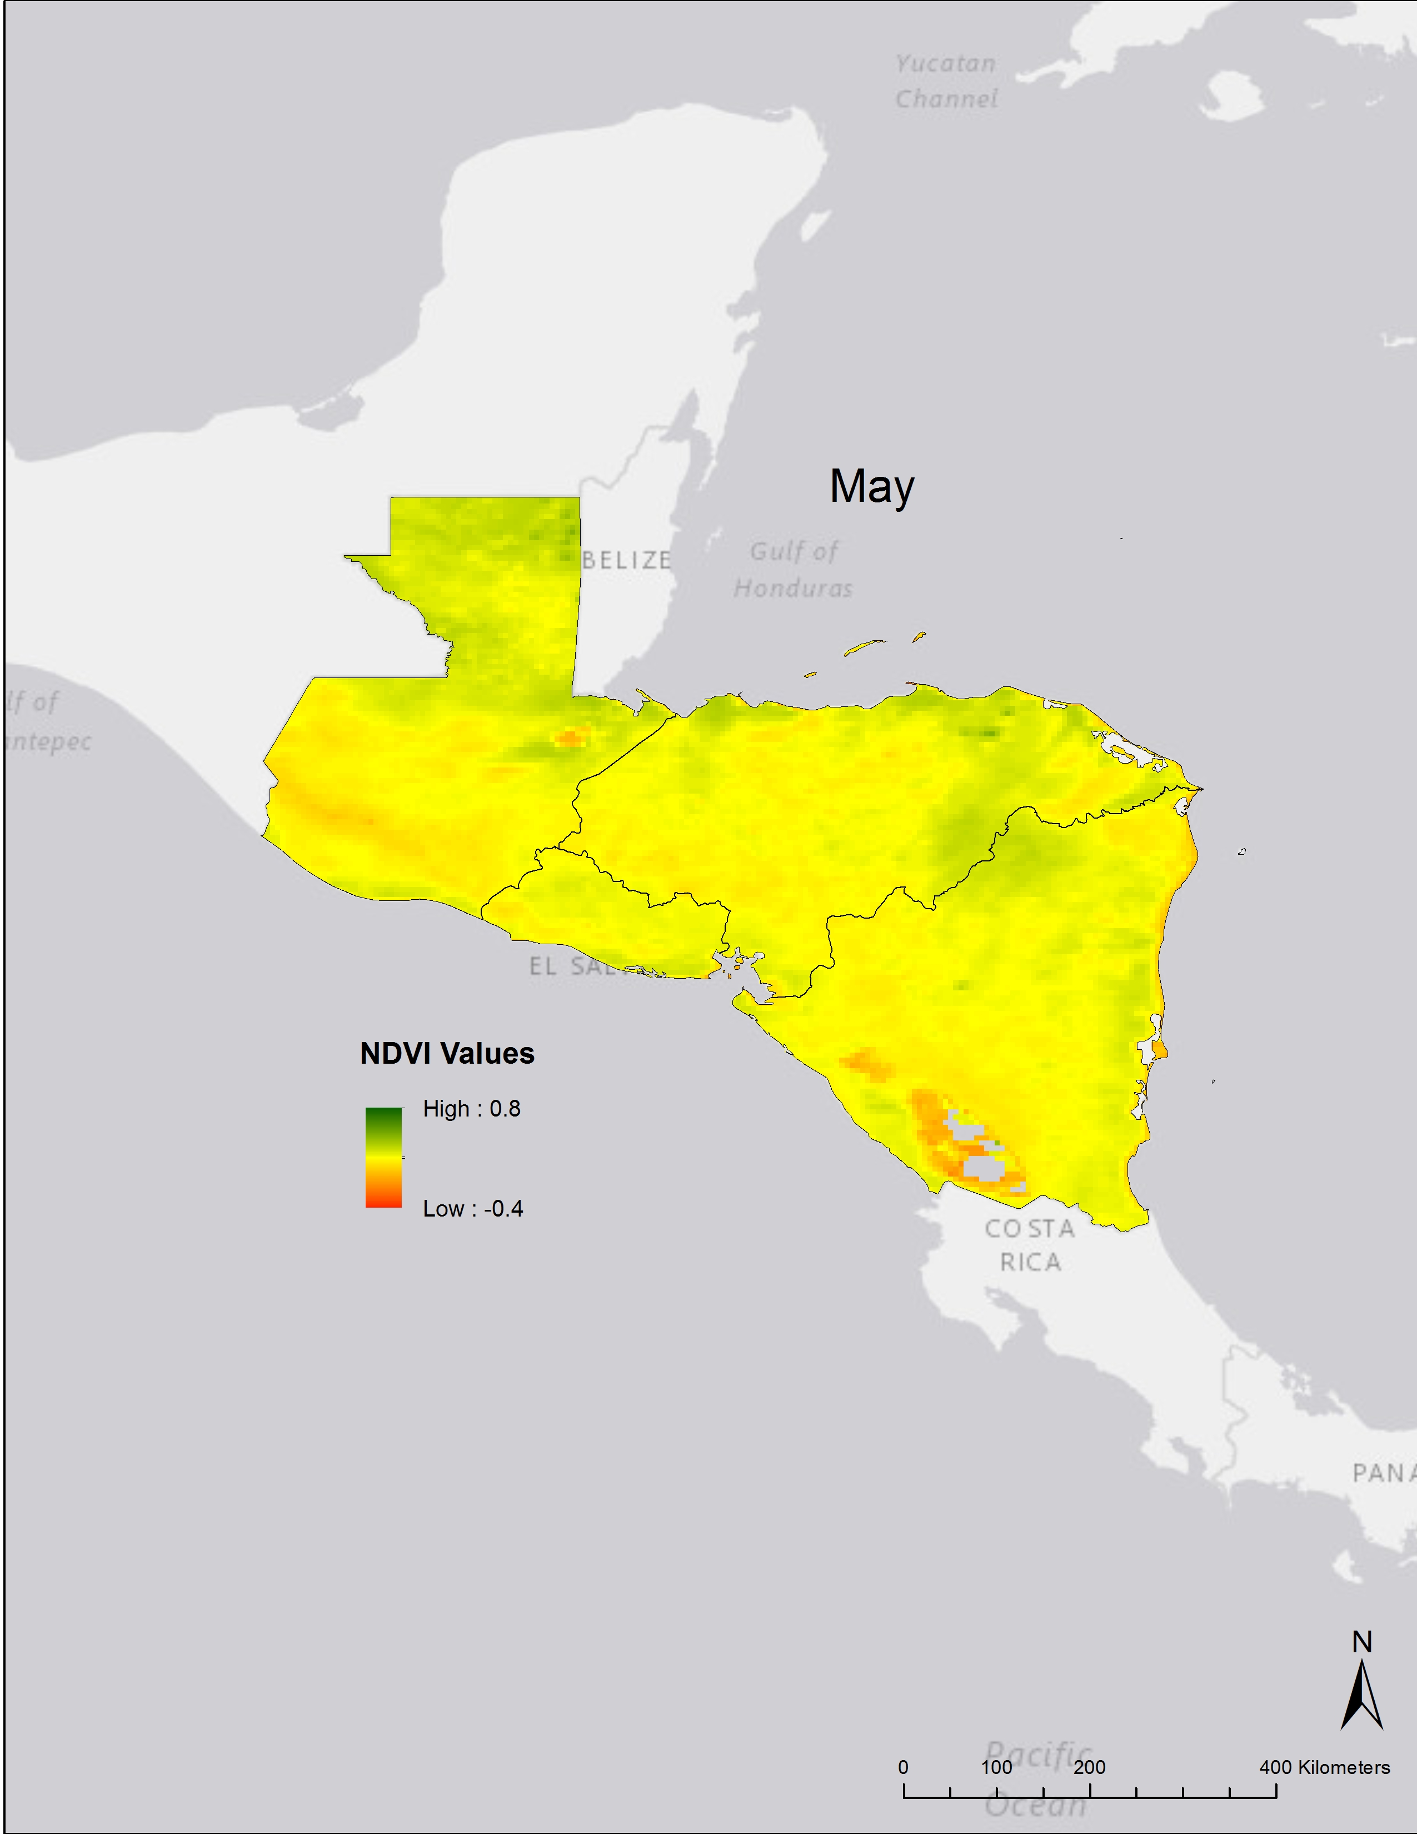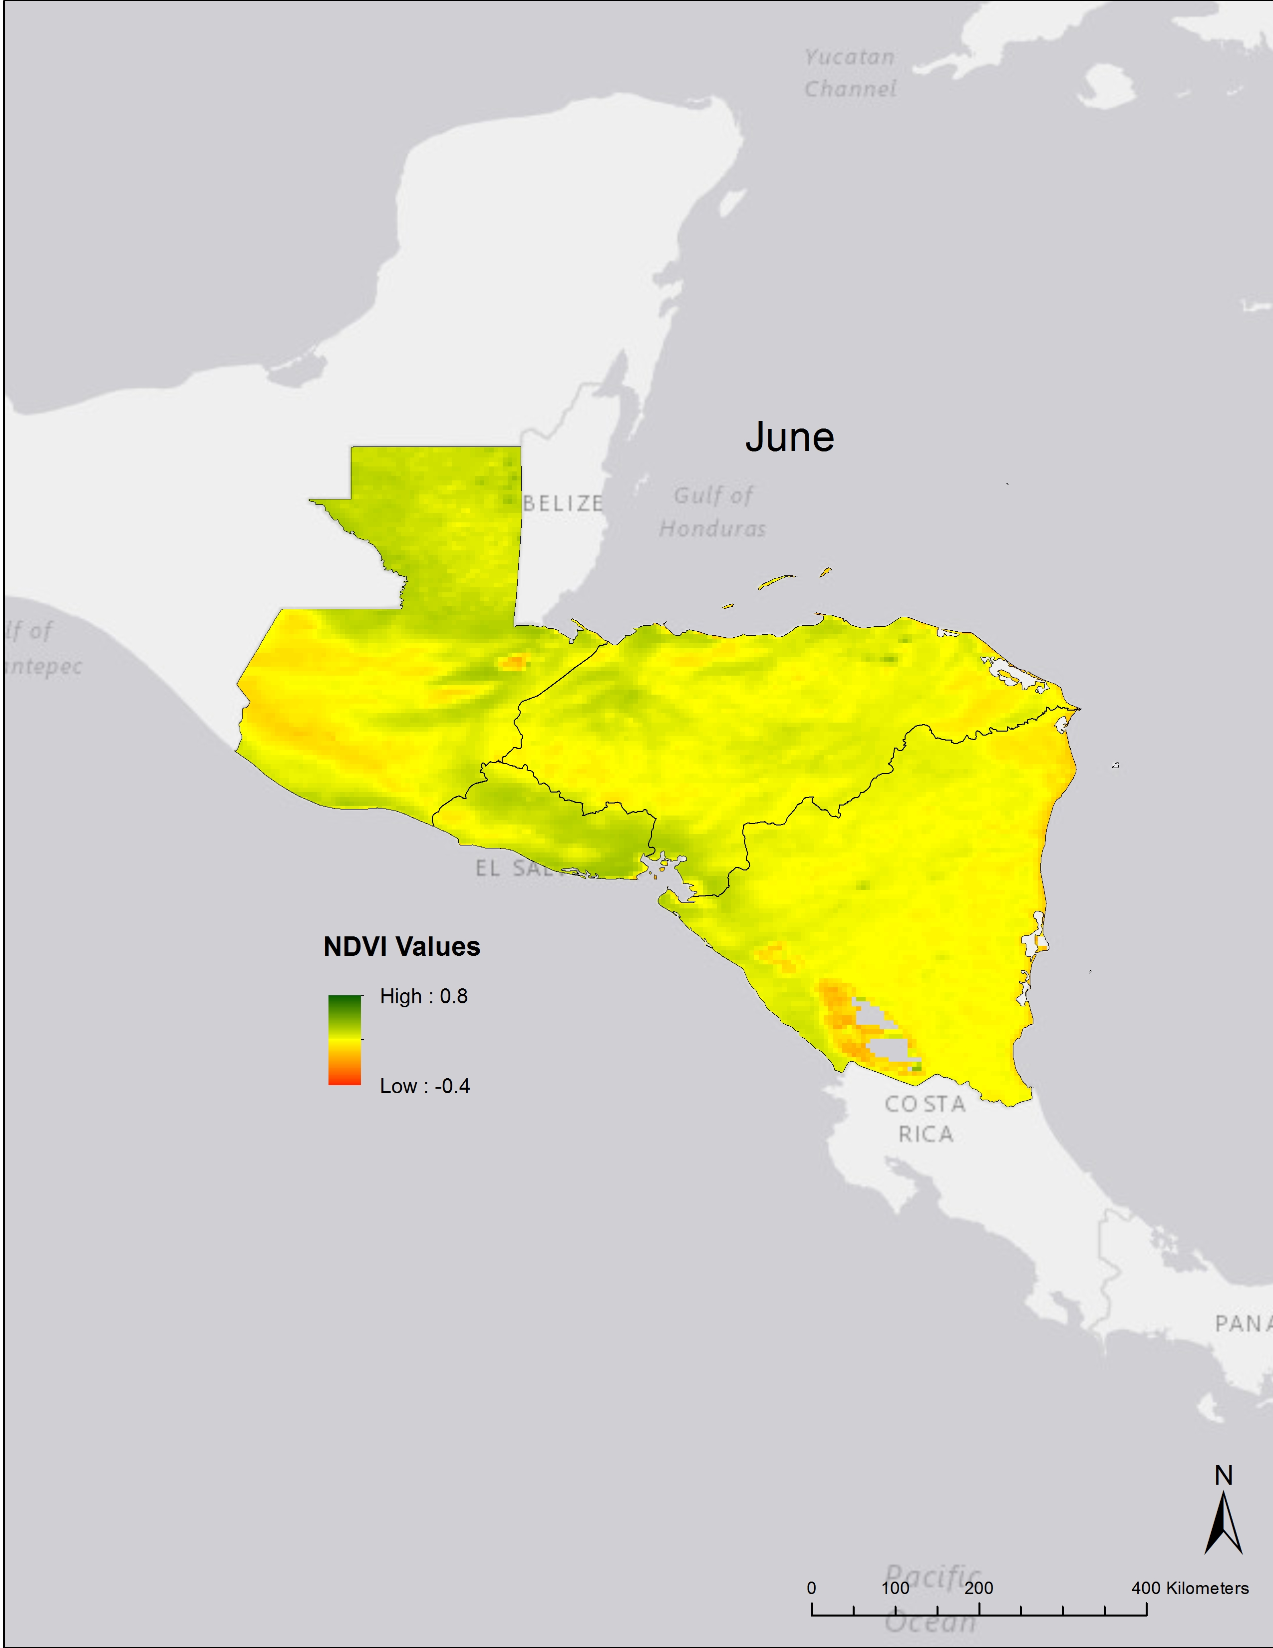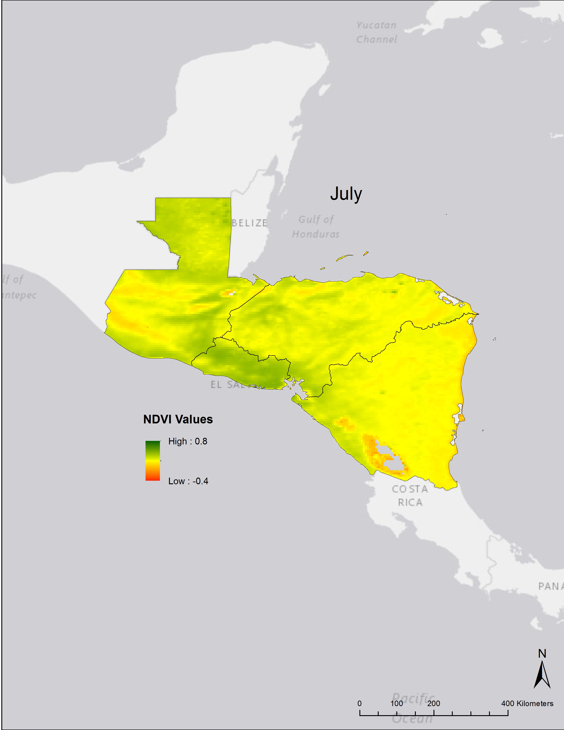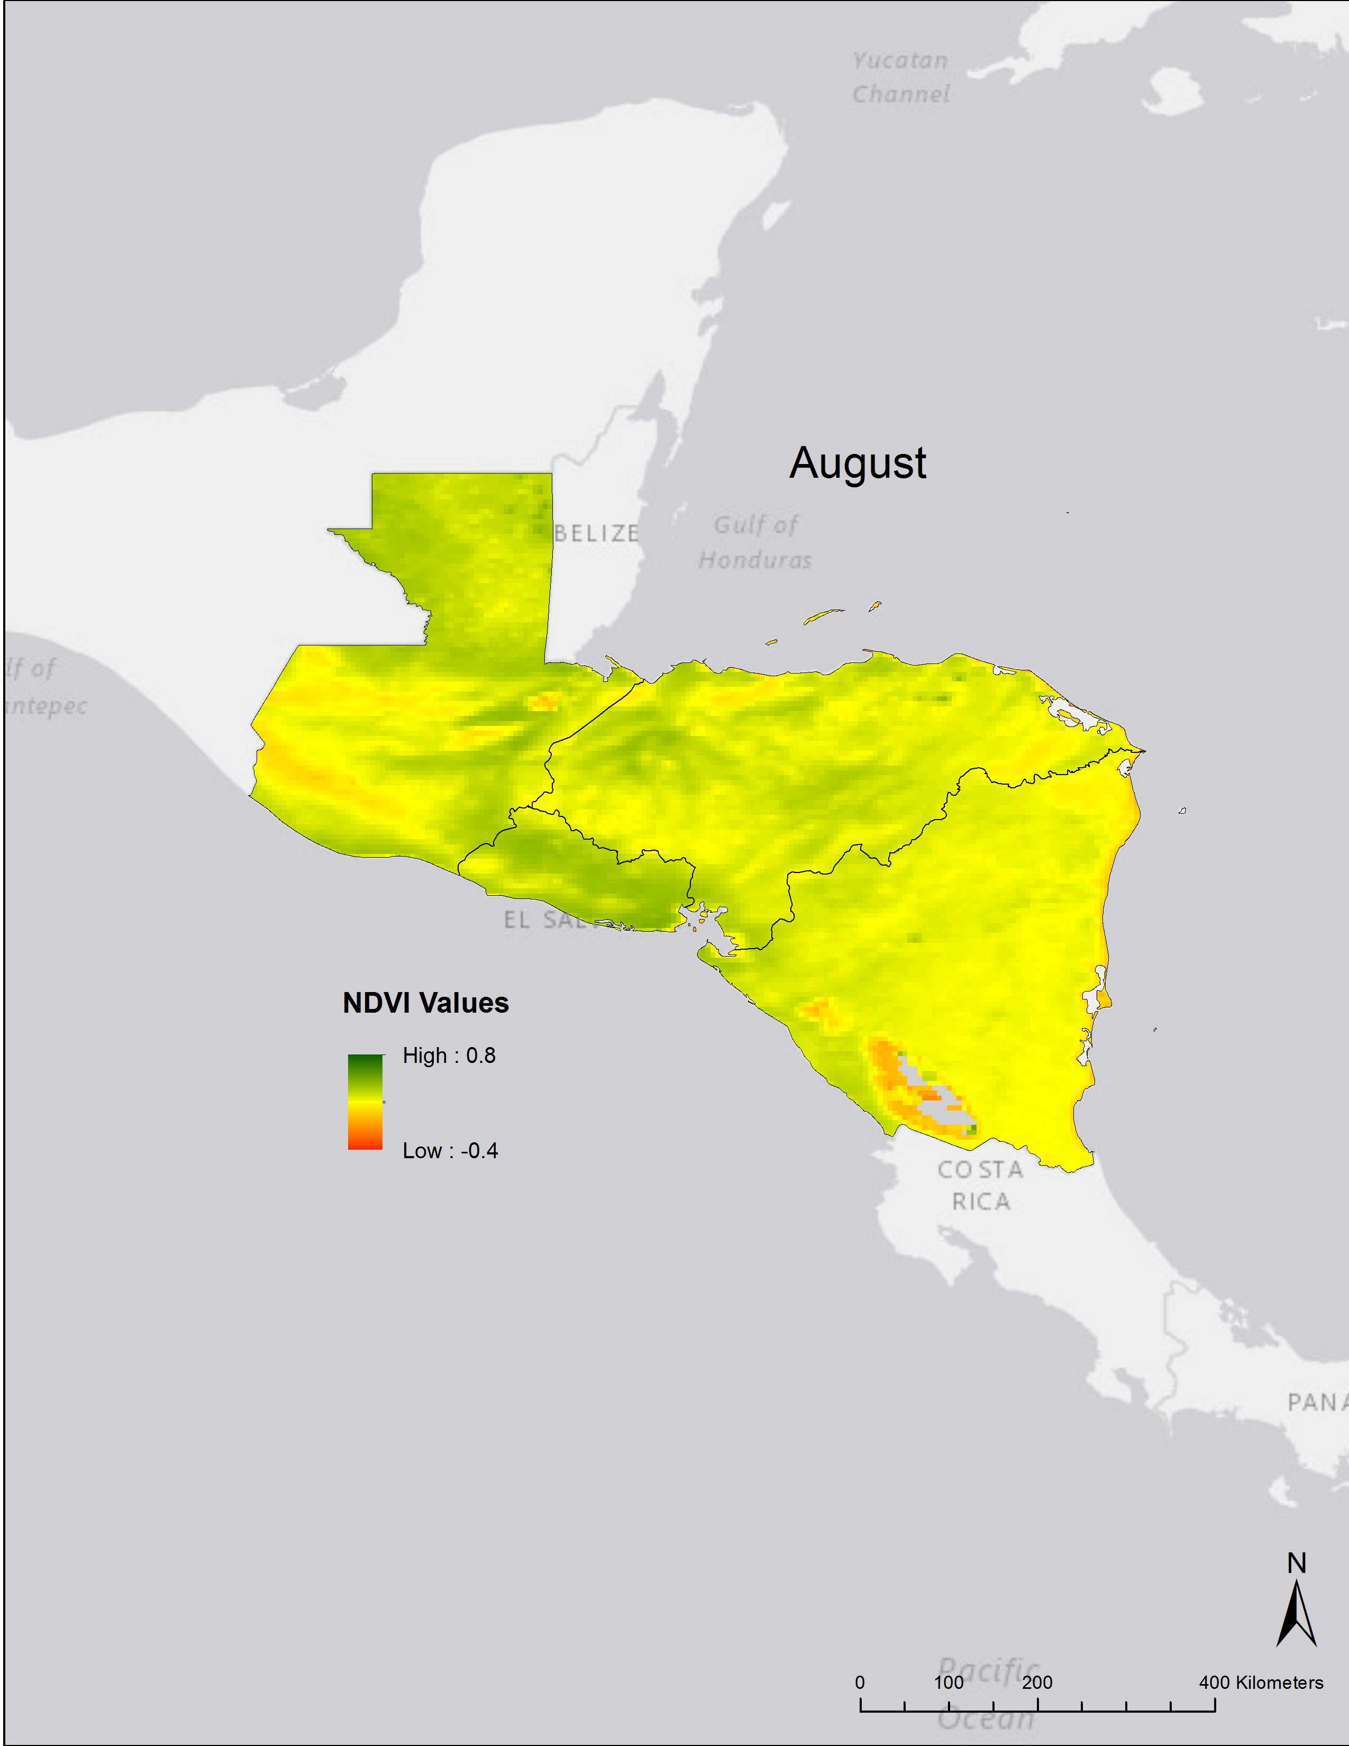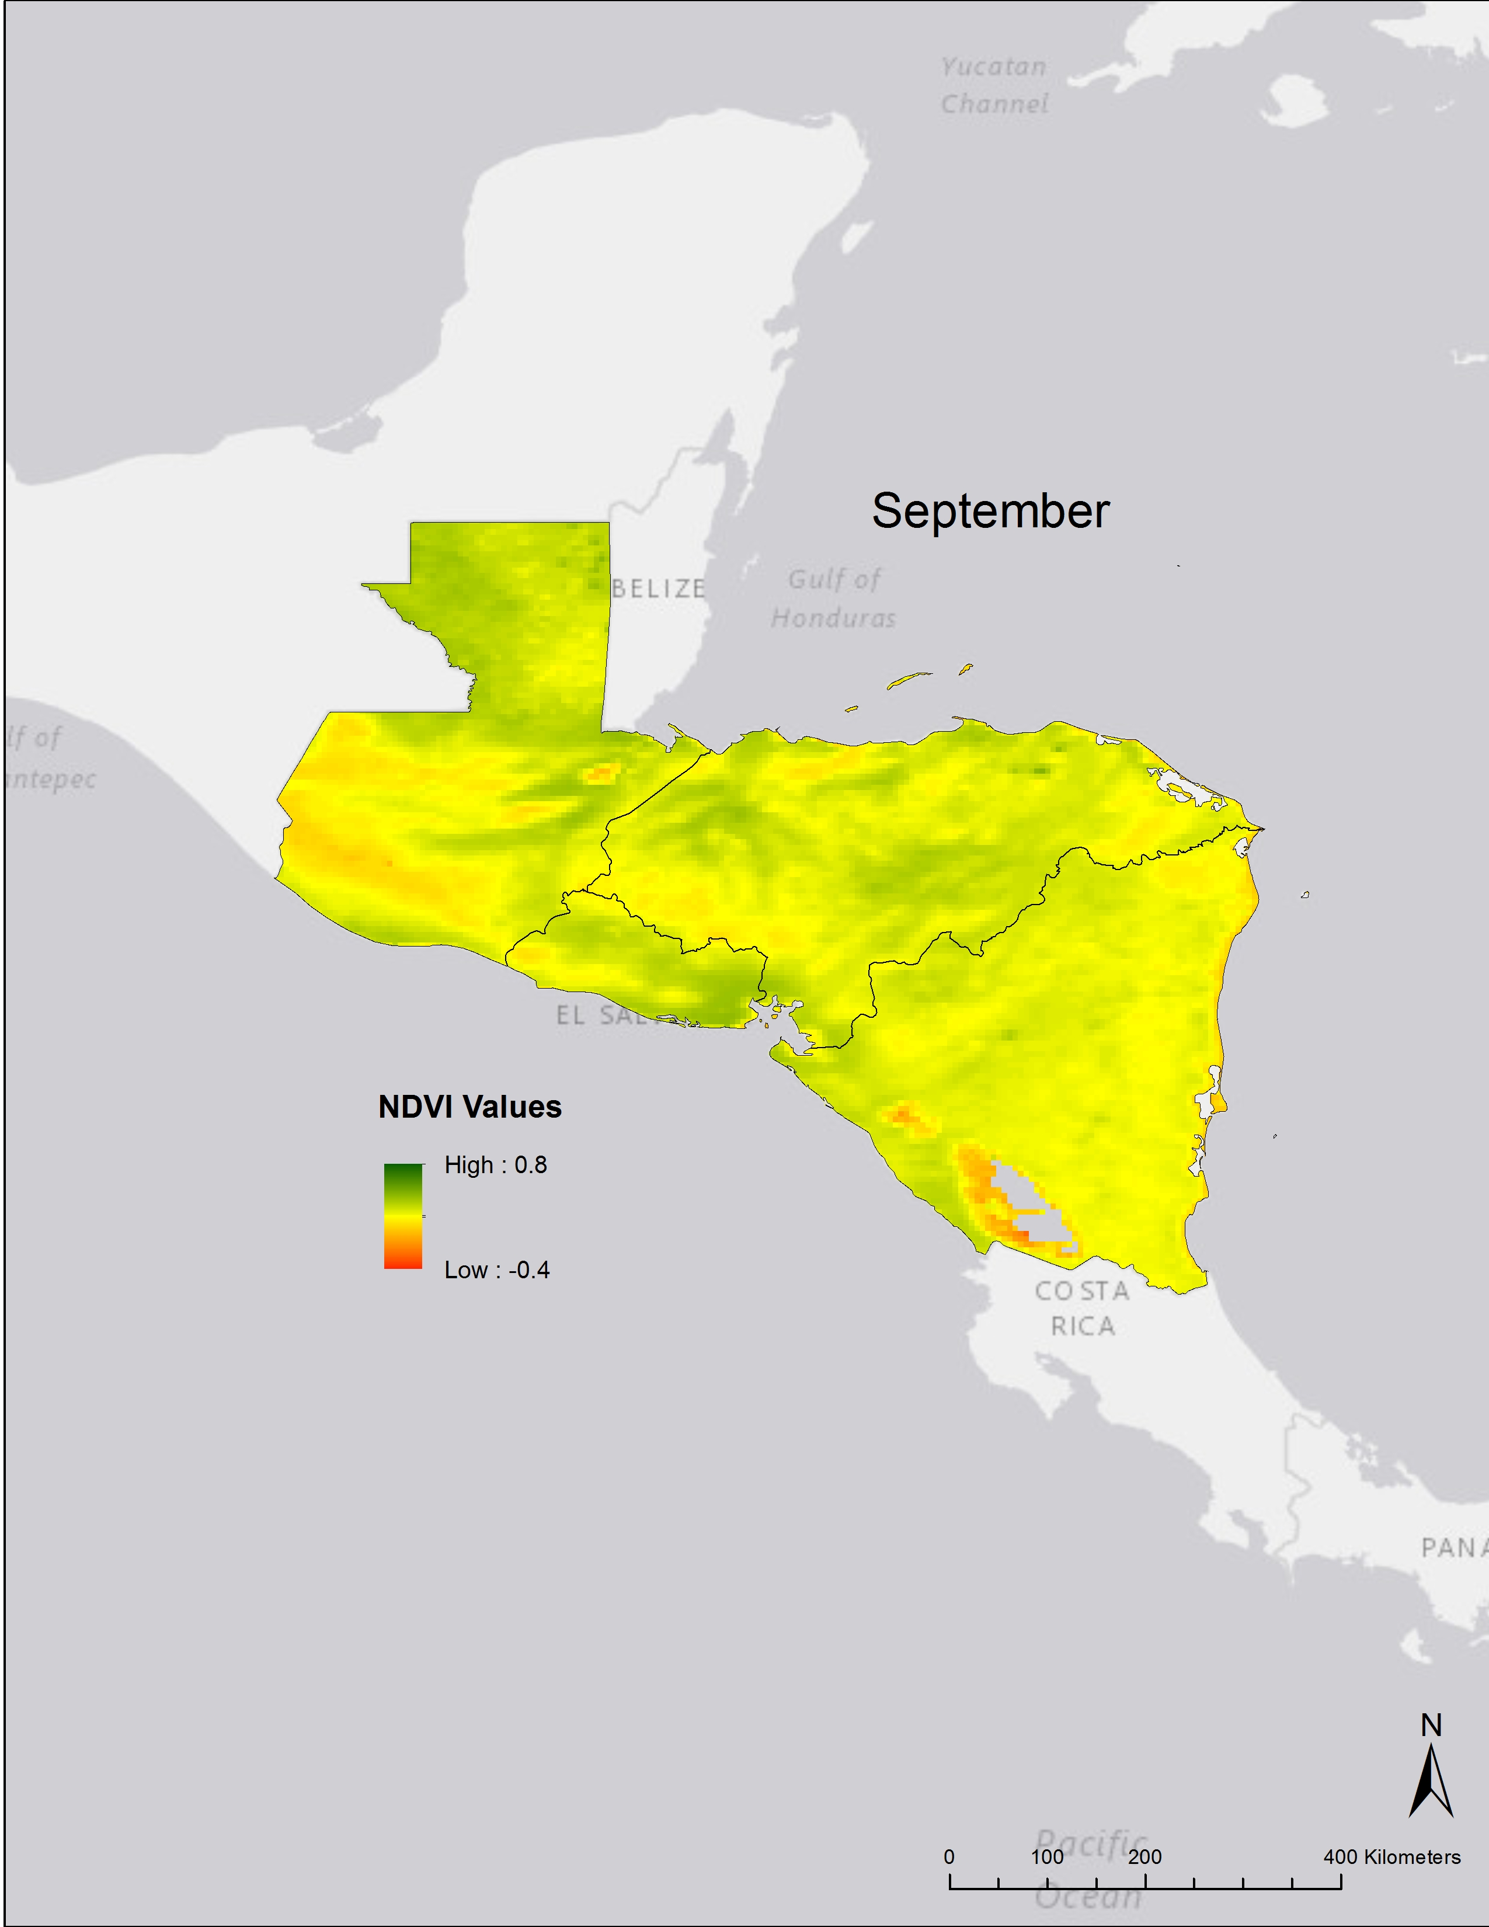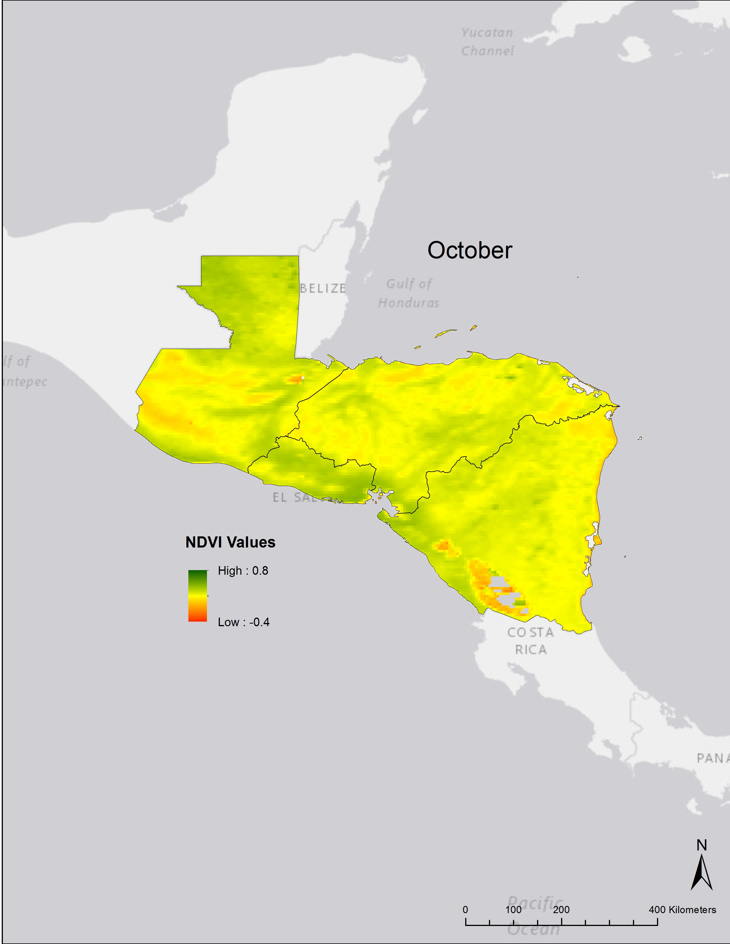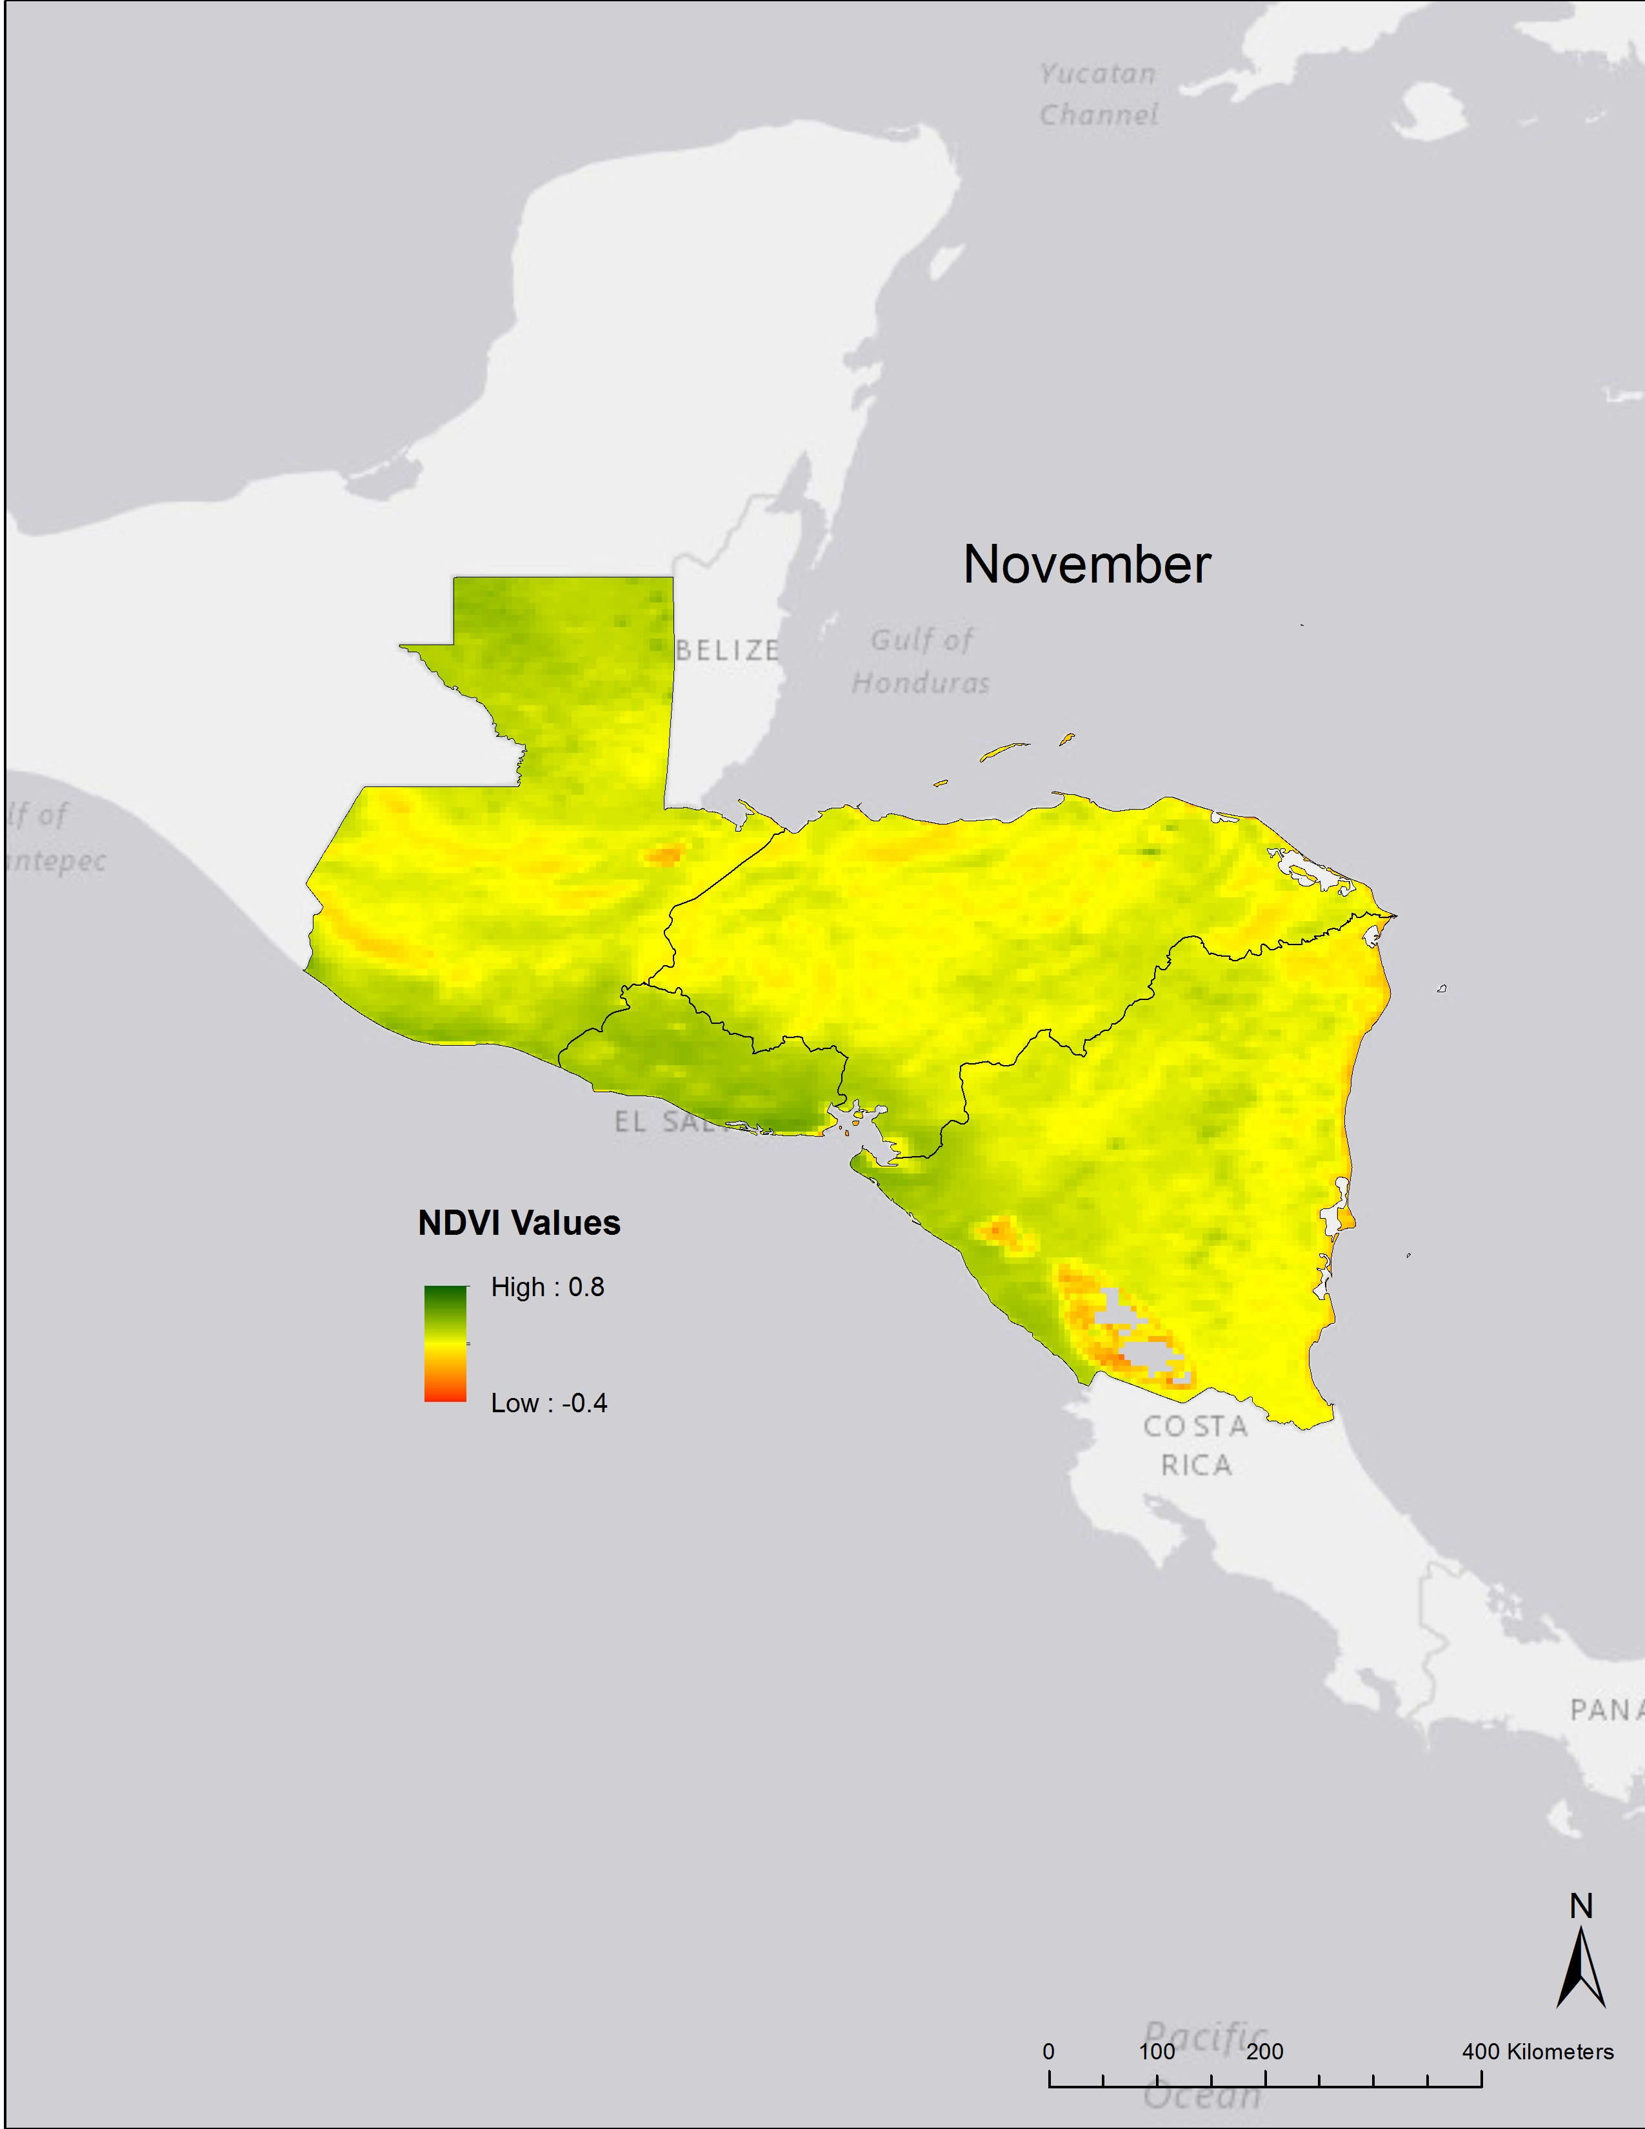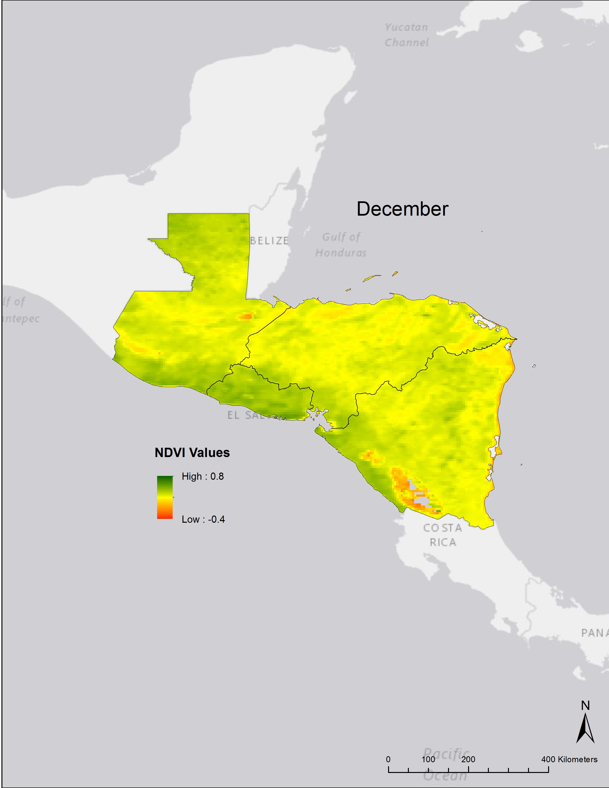
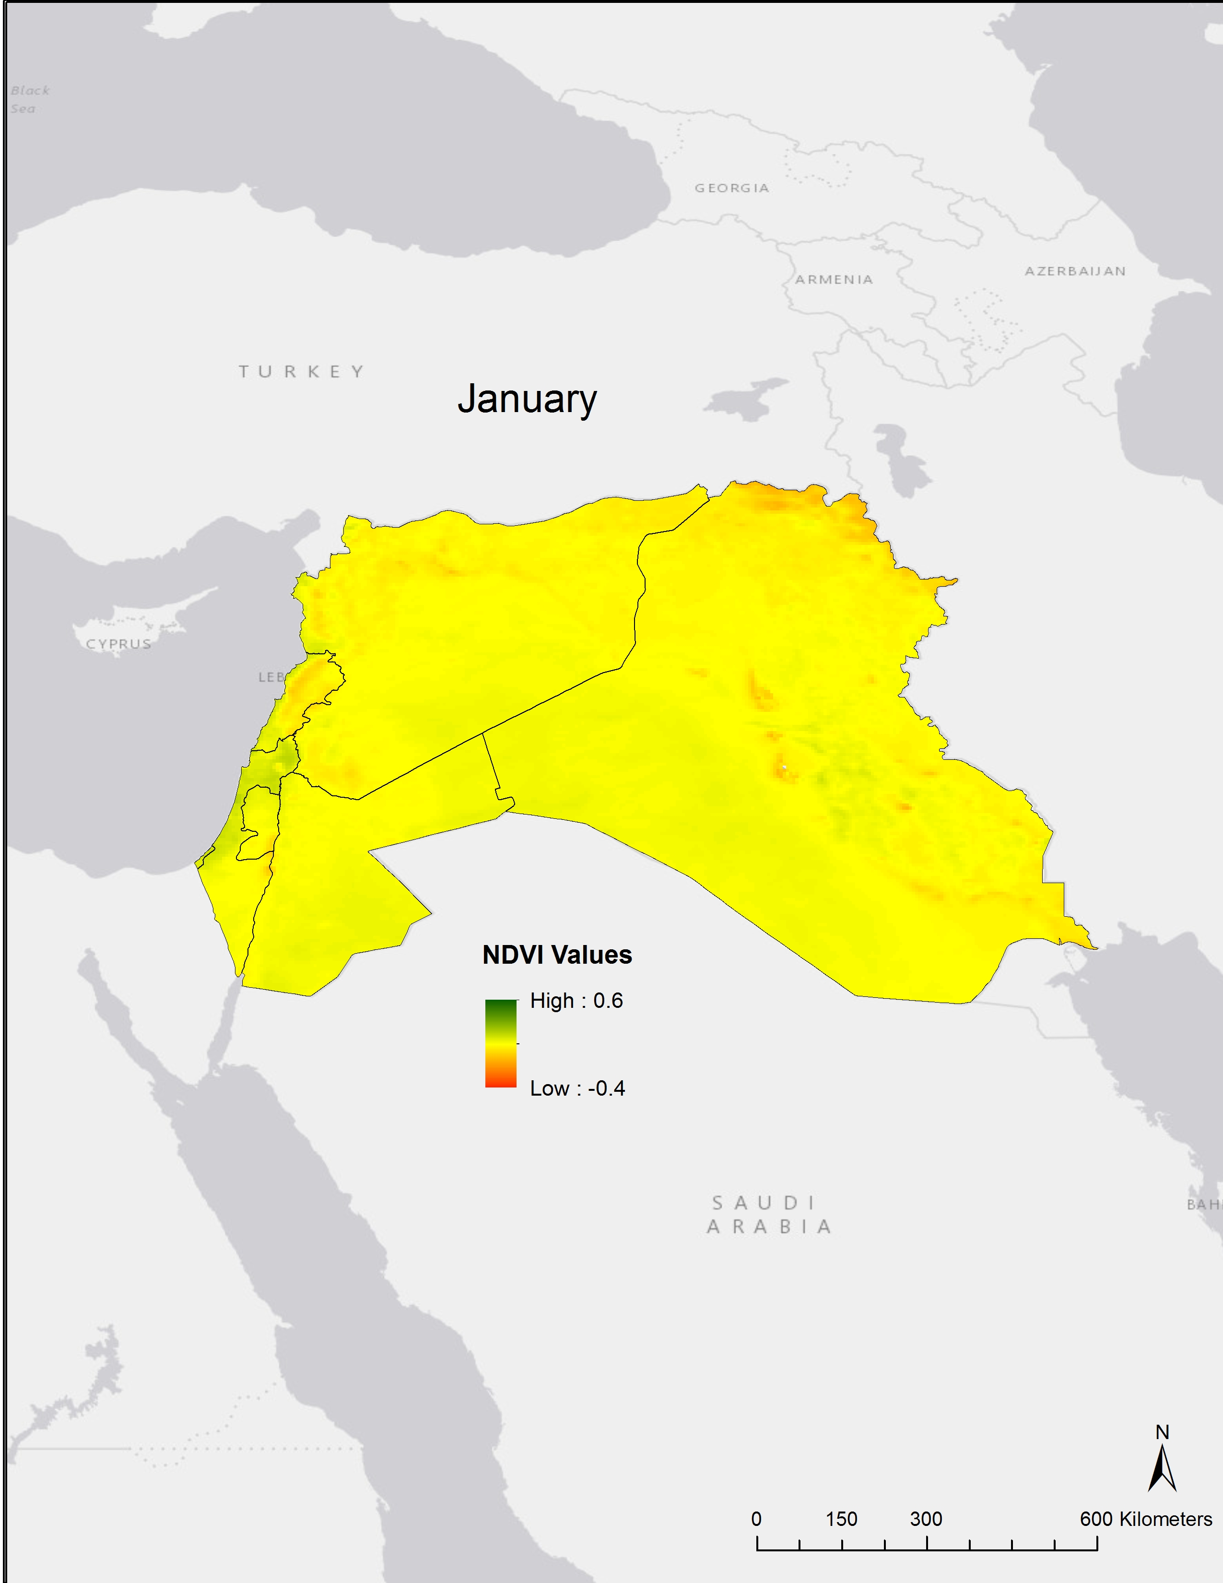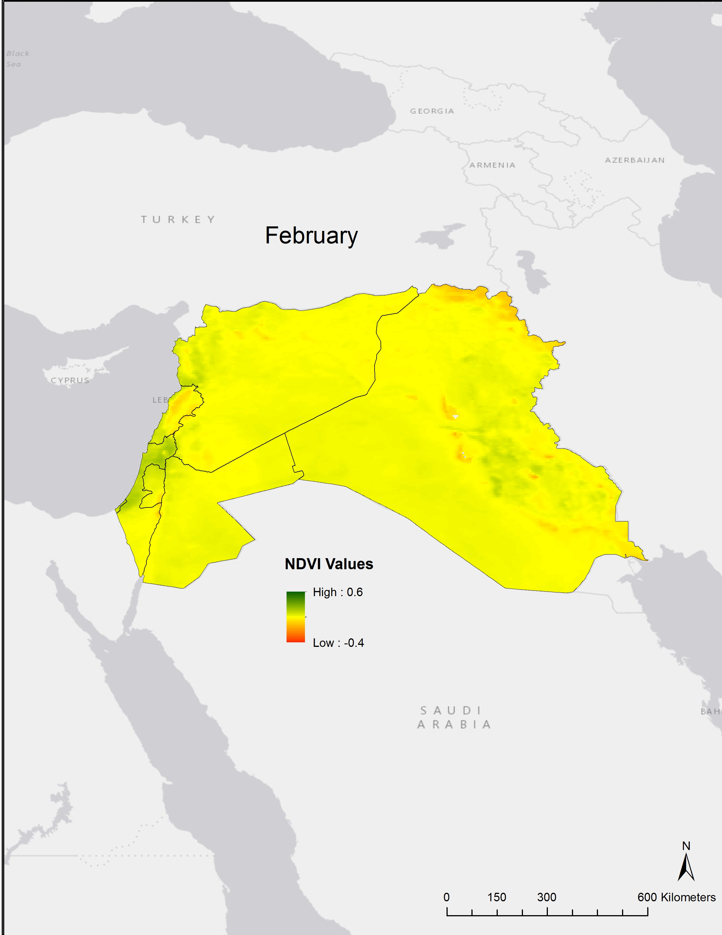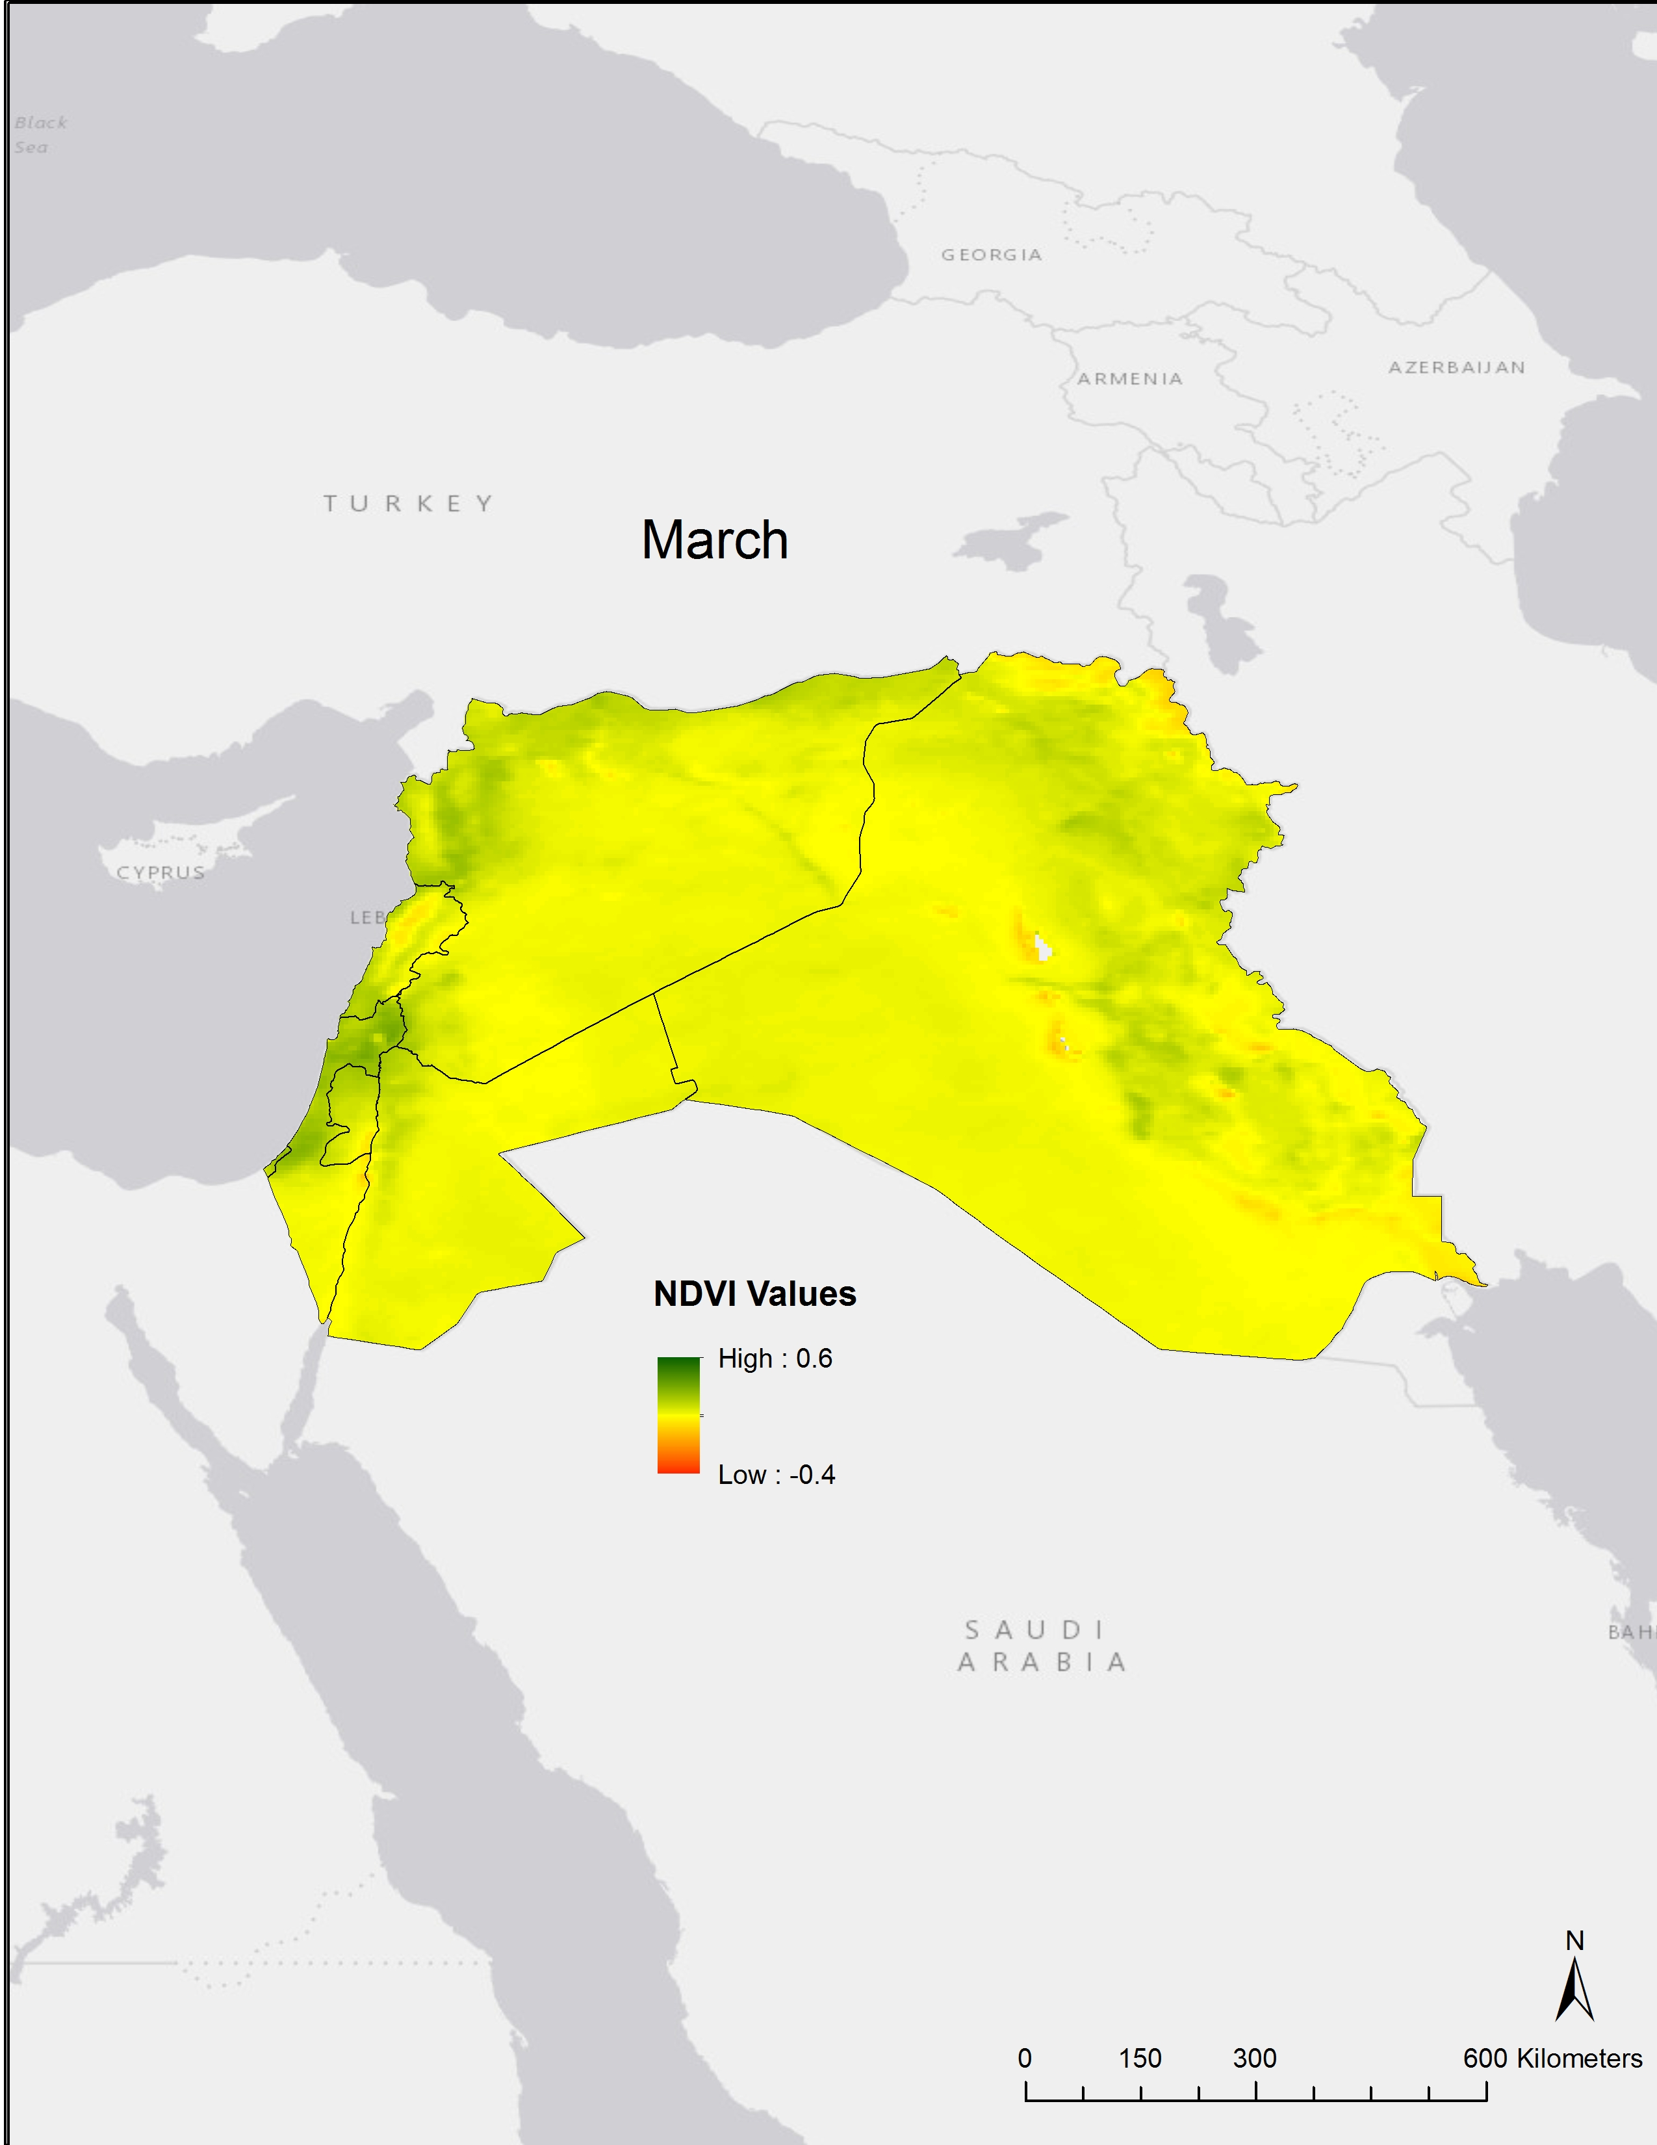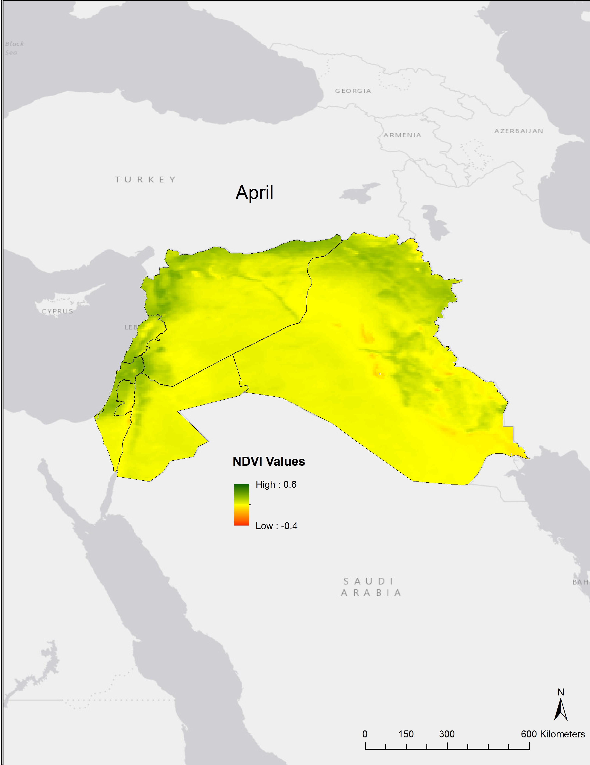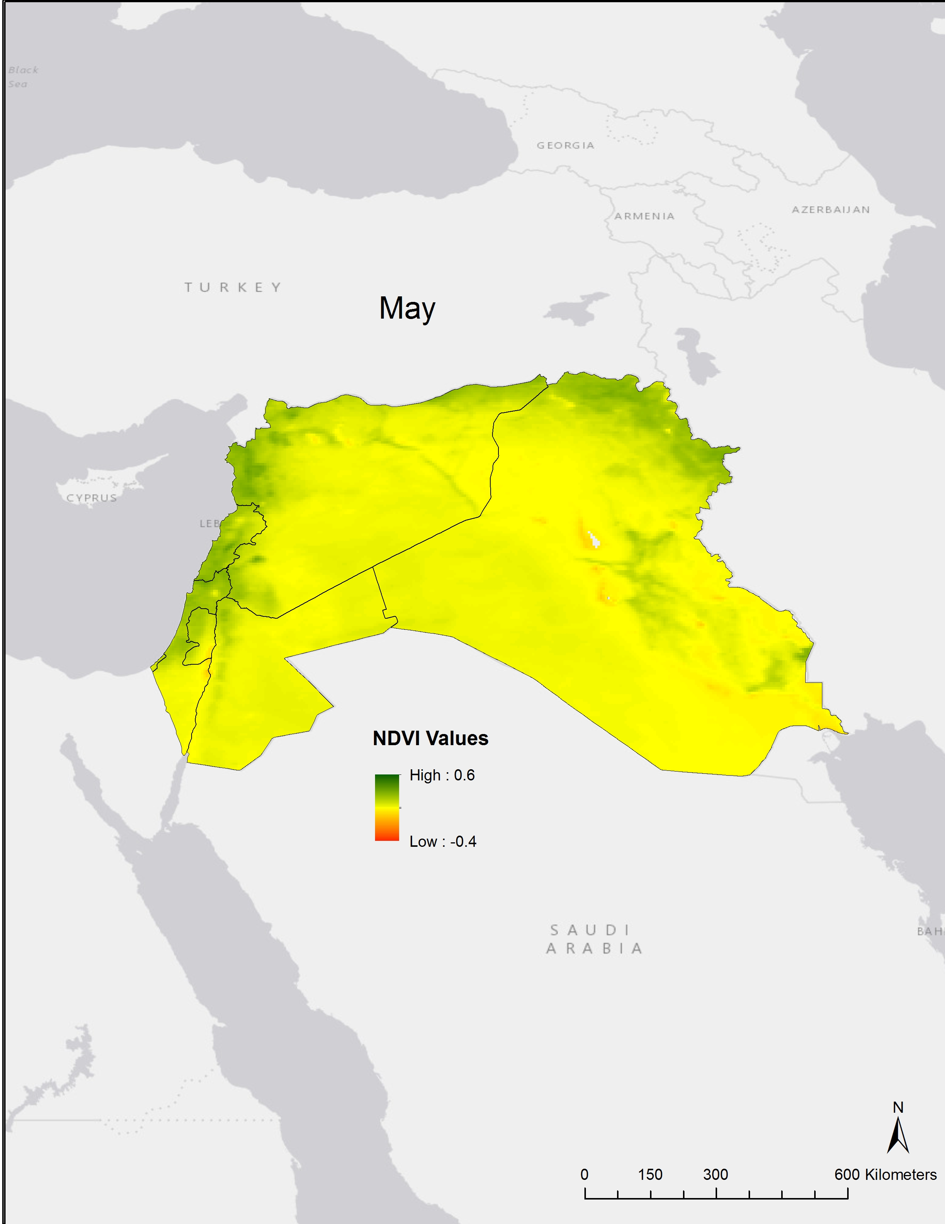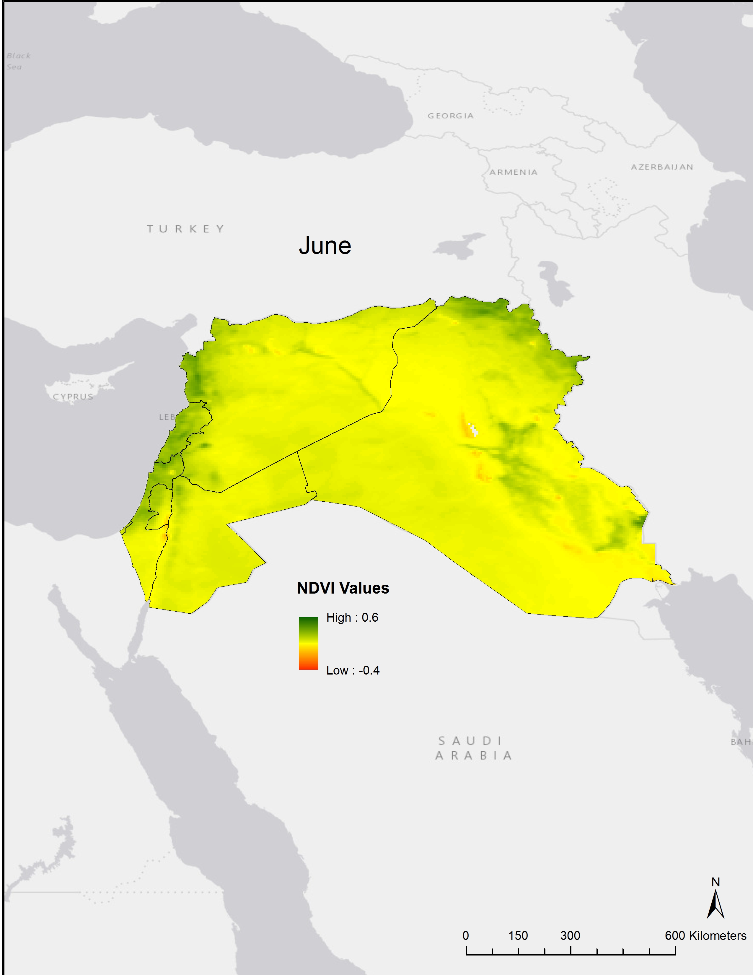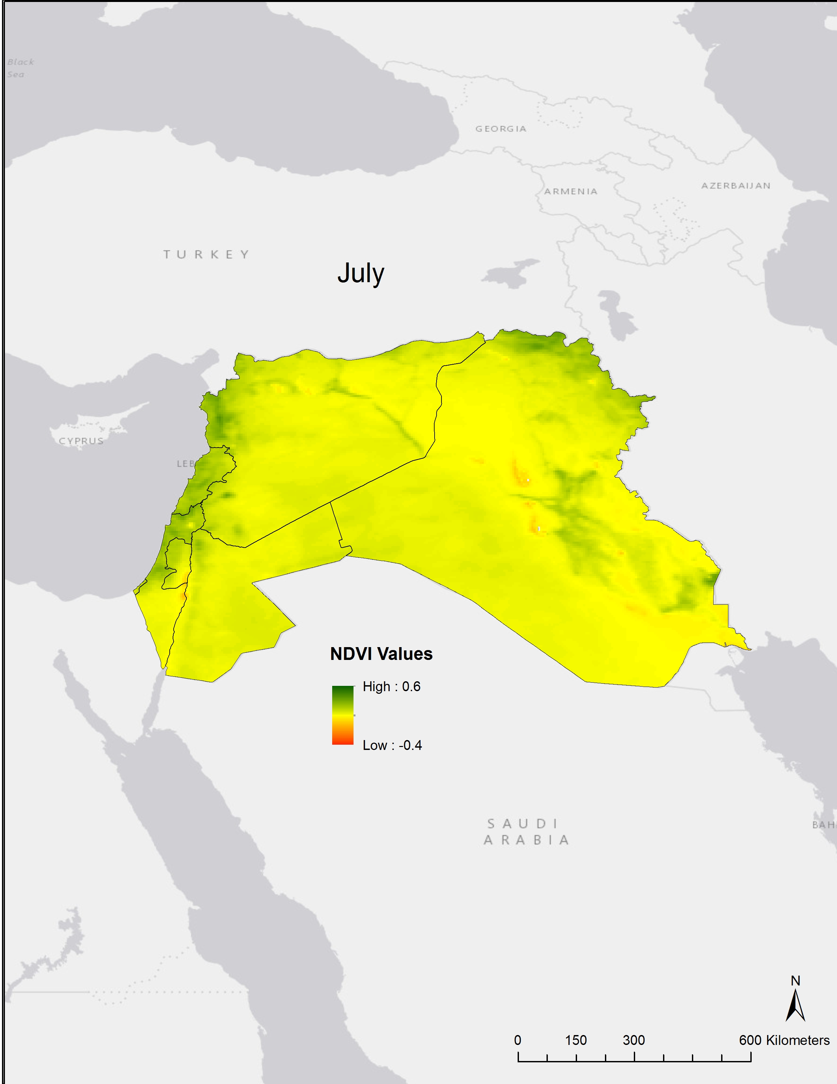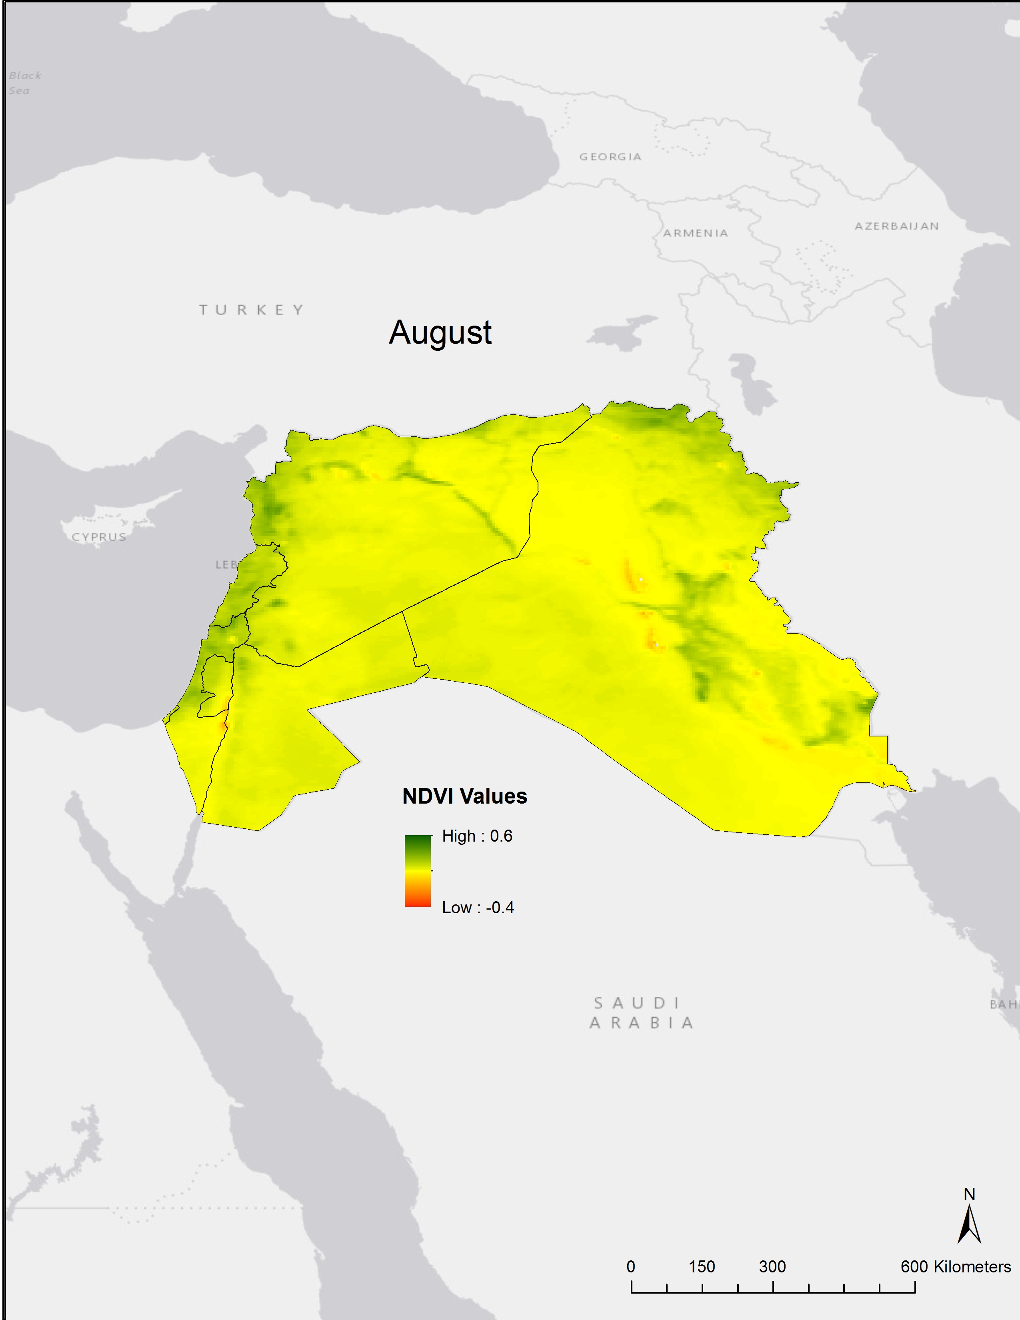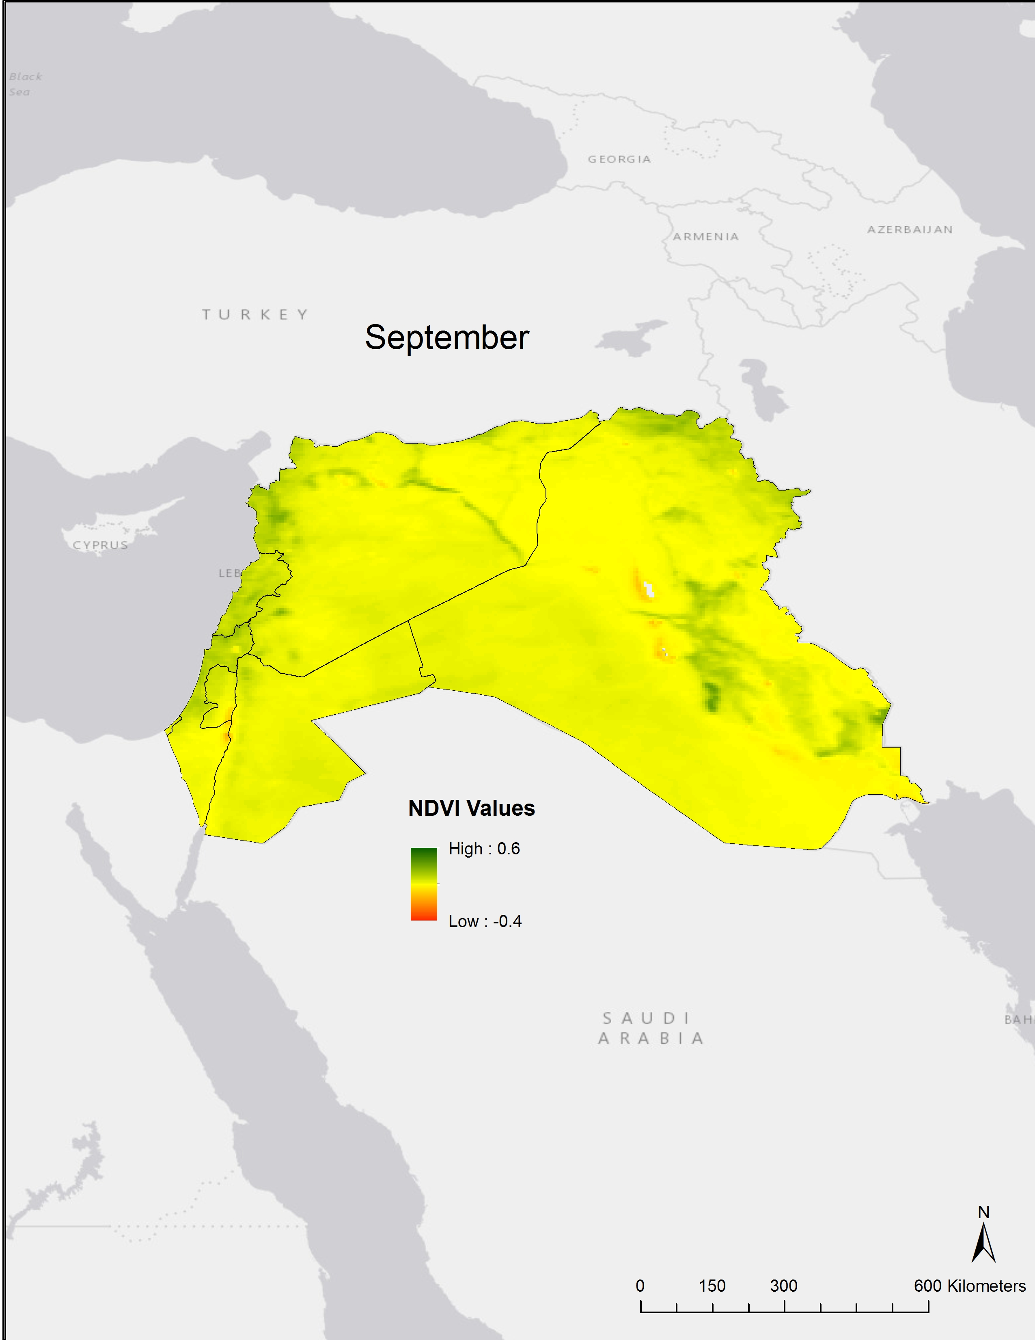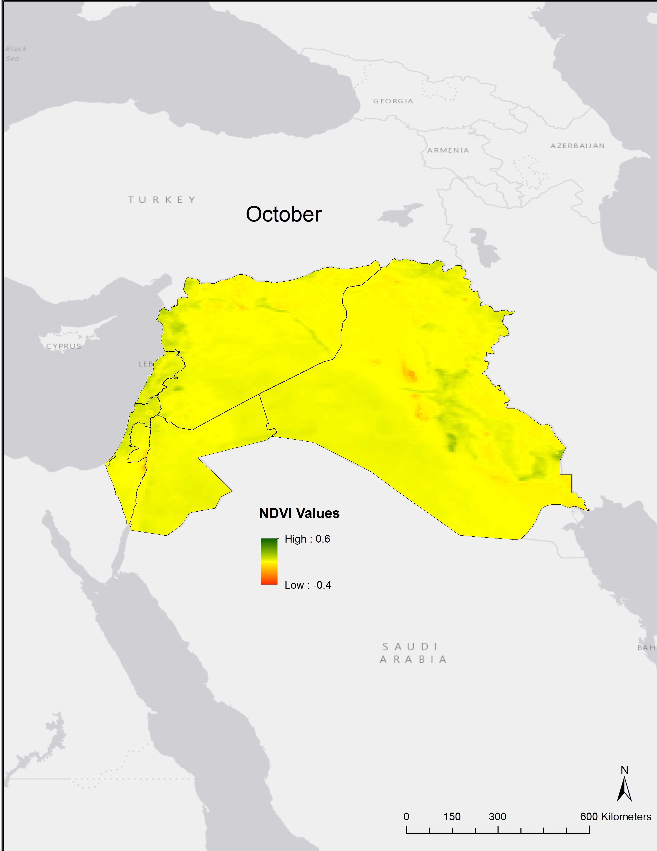
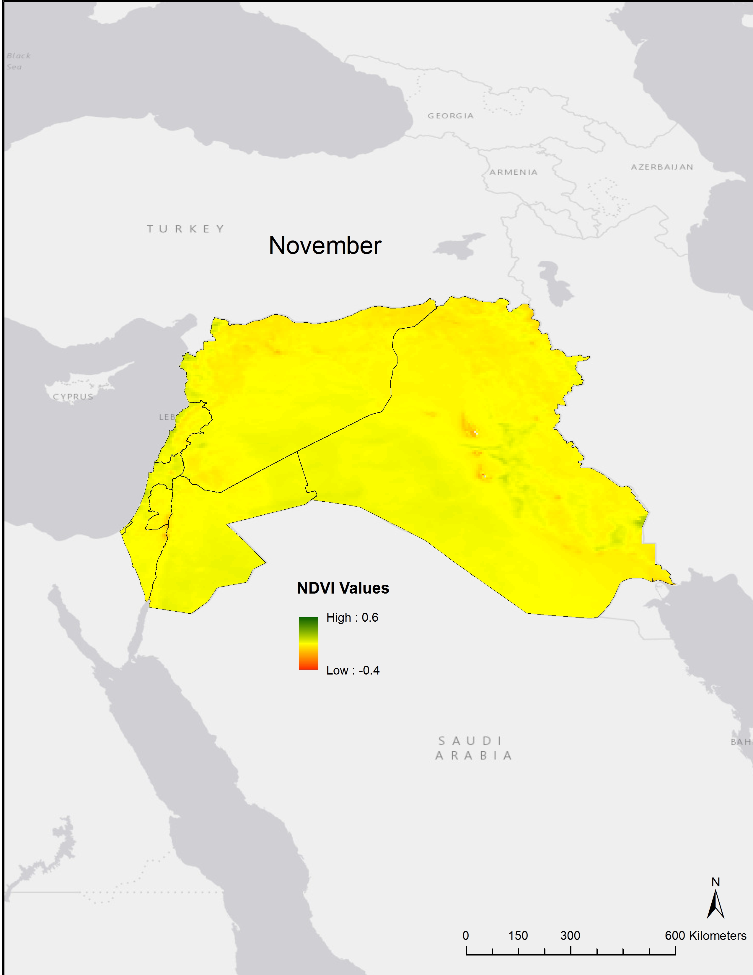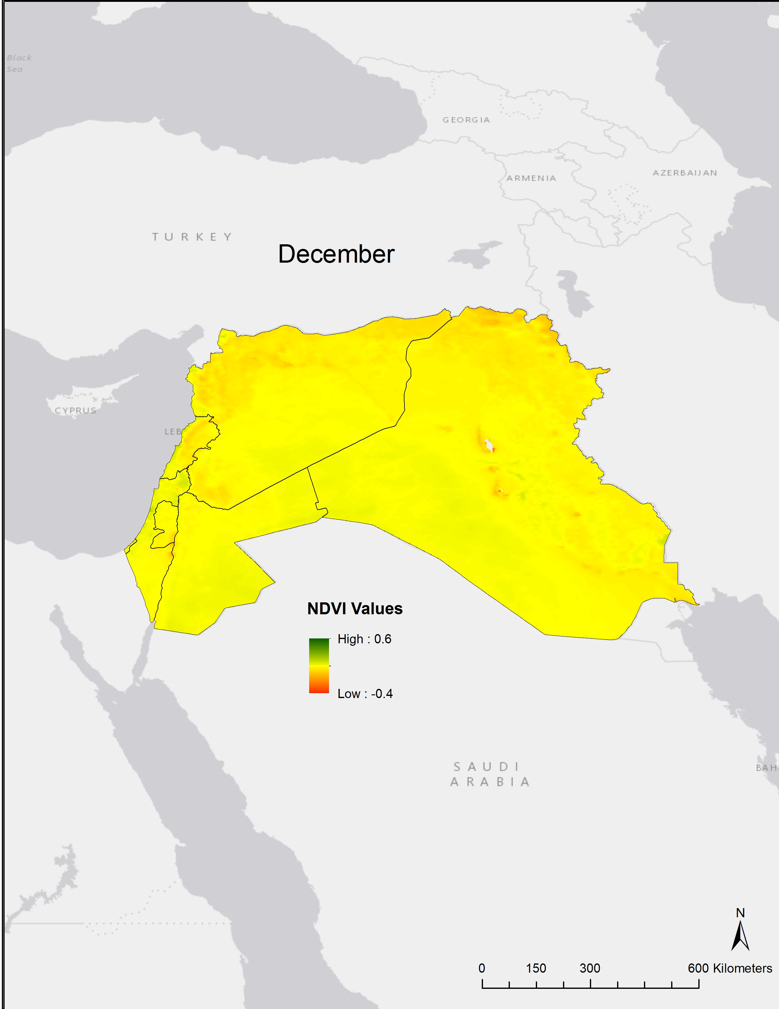
Linear Trends Separated by 90-day Seasons

Central America

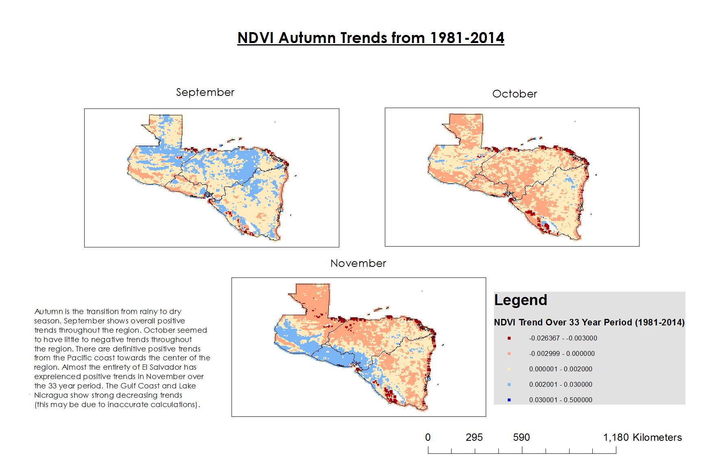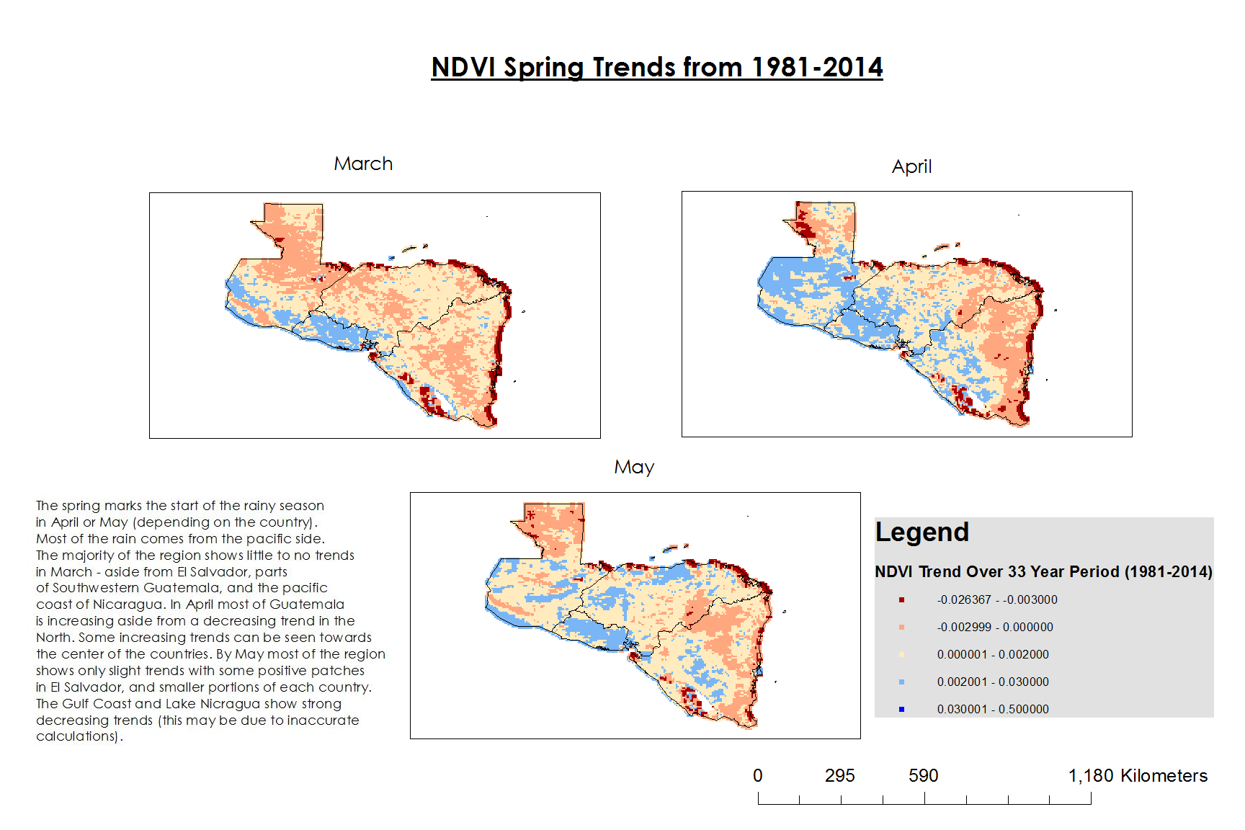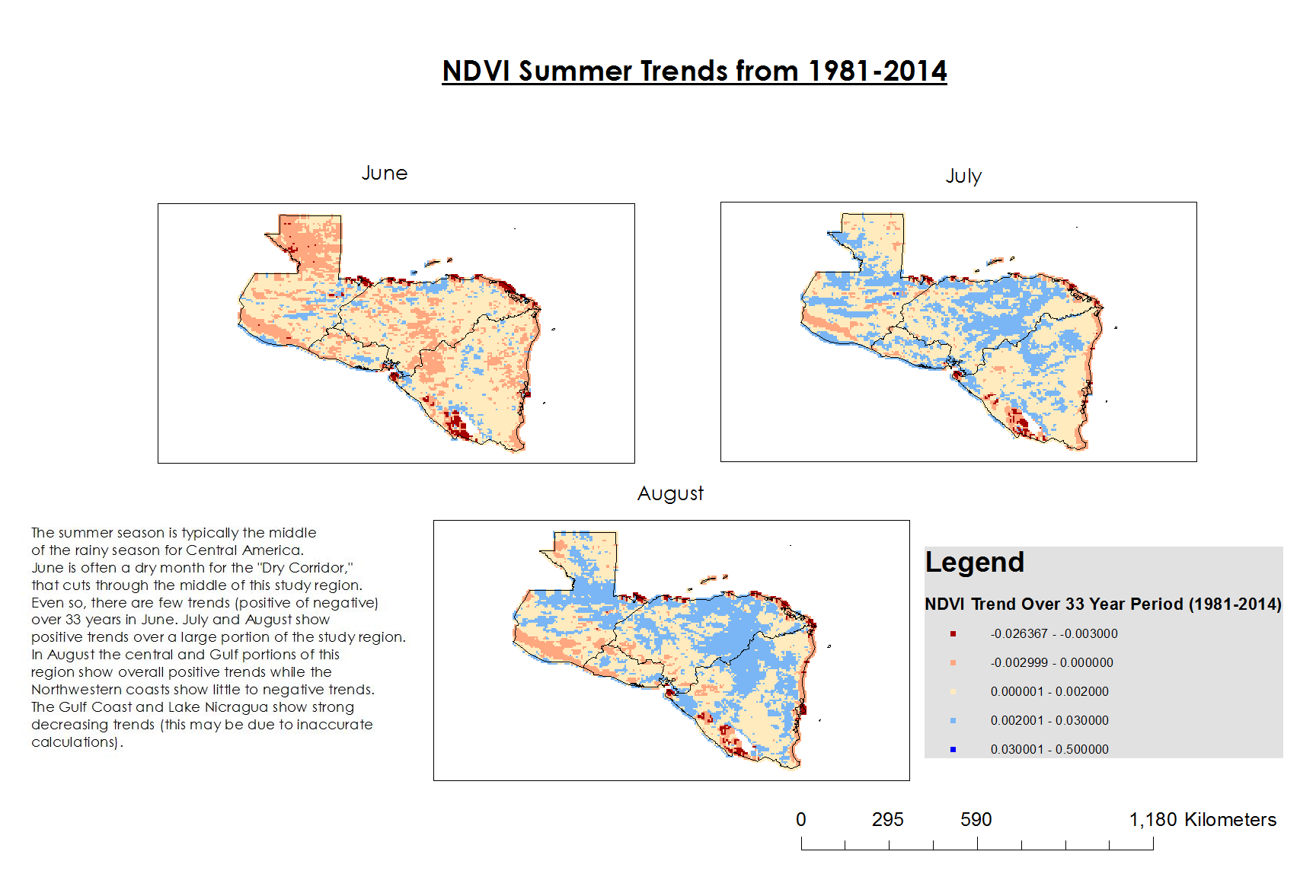
NDVI Spring Trends from 1981-2014
May
March
April
NDVI Autumn Trends from 1981-2014
September
October
November
August
July
June
NDVI Summer Trends from 1981-2014
February
December
January
NDVI Winter Trends from 1981-2014
The Levant

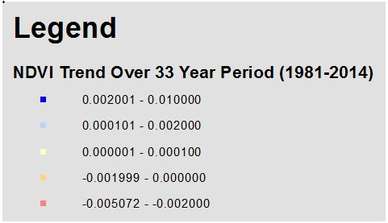
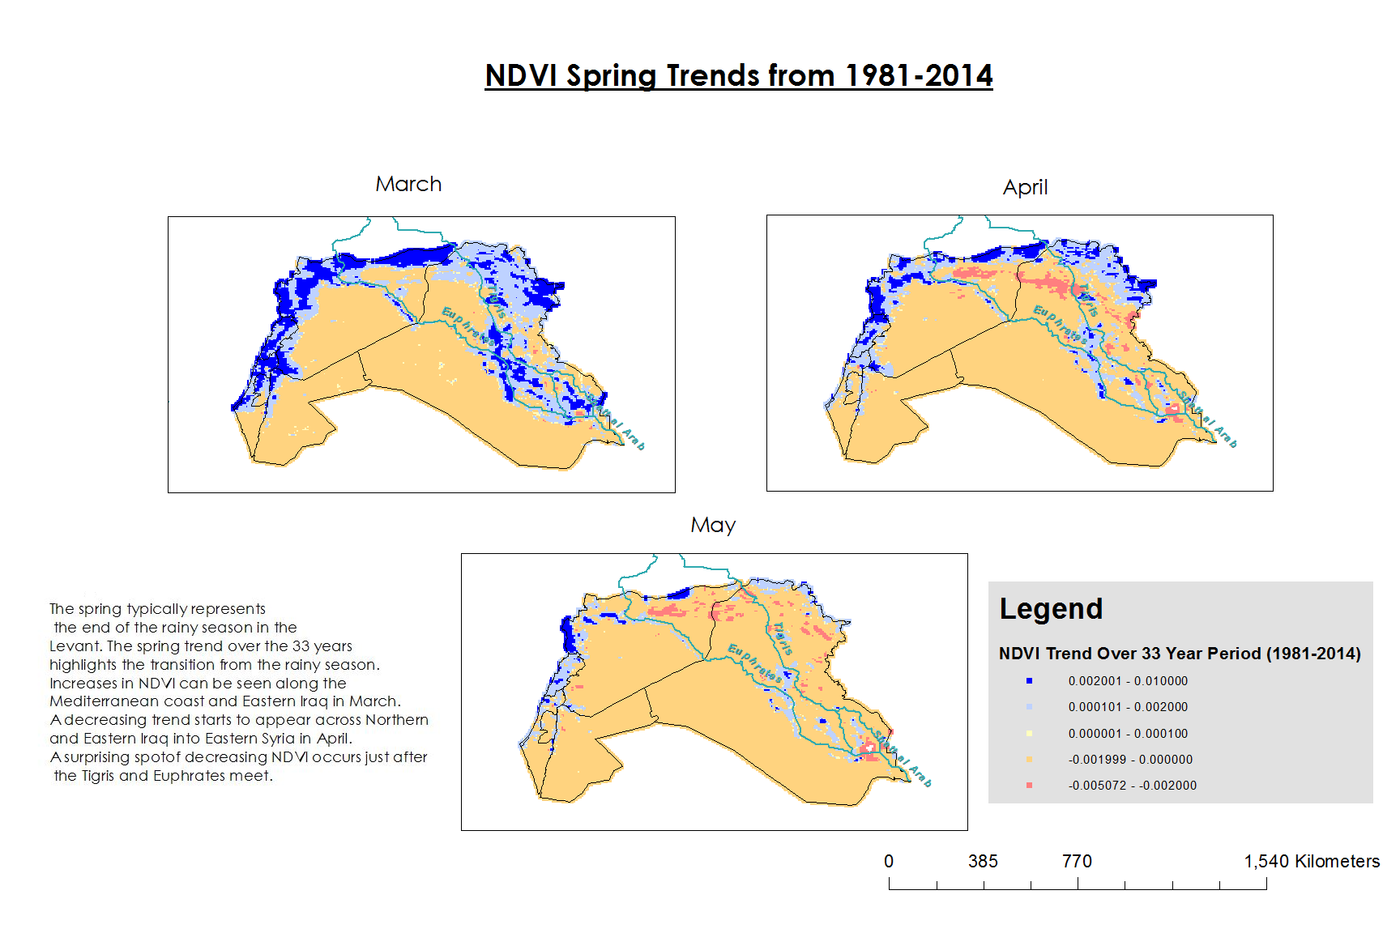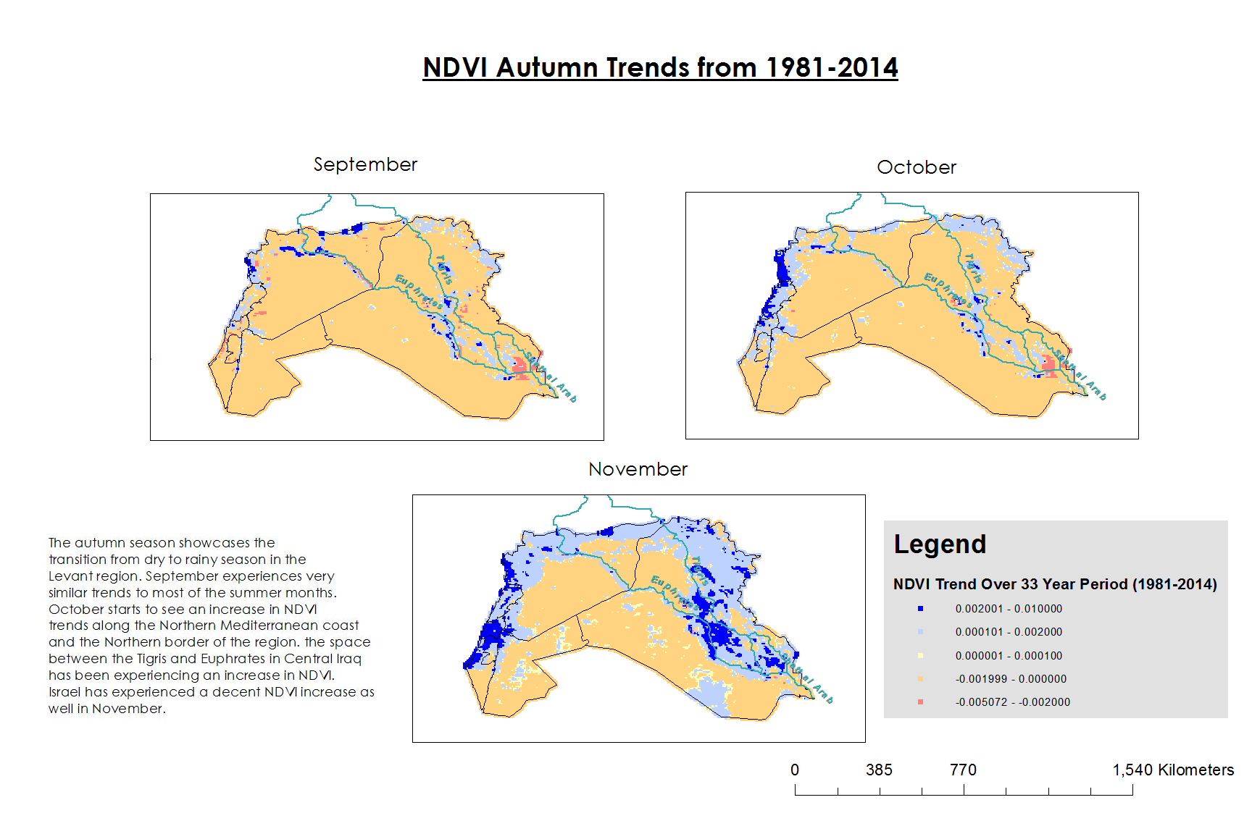
November
NDVI Autumn Trends from 1981-2014
September
October
April
March
NDVI Spring Trends from 1981-2014
May
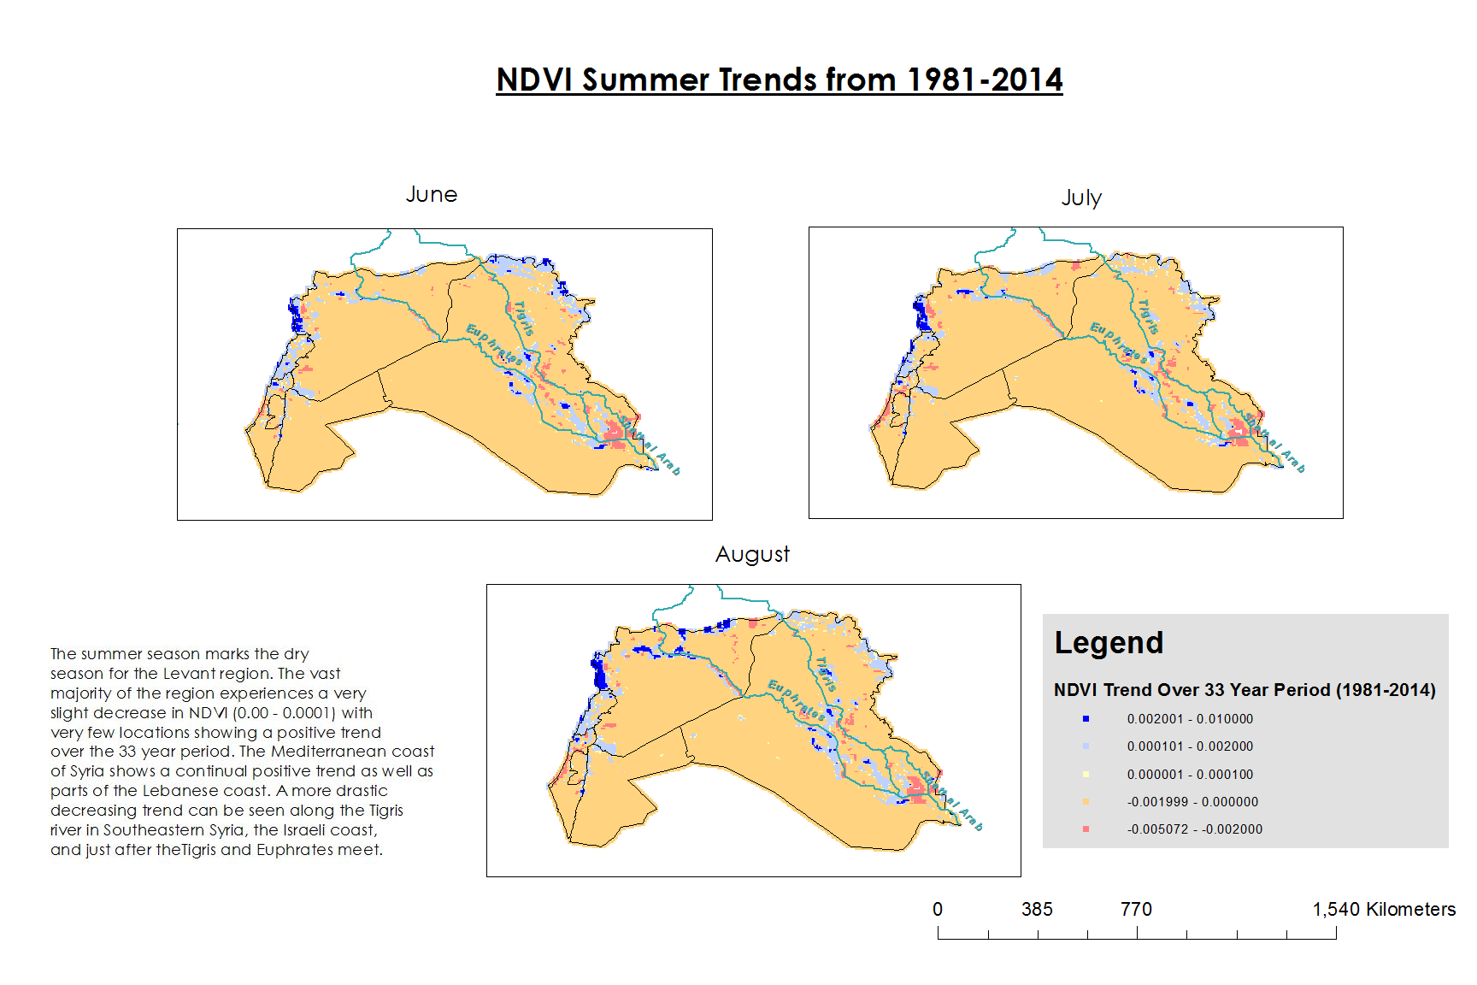
January
December
March
NDVI Winter Trends from 1981-2014
NDVI Summer Trends from 1981-2014
August
June
July

Trend Value P-values

Central America

Region | Month | P-value of F Test
Central America | January | 2.2E-16
Central America | February | 2.2E-16
Central America | March | 2.2E-16
Central America | April | 2.2E-16
Central America | May | 2.2E-16
Central America | June | 2.2E-16
Central America | July | 2.2E-16
Central America | August | 2.2E-16
Central America | September | 2.2E-16
Central America | October | 2.2E-16
Central America | November | 2.2E-16
Central America | December | 2.2E-16

Levant
Region | Month | P-value of F Test
Levant | January | 2.2E-16
Levant | February | 1.57E-06
Levant | March | 2.2E-16
Levant | April | 2.2E-16
Levant | May | 2.2E-16
Levant | June | 2.2E-16
Levant | July | 2.2E-16
Levant | August | 2.2E-16
Levant | September | 2.2E-16
Levant | October | 2.2E-16
Levant | November | 2.2E-16
Levant | December | 2.2E-16

