**NASA DEVELOP National Program**



Mobile County Health Department

*Summer 2013*

Southeast Agriculture and Disasters

*Assisting State and Federal Post-Wildfire Assessments through the Application of EOS Data*

**Technical Report**

August 9, 2013

Walt Clark, University of South Alabama (Center Lead)

Rachael Isphording, Embry-Riddle Aeronautical University

Rebecca Lanier, University of Southern Mississippi

Shikher Mishra, University of South Alabama

Skyler Sampson, University of South Alabama

Dr. Bernard Eichold, M.D., Dr.P.H., Mobile County Health Department (Science Advisor)

Dr. Kenton Ross, PhD., NASA Langley Research Center (Science Advisor)

Joe Spruce, Computer Sciences Corporation (Science Advisor)

# Abstract

As the Southeast United States expands in population, the threat and risk of wildfires have caused increasing social, economic, and health concerns. Additionally, forestry and the forest products provide prominent economic and environmental benefits to the region. To help end-user organizations use various NASA Earth Observation data in assessing wildfire effects, the Mobile County Health Department NASA DEVELOP team identified multiple recent, significant wildfires for use as case studies. Relevant satellite data was downloaded for days before, during, and after each studied fire from the Moderate Resolution Imaging Spectrometer (MODIS) sensor onboard Terra/Aqua, the Visible Infrared Imaging Radiometer Suite (VIIRS) sensor onboard Suomi NPP, as well as Landsat’s Thematic Mapper (TM), the Enhanced Thematic Mapper Plus (ETM+), and the Operational Land Imager (OLI) satellite data. Several fire severity variables were derived from the satellite data sets and compared. Satellite-based total burn extent, greatest burn temperature, and fire radiative power (FRP) for each fire were obtained. The Relative differenced Normalized Burn Ratio (RdNBR) was calculated for each fire using available Landsat, MODIS, and VIIRS data. Cross sensor comparisons of RdNBR were made as well as comparisons to temperature, FRP, and other fire event variables.

Given that regional air quality and forestry managers still find it difficult to ascertain fire aerosol contributions to ambient air quality, the project team reviewed an innovative method to estimate biomass burned and aerosol contributions. These aerosols were first identified using both VIIRS and MODIS aerosol optical depth (AOD) data and imagery. The team then estimated the effects the fires had on AOD data by approximating the total biomass burned and resultant aerosol loading based on coefficients of smoke aerosol emission rates and MODIS derived FRP.

After project implementation, the main findings were presented to Southeastern forestry agencies through an open webinar. In this presentation, case study results were presented including products depicting different fire severity indicator metrics. The benefits and caveats of using products from different sensors and their utility in the field were also discussed. The new method for estimating aerosol emission rates was presented and relevant methodologies were handed off to interested partners. The presentation focused on the potential of near real time fire assessment products in regards to burn severity and fire aerosol contributions.

**Keywords**

Wildfire, Biomass Burning, Fire Radiative Power, Wildfire Management, MODIS, VIIRS, Landsat, Air Optical Depth, Air Quality

# Introduction

As the growing season for the Southeast United States’ forests gradually becomes longer and hotter, the risk of disastrous wildfires occurring worsens [*The U.S. Forest Service–An Overview,* pp. 11]. This climate risk is compounded with the Southeast expansion of urban areas, which increases the Wildland-Urban Interface (WUI), making the impacts of wildfires more extreme. The United States Forest Service (USFS) notes that climate change and urban growth are causing their costs of fire containment and prevention to “skyrocket,” heavily influencing the budgeting of their resources [*The U.S. Forest Service –An Overview*, pp. 25].

The effects of fires on the environment are not limited to simply damage caused by flame, but also attribute to the energy budget, carbon cycle, and air quality. For example, an estimated 1.1 x 109 tons of biomass carbon is emitted into the atmosphere through combustion each year [*Ichoku*, 2005]. Also, a large portion of the Southern United States’ agricultural sector depends on products manufactured in the forestry industry. Based on recent statistics, products created from timber harvests are the most valuable crop produced in the United States, and 40% of these products are produced in the Southeast. Forestry, agriculture, and the forest products industry are among the top primary industries in the Southeast. In Florida alone, 47% of the total land area consists of timberland, and $16.5 billion is generated through the forestry products industry [Florida Forestry Service]. The total area comprised of timberland is not quite as high in Texas—consisting of only 37% of the total land cover—but it still contributes a large amount to the state’s economy at $23.7 billion [*Li*, 2011]. Forestry is also very prominent in Alabama as 68% of the land cover is harvestable timber, and $21 billion is generated through forestry products and the timber processing industry [*AL Coop Extension Service*, 2013]. With forested lands and the forestry products industry contributing so largely to the economy and land cover of the Southeast United States, protecting these lands from wildfires are a top priority for forestry management. Prescribed burning is the most common method in the Southeast to prevent wildfire. While economically effective for growing tree crops, this method can adversely affect the air quality of nearby communities through the output of aerosols in smoke emissions. At present, the impacts of smoke emissions on air quality from either prescribed burns or wildfires can be determined by field estimates of post-wildfire burned biomass, through direct sensing of the air around an active wildfire, or through remote sensing applications. In order to assess the diverse effects that wildfires can have on the Southeast US in regards to the impacts on air quality, the Mobile County Health Department (MCHD) NASA DEVELOP team performed a wide scale analysis to develop a methodology to supplement post-wildfire mitigation efforts.

To begin this analysis, the team identified three wildfires that were significant for their ecoregion. The case studies used by the MCHD team were: the County Line Fire northeast of Lake City, FL, just below the Georgia state line (April 5-15, 2012), the Huckabee Fire in southern Florida within the Big Cypress National Preserve (March 29-April 5, 2013), and the Bear Creek Fire in Cass County, Texas four miles southwest of Linden, TX (September 4-18, 2011~~)~~. Later, we also investigated the air quality aspect of the West Fork Complex Fire, 14.5 miles NE of Pagosa Springs, CO (June 05 – July 06, 2013) (See Figure 1).

Table 1: Case Study Information

|  |  |  |  |
| --- | --- | --- | --- |
| **Wildfire Name** | **Location** | **Dates** | **Acreage Burned** |
| County Line Fire | NE of Lake City, FL  Below the GA state line | April 5-15, 2012 | 34,936 |
| Huckabee Fire | Big Cypress National Preserve  South FL | March 29-April 5, 2013 | 19,920 |
| Bear Creek Fire | Cass County, TX  4 miles SW of Linden, TX | September 4-18, 2011 | 40,979 |
| West Fork Complex Fire | 14.5 miles NE of Pagosa Springs, CO | June 05-July 06, 2013 | 109,615 acres |

The MCHD team evaluated each of these fires separately using NASA Earth Observation System satellites to create enhanced decision support tools to monitor fire severity. The team applied imagery from the Terra/Aqua Moderate Resolution Imaging Spectrometer (MODIS), Suomi NPP Visible Infrared Imaging Radiometer Suite (VIIRS), and Landsat 5, 7 & 8 Thematic Mapper (TM), Enhanced Thematic Mapper Plus (ETM+), and Operational Land Imager (OLI) sensors to derive burn severity, burn extent, temperature, fire radiative power (FRP), and aerosol data. Burn severity was analyzed after the Relative difference Normalized Burn Ratio (RdNBR) was calculated from relevant sensor data set. The RdNBR from each sensor was qualitatively compared to determine agreement among different burn metrics and different sensors.

Given that regional air quality and forestry managers still find it difficult to ascertain the contributions of fire aerosols to ambient air quality, the MCHD team reviewed an innovative method to estimate the rate of smoke aerosol emissions through the FRP. Temporal integration of FRP can be used to calculate the fire radiative energy (FRE) for the course of the fire; the FRE is directly proportional to the amount of dry biomass combusted and the total amount of aerosols emitted (Ichoku, 2005). This method approximates the rate of smoke aerosol emissions based on emission coefficients and derived FRP of the fire in question. To expand upon Dr. Ichoku’s method, the MCHD team also looked at MODIS aerosol optical depth (AOD) data. Further agreement between aerosol concentrations in the AOD data and other fire severity metrics was analyzed using the Hybrid Single Particle Lagrangian Integrated Trajectory (HYSPLIT) Dispersion Model and the AOD data.

Upon completion of the project, the main findings were presented to Southeastern forestry agencies and the USFS Remote Sensing Applications Center (RSAC) through an open webinar. The case studies were presented along with products depicting different fire severity indicator metrics. The benefits and caveats of different sensors and their utility in the field were also discussed. The new method for estimating aerosol emission rates was presented, and relevant methodologies were handed off to interested partners. The presentation focused on the potential of near-real time fire assessment products in regards to burn severity and fire aerosol contributions by demonstrating utility in the field and educating foresters on data availability.

# Methodology

*Relative difference Normalized Burn Ratio Computations:*

The MCHD team began their investigation by acquiring data for the RdNBR analyses from Terra/Aqua MODIS, Suomi NPP VIIRS, and Landsat 5 TM and 7 ETM+ sensors. This index compares the near-infrared (NIR) and mid-infrared (MIR) bands of the fire-affected vegetation and this ratio is traditionally scaled by 1000 to convert the numbers into integer format. The goal is to find the areas with a decrease in vegetation (NIR band) and an increase in soil reflectance (MIR band). The next step is to calculate the differenced NBR (dNBR). The dNBR is calculated by subtracting the post-fire NBR from the pre-fire NBR. The Relative Differenced Normalized Burn Ratio (RdNBR) is then calculated, and is useful because it helps to remove the biasing effect of the pre-fire conditions by accounting for the varying type and density of the pre-fire vegetation [*Miller and Thode*, 2007].

Various formulas used in calculating RdNBR are given below:

$$NBR=1000*\frac{NIR-MIR}{NIR+MIR}$$

$$dNBR=NBRpre-NBRpost$$

$$RdNBR=\frac{dNBR}{\sqrt{ABS\left(\frac{NBRpre}{1000}\right)}}$$

Equations: [*Miller*, 2008]

Where:

NBR = Normalized Burn Ratio

NIR = Near Infrared

MIR = Mid Infrared

dNBR = Differenced Normalized Burn Ratio

NBRpre = NBR before fire

NBRpost = NBR after fire

RdNBR = Relative Differenced Normalized Burn Ratio

For the County Line Fire, Landsat images were acquired from the Landsat 7 ETM+ from the USGS Global Visualization Viewer (GLOVIS) database. The pre-fire image was obtained for March 23, 2012, and the post-fire images were taken from April 20, 2012, and May 10, 2012. Multiple images for the post-fire NBR analysis were needed to help rectify for data drop outs due to the failure of the scan line corrector (SLC) onboard Landsat 7. Two pre-fire images were not used as there was only one consecutive “cloud-free” image available. In order to correct for the SLC, the value from the previous image was inserted into the more recent image in areas where “no data” was found. In doing so, bands 4 and 7 were downloaded to complete the RdNBR calculation.

Landsat 7 data for the RdNBR analysis for the Huckabee Fire was also downloaded from GLOVIS. Because these images also came from Landsat 7, multiple pre-fire and post-fire images were needed to help account for the SLC failure. The pre-fire images were obtained for February 24, 2013, and March 28, 2013, and the post-fire images were acquired for May 15, 2013, and June 16, 2013. Although the pre-fire and post-fire images are from different seasons, the tropical climate in Florida causes little vegetation differences between seasons, so the RdNBR analysis could still be performed.

The pre-fire and post-fire images for the Bear Creek Fire RdNBR calculation came from the Landsat 5 TM, so only one pre-fire image and one post-fire image was needed. The pre-fire image was acquired for August 28, 2011, and the post-fire image was acquired for September 29, 2011. These images were also downloaded from the USGS GLOVIS database.

After acquiring the Landsat imagery for each fire to calculate the RdNBR, the MCHD team progressed to obtaining reflectance imagery from MODIS and VIIRS to compare sensor and temporal differences in RdNBR. MODIS reflectance data (bands 2 and 7) were downloaded from Reverb. The MODIS data downloaded for the RdNBR calculation came from Aqua MODIS and consisted of the 500 meter resolution surface reflectance data from the Land Level 2 data MYD09GA. The MCHD team downloaded MODIS data for the same dates that were available for Landsat 7 ETM+ and Landsat 5 TM; in the cases where multiple images were needed to account for the SLC in the Landsat images, the dates closest to the occurrence of the fire were downloaded. For the County Line Fire, MODIS data was acquired for March 23, 2012, and April 24, 2012; for the Huckabee Fire, MODIS data was initially downloaded for March 28, 2013, and May 15, 2013. However, due to cloud cover occurring on May 15, data from May 17, 2013 was used because it contained less cloud cover. For the Bear Creek Fire, the team constructed a time series of RdNBR analyses from the day after the fire ended to the day the Landsat images were available. Only the days that were cloud free were chosen. The date of the MODIS pre-fire image will remain the same as the pre-fire date used for the Landsat RdNBR, August 28, 2011, but the dates of the post-fire series will be from September 23, 2011 to September 29, 2011. As VIIRS is a relatively new sensor (the first available images are for November 21, 2011), the MCHD team could not calculate RdNBR from VIIRS for the Bear Creek Fire in TX. However, they did download VIIRS data for County Line Fire and the Huckabee Fire from NOAA’s Comprehensive Large Array-Data Stewardship System (CLASS). Reflectance data from bands 7 and 11 were initially downloaded for March 28, 2013 and May 15, 2013 for the Huckabee Fire and March 23, 2012 and April 24, 2012 the County Line Fire. The VIIRS RdNBR for the Huckabee Fire was also calculated on May 17, 2013 due to slightly less cloud cover than was present in the May 15th image.

In determining what thresholds to use in the RdNBR analysis results, the project team found that there is no standard way of doing so. Most sources state that the threshold values can vary for individual fires. One common way of determining threshold values is to find values which show the structure of the fire best, or to simply base them of other metrics such as normalized difference vegetation index (NDVI), NBR, or composite burn index (CBI) [*Miller and Thode*, 2007]. The team decided on using thresholds that suit each fire’s structure and to have five classes including: Unburned, Possible Regrowth; Unchanged; Low; Medium; High.

*Estimating the Rate of Aerosol Emissions:*

MODIS and VIIRS sensors both contain an Active Fire Product (AFP) which derives fire points from hotspots within the fire. The MODIS sensor detects temperature and Fire Radiative Power (FRP). VIIRS currently does not calculate either of those two variables, but will hopefully do so in the near future. The Active Fire Points from each sensor were downloaded from the Remote Sensing Application Center’s (RSAC) webpage in shapefile format.

The research team then began to estimate aerosol loading into the atmosphere as a result of the fires. The team applied an innovative method developed by Dr. Ichoku and Dr. Kaufman in the work *Ichoku* [2005] that estimates the rate of smoke aerosol emissions. The method described by *Ichoku* [2005] can be used to determine the rate of smoke aerosol emissions by using FRP derived through remote sensing. Ichoku and Kaufman developed a linear relationship between derived FRP, and the smoke aerosol emission rate (Rsa) of a fire in question. Rsa is derived from themass of emitted aerosols and the corresponding wind speed. Mass of emitted aerosols was estimated with the use of MODIS derived AOD and smoke aerosol specific extinction or mass extinction efficiency (βe). βe is the sum of mass scattering efficiency (βs) and mass absorption efficiency (βa), which can be obtained using various techniques, especially from the *in situ* measurements [*Ichoku*, 2005].

For similar ecological regions, the graph between FRP and Rsa (obtained from *Ichoku* [2005]) showed a strong correlation given by the equation:

sa

Where *Ce* is the smoke emission coefficient; this coefficient remains constant for similar ecological regions.

Fire Radiative Energy (FRE) derived from FRP can render the mass of smoke aerosols (sa) emitted given by the equation:

sa

Continuous FRP values are needed to calculate FRE, as FRE can be estimated through temporal integration of FRP values. Only a geostationary satellite can provide continuous FRP values. An alternate approach can be taken by using a collection of polar orbiting satellites with a minimal time gap to obtain many FRP values at different times during the fire. However, a collection of polar orbiting satellites does not allow optimum rendering of FRE values, but this approach can give a decent approximation. The MCHD team calculated the instantaneous rate of smoke aerosol emissions during each fire for each satellite pass.

To apply Dr. Ichoku’s method, the team used MODIS and VIIRS FRP measurements from their respective AFP. The MODIS FRP came directly from the shapefiles downloaded from RSAC, while the VIIRS shapefiles did not contain the FRP measurement. Dr. Wilfred Schroeder of the University of Maryland graciously computed the FRP values from the VIIRS sensor for the West Fork Complex Fire in Colorado. To show the operational utility of this method, another fire was analyzed for these calculations: the West Fork Complex Fire in Colorado that burned from June 5, 2013 until July 6, 2013 (the date that the last fire pixel was detected by satellite). The first step was aggregating all of the FRP points. This is done by taking the sum of all of the FRP values from each detected point from each sensor’s daily pass. From there, Dr. Ichoku’s emission coefficients were applied. Dr. Ichoku supplied the MCHD team an excel document with his coefficients organized by latitude and longitude values. Each coefficient represents a one degree square of longitude and latitude. Then, the data was inputted into ArcGIS and converted to a raster format. Luckily, each case study fell entirely in one raster cell, meaning that only one coefficient was needed per fire. However, the West Fork Fire fell into a data void region. To find its emission coefficient, the average of the nearest cells was used. Next, the coefficient found for each fire was multiplied by the total FRP for each Aqua-MODIS, Terra-MODIS, and VIIRS pass; the result is the total rate of emissions.

*Application of Aerosol Optical Depth Data:*

AOD is a dimensionless measure of the degree to which particulate matter and other aerosols present in the atmosphere block sunlight from radiating to Earth’s surface through a column of air in the atmosphere. [*The Dictionary of Climate Debate*]. MODIS AOD data was downloaded for the Bear Creek Fire, County Line Fire and Huckabee Fire, but VIIRS AOD data was only downloaded for the Huckabee Fire. The VIIRS AOD data, downloaded from NOAA CLASS, was unable to be used in the analysis due to an odd gridding format. The MODIS AOD data was downloaded from LAADS and post processed into GeoTIFF format for easy use in ArcMap. The primary case study used to examine the AOD data was the County Line Fire. To show that the higher AOD values detected were from the fire, the team ran HYSPLIT dispersion models.

In order to show the FRP points, temperature points, Julian day points, final RdNBR analyses, aerosol emission rates, and the AOD for each fire in a way that was easily comprehendible to the project partners in the webinar, the data was exported as zipped Google Earth files. The conversion to zipped Google Earth files was easily done using the Conversion Toolbox in ArcMap. Since the data is referenced geographically, it automatically opens in Google Earth in its corresponding location. However, the related legends had to be created and exported separately as PNG images. The legend image was then added into Google Earth files with the help of KML coding. KML coding was also used to create a time-series animation for aerosol emission rates and AOD.

Longitude, latitude, date, time and the corresponding aggregated emission rates were used to create the KML code for the time series of the emission rates. Proportionally sized symbols and an appropriate color ramp were used to animate the time series. Similarly, the KML code for the HYSPLIT dispersion model was customized to overlay the AOD trends to validate the aerosols seen in the MODIS data. Finally, the KML code was converted into zipped Google Earth files.

# 

# Results & Discussion

The County Line fire showed significant results from the RdNBR analysis. The burn extent was well defined in the Landsat analysis despite the SLC issues in the images as the fire was predominantly in the center of the Landsat scene. The MODIS and VIIRS RdNBR for the County Line Fire also showed significant results. Both sensors have a coarser resolution compared to Landsat, so the details of the fire are not as defined. However, a general trend in RdNBR’s was visible. (See Figure 2).

The RdNBR analyses for the Bear Creek Fire displayed results similar to those seen in the County Line Fire. The Landsat RdNBR defined the burn extent significantly, while the MODIS RdNBR displayed the fire with less precision (See Figure 3). For the Bear Creek Case study, a time series of MODIS RdNBR analyses were created to further exemplify the utility of near-real time EOS data. The MCHD team created a time series of MODIS RdNBR calculations from three days after the fire through the date the post-fire Landsat image was acquired. Although the Landsat has a finer resolution and shows a more detailed burn extent, the MODIS time series shows how MODIS data can be used to obtain a general idea of a fire’s burn severity immediately after the fire ends (See Figure 4). VIIRS could not be used to calculate RdNBR for this fire because it had not yet been launched, but VIIRS near-real time data has applications similar to that of MODIS data.

The analyses performed on the Huckabee Fire were the only ones to consecutively show poor RdNBR results for all three sensors. The inconclusive results are possibly due to cloud cover or the general high water content characteristic of south Florida’s ecoregion; the RdNBR analysis uses the band which is sensitive to moisture in both soil and vegetation. Another possible reason may be due to cloud cover (See Figure 5). The pre-fire image was cloud free, but finding a cloud-free image in south Florida during summer months is extremely difficult. The Landsat post-fire image chosen to use in the analysis was the least cloudy Landsat image available. Because MODIS and VIIRS have daily passes, there were more post-fire images to choose from. The MCHD team selected MODIS and VIIRS images with slightly less cloud cover than the Landsat image occurring two days after. Although the RdNBR analyses performed for MODIS and VIIRS used a clearer image two days after the post-fire image used for the Landsat RdNBR, the MODIS and VIIRS RdNBR results were only slightly improved. A cloud mask was performed on the MODIS reflectance imagery for May 17, 2013 to show that it detected almost solid cloud cover for that day (See Figure 6). Because the RdNBR results were poor, the NDVI was calculated using a Landsat 8 image. However, the Landsat 8 image was only available while the fire was still smoldering in some places. The Landsat 8 image was chosen because it provided a cloud-free day, contained no scan line corrector issues, and had a high spatial resolution. The NDVI showed promising results with a decrease in vegetation in the exact location of the fire proving that something did occur. (See Figure 5, part d).

Instantaneous smoke aerosol emission rates for each of the case studies were calculated using Dr. Ichoku’s emission coefficients and MODIS/VIIRS derived FRP for each satellite pass. These results could then be used in future work to estimate the total mass of aerosols emitted.

The AOD was visually analyzed for the County Line Fire. The daily time-series for County Line AOD was created and overlaid with HYSPLIT dispersion model results. It showed there was a good correlation between the model dispersion results and the high AOD values (See Figure 7).

*Errors & Uncertainty:*

The scan line corrector (SLC) issue on the Landsat 7 ETM+ images caused some error. As stated previously, the team attempted to rectify some of the issues, but even then, the images were still left with data void areas.

Some uncertainty and error also accompanies the RdNBR analysis for the Huckabee Fire. There are many possible explanations for the RdNBR analysis failings. The scene geometry plays a large role as the fire was located on the extreme edge of the image. Another possibility is the amount of standing water located in southern Florida. This causes error to be associated with the calculations as they depend on the MIR band.

Cloud cover can also be attributed to failed RdNBR calculations. For instance, extensive cloud cover was present in most images for the Huckabee Fire RdNBR analysis. The days after the fire and leading up to the day of the Landsat scene, were heavily contaminated by cloud cover.

The emission coefficients used to estimate the rate of smoke aerosol emissions are prone to a number of errors as mentioned in [*Ichoku and Kaufman*, 2005]. This work also comments that AOD is susceptible to errors from the aerosol retrieval processes and assumptions.

*Future Work:*

The team used the method described by Dr. Ichoku to calculate smoke aerosol emission rates from MODIS derived FRP. These emission rates give a general idea of the aerosol loading due to wildfires as they are instantaneous emission rates from each satellite pass. To better obtain a better estimate of aerosol loading from a wildfire, one should calculate the mass of aerosol emissions. This value is directly proportional to the mass of the biomass burned. The mass of the aerosol emissions can be calculated by applying the FRE values. FRE is simply the temporal integration of FRP [*Ichoku and Ellison*, 2012]. The calculation of FRE from MODIS derived FRP values is impractical because MODIS can provide data only twice-a-day. Therefore, FRP values from a geostationary satellite, such as GOES, can render a better approximation of FRE as GOES is capable of providing data with a time gap of 30 minutes. This methodology could help forestry agencies to estimate aerosol loading and the mass of biomass burned in near-real time [*Ichoku*, 2005].

It is also possible to perform a correlation analysis between FRE and RdNBR analyses. If a strong correlation is found, then further research can be done by correlating FRE with burn severity using field data. Therefore, FRE could better estimate burn severity if it shows a stronger correlation with field data as opposed to RdNBR. This approach is beneficial as it can provide burn severity measurements at near-real time.

# Conclusions

When the team began the project, it became clear Southern forestry interests were not as aware and certainly didn’t apply remotely sensed data to wildfire management as robustly as the Western region. In holding our web seminar, we hope we were able to make a dent on this decision support discrepancy.

RdNBR analyses are still considered to be among the best remotely sensed burn severity metrics available. When Landsat passes cannot be used due to temporal resolution or cloud cover, MODIS and VIIRS can act as surrogates to ascertain area and relative trends in burn severity. The MODIS and VIIRS products provide users with daily passes, allowing for immediate burn severity measurements. Although the resolution will be coarser if using MODIS or VIIRS, the general trend of burn severity can be attained. RdNBR analyses are still limited in some ways, such as its sensitivity to moisture. The Huckabee Fire in this study exemplifies this.

The variables associated with active fire points (temperature, fire radiative power and fire radiative energy) are underutilized by many despite their applications and solid theoretical basis. FRP and FRE have the potential to explain various aspects of wildfires, such as the amount of biomass burned, a fire’s aerosol emission rate, the amount of aerosol emitted, and possibly burn severity.

Dr. Ichoku’s Emission Coefficients Product provides an innovative approach to determine aerosol emission rates operationally. Because Dr. Ichoku’s method to calculate the aerosol emission rate is easy to implement with simple multiplication, it can be calculated quickly and as soon as FRP values are available. Forthcoming VIIRS FRP values will allow a total of three daily retrievals of these values. Additionally, GOES can be used to calculate total daily aerosol loads through the application of FRE.

The MCHD team’s theoretical research suggests that FRE could potentially provide a strong correlation with small temporal windows of burn severity. If a strong correlation is present, it could strengthen the use of FRP/FRE as a fire metric.

MODIS and VIIRS AOD data can be used by air quality interests to determine wildfire impacts to regional air quality. This process becomes especially simple as this data can be obtained in an easy to use format, such as GeoTIFF. In order to verify that the aerosols seen in this data are a result of wildfires, HYSPLIT dispersion or trajectory models can be utilized to show the direction smoke plumes from the fire in question travelled. If higher aerosol concentrations visible in the AOD data correlate with the results from the HYSPLIT model, it can be confirmed that high aerosol loading resulted from the wildfire.

# Acknowledgments

The Mobile County Health Department NASA DEVELOP Team would like to offer its gratitude to the following individuals for their assistance throughout this project.

Dr. Bernard Eichold, M.D., Dr. P.H., FACP

Joseph Spruce, Computer Sciences Corporation, Stennis Space Center

Dr. Ross Kenton, Sscience Systems and Applications Inc., Langley Research Center

Brad Quayle, United States Forest Service Remote Sensing Applications Center

Dr. Charles Ichoku, Science Systems and Application Inc., Goddard Space Flight Center

Luke Ellison, Science Systems and Application Inc., Goddard Space Flight Center

Dr. Wilfred Schroeder, National Oceanic and Atmospheric Administration, University of Maryland

Chris Schmidt, Cooperative Institute for Meteorological Satellite Studies, University of Wisconsin, Madison

# References

Alabama Cooperative Extension System (2013), Forest and Wildlife Extension Services, web page, <http://www.aces.edu/forestry/>.

# Ichoku, C., and L. Ellison (2012), Derivation of a New Smoke Emissions Inventory using Remote Sensing, and Its Implications for Near Real-Time Air Quality Applications, *Poster presented at the International Emission Inventory Conference.*

Ichoku, C. and Y. J. Kaufman (2005), A method to derive smoke emission rates from MODIS fire radiative energy measurements*, IEEE Trans. Geosci. Remote Sens.*, 43 (11), 2636–2649. radiative energy release, *J. Geophys. Res.*, 110, D24311.

Li, Y., and C. Edgar, and A. B. Carraway (2011), Economic Impact of the Texas Forest Sector, Report, Texas Forestry Service.

Miller, J., et al (2008), Calibration and validation of the relative differenced Normalized Burn Ratio (RdNBR) to three measures of fire severity in the Sierra Nevada and Klamath Mountains, California, USA. *Remote Sensing of the Env.*

Miller, J. D., & Thode, A. E. (2007), Quantifying burn severity in a heterogeneous landscape with a relative version of the delta Normalized Burn Ratio (dNBR), *Remote Sensing of Environment*, 109, 66−80.

The Dictionary of the Climate Debate, aerosol optical depth, web page, <http://www.odlt.org/dcd/ballast/aerosol_optical_depth.html>.

The U.S. Forest Service– An Overview, report, pp. 11–25, The U.S. Forest Service, Washington, DC

Wooster, M. J., G. Roberts, G. L. W. Perry, and Y. J. Kaufman (2005), Retrieval of biomass combustion rates and totals from fire radiative power observations: FRP derivation and calibration relationships between biomass consumption and fire

Florida Forestry facts are available at <http://askharvest.com/Documents/forestfacts.pdf>

South Carolina forestry facts are available at <http://www.state.sc.us/forest/refmgt.htm>

# 

# Appendices

Figure 1: Locations of fires within Study Area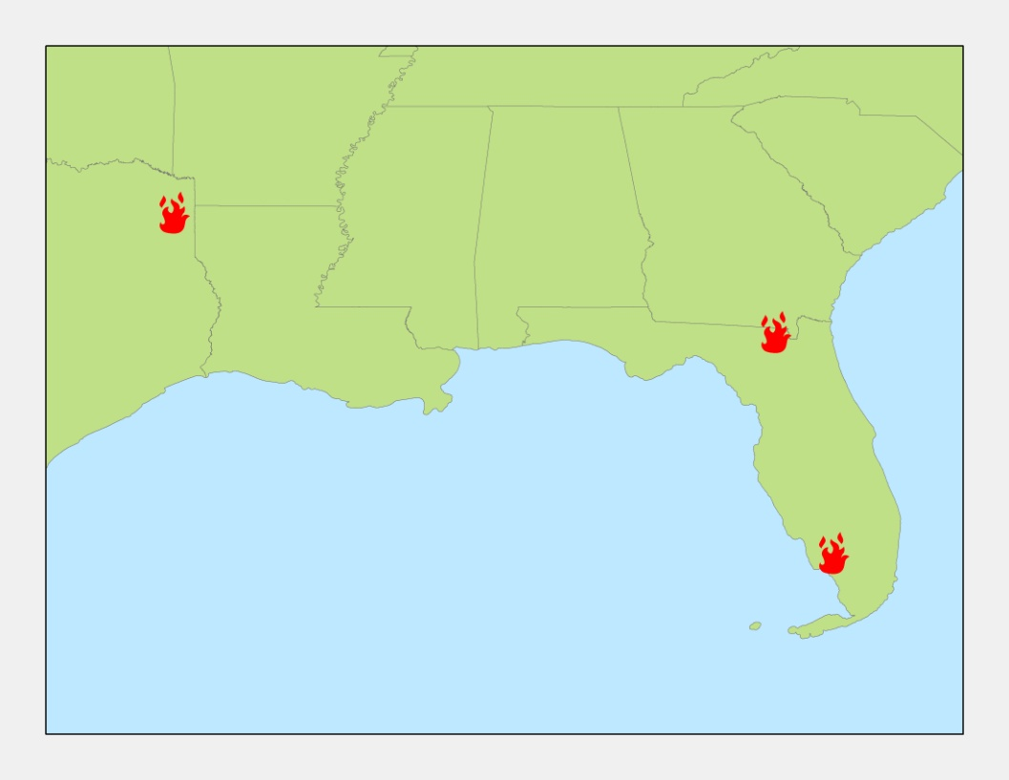

Huckabee Fire, FL

County Line Fire, FL

Bear Creek Fire, TX

Figure 2: County Line Fire RdNBR Analyses: a) Landsat 7 ETM+ RdNBR; b) MODIS RdNBR; c) VIIRS RdNBR

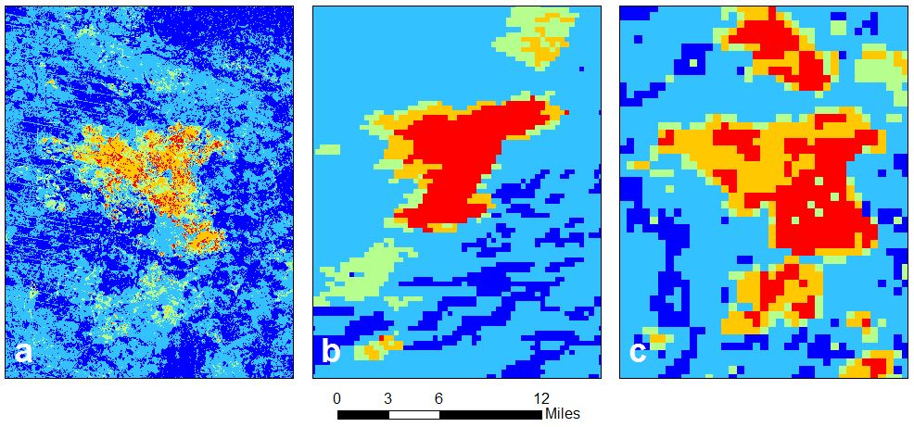

Figure 3: Bear Creek Fire RdNBR Analyses: a) Landsat 5 TM RdNBR; b) MODIS RdNBR

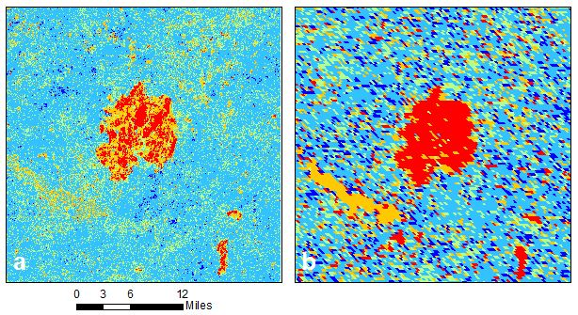

Figure 4: Bear Creek RdNBR Time Series

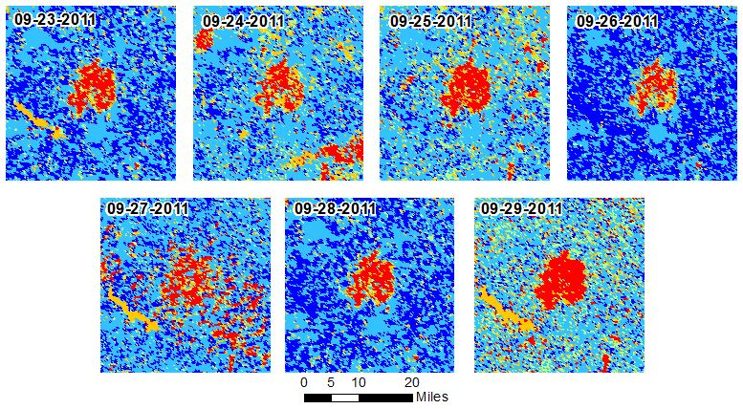

Figure 5: Huckabee Fire RdNBR Analyses: a) Landsat 7 ETM+ RdNBR; b) MODIS RdNBR; c) VIIRS RdNBR; d) Landsat 8 NDVI

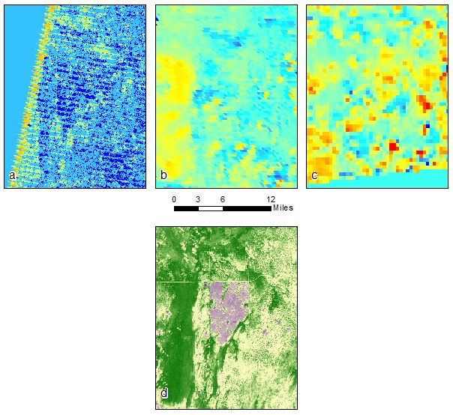

Figure 6: Cloud mask from MODIS on May 17, 2013

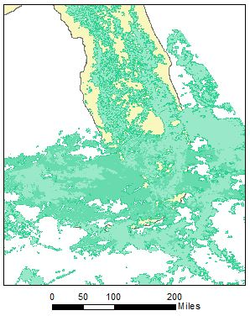

Figure 7: HYPLIT Dispersion Model results overlaying MODIS AOD Data from April 7, 2012 for the County Line Fire

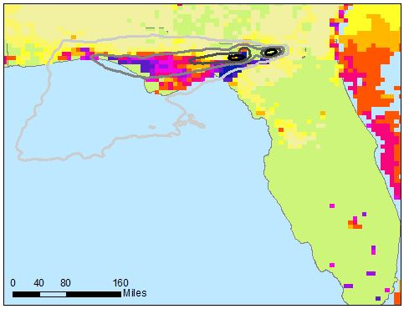

**FINAL GOOGLE EARTH FILES SHOULD ACCOMPANY THIS REPORT**