**NASA DEVELOP National Program**

****NOAA National Centers for Environmental Information

**Summer 2015**

**Short Title: Pacific Water Resources**

**Subtitle:** Using NOAA CDRs and Satellite Data to Connect Phases of the El Niño Southern Oscillation (ENSO) with Precipitation across Hawaii and the U.S. Affiliated Pacific Islands (USAPI)

**VPS Title:** Mapping ENSO: Precipitation for the U.S. Affiliated Pacific Islands

**Project Team & Partners**

**Project Team:**

Jessica Sutton (Project Lead), [jessica.sutton@noaa.gov](mailto:jessica.sutton@noaa.gov)

Nicolas Luchetti

Ethan Wright

**Advisors & Mentors:**

Michael Kruk (Earth Resources Technology (ERT)

John Marra (NOAA Region Climate Services, Director, Pacific Region)

**Partner Organizations**

ERT, Collaborator, POC: Michael Kruk

Regional Climate Services Director (RCSD), Collaborator, POC: John Marra,

Pacific ENSO Applications Climate (PEAC) Center, Boundary Organization, POC: Carl Noblitt

**Project Details**

**Applied Sciences National Applications Addressed:** Water Resources, Climate

**Study Area:** Exclusive Economic Zones (EEZ’s) encompassing American Samoa, Guam, the Republic of the Marshall Islands (RMI), the Federated States of Micronesia (FSM), and the Commonwealth of the Northern Mariana Islands (CNMI), the Republic of Palau, and Hawaii

**Study Period:** January 1985 – December 2014

**Earth Observations & Parameters**

PERSIANN CDR– Precipitation Estimation

**Ancillary Datasets Utilized**

* NOAA Climate Prediction Center (CPC), Monthly Oceanic Nino Index (ONI)- ENSO phases
* NOAA Global Historical Climatology Network (GHCN) daily precipitation observations

**Software Utilized**

PERSIANN CDR:

ArcGIS – NetCDF to raster, raster processing

R - statistical analysis

Dnppy – Python scripting

wget – Ftp download

Microsoft Excel – Simple graphing

NOAA GHCN precipitation:

ArcGIS – Data visualization

R – Data processing, statistical analysis, graphing

Microsoft Excel – Simple graphing

**Project Overview**

**80-100 Word Objectives Overview**

This project examined the influence of five phases of the El Niño Southern Oscillation (ENSO) on long-term precipitation averages for the Exclusive Economic Zones (EEZ’s) encompassing American Samoa, Guam, the Republic of the Marshall Islands (RMI), the Federated States of Micronesia (FSM), the Commonwealth of the Northern Mariana Islands (CNMI), the Republic of Palau, and the Hawaiian Islands. This study utilized remotely sensed precipitation from the PERSIANN CDR, the Oceanic Nino Index, and *in situ* precipitation from NOAA stations. The results from this project will be used to help manage water resources on the islands during different ENSO phases.

**Abstract**

The United States Affiliated Pacific Islands (USAPI) are highly susceptible to extreme precipitation events such as drought and flooding, which directly affect their freshwater availability. Precipitation distribution differs by sub-region, and is predominantly influenced by phases of the El Niño Southern Oscillation (ENSO). Forecasters currently rely on ENSO climatologies from sparse *in situ* station data to inform their precipitation outlooks. This project provided an updated ENSO-based climatology of long-term precipitation patterns for each USAPI Exclusive Economic Zone (EEZ) using the NOAA PERSIANN Climate Data Record (CDR). This data provided a 30-year record (1984-2015) of daily precipitation at 0.25° resolution, which was used to calculate monthly, seasonal, and yearly precipitation. Results indicated that while the PERSIANN precipitation accurately described the monthly, seasonal, and annual trends, it under-predicted the precipitation on the islands. Additionally, maps showing percent departure from normal (30 year average) were made for each three month season based on the Oceanic Niño Index (ONI) for five ENSO phases (moderate-strong El Niño and La Niña, weak El Niño and La Niña, and neutral). Local weather service offices plan on using these results and maps to better understand how the different ENSO phases influence precipitation patterns.

**Community Concerns**

* Pacific Island Nations’ leaders and decision-makers are increasingly interested in growing their understanding and knowledge of regional climate variability and the associated impacts.
* Leaders of these nations are especially interested in understanding how ENSO affects their freshwater sources, as water resources for these nations are heavily dependent upon precipitation.
* Leaders are becoming increasingly concerned with the frequency and distribution of future heavy precipitation and drought events as they relate to the dynamical nature of the climate system.

**Current Management Practices & Policies**

Meteorologists at the Weather Station Offices located throughout the United States Affiliated Pacific Islands USAPI currently collaborate with the Pacific El Niño Southern Oscillation Applications Climate (PEAC) Center when forecasting seasonal precipitation and impact outlooks. PEAC makes use of the Climate Prediction Center (CPC)’s ENSO products and observational analysis tools in order to create regional climate overviews and forecasts. Additionally, forecasters and decision-makers make use of *in situ* station-based ENSO precipitation climatologies in order to assess and mitigate potential impacts from different phases of ENSO. However, these *in situ* stations are unreliable in certain locations and sparse throughout the region. Additionally, the *in situ* station-based ENSO precipitation climatologies are outdated and lack spatial coverage.

**Decision Support Tools & Benefits**

|  |  |  |
| --- | --- | --- |
| **End-Product** | **Earth Observations Used** | **Benefit & Impact** |
| 30 Year Climatology Maps & Figures | PERSIANN CDR – precipitation | Enhance water resource management by providing quantitative information on how ENSO impacts monthly, seasonal, and annual precipitation in the region. |
| Anomalous Wet and Dry Maps | PERSIANN CDR – precipitation | Enhance drought mitigation management by Identification of abnormally wet and dry seasons as they relate to different phases on ENSO. |
| Validation Analysis of PERSIANN CDR with *In Situ* Data | PERSIANN CDR – precipitation | Enhance end-user knowledge of the usefulness and accuracy of satellite-derived precipitation databases. |

**Project Imagery**

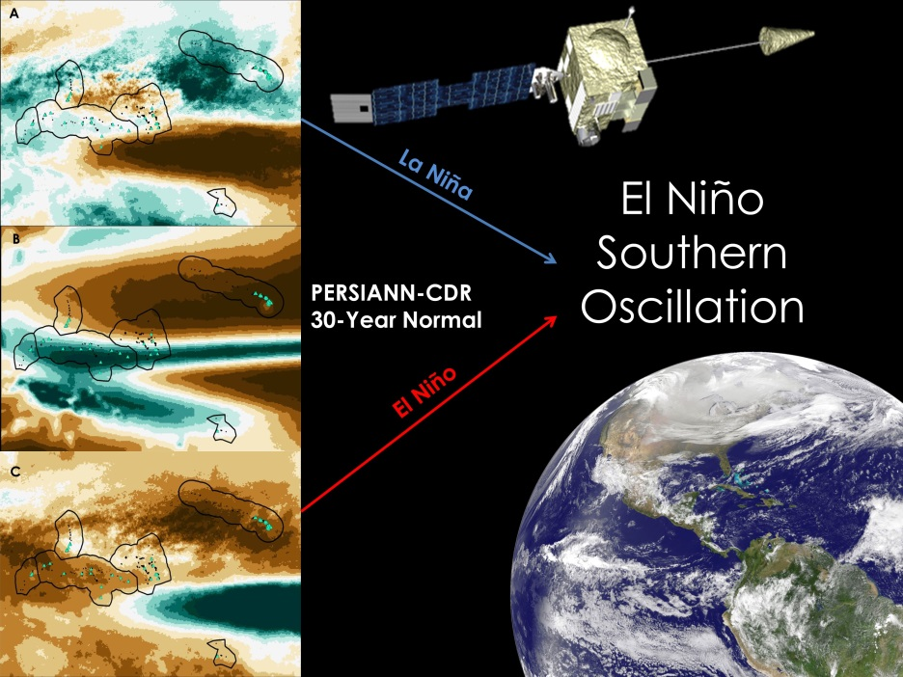

**Caption:** Average winter (DJF) precipitation anomalies during moderate-strong La Niña events (A) and El Niño events (C). Average 30 year winter precipitation (B). Credit: Pacific Water Resources Team.

**Image:** 2015Sum_NCEI_VPS_PWR_FinalImage