**NASA DEVELOP National Program**



International Research Institute for Climate and Society

*Fall 2015*

New Jersey Health and Air Quality

*Modeling of Near Surface Air Temperature Profile of Complex Urban Systems Based on Land Surface Properties*

 **Technical Report**

Rough Draft – October 8, 2015

Maryam Karimi, The Graduate Center,CUNY (Project lead)

Jerrod Lessel, California State University, Fresno

Pietro Ceccato, The International Research Institute for Climate and Society (Science Advisor)

# I. Abstract

Urbanization has created an increase in what is known as urban heat island (UHI). UHI reflects an elevated temperature in cities as compared with nearby rural areas. This is due to the change in landscape from grass cover and vegetation to concrete and asphalt with three-dimensional structures. The excess heat in these urban environments has lead to a rise in heat related illnesses in urban environments. There exists an understanding in the change of temperature beginning at a kilometer above the Earth’s surface (roughly 9.8 °C drop every kilometer) but little understanding exists of the microclimate. As such, a quantitative study was completed analyzing on-site locations representing varied microclimates and analyzing satellite imagery of Glassboro, NJ. A correlation is being developed to be able to obtain the true surface temperature and near surface air temperature of a microclimate based on the environmental factors visible via satellite. The on-site study revealed that varied environments (grass, water, and concrete) result in different temperature profiles within the range of 0’ to 10’. Grass was the coolest environment, water was the most temperate, and concrete had the highest peak temperatures. The satellite study revealed that increased levels of urbanization, with no methods of heat mitigation, resulted in higher average temperatures. Both the on-site and satellite data confirm that the increased urbanization leads to increased temperatures within microclimates.

**Keywords**

Microclimate, Urban Heat Island, Heat Mitigation, Urban Environment, Remote Sensing, On-Site Temperature Monitoring

# II. Introduction

Urbanization has created an increase in what is known as the urban heat island (UHI) effect. UHI reflects an elevated temperature in cities as compared with nearby rural areas. This is due to landscapes changing from permeable moist surfaces to impermeable dry surfaces [11]. This issue is most prevalent in large cities in which the surface type is mainly impermeable concrete. Along with the change in surface type, the landscape has been altered and is now three-dimensional landscape and there is a lack of vegetation. These changes can lead to heat being trapped within the urban environments. UHI can create numerous health problems including respiratory difficulties, heat cramps, heat stroke, and heat-related mortality [4].

The term “heat island” describes urban areas that are hotter than the nearby rural areas [8]. This is due to change of landscapes from grass with high reflectance/diffusion rate in rural areas to predominantly concrete and asphalt with high absorption rate in the cities [9]. Heat islands can significantly change the energy demand seasonally, increase heat related illness and mortality, and even have negative impact on water quality [8]. The increased energy demand creates pressure on power grids, which can also lead to elevated emissions of air pollutants and greenhouse gases [9].

Heat-related mortality is a function of temperature and a population’s sensitivity to temperature. Both vary on the neighborhood scale: temperature varies due to physical characteristics of surface cover; temperature sensitivity varies mainly due to socio-economic factors [4]. As temperature increases above the heat threshold, mortality is seen to become increasingly sensitive to small changes in temperature. The increased temperature of pavements and rooftop surfaces transfer their excess heat to storm water, which drains into streams, rivers, and ponds. This causes the temperature of the aquatic ecosystems to rise, creating stress on the environment [10]. With these changes and environmental impact, studies focusing on microclimate and heat measurement have improved knowledge of thermal behavior.

These changes in temperatures are creating a change in the climate society lives in. While humans live in a microclimate, research on the change of temperature of the Earth’s surface has focused primarily on macroclimates. Suggestions for reducing the impact of urban heat island within a microclimate include increasing vegetation in an area, using reflective materials for roof tops, and using pavements that are modified to not absorb as much heat [10].

Research has shown that increased rates of heat mortality are a result of areas being more vulnerable to its effects. Differences in vulnerability exist depending on climate, culture, infrastructure, and other factors [3]. Reid et al. mapped and analyzed 10 vulnerability factors for heat-related mortality within the United States and found that urban areas showed the highest vulnerability to heat [7]. This vulnerability to heat then leads to extremes in temperature, which are associated with short-term increases in daily mortality [5].

Thermal indices have been developed in order to describe the effect humans feel on their body based on the environment. This is used to attempt to quantify the exact effects that are felt on humans due to excess heat in urban environments. Gulyás et al. [1] conducted two field-surveys in Szeged, a South-Hungarian city. The study placed special emphasis to the human-biometeorological assessment of the microclimate of complex urban environments through the application of the thermal index Physiological Equivalent Temperature (PET). The study resulted in differences in the PET index as high as 15-20 °C due to the different irradiation and that the different modelled environments (only buildings, buildings and trees, and only trees) revealed significant alterations in the human comfort sensations between the situations [1]. Taleghani et al. [8] modeled different thermal environments to understand how PET can change based on the layout of an urban environment. It was found that the duration of direct sun and mean radiant temperature (influenced by urban form) play the most important role in thermal comfort [8]. Nastos et al. [13] analyzed the region of Athens, Greece by comparing the daily mortality with the daily values of PET and Universal Thermal Climate Index (UTCI). The comparison was completed by applying Pearson’s chi-squared test to find the probability of mortality relating to the thermal indices and it was concluded that the air temperature and PET/UTCI exceedances over specific thresholds depending on the distribution reveal that, very hot conditions are risk factors for the daily mortality [6].

The heat mitigation strategies can only be confirmed once monitored over long periods of time. Proper monitoring methods have yet to be developed. Voogt and Oke [12] performed a review on thermal remote sensing of urban areas and found that is mainly a qualitative description of thermal patterns and simple correlations. Improvements in the spatial and spectral resolution of current and next generation satellite-based sensors and high resolution portable thermal scanners will allow for the progress in the application of urban thermal remote sensing to study the climate of urban areas [12]. A new method was introduced by Huang et al. [2] in which a spatiotemporal image fusion model is used to produce high spatiotemporal resolution LST data. This is done by combining the high spatial resolution of Landsat images the frequent coverage of Moderate Resolution Imaging Spectroradiometer (MODIS) images. This method accounts for the warming and cooling effect of ground objects in urban areas and establishes a new weight function to account for the effect of neighboring pixels [2].

# III. Methodology

In order to model the behavior of air temperature within the microclimate, a temperature probe setup was designed to acquire the data. The setup included 21 HOBO Pendant Temp/Light, 64K sensors. The sensors were spaced at half-foot increments on a 10-foot pvc pole. By doing so, the probes would be able to obtain data at varying heights above the land surface (Figure 1). The temperature probe setup was then employed within varying microclimates located on the Rowan University campus. The chosen microclimates exhibited three different surface types: mainly grass surface, area with a water surface, and a mainly concrete surface.



Figure 1: Temperature Probe Setup

The main analysis of this project dealt with the recorded air temperatures from the temperature probe setup. The near surface air temperatures was gathered from the Onset Temperature Pendants. Each pendant was set to acquire data every 10 minutes.

Each of the HOBO Pendant Temp/Light had the ability to measure and record the light intensity at each height above the ground surface. The light intensity at each height was measured in units of lux. This data was used in further analysis of the urban heat island effect; however, this research focused on the air temperature obtained using the HOBO Pendant Temp/Light sensors.

The raw data was combined utilizing Matlab software and then analyzed using Microsoft Excel. The raw data contained temperature readings at every 0.5’ that were taken every 10 minutes over the time period of February 5, 2015 to March 26, 2015. The first day and last day of deployment of the probes were omitted from analysis due to false data readings caused by set up of the probes and removal of the probes from their environment. This data was then separated into daily readings to further analyze the differences between the environments that the temperature probe setups were placed.

The temperature pendant data was analyzed using a three-dimensional graph. The graph depicts the time of day along the x-axis, the height in feet at which the temperature data was recorded along the y-axis, and the temperature in Celsius as a color gradient ranging from blue as cold to red as hot.

# IV. Results & Discussion

Figures 2 - 4 below represent the daily temperatures taken on February 11, 2015. Fig. 2 represents the data obtained from the probe placed within the grass environment, Fig. 3 for the probe within the water environment, and Fig. 4 for the probe within the concrete environment. According to past weather reports, within Glassboro, NJ the reported high for this day was 42 °F or ~5.56 °C. When analyzing the figures, it can be seen that the grass environment remained around this temperature range and occasionally reached a temperature range between 8-10 °C around noon, which is likely to be due to direct sunlight onto the temperature pendants.

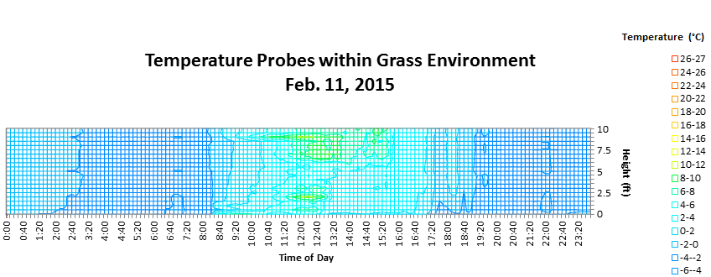

Figure 2: Temperature Profile from 0’ - 10’ within Grass Environment

However within the water environment, the temperature values increase to ranges as high as 20-22 °C. This is possibly due to the placement of the probe itself, as it was deployed between the engineering building of Rowan Hall and a small lake. There could have been excess temperature sensed by the probe due to the reflectance of the building and the reflectance of the lake. Another interesting item to notice is that the water environment stays rather temperate; the ground and air temperatures are stay relatively the same.

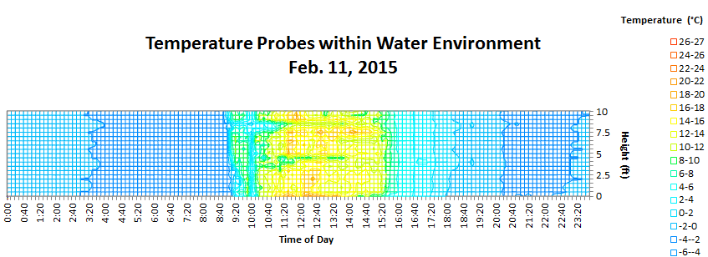

Figure 3: Temperature Profile from 0’ - 10’ within Water Environment

An even larger difference can be observed within the concrete environment. The recorded temperature reached its highest amount of the day at 26-27 °C. This temperature range occurred at noon, as expected, and only seemed to occur near the surface of the material. This created what could be called a belly or pocket of heat.

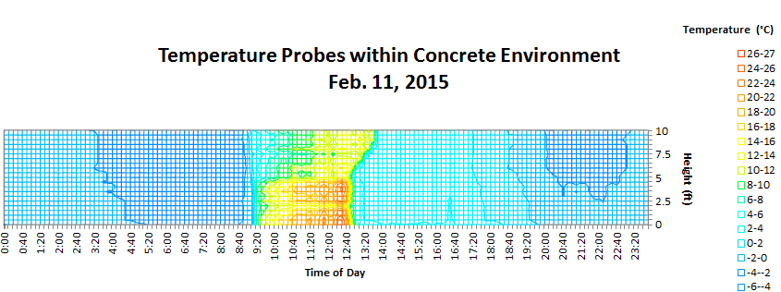

Figure 4: Temperature Profile from 0’ - 10’ Concrete Grass Environment

From the analysis of data for the month of February 2015, it can be postulated that an equation could be developed to calculate the near surface temperatures based on environmental factors.

**More results and discussion forthcoming in final draft.**

# V. Conclusions

Using results from this work and future work, different constants could be calculated in order to complete the empirical formula. However, even after the formula is completed there may still be errors due to changes in conditions from those that were used to find the formula’s constants. As such, an offset table should be included in order to correct for weather types and surface types in different environments. The formula constants would need to be derived after continued analysis of varied environments with hourly weather records kept. This would then need to have statistical analysis completed on it to find an average air temperature offset. This will likely need to be found by calculating the difference in air temperatures recorded by weather reports and that of the temperature pendants, and then comparing that data to that of known environmental factors that can change air temperature (i.e. cloudy day, rain, heavy winds, etc.).

**More conclusions forthcoming in the final draft.**

# VII. References

1. Gulyás, Ágnes, János Unger, and Andreas Matzarakis. "Assessment of the Microclimatic and Human Comfort Conditions in a Complex Urban Environment: Modelling and Measurements." Building and Environment 41.12 (2006): 1713-722. Web.

2. Huang, Bo, Juan Wang, Huihui Song, Dongjie Fu, and Kwankit Wong. "Generating High Spatiotemporal Resolution Land Surface Temperature for Urban Heat Island Monitoring."IEEE Geoscience and Remote Sensing Letters 10.5 (2013): 1011-015. Web.

3. Kovats, R. Sari, and Shakoor Hajat. "Heat Stress and Public Health: A Critical Review." Annual Review of Public Health 29.1 (2008): 41-55. Web.

4. Li, Tiantian, Radley M. Horton, and Patrick Kinney. “Future Projections of Seasonal Patterns in Temperature-Related Deaths for Manhattan.” Nature climate change 3 (2013): 717–721. PMC. Web.

5. Medina-Ramón, Mercedes, Antonella Zanobetti, David Paul Cavanagh, and Joel Schwartz. "Extreme Temperatures and Mortality: Assessing Effect Modification by Personal Characteristics and Specific Cause of Death in a Multi-City Case-Only Analysis."Environmental Health Perspectives 114.9 (2006): 1331-336. Web.

6. Norton, Briony A., Andrew M. Coutts, Stephen J. Livesley, Richard J. Harris, Annie M. Hunter, and Nicholas S.g. Williams. "Planning for Cooler Cities: A Framework to Prioritise Green Infrastructure to Mitigate High Temperatures in Urban Landscapes." Landscape and Urban Planning 134 (2015): 127-38. Web.

7. Reid, Colleen, Marie O'neill, Carina Gronlund, Shannon Brines, Dan Brown, Ana Diez-Roux, and Joel Schwartz. "Mapping Community Determinants of Heat Vulnerability."Environmental Health Perspectives (2009): n. pag. Web.

8. Taleghani, Mohammad, Laura Kleerekoper, Martin Tenpierik, and Andy Van Den Dobbelsteen. "Outdoor Thermal Comfort within Five Different Urban Forms in the Netherlands." Building and Environment 83 (2015): 65-78. Web.

9. Taleghani, Mohammad, David J. Sailor, Martin Tenpierik, and Andy Van Den Dobbelsteen. "Thermal Assessment of Heat Mitigation Strategies: The Case of Portland State University, Oregon, USA." Building and Environment 73 (2014): 138-50. Web.

10. United States Environmental Protection Agency. “Heat Island Effect.” EPA. EPA. Web. http://www.epa.gov/heatisland/

11. United States Environmental Protection Agency. “Heat Island Effect: Basic Information.” EPA. EPA. Web. http://www.epa.gov/heatisland/about/index.htm

12. Voogt, J.a, and T.r Oke. "Thermal Remote Sensing of Urban Climates." Remote Sensing of Environment 86.3 (2003): 370-84. Web.

13. Nastos, Panagiotis T., and Andreas Matzarakis. "The Effect of Air Temperature and Human Thermal Indices on Mortality in Athens, Greece." Theoretical and Applied Climatology 108.3-4 (2012): 591-99. Web.