**NASA DEVELOP National Program**

 John C. Stennis Space Center

**Fall 2013**

**Coastal Texas Oceans**

*Enhancing Remote Sensing Capabilities of the Sargassum Early Advisory System (SEAS) Through the Use of NASA EOS and Open Source GIS*

**Team Lead:** Shelby Barrett (William Carey University), shelby.g.barrett@nasa.gov

**Team Members:**

Brittany Arceneaux (University of New Orleans)

Mekdes Smith (University of Southern Mississippi)

**Advisors & Mentors:**

Joe Spruce (SSC, Computer Sciences Corporation)

Dr. Kenton Ross (Langley Research Center, NASA)

Dr. Thomas Linton (Texas A&M, Galveston, *Sargassum* Early Advisory System)

Chuanmin Hu (University of South Florida)

**Applied Sciences National Applications Addressed:**

Oceans

**Study Area:**

Texas Gulf Coast

**Study Period:** March 2000 - September 2013

**Community Concerns**

* Communities nestled along the coastline rely heavily on tourism as a primary source of income, with Texas beach tourism generating approximately $7 billion per year.
* Public use of these beaches can be severely restricted by the periodic mass landings of free-floating brown macroalgae known as *Sargassum*.
* These *Sargassum* landings often occur with little or no warning, and can last for weeks at a time, usually during the prime tourist season, thereby negatively affecting the economies of the region.
* Trapped anthropogenic litter within the *Sargassum* can include plastics, paper, and medical and industrial waste, potentially creating a health hazard.

**80-100 Word Blurb**

Every year the Texas Gulf Coast economy is threatened by periodic mass landings of *Sargassum*, also known as Gulfweed. Anthropogenic litter can become trapped within the *Sargassum* creating a hazardous environment for marine life and tourists. Managing these landings creates financial strains on coastal municipalities. Scientists at Texas A&M University at Galveston have implemented the *Sargassum* Early Advisory System (SEAS), which aims to provide coastal managers with landing predictions through the use of remote sensing. This terms objectives include providing SEAS with enhanced remote sensing methodologies to aid in the detection and tracking of *Sargassum* near the Texas Gulf Coast.

**Abstract**

*Sargassum* is a pelagic brown macroalgae that can be found floating in large, dense mats in the Gulf of Mexico. In open water, these *Sargassum* mats serve as a valuable habitat to unique communities of marine organisms. However, when these large quantities of *Sargassum* land on Galveston, TX beaches, they pose a serious threat to local tourism. The decomposition of *Sargassum* and the organisms therein give rise to unattractive odors. *Sargassum* can also trap plastics, paper, medical and industrial waste. The removal of these large mats is both costly and time consuming, especially if unexpected. If provided with early notice of the arrival of *Sargassum*, land managers can be better prepared to allocate resources for beach cleanup. Scientists at Texas A&M University at Galveston are exploring the use of NASA supported EOS data, specifically Landsat images, to track *Sargassum* mats in the Gulf of Mexico as they approach the Texas Gulf Coast. Their *Sargassum* Early Advisory System (SEAS) aims to forewarn coastal managers of these *Sargassum* mats so that managers are better prepared for proper cleanup efforts and resources can be allocated appropriately. This project focused on providing SEAS with an improved remote sensing methodology for image manipulation in order to enhance visual detection of *Sargassum* as it approaches the Texas Coast. This includes calculating various surface water monitoring indices on NASA EOS images such as Normalized Difference Vegetation Index (NDVI), Floating Algae Index (FAI), and various band combinations, in order to assess and determine the easiest and most accurate detection of *Sargassum*.

**Partners/Collaborators**

Dr. Thomas Linton, Texas A&M University, *Sargassum* Early Advisory System (SEAS)

**Current Management Practices & Policies**

The Texas Gulf Coast provides a natural recreational asset to thousands of visitors every year. This three hundred mile beach system is managed and maintained by both public and private stakeholders. Each year over $2.91 million dollars is allocated to removing the abundance of *Sargassum* that lands on Texas Gulf shores. Beach managers have typically had to rely on emergency funds to assist in removing heavier than normal *Sargassum* from the beach. This creates an unexpected hardship, since their annual budgets have little to no room for unforeseen expenditures. In response, Texas A&M University Galveston developed the *Sargassum* Early Advisory System (SEAS) to investigate the use of remote sensing and geospatial technologies to give coastal managers as much warning about incoming *Sargassum* mats as possible. These predictions potentially allow beach managers to adjust their allocation of resources for the timely and efficient management of *Sargassum* landings.

Currently, SEAS uses basic remote sensing tools and analysis techniques, employing LandsatLook .jpeg images from Landsat 7 and wind and current data from local buoys to track and predict the movement of *Sargassum* as it approaches the Texas Gulf Coast. SEAS is analyzing these images in Microsoft Paint which limits more advanced analysis techniques such as contrast stretching which can enhance visual detection.

**Benefit to End-User:**

* Overview of remote sensing, how to apply remotely sensed data, and overall usefulness of NASA EOS
* Enhanced *Sargassum* detection methodology that can be replicated in open source GIS software for cost-effectiveness

**Decision Support Tools**

* Improved *Sargassum* detection methodology enabling end-users to implement the use of open source GIS software instead of Paint. This would potentially allow for image manipulation in order to enhance visual detection of *Sargassum.* This will include technical paper, WebEx meeting, and workshop or tutorials explaining project methodologies and results
* Example products of indices, classifications, and image enhancements to better detect *Sargassum* in Landsat 7 and 8 data

**Earth Observations & Parameters**

Landsat 4-5 TM- Spectral vegetation indices and Visible/NIR imagery

Landsat 7, ETM+-Spectral vegetation indices and Visible/NIR imagery

Landsat 8, OLI - Spectral vegetation indices and Visible/NIR imagery

**Future Applicable NASA Missions**

Aqua, AMSR-E (Advanced Microwave Scanning Radiometer)-SST; Sea Surface Winds

Aqua & Terra, MODIS (Moderate Resolution Imaging Spectroradiometer)- Remote Sensing Reflectance-250m products

**Models Utilized**

Navy Coastal Ocean Model (NCOM) current predictions – Naval Research Lab (NRL)

General NOAA Ocean Modeling Environment (GNOME)

**Ancillary Datasets Utilized**

NOAA National Data Buoy Center – In-situ measurements of wind and currents

Texas Automated Buoy System (TABS) – In-situ measurements of wind and currents

**Software Utilized**

Erdas Imagine - land classification of Landsat imagery

ArcGIS - Raster Manipulation/Analysis, Image Enhancement & Map Creation of Landsat 7 ETM+, Landsat 8 OLI

**Imagery & Captions (only to be included in the final draft, not rough draft)**

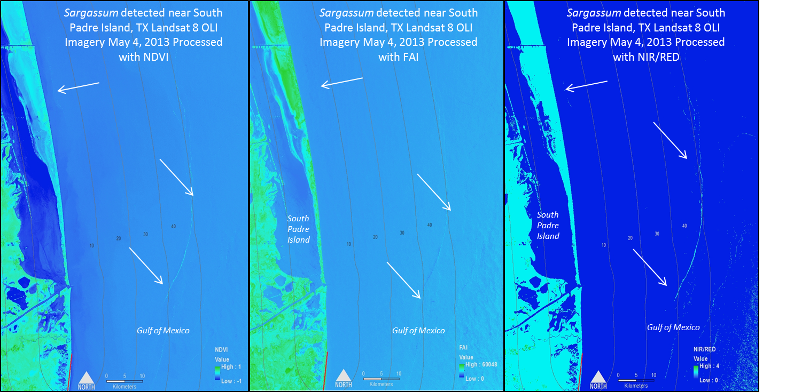

These Landsat 8 images show *Sargassum* detected in the Gulf of Mexico off the coast of Texas, near Padre Island on May 4, 2013. The image to the left shows NDVI calculated for this date. The center image shows a modified Floating Algae Index (FAI)calculated for this date. The image to the right shows a Near Infrared/Red band ratio for this same date. The blue hues indicate water, whereas the greener hues indicate *Sargassum*.